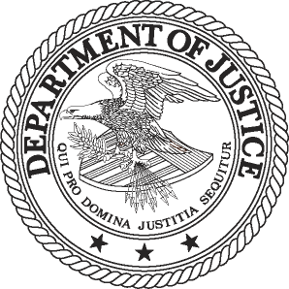
FOR IMMEDIATE RELEASE AT
THURSDAY, JUNE 9, 2011 (202) 514-2007
WWW.JUSTICE.GOV TTY 1-866-544-5309

OWNER OF ILLINOIS TECHNOLOGY COMPANY SENTENCED TO SERVE 12 MONTHS AND A DAY IN PRISON FOR ROLE IN CONSPIRACY TO DEFRAUD THE FEDERAL E-RATE PROGRAM

WASHINGTON - An owner of an Illinois-based technology company was sentenced today to serve one year and a day in prison for his participation in a conspiracy to defraud the federal E-Rate program, the Department of Justice announced.

Barrett C. White was also sentenced by U.S. District Court Judge Eldon Fallon to pay a $4,000 criminal fine for conspiring to defraud the E-Rate program by providing bribes and kickbacks to school officials in multiple states. White was charged with the conspiracy in U.S. District Court in New Orleans on Nov. 18, 2010, and he pleaded guilty on March 3, 2011.

As a result of the Antitrust Division’s investigation into fraud and anticompetitive conduct in the E-Rate program, including today’s sentencing, a total of seven companies and 24 individuals have pleaded guilty, been convicted at trial or entered civil settlements. Those companies and individuals have been sentenced to pay criminal fines and restitution totaling more than $40 million. Sixteen individuals, including White, have been sentenced to serve prison time.

According to court documents, White participated in the conspiracy beginning on or about February 2004 through August 2005. The department said that White offered and delivered bribes and kickbacks to school officials responsible for the procurement of Internet access services. In return for those payments, E-Rate contracts were awarded to his co-conspirators’ companies. White’s co-conspirators, Gloria Harper and Tyrone Pipkin, have also pleaded guilty to the conspiracy in separate charges and await sentencing.

The E-Rate program was created by Congress in the Telecommunications Act of 1996 and is administered by the Universal Service Administrative Company, under the oversight of the Federal Communications Commission (FCC). The program provides subsidies to economically disadvantaged schools and libraries. Depending on the financial needs of the applicant schools, the program pays 20 to 90 percent of the cost for Internet access and telecommunications services, as well as internal computer and communications networks.
Today’s sentencing resulted from an investigation by the Department of Justice Antitrust Division’s Dallas Field Office, the FBI’s Dallas Field Office and the FCC’s Office of Inspector General, with assistance from the U.S. Attorney’s Office for the Eastern District of Louisiana. Anyone with information concerning violations of the E-Rate program is urged to call the Antitrust Division’s Dallas Field Office at 214-661-8600 or visit http://www.justice.gov/atr/contact/newcase.html.

# # #

11-755

