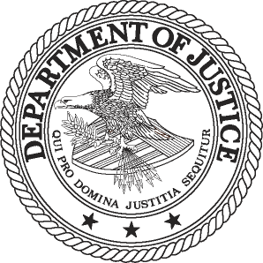
FOR IMMEDIATE RELEASE AT
FRIDAY, DECEMBER 16, 2011 (202) 514-2007
WWW.JUSTICE.GOV TTY (866) 544-5309

CEO OF COMCAST BRIAN ROBERTS TO PAY $500,000 CIVIL PENALTY FOR VIOLATING ANTITRUST PREMERGER NOTIFICATION REQUIREMENTS

Violations Occurred When Roberts Acquired Comcast Voting Securities

WASHINGTON – Comcast Corporation’s CEO Brian L. Roberts will pay a $500,000 civil penalty to settle charges that he violated premerger reporting and waiting requirements when he acquired Comcast voting securities, the Department of Justice announced today.

The Justice Department’s Antitrust Division, at the request of the Federal Trade Commission, filed a civil antitrust lawsuit today in U.S. District Court in Washington, D.C., against Roberts for violating the notification requirements of the Hart-Scott-Rodino (HSR) Act of 1976. At the same time, the department filed a proposed settlement that, if approved by the court, will settle the charges.

Roberts is also chairman of the board of Comcast, a leading provider of cable television services headquartered in Philadelphia.

According to the complaint, Roberts failed to comply with the antitrust premerger notification requirements of the HSR Act before acquiring voting securities of Comcast as part of his compensation as chairman and chief executive officer of Comcast beginning on Oct. 22, 2007, which resulted in his holding more than $119.6 million of Comcast stock. On Aug. 25, 2009, Roberts made a corrective filing for Comcast voting securities he had acquired. Although this is the first time Roberts has been charged with an HSR Act violation, previously he had twice made corrective filings regarding transactions that he acknowledged were reportable under the HSR Act, asserting that the failures to file and observe the waiting period were inadvertent.

The Hart-Scott-Rodino Act of 1976, an amendment to the Clayton Act, imposes notification and waiting period requirements on individuals and companies over a certain size before they consummate acquisitions resulting in holding stock or assets above a certain value, which was $59.8 million in 2007 and is currently $66 million.

Federal courts can assess civil penalties for premerger notification violations under the HSR Act in lawsuits brought by the Department of Justice. For a party in violation of the HSR Act before Feb. 10, 2009, the maximum civil penalty is $11,000 a day for each day it is in violation of the Act. For a party in violation of the HSR Act on or after Feb. 10, 2009, the maximum penalty is $16,000 a day.

# # #
11-1655

