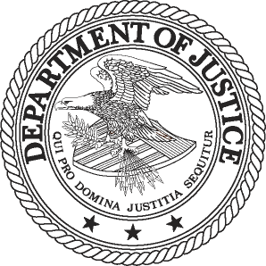
FOR IMMEDIATE RELEASE AT
WEDNESDAY, APRIL 10, 2013 (202) 514-2007
WWW.JUSTICE.GOV TTY (866) 544-5309

JUSTICE DEPARTMENT AND FEDERAL TRADE COMMISSION

ACCOUNTABLE CARE ORGANIZATION WORKING GROUP

ISSUES SUMMARY OF ACTIVITIES

WASHINGTON – The Department of Justice and the Federal Trade Commission (FTC) issued a joint summary of the activities of the Accountable Care Organization (ACO) Working Group, which took place between October 2011 and March 31, 2013. The department and the FTC established the working group to collaborate and discuss issues concerning ACOs created under the Affordable Care Act of 2010. The act encourages physicians, hospitals and other health care providers to integrate their health care delivery systems in order to improve the quality and reduce the costs of health care services.

The summary, which follows issuance of the agencies’ October 2011 antitrust enforcement policy statement regarding ACOs participating in the Medicare Shared Savings Program (MSSP), reports that during the time period covered, the ACO Working Group fielded 33 questions related principally to primary service area (PSA) share calculations, and two requests for voluntary expedited review from proposed ACOs.

Under the policy statement, an ACO may calculate its PSA shares to determine whether it falls within an antitrust safety zone for certain ACOs that are highly likely to raise significant competitive concerns. The ACO Working Group responded to most of the 33 PSA share questions within five business days, and in connection with the release of the summary is now making the questions and answers publicly available on their websites. The largest category of questions concerned obtaining and using Medicare and other data to calculate PSA shares.

Also under the policy statement, a newly formed ACO may request voluntary expedited antitrust review of its program. Both of the ACOs that sought such review during the time period covered by the summary withdrew their requests.
The joint summary and questions and answers can be found on the department’s website at http://www.justice.gov/atr/public/health_care/aco.html.

###
13-410

MEDIA CONTACT: Gina Talamona
Department of Justice
Office of Public Affairs
202-514-2007

Mitch Katz
FTC
Office of Public Affairs
202-326-2180

