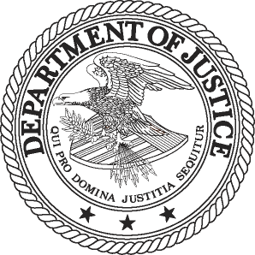
FOR IMMEDIATE RELEASE AT
THURSDAY, APRIL 11, 2013 (202) 514-2007
WWW.JUSTICE.GOV TTY (866) 544-5309

ANTITRUST DIVISION ISSUES 2013 EDITION OF ITS ANNUAL NEWSLETTER

WASHINGTON – The Department of Justice’s Antitrust Division today issued the 2013 edition of its annual newsletter on its website. The newsletter includes a message from Assistant Attorney General Bill Baer which focuses on the need to protect and promote competition in industries that directly affect the day-to-day lives of consumers, as well as articles about the Antitrust Division’s civil and criminal enforcement actions, international cooperation efforts and competition advocacy.

The newsletter highlights the division’s criminal enforcement matters, including the significant fines and prison sentences obtained and litigation victories in trials relating to the liquid crystal display, municipal bonds and coastal freight investigations. The division also achieved convictions in its auto parts, real estate foreclosure auctions and tax liens cartel investigations.

Other newsletter articles describe the division’s active civil enforcement program–as evidenced by the six civil cases currently in litigation–in key sectors such as health care, telecommunications and technology, transportation, office supplies and other consumer products.

The newsletter also features articles about some of the division’s talented career litigators, the division’s new economics deputy, and competition advocacy efforts involving public workshops on intellectual property and most favored nations clauses.

The newsletter can be found at http://www.justice.gov/atr/public/division-update/2013/index.html. Within each article, hyperlinks are provided so that the reader can easily access relevant documents such as press releases, court filings and speeches.

###
13-421

