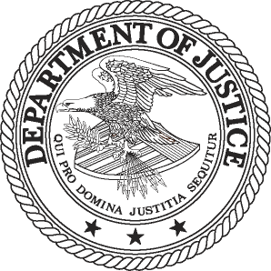
______________________________________________________________________________
FOR IMMEDIATE RELEASE AT
WEDNESDAY, SEPTEMBER 25, 2013 (202) 514-2007
WWW.JUSTICE.GOV TTY (866) 544-5309

JUSTICE DEPARTMENT AND FEDERAL TRADE COMMISSION ISSUE UPDATED MODEL WAIVER OF CONFIDENTIALITY FOR INTERNATIONAL CIVIL MATTERS AND Accompanying FAQ

Updated Model Waiver is Designed to Streamline Process, Reduce Time and Resources

WASHINGTON – The Department of Justice’s Antitrust Division and the staff of the Federal Trade Commission (FTC) today issued a joint model waiver of confidentiality for individuals and companies to use in merger and civil non-merger matters involving concurrent review by the DOJ or FTC and non-U.S. competition authorities.

A waiver provides the terms on which an individual or company agrees to waive statutory confidentiality protections to the agency that originally received the company’s confidential information. The model waiver is designed to streamline the waiver process to significantly reduce the burden on individuals and companies, as well as to reduce the agencies’ time and resources involved in negotiating waivers.

The model waiver updates and replaces the agencies’ prior forms. It reflects both agencies’ recent experience with waivers, incorporating updated language and provisions, including a provision addressing the agencies’ treatment of privileged information.

A waiver of confidentiality is voluntarily provided by an individual or company involved in a civil matter. A waiver describes an agency’s policy regarding its treatment of information received from another competition agency under a waiver, although it is not an agreement signed by the agency. A waiver allows for the sharing of confidential information only among the competition agencies listed in the waiver.

Waivers enable more complete communication, cooperation and coordination between competition agencies concurrently investigating a matter. By permitting cooperating agencies to discuss or otherwise exchange the individual’s or company’s confidential information, a waiver enables agencies to make more informed, consistent decisions and coordinate more effectively, often expediting the review.

To promote greater transparency and better understanding of the DOJ’s and FTC’s policies and practices related to waivers, DOJ and staff of the FTC also released a Frequently Asked Questions (FAQ) document to accompany the model waiver. The FAQ provides introductory information on waivers and on the confidentiality rules applicable to the information provided under the model waiver. It also describes the process for providing a waiver to either agency and explains specific provisions of the model waiver. By issuing the model waiver and accompanying FAQ jointly, the Department of Justice and the Federal Trade Commission hope to facilitate parties’ use of waivers generally and, in particular, the model waiver.

Further information about waivers of confidentiality, the model waiver of confidentiality, and FAQ are available at http://www.justice.gov/atr/public/international/index.html and http://www.ftc.gov/oia/waivers/index.shtm.

###

13-1066

