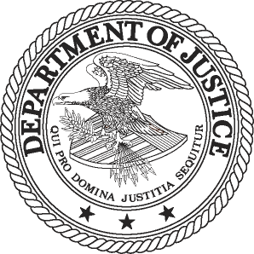

FOR IMMEDIATE RELEASE  AT

THURSDAY, JANUARY 9, 2014 (202) 514-2007

[WWW.JUSTICE.GOV](http://WWW.JUSTICE.GOV) TTY (866) 544-5309

**JUSTICE DEPARTMENT ISSUES STATEMENT ON U.S. DISTRICT COURT RULING THAT BAZAARVOICE’S ACQUISITION OF POWERREVIEWS VIOLATED ANTITRUST LAWS**

WASHINGTON — Assistant Attorney General Bill Baer in charge of the Department of Justice’s Antitrust Division made the following statement today after the U.S. District Court for the Northern District of California found that Bazaarvoice Inc. violated Section 7 of the Clayton Act by acquiring its primary rival, PowerReviews Inc:

“By acquiring its only significant rival, Bazaarvoice deprived its customers of the benefits of competition.  We are pleased that the court, after carefully weighing all of the evidence, agreed with the Justice Department that Bazaarvoice’s acquisition of PowerReviews was likely to extinguish price competition and substantially diminish the pace of innovation in the market for product ratings and reviews platforms.

“As shown during trial, Bazaarvoice executives clearly intended to eliminate competition by acquiring PowerReviews.  Consistent with Bazaarvoice’s own pre-merger view of the marketplace, the evidence presented at trial demonstrated that PowerReviews was a significant threat to Bazaarvoice and that other rivals are poorly positioned to fill the competitive void created by the merger.

“I am proud of the excellent work done by the trial team on behalf of U.S. consumers.  As today’s decision reaffirms, anticompetitive transactions that are not reported to federal agencies will not receive a free pass from antitrust scrutiny.”

**Background**

On Jan.10, 2013, the department filed a civil antitrust lawsuit in the U.S. District Court for the Northern District of California against Bazaarvoice.  The department alleged that Bazaarvoice’s June 2012 acquisition of PowerReviews eliminated the company’s only significant rival, in violation of the antitrust laws.

Bazaarvoice’s acquisition of PowerReviews was not required to be reported under the Hart-Scott-Rodino Antitrust Improvements Act of 1976, which requires companies to notify and provide information to the department and the Federal Trade Commission before consummating certain acquisitions.  The department began its investigation shortly after the transaction closed.

The department’s trial against Bazaarvoice, which was overseen by Judge William Orrick, began on Sept. 23, 2013.  The trial lasted three weeks, with closing arguments taking place on Oct. 15, 2013.  The court scheduled a hearing on Jan. 22, 2014, to discuss procedures for the remedy phase of the litigation.

###

14-026