FY 2010

PERFORMANCE BUDGET

Congressional Submission



Office of the Federal Detention Trustee

U. S. Department of Justice

Table of Contents

I. Overview 3
II. Summary of Program Changes 13
III. Appropriation Language and Analysis of Appropriations Language 14
IV. Decision Unit Justification 15
Program Description 15
Detention Services 15
Transportation 16
Enterprise Information Technology (IT) Infrastructure……………………………17
Performance Resource Table 21
Performance, Resources, and Strategies …………………………………………....25
V. Program Increases by Item 35
Southwest Border Enforcement 35
Operating Costs 38
JPATS Transportation 40
VI. Exhibits.

A. Organizational Chart
B. Summary of Requirements
C. Program Increases by Decision Unit
D. Resources by DOJ Strategic Goal/Objective
E. Justification for Base Adjustments
F. Crosswalk of 2008 Availability
G. Crosswalk of 2009 Availability
H. Summary of Reimbursable Resources
I. Detail of Permanent Positions by Category
J. Financial Analysis of Program Increases
K. Summary of Requirements by Grade
L. Summary of Requirements by Object Class
M. Status of Congressionally Requested Studies, Reports - Not Applicable
N. Resource Summary
I. Overview

A. Introduction
The Office of the Federal Detention Trustee (OFDT) requests a total of 27 permanent positions, 25 full-time equivalents (FTE), and $1,438,663,000 for Fiscal Year (FY) 2010.

The request represents an increase of $143,344,000 over the FY 2009 appropriation. The requested increase includes $117,000 for adjustments-to-base and $143,227,000 for program increases. The request by strategic goal follows:

DOJ Strategic Goal | OFDT  Program Activity | Request
3.3 | Detention Services | $1,402,906,000
3.1 | JPATS Transportation | 35,757,000
Total Request |  | $1,438,663,000

Electronic copies of the Department of Justice’s Congressional Budget Justifications and Capital Asset Plan and Business Case exhibits can be viewed or downloaded from the Internet using the Internet address: http://www.usdoj.gov/jmd/2010justification/.

B. Mission
OFDT was established as a DOJ organization in September 2001 by Congressional directive in response to growing concerns regarding federal detention. Congress believed that the size and scope of federal detention demanded a central organization that could direct resources, facilitate the implementation of programmatic changes, and improve the coordination of detention activities for DOJ and the immigration agencies that are now part of the Department of Homeland Security (DHS).

In 2005, Congress directed OFDT to assume the responsibility of managing the Justice Prisoner and Alien Transportation System (JPATS) to improve management and ensure unimpeded prisoner transportation operations and equality among agencies. In FY 2007 JPATS funding was transferred to OFDT.

Mission Statement
Manage and regulate the Federal detention programs and JPATS by establishing a secure and effective operating environment that drives efficient and fair expenditure of appropriated funds.

OFDT has proven successful in achieving efficiencies and cost reduction and avoidance in detention through process and infrastructure improvements outlined in a national detention strategy which addresses the requirements of the United States Marshal Service (USMS), the Bureau of Prisons (BOP), and Bureau of Immigration and Customs Enforcement (ICE). With that strategy firmly in place, OFDT is now strengthening its focus on the regulatory aspects of its mission. In addition, OFDT will explore new approaches to address diminishing detention capacity in an environment of ever increasing detention populations resulting from aggressive immigration and other law enforcement initiatives.

C. FY 2010 Budget Request by Strategic Goal
The OFDT budget is aligned with DOJ and OFDT strategic and performance goals and the mission is defined by two program activities: 1) Detention Services; and 2) JPATS Transportation. These program activities correspond directly with DOJ Strategic Goals as shown below. Further, each program activity identifies the related performance objectives as well as related resources. All of this information as well as critical performance targets and workload projections are included in the Performance and Resources Table (See page 21). The alignment of DOJ Strategic Goals, OFDT Strategic Goals, and program activities follows.

DOJ Strategic Goal 3.1 Protect judges, witnesses, and other participants in federal proceedings, and ensure the appearance of criminal defendants for judicial proceedings or confinement

OFDT Program Activity: JPATS Transportation
OFDT Strategic Goal 3: Increase efficiency of the JPATS program

DOJ Strategic Goal 3.3 Provide for the safe, secure, and humane confinement of detained persons awaiting trial and/or sentencing and those in custody of the Federal Prison System

OFDT Program Activity: Detention Services
OFDT Strategic Goal 1: Meet the Nation’s Detention Requirements in the most economical manner
OFDT Strategic Goal 2: Ensure safe, secure, and humane confinement

C.1 Budget Request - Detention Services/DOJ Strategic Goal 3.3
FY 2010 Request: OFDT’s request includes $1,402,905,547 in appropriated resources for detention services. This amount includes $1,284,192,703 for detention costs. Program costs for health care and medical guards are $86,262,868 and $15,454,259, respectively. Also included in the total cost for this program activity is $13,654,826 for intra-district transportation and $3,340,891 for other associated costs.

Adjustments-to-base: OFDT requests $117,000 for pay and benefit adjustments, rent, recurring base adjustments, and other inflationary cost increases. (See Exhibit B).

Program Changes: OFDT requests $140,390,000 for program enhancements. The request includes $44,579,000 for the Southwest Border Enforcement Initiative, of which, $371,000 is requested to support the human capital needs for office operations, and $95,811,000 is requested for increases in operating costs.

The Southwest Border Enforcement funding of $44,579,000 will be used to accommodate an anticipated increase in the number of detainees placed in non-federal facilities along the Southwest Border (SWB). These resources will be utilized to fund the costs associated with providing housing, care and transportation of detainees. This program increase will support detention housing for an additional 7,000 immigration offenders apprehended by the Department of Homeland Security and processed by the U.S. Marshals Service. Also, $371,000 and four additional positions are required to improve office operations. As detention needs have grown, particularly over the last year as a result of increased operations at the SWB, so has the demand for information and services provided by the OFDT staff. The additional positions will support the increased demands.

OFDT is requesting an increase of $95,811,000 in operating costs to sustain detention operations. Over the past 2 years, the detention account experienced funding shortfalls. The insufficient funding resulted from increased immigration enforcement activity by the Department of Homeland Security at the Southwest Border, which began in FY 2008 and continues through FY 2009. The culmination of these law enforcement activities along with anticipated increases in per diem rates, medical hospital service costs and fuel prices, have exhausted funding for the account. While OFDT strives to gain efficiencies where possible, this increase is necessary to ensure sufficient resources are available in the detention account.

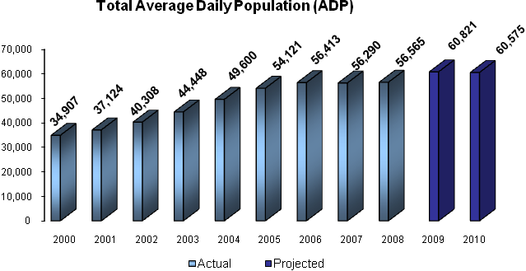

ADP Projections: The ADP is projected to be 60,575 in FY 2010 based on estimated bookings and time-in-detention. The FY 2010 ADP projection is very close to the projection for ADP in 2009. While it is expected that total bookings will increase between 2009 and 2010, this increase in bookings is offset by a decrease in time-in-detention. Although the ADP is projected to be flat, more detainees will be placed in paid beds as opposed to Federal bed space due to constraints at BOP.

Projected ADP is dependent upon the number of persons arrested by the federal law enforcement agencies coupled with the length of time defendants are detained pending adjudication, release and subsequent transfer to the BOP following conviction and sentencing. Proactive initiatives undertaken by the OFDT in conjunction with streamlining efforts by the US Attorneys will continue to reduce the number of defendants ordered detained. Other continuing initiatives, such as fast-tracking the prosecution of selected offenses, expediting the designation and transfer of sentenced prisoners to BOP correctional institutions, and utilizing detention alternatives have proven successful at reducing detention costs.

Time in detention is projected to be an average of 115 days for all prisoners booked during FY 2010. The type of offense impacts heavily on time-in-detention; therefore, any shift in the projected number of people arrested by offense will likely impact the projected overall time in detention. In recent years, OFDT has observed that overall time-in-detention has decreased as a result of the increasing population of immigration offenders referred for prosecution. Compared to drug, violent and weapons defendants, immigration defendants are housed for half of the time.
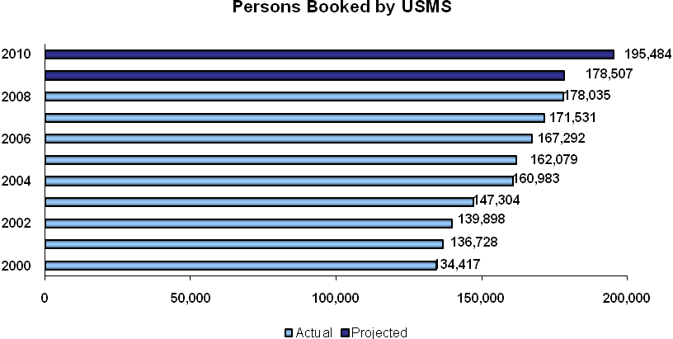

Detention Population Forecasting Model
The OFDT population forecasting model uses a statistical approach for predicting detention needs using factors such as population, demographic trends, number and type of criminal cases processed, average processing time per type of case, and the authorized positions of federal law enforcement, US Attorneys, US District Court judges, and immigration judges. These factors allow for the development of impact scenarios that address proposed legislation, known DOJ law enforcement initiatives and current activities.

The primary correlates of detention expenditures are the number of prisoners booked by the US Marshals Service and length of time those prisoners are held in detention. However, both of these factors are directly influenced by the activities and decisions of federal law enforcement, US Attorneys, and the federal judiciary. As the activities and decisions of these groups change from that historically observed, detention expenditures are directly affected. Accordingly, OFDT regularly monitors – and tries to anticipate – changes in federal law enforcement priorities and the number of on-board staff to assist with its projection of future bookings and the size of the detention population. Nowhere has the impact of changing law enforcement priorities on detention expenditures been more observable than with the implementation of zero tolerance immigration enforcement policies by the Department of Homeland Security along the Southwest border. Prior to the implementation of these policies beginning in December 2005, fewer than 40,000 persons were arrested and booked annually for a criminal immigration offense. However, since implementation of these policies, the number of annual bookings for criminal immigration offenses has nearly doubled, increasing to approximately 78,000 during fiscal year 2008.

While OFDT routinely anticipates growth in bookings for immigration offenses, the growth observed since December 2005 has been unprecedented, based on trends in historical data. For example, when OFDT originally formulated for its fiscal year 2009 budget, approximately 70,000 bookings for immigration offenses were projected. This level represented a 13% annual increase over the 2007 level. Current trends suggest, however, that immigration bookings will increase to more than 96,000 during fiscal year 2009, or a 26% annual increase over the 2008 level.

The impact of the added immigration bookings has been mitigated to a substantial extent by policies adopted by the US Attorneys and the federal judiciary to fast-track these cases through the criminal justice process. While the average time-in-detention for immigration offenses had been more than 100 days, the fast-tracking policies have reduced time-in-detention to less than 85 days, on average. Accordingly, the average daily population of immigration offenders is expected to increase from 12,500 during fiscal year 2007 to nearly 17,000 during fiscal year 2009.

Rate and Category of Bookings
The growth rate in federal arrests varies considerably by region and offense category, reflecting law enforcement challenges and priorities of the US Attorneys.

While OFDT is continually monitoring the federal criminal caseload and undertaking efforts to improve the reliability of its projection methodologies, not all policy, program, and/or environmental factors may be known when projecting future levels of federal arrests. In addition to tracking the general rate of growth in detention, it is also essential to track detention bookings by type of offense. The number of persons held for immigration offenses is growing at a faster rate than other offense categories. Due to district-level initiatives to expedite adjudication of immigration bookings, particularly in Western and Southern Texas, a substantial reduction of time-in-detention has been observed during FY 2008. For example, in Western and Southern Texas, expedited adjudication programs have resulted in detention stays as short as 4 or 5 days, but typically fewer than 20 days for some offenders. Accordingly, time in detention for immigration offenses has decreased by as much as 25 days since FY 2005.

Capital Improvement Program (CIP): The CIP is a comprehensive program, offering various contractual vehicles to provide Federal funding for the expansion, renovation and construction of jails or the acquisition of equipment, supplies, or materials required to address detention space needs in critical areas. The program is available to fund projects primarily by State and local authorities. There are two parts of the program: the Cooperative Agreement Program (CAP) and the Non-Refundable Service Charge Contract.

Cooperative Agreement Program

CAP provides resources to select state and local governments to renovate, construct, and equip detention facilities in return for guaranteed bed space for a fixed period of time and fixed per diem for federal detainees in or near federal court cities. This program provides an avenue for securing bed space in areas where detention space is scare and private facilities are unable to fill the gap. Historically, CAP funds were generally awarded in large amounts to a select number of state and local governments in areas with an identified detention space need. State and local governments are responsible for the construction and seek reimbursement from the Federal government for the associated costs.

OFDT has identified ways to ensure that it obtains the maximum return on its investment, including leveraging a long-term, fixed per diem rate, which allows for per diem rate increases within a fixed acceptable margin of growth, mirroring the length of the CAP agreement. This will ensure that the government receives the highest return on the capital investment for the entire period of the agreement. This is the same approach used when contracting for detention space with private industry. Additionally, OFDT is examining methods to streamline the CAP process and distribute CAP funds in a more expeditious manner.

Non-Refundable Service Charge Contract

OFDT is currently examining the use of a non-refundable service charge contract as a vehicle to address the shortage of detention space in critical need areas. This program will provide a method for OFDT to directly contract with a State or local government to provide up-front funding for renovation or construction of jails in exchange for guaranteed bed space at a fixed rate to house Federal detainees. The program is based on a similar program used by BOP to obtain space in critical need areas. The program will be subject to the guidelines set by the Federal Acquisition Regulation (FAR) and will allow OFDT to directly infuse resources into participating State and local facilities to meet Federal detention housing needs.

C.2 Budget Request - JPATS Transportation/DOJ Strategic Goal 3.1

FY 2010 Request: OFDT requests $35,757,453 for JPATS prisoner transportation. This includes $31,529,024 for air transportation and $4,228,429 for transportation support.

Adjustments-to-base: OFDT requests no adjustments-to-base. (See Exhibit B).

Program Changes: The request includes $2,837,000 for air transportation increases along Southwest Border.
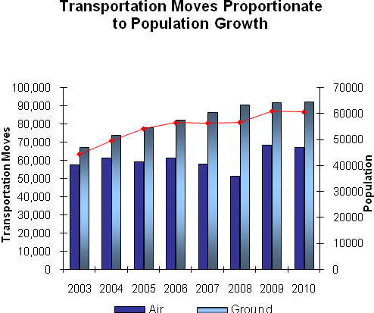

FY 2010 Transportation Moves
Transportation needs are related to the distances between courts, district offices, JPATS, and medical facilities. JPATS continues to be a critical tool in the safe, efficient and cost-effective movement of USMS detainees and sentenced prisoners, prisoners that require medical attention, and high-threat prisoners requiring additional security. As the number of detainees and facilities has grown, transportation usage has increased.

D. Full Program Cost

Full Program Cost by Program Activity

Program Activity | Dollars  In Thousands
Detention Services | Housing & Subsistence | 1,284,193
Detention Services | Health Care Services | 86,263
Detention Services | Medical Guards | 15,454
Detention Services | Transportation | 13,655
Detention Services | Other | 3,341
Detention Services | Subtotal | 1,402,906
JPATS Transportation | JPATS | 35,757
Grand Total………………..…………………………………. $1,438,663
*Amounts may not add due to rounding.

OFDT’s program is designed to provide for the effective and efficient expenditure of detention resources. The FY 2010 budget request continues to support efforts and fund strategies that support OFDT’s performance goals. One of OFDT’s greatest mission challenges is the state of technology within the detention community, pulling together data and processes of multiple agencies with disparate and incompatible legacy IT systems and capabilities. An effective IT backbone will support OFDT’s efforts to drive efficiencies in detention operations and processes.

OFDT has successfully implemented efficiencies in several programs including: eDesignate, which reduces post-sentencing time in detention; eIGA, which standardizes the pricing strategy for non-federal detention space, controlling costs and providing greater certainty in rates to be paid; and the Quality Assurance Program, which ensures non-federal facilities housing meets DOJ requirements for safe, secure and humane confinement. Central to this strategy is the integration with the USMS Justice Detainee Information System (JDIS). Detainee data that is provided and managed within JDIS is critical to many of OFDT’s planned solutions.

OFDT continues its long-established partnership with the Federal Judiciary to ensure that adequate funds are available for the courts to place defendants, who would otherwise be detained, into non-secure detention settings (e.g., halfway house and home confinement), with an electronic monitoring component. Use of non-secure detention is significantly less expensive than secure detention.

OFDT continually seeks ways to realize efficiencies without hampering operations and strives for savings that can be reinvested in infrastructure improvements that provide cost containment over the long-term. In FY 2010, OFDT will initiate the following solutions:

- Detention Invoicing and Reconciliation System. OFDT will contract for the design, development, and testing of an automated centralized detention invoicing and tracking system. The system will be hosted on the web-based Detention Services Network (DSNetwork). The system will convert a decentralized and non-standardized manual invoicing process into a time- and cost-efficient, automated, web-based system. The system will integrate with existing USMS processes, JDIS, and potentially, with DOJ sponsored systems to efficiently effect jail bill reconciliation and ease payment processing from the districts. This system would significantly reduce the labor associated with the current manual systems and result in a more efficient process with automated analytical capabilities.

- OFDT Staff Positions. OFDT is requesting 4 positions to improve field coordination, adequately address the imbalance of FTE to contractor staff, enhance development of population projections, and address succession planning. These positions will strengthen OFDT’s detention population management structure and provide more depth to the overall organization.

OFDT is a small office that develops policy to move the detention program forward. Law enforcement initiatives, including an increased focus on illegal immigration, have created a complex detention program that requires additional resources to meet increasing demands. While contractor support is available, the requested positions serve roles in managing funds, contracts, and people.

OFDT considers these positions to be critical to improve the detention program and drive additional initiatives, accelerate current initiatives, and provide for adequate succession planning. The positions requested and further justifications are in “Section V” on page 35.

E. Mission Challenges
The internal and external mission challenges are incorporated into Section IV Decision Unit Justification (See pages 15-34).

F. Planned Improvements
OFDT’s improvement plan includes:
- Automate the detention billing and payment system: The concept design was completed and OFDT was in the process of developing a Project Plan to capture the financial requirements, processes, and procedures when the project was placed on hold due to funding issues. Efforts are expected to resume in FY 2010 to fully develop the requirements. With sufficient funding, the IT system development will occur in FY 2011 with a pilot test and refinements occurring in FY 2012, culminating with implementation in FY 2012/3.
- Revitalizing and restructuring the Cooperative Agreement Program (CAP): The former Cooperative Agreement Program (CAP) has been expanded and restructured to the new Capital Improvement Program (CIP). This program has both grant and contract components. The outline of the program is currently under development. Implementation will likely occur in FY 2011.
- Developing a new measure to capture improvements in detention facility operations: The OFDT Quality Assurance Review (QAR) process is the vehicle for assessing facility compliance with national detention standards. With additional software development, OFDT will have data analysis capability that is currently unavailable. Once this capability is in place, OFDT will be able to measure facility improvements by functional area. This software development will be complete in FY 2009 and the new measure will be implemented in FY 2010.

G. OFDT Organization
In December of 2007, Congress approved the proposed organization of the Office of the Federal Detention Trustee (OFDT). This organization supports OFDT’s mandate to oversee detention management and to improve the operations and coordination of detention activities. In general, the new organizational structure provides better alignment to support: increased emphasis on strategic planning, better outcome measurement, improved projection methodologies, strengthened financial management, enhanced program review of detention operations, and better linkage between performance and budget.
The Federal Detention Trustee and Deputy Federal Detention Trustee currently oversee 21 full-time equivalent employees organized into four primary divisions: Budget, Finance and Forecasting; Information Technology; Procurement; and Detention Standards and Compliance. The General Counsel and the Administration and Management Division provide overall support to the office.
The organization chart is shown at Exhibit A.

- Summary of Program Changes

Item Name | Description | Pos. | FTE | Dollars ($000) | Page
Southwest Border Enforcement | Anticipated increases in the number of detainees housed in non-federal detention facilities and associated costs (health, guards, etc) for Southwest Border and transportation due to increased immigration apprehensions along the Southwest Border.  4 positions and 2 FTE to permit adequate staffing to develop policy, design and drive program initiatives, and address the imbalance of FTE to contractor staff | 4 | 2 | 44,579 | 35
Operating Costs | An increase of $95,811,000 in operating costs is requested to sustain detention operations. | … | … | 95,811 | 38
JPATS Transportation | Increased flights to support the activity along the SWB. | … | … | 2,837 | 40

III. Appropriation Language

For necessary expenses of the Federal Detention Trustee, [$1,295,319,000] $1,438,663,000 to remain available until expended: Provided, That the Trustee shall be responsible for managing the Justice Prisoner and Alien Transportation System: Provided further, That not to exceed $5,000,000 shall be considered “funds appropriated for State and local law enforcement assistance” pursuant to 18 U.S.C. § 4013(b). (Department of Justice Appropriations Act, 2009.)

Analysis of Appropriations Language

No substantive changes proposed.

IV. Decision Unit Justification

Office of the Federal Detention Trustee | Perm. Pos. | FTE | Amount
2008 Enacted | 21 | 21 | 1,225,920
2009 Enacted | 23 | 23 | 1,295,319
Adjustments to Base | … | … | 117
2010 Current Services | 23 | 23 | 1,295,436
2010 Program Increases | 4 | 2 | 143,227
2010 Request | 27 | 25 | 1,438,663
Total Change 2009-2010 | 4 | 2 | 143,344

A. Program Description

A.1 Detention Services

The mandate of the Detention Trustee is to manage detention resources, exercising financial supervision of detention operations and setting government-wide detention policy. OFDT has oversight responsibility for federal detention services relating to the detention of federal detainees.

These resources provide the housing and care for federal detainees remanded to USMS custody. Resources are expended from the time a prisoner is brought into USMS custody and extend through termination of the criminal proceeding and/or commitment to BOP.

The decision to detain an individual is by order of the court. The USMS is responsible for processing, housing, and producing federal detainees for all federal court actions.
The number of detainees remanded to USMS custody is the direct result of the number of arrests made by federal law and border enforcement agencies and the prosecutorial efforts of the U.S. Attorneys.

The Federal Government relies on various methods to house detainees. Detention bed space for federal detainees is acquired “as effectively and efficiently as possible” through: (1) federal detention facilities, where the government pays for construction and subsequent operation of the facility through the BOP; (2) Intergovernmental Agreements (IGA) with state and local jurisdictions who have excess prison/jail bed capacity and receive a daily rate for the use of a bed; (3) private jail facilities where a daily rate is paid per bed; and, 4) CAP, where capital investment funding is provided to State and local governments for guaranteed detention bed space in exchange for a daily rate through an IGA.

In recent years, DOJ has not been able to rely as much on IGAs and federal facilities to meet the surge in the detention population, primarily because state and local governments are increasingly using their facilities for their own detention requirements and no new federal detention facilities have been built. With space unavailable in areas where more federal bed space is needed, DOJ has increasingly turned to the private sector. By 2010 it is expected that the capacity of the federal facilities will accommodate only 19% of the USMS detention population. By contrast, during FY 2000, federal facilities housed approximately 30% of the USMS detention population.

Regional Transfer Centers (RTC) and Ground Transfer Centers (GTC) assist in reducing the bottleneck of prisoner transportation through the Federal Transfer Center (FTC) in Oklahoma City, OK. The RTCs and GTCs provide cost-effective, short-term detention beds to facilitate the movement of prisoners, often by-passing the FTC. Working in close coordination with JPATS, the RTCs and GTCs provide additional bed-space and transportation infrastructure to accelerate prisoners who are awaiting movement to their designated BOP facility.

Detention Services Efficiencies
Detention efficiencies have been discussed generally above. A more detailed discussion of OFDT accomplishments, efficiencies and cost containment measures is provided in Section C: Performance, Resources, and Strategies (See pages 25-34).

A.2 JPATS Transportation

JPATS is responsible for the efficient movement of federal prisoners and detainees by air as well as coordination of ground movement, including sentenced prisoners, pretrial detainees, and deportable and criminal aliens in the custody of the USMS, BOP, or ICE. JPATS operates as a revolving fund activity with total operating costs reimbursed by customer agencies. Reimbursement is calculated using a cost-per-flight-hour methodology that identifies costs that are inclusive to each customer agency, differentiates the costs by fixed and variable rates, and establishes the hourly costs for large and small aircraft usage.

JPATS Efficiencies

JPATS receives over 900 requests daily to move prisoners between judicial districts, correctional institutions, and other locations. Previously, JPATS relied on a single, centrally located Federal Transfer Center (FTC) to house prisoners overnight between flights. When the facility reached full capacity and could not process additional incoming prisoners the delays created a backlog of prisoner movement requests through the nation. This resulted in increased length of stay in detention facilities and a corresponding increase in detention costs.

In cooperation with OFDT, JPATS, other government agencies, and private entities, RTCs were established to facilitate the movement of sentenced prisoners to designated correctional institutions. Establishing these hubs expands the transit infrastructure in several ways – it improves the transportation system, reduces in-transit time, expands ground transportation capabilities, decreases reliance on the FTC by strategically placing housing near airlift sites, frees bed space in highly impacted districts by expediting moves, assists in addressing BOP prisoner capacity demands, and reduces detention costs.

A.3 Enterprise Information Technology (IT) Infrastructure

A key strategy for OFDT is to coordinate with detention stakeholders to create enterprise architecture of technology solutions and data sharing opportunities to drive efficiencies. While detention agencies are actively discussing data sharing initiatives and making incremental advances in modernizing technology, the detention community’s IT systems remain “stove-piped,” outdated, and incompatible. Developing a strategy that aligns the operational needs of the detention community with new, but proven, technologies will assist in streamlining detention operations and provide for monitoring and performance based reporting.

OFDT is leading the effort to develop the necessary strategies and corresponding solutions that facilitate greater efficiencies across detention agencies. OFDT continues to invest in an IT project management environment to provide cost effective solutions as well as integrate with existing agency systems.

OFDT’s IT Division Enterprise & Project Management Office. OFDT is at the forefront of effective enterprise management at the Department, largely due to its ability to invest in effective project management. OFDT continues to improve its Information Technology enterprise architecture by building its Project Management Office (PMO). The PMO provides standardization and controls to effectively plan, coordinate and implement quality solutions within the enterprise architecture. Comprehensive governmental oversight of IT projects and adherence to a proven software development lifecycle process will result in maximizing the government’s return on investment while mitigating risk.

Highlights of OFDT’s project management efforts encompass three areas: incorporating industry standards for best practices, developing inter-agency technology solutions for the detention community, and facilitating data-sharing.

- Industry Standards – OFDT is committed to ensuring its IT Division uses industry best practices, including the area of project management. In FY 2008, this included:

- Implementation of Project Web Access and the Enterprise Project Management Suite, a leading tool in the planning and monitoring of information technology projects.
- Certification of all OFDT IT staff members in the Information Technology Infrastructure Library (ITIL) V3, an internationally recognized standard for managing information technology infrastructure, development and operations.

- Inter-Agency Technology Solutions – OFDT continued to build on its successful record of working across the detention community to develop and refine IT solutions. Successes in FY 2008 included:

- Continued partnership with the Administrative Office for the United States Courts (AOUSC) that resulted in the creation of a Centralized Probation Automated Court Tracking System (PACTS)/eDesignate Client, allowing data to be readily shared, securely, with eDesignate. The centralized client provides for greater standardization and better monitoring and serves to transfer the burden of support away from the 94 field offices to one central office staffed to manage it.
- Continued to maintain the OFDT Service Desk in support of OFDT applications supporting over 4,000 users nation-wide

- Data-Sharing – OFDT continues to build on its success in developing improved methods to share data across the detention community, including:

- Creation of the Unified Facility Database (UFD) V1.0 to standardize and synchronize detention facility information across OFDT systems and share that information with other detention agencies.
- Creation of web services with ONEDOJ and JABS to share detention related data necessary for the Sentence to Commitment process.
- Continued support for integration with USMS Justice Detainee Information System (JDIS)

Key IT programs driving mission efficiencies include the cross-agency initiatives of eDesignate and the DSNetwork.

eDesignate: eDesignate is the technology application and process sanctioned by the U.S. Courts, USMS, and BOP to designate federal prisoners. Phase One of the project was successfully implemented with all 94 U.S. Judicial districts processing detainee data and documents via eDesignate to the BOP’s Designation and Sentence Computation Center (DSCC) to complete the sentence to designation portion of the process. Phase Two of the eDesignate Project- Movement to Commitment- is currently being piloted in several districts.

Currently within eDesignate, the BOP completes sentence computations and designations on individual cases received from the Courts and returns disposition to the USMS. Based on the computations, the USMS either maintains custody until the sentence is served, in the case of a short sentence, or prepares the prisoner for movement to their commitment location. eDesignate also serves to provide a workflow for medical designations and studies as well as enables the gaining BOP institution a means of receiving designated prisoner documentation in preparation for receipt of the individual. Delivering the necessary prisoner electronic documents and data in one complete package to the DSCC via a secure system and enabling all agencies to monitor and provide relevant information, when needed, shortens the post-sentence process thereby saving detention costs.

eDesignate eliminated the paper-based process, created a more transparent and effective business workflow and enabled detention data sharing across agencies. Specifically, automated detainee data sharing across agency lines eliminates redundant efforts saving time, reduces errors, provides better visibility of the process, enables better problem resolution across agencies and serves to create the information necessary to make prudent decisions.

Finally, eDesignate provides the means and data necessary to monitor performance objectives and metrics within, and across, agencies as well as gives managers the ability to watch and react to operational issues and trends.

Detention Services Network (DSNetwork): The concept of the Detention Services Network (DSNetwork) is that of a multifaceted, full-service internet site for detention services. The goal of DSNetwork is to improve interaction between government agencies and service providers as well as reduce lengthy and cumbersome workloads. The vision of the DSNetwork site is to provide information to authorized detention stakeholders regarding detention service procurement, availability of detention bed space for federal use, and detention facility data. The detention services offerings continue to be developed and implemented as detention needs arise. Currently, the following modules exist:

- Electronic Intergovernmental Agreement (eIGA). The eIGA system was successfully deployed in 2008 to manage the interaction between facility providers offering detention services and a federal agency. eIGA automates the application process by enabling a facility to provide essential information via a secure, web based system and then provides the government with a reliable and justifiable structure for negotiation. The facilities IGA application is routed electronically for review to specific federal agencies that might require the services. The system streamlines the former paper-based process, tracks the negotiation between detention provider and the government, and provides a full range of potential audit and reporting tools.

- Facility Review Management System (FRMS). The FRMS is a web-based application that facilitates, standardizes, records, and reports the results of Quality Assurance Reviews (QAR) performed on private contracts, high-volume IGAs, as well as other IGA facilities. Since its implementation, FRMS has been utilized successfully in numerous QARs and continues to be improved. Most recently, a reports module has been developed to provide OFDT’s Detention Standards and Compliance Division (DSCD) data and trend analysis information. In 2008, FRMS was chosen to receive the Attorney General’s Award for Information Technology Excellence based on its innovative concept, successful implementation and continued program success.

- My Facility/Facility Information. My Facility is the module that will enable detention providers with IGAs to view and update their facility information as necessary. Facility information is currently available for detention agencies with approved access to search and view attributes of facilities including location, services provided, certifications, etc. The vision of My Facility/Facility Information is to provide timely and accurate information required by detention agencies and stakeholders to enable them to make prudent detention- related decisions.

The DSNetwork portal is intended to meet the ever changing needs of the detention community by providing procurement services for housing, transportation, and medical care as well as offering the government management analysis and reporting through electronic documentation and data collection.

Trustee Automated Office System (TAOS). TAOS is OFDT’s enterprise knowledge management application developed to support office collaboration, business workflows, document management, and performance tracking. TAOS serves to increase the effectiveness of internal office practices by sharing work products, automating routine office functions, and eliminating paper-based transactions. Through TAOS, OFDT is able to conduct day-to-day business processes electronically in a timely and effective manner, as well as store content for future transactions.

The following represents OFDT’s Information Technology Program Base:

Information Technology Base

Detention Services Network (DSNetwork) | 1,100,000
OFDT Workflow Systems (OWS) | 1,820,000
The Trustee Automated Office System (TAOS) | 490,000
Detention Invoicing and Reconciliation System | 750,000
Reimbursable Agreement - OCIO | 207,000
Reimbursable Agreement - E-Gov – OCIO | 213,000
Reimbursable Agreement - IT Security- OCIO | 380,000
IT Division Salaries | 537,000
Total | $5,497,000

Note: Includes IT project that will be funded from base resources (See “Centralized Billing System”)
Performance and Resource Table
Decision Unit: Office of the Federal Detention Trustee DOJ Strategic Objectives:
3.1 Protect judges, witnesses, and other participants in federal proceedings, and ensure the appearance of criminal defendants for judicial proceedings or confinement
3.3 Provide for the safe, secure, and humane confinement of detained persons awaiting trial and /or sentencing and those in custody of the Federal Prison System
Workload/Resources |  |  | Final Target |  | Actual |  | Projected |  |  | Changes |  | Requested (Total)
 |  |  | FY 2008 |  | FY 2008 |  | FY 2009  Requirements |  |  | Program Adjustments |  | FY 2010 Request
Workload: Total Average Daily Population: |  |  | 59,001 |  | 56,565 |  | 60,821 |  |  | (246) |  | 60,575
State & Local Gov’t (IGA) Facilities |  |  | 38,711 |  | 37,262 |  | 40,486 |  |  | (2,993) |  | 37,493
Private Facilities |  |  | 7,405 |  | 6,992 |  | 7,450 |  |  | 3,780 |  | 11,230
Subtotal Non-Federal Facilities |  |  | 46,116 |  | 44,254 |  | 47,936 |  |  | 787 |  | 48,723
Federal (BOP) Facilities |  |  | 12,035 |  | 11,592 |  | 12,035 |  |  | (558) |  | 11,477
Non-Paid Beds |  |  | 850 |  | 718 |  | 850 |  |  | (475) |  | 375
Total Costs and FTE |  |  | FTE | $000 | FTE | $000 | FTE | $000 |  | FTE | $000 | FTE | $000
(Reimbursable FTE are included, reimbursable costs are bracketed and not included in the total) |  |  | 22 | 1,225,920 | 22 | 1,256,753 | 23 | 1,295,319 |  | 2 | 143,344 | 25 | 1,438,663
Type/  Strategic Obj. | Performance/Resources |  | FY 2008 |  | FY 2008 |  | FY 2008 |  |  | Current Svc &  Prog. Changes |  | FY 2009 Request
DOJ SO 3.3 | Detention Services | Resources | FTE | $000 | FTE | $000 | FTE | $000 |  | FTE | $000 | FTE |  | $000
Program Activity | Detention Services | Direct Pres Bud: | … | 1,184,413 | … | 1,219,081 | … | 1,252,583 |  | … | 140,019 | … |  | 1,392,602
Program Activity | Detention Services | Support: | 21 | 9,672 | 21 | 9,672 | 22 | 9,816 |  | 2 | 488 | 24 |  | 10,304
Program Activity | Detention Services | Total: | 21 | 1,194,085 | 21 | 1,228,753 | 22 | 1,262,399 |  | … | 140,507 | 24 |  | 1,402,906
Efficiency | Per Day Jail Cost (Non-Federal) |  | $65.62 |  | $67.47 |  | $68.73 |  |  | +0.32 |  | $69.05
Performance | Health Care Cost Per Capita (Non-Federal) |  | $1,936 |  | $1,939  Adjusted: $1,528 |  | $1,724 |  |  | +$112 |  | $1,836
Performance | # Targeted Non-Federal Facility Reviews Completed |  | 25 |  | 26 |  | 28 |  |  | +1 |  | 29
OUTCOME | Per Day Detention Cost |  | $70.92 |  | $72.79 |  | $74.81 |  |  | -0.73 |  | $74.08
OUTCOME | Targeted Non-Federal Facilities Meeting Min Stds |  | 92%  23 of 25 |  | 100%  26 of 26 |  | 93%  26 of 28 |  |  | +3%  +1 |  | 96%  28 of 29
DOJ SO 3.1 | JPATS Transportation | Resources | FTE | $000 | FTE | $000 | FTE |  | $000 | FTE | $000 | FTE | $000
Program Activity | JPATS Transportation | Direct Pres Bud: | - | 31,835 | … | 28,000 | - |  | 32,920 | … | 2,837 | - | 35,757
Program Activity | JPATS Transportation | Support: | 1 | - | 1 |  | 1 |  | - | … | - | 1
Program Activity | JPATS Transportation | Total: | 1 | 31,835 | 1 | 28,000 | 1 |  | 32,920 | … | 2,837 | 1 | 35,757
Workload | # Transportation Moves of USMS Prisoners – Air |  | 66,915 |  | 51,450 |  | 68,321 |  |  | -1,406 |  | 66,915
Workload | # Transportation Moves of USMS Prisoners – Ground |  | 88,134 |  | 90,580 |  | 92,037 |  |  | +97 |  | 92,134
OUTCOME | Transportation Unit Cost |  | $1,105 |  | $999 |  | $1,148 |  |  | -$198 |  | $950

Performance Measure Table

Decision Unit: Office of the Federal Detention Trustee

Performance Report & Performance Plan | FY 2001 | FY 2002 | FY 2003 | FY 2004 | FY 2005 | FY 2006 | FY 2007 | FY 2008 |  | FY 2009 | FY 2010
Performance Report & Performance Plan | Actual | Actual | Actual | Actual | Actual | Actual | Actual | Target | Actual | Target | Target
Per Day Jail Costs  (Non-Federal) | $59.01 | $60.07 | $60.87 | $61.87 | $61.92 | $62.73 | $64.40 | $65.62 | $67.47 | $68.73 | $69.05
Health Care Cost Per Capita *  (Non-Federal) | N/A | N/A | $1,315 | $1,333 | $1,364 | $1,544 | $1,478 | $1,525 | $1,939  Adjusted: $1,528 | $1,724 | $1836
# Targeted Facility Reviews  (Non-Federal) | N/A | N/A | N/A | N/A | N/A | 100%  20 | 22 | 25 | 26 | 28 | 29
# Transportation Moves of USMS Prisoners – Air | N/A | N/A | 57,465 | 61,188 | 59,227 | 63,353 | 58,029 | 66,915 | 51,450 | 68,321 | 66,915
# Transportation Moves of USMS Prisoners – Ground | N/A | N/A | 67,397 | 74,061 | 78,033 | 81,584 | 86,372 | 88,134 | 90,580 | 92,037 | 92,134
Reduce “Wait Time” in Detention from Designation to Commitment | N/A | N/A | N/A | 21 | 20 | 16 | 21 | Discontinued
Per Day Detention Cost*  (Non-Federal) | $ | $ | $ | $66.06 | $66.33 | $67.72 | $69.30 | $70.92 | $72.79 | $74.81 | $74.08
Facilities Meeting Minimum Standards (Non-Federal) | N/A | N/A | N/A | N/A | N/A | 95%**  19 of 20 | 100%  22of 22 | 92%  23 of 25*** | 100%  26of 26 | 93%  26of 28 | 96%  28 of 29
Transportation Unit Costs | N/A | N/A | N/A | N/A | N/A | $1,001 | $950 | $1,105 | $999 | $1,148 | $950

*Note: Historical data and out year projections have been adjusted to accommodate the revised Health Care Cost Per Capita measure excluding transportation as defined on the following pages
**Note: FY 2006 data has been adjusted to be consistent with the refined Data Definition on the following page.
*** Note: Although there will actually be 9 Private facilities in FY 2008, one facility will be under a new contract and that facility is given one year to achieve the standards identified in the new contract.
Data Definitions, Validation, Verification, and Limitations:

Performance Measure: Paid Jail Days (IGA and Private)
Data Collection and Storage: Data are maintained in 94 separate district Prisoner Tracking System (PTS) databases. This information is downloaded on a nightly basis to the Justice Detainee Information System (JDIS). All prisoner statistical reporting now comes from the JDIS system. Jail rate information is maintained in PTS/JDIS by USMS Headquarters and is updated as changes are made to contractual agreements.
Data Validation and Verification: Monthly data from JDIS is verified each month by completing a comparison, by district, between obligation data being reported out of FMS and prisoner program data reported from JDIS. Jail rate information is verified and validated against actual jail contracts.
Data Limitations: Previous limitations on the access to timely data have been eliminated through the implementation of JDIS. Much more robust data reporting is available now than in the past. The only limitation is ensuring that USMS district level input into PTS occurs in a timely and correct manner.

Performance Measure: Per Day Jail Cost
Data Definition: Actual average price paid (over a 12-month period) by the USMS to house federal prisoners in non-federal detention facilities. IGA jail cost represents the average cost paid by the USMS to house prisoners in facilities operated by state and/or local governments. Private jail costs represent the average cost paid by the USMS to house prisoners in facilities operated by non-governmental entities (such as for-profit corporations). Average price paid is weighted by actual jail day usage at individual detention facilities.
Data Collection and Storage: Data describing the actual price charged by state, local, and private detention facility operators is maintained by the USMS in their PTS and it is updated on an as-needed, case-by-case basis when rate changes are implemented. Rate information for specific facilities is maintained by USMS headquarters staff. In conjunction with daily reports to OFDT of prisoners housed, OFDT compiles reports describing the price paid for non-federal detention space on a weekly and monthly basis. Data are reported on both district and national levels.
Data Validation and Verification: Data reported to OFDT are validated and verified against monthly reports describing district-level jail utilization and housing costs prepared by the USMS.
Data Limitations: Maintaining prisoner movement data is a labor-intensive process. The reliability of the reported data is often compromised by time lags between the actual movement of prisoners and key-punching of those events into the PTS system. Accordingly, it is often necessary to delay reporting of official statistics several weeks to ensure that prisoner movement records have been properly updated.

Performance Measure: Health Care Cost Per Capita
Data Definition: Cost of health care services provided to federal prisoners under the custodial jurisdiction of the USMS. Total health care costs include the costs of health services provided by medical practitioners and medical guard services. Per capita health care costs are determined by dividing total health care expenditures for the reporting period by the average daily prisoner population for that reporting period.
Data Collection and Methodology: Data describing funds obligated for prisoner health care services are reported to OFDT by the USMS through reports generated from the USMS STARS financial system.
Data Validation and Verification: In accordance with generally accepted accounting principles, the USMS routinely monitors its financial data for new obligations and de-obligations.
Data Limitation: Data reported reflect the anticipated cost of services provided to USMS prisoners. In the event that the actual cost is different from the anticipated cost, additional funds may need to be obligated or obligated funds, de-obligated. Because of the time lag between the rendering of services and the payment of invoices, several weeks may lapse before the actual cost of health care services provided to an individual prisoner can be dispositively determined.

Performance Measure: Per Day Detention Cost
Data Definition: Total detention costs represent the aggregation of paid jail costs and health care costs on a per capita, per day basis.
Data Collection and Storage: See, Paid Jail Costs and Health Care Costs, above.
Data Validation and Verification: See, Paid Jail Costs and Health Care Costs, above.
Data Limitations: See, Paid Jail Costs and Health Care Costs, above.

Performance Measure: Targeted Non-Federal Facilities Reviews and Targeted Non-Federal Facilities Meeting Minimum Standards
Data Definitions: Targeted Non-Federal Facilities: All Private Facilities, all Intergovernmental Agreement (IGA) facilities with an average daily population (ADP) of approximately 500 or more, and other select facilities such as those involved in agency requested facility reviews.
Number of Targeted Reviews Completed: Targeted Non-Federal Facility Quality Assurance Reviews (QARs) completed during the fiscal year.
Meeting Minimum Standards: In the QAR review process, a facility may receive one of five rating levels: Excellent: Level of performance exceeds minimum standards, deficiencies are nonexistent or minor. Good: Level of performance meets minimum standards, deficiencies are minor and are offset by outstanding elements of performance. Acceptable: Level of performance meets minimum standards, deficiencies are minor. Deficient: Level of performance indicates performance is weak, corrective action plans for internal controls are needed to maintain minimum standards. At-Risk: Level of performance does not meet minimum standards and requires immediate corrective action plans. Facilities must receive a rating above the At Risk level to be considered to be Meeting Minimum Standards.
Targeted Number of Non-federal Facilities Meeting Minimum Standards: This percentage is calculated by dividing the Targeted Non-Federal Facilities Meeting Minimum Standards by the number of these facilities scheduled for review during the fiscal year.
Data Collection and Storage: Data describing the facility ratings and standards that are met by the individual facilities will be maintained in the FRMS system. In conjunction with the QAR reviews; state, local, and other agency inspection reports are maintained.
Data Validation and Verification: Data reported to OFDT are validated and verified against QAR reports, repository information, state, local or other agency reported data (i.e. BOP Sentry, USMS PTS).
Data Limitations: Data reported often reflect a delay in reporting due to reporting systems inaccessible to OFDT.

Performance Measure: Transportation Moves (Air and Land)
Data Definition: A prisoner transportation movement represents a single leg of a transport between the point of origin and the final destination; multiple movements may be required to transport a prisoner to his destination. Air movements are transports involving a JPATS operated aircraft; excluded are commercial charters. Ground movements are transports involving a bus or other vehicle.
Data Collection and Storage: Data describing prisoner transportation movements are maintained by JPATS in their APPS. These data are currently reported to OFDT on a quarterly basis as part of quarterly and annual reports describing the activities of JPATS.
Data Validation and Verification: Transportation movement data are reported to OFDT by JPATS.
Data Limitations: Data are limited to movements of prisoners conducted by JPATS and do not include in-district movements coordinated by USMS district offices without the assistance of JPATS.

Performance Measure: Transportation Unit Cost
Data Definition: The total cost per prisoner (transported by JPATS) incurred from the prisoner’s point of origin to final destination. Component costs include the cost of transporting the prisoner (by air, bus, van, and car) and the cost of housing the prisoner while in-transit. The cost of BOP-provided in-transit housing is included as part of the reported housing costs.
Data Collection and Storage: Data describing prisoner movements and the costs associated with those movements are maintained in several databases. The USMS JPATS APSS data system maintains information describing prisoner movements such as the points of origin and final destination, how the prisoner was moved, and where the prisoner was housed, as applicable, while in-transit. The USMS JPATS JCAS data system maintains information describing the cost of air movements and JPATS-sponsored ground transportation. BOP provides information describing the cost of BOP-sponsored bus transportation. The USMS PTS data system provides information describing the cost of non-federal housing. Data are maintained on each prisoner transported by JPATS. Data from the various systems are aggregated together by OFDT to determine the prisoner-specific transportation costs.
Data Validation and Verification: Component data are provided to OFDT by the various agencies. OFDT validates the data for completeness and to ensure that the data provided are within historical parameters.
Data Limitations: Maintaining prisoner movement data is a labor-intensive process. The reliability of the component data is often compromised by unvalidated data entry. Accordingly, labor-intensive data analysis is often required to ensure that the data provided to OFDT passes certain logical tests. Additionally, data describing the cost of BOP-sponsored transportation is based on standardized formulae provided by the BOP for calculating the cost of operating their buses, the costs BOP-provided in-transit housing is based on BOP-reported per capita cost of operating BOP facilities, particularly the Federal Transfer Center in Oklahoma City.

C. Performance, Resources, and Strategies

Program Activity: Detention Services

OFDT Strategic Goal 1:
Meet the Nation’s Detention Requirements in the most economical manner

To measure success toward achieving this strategic goal, OFDT established a performance goal of holding per day detention costs at or below the rate of inflation. This chart reflects the targeted level required to achieve that goal. The discussions below specify the mission challenges and strategies required to make the targeted level attainable. In addition, the graph depicts the specific performance level required for each contributing initiative.
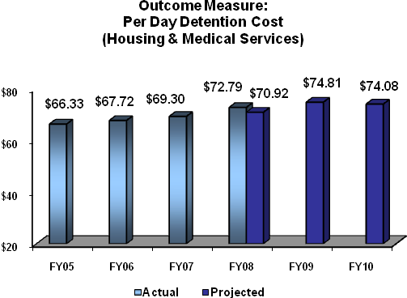

Performance Plan and Report:
Measure: Per Day Detention Cost (Housing and Medical Services)
FY 2008 Target: $70.92
FY 2008 Actual: $72.79
The target was not met due to the failure to meet projected levels for jail cost per capita as well as health care cost per capita. More detail is provided under the discussion for each of those indicators.

NOTE: The graph displays revised historical data and out year projections which have been adjusted to accommodate the revised Health Care Cost Per Capita measure excluding transportation.

Challenge: Adequate Detention Beds
As state and local governments are requiring more of their available capacity to house their own prisoners, fewer detention beds are available to accommodate federal detainees. This saturation of state and local facilities forces an increased reliance on private facilities that are historically higher in cost.

Strategy: Maximize the use of available bed space via the DSNetwork
The DSNetwork’s goals have been enhanced to include, on a real-time basis, a full-service detention housing tool to monitor detention bed space usage and to allow for oversight of non-federal facility contracts and services. As a consolidated detention services site, the DSNetwork will also provide a vehicle for automated processing of IGAs, a Detention Services Schedule, detention facility review information, and other detention services and procurement data for agencies to assess, monitor, and manage detention bed space. This initiative will allow field agencies increased flexibility to determine the best value to the Federal Government by better leveraging available space, transportation, and care capabilities. It will result in securing beds and related services easier and faster and is vital to maintaining detention costs below inflation levels.

Strategy: Multi-year Acquisition Plan (MAP)
OFDT is strategically planning detention procurement needs utilizing MAP. An effective MAP will provide a foundation to identify the agencies’ anticipated bed space needs and the impact the bed space requirements will have on OFDT. In addition, the MAP will provide OFDT with the ability to consolidate and coordinate bed space and find the most effective detention space. The MAP will allow future rate increases to be planned, eliminate discretionary negotiations for actual costs, and help determine the amount needed in future budget requests. As a result, MAP will create a unified process which will lead to equality in rates.

Challenge: Insufficient bed space at mission critical locations
As discussed previously, JPATS used a single Federal Transfer Center (FTC) which often operated at full capacity. When the facility was unable to process additional incoming prisoners, delays were created that slowed prisoner movements in other districts, thereby increasing the length of stay and resulting in increased housing costs. In FY 2006, OFDT facilitated the identification and implementation of Grady County Detention Center for use as an overflow facility for FTC Oklahoma and has since been able to increase the number of prisoner movements routed through Oklahoma City.

Strategy: Increase the number of Regional Transfer Centers (RTC) and Ground Transfer Centers (GTC) as necessary
With the success of Grady County as an overflow facility, OFDT recognized that additional RTCs strategically located near high detention populations and BOP facilities would further reduce the dependence on FTC Oklahoma and could result in additional detention time savings. In particular, OFDT analysis showed that locating an additional transfer center in the Central District of California, where a JPATS aircraft would stage overnight instead of returning to Oklahoma City, would significantly facilitate transfers along the west coast. Following the model of Grady, OFDT facilitated and identified the San Bernadino, California facility as one that could accommodate overnight prisoners, allowing the aircraft to remain in California, thus eliminating flight legs back and forth between Oklahoma and California. The San Bernadino agreement also provides for ground transportation between the airlift and the facility, along with transportation to other close proximity BOP facilities. Lastly, the needs on the east coast are being met by the Robert Deyton Detention Facility in Lovejoy, GA. The Deyton facility, much like San Bernardino, allows for prisoners to remain in the east without having to pass through Oklahoma City. The facility meets three (3) separate airlift sites in Atlanta, Tampa, and Jacksonville, along with providing ground transportation to BOP facilities in the southeast and mid-Atlantic.

To improve the efficiency of ground transportation, the new Laredo, Texas Detention Center was constructed and activated in October 2008. This new GTC provides approximately 1,300 beds available for a staging area for in-state designations, and for “short-term” sentenced prisoners. Additionally, ground transportation capabilities have also been expanded from the JPATS major use detention facilities at CCA Leavenworth, Kansas and CCA Florence, Arizona.

Future centers will most likely use existing state, local or private jail facilities where OFDT will enter into agreements/contracts for the transfer center beds. Where practical and feasible, OFDT will negotiate transportation agreements with the jail facilities in order to augment and accelerate ground transfer to BOP facilities as well. When identifying the best transfer center locations to determine if other overnight staging of JPATS aircraft is both feasible and provides significant cost and/or operational benefits,
additional analysis of transportation routes, costs, needs, location of BOP facilities and length of stay will be conducted.

1.2: Ensure efficient use of detention space and minimize price increases

Challenge: Projection of IGA Increases
DOJ utilizes IGAs to establish the relationship with a state or local government for the use of excess bed space at a negotiated per diem rate. During the life of the agreement, a state or local government may request rate adjustments from DOJ. Historically, it was unknown how many or at what frequency the state or local governments would request such an adjustment or the magnitude of the adjustment, making it difficult to project rate increases for budgeting purposes.

Strategy: eIGA
OFDT developed eIGA to provide a measure of standardization for the cost and the manner in which the Intergovernmental Agreement (IGA) rates for State and local facilities are calculated. eIGA establishes a negotiated fixed per diem rate for each facility based on rates of similar local facilities and limits future adjustments to the per diem rate. This allows the cost of housing detainees to be more predictive as historical trends and set prices are integrated to provide more comprehensive bed space requirements. Implementation of eIGA extends over a 3-4 year period that began in FY 2007. There were 65 eIGAs completed in 2008.

Strategy: Reduce prisoner processing time (via: eDesignate)
As discussed previously, eDesignate provides for a more efficient workflow between the US Probation offices, the USMS, and the BOP during the sentence-to-commitment process by reducing the workload of agency personnel involved in the administratively taxing designation process. At the end of FY 2008, all 94 Judicial Districts were using eDesignate.
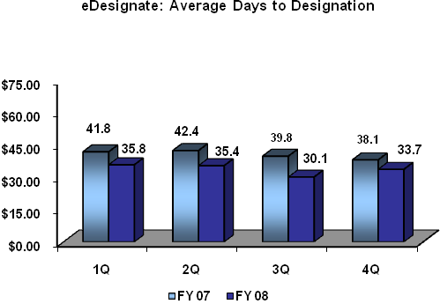
Using designation data to compare those districts that have been using eDesignate for two full years (37 districts) the average time from sentence to designation was reduced by 6.6 days from FY 2007 to FY 2008. This reduction in the average designation days for these districts alone can be attributed to over $15.8M in cost avoidance within the detention account. Today, all 94 districts are using eDesignate and realizing greater efficiencies and cost avoidance.

Strategy: Increase use of detention alternatives
OFDT will continue to provide funding to the Federal Judiciary to support alternatives to pretrial detention, such as electronic monitoring, halfway house placement, and drug testing and treatment. The budgetary impact of these programs is significant. In FY 2008, OFDT expended approximately $3 million. Historical data indicates that the federal detention account would have incurred additional detention costs of $41 million in FY 2008 if the defendants who were in the detention alternative program were detained in secure facilities.

Performance Plan and Report:
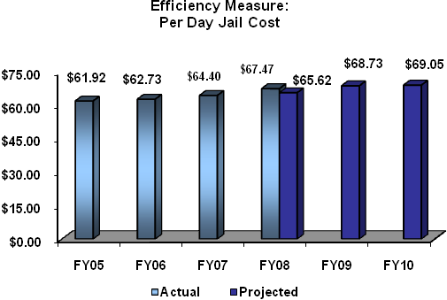
Measure: Per Day Jail Cost
FY 2008 Target: $65.62
FY 2008 Actual: $67.47
The target was not met due to several factors. Federal bed-space was not utilized as projected due to BOP reduction in available capacity, resulting in the use of more IGA bed-space that has a higher cost. In addition, Operation Streamline did not generate the increase in average daily population in specific locations and for the durations expected. This prevented OFDT from realizing the economies of scale factored for certain contracts.

1.3: Ensure adequate medical services are provided in the most economical manner

Challenge: Rising Medical Costs
An important facet of the conditions of confinement is ensuring the appropriate medical care for detainees at or near detention facilities. The challenge is to provide a uniform approach to these services at the best value to the government while minimizing the cumbersome process for field operations.

Strategy: National Medical Contract
OFDT awarded a national managed-care medical contract to meet the needs of the USMS, the legislative requirements of Medicare and Medicaid, and the Federal Acquisition Regulations. The national managed-care medical contract provides a uniform, systematic approach that will reduce staff work hours and track medical savings nationwide. Implementation continues with a Nationwide Pharmacy Program, Provider Network, and Re-pricing all in place during the first quarter of FY 2009.

During the remainder of FY 2009, OFDT is establishing an automated centralized medical claims system to process and re-price valid medical claims for USMS prisoners to rates that do not exceed Medicare rates. The automated system will provide a centralized database and an interactive website to support medical request pre-authorizations and medical case management. Additionally, the system will include centralized billing and claims payment. In the fall of 2009, OFDT in conjunction with USMS plans to pilot the automated system in five Districts, including New Mexico, South Dakota, Nevada, Western North Carolina and Northern Texas

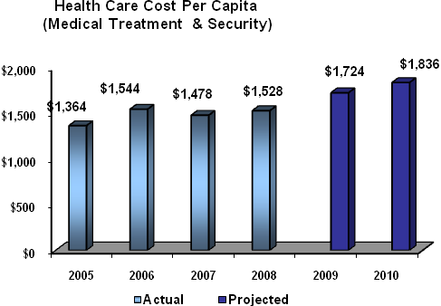
Performance Plan and Report:
Measure: Health Care Cost Per Capital (Medical Treatment, Transportation and Security)
Original FY 2008 Target: $1,936
Original FY 2008 Actual: $1,939
Adjusted FY 2008 Actual:
$1,528
Although medical costs were in-line with original projections, associated transportation costs exceeded expectations. To remedy the problem of transportation skewing the health care cost, OFDT management decided to remove transportation from the health care measure for a more transparent reporting of medical treatment and associated guard cost.

NOTE: The graph displays adjusted historical data and out year projections which correlate to the revised Health Care Cost Per Capita measure excluding transportation.

OFDT Strategic Goal 2: Ensure safe, secure, and humane confinement

To measure success toward achieving this strategic goal, OFDT established a performance goal of ensuring that 100% of all private detention facilities meet minimum standards annually and 100% of high volume IGA facilities meet minimum standards. The discussions below specify the mission challenges and strategies required to make the targeted levels attainable.

2.1: Ensure detention facilities meet established standards for confinement

Challenge: Varying Detention Standards
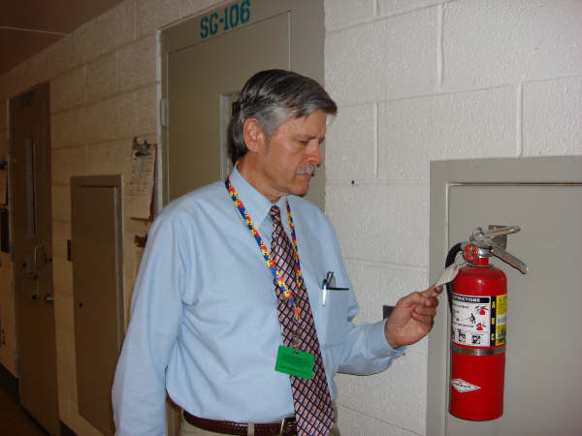
Concurrent with the desire to create efficiencies within detention is the need to ensure that facilities provide for the safe, secure, and humane confinement of detainees. This is especially challenging considering the vast number of state, local, and private facilities in use. The standards for confinement at these facilities vary according to local and state requirements. To address this issue, OFDT developed a comprehensive Quality Assurance Program to ensure that the facilities providing detention bed space to the Federal government meet a minimum condition of confinement standard.
QAR Review in Process at the Central Arizona Detention Center

Strategy: Implementation of a Comprehensive Quality Assurance Program
The OFDT Quality Assurance Program is a multi-faceted approach to ensure the safe, secure, and humane confinement of detainees as well as address Congress’ concerns for public safety as it relates to violent prisoners (e.g., Interstate Transportation of Dangerous Criminals Act, also known as Jenna’s Act). The National Detention Standards provide the foundation for the program, while the various program components ensure compliance to the standards. These components (listed below) cover all aspects of detention from construction to operational review and training.

- Performance-Based Contracts: To define acceptable conditions of confinement, OFDT created Federal Performance-Based Detention Standards (FPBDS) in cooperation and coordination with the BOP, USMS, and ICE. The FPBDS provides a system of objective checks and balances to ensure that all providers achieve and maintain the standards. Federal contract vehicles are written or modified to reflect the FPBDS for all private contract facilities and high-volume (ADP >500) state and local facilities. To ensure compliance with the standards, private contractor performance evaluation and compensation is based on each facility’s ability to demonstrate alignment with the standards.

- Quality Assurance Reviews (QAR): The goal of the QAR program is to conduct on-site reviews for 100% of Targeted Non-Federal Facilities, which is defined as: all private facilities, all agency requested reviews, all high-volume IGA, as well as smaller IGA facilities that have been selected for review using various criteria, e.g., a significant incident has occurred or USMS requested a review. The reviews identify facility deficiencies as related to the delivery of contract services. Corrective actions are then identified by the facility and monitored by OFDT for resolution.
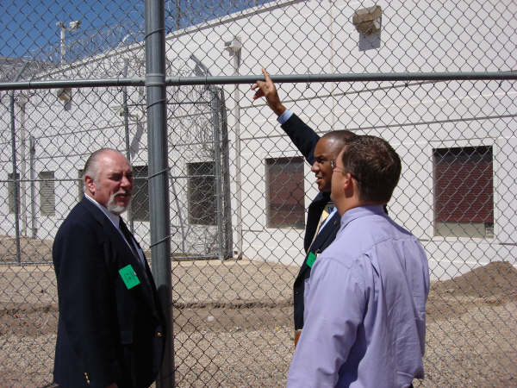
QAR Review in Process at the Central Arizona Detention Center

As the QAR program enters its third year, indications are that there is a marked improvement in the quality of detention services. Specifically notable is the reduction in repeat deficiencies. It is anticipated that the cumulative effect of these improvements will result in increased ratings and services. The IT system, FRMS, currently captures the data collected during the review process. During FY 2009, the functionality will be expanded to permit trend analysis and enable the identification of high-risk facilities for annual QAR scheduling.

- Contract Monitoring Instrument (CMI) Training: This training provides the skill-set necessary to monitor private and large IGA detention facilities to ensure the safe, humane, and secure detention services.

- Contract Monitoring and Enforcement Training (CMET): This training provides instruction on Contractor Officer Technical Representative (COTR) roles and responsibilities of administering and monitoring detention facility performance-based contracts. It includes the identification of services vulnerable to inflated costs, the documentation of trends and the necessary steps to take to enforce contract compliance.

- Private Detention Facility Construction and Activation Monitoring: To ensure that newly constructed facilities meet all aspects of the FPBDS in addition to local and state requirements, OFDT has awarded a contract to monitor private detention facility construction and activation.

Outcome Measure:
Percent of Targeted Non-Federal Facilities Meeting Minimum Standards

Facility Type | 2006  Actual | 2007  Actual | 2008  Target | 2008  Actual | 2009  Target | 2010  Target
Private | 100%  (9 of 9 facilities) | 100%  (9 facilities) | 100%  (8 facilities) | 100%  (8 of 8 facilities) | 100%  (11 facilities) | 100%  (12 facilities)
IGA (ADP>500)  And other | 91%*  (10 of 11 facilities) | 100%  (13 facilities) | 88%  (14 of 16 facilities) | 100%  (18 of 18 facilities) | 88%  (15 of 17 facilities) | 94%  (16 of 17 facilities)
Total Targeted Non Federal | 95%*  (19 of 20 facilities) | 100%  (22 facilities) | 92%  (23 of 25 facilities) | 100%  (26 of 26 facilities) | 93%  (26 of 28 facilities) | 28 of 29

Performance Plan and Report:
Measure: Percent of Targeted Non-Federal Facilities Meeting Minimum Standards
FY 2008 Target: 23 of 25 (92%)
FY 2008 Actual: 26 of 26 (100%)
Although there were some shifts among the facilities reviewed and those originally scheduled, all facilities reviewed met minimum standards.

*Note: FY 2006 data has been adjusted to be consistent with the refined Data Definition (page 24).
** Note: Although there were actually 9 Private facilities in FY 2008, one facility was under a new contract and was therefore given one year to achieve the standards identified in that contract.

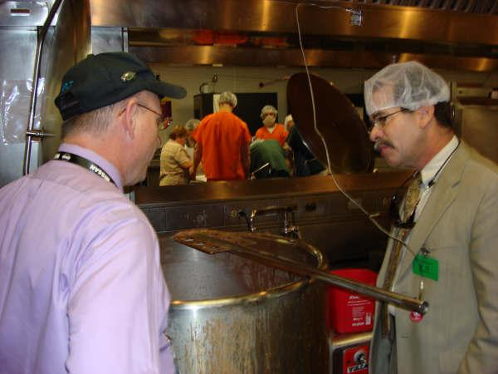
Inspector at Central Arizona Facility

Program Activity: JPATS Transportation

OFDT Strategic Goal 3: Increase the efficiency of the JPATS program

To measure success toward achieving this strategic goal, OFDT established a performance goal of holding detention transportation costs at or below inflation. The discussions that follow specify the mission challenge and strategies required to make the targeted level attainable.

Challenge: Increasing demands on limited resources

3.1: Move prisoners faster within available resources

The demand for transportation will continue to rise with the increase in detainee population. Given limited resources and uncontrollable fuel prices, OFDT must look for innovative solutions to create greater efficiency within the current infrastructure. The interdependence of transportation and housing within detention operations precludes addressing one without having an impact on the other. The strategies to increase the number of transfer centers and the reduction in “wait time” in detention from designation to commitment (via eDesignate) have already been discussed.

Strategy: Maximize efficiency of the transportation system OFDT will lead and facilitate a thorough review of all JPATS scheduling (e.g., ground, air) processes and procedures to determine potential transportation efficiencies and merge those procedures into existing strategies. This will have the impact of reducing the burden on air transportation and the cost per move. However, as transportation and housing costs are interdependent, the performance measure, Transportation Unit Cost (below) captures both elements from the detainee’s point of origin to the final destination. With additional RTCs and GTCs in place, bed space bottlenecks will be reduced, thereby permitting a more efficient transportation flow and an overall reduction in the cost (housing plus transportation) per move.

Performance Plan and Report:
Measure: Transportation Unit Cost (Transportation via JPATS & Related Housing Cost)
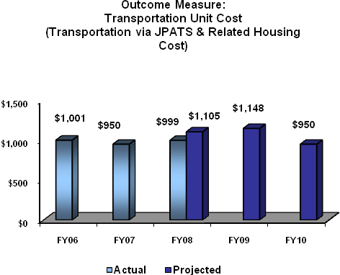
FY 2008 Projection: $1,105
FY 2008 Actual: $999
Due to the reduction in Air transportation and corresponding increase in ground transportation, actual costs were below projected levels.


Unloading prisoners after a JPATS flight

V. Program Increases by Item

DetentionServices

Item Name: Southwest Border Enforcement
Budget Decision Unit(s): Office of the Federal Detention Trustee___________
Strategic Goal(s) & Objective(s): Goal 3.3____________________________________
Organizational Program: Detention Services

Component Ranking of Item: __1 of 3_

Program Increase: Positions 4 Agt/Atty 0 FTE 2 Dollars $44,579,000

Description of Item
The Office of the Federal Detention Trustee (OFDT) requests an additional $44,579,000 for costs associated with prisoner detention and care for the Southwest Border prosecutorial initiative. This includes $371,000 to support increased human capital needs for office operations.

Justification
The program increase is to accommodate the increased housing requirements for criminal aliens apprehended along the Southwest border and prosecuted in U.S. district court during FY 2010. This program increase will support detention housing for an additional 7,000 immigration offenders apprehended by the DHS and processed by the U.S. Marshals Service.

As the workload and responsibilities of OFDT grows, especially when faced with the strains of supporting the Southwest Border, additional human capital is required to provide necessary oversight and expertise. OFDT is a small policy office that relies upon positions that are typically support in nature to develop policy and vision for the detention program. Given the daily demands upon the staff, management responsibilities within the divisions suffer. While contractor support is available, OFDT’s positions serve inherently governmental roles in managing funds, contracts, and people. Currently, the ratio of FTE to contractor support is skewed too heavily to contractors and cannot be sustained. As detention needs have grown, particularly over the last year as a result of increased operations at the Southwest Border, so has the demand for information and services provided by the OFDT staff. OFDT is requesting an additional four positions to manage the increased demands, including:

- Detention Population Managers - OFDT is requesting funding for two detention population managers. These positions will serve as liaisons between USMS, ICE and BOP field personnel, as well as the Federal Judiciary, to identify areas of concern and facilitate coordination between various parties. They will help manage population and provide solutions to alleviate detention problem areas. The Detention Population Managers will provide project implementation and development support that contributes to better business practices, assist in determining adequate use of detention resources, and aid the organization in servicing its customers more efficiently. This includes advice and counsel in interpreting results, analyzing the systems that produce them, and developing action plans to further improve business activities. The addition of these positions is essential to strengthen OFDT’s detention population management structure, particularly in developing solutions for regions experiencing significant changes in the type of facilities used to house the detention population, such as the Southwest Border.

- Statistician - OFDT is requesting funding for one additional statistician. Currently, OFDT has one full-time statistician dedicated to monitoring the federal detention population and developing projections of future federal criminal activities and the size of the detention population. Additional staff would allow for succession planning and give OFDT the ability to transfer and retain institutional knowledge as well as provide for professional development. As OFDT continues to refine its projections, an additional statistician is needed to expand law enforcement and prosecutorial staffing patterns into the detention population projection model, evaluate pretrial release and detention practices, assess current prisoner transportation practices, model future needs based on the increasing detention population and availability of BOP bed space, and conduct a regular survey of the U.S. Attorneys to determine prosecutorial priorities and the potential impact on the detainee population.

Both the FY 2009 House and Senate marks express a need for additional detention data. The House Mark recommends that the Department work with the National Academy of Sciences to develop a model for estimating the impact of immigration workload on the Department. The Senate Mark directs OFDT to report quarterly on the numbers of individuals in detention and associated costs. The additional statistician is required to meet these efforts.

- Detention Facility Specialist – One position is requested for the Detention Standards and Compliance (DS&C) Division to assist the facility contractor and USMS with coordination of JPATS transportation at Regional Transportation Centers (RTCs). The RTCs, which serve as the staging area for sentenced detainees in route to BOP facilities, face unique challenges in coordinating significant numbers of detainees in short timeframes. This position will be dedicated to working with the facilities to monitor JPATS performance measures as well as ensuring specific facility compliance with detention standards. In addition, the position will provide assistance to IT in the development and deployment of a centralized billing system for the RTC’s as well as oversight of the system upon full deployment.

Impact on Performance
The OFDT requires additional resources to house all federal detainees and support activities along the Southwest Border as well as ensure this most efficient use of resources. Without this increase, OFDT will be unable to house and transport all federal detainees committed to its custody and will be limited in its abilities to provide sufficient oversight and timely and accurate information and data.

Funding –

Base Funding

FY 2008 Availability |  |  |  | FY 2009 Enacted |  |  |  | FY 2010 Current Services
Pos | agt/  atty | FTE | $(000) | Pos | agt/  atty | FTE | $(000) | Pos | agt/  atty | FTE | $(000)
… | … | … | 338,799 | … | … | … | 366,697 | … | … | … | 366,697

Personnel Increase Cost Summary

Type of Position | Modular Cost  per Position ($000) | Number of  Positions  Requested | FY 2010  Request ($000) | FY 2011  Net Annualization  (change from 2010)  ($000)
Population Manager | 239 | 1 | 104 | 90
Population Manager | 209 | 1 | 89 | 75
Detention Facility Specialist | 209 | 1 | 89 | 75
Statistician | 209 | 1 | 89 | 75
Total Personnel | 866 | 4 | 371 | 315

Non-Personnel Increase Cost Summary

Non-Personnel Item | Unit Cost | Quantity | FY 2010 Request  ($000) | FY 2011 Net  Annualization  (Change from 2010)  ($000)
Housing of Prisoners | 55.76 | 710,707 | 44,208 | …
Note: For the purpose of this exhibit, the average unit cost for detention and detention-related services associated with the increased number of required detention bed days is $55.76. The unit cost reported in other exhibits reflects the average cost for 17 million non-federal bed days to be purchased by the USMS during FY 2010, to include locations where the unit cost paid is substantially higher than the average unit cost along the Southwest Border. The program increase reflects the actual cost of where the additional prisoners are expected to be housed.

Total Request for this Item

 | Pos | Agt/Atty | FTE | Personnel  ($000) | Non-Personnel  ($000) | Total  ($000)
Current Services |  |  |  |  | 366,697 | 366,697
Increases | 4 |  | 2 | 371 | 44,208 | 44,579
Grand Total | 4 |  | 2 | 371 | 410,905 | 411,276

Detention Services

Item Name: Operating Costs
Budget Decision Unit(s): Office of the Federal Detention Trustee___________
Strategic Goal(s) & Objective(s): Goal 3.3____________________________________
Organizational Program: Detention Services

Component Ranking of Item: __2 of 3_

Program Increase: Positions 0 Agt/Atty 2 FTE 0 Dollars $95,811,000

Description of Item

OFDT requests $95,811,000 for anticipated increases in per diem rates for IGAs, and medical costs.

Justification

OFDT is requesting an increase of $95,811,000 in operating to costs to sustain detention operations at the current level. Over the past 2 years, the detention account experienced funding shortfalls. The insufficient funding resulted from increased unfunded immigration enforcement activity by the Department of Homeland Security at the Southwest Border, which began in FY 2008 and continues through FY 2009. The culmination of these law enforcement activities along with anticipated increases in per diem rates, medical hospital service costs and fuel prices, have exhausted funding for the account. This increase is necessary to ensure sufficient resources are available in the detention account.

Impact on Performance (Relationship of Increase to Strategic Goals)

If additional funding is not received, OFDT will face a significant shortfall in detention resources.

Funding

Base Funding

FY 2008 Availability |  |  |  | FY 2009 Enacted |  |  |  | FY 2010 Current Services
Pos | agt/  atty | FTE | $(000) | Pos | agt/  atty | FTE | $(000) | Pos | agt/  atty | FTE | $(000)
21 |  | 21 | 845,614 | 23 |  | 23 | 895,702 | 23 |  | 23 | 895,819

Non-Personnel Increase Cost Summary

Non-Personnel Item | Unit Cost | Quantity | FY 2010 Request  ($000) | FY 2011 Net  Annualization  (Change from 2010)  ($000)
Operating Costs |  |  | 95,811
Total Non-Personnel |  |  | 95,811

Total Request for this Item

 | Pos | Agt/Atty | FTE | Personnel  ($000) | Non-Personnel  ($000) | Total  ($000)
Current Services | 23 |  | 23 | 9,933 | 885,886 | 895,819
Increases |  |  |  |  | 95,811 | 95,811
Grand Total | 23 |  | 23 | 9,933 | 981,697 | 991,630

JPATS

Item Name: JPATS Transportation
Budget Decision Unit(s): Office of the Federal Detention Trustee___________
Strategic Goal(s) & Objective(s): Goal 3.1____________________________________
Organizational Program: JPATS Transportation

Component Ranking of Item: __3 of 3_

Program Increase: Positions 0 Agt/Atty 0 FTE 0 Dollars $2,837,000

Description of Item
Due to the expected increases in fuel prices and prisoner transport flights along the Southwest Border, the OFDT requests $2,837,000 to support the JPATS.

Justification
The request includes $2,837,000 for air transportation increases along Southwest Border. Border.

Impact on Performance
This increase is necessary to protect the program and eliminate the need for mission reductions.

Funding

Base Funding
FY 2008 Availability |  |  |  | FY 2009 Enacted |  |  |  | FY 2010 Current Services
Pos | agt/  atty | FTE | $(000) | Pos | agt/  atty | FTE | $(000) | Pos | agt/  atty | FTE | $(000)
… | … | … | 31,835 | … | … | … | 32,920 | … | … | … | 32,920

Non-Personnel Increase Cost Summary

Non-Personnel Item | Unit Cost | Quantity | FY 2010 Request  ($000) | FY 2011 Net  Annualization  (Change from 2009)  ($000)
JPATS Transportation | … | … | 2,837 | …
Total Non-Personnel | … | … | 2,837 | …

Total Request for this Item

 | Pos | Agt/Atty | FTE | Personnel  ($000) | Non-Personnel  ($000) | Total  ($000)
Current Services |  |  |  | … | 32,920 | 32,920
Increases |  |  |  | … | 2,837 | 2,837
Grand Total |  |  |  | … | 35,757 | 35,757

