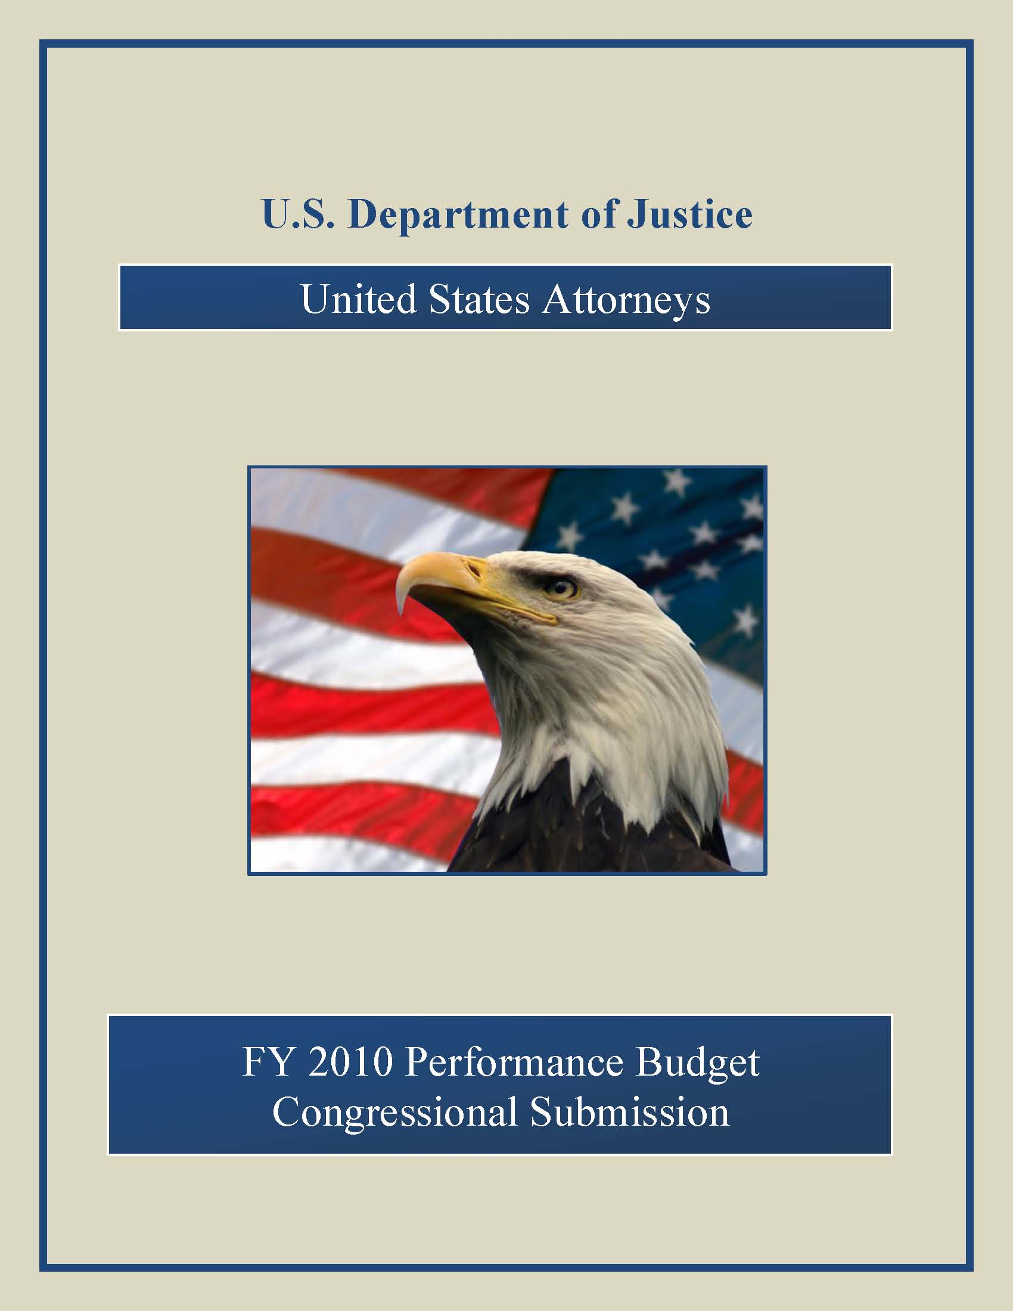
Draft

Table of Contents

Page No.

I. Overview 1

II. Summary of Program Changes 18

III. Appropriations Language and Analysis of Appropriations Language 19

IV. Decision Unit Justification 20

A. Criminal 20

1. Program Description 21

2. Performance Tables 22

3. Performance, Resources, and Strategies 24

a. Performance Plan and Report for Outcomes 24

b. Strategies to Accomplish Outcomes 25

4. Program Increases 27
- Illegal Immigration and Southwest Border Enforcement 27
- Combating Financial Fraud and Protecting the Federal Fisc 33

B. Civil 40

1. Program Description 41

2. Performance Tables 43

3. Performance, Resources, and Strategies 45
- Performance Plan and Report for Outcomes 45
- Strategies to Accomplish Outcomes 45

C. Legal Education 46

1. Program Description 47

2. Performance Table 51

3. Performance, Resources, and Strategies 52
- Performance Plan and Report for Outcomes 52
- Strategies to Accomplish Outcomes 53
4. Program Increase 54
c. National Advocacy Center 54

V. E-Gov Initiatives 58

VI. Exhibits 60

- Organizational Chart
- Summary of Requirements
- Program Increases by Decision Unit
- Resources by DOJ Strategic Goal/Objective
- Justification for Base Adjustments
- Crosswalk of 2008 Availability
- Crosswalk of 2009 Availability
- Summary of Reimbursable Resources
- Detail of Permanent Positions by Category
- Financial Analysis of Program Changes
- Summary of Requirements by Grade
- Summary of Requirements by Object Class
- Status of Congressionally Requested Studies, Reports, and Evaluations

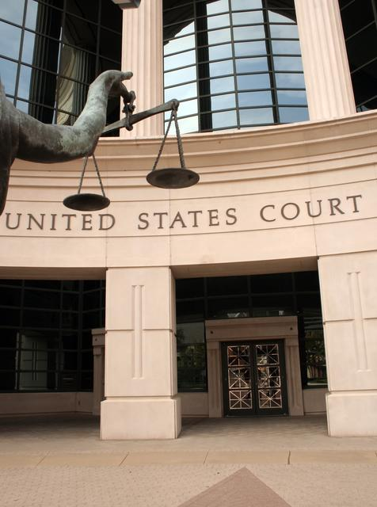

I. Overview for the United States Attorneys

A. Introduction

The United States Attorneys’ mission supports two of the Department of Justice’s strategic
goals - (1) prevent terrorism and promote the nation’s security, and (2) prevent crime, enforce federal laws and represent the rights and interests of the American people. The Fiscal Year (FY) 2010 budget request totals $1,926,003,000, including $8,127,000 for the Illegal Immigration and Southwest Border Enforcement Initiative, $7,500,000 for Combating Financial Fraud and Protecting the Federal Fisc and $5,300,000 for expansion of the National Advocacy Center.

Electronic copies of the Department of Justice’s Congressional Budget Justifications and Capital Asset Plan and Business Case exhibits can be viewed or downloaded from the Internet using the Internet address: http://www.usdoj.gov/jmd/2010justification/.

The United States Attorneys serve as the nation’s principal litigators. In response to the mandates of the Constitution that required establishment of a system of federal courts, Congress enacted the Judiciary Act of 1789 directing the President to appoint, in each federal district, “a person learned in the law to act as an attorney for the United States.” Before 1870, the U.S. Attorneys acted independently, but since then they have worked under the direction of the U.S. Department of Justice.

There are 94 United States Attorneys’ Offices (USAOs) located throughout the United States, Puerto Rico, the Virgin Islands, Guam, and the Northern Mariana Islands. The 93 United States Attorneys (Guam and the Northern Mariana Islands are under the direction of a single U.S. Attorney) are appointed by, and serve at the discretion of, the President of the United States, with the advice and consent of the United States Senate. The map on page 3 depicts the United States Attorneys’ current district and branch office locations.

The United States Attorneys report to the Attorney General, through the Deputy Attorney General. Each United States Attorney serves as the chief federal law enforcement officer within his or her judicial district and, as such, is responsible for the prosecution of criminal cases brought by the federal government; the litigation and defense of civil cases in which the United States is a party; the handling of criminal and civil appellate cases before United States Courts of Appeals; and the collection of civil and criminal debts and restitutions owed the federal government which are administratively uncollectible.

The United States Attorneys and their Assistant United States Attorneys (AUSAs) serve in small towns and big cities, representing the interests of the United States. Through their hard work and dedication, justice is served throughout the nation. United States Attorneys’ Offices conduct

most of the trial work in which the United States is a party. Although the distribution of caseload varies between districts, each USAO has every category of cases and handles a mixture of simple and complex litigation. Each United States Attorney exercises wide discretion in the
use of his/her resources to further the priorities of the local jurisdictions and needs of their communities.

United States Attorneys provide advice and counsel to the Attorney General and senior policy leadership through the Attorney General’s Advisory Committee (AGAC) and its various Subcommittees. The AGAC was established in 1973 to give United States Attorneys a voice in Department policies and to advise the Attorney General. The Committee, comprised of approximately 20 United States Attorney members who represent various federal judicial districts, geographic locations, and small, medium and large size offices, meets monthly with the Deputy Attorney General and Attorney General. The AGAC creates Subcommittees and working groups to address the Administration’s priorities. In FY 2008, the Subcommittees included: Border and Immigration Law Enforcement; Civil Rights; Controlled Substances and Asset Forfeiture; Cyber/Intellectual Property; Environmental Issues; Violent and Organized Crime; LECC/Victim/Community Issues; Native American Issues; Office Management and Budget; Sentencing Guidelines; Terrorism/National Security; and White Collar/Fraud which includes Health Care/Program Fraud and Public Corruption. The FY 2008 Working Groups included: Military Issues; Child Exploitation and Obscenity; Methamphetamine; Health Care Fraud; Regional Law Enforcement Information Sharing; Civil Chiefs; Criminal Chiefs; and Appellate Chiefs.

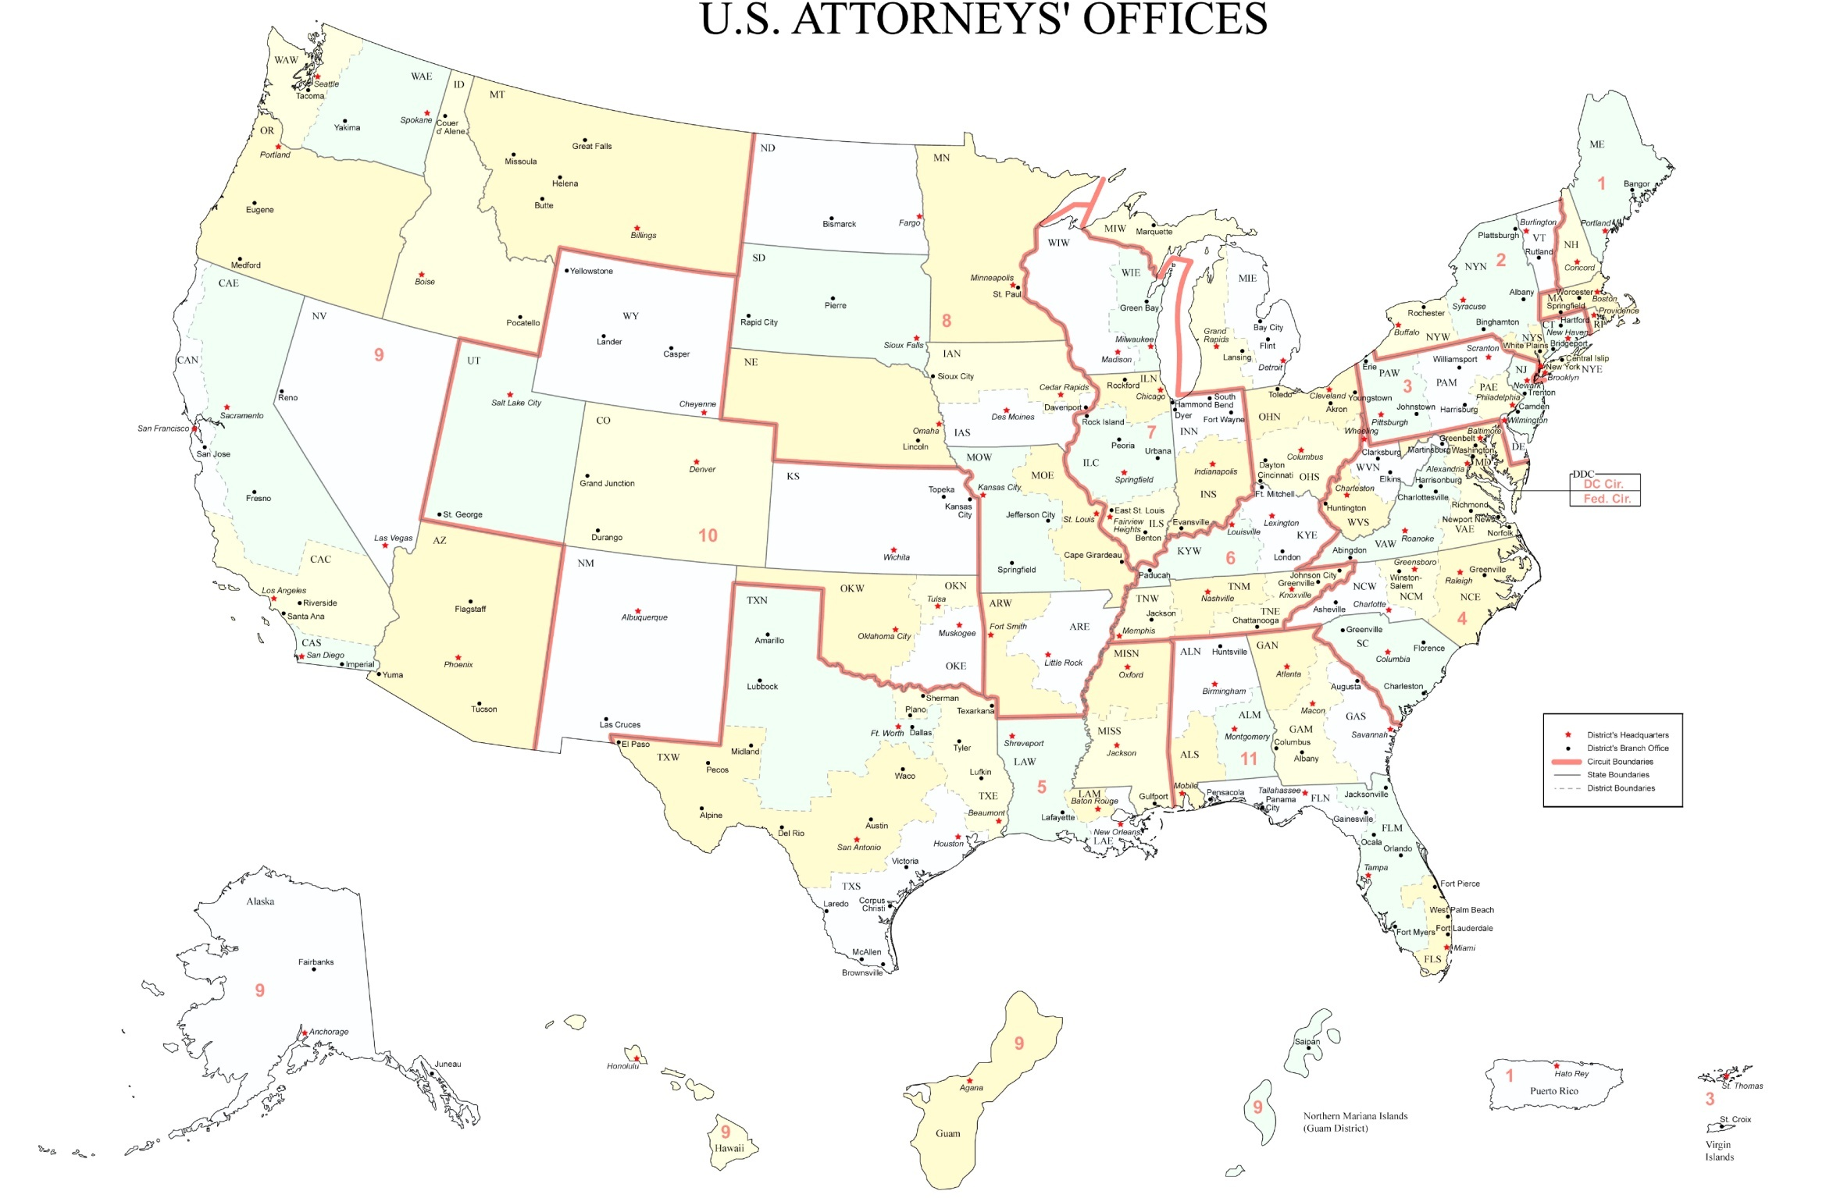

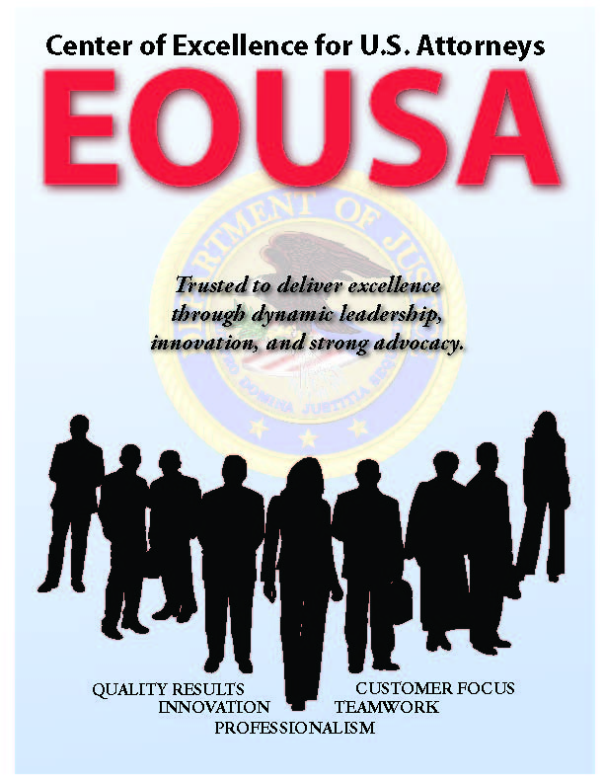
EXECUTIVE OFFICE FOR UNITED STATES ATTORNEYS

In 1953, Attorney General Order No. 8-53 established the Executive Office for United States Attorneys (EOUSA) to “provide general executive assistance and supervision to the offices of the United States Attorneys.” One of the original directives instructed the Executive Office to “serve as liaison, coordinator, and expediter with respect to the Offices of the United States Attorneys, and between these offices and other elements of the Department [of Justice].” Under the guidance of the Director of EOUSA, the EOUSA staff provides the 93 United States Attorneys with general executive assistance and direction; policy development; administrative management direction and oversight; operational support; and coordination with other components of the Department and other federal agencies. These responsibilities include legal, budgetary, administrative, and personnel services, as well as continuing legal education. EOUSA provides support and assistance to nearly 12,000 employees in more than 200 staffed offices throughout the country. See Exhibit A for an organization chart of EOUSA. Specific offices and functions of EOUSA are outlined below:

- Chief Operating Officer (COO) is a key advisor to the Director of EOUSA and the AGAC on nationwide issues. The COO manages and directs the following staffs: The Employee Assistance Program (EAP) provides free, confidential assessments, short-term counseling, and community referrals for EOUSA employees and their families. The Facilities and Support Services (FASS) Staff provides direct support and oversight of all USAOs in the areas of real property management, including space acquisition, relocation, design, repair, and management of rent payments. Support services include forms management, printing, and mail metering. The Acquisitions Staff supports both EOUSA and the USAOs by issuing contracts for supplies/services nationwide in compliance with applicable federal, departmental, and other regulations, polices, and procedures. The Personnel Staff develops and maintains a component-wide personnel program for attorneys and support staff throughout the USAOs and EOUSA. The Security Programs Staff provides security program support for USAOs, including policy and procedural assistance, training, education and awareness efforts, and emergency and contingency planning.

- Chief Financial Officer (CFO), through the Resource Management and Planning Staff (RMP), is responsible for budget formulation, budget execution, financial management, audit reviews, and long-range planning. The CFO is a key advisor to the Director of EOUSA, the AGAC, and AGAC’s Office Management and Budget (OM&B) Subcommittee. The CFO also provides the Director of EOUSA with expert advice on an annual budget of approximately $1.9 billion, FTE allocations, and reimbursable agreements with department and other federal agencies. The RMP staff consolidates resource needs and formulates an annual budget submission for presentation to the Department, the Office of Management and Budget (OMB), and Congress. It also manages the day-to-day financial operations through daily contact with USAOs and through review of regular accountability reports. An internal Audit and Review Staff participates with the Evaluation and Review Staff (EARS) in evaluating internal controls in USAOs. RMP also develops performance measures for the United States Attorneys in accordance with the Government Performance and Results Act (GPRA) and coordinates quarterly status reporting and program assessments.


- Chief Information Officer (CIO) is responsible for providing advice and assistance to the Director of EOUSA and senior staff to ensure that Information Technology (IT) is acquired and managed according to Department and EOUSA policies and procedures. The CIO ensures the integration of IT into strategic planning, acquisition, and program management processes to support the mission of the United States Attorney Community. The CIO directs and manages the following staffs: The Case Management Staff provides case management systems. The Office Automation Staff supports the purchase and installation of computer systems, equipment, and software, maintenance of hardware and software, and end-user training. The Telecommunications and Technology Development Staff provides administrative and technical support to USAOs in all telecommunications activities, including voice, data and video. The Information Security Staff ensures the confidentiality, integrity, and availability of Information and Information Systems to best support the mission of the United States Attorneys.


In FY 2008, the IT program accomplished several goals related to implementing business improvements involving technology. The Enterprise Multi-functional Printer standardized printer and multi-function printer (MFP) configurations to provide the U.S. Attorneys with replacements for end-of-life printers and to meet the organization’s need for scanning, copying and printing. Over 8,000 printers and/or MFPs were deployed. Similarly, EOUSA/OCIO established a contract vehicle to order toner supplies for the printer and MFP devices. The Enterprise Voice over Internet Protocol (EVOIP) deployment continues to deploy IP phones to the USAOs for office relocation/expansion, failing Time Division Multiplexing (TDM) phone systems and end of TDM system life cycle. Thus far, EOUSA has deployed over 4,000 IP phones to the USAOs. The EOUSA/OCIO implemented a cost-savings Litigation Technology Service Center which provides needed case-related support services for both paper-based and electronic-data discovery support. For FY 2008, the facility processed over 4 million pieces of paper discovery along with 240 gigabytes of electronic discovery supporting 45 districts.

- Legal Initiatives Staff represents USAOs in communications with the Department’s Office of Legislative Affairs (OLA) and Office of Public Affairs (OPA), and serves as an ombudsman for USAOs with other Justice components. The staff develops new programs and initiatives in the areas of legislation and public affairs, and provides expertise concerning substantive issues to the Director, EOUSA, the AGAC Subcommittees and working groups. The staff responds to legislative comments, Congressional inquiries and letters, and assists in the preparation of testimony by United States Attorneys, AUSAs or staff.

- Office of Legal Education (OLE) develops, conducts, and authorizes the training of all federal legal personnel. OLE coordinates legal education and attorney training for the Department of Justice, other federal departments and agencies, as well as state and local law enforcement. OLE is a separate decision unit of this budget and its functions and mission, which are largely completed at the National Advocacy Center (NAC) in Columbia, South Carolina, are discussed in greater detail in Section IV C.

- Legal Programs and Policy Office includes three staffs: Financial Litigation Staff, Legal Programs Staff, and Law Enforcement Coordinating Committee (LECC)/Victim-Witness Staff. The Financial Litigation Staff (FLS) supports the collection and enforcement efforts of district financial litigation programs. FLS assists in the development of financial litigation policy, development and implementation of procedures and programs, and provides liaison functions within the Department and with outside agencies. The Legal Programs Staff (LPS) coordinates asset forfeiture, health care fraud, civil issues, and white collar crime programs in USAOs and develops national policies and initiatives. In addition, LPS coordinates the activities of the Affirmative Civil Enforcement (ACE) Program, which uses civil statutes for federal law enforcement efforts in fighting economic fraud.


The Law Enforcement Coordinating Committee (LECC)/Victim-Witness Staff provides support through EOUSA for district LECC and Victim-Witness programs through liaison, monitoring, and assistance activities. LECC coordinators, at the district level, carry out the important role of coordination and liaison with federal, state, and local law enforcement, and with members of the community on various crime reduction programs. Each District’s LECC is under the supervision of the United States Attorney, who serves as the LECC chairperson or co-chairperson. Through the LECC program, training is provided to federal, state, and local law enforcement in areas such as anti-terrorism, gun crime, asset forfeiture, gang investigations, racial profiling, domestic violence, emerging drug trends, community policing, victim issues, and officer safety. USAOs’ Victim Witness personnel enhance and protect the necessary role of crime victims and witnesses in the criminal justice process, ensuring that the federal government does all it can to assist those individuals through an often extremely difficult process. Victim Witness personnel handle victim notification, explain to victims the criminal justice process, prepare victims and witnesses for testimony and allocution, coordinate their attendance at proceedings and accompany them, and provide victims with referrals and emergency assistance. Victims’ rights have taken on new importance since the passage of the Crime Victims’ Rights Act of 2004, which provided victims with enumerated rights and, for the first time at the federal level, the mechanisms to enforce their rights. Victims are now playing a more central role in the criminal process, and exercising their rights in greater numbers than ever before. The number of notifications sent to victims alone has doubled since the Act passed.


- Data Analysis Staff is the primary source of statistical information and analysis for EOUSA. The staff provides data and analysis to EOUSA components allowing them to respond to requests from, among others, the Department, the White House, Congress, and the public. The staff also provides the United States Attorney Community comprehensive quarterly analysis of work year, caseload and workload information and produces the United States Attorneys’ Annual Statistical Report. During FY 2008, the Data Analysis staff responded to approximately 770 requests for statistical and narrative information.


- General Counsel’s Office provides advice to USAOs and to EOUSA on a broad array of legal and ethical issues. It provides guidance to USAOs and EOUSA personnel regarding ethics and standards of conduct matters including conflicts of interest, recusals, outside activities, gifts and financial disclosures, allegations of misconduct, personnel legal issues, discovery requests and compliance with subpoenas. The General Counsel’s Office is also responsible for the employee relations programs of EOUSA and the USAOs.

- Freedom of Information and Privacy Act (FOIA) Staff processes all FOIA and Privacy Act (PA) requests for records located throughout EOUSA and the USAOs, provides legal guidance to USAOs concerning FOIA/Privacy Act issues, represents them in administrative appeals, and assists AUSAs and Department of Justice attorneys in litigation in federal courts by providing draft pleadings and preparing legal documents.


- Equal Employment Opportunity (EEO) Staff provides centralized leadership, coordination, and evaluation of all equal employment efforts within EOUSA and the USAOs. The EEO Staff is comprised of two components – Complaint Processing and Affirmative Employment/Special Emphasis Programs. The EEO mission supports the USAOs and EOUSA by providing timely, impartial and superior customer service in the areas of conflict resolution; EEO complaint processing; civil rights policy development and training; language assistance plans; and by conducting proactive diversity initiatives through outreach and recruitment.

- Evaluation and Review Staff (EARS) conducts a district evaluation program, enabling the Director of EOUSA to fulfill the responsibility of conducting reviews of internal management controls and preventing waste, loss, unauthorized use or misappropriation in federal programs, as required by the Federal Manager's Financial Integrity Act and OMB Circular No. A - 123. The EARS evaluation program reviews legal management, administrative operations and financial litigation in each USAO and provides on-site management assistance. The Financial Management (FM)-EARS evaluation program reviews USAOs’ financial management and operational practices. EARS and FM-EARS conduct evaluations at the same districts each year. In FY 2008, EARS and FM-EARS conducted 26 evaluation visits, and 20 follow-up visits to ensure that those issues identified as a result of the evaluation process were corrected. FM-EARS conducted 29 evaluation visits and 29 off-site reviews to ensure that USAOs were in compliance with financial management laws, regulations, and procedures. During FY 2009, EARS and FM-EARS have each scheduled 30 evaluation visits.

••• U.S. Attorney Community At a Glance •••

Organizational Structure Summary

- 94 United States Attorneys’ Offices
  - 161 other staffed locations throughout the continental United States and United States Territories

- 93 United States Attorneys (Guam and the Northern Mariana Islands are under the direction of a single United States Attorney)

- EOUSA provides executive assistance and direction, support and policy development through its subordinate offices, which include:

  - Chief Operating Officer
  - Chief Financial Officer
  - Chief Information Officer
  - Legal Initiatives Staff
  - Office of Legal Education
  - Legal Programs and Policy Office
  - Data Analysis Staff
  - General Counsel’s Office
  - Freedom of Information and Privacy Act Staff
  - Equal Employment Opportunity Staff
  - Evaluation and Review Staff

CRIMINAL PROSECUTIONS


The USAOs investigate and prosecute the vast majority of criminal cases brought by the federal government—representing a more diverse workload than ever before. The types of cases include international and domestic terrorism; immigration; child exploitation and obscenity; firearms and violent crime; complex and time-consuming fraud – including health care, identity theft, white collar crime and public corruption, procurement, mortgage, Katrina-related, and student loan fraud; gangs and organized crime; drug enforcement; human trafficking and criminal civil rights enforcement. Many of these cases involve multiple defendants and are extremely complex. The nature of today’s crimes has required the U.S. Attorney Community to become conversant in a wide range of fields, such as banking and health care, computer technology, securities, foreign cultures and languages, and manufacturing processes affected by environmental and other federal regulations.

The United States Attorneys receive most of their criminal referrals, or “matters,” from federal investigative agencies, including the Federal Bureau of Investigation (FBI), the Drug Enforcement Administration (DEA), the Bureau of Alcohol, Tobacco, Firearms and Explosives (ATF), the United States Immigration and Customs Enforcement (ICE), the United States Secret Service, and the United States Postal Inspection Service. USAOs also receive criminal matters from state and local investigative agencies, as well as violations reported by private citizens. Following careful consideration of each criminal matter, the United States Attorneys decide the appropriateness of bringing criminal charges and, when deemed appropriate, initiate prosecution. Except for misdemeanor offenses and instances in which an alleged offender waives the right to a grand jury indictment, the United States Attorneys present evidence against an alleged offender to a grand jury. The grand jurors then decide whether to return an indictment and, if an indictment is returned, the United States Attorneys then present the criminal charges in open court at the arraignment of the defendant.
Federal Law Enforcement Partners
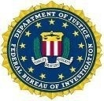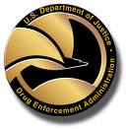

Although historically a large number of criminal defendants enter a plea of guilty prior to trial, the United States Attorneys must always fully investigate the crime, prepare the charging document, and be ready to go to trial. Consistent preparation for trial minimizes the risk of dismissal for noncompliance with the Speedy Trial Act and strengthens the government’s position in negotiations with defense counsel for a guilty plea. Pretrial discovery practice also strengthens the government’s position. When a guilty plea is not obtainable, a trial becomes necessary. The United States Attorneys then present factual evidence to the jury, or to the judge in a non-jury (bench) trial. If the defendant is convicted, the United States Attorneys must prepare and present evidence at the defendant’s sentencing hearing and then defend the conviction at post-trial hearings and appeals. The USAOs handle most criminal appeals at the intermediate appellate level. After filing an appeal brief, the United States Attorneys may be required to participate in oral arguments before the United States Courts of Appeals. If there is a further appeal, the United States Attorneys may be called upon to assist the Solicitor General in preparing the case for review by the United States Supreme Court.

CIVIL LITIGATION

The United States Attorneys initiate civil actions, referred to as affirmative litigation, to assert and protect the interests of the United States. They also defend the interests of the government in lawsuits filed against the United States, referred to as defensive civil litigation. In other civil cases, the United States is a third party, a creditor, or an intervener.

Examples of affirmative litigation include civil actions brought to: enforce the nation’s environmental, admiralty, and civil rights laws; represent the government’s interests in bankruptcy actions; recoup money and recover damages resulting from federal program and other fraud; and enforce administrative summonses and asset forfeiture litigation, which involve assets seized by federal, state, and local law enforcement.

Defensive litigation includes tort suits brought by those who allege suffering as a result of government action, adjudication of Social Security disability claims, alleged contract violations, habeas corpus petitions, and race, sex, and age discrimination actions. The USAOs represent and defend the government in its many roles – employer, regulator, law enforcer, medical care provider, revenue collector, contractor, procurer, property owner, judicial and correctional system manager, and as administrator of federal benefits. In those cases where the United States is sued, the Department of Justice must be its representative.

Civil defensive work is unique because it is non-discretionary and non-delegable. Unlike criminal divisions or sections, civil units of USAOs cannot employ “declination” criteria to manage or reduce the civil defensive caseload. All cases filed against the government, its agencies, and employees in their official capacities must be defended.

CRIMINAL AND CIVIL APPEALS

Appeals are generally very time-consuming, requiring a thorough review of the entire record in the case, the filing of a brief and reply brief, and, in most cases, participation in oral argument requiring travel to the city where the United States Courts of Appeals for the circuit is located. Furthermore, the complexity of appellate work and the time required to handle that work increases when convictions are based on complex facts, such as those found in organized crime drug enforcement and other narcotics cases, financial institution fraud, other organized crime, armed career criminal, public corruption, health care fraud, and computer fraud cases.

The appellate workload of the United States Attorneys fluctuates due to additional appeals prompted by Supreme Court rulings, legislative changes, and changes under the U.S. Sentencing Guidelines. In FY 2006, for example, the Supreme Court held that the Sixth Amendment right to jury trial applied to factual findings supporting certain sentencing enhancements under the U.S. Sentencing Guidelines, and that the Guidelines are advisory instead of mandatory. As a result, post-sentencing motions filed by incarcerated defendants increased by more than 10 percent for approximately two years.


CRIMINAL AND CIVIL DEBT COLLECTION

USAOs are responsible for collecting both criminal and civil debt for the U.S. Government. Each USAO has a Financial Litigation Unit (FLU) with the responsibility for both criminal and civil debt collection activities. In addition to the FLUs, USAOs have Affirmative Civil Enforcement (ACE) staff devoted to the collection of civil debts.

Debts are ordered to be collected from a criminal defendant when the defendant is sentenced by the court. These debts may be in the form of restitution to victims of crime, fines imposed by the court to penalize criminals, special assessments on each criminal conviction count, costs of prosecution and other costs, or forfeitures of appearance bonds. Interest may also be collected in certain cases. In instances where restitution is ordered, the USAOs are involved in collecting federal restitution payments, or restitution which is owed to the United States, and in collecting non-federal restitution, or that which is owed to private individuals and entities. As a result of the Mandatory Victims Restitution Act (MVRA), courts now must impose monetary restitution orders in all violent crimes and most property crimes. United States Attorneys are required to enforce restitution orders on behalf of all victims of federal crimes. The amount of outstanding criminal debt has risen dramatically since the enactment of the MVRA in 1996, to $55.3 billion by the end of FY 2008. Of this amount, 25 percent or $13.82 billion was considered collectible.
••• Debt Collection At a Glance •••

In FY 2008, the USAOs collected $3.9 billion of criminal and civil debts owed. Of the total debts collected, USAOs recovered:

(1) $1.7 billion in criminal debts; and
(2) $2.2 billion in civil debts.

The United States Attorneys’ collection efforts, handled by a very small percentage of the total workforce, returns to the Treasury over twice the $1.75 billion appropriated in the FY 2008 budget for the entire U.S. Attorney Community.

The U.S. Attorneys are also the legal representatives for other federal agencies to pursue repayment of debts. For example, when federal agencies lend money and the recipients default on repayment of the loans, or when federal agencies have paid on guaranteed loans and have not been repaid as provided for in the lending agreement, United States Attorneys pursue the repayment of debt. The Departments of Agriculture, Education, Health and Human Services, Housing and Urban Development, Transportation, Veterans Affairs, and the Small Business Administration are some of these client agencies. United States Attorneys file suit to obtain judgments to collect debts, foreclose on real property, compel physicians to repay or fulfill their commitment to the Public Health Service in return for education grants, sue to set aside fraudulent transfers of property which could be used to satisfy defaulted loans, and manage debtor repayment schedules. The below table illustrates the significant return of debts collected in the last five years:

Dollars in Billions
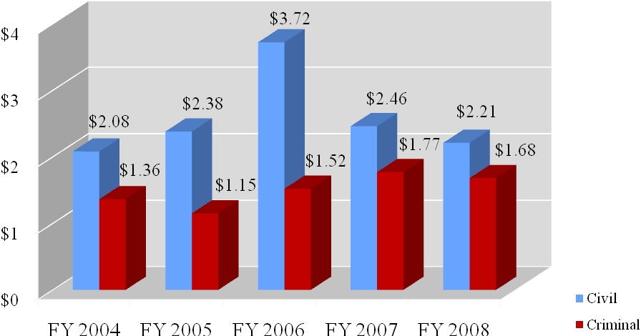

In FY 2008, the USAOs collected $3.9 billion of criminal and civil debts owed. Of the total debts collected, USAOs recovered: (1) $1.68 billion in criminal debts; and (2) $2.21 billion in civil debts. The United States Attorneys’ collection efforts, handled by a very small percentage of the total workforce, returns to the Treasury over twice the $1.75 billion appropriated in the FY 2008 budget for the entire United States Attorney Community.

B. Issues, Outcomes, and Strategies

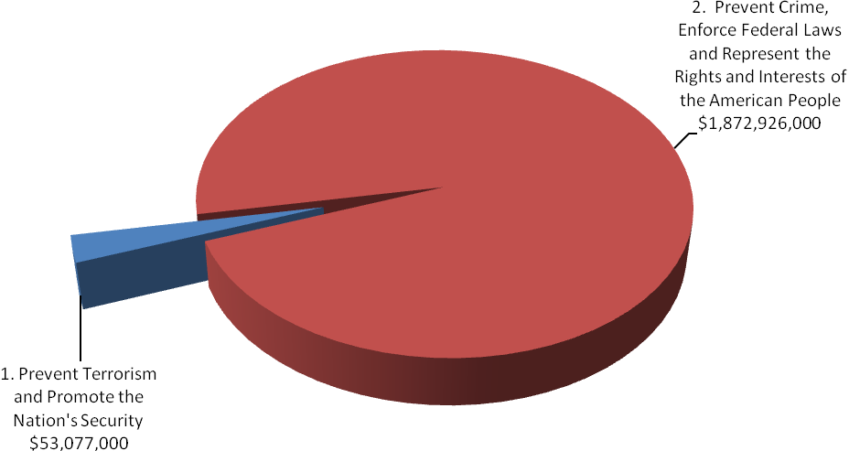
FY 2010 Total Request by DOJ Strategic Goal

The following is a brief summary of the Department’s Strategic Goals and Objectives in which the United States Attorneys play a role.

DOJ Strategic Goal 1: Prevent Terrorism and Promote the Nation’s Security ($53,077,000)

● Prevent, disrupt, and defeat terrorist operations before they occur (1.1).
● Strengthen partnerships to prevent, deter, and respond to terrorist incidents (1.2).
● Prosecute those who have committed, or intend to commit, terrorist acts in the United States (1.3).

DOJ Strategic Goal 2: Prevent Crime, Enforce Federal Laws and Represent the Rights and Interests of the American People ($1,872,926,000)

● Strengthen partnerships for safer communities and enhance the Nation’s capacity to prevent, solve, and control crime (2.1).
● Reduce the threat, incidence, and prevalence of violent crime (2.2).
● Prevent, suppress, and intervene in crimes against children (2.3).
● Reduce the threat, trafficking, use, and related violence of illegal drugs (2.4).
● Combat public and corporate corruption, fraud, economic crime, and cybercrime (2.5).
● Uphold the civil and constitutional rights of all Americans (2.6).
● Vigorously enforce and represent the interests of the United States in all matters over which the Department has jurisdiction (2.7).

C. Full Program Costs

This request funds the strategies that support the United States Attorneys’ objectives. We will continue to provide federal leadership in preventing and controlling crime and seeking just punishment of those guilty of unlawful behavior.

FY 2010 Budget Request by Decision Unit
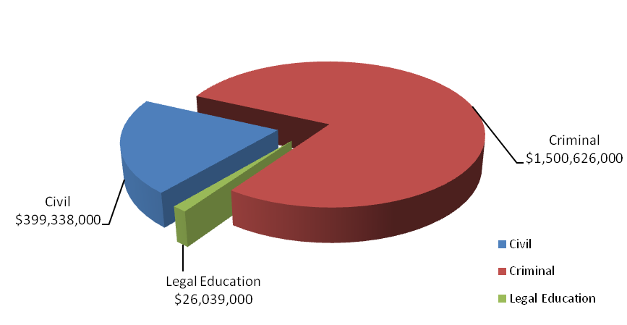

The United States Attorneys’ $1,926,003,000 budget request for FY 2010 is divided into three decision units: criminal, civil, and legal education. Some programs, as well as management and administration costs, cross decision units. Both performance and resource tables within each decision unit define the total costs of achieving the strategies the United States Attorneys will employ in FY 2010. The various resource and performance charts incorporate the costs of lower level strategies which also contribute to the achievement of objectives, but which may not be highlighted in detail in order to provide a concise narrative. Also included are the indirect costs of continuing activities, which are central to the operations of each decision unit.

D. Performance Challenges

The challenges that impede progress toward the achievement of agency goals are complex and ever-changing. National priorities since September 11th affected everyone in the law enforcement community as resources and personnel were redirected to prosecute the Global War on Terror. Illegal immigration and border security have become key components of the Nation’s counterterrorism strategy following September 11th. Federal prosecution of border crime is now a critical part of our Nation’s defense. Additionally, the current economic crisis requires that the U.S. Attorney Community focus attention on ever increasing Mortgage and Financial Fraud, and bankruptcy cases. Internal agency dynamics, policy decisions, technological developments, and criminal behavior are factors that broadly impact law enforcement practices and pose challenges that demand attention.

The United States Attorney Community continues to work to become a more fiscally efficient organization. In order to ensure that costs remained within funded levels, cost saving measures were implemented, including:

- Reducing space and delayed renovations in District Offices;
- Reducing video and data telecommunication lines;
- Utilizing on-line law library services rather than hard copies;
- Limiting ordering of real time or hourly transcripts and translation services;
- Reducing travel; and
- Delaying spending on infrastructure for physical security and information technology.

However, even with these cost savings measures, positions were left vacant. In FY 2004, 198 Full Time Equivalents (FTE) were left unfilled; that number grew to a high of 1,180 FTE in October 2007.

Vacant positions had a substantial impact on the U.S. Attorneys’ workload. Criminal cases pending or what could be considered as “backlog” increased by 11 percent. Additionally, in the civil area, new cases filed decreased by 4.5 percent and the number of civil affirmative cases filed decreased by 21 percent between FY 2003 and FY 2006.

In FY 2007 and FY 2008, the U.S. Attorney Community began an aggressive campaign to fill positions previously left vacant. United States Attorneys’ Offices have been taking the necessary management steps to restructure the workforce by backfilling positions with lower salaried employees. As the chart below shows, the incremental increases in the average non-supervisory attorney salary (82 percent of the total attorney workforce are non-supervisors) are well below the cost-of-living adjustment over the last several years:

Fiscal Year | Average Salary | $ Change in Average Salary | % Change in Average Salary
FY 2008 | $106,928 | $494 | .5%
FY 2007 | $106,434 | $1,003 | .9%
FY 2006 | $105,431 | $745 | .7%
FY 2005 | $104,686 | $1,638 | 1.6%
FY 2004 | $103,048 | $2,910 | 2.9%
FY 2003 | $100,138

As positions were filled, workload statistics improved. By the end of FY 2008 (with higher on-board levels), criminal cases filed increased by 7.4 percent over the FY 2006 total; total cases pending increased by just 1 percent. Additionally, civil affirmative cases filed between the beginning of FY 2007 and the end of FY 2008 increased 21.5 percent. In FY 2009, the USAOs will continue to fill vacant positions thereby reducing the vacancy rate and further increasing the number of criminal and civil cases filed. The United States Attorneys continue to implement cost saving measures that contribute to the organization meeting our financial goals. By the end of FY 2009, the United States Attorneys plan to be back to the FY 2004 unfilled FTE levels of approximately 200. A vacancy rate of 200 is one which the United States Attorneys considers appropriate for normal attrition.

External Challenges

A highly skilled, dynamic workforce is more important now than ever before. Since
September 11th, USAOs have taken on more responsibilities in new areas. AUSAs coordinate with state, local, and federal agencies in preventing, investigating, and prosecuting terrorist acts. Furthermore, AUSAs participate in disaster planning and emergency preparedness. These coordination activities involve non-traditional roles for AUSAs and present challenges as we continue combating terrorism.

Coordination with state, local, and federal agencies is not unique to combating terrorism. USAOs are actively involved in these activities in program areas ranging from border enforcement/prosecution to gun violence reduction to disrupting and dismantling drug organizations, and now child exploitation. In the border enforcement and prosecution area, additional Border Patrol Agents are resulting in substantial increases in misdemeanor cases requiring even closer coordination with the U.S. Marshals Service, the Office of the Detention Trustee, the Bureau of Prisons, the Department of Homeland Security, the Courts and the local defense bar concerning the availability of bed space, prisoner transport, and translators for those who are detained.

In addition, the economy and emerging criminal activities, often driven by technology, such as cybercrime, are external challenges beyond our control. Downturns in the economy often correlate with increases in criminal activity. As a result of the recent economic crisis, the number of active FBI mortgage fraud investigations has tripled in the last three years. In addition, financial institutions have reported a record number of mortgage fraud cases to the Treasury Department — 10 times the number reported in 2001-2002. The reports document billions of dollars in losses. Further, the Housing and Urban Development Inspector General anticipates a greatly increased mortgage fraud caseload based on the new broadened standards for obtaining FHA-backed loans. Inevitably, these investigations will result in more referrals for prosecution to the USAOs throughout the country.

We will continue to focus on areas within our spheres of influence and control, concentrating on coordination efforts with state, local, and federal agencies and ensuring our workforce is trained for emerging and complex issues.

Internal Challenges

One internal challenge to the United States Attorney Community is keeping the workforce flexible and adaptable. Over the past few years, terrorism, corporate fraud, violent crime and gangs, immigration, internet-related crime, and child exploitation have emerged as important national priorities. The United States Attorney Community needs to be able to shift resources to respond to changes in case type and case load. The United States Attorneys have developed an effective allocation process that distributes new positions and funding to districts with the greatest demonstrated need. Necessary training is provided through the National Advocacy Center (NAC) to ensure that attorneys and support staff have the expertise in these areas. Regular reviews and monitoring of case work and USAOs’ needs are essential to continued responsiveness.

Another related internal challenge is the need to restructure the workforce and to grapple with the upcoming “brain drain” as Baby Boomers reach retirement age. Several years of using the tool provided by the Voluntary Early Retirement (VERA)/Voluntary Separation Incentive Payment (VSIP) authority have allowed offices to replace those taking the VERA/VSIP with employees hired at lower salaries and with a different mix of skill sets. Given the current economic condition, however, fewer employees are likely to voluntarily separate or retire, thereby reducing the flexibility of the USAOs to continue to restructure the workforce and achieve cost savings by hiring new employees at lower salaries.

II. Summary of Program Changes

For FY 2010, the United States Attorneys’ budget request is $1,926,003,000. The request includes $20,927,000 in enhancements and 118 new positions (59 FTE). The following enhancements that support Presidential priorities are requested: 1) Illegal Immigration and Southwest Border Enforcement, 2) Combating Financial Fraud and Protecting the Federal Fisc and 3) Expansion of the National Advocacy Center.

Item Name | Description |  |  |  | Page
Item Name | Purpose | Pos. | FTE | Dollars ($000) | Page
Illegal Immigration and Southwest Border Enforcement | Provides for additional prosecution resources to address illegal immigration and cross border violence. | 75 | 38 | $8,127 | 27
Combating Financial Fraud and Protecting the Federal Fisc | Provides for additional prosecution resources to enhance efforts in the areas of mortgage fraud, bankruptcy, affirmative civil enforcement and white collar crime/public corruption and support extraordinary litigation expenses and information technology. | 43 | 21 | 7,500 | 33
National Advocacy Center | Provides resources for upgrades associated with the expansion of the National Advocacy Center to achieve efficiencies, keep pace with current and future demands for training of all federal legal personnel, and ensure the security and continuity of EOUSA operations. | 0 | 0 | 5,300 | 54
TOTAL |  | 118 | 59 | $20,927

III. Appropriations Language and Analysis of Appropriations Language

Appropriations Language

For necessary expenses of the Offices of the United States Attorneys, including inter-governmental and cooperative agreements, [$1,836,336,000] $1,926,003,000: Provided, That of the total amount appropriated, not to exceed $8,000 shall be available for official reception and representation expenses: Provided further, That not to exceed $25,000,000 shall remain available until expended[: Provided further, That of the amount provided under this heading, not less than $33,600,000 shall be used for salaries and expenses for Assistant United States Attorneys to carry out section 704 of the Adam Walsh Child Protection and Safety Act of 2006 22 (Public Law 109-248) concerning the prosecution of offenses relating to the sexual exploitation of children].

Analysis of Appropriations Language

The following language has been deleted from the FY 2009 appropriations language for FY 2010:

“: Provided further, That of the amount provided under this heading, not less than $33,600,000 shall be used for salaries and expenses for Assistant United States Attorneys to carry out section 704 of the Adam Walsh Child Protection and Safety Act of 2006 22 (Public Law 109-248) concerning the prosecution of offenses relating to the sexual exploitation of children”

This language has been proposed for deletion, as this provision restricts the ability of the Attorney General to manage Department of Justice resources.

IV. Decision Unit Justification

- CRIMINAL

Criminal Litigation TOTAL | Perm. Pos. | FTE | Amount  (Dollars in Thousands)
2008 Enacted | 8,026 | 8,002 | $ 1,367,795
2008 Supplementals | -- | -- | $ 5,000
2008 Enacted and Supplementals | 8,026 | 8,002 | $ 1,372,795
2009 Enacted | 8,150 | 8,116 | $ 1,433,467
Adjustments to Base and Technical Adjustments | -- | 62 | $ 53,762
2010 Current Services | 8,150 | 8,178 | $ 1,487,229
2010 Program Increases | 105 | 53 | $ 13,397
2010 Request | 8,255 | 8,231 | $ 1,500,626
Total Change 2009-2010 | 105 | 115 | $ 67,159

Criminal Litigation—Information Technology Breakout (of Decision Unit Total) | Perm. Pos. | FTE | Amount  (Dollars in Thousands)
2008 Enacted | 294 | 294 | $ 115,260
2009 Enacted | 294 | 294 | $ 118,395
2010 Adjustments to Base | -- | -- | $ 2,137
2010 Current Services | 294 | 294 | $ 120,532
2010 Program Increase | -- | -- | $ 1,050
2010 Request | 294 | 294 | $ 121,582
Total Change 2009-2010 | -- | -- | $ 3,187

1. Program Description–Criminal Decision Unit

The USAOs investigate and prosecute the vast majority of criminal cases brought by the federal government—including a more diverse and complex workload than ever before. For example, criminal caseloads include: international and domestic terrorism, illegal immigration, mortgage and disaster relief fraud, youth violence, firearms and gangs, child exploitation and obscenity, complex and time consuming white collar and health care fraud, financial institution and computer fraud, environmental crime, public corruption and organized crime, drug enforcement, civil rights violations, human trafficking and cases involving multiple defendants and international organizations.

The USAOs receive most of their criminal referrals, or "matters," from federal investigative agencies or become aware of criminal activities in the course of investigating or prosecuting other cases. They also receive criminal matters from state and local investigative agencies. Criminal violations are also reported to the USAOs by citizens. After careful consideration of each criminal matter, the U.S. Attorney decides the appropriateness of bringing criminal charges and initiates prosecution.

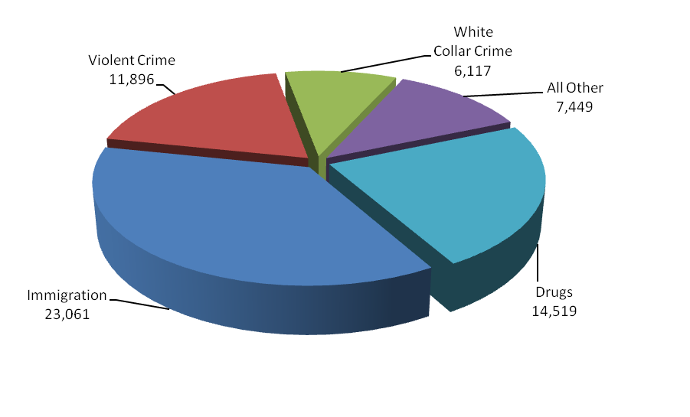
Criminal Workload
FY 2008 Cases Filed - 63,042

During FY 2008, the USAOs filed 63,042 criminal cases against 85,122 defendants in United States District Court. The number of new cases filed increased by 5 percent from FY 2005 to
FY 2008 – going from 60,062 cases to 63,042.

A total of 63,595 cases against 85,083 defendants were closed during FY 2008. Of the 85,083 defendants whose cases were closed, 92 percent or 78,140, either pled guilty or were found guilty. Of these, 64,198 received prison sentences, and 215 guilty defendants received sentences of life imprisonment. The rate of convicted defendants who received prison sentences has consistently exceeded 80 percent over the last six years
.
2. Performance Tables

3. Performance, Resources, and Strategies

The Criminal Decision Unit contributes to the Department’s Strategic Goal I: Prevent Terrorism and Promote the Nation’s Security. Within this goal, the decision unit’s resources address three of the Department’s Strategic Objectives: 1.1 - Prevent, disrupt, and defeat terrorist operations before they occur; 1.2 - Strengthen partnerships to prevent, deter, and respond to terrorist incidents, and 1.3 - Prosecute those who have committed, or intend to commit, terrorist acts in the United States.

The Criminal Decision Unit also contributes to Goal II: Prevent Crime, Enforce Federal Laws and Represent the Rights and Interests of the American People. Within this goal, the decision unit’s resources address five of the Department’s Strategic Objectives: 2.1 - Strengthen partnerships for safer communities and enhance the Nation’s capacity to prevent, solve, and control crime; 2.2 - Reduce the threat, incidence, and prevalence of violent crime; 2.3 - Prevent, suppress, and intervene in crimes against children; 2.4 - Reduce the threat, trafficking, use, and related violence of illegal drugs; 2.5 - Combat public and corporate corruption, fraud, economic crime, and cybercrime; 2.6 - Uphold the civil and constitutional rights of all Americans; and 2.7 - Vigorously enforce and represent the interests of the United States in all matters for which the Department has jurisdiction.

a. Performance Plan and Report for Outcomes
In the criminal area, there are two primary performance measures for the U.S. Attorneys, including 1) terrorism convictions, and 2) criminal cases favorably resolved.

1.) Terrorism/Anti-Terrorism Convictions
••• Terrorism At a Glance •••

Hassan Abu-Jihaad (aka Paul R. Hall) was convicted in March 2008 for providing material support to terrorists, and delivering classified U.S. Navy information to a terror support group.

Mahammed Mansour Jabarah,
an al Qaeda-trained terrorist, was sentenced in January 2008 to life in prison, following his convictions for participating in plots to bomb U.S. embassies in Singapore and the Philippines.

The prevention of terrorist attacks and the prosecution of the war on terrorism remain the top priorities of the Department of Justice. In FY 2008, the U.S. Attorneys filed a total of 263 terrorism, anti-terrorism, and hoax and financing cases against 369 defendants. This includes international and domestic terrorism, terrorism-related financing, and terrorism-related hoaxes, as well as anti-terrorism cases. Defendants convicted in cases listed as anti-terrorism cases have not necessarily engaged in terrorist activity. Rather, these cases were brought to prevent or disrupt potential or actual terrorist threats where the offensive conduct is not obviously a federal crime of terrorism. A total of 273 cases against 427 defendants were terminated in FY 2008.

The terrorism performance measure is the number of terrorism/anti-terrorism/financing and hoax convictions based on the definitions described above and derived from the U.S. Attorneys’ Case Management System. Included in the terrorism convictions are the original program categories of international terrorism and domestic terrorism. Examples of offenses that could be classified as international or domestic terrorism include the following: destruction of an aircraft or interference with a flight crew; attack on a mass transit facility or on the means of interstate communication; use of weapons of mass destruction; and material support for terrorism. Terrorism-related hoaxes and terrorist financing were added after September 11, 2001 to allow the U.S. Attorneys’ Case Management System to better capture terrorism-related activities. Anti-terrorism cases are those where the underlying purpose or object of the case is to prevent or disrupt potential or actual terrorist threats where the offensive conduct is not obviously a federal crime of terrorism. In FY 2008, there were a total of 372 convictions.

2.) Criminal Cases Favorably Resolved

The USAOs handle most of the criminal cases prosecuted by the Department of Justice. The
U.S. Attorneys receive most of their criminal referrals from federal investigative agencies, including the FBI, DEA, ATF, ICE, and the United States Secret Service. Criminal referrals may also be received from state and local investigative agencies or U.S. Attorneys may become aware of criminal activities in the course of investigating or prosecuting other cases.

The United States Attorneys are called upon to respond to changing priorities and to become involved in specific crime reduction programs. After the events of September 11, 2001, the number one priority of the U.S. Attorneys became the prevention of terrorist acts and the investigation and prosecution of those involved in terrorist attacks. More recently, Southwest Border enforcement - responding to the enormous number of illegal aliens crossing the Southwest Border into the U.S. - has become critical. The United States Attorneys also have continued their longstanding commitment to address drug and violent crimes. Within the violent crime category, the U.S. Attorneys continue to address the illegal use of firearms by those who commit crimes and accompanying acts of violence in our communities. Drug prosecutions continue to be a priority of the U.S. Attorneys, with particular emphasis on the operations of large drug organizations. Additionally, child exploitation cases and the litigation of mortgage and other financial fraud are among the priorities the U.S. Attorneys litigate.

The performance measure for criminal litigation relates to the percentage of criminal cases favorably resolved. In FY 2008, cases involving 78,140 defendants were favorably resolved, superseding the 90 percent goal by more than 2 percent. The FY 2008 total includes 77,768 defendants found guilty of non-terrorist criminal activity, such as violent crime, drug trafficking, and white collar crime.

b. Strategies to Accomplish Outcomes

In FY 2010, the U.S. Attorneys will continue to place a high priority on prosecution and security efforts in the war on terror as well as addressing other important priorities such as financial fraud, identity theft, white collar fraud, immigration, child exploitation, violent crime and gangs, and drug trafficking. As part of these efforts, enhancements of $8.127 million and 75 positions for Illegal Immigration and Southwest Border Enforcement and $7.5 million and 43 positions for Combating Financial Fraud and Protecting the Federal Fisc are requested. Other strategies include:

- Aggressive hiring to fill vacant positions.
- Restructuring the workforce by backfilling some positions with lower salaried employees.
- Leveraging technology to improve efficiency and enhance information flow organization-wide and with our partners.
- Regular reviews and monitoring of case and work load data.
- Ensuring sufficient resources are allocated to meet the caseloads, especially focusing on priority areas.
- Expanded training at the NAC to address substantive new areas as well as leadership and management.

4. Program Increases

Item Name: Illegal Immigration and Southwest Border
Enforcement

Budget Decision Unit(s): Criminal

Strategic Goal(s) & Objective(s): Goal II: Prevent crime, enforce federal laws, and represent the rights and interests of the American people.
Objective 2.2: Reduce the threat, incidence, and prevalence of violent crime.
Objective 2.7: Vigorously enforce and represent the interests of the United States in all matters over which the Department has jurisdiction.

Component Ranking of Item: 1

Program Increase: Positions 75 Atty 50 FTE 38 Dollars $8,127,000

Description of Item

In FY 2010, the United States Attorneys request 75 positions (50 attorneys), 38 FTE, and $8,127,000 for the Illegal Immigration and Southwest Border Enforcement. This initiative will focus prosecution efforts on a range of immigration related offenses including: re-entry after removal, human trafficking, migrant smuggling, and document fraud. Efforts will also focus on the recent surge in violent crime along the southwest border related to illicit gun and drug trafficking. Resources will be distributed among the Nation’s northern and southern borders and as required throughout the interior of the country. Resources will be allocated through a competitive process. Of the requested amount, a total of $46,000 in non-personnel costs is included for additional immigration specific training for new AUSAs.

Justification

Federal prosecution of border crime is a critical part of our Nation’s defense and gaining operational control of our Nation’s borders is essential. The USAOs in border districts are tasked to support the federal law enforcement agencies that patrol 5,525 miles of our border with Canada and 1,933 miles of our border with Mexico. These borders pose different but equally important challenges. While the southwestern border faces a number of both felony and misdemeanor immigration cases, the northern border confronts significant threats from designated criminal and terrorist organizations with a presence in Canada. The strategies employed by the USAOs to combat violations of immigration offenses include:

- Ensuring a sufficient USAO presence to meet the steadily increasing case load generated by additional law enforcement and investigative resources, and
- Aggressive enforcement of the immigration statutes, including those against alien smuggling organizations; those involved in terrorism and violent crimes; and those against aliens, who after deportation, attempt to re-enter or are found in the United States illegally.

Northern Border and Interior Enforcement – Illegal immigration provides the initial foothold with which criminal elements, including organized crime syndicates, use to engage in a myriad of illicit activities ranging from immigration document fraud and migrant smuggling to human trafficking. Left unchecked, these criminal elements become entrenched in the legal and illegal economies of the United States. However, prosecution of immigration violations is often the Achilles’ heel for these offenders and provides a valuable opportunity to attack this vulnerability and disrupt and destroy the infrastructure that supports these illegal operations.

Federal prosecution of border crime is a critical part of our Nation’s defense and federal jurisdiction over these offenses is exclusive. The Northern District of New York, for example, has an extensive land and water border with Canada and serves as the primary route of travel for terrorists and drug smugglers between the major cities of Canada and the Eastern Seaboard of the United States. Proactive border law enforcement is an important component of our counterterrorism mission because it is known that terrorist organizations utilize cross-border criminal activity as a source of revenue and that smuggling organizations offer terrorists easy access to the United States.

Northern border districts have filed increasing numbers of immigration cases in recent years. For example, in the District of New Hampshire, felony immigration cases grew by more than 83 percent in one year alone, between FY 2007 and FY 2008. The Western District of New York has seen a 63 percent increase in felony immigration cases over the same time period, and a more than 450 percent increase in workload from FY 1996.

Not long after being confirmed in 2009, Department of Homeland Security (DHS) Secretary Napolitano ordered a review of the department’s border security plans, particularly those plans dealing with the northern border. The review stated that, although “more attention has been focused on the southern border with Mexico … the terrorist threat is greater on the United States-Canadian border, given its length and limited law enforcement.” For the past several years, recent focus regarding illegal immigration has been directed towards the southern border due to staffing growth in the Customs and Border Protection’s (CBP) southwestern sectors and their targeted immigration initiatives. However, attention must also be directed to both the northern border of the United States and the interior of the country. Along the northern border, districts have received increased staffing levels of law enforcement agents and, as a result, have seen a dramatic increase in apprehensions of “special interest” aliens in their districts. Without additional prosecutorial resources, federal law enforcement efforts along the northern border will be in peril of becoming marginalized.

The arrest of Ahmed Ressam, who was apprehended while attempting to enter the United States at Port Angeles, Washington and later convicted of a plot to detonate an explosive device at the Los Angeles International Airport, alerted America to its vulnerability along the United States-Canadian border. An Al Qaeda-affiliated Internet forum recently encouraged small groups of terrorists with explosive expertise to enter from Canada to carry out attacks.

According to the joint DEA/FBI/Royal Canadian Mounted Police “Canada/U.S. Organized Crime Threat Assessment,” Canada and the United States are targets for criminal organizations seeking profitable markets. Among the report’s key findings is that human trafficking and migrant smuggling are the third largest source of revenue for organized crime (after drugs and arms trafficking), generating approximately $5 billion a year in revenue. Specifically, the report notes that Asian Organized Crime groups are active in several Canadian provinces and are active throughout the United States in major metropolitan areas and isolated rural communities. Chinese criminal organizations often smuggle large numbers of Chinese migrants into North America, who are forced into indentured servitude to pay the smuggling organization, engaging in virtual slavery in brothels, sweatshops, or restaurants.

In January 2009, ICE, principally the Office of Detention and Removal Operations, arrested nearly 2,000 gang members in the Southern California area, and referred 850 of that number for prosecution by state or federal authorities in 2008. These enforcement efforts also occur in areas far removed from the actual border. DHS has increased its presence and footprint not only along the southwest and northern borders, but also within the interior of the United States. In 2008, two Mexican nationals were prosecuted for illegal re-entry in West Palm Beach, Florida; earlier in the year, DHS had conducted a similar operation in New York.

Former DHS Secretary Chertoff discussed the importance of focusing enforcement efforts in more than just districts along the Nation’s northern and southern borders. According to Secretary Chertoff, in FY 2007, ICE Fugitive Operations Teams arrested more than 30,000 individuals, nearly double the number of arrests in FY 2006. The teams, which grew by 400 percent from 15 in 2005 to 75 in 2007, identify, locate, arrest and remove aliens who have failed to depart the United States pursuant to a final order of removal, deportation, or exclusion; or who have failed to report to a Detention and Removal Officer after receiving notice to do so. In
FY 2008, Congress authorized an additional 29 teams. Fugitive Operations Teams have arrested more than 10,000 individuals this year. The workload of the USAOs is likely to increase as a result of these aggressive illegal fugitive investigation efforts.

Violent Crime along the Southwest Border – Numerous media outlets have reported on the increasing violence in Mexico. In late February 2009, gunmen attacked a convoy carrying the governor of the Mexican state of Chihuahua, a violence-wracked border state, killing one of his bodyguards and wounding two other agents. The convoy attack came two days after the police chief of Ciudad Juárez, the biggest city in Chihuahua, bowed to crime gang demands to resign because they threatened to kill at least one of his officers every 48 hours. The El Paso Times reported that Mayor Jose Reyes Ferriz of Juárez, the border city directly across from El Paso, Texas, moved his family to El Paso because of threats made against his family. The Governor of Texas has asked for one thousand Army or National Guard troops to be used to help secure the United States-Mexico border.

Mexican drug cartels have taken over most of the drug trade in the United States, and are working with twenty gangs, including the Barrio Aztecas, according to a just-released report by the National Drug Intelligence Center entitled National Drug Threat Assessment 2009. According to this threat assessment, Mexican drug trafficking organizations represent the greatest organized crime threat to the United States and the influence of Mexican drug trafficking organizations over domestic drug trafficking is unrivaled.

A January 2009 report by the United States Joint Forces Command highlights the current situation in Mexico in terms of cartel violence and its potential impact on the United States. According to the report, one of the most serious impediments to growth in Latin America remains the power of criminal gangs and drug cartels to corrupt, distort, and damage the region’s potential. The report goes on to address a potential for the sudden collapse of the Mexican state, due to a weakened government and political infrastructure, which are under sustained assault and pressure by criminal gangs and drug cartels. In particular, the report warns, the growing assault by the drug cartels and their “thugs” on the Mexican government over the past several years is a reminder that an unstable Mexico could represent a homeland security problem of immense proportions to the United States.

This violence is not confined to Mexico, however, and has inconceivably crossed into the United States. Press reports from numerous media sources highlight an unprecedented wave of kidnappings by well-armed drug gangs in Phoenix, Arizona which has stymied city leaders and law enforcement while driving up the city’s crime rate dramatically. Despite arrests and the dismantlement of at least twenty kidnapping cells, the crime wave has turned Phoenix into the kidnap-for-ransom capital of the United States. Police say the crimes are linked to the local drug trade – the surrounding Valley of the Sun is a national distribution hub for the United States’ drug trade – but others suggest that Mexico’s war on narcotics has fully engulfed the city. In 2007 and 2008, Phoenix police received 359 and 366 kidnapping-for-ransom reports, respectively, with authorities estimating twice that number going unreported. To address this extraordinary spike in kidnapping-for-ransom, Phoenix police spun off a separate detective unit in September 2008 to handle only these smuggling-related kidnappings and home-invasion robberies. The unit’s detectives are now considered among the Nation’s experts in tackling these types of violent crimes.

The unlawful exportation of firearms and ammunition from the United States to Mexico is also a major cause of the violence in Mexico. In February 2009, National Public Radio reported that, though one direction (headed north) usually gets most of the attention, smuggling between the United States and Mexico is actually a two-way street. According to an agent from the Department of Justice’s Bureau of Alcohol, Tobacco, Firearms and Explosives (ATF), the transit of drugs coming north and guns and ammunition going south has been fueling a war between drug cartels and law enforcement — a war that left thousands dead last year. More than 5,000 people were murdered in Mexico last year alone, according to ATF, and 95 percent of the weapons recovered from those killings were traced back to the United States.

In recognition of the continued threat to the United States, the United States Attorneys have already begun to implement training to meet this surge of violence. In summer 2009, the United States Attorneys will host training at the National Advocacy Center focused solely on Southwest Border Firearms Trafficking. The training will be geared to federal prosecutors and agents, as well as state and local authorities.

The five USAOs along the Southwest Border already account for more than two thirds of all immigration felony cases in the United States; one third of all non-Organized Crime Drug Enforcement Task Force or reactive narcotics cases in the United States; and more than one third of all federal felony cases in the United States. With additional investigative resources appropriated to the DHS, DEA, FBI, and ATF, the United States Attorneys will need more prosecutors, staff, and office infrastructure to appropriately support the criminal cases developed by partner agencies.

Impact on Performance

This initiative will address Strategic Goal II, Prevent crime, enforce federal laws, and represent the rights and interests of the American people, and Objectives 2.2, Reduce the threat, incidence, and prevalence of violent crime and Objective 2.7, Vigorously enforce and represent the interests of the United States in all matters over which the Department has jurisdiction.

Without additional resources, the USAOs will not be able to keep pace with the law enforcement efforts of additional FBI, DEA, ATF, ICE, CBP, and Treasury federal investigators hired in
FY 2007 and FY 2008. The number of immigration cases filed, including those related to the illicit trafficking of firearms and drugs, will likely increase and the number of pending cases will continue to expand. The United States Attorneys are hitting their maximum productivity and cannot reprioritize other types of cases in order to accept more immigration cases. The risk of not prosecuting these immigration cases poses not only a national security risk as organized criminal groups manipulate key financial and infrastructure sectors of the United States, but also a risk of criminal and fraudulent activity, increased rates of victimization and continued violent crime along the southern border.

Illegal Immigration and Southwest Border Enforcement

Base Funding

FY 2008 Enacted |  |  |  | FY 2009 Enacted |  |  |  | FY 2010 Current Services
Pos | Agt/  Atty | FTE | Dollars | Pos | Agt/  Atty | FTE | Dollars | Pos | Agt/  Atty | FTE | Dollars
481 | 331 | 449 | $59,132,000 | 564 | 381 | 491 | $62,565,000 | 564 | 381 | 532 | $67, 819,000

Personnel Increase Cost Summary

Type of Position | Modular Cost  per Position | Number of Positions Requested | FY 2010  Request | FY 2011  Net Annualization  (change from 2010)
Attorney | $126,725 | 50 | $6,336,000 | $3,742,000
Paralegal | 71,626 | 19 | 1,361,000 | 537,000
Clerical | 63,949 | 6 | 384,000 | 126,000
Total Personnel |  | 75 | $8,081,000 | $4,405,000

Non-Personnel Increase Cost Summary

Non-Personnel Item | Unit Cost | Quantity | FY 2010 Request | FY 2011 Net  Annualization  (Change from 2010)
Case-Related Costs | N/A | N/A | $46,000 | $46,000
Total Non-Personnel | N/A | N/A | $46,000 | $46,000

Total Request for this Item

 | Pos | Agt/Atty | FTE | Personnel | Non-Personnel | Total
Current Services | 564 | 381 |  | $60,503,000 | $0 | $60,503,000
Increases | 75 | 50 | 38 | 8,081,000 | 46,000 | 8,127,000
Grand Total | 639 | 431 |  | $68,584,000 | $46,000 | $68,630,000

Item Name: Combating Financial Fraud and Protecting the
Federal Fisc

Budget Decision Unit(s): Criminal and Civil

Strategic Goal(s) & Objective(s): Goal II: Prevent crime, enforce federal laws, and represent the rights and interests of the American people.
Objective 2.5: Combat public and corporate corruption, fraud, economic crime, and cybercrime.
Objective 2.7: Vigorously enforce and represent the interests of the United States in all matters over which the Department has jurisdiction.

Component Ranking of Item: 2

Program Increase: Positions 43 Atty 35 FTE 21 Dollars $7,500,000

Description of Item

In FY 2010, the United States Attorneys request 43 positions (35 attorneys), 21 FTE, and $7,500,000 for the Combating Financial Fraud and Protecting the Federal Fisc Initiative, focusing on prosecution efforts in the areas of mortgage fraud, bankruptcy and white collar crime/public corruption. This initiative provides $5,008,000 in personnel funding for 35 attorneys and 8 paralegals, as well as $2,492,000 in non-personnel resources to address extraordinary litigation expenses and information technology requirements needed to support these complex cases. Of this, 30 positions (25 attorneys and 5 paralegals) and $5,270,000 will be dedicated to criminal financial fraud prosecutions, while 13 positions (10 attorneys and 3 paralegals) and $2,230,000 will be dedicated to civil financial fraud prosecutorial efforts. The resources will be allocated based on a competitive process to districts that experience a high prevalence of financial fraud.

Justification

Based upon the varied and multifaceted financial fraud cases received in recent months, as well as the anticipated increase of case receipts into the USAOs, a total of 43 positions (35 attorneys) and $7,500,000 is requested to prosecute financial fraud cases and address these critical requirements. Areas of particular concern are mortgage fraud, bankruptcy and white collar crime/public corruption.

Mortgage Fraud – Mortgage and related fraud enforcement is a Department of Justice priority as a result of the mortgage crisis our nation is currently experiencing. This crisis was caused, in part, by fraudulent schemes directed at mortgage lenders and at homeowners in danger of foreclosure. The FBI reports a current mortgage fraud caseload 50 percent larger than that pending at the close of FY 2006. In 2008, the FBI reported an active caseload of 1,600 cases with 2,000 other referrals not yet addressed. The number of active investigations has tripled in the last three years. As of February 2009, the FBI had more than 530 corporate fraud investigations open, including 38 directly related to the current financial crisis. During a Congressional hearing in February 2009, the FBI’s Deputy Director predicted this number could rise into the hundreds. To address these cases, the FBI has announced that it will shift existing resources to mortgage fraud enforcement thereby bringing more matters to the USAOs throughout the country.

Financial institutions have reported a record number of mortgage fraud cases to the Treasury Department — 10 times the number reported in 2001-2002. The reports document billions of dollars in losses. In addition, the Housing and Urban Development Inspector General anticipates a greatly increased mortgage fraud caseload based on the new broadened standards for obtaining FHA-backed loans.

The FBI is in the process of launching a National Mortgage Fraud Team Initiative to effectively target cases most deserving of criminal and/or civil prosecution. The number of cases is overwhelming and continuing to grow. Inevitably, cases emerging from the Mortgage Fraud Task Forces across the country will increase the number of prosecutions. For example, IndyMac Bank, a failed institution, recently sent the FBI numerous referrals on loan brokers relating to fraudulent loans. Criminal prosecutions alone cannot adequately address the problem. The use of the very powerful and efficient civil penalty and injunction statutes is an integral part of any solution, and can be used effectively in conjunction with criminal prosecutions to maximize the impact of the Department’s efforts to combat mortgage and other financial fraud. Despite the ramp up of financial fraud investigations, no additional resources have been allocated to USAOs to address the prosecution of these crimes.

Criminal Mortgage Fraud. Mortgage Fraud Rescue Scams, which promise to help struggling homeowners stave off foreclosure and keep their homes, have proliferated as foreclosure rates increase. Single cases involving rescue scams may involve hundreds of homeowners who often end up unwittingly transferring ownership of their homes to con artists. Mortgage fraud and foreclosure rescue scams routinely involve millions of dollars in losses and multiple defendants, including mortgage brokers, real estate agents, appraisers, closing agents, false buyers and sellers who receive kickbacks. In one case alone, a mortgage fraud scheme resulted in 166 felony counts. The defendant in United States v. Hill was sentenced to 28 years in prison and restitution of $41.7 million. The defendant was the owner and operator of numerous corporations, portraying himself as a real estate developer, and either individually or through one or more of the corporations he controlled, purchased and sold numerous residential properties. The defendant oversaw the conspiracy, loan fraud, wire and mail fraud and money laundering activity related to mortgages obtained in the sale of over 50 homes and over 250 condominiums in eight condominium complexes.

In another case, United States v. Davis, the defendant, a real estate “consultant,” was sentenced to 200 months for mortgage fraud after being found guilty of conspiracy and a fraud scheme involving newly built houses. The defendant and others had defrauded mortgage lenders by submitting false and misleading documents, particularly HUD-1 settlement statements, to induce the lenders to make loans to borrowers. Among the false statements in these documents were inflated sales prices, backed by appraisals, down payments secretly provided by the seller, and hidden cash kickbacks. The defendant and others had also defrauded individuals who were told they could "lease-to-own" the houses until their credit was repaired. These victims lost thousands of dollars in down payments and monthly payments they believed would be applied to house purchases. They created fake sales prices for houses based on appraisals rather than a bargain between a real buyer and seller.

Civil Mortgage Fraud. In addition to criminal statutes, civil penalty statutes provide powerful tools to punish past fraud and, even more importantly, deter fraud in the future. Civil statutes including the Financial Institution, Reform Recovery, and Enforcement Act (FIRREA) and the False Claims Act can be used in conjunction with criminal prosecutions to punish the less culpable individuals in a large criminal conspiracy, who normally would not be prosecuted. For example, the Central District of California is considering a combination of criminal prosecutions and injunctive relief with respect to ring leaders of a massive loan fraud scheme targeting financial institutions, the FHA and the VA. Civil penalties are being considered in that case against the less culpable and those for which the criminal burden of proof may be difficult to meet. Civil penalties could be considered in cases that do not meet district prosecution guidelines, cases in which the evidence is not sufficient to prove a case beyond a reasonable doubt, but is sufficient to meet the preponderance of the evidence standard, and in cases involving corporations, where incarceration is not a consideration.

Civil Bankruptcy – It is in the interest of the United States to have a strong voice in civil bankruptcy proceedings under Title 11 of the Bankruptcy Code, which allows honest debtors to either discharge or reorganize their debts. Bankruptcy depends upon complete and accurate self-disclosure. Overwhelmingly, the majority of debtors are either individuals or businesses. The primary purposes of bankruptcy are two-fold – a fresh start for the bankruptcy debtor and an equitable distribution of assets to the creditors. The United States usually participates in those bankruptcy cases where it is a creditor for unpaid taxes or uncollected government loans. When a debtor submits to the jurisdiction of the bankruptcy court, the creditors, including the United States in that role, must abide by the provisions of the Bankruptcy Code and the Federal Rules of Bankruptcy Procedure, which severely restrict their collection actions. In FY 2008, the United States Attorneys filed or responded to a total of almost 10,500 bankruptcy cases. Most cases are in response to the filing of a bankruptcy petition by a debtor against whom the United States has a claim, usually referred to a USAO by another government agency. Bankruptcy cases filed in United States Bankruptcy Courts for FY 2008 totaled more than one million.

In an ongoing case in the Eastern District of Virginia, In re Circuit City, the United States Attorneys’ Office is representing the Department of Commerce regarding the retail purchases and returns of digital converter boxes. In another pending case, also in the Eastern District of Virginia, In re Michael Vick, the United States Attorneys’ Office is representing the Internal Revenue Service in the Chapter 11 reorganization of former National Football League player Michael Vick. In the Southern District of New York, the USAO is currently representing significant government contract and regulatory interests in the bankruptcy of Lehman Brothers (In re Lehman Brothers Holdings Inc., et al) and the interests of government loan programs at the Small Business Administration and the Department of Agriculture in the bankruptcy of a small business lender, Ciena Capital LLC.

The Southern District of New York also continues to litigate and negotiate the wind-down of various other large bankruptcies, including the Enron, Worldcom and Global Crossing bankruptcy estates. In another suit, the government sought environmental damages from Dana Corporation, an auto parts supplier with approximately 35,000 employees and annual sales of more than $8 billion, which had filed for bankruptcy in March 2006. Dana Corporation was, in the government's view, responsible for environmental clean-up and other costs at six Superfund sites, resulting in a $397 million claim in the bankruptcy. Ultimately, the case was mediated in February 2008 and resulted in a settlement of a $125 million allowed claim.

White Collar Crime/Public Corruption – Most USAOs routinely handle white collar crime investigations and cases. These may include investigations and/or cases against corporations, small businesses, international companies, investment companies and public figures. As the business community becomes more national and global in its practice, the costs of regulating, investigating, and prosecuting those companies and individuals increases.

The need for vigorous white collar crime enforcement has been amply demonstrated by the recent financial crisis. The American people are entitled to a thorough review of whether and what criminal conduct contributed to the nation’s present financial difficulties. Also, the United States Government’s current effort to reduce the impact of the crisis and reinvigorate the economy provides innumerable opportunities for the nation’s white collar offenders. More than $700 billion in federal funds is being disbursed under the Treasury Department’s Troubled Asset Relief Program. Additional hundreds of billions of dollars of credit is now being provided through the Federal Reserve, and additional hundreds of billions are being disbursed through the FY 2009 stimulus bill. We stand on the precipice of the largest infusion of Government funds over the shortest period of time in our Nation’s history. Unfortunately, history teaches us that an outlay of so much money in such a short period of time will inevitably draw those seeking to profit criminally. This is especially true where the funds are to be provided by new entities without established controls who are encouraged to distribute funds quickly. One need not look further than the recent outlay for Hurricane relief, Iraq reconstruction, or the not-so-distant efforts of the Resolution Trust Corporation as important lessons. To fully address this potential criminal vulnerability, it is essential that the appropriate resources be dedicated, in advance, to meet the challenges of deterring and prosecuting fraud in connection with these programs.

Integrity in business is essential for a strong America. Citizens rely on the honesty and integrity of government officials and corporate executives. At every level – federal, state and local – it is imperative that we enforce the laws that protect the integrity of our economic systems. Corporations must be held accountable for their utilization of investors’ assets, charities must be accountable for donations, and the governments must be accountable for their stewardship of taxpayers’ dollars.

USAOs around the country have made progress over the past several years in uncovering and prosecuting white collar crime. As the Enron scandal showed, when companies collapse, it costs investors billions of dollars and thousands of workers lose their jobs. Corporate fraud has become a significant problem. Losses in these cases have ranged from millions to billions of dollars and white collar crime and fraud impact a growing number of our citizens. In the Enron case, former Chief Executive Officer Jeffrey Skilling was sentenced in October 2006 to 24 years in prison on conspiracy, securities fraud and other related charges. His conviction was the result of five years of hard work and dedication by the prosecutors and investigators of the Enron Task Force.

Non-personnel Requirements – The FY 2010 request includes $2,492,000 in non-personnel resources to support operational, information technology and other infrastructure requirements for the Combating Financial Fraud and Protecting the Federal Fisc Initiative. Over the past decade, USAOs have steadily moved from processing cases using paper-based methods to utilizing electronic evidence and document images. In many instances, the courts have mandated the use of multi-media in trials and to expedite court proceedings. Due to the nature and complexity of financial fraud prosecutorial efforts, a great emphasis is placed on ensuring the appropriate collection, easy exploitation and storage of massive amounts of data and documentation that is accumulated throughout these investigations. These information technology requirements are costly and USAOs require additional funding to upgrade current system capabilities and capacity. This will also enable information sharing across other Justice and partner agencies that have a role in financial fraud investigations to eliminate stove-piped systems and provide for greater efficiency in the utilization of limited manpower.

The request includes $1,450,000 for enhanced information technology infrastructure and data storage capacity and $1,042,000 for extraordinary one-time litigation costs. Litigation costs include expenditures for depositions, grand jury proceedings, court reporters, bank records, and litigation support (development and maintenance of automated files supporting litigative activities), as well as other travel requirements. It cannot be predicted which companies will commit crimes requiring litigation, nor can it be predicted how widespread corporate fraud will be or which public officials will be corrupt. Therefore, separate funds available to USAOs only upon a showing of an extraordinary need will benefit all offices without directly increasing their budgets.

The cost to litigate public corruption and other financial fraud cases can be very expensive. Prosecutions tend to be very complex and often involve financial schemes that cross district, state, and international boundaries. These costs include travel to interview witnesses, extensive copying and scanning costs, and transcribing tape recordings. As more courtrooms install computer display systems and as more judges order and/or expect “paperless” trials, the costs of managing litigation documents is increasing. In these cases, the government is oftentimes being outspent by corporate clients for trial preparation litigation costs. This puts the government in a serious disadvantage in trial preparation, as well as in settlement negotiations. This initiative will assist USAOs in leveling the playing field in financial fraud cases.

Impact on Performance

This initiative will address Strategic Goal II, Prevent crime, enforce federal laws, and represent the rights and interests of the American people, including Objective 2.5, Combat public and corporate corruption, fraud, economic crime, and cybercrime, and Objective 2.7, Vigorously enforce and represent the interests of the United States in all matters over which the Department has jurisdiction.

Since 2002, the United States Attorneys’ Offices have increased their focus on corporate fraud cases and securing the integrity of the system without comparable increases in attorneys or support staff. Corporate compliance has increased due to the strong stance that United States Attorneys’ Offices have taken against white collar and other financial fraud crime. However, this level of work simply cannot be sustained without additional resources.

Both federal investigative and prosecutive law enforcement could do more with additional resources. In the wake of the $160 million savings and loan crisis of the 1980s, the Department of Justice realized more than 600 convictions and $130 million in restitution with the dedication of 1,000 agents and forensic investigators and dozens of federal prosecutors to the effort. Current estimations point to global financial institutions losing more than $1 trillion in assets as a result of the economic crisis our country is now experiencing.

With the American Recovery and Reinvestment Act of 2009 just signed into law, the United States is facing the largest infusion of government funds over the shortest period of time in our nation's history. Although unprecedented oversight and regulation will accompany these funds, it is possible that some opportunists will attempt to criminally defraud industry and government financiers. The Department of Justice and Congress recognize the need to shore up resources and proactively deter financial fraud activities. Additional staff will enable the United States Government to recover more funds and initiate new prosecutions.

Combating Financial Fraud and Protecting the Federal Fisc

Base Funding

FY 2008 Enacted |  |  |  | FY 2009 Enacted |  |  |  | FY 2010 Current Services
Pos | Agt/  Atty | FTE | Dollars | Pos | Agt/  Atty | FTE | Dollars | Pos | Agt/  Atty | FTE | Dollars
2,219 | 1,441 | 2,219 | $279,206,000 | 2,219 | 1,441 | 2,219 | $290,095,000 | 2,219 | 1,441 | 2,219 | $295,897,000

Personnel Increase Cost Summary

Type of Position | Modular Cost  per Position | Number of Positions Requested | FY 2010  Request | FY 2011  Net Annualization  (change from 2010)
Attorney | $126,725 | 35 | $4,435,375 | $ 2,759,540
Paralegal | 71,626 | 8 | 573,008 | 226,296
Total Personnel |  | 43 | $5,008,383 | $2,985,836

Non-Personnel Increase Cost Summary

Non-Personnel Item | Unit Cost | Quantity | FY 2010 Request | FY 2011 Net  Annualization  (Change from 2010)
Data Storage | N/A | N/A | $1,450,000 | $362,500
Extraordinary Litigation Costs | N/A | N/A | 1,042,000 | 1,042,000
Total Non-Personnel | N/A | N/A | $2,492,000 | $1,404,500

Total Request for this Item

 | Pos | Agt/Atty | FTE | Personnel | Non-Personnel | Total
Current Services | 2,219 | 1,441 | 2,219 | $295,897,000 | $0 | $295,897,000
Increases | 43 | 35 | 21 | 5,008,000 | 2,492,000 | 7,500,000
Grand Total | 2,262 | 1,476 | 2,240 | $300,906,000 | $2,492,000 | $303,397,000

B. CIVIL

Civil Litigation | Perm. Pos. | FTE | Amount  (Dollars in Thousands
2008 Enacted | 2,142 | 2,225 | $ 367,366
2008 Supplementals | -- | -- | --
2008 Enacted and Supplementals | 2,142 | 2,225 | 367,366
2009 Enacted | 2,142 | 2,225 | 382,817
Adjustments to Base and Technical Adjustments |  |  | 14,291
2010 Current Services | 2,142 | 2,225 | 397,108
2010 Program Increases | 13 | 6 | 2,230
2010 Request | 2,155 | 2,231 | 399,338
Total Change 2009-2010 | 13 | 6 | $ 16,521

Civil Litigation—Information Technology Breakout (of Decision Unit Total) | Perm. Pos. | FTE | Amount  (Dollars in Thousands
2008 Enacted | 80 | 80 | $ 30,112
2009 Enacted | 80 | 80 | $ 31,015
2010 Adjustments to Base | -- | -- | $ 931
2010 Current Services | 80 | 80 | $ 31,946
2010 Program Increase | -- | -- | $ 450
2010 Request | 80 | 80 | $ 32,396
Total Change 2009-2010 | -- | -- | $ 1,381

1. Program Description–Civil Decision Unit

Civil litigation pursued by the United States Attorneys falls into two basic categories: affirmative civil litigation, where the United States is the plaintiff, and defensive civil litigation, where the United States is the defendant. Affirmative civil litigation cases are actions taken by U.S. Attorneys to assert and protect the government’s interests, and they include such issues as the enforcement of the nation’s environmental, admiralty, and civil rights laws, as well as the recovery of damages done to the government through fraud. U.S. Attorneys also use affirmative civil litigation to recoup money owed and recover damages done to the government. Defensive civil litigation cases are lawsuits brought against the government by those who allege suffering due to government actions, and they include such issues as the adjudication of Social Security disability claims, alleged contract violations, and alleged race, sex, and age discrimination. The U.S. Attorneys may also be called upon to represent the United States in cases which are not clearly defined as either affirmative or defensive civil litigation, but in which the government has an interest, such as bankruptcy cases in which the United States is a party. One key difference between affirmative and defensive civil litigation is that while U.S. Attorneys have some discretion in deciding which affirmative civil cases they will pursue, U.S. Attorneys must defend the government in all defensive civil litigation.

Affirmative civil cases can return substantial monies to the federal Treasury: USAOs collected $2.21 billion in civil debts in FY 2008. In two recent cases, Cephalon, Inc. agreed to pay a total of $375 million plus interest, to resolve civil liabilities stemming from the alleged promotion of drugs for “off- label” uses (that is, uses other than those approved by the FDA). The states’ Medicaid Programs received $117 million of this settlement. In addition, in two separate settlements, Merck and Company agreed to pay the government $650 million to resolve civil liabilities based on allegations that the company failed to properly include discounts on several drugs in the “best prices” reported to the government under the Medicaid Rebate Program, thereby underpaying rebates owed to the states. From this settlement, the states’ Medicaid Programs received $295 million.

Civil matters and cases represent a significant part of the U.S. Attorneys’ workload. In FY 2008, U.S. Attorneys received 109,860 civil matters, which represented 42.19 percent of all of the 260,332 criminal and civil matters received during the fiscal year. Of the civil matters received, 75.2 percent or 82,668 were defensive matters, 12,304 or 11.2 percent were affirmative matters, and 14,888 or 13.6 percent were other civil matters. The United States Attorneys filed or responded to 101,069 civil cases in FY 2008, which represented 61.58 percent of the 164,111 criminal and civil cases filed during the fiscal year. Of the civil cases filed, 80.6 percent or 81,475 were defensive cases, 7,361 or 7.3 percent were affirmative cases, and 12,233 or 12.1 percent were other civil cases.

Civil Workload
FY 2008 Cases Filed/Responded To – 101,069
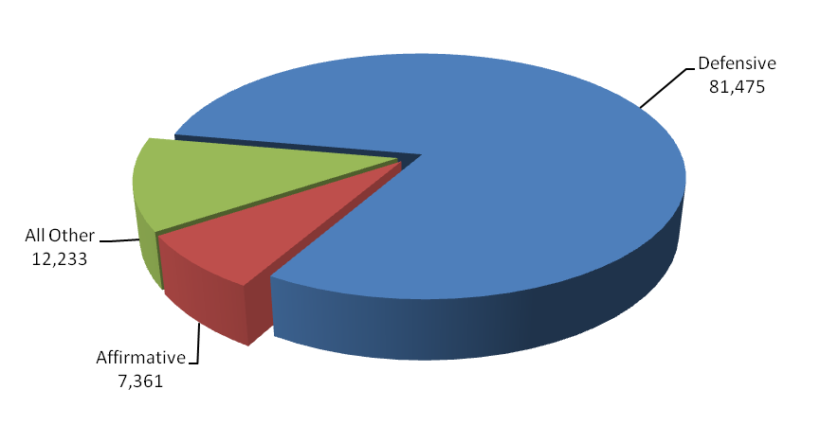

Between FY 2004 and FY 2008, the number of civil cases filed or responded to increased by
30 percent or 23,266 - from 77,803 cases to 101,069, and the number of civil cases referred to U.S. Attorneys increased by 27 percent or 23,544 - from 86,316 in FY 2004 to 109,860 cases in FY 2008. The number of defensive civil cases filed increased by 57 percent or 29,593 - from 51,882 cases in FY 2004 to 81,475 in FY 2008. A change in the interpretation of the U.S. Sentencing Guidelines in January 2005 increased the number of civil cases filed between FY 2006 and FY 2008. The number of affirmative cases filed has decreased by 2 percent or 153 - from 7,514 cases in FY 2004 to 7,361 in FY 2008.

In FY 2008, 87 percent of all judgments in affirmative civil cases were in favor of the United States, the highest favorable judgment rate of all case classes. Through affirmative litigation, the U.S. Attorneys collected $2.21 billion in civil debts owed to the United States, which is more than the U.S. Attorneys’ FY 2008 budget.

2. Performance Tables

3. Performance, Resources, and Strategies

The Civil Decision Unit contributes to the Department’s Strategic Goal II: Prevent Crime, Enforce Federal Laws and Represent the Rights and Interests of the American People. Within this goal, the Civil Decision Unit’s resources specifically address two of the Department’s Strategic Objectives: 2.6 - Uphold the civil and Constitutional rights of all Americans, and 2.7 - Vigorously enforce and represent the interests of the United States in all matters for which the Department has jurisdiction.

a. Performance Plan and Report for Outcomes
••• Mortgage Fraud At a Glance •••

In one case alone a mortgage fraud scheme resulted in 166 felony counts. The defendant in United States v. Hill was sentenced to 28 years in prison and restitution of $41.7 million. Hill was the owner and operator of numerous corporations, and held himself out to be a real estate developer, and either individually or through one or more of the corporations he controlled, purchased and sold numerous residential properties. Hill oversaw the conspiracy, loan fraud, wire and mail fraud and money laundering activity related to mortgages obtained in the sale of over 50 homes and over 250 condominiums in eight condominium complexes.

Prosecution of civil litigation is an essential and vital component of the mission of the U.S. Attorneys. Civil cases prosecute fraud, waste, and abuse in federal programs and ensure that the government is fully compensated for the losses and damages caused by those who have enriched themselves at the government’s expense. In addition, all lawsuits filed against the government must be defended. U.S. Attorneys represented the government in 81,475 defensive civil cases that were filed in court during FY 2008. The U.S. Attorneys’ successes in civil litigation preserve taxpayer dollars and uphold the requirements and intent of federal laws and programs.

The performance measure for civil litigation relates to the percentage of judgments and settlements resolved in favor of the government. The target for FY 2008 was 80 percent and the actual figure was 79.2 percent.

b. Strategies to Accomplish Outcomes

The two biggest challenges for U.S. Attorneys are to maintain a high favorable resolution rate with existing resources and for AUSAs in particular to adjust to the increased use of technology in the practice of law. Technology is providing a means to increase productivity with existing resources. However, civil cases are increasingly “electronic” – meaning that technology plays a major role in areas such as electronic filing and e-discovery. Some AUSAs and support staff have difficulty making the transition to these different approaches. Technical training and hiring employees with the appropriate skill sets are both part of the U.S. Attorneys’ strategy for the successful furtherance of our mission.

- LEGAL EDUCATION

Legal Education TOTAL | Perm. Pos. | FTE | Amount  (Dollars in Thousands
2008 Enacted | 48 | 48 | $ 19,661
2008 Supplementals | -- | -- | --
2008 Enacted and Supplementals | 48 | 48 | $ 19,661
2009 Enacted | 48 | 48 | $ 20,052
Adjustments to Base and Technical Adjustments | -- | -- | $ 687
2010 Current Services | 48 | 48 | $ 20,739
2010 Program Increases | -- | -- | 5,300
2010 Request | 48 | 48 | $ 26,039
Total Change 2009-2010 | -- | -- | $ 5,987

Legal Education —Information Technology Breakout (of Decision Unit Total) | Perm. Pos. | FTE | Amount  (Dollars in Thousands
2008 Enacted | 20 | 20 | $ 6,833
2009 Enacted | 20 | 20 | $ 7,038
2010 Adjustments to Base | -- | -- | $ 211
2010 Current Services | 20 | 20 | $ 7,249
2010 Program Increases | -- | -- | $ 0
2010 Request | 20 | 20 | $ 7,249
Total Change 2009-2010 | -- | -- | $ 211

1. Program Description–Legal Education

The Office of Legal Education (OLE) develops, conducts, and authorizes the training of all federal legal personnel [28 C.F.R. §0.22 (1990)]. OLE coordinates legal education and attorney training for the Department of Justice and other departments and agencies of the Executive Branch. Virtually all of OLE’s classroom training is conducted at the National Advocacy Center (NAC), a premier federal training facility in Columbia, South Carolina. The NAC features an integrated instructional and residential facility augmented by a conference and research center with student and support services on site.

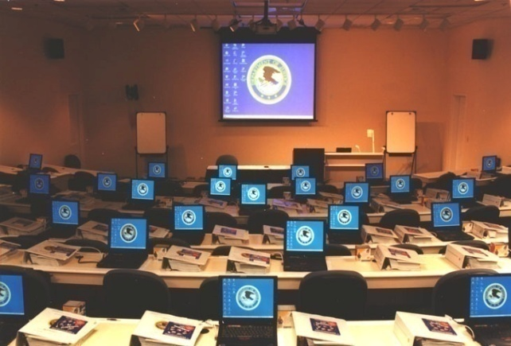
In FY 2008, OLE was responsible for the management of 286 events at the NAC, including 203 classroom events such as traditional advocacy training, national conferences, seminars, symposia and educational forums on substantive areas of the law provided. In FY 2008, approximately 23,250 individuals were trained, of which 17,500 attended live training through courses or other events hosted by OLE and 5,750 individuals received training through one of OLE’s distance education offerings, including continuing legal education programs broadcast via satellite, video-on-demand, and other means. Eighty-six percent of the 23,250 individuals, or approximately 20,000, were Justice employees in legal positions while the other 14 percent or 3,250 were non-Justice employees in legal positions with various federal agencies or state and local government. More than 6,500 individuals receiving training at the NAC attended courses in areas covered in the Department’s Strategic Plan, including Fraud and Cybercrime, Crimes Against Children, and Anti-Terrorism.


In FY 2007, OLE introduced Video on Demand (VOD), permitting users to view OLE programming “on demand” at their desktop. OLE continued to add new content to its VOD library accessed through JUSTLearn, and there are currently more than 400 programs available, including training videos on Criminal Trial Advocacy, Core Competencies in Federal Civil Law, and a New Employee Orientation video containing all of the mandatory programs new DOJ employees must view. In FY 2008, approximately 72,000 employees accessed the VOD library, viewing available videos more than 27,000 times. The “Week in Review” (WIR), a weekly series of news clips highlighting the accomplishments of the USAOs nationwide, continues to be among the more popular VOD offering with 38,260 viewers in FY 2008, up from the 22,320 viewers in FY 2007. Another new feature allows Training Officers to record in JUSTLearn other training events such as a group viewing of a Justice Television Network (JTN) show or VOD show, online courses, district-wide training, self-study, and college courses.

••• PARTNERS IN LEGAL EDUCATION •••

Since the opening of the NAC in April 1998, OLE has engaged in a collaborative effort with the National District Attorneys Association (NDAA) and the Executive Office for United States Trustees to create a premier training center that brings together federal, state, and local prosecutors to train in a state-of-the-art facility. In FY 2008, training for NDAA personnel is paid for through a grant administered by the Office of Justice Programs. During FY 2008,
1,685 people attended courses sponsored by these two training partners.

The Publications Unit of the Office of Legal Education edits and publishes the United States Attorneys’ Manual, the United States Attorneys’ Bulletin, and a number of practical skills manuals. OLE’s Publications Unit remained busy in FY 2008 with the publication of 6 editions of the United States Attorneys’ Bulletin on a variety of topics, including Asset Forfeiture, Identity Theft, Electronic Discovery, and Civil Rights, all of which are accessible on the Department of Justice intranet website. The Publications Unit continued to maintain and update the USABook Online Library, which has now grown to include hundreds of policy manuals, textbooks, and monographs and has become a federal practice encyclopedia. In FY 2008, the USABook site experienced more than 2.5 million page views, up from 1.5 million in FY 2007.
OLE initiated the JTN during FY 2001. JTN is a satellite-based system that provides training and news to the 94 USAOs, as well as branch offices. The JTN schedule includes 40 hours of programming each week, and a 15 hour "re-feed" to the West Coast each workday. In FY 2008, OLE provided 1,190 hours of programming through JTN. In an effort to enhance its distance learning options for USAOs, OLE developed new training modules on Appellate Advocacy, Electronic Discovery, Professional Responsibility, and Retirement Planning, and updated the Grand Jury module. A copy of each module was sent to every district in FY 2008 to be used for in-house training.

Continuing legal education (CLE) credit is provided through OLE for many OLE-sponsored courses. OLE is the primary source of instruction for Department of Justice attorneys and AUSAs from the 94 USAOs. Basic programs for newly hired attorneys include criminal, civil, and appellate advocacy; federal practice seminars; and specialty courses in priority substantive areas of the law. Advocacy skills programs are available to new and advanced trial attorneys. The Federal Practice Program is designed for attorneys with litigation experience who are new to the federal civilian legal system (e.g., former state and military prosecutors), and as continuing training for Department of Justice attorneys after the basic criminal, civil, and appellate advocacy courses. In FY 2008, OLE provided an additional 8,500 CLE programs to USAO and Department of Justice attorneys over the Internet.

OLE continued its tradition of providing training support to Department of Justice personnel assisting foreign prosecutors through the Criminal Division’s Office of Overseas Prosecutorial Development, Assistance and Training (OPDAT). OLE hosted briefings and tours of the NAC for visiting prosecutors from Korea, Qatar, Bulgaria and Indonesia.

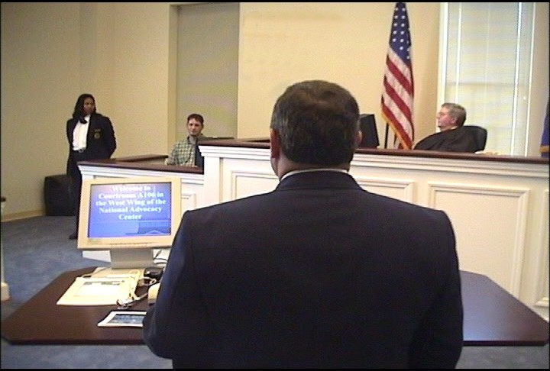
For all its programs, OLE uses experienced federal trial and appellate attorneys as instructors to present lectures, lead discussion groups, direct evidentiary exercises, and offer personalized critiques. Federal judges also participate in OLE's advocacy courses, presiding over mock trials and mock appellate arguments. The caliber of the OLE faculty and the use of sophisticated videotaping facilities provide students with unique training experiences in trial and appellate advocacy. A significant feature of the advocacy training is the use of "learn-by-doing" exercises which concentrate on courtroom skills. These exercises simulate courtroom activities and provide students with classroom critiques and individual video replay analysis. Finally, OLE is meeting the demand for attorney management training for senior criminal and civil attorneys by providing management courses for attorney supervisors of all levels.

OLE conducts programs on federal, civil, and administrative law practices for attorneys in the Executive Branch, including those in the Department of Justice. OLE offers training in civil discovery and trial techniques; negotiation techniques; and administrative law areas such as bankruptcy, the Freedom of Information Act, ethics, environmental law, federal employment, regulatory processes, government contracts, legal research and writing for attorneys, management of attorneys, and computer crime. Course instruction emphasizes the realities of federal practice. Federal attorneys from every agency, including the Department of Justice, are participants as well as advisors, curriculum developers, lecturers, and instructors. Most instructors come from a cadre of federal prosecutors. On a few occasions, OLE also contracts with professional educators as instructors for these courses.

OLE develops and administers paralegal courses covering basic and advanced skills in civil, criminal, and appellate practice. Training for other support staff personnel (e.g., legal assistants, systems managers, Administrative Officers and Budget Officers) in USAOs is provided through OLE, which develops the curriculum and recruits instructors.

2. Performance Table

3. Performance, Resources, and Strategies

The Legal Education Decision Unit contributes to the Department’s Strategic Goal I: Prevent Terrorism and Promote the Nation’s Security. Within this goal, the decision unit’s resources address three of the Department’s Strategic Objectives: 1.1 - Prevent, disrupt, and defeat terrorist operations before they occur; 1.2 - Strengthen partnerships to prevent, deter, and respond to terrorist incidents; and 1.3 - Prosecute those who have committed, or intend to commit, terrorist acts in the United States.

The Legal Education Decision Unit also contributes to Goal II: Prevent Crime, Enforce Federal Laws and Represent the Rights and Interests of the American People. Within this goal, the decision unit’s resources address five of the Department’s Strategic Objectives: 2.1 - Strengthen partnerships for safer communities and enhance the Nation’s capacity to prevent, solve, and control crime; 2.2 - Reduce the threat, incidence, and prevalence of violent crime; 2.3 - Prevent, suppress, and intervene in crimes against children; 2.4 - Reduce the threat, trafficking, use, and related violence of illegal drugs; 2.5 - Combat public and corporate corruption, fraud, economic crime, and cybercrime; 2.6 - Uphold the civil and constitutional rights of all Americans; and 2.7 - Vigorously enforce and represent the interests of the United States in all matters for which the Department has jurisdiction.

a. Performance Plan and Report for Outcomes

The performance measure for this decision unit is the number of students trained. In FY 2008, OLE sponsored classroom training and other live events for 17,500 students. In addition, approximately 5,750 students were trained via satellite, videotape, and other means, for a total of 23,250 students trained in FY 2008.
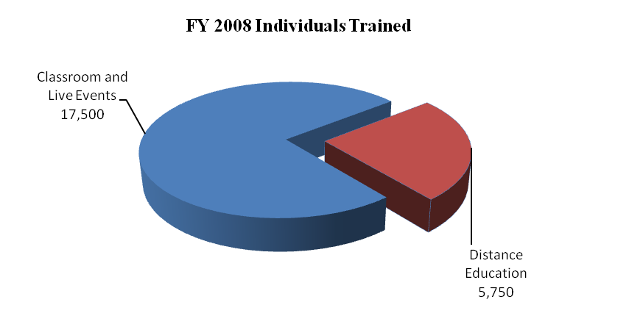
This compares with a total of 25,280 in FY 2007 – 16,215 students trained in-person and 9,065 students trained by satellite, videotape and other training. Eighty-six percent of the 23,250 individuals were Department of Justice employees in legal positions while the other 14 percent were non-Department of Justice employees in legal positions with various federal agencies or state and local government. OLE anticipates training a total of 25,000 students in each of
FYs 2009 and 2010 in combined classroom, satellite and other training.
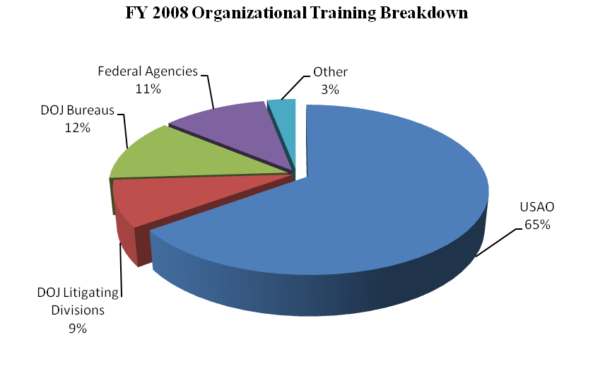

DOJ DIV = DOJ Litigative Divisions
DOJ BUREAUS = FBI, DEA, ATF, BOP, NSD, etc
OTHER = State and Local
FED AGENCIES = DOD, HHS, DHS, USPS, etc

More than 6,500 of the participants receiving OLE training at the NAC attended courses in topical areas covered in the Department’s Strategic Plan, including Fraud and Cybercrime, Crimes Against Children, and Anti-Terrorism.

Overall in FY 2008, OLE was responsible for the management of 286 events, including traditional advocacy training, national conferences, seminars, symposia, and educational forums on substantive areas of the law. During FY 2008, OLE expanded VOD and approximately 72,000 individuals accessed the VOD library viewing available programs more than 27,000 times. There are now over 400 separate programs available through VOD. Additionally, during FY 2008, 1,685 people attended courses sponsored by OLE’s two training partners, the NDAA and the National Bankruptcy Training Institute.

b. Strategies to Accomplish Outcomes

The U.S. Attorneys will continue to ensure that high quality legal education is available for basic and advanced legal training through traditional classroom instruction and expanded use of JTN and distance learning. Additional training will be needed to support the requested Illegal Immigration and Southwest Border Enforcement Initiative and Combating Financial Fraud and Protecting the Federal Fisc Initiative.

4. Program Increase

Item Name: National Advocacy Center

Budget Decision Unit(s): Office of Legal Education

Strategic Goal(s) & Objective(s): Goal I: Prevent terrorism and promote the nation’s security.
Goal II: Prevent crime, enforce federal laws, and represent the rights and interests of the American people.

Component Ranking of Item: 3

Program Increase: Positions 0 Atty 0 FTE 0 Dollars $5,300,000

Description of Item

In FY 2010, the United States Attorneys request $5,300,000 (all non-personnel) for upgrades associated with the expansion of the National Advocacy Center (NAC) located in Columbia, South Carolina, on the University of South Carolina (USC) campus. These upgrades are above and beyond what is being provided by USC during the renovation phase of the Close-Hipp Building. The expansion of the NAC facility was presented in the Congressional Relocation Report (CRR) submitted by the Department of Justice (DOJ) on March 24, 2009.

Justification

The Executive Office for United States Attorneys’ (EOUSA) Office of Legal Education’s (OLE) mission is to “develop, conduct and authorize the training of all federal legal personnel.” Under 28 CFR 0.22 c., OLE serves as the primary training office for DOJ, particularly the United States Attorneys’ Offices (USAOs). OLE also trains employees from other federal, state, and local agencies. In addition, the NAC is home to the National District Attorney’s Association and the National Bankruptcy Training Institute. In FY 2006, in addition to the normal training requirements, the Congress passed legislation requiring DOJ components (absent a waiver) to conduct all training in government facilities, which has greatly increased the demand for NAC facilities. As a result, the NAC has been unable to meet all of the requests for training from DOJ components and other federal agencies due to limitations on the availability of classrooms, courtrooms, computer labs and meeting space.

The NAC was designed as a residential education facility tailored to meet the training needs of our nation’s prosecutors and support staff. The current facility contains 262,000 square feet of space, including two advocacy suites with associated lecture halls, 10 courtrooms, video control rooms, conference rooms, three large lecture halls, a multi-purpose assembly room, two computer labs, a video production studio, and other specialized space for training. The NAC also has a residential and dining component. Over the years, the Department has enjoyed a history of partnership and expansion with USC, including the opening of an Information Technology Education Center and additional residential facilities to accommodate demand.

Through the CRR submission, the Department proposed an expansion of the NAC and the relocation of several administrative functions from the District of Columbia to the NAC. As a result of the proposed expansion and relocation, EOUSA expects to achieve the following benefits: the creation of a Continuity of Operations (COOP) site for EOUSA; co-location of the USAO in South Carolina (USAO-SC) with the NAC; and the expansion of NAC operations to meet increasing training demands. The specific EOUSA functions to be relocated are: Operations, which consists of Personnel, Facilities, Procurement, Security, District Assistance Program, and Employee Assistance staffs; and Information Technology, which consists of the Office Automation, Telecommunications and Technology Development, Information Security, and Case Management staffs.

Working with USC, the Department has negotiated the use of the Close-Hipp Office Building located immediately adjacent to the current NAC. The building will provide approximately 326,000 additional rentable square feet of space for a term of 20 years. Beginning in FY 2010, renovations of the Close-Hipp Building will begin. The renovation phase is expected to take three years to complete and will be funded largely through a tenant improvement allowance provided by the University.

During the three year renovation period – FY 2010 through 2012, the United States Attorneys request $5.3 million to pay for additional upgrades to the building. The upgrades include significant security enhancements not included in the USC tenant improvement allowance. Because the Close-Hipp Building will be part of EOUSA’s COOP site and house the USAO-SC, additional security enhancements will be critically important. Additional upgrades to the building also include unique space configurations for auditoriums and some special classroom facilities. These unique configurations will allow the NAC to accommodate larger conferences and groups.

Physical security for prosecutors and other judicial officers is a growing issue as a result of the potential threat posed by terrorists and others who wish to do harm to the United States Attorney community. The security and safety of prosecutors and their support staff is of critical importance. The security upgrades will include the 1) requisite physical security improvements dictated by security threat assessments undertaken to determine the vulnerabilities that exist wherever USAOs are located; 2) the construction and equipment for an accredited Sensitive Compartmentalized Information Facility (SCIF) at the NAC to store, handle and protect highly classified information; and 3) a secure mailroom which will provide a separate, filtered ventilating system to secure the environment for opening and processing mail. Once the Close-Hipp Building is occupied in FY 2013, the requested $5.3 million will be used to fund annual rent costs at an agreed upon rate of $16.25 per rentable square foot.

The additional space will provide the NAC the ability to increase the number of students trained and the capacity to meet the ever growing demand for use of the facility. The expansion will allow for additional courtrooms, classrooms, lecture halls, computer labs, and specialized training space. Larger conference areas will also be made available to meet requests to accommodate larger conferences and groups.

In addition to ensuring the continuity of EOUSA operations by permanently moving certain staffs to the USC campus location, the expansion of the NAC will enhance its currently established function as a base of operations in the event of a COOP emergency. As was demonstrated on September 11, 2001, Washington, D.C. is a likely target for those wanting to disrupt and attack our nation. EOUSA has already taken advantage of the location of the NAC to create a Network Operations Center to support network and data storage redundancy. The proposed expansion would further support the continuity of operations of USAOs nationwide in local or nationwide emergencies.

Another important aspect of the NAC’s expansion is that it provides for the additional space required for EOUSA's Litigation Technology Service Center (LTSC). The LTSC provides "Litigation Technology" services for USAO projects involving paper and/or Electronic Data Discovery. The Federal Rules of Civil Procedure were amended in December 2006 to make all Electronically Stored Information discoverable. Criminal cases are also engaging in eDiscovery – even absent court Rules. Because discovery is often law enforcement sensitive and privileged (e.g., Grand Jury, Privacy Act, Tax), it must be handled in a secure setting by staff with appropriate security clearances and no conflicts of interest. The LTSC provides this technology service and is a consolidated, centralized facility that brings a standardized approach to litigation technology needs and work product to all 94 districts and provides a secure, cost effective and efficient response to the litigation needs of the USAOs. With demand for LTSC’s services increasing, additional space is required to meet the litigation technology requirements of all 94 districts.

Further, the NAC expansion envisions the relocation of the USAO-SC already located in Columbia, South Carolina, to the expansion space on the USC campus. This consolidation of office space provides numerous benefits such as alleviating security concerns with the existing office arrangement by providing controlled access for appropriate personnel, and gaining economies of scale by sharing computer space, a copy center and other information technology and operational services with the co-located IT staffs from EOUSA at the NAC.

Impact on Performance

This initiative will address Strategic Goal I, Prevent terrorism and promote the nation’s security and Goal II, Prevent crime, enforce federal laws, and represent the rights and interests of the American people.

The expansion of the National Advocacy Center will allow EOUSA to keep pace with current and future demands for training of all federal legal personnel, ensure the continuity of EOUSA operations, and achieve efficiencies by co-locating office space at the NAC. This project represents the perfect synergy of good government – it improves the efficiency and effectiveness of our operations at a lower cost, provides additional space, and expands our successful partnership with the University of South Carolina.

National Advocacy Center

Base Funding

FY 2008 Enacted |  |  |  | FY 2009 Enacted |  |  |  | FY 2010 Current Services
Pos | Agt/  Atty | FTE | Dollars | Pos | Agt/  Atty | FTE | Dollars | Pos | Agt/  Atty | FTE | Dollars
48 | 6 | 48 | $19,661 | 48 | 6 | 48 | $20,052 | 48 | 6 | 48 | $20,739

Non-Personnel Increase Cost Summary

Non-Personnel Item | Unit Cost | Quantity | FY 2010 Request | FY 2011 Net  Annualization  (Change from 2010)
Additional Upgrades to the Close-Hipp Building | N/A | N/A | $5,300,000 | $5,300,000
Total Non-Personnel | N/A | N/A | $5,300,000 | $5,300,000

Total Request for this Item

 | Pos | Agt/Atty | FTE | Personnel | Non-Personnel | Total
Current Services | 48 | 6 | 48 | $6,222,000 | $14,517,000 | $20,739,000
Increases | 0 | 0 | 0 | 0 | 5,300,000 | $5,300,000
Grand Total | 48 | 6 | 48 | $6,222,000 | $19,817,000 | $26,039,000

Any FY 2009 costs will be paid from unobligated balances carried forward from prior years.

V. E-Gov Initiatives

The Justice Department is fully committed to the e-Government (e-Gov) initiatives. The e-Gov initiatives serve citizens, business, and federal employees by delivering high quality services more efficiently at a lower price. The Department is in varying stages of implementing e-Gov solutions and services including initiatives focused on integrating government- wide transactions, processes, standards adoption, and consolidation of administrative systems that are necessary tools for agency administration, but are not core to Department of Justice’s mission. To ensure that Department of Justice obtains value from the various initiatives, the Department actively participates in the governance bodies that direct the initiatives and we communicate regularly with the other federal agencies that are serving as the “Managing Partners” to ensure that the initiatives meet the needs of the Department and its customers. The Department believes that working with other agencies to implement common or consolidated solutions will help reduce the funding requirements for administrative and public-facing systems, thereby allowing focus on more of our limited resources for higher priority, mission related needs. The Department’s contributions to the Administration’s e-Gov projects will facilitate achievement of this objective.

a. Funding and Costs

The Department of Justice participates in the following e-Gov initiatives and Lines of Business (LoB):
Business Gateway | e-Travel | Integrated Acquisition Environment | Case Management LoB
Disaster Assistance Improvement | Federal Asset Sales | IAE – Loans & Grants – Dunn & Bradstreet | Geospatial LoB
Disaster Assistance Improvement Plan – Capacity Surge | Geospatial One-Stop | Financial Management LoB | Budget Formulation and Execution LoB
e-Authentication | GovBenefits.gov | Human Resources LoB | IT Infrastructure LoB
e-Rulemaking | Grants.gov | Grants Management LoB
e-Gov Initiatives and Lines of Business (LoB)

The Department of Justice e-Gov expenses – i.e. Department of Justice’s share of e-Gov initiatives managed by other federal agencies – are paid for from the Department’s Working Capital Fund (WCF). These costs, along with other internal e-Gov related expenses (oversight and administrative expenses such as salaries, rent, etc.) are reimbursed by the components to the WCF. The U. S. Attorneys reimbursement amount is based on the anticipated or realized benefits from an e-Gov initiative. The table below identifies the U.S. Attorneys’ actual or
planned reimbursement to the Department’s WCF. As such, our reimbursement to the WCF was $2,109,000 for FY 2008. The anticipated U.S. Attorney e-Gov reimbursement to WCF is $765,000 for FY 2009.

b. Benefits
The U.S. Attorneys established baseline cost estimates for each IT investment being modified, replaced, or retired due to the Department’s use of an e-Gov or Line of Business initiative. The U.S. Attorneys are measuring actual costs of these investments on an ongoing basis. As the U.S. Attorneys complete migrations to common solutions provided by an e-Gov or Line of Business initiative, the U.S. Attorneys expect to realize cost savings or avoidance through retirement or replacement of legacy systems and/or decreased operational costs. The list below represents only those e-Gov initiatives and Lines of Businesses where cost benefits are expected to be realized.
Litigation Case Management Systems (LCMS). The Justice Management Division is developing and implementing a Department-wide case management system which will replace EOUSA’s legacy systems, as part of the Case Management System LoB.
e-Qip. USAOs and EOUSA are using the government-wide e-Qip system for online personnel security processing for all new hires. This saves time, reduces postage costs, and overall streamlines the process.
e-HR. EOUSA awarded a contract to procure automated systems for recruitment and staffing, as well as on-boarding. OPM’s USAStaffing system will allow candidates to apply on-line, submit all necessary documents on-line, and receive notification regarding receipt of application and status reports. In addition, the system will be used to evaluate candidates, generate certificates of eligibles, and provide selecting officials with on-line access to applications. As a result, we will be able to streamline recruitment and hiring, deliver high quality service, and support the Pledge to Applicants. The HRWorx’s On-Boarding System will provide for automated offer letters and reporting instructions, as well as allow new employees to enter data required to populate multiple accession forms. The data and forms collected will be archived in preparation for another major human resources E-Gov initiative, electronic Official Personnel Folders
e-Travel. USAOs and EOUSA piggy back on a Department-wide contract with a travel provider to book their airline tickets, hotel reservations, and car rentals and substantial savings are associated with the on-line booking feature.

.

VI. EXHIBITS

The financial fraud enhancement crosses both the Criminal and Civil decision units. Exhibit C displays the distribution of the enhancement across the decision units. For clarity, the justification is discussed entirely in this section.

