United States Marshals Service
FY 2011 Performance Budget
Congressional Submission

Justice Prisoner and Alien Transportation System
Revolving Fund



January 2010

Table of Contents

I. Overview of the Justice Prisoner and Alien Transportation System (JPATS) 3
II. Summary of Program Changes 3
A. Justice Prisoner and Alien Transportation System 3
1. Program Description 3
2. Performance Tables 3
3. Performance, Resources, and Strategies 3
a. Performance Plan and Report for Outcomes 3
b. Strategies to Accomplish Outcomes 3

A. Organizational Chart
B. Summary of Requirements
C. Program Increases by Decision Unit
D. Resources by DOJ Strategic Goal/Objective
E. Justification for Base Adjustments (N/A)
F. Crosswalk of 2008 Availability
G. Crosswalk of 2009 Availability (N/A)
H. Summary of Reimbursable Resources
I. Detail of Permanent Positions by Category
J. Financial Analysis of Program Increases/Offsets (N/A)
K. Summary of Requirements by Grade
L. Summary of Requirements by Object Class
M. Status of Congressionally Requested Studies, Reports, and Evaluations (N/A)
N. Schedule of Aircraft

I. Overview of the Justice Prisoner and Alien Transportation System (JPATS)

A. Introduction

JPATS was created on October 1, 1995, by merging the USMS National Prisoner Transportation System and Immigration and Naturalization Service (INS) Air Transport Branch. This merger was based on an August 15, 1994 memorandum in which the Attorney General directed the consolidation [by FY 1996] of the prisoner and detainee air transportation functions that were being performed by the USMS and INS into a single entity to be managed by the USMS. The JPATS mission is to transport federal detainees and prisoners, including pretrial, sentenced, and deportable aliens, whether in the custody of the USMS, Bureau of Prisons (BOP), or Immigration and Customs Enforcement (ICE). JPATS also provides prisoner transportation for the Department of Defense (DOD), state, and local law enforcement agencies on a reimbursable, space-available basis. JPATS transports prisoners and detainees in a cost-effective manner without sacrificing the safety of the public, federal employees, or those in custody.

In 1997, Coopers & Lybrand prepared a JPATS 5-Year Strategic Plan that included a recommendation that JPATS be funded through a revolving fund to allow flexibility in its financial planning, operational decision-making, and the delivery of services. On October 1, 1998, JPATS began operating as a revolving fund activity with the goal of having all operating costs reimbursed by customer agencies. The benefits of the JPATS revolving fund are: 1) it is a no-year account with a consistent funding stream from the customer agencies, thus not subject to Continuing Resolution restrictions; 2) it operates under the concept of full-cost recovery; 3) it provides for multi-year funding/leasing authority for capital acquisitions; and 4) it has authority to retain proceeds from the disposal of JPATS aircraft and parts. The JPATS Revolving Fund provides stability in costs to the customer agencies since the fund can absorb, on a short-time basis, cost fluctuations for operating expenses such as fuel and major aircraft maintenance. It also simplifies the task of replacing aircraft and obtaining major aircraft parts by enabling managers to extend the cost of equipment purchases or equipment leases over several years, and to plan the procurement of equipment, or equipment lease agreements when needed, rather than waiting for available, appropriated funding.

JPATS receives compulsory guidance from the General Services Administration (GSA), which is charged with monitoring the effective use of all government aircraft in accordance with Office of Management and Budget (OMB) requirements. JPATS follows GSA directives with assistance from Justice Management Division’s (JMD) Facilities and Administrative Services Staff (FASS), a member of GSA’s Interagency Committee for Aviation Policy (ICAP). FASS serves as an effective intermediary between JPATS and GSA, passing along technical and operational advice from GSA-ICAP to JPATS, while transmitting JPATS data to GSA through the Federal Aviation Interactive Reporting System (FAIRS). ICAP provides direct assistance to JPATS through programs like the ICAP Aviation Resources Management (ARMS), which engages professional aviators from other government programs in safety reviews of JPATS operations. The ARMS program offers a comprehensive survey, on request, of an agency's flight program (management/administration, operations, maintenance, safety, and training). GSA puts together a team of aviation experts, which generally spends about two weeks on-site with the requesting agency's aviation program. JPATS completed an ARMS review in December 2007.
JPATS adheres to all of the Federal Aviation Administration (FAA) public sector aviation rules and regulations regarding aviation safety, operations, and maintenance. JPATS is an organizational component within the USMS with the Assistant Director for JPATS reporting to the Associate Director for Operations of the USMS. USMS was both management and customer for JPATS since its inception in FY 1996 until FY 2006. In FY 2007, USMS Salaries and Expenses funding for prisoner transportation was transferred to the Office of the Federal Detention Trustee (OFDT). OFDT’s control of funds for both detention and transportation is expected to result in greater cost efficiencies. The JPATS Revolving Fund budget reflects the anticipated revenue and expenditures that are related to the movement of detainees and prisoners. Program funding requirements are identified in the budget submission of each customer agency.

B. Issues, Outcomes, and Strategies

JPATS coordinates with the OFDT, USMS, ICE, and BOP to ensure that:

- Detainees, prisoners, and deportable aliens are transported and detained in a cost effective manner, utilizing procedures that safeguard USMS personnel and the public.
- Persons in custody reach their destinations in a timely manner.

JPATS is currently utilizing a long-term leasing strategy that provides increased aircraft reliability, fuel efficiency, and prisoner capacity in the large aircraft leased for all JPATS operations. These leased aircraft are operating at the following locations: two at Mesa, Arizona; two at Alexandria, Louisiana; and two at Oklahoma City, Oklahoma. In addition, JPATS is establishing a Blanket Purchase Agreement (BPA) with GSA for the dry and wet lease of additional aircraft to supplement customer transportation needs. This BPA will provide the option to lease any size aircraft. This short-term aircraft lease will be awarded in FY2010 and will provide increased operational flexibility to meet changes in customer requirements.

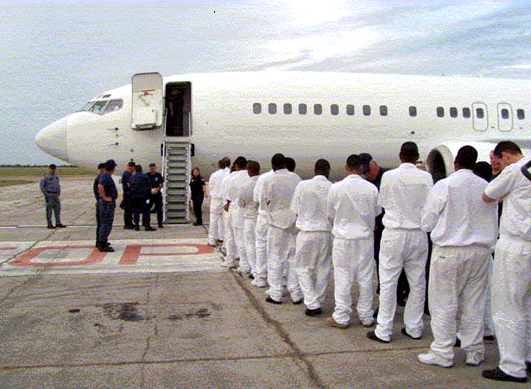

The Oklahoma City hangar has two years remaining on its lease. The annual lease payment is approximately $1 million. Since OMB Circular A-11 requires agencies to reserve sufficient budgetary authority equal to the net present value of the Government’s total estimated legal obligations over the life of a lease, JPATS obligated $4 million from retained earnings in
FY 2007 to cover the remaining years of the lease. This action corrected a non-compliance issue identified in the financial audit.

The following is a brief summary of the Department’s Strategic Goal and Objective supported by JPATS.

DOJ Strategic Goal III: Ensure the Fair and Efficient Operation of the Federal Justice System

- Protect judges, witnesses, and other participants in federal proceedings, and ensure the appearance of criminal defendants for judicial proceedings or confinement (Goal III, Objective 3.1)

JPATS supports the DOJ Strategic Plan by moving prisoners and aliens as quickly, safely, and as cost effectively as possible. The following chart shows the actual and projected levels of air transportation movements and flight hours for all JPATS customer agencies from FY 2003 to
FY 2011:

Fiscal Year | Air Movements | Flight Hours
2003 | 175,220 | 11,635
2004 | 176,519 | 11,746
2005 | 181,951 | 10,512
2006 | 213,138 | 11,674
2007 | 244,137 | 14,069
2008 | 229,392 | 13,171
2009 | 196,524 | 10,524
2010 (Est) | 213,335 | 10,100
2011 (Est) | 214,709 | 10,825

.

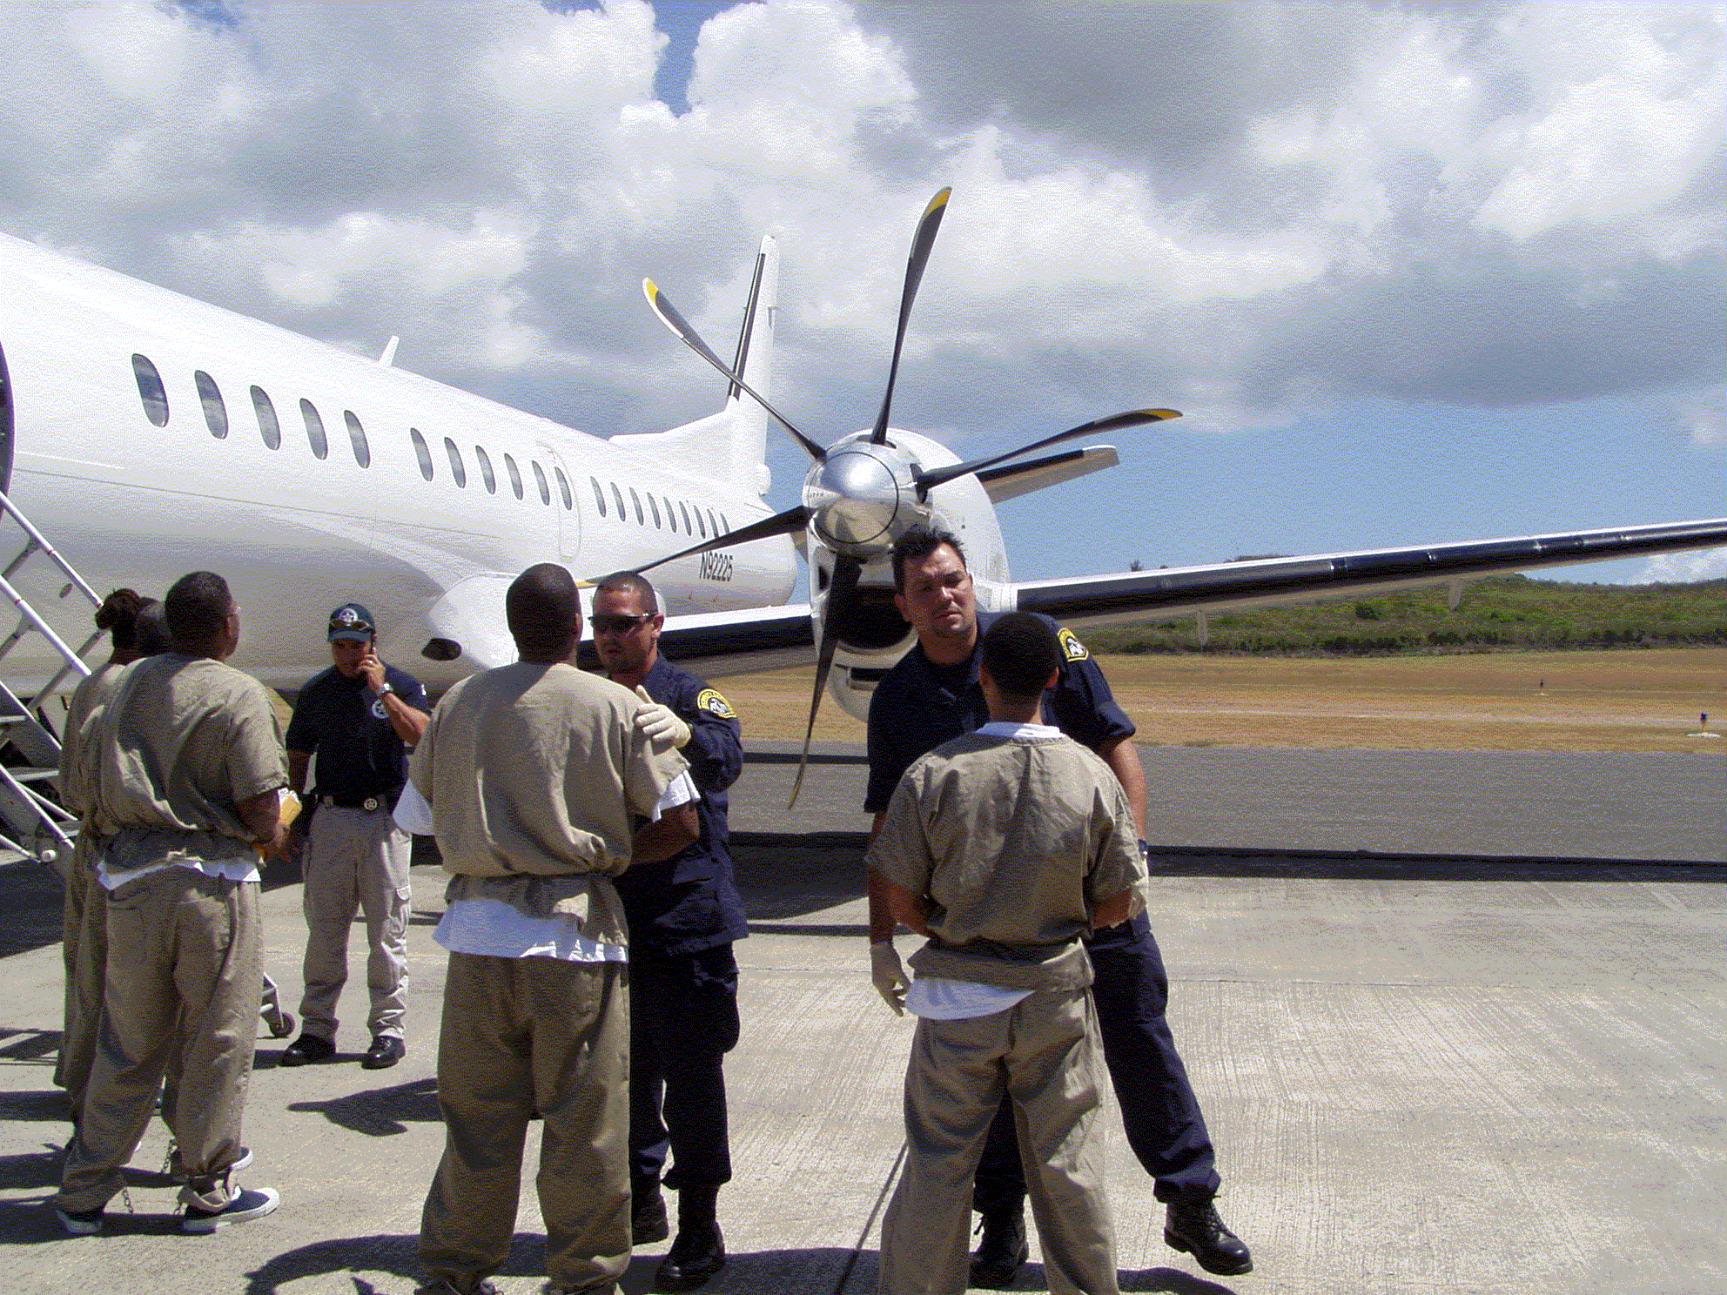

C. Full Program Costs

On October 1, 1998, JPATS began operating as a revolving fund activity with total operating costs being reimbursed by customer agencies. A price-per-flying-hour methodology was developed by the JPATS Business Office in conjunction with financial and operational staff members from the Justice Management Division (JMD), BOP, ICE, and the USMS. This methodology was implemented in 2002, and replaced the price-per-movement methodology that was used during the first 3 years of JPATS operation. The goal was to develop an accurate, fair, and equitable pricing methodology for all agencies with full cost recovery. This was accomplished by following OMB Circular A-126 guidelines that identify fixed and variable cost categories and by establishing specific prices-per-flying-hour for JPATS customers. Using this methodology, fixed and variable costs were identified by large and small aircraft. JPATS budget projections have incorporated an additional tool known as “activity based costing” to further refine the accuracy of customer pricing initiatives begun in FY 2002. In FY 2006, the methodology was further refined to a price-per-flight-hour-per-seat basis. Customers are billed based on the number of flight hours and the number of seats they actually utilize to move their prisoners/detainees. Aircraft usage requirement projections are provided by the customer agencies prior to the beginning of the budget cycle.

D. Performance Challenges

JPATS faces a variety of challenges in accomplishing its mission. These challenges fall into two broad categories:

External Challenges

The JPATS aviation program is subject to a variety of influences and regulations external to the Department of Justice. JPATS workload is generated by other federal agencies, particularly Department of Homeland Security (DHS) due to immigration related prisoner movements, and the federal Judiciary. JPATS determines the schedule to move prisoners based on the appearance dates specified in court orders.

JPATS must continually anticipate customer needs into the future. During FY09 customer requirements were adjusted significantly, causing the planned Alaska operation to be placed on indefinite hold. In addition, planned increases for ICE alien deportation flights did not materialize, resulting in a cancellation of the San Antonio operation. During FY2010 and FY2011, we anticipate that customer requirements will stabilize with variable increases based upon JPATS’ augmented aircraft availability and operational flexibility realized by the establishment of the short term aircraft BPA.

Internal Challenges

The greatest internal challenge is ensuring the safety of the aircraft, staff, and prisoners/detainees. A Safety Officer and a formal safety program are in place to meet this challenge. The Safety Officer provides constant monitoring of the aviation program and conducts numerous training sessions each year to help JPATS continue to meet its high standards of aviation safety.

A second significant internal challenge is ensuring that JPATS has access to an adequate number of aircraft to meet customer demands. When a leased aircraft requires maintenance, the aircraft leasing company must locate a replacement aircraft for the scheduled mission. If a replacement aircraft cannot be immediately located, or if a JPATS-owned aircraft requires unscheduled maintenance, JPATS either locates another leased aircraft or reschedules the mission. The acquisition strategy of leasing newer, more reliable aircraft will increase the operational readiness of the air fleet, reducing unscheduled downtime and enabling JPATS to meet customer missions.

A third internal challenge is appropriately staffing each scheduled flight with flight personnel/security officers to secure the prisoners/detainees being transported, to include a Public Health Service (PHS) nurse or contracted medical support to attend to any urgent health issues. JPATS now provides ground security at all airlift stops for the loading and transferring of prisoners/detainees, historically provided by USMS, BOP, and ICE personnel. Through a standardized training program and the use of standardized weapons, these specialized security personnel strengthen the safety of prisoner movements. Meeting these challenges will ensure that the JPATS missions will fly as scheduled in the safest manner possible.

II. Summary of Program Changes

Item Name | Description |  |  |  | Pages
Item Name |  | Pos. | FTE | Dollars ($000) | Pages
Customer Requirements |  |  |  | $4,237 | 4,8,9
Inflation factor of 2% |  |  |  | $2,705 | 9
Total |  |  |  | $6,942
.

III. Appropriation Language and Analysis of Appropriations Language (N/A)

Not applicable because the JPATS Revolving Fund is not an appropriated account.
IV. Decision Unit Justification

A. Justice Prisoner and Alien Transportation System

Justice Prisoner and Alien Transportation System – TOTAL | Perm. Pos. | FTE | Amount ($000)
2009 Operating Level | 249 | 249 | 119,774
2010 Adjustments to Base and Technical Adjustments | (53) | (53) | (5,042)
2010 Changes to Operating Level | 0 | 0 | 20,520
2010 Operating Level | 196 | 196 | 135,252
2011 Changes to Operating Level | 0 | 0 | 6,942
2011 Operating Level | 196 | 196 | 142,194
Total Change 2010-2011 | 0 | 0 | 6,942

1. Program Description

JPATS moves federal prisoners and detainees by air, including sentenced, pretrial and deportable aliens, whether in the custody of the U.S. Marshals Service (USMS), Bureau of Prisons (BOP), or Bureau of Immigration and Customs Enforcement (ICE). JPATS also transports Department of Defense and state and local prisoners on a reimbursable, space-available basis. The JPATS goal is to move prisoners and deportable aliens safely and securely, in the most cost efficient manner possible.

Customer agencies provide projected aircraft utilization requirements. JPATS estimates non-federal requirements based on historical data. Due to changes in customer requirements, JPATS has cancelled plans for a hub in the southwest and Alaska. The corresponding increase to JPATS FTE is no longer a requirement for FY09. Commensurate adjustments were made to the April 2009 Congressional Submission. The FY2011 program reflects an inflation factor and program adjustments to support an increase to customer requirements. The advent of Blanket Purchase Agreement (BPA) with GSA for the dry and wet lease of additional aircraft will offer greater operational flexibilities to supplement customer transportation needs.

JPATS is committed to ensuring that each scheduled flight is staffed with qualified flight personnel to safely operate each aircraft, that adequate security officers are present to ensure the safety of the detainees/prisoners being transported, and that at least one Public Health Service (PHS) nurse or contracted medical support is present for any medical emergency. In response to current and projected external influences and to safely and efficiently satisfy service demands, JPATS operational support FTE will remain at 196 FTE for FY 2011. The chart below shows the projected personnel requirements by location in FY 2011:

Proposed Personnel Requirements by Location
 | Alexandria, LA | Kansas City, MO | Oklahoma City, OK | Phoenix, AZ | Puerto Rico | Totals
JPATS Total | 35 | 57 | 58 | 32 | 14 | 196

2. Performance Tables
PERFORMANCE AND RESOURCES TABLE
Decision Unit: Justice Prisoner and Alien Transportation System
DOJ Strategic Goal/Objective: III: Ensure the Fair and Efficient Operation of the Federal Justice System. 3.1 Protect judges, witnesses, and other participants in federal proceedings, and ensure the appearance of criminal defendants for judicial proceedings or confinement.
WORKLOAD/ RESOURCES |  | Final Target |  | Actual |  | Projected |  |  |  | Changes |  | Requested (Total)
 |  | FY 2009 |  | FY 2009 |  | 2010 President’s Budget |  |  |  | Current Services Adjustments and FY 2010 Program |  | FY 2011 Request
1. Number of requests for transportation of prisoners |  | 223,786 |  | 219,478 |  | 223,786 |  |  |  | 24,078 |  | 247,864
Total Costs and FTE (reimbursable FTE are included, but reimbursable costs are bracketed and not included in the total |  | FTE | $000 | FTE | $000 | FTE | $000 |  |  | FTE | $000 | FTE | $000
 |  | 249 | $159,422 | 196 | $119,774 | 196 | $135,252 |  |  | 0 | $6,942 | 196 | $142,194
TYPE/ STRATEGIC OBJECTIVE | PERFORMANCE | FY 2009 |  | FY 2009 |  | 2010 Requirements |  |  |  | Current Services Adjustments and FY 2011 Program |  | FY 2011 Request
Program Activity |  | FTE | $000 | FTE | $0 | FTE | $000 |  |  | FTE | $000 | FTE | $000
Program Activity | 1. Prisoner Movement | 249 | $159,422 | 196 | $119,774 | 196 | $135,252 |  |  | 0 | $6,942 | 196 | $142,194
Performance Measure | 1. Number of prisoner and detainee air movements accomplished. | 213,335 |  | 196,524 |  | 213,335 |  |  |  | 1,374 |  | 214,709
Performance Measure | 2. Number of hours to accomplish air movements. | 10,100 |  | 10,524 |  | 10,100 |  |  |  | 725 |  | 10,825
Efficiency Measure | 3. Average cost per hour for large aircraft. | $9,800 |  | $10,335 |  | $9,800 |  |  |  | $2,400 |  | $12,200
Efficiency Measure | 4. Average cost per hour for small aircraft. | $5,600 |  | $5,204 |  | $5,600 |  |  |  | $800 |  | $6,400
Efficiency Measure | 5. Average age of JPATS owned (in use) aircraft (years). | 24 |  | 22 |  | 25 |  |  |  | 1 |  | 26
Performance Measure | 6. Percent of time JPATS owned aircraft not available to fly due to unscheduled maintenance | 3.8% |  | 2.6% |  | 3.8% |  |  |  | 0 |  | 3.8%
Performance Measure | 7. Number of:
Performance Measure | a. Incidents on JPATS movements | 0 |  | 1 |  | 0 |  |  |  | 0 |  | 0
Performance Measure | b. Injuries on JPATS aircraft
Performance Measure | i. Prisoner injuries | 0 |  | 0 |  | 0 |  |  |  | 0 |  | 0
Performance Measure | ii. JPATS personnel injuries | 0 |  | 0 |  | 0 |  |  |  | 0 |  | 0
Outcome Measures | 8. Number of:
Outcome Measures | a. Accidents involving JPATS aircraft | 0 |  | 0 |  | 0 |  |  |  | 0 |  | 0
Outcome Measures | b. Escapes from JPATS aircraft | 0 |  | 0 |  | 0 |  |  |  | 0 |  | 0

A. Definition of Terms or explanations for Indicators.

Workload:
1. JPATS receives requests to move prisoners and determines the appropriate mode of transportation (i.e., ground and/or air movement). JPATS uses the Automated Prisoner Scheduling System (APSS), a module within the Justice Detainee Information System (JDIS), to schedule and track movements electronically.

Performance Measures:
1. The number of air movements accomplished using JPATS owned or leased aircraft.
2. Represents the number of flight hours accomplished. Customer agencies provide estimated flight hours for budget development.
3. Represents the average cost-per-hour for large (75-140 passengers) aircraft. Individual prices for cost-per-hour were developed for each customer. Prior to setting outyear targets, JPATS requests customer projection of services required (how many flight hours needed). Further, the analysis performed to project future costs includes the inflationary factors for employee pay raises and the escalating costs for non-labor categories such as aircraft leases, space rental, the market price for fuel, and other supplies.
4. Represents the average cost-per-hour for small (8-50 passengers) aircraft. Individual prices for cost-per-hour were developed for each location utilizing activity based costing methodology. Prior to setting outyear targets, JPATS requests customer projection of services required (how many flight hours needed). Further, the analysis performed to project future costs includes the escalating costs mentioned above in #3.
5. Depicts the average age of owned aircraft in the JPATS fleet. Aircraft that are beyond economical repair and sold are excluded from the fleet’s average age. As the aircraft age, the cost to maintain increases and availability decreases due to increased maintenance required.
6. Unscheduled maintenance causes decreased ability to meet mission goals along with increased operating costs.
7 and 8. Incident reports are filled out and tracked whenever a critical event occurs, such as a prisoner escape or flight accident.

B. Factors Affecting FY 2009 Program Performance.
The plan to establish begin a new operation in Alaska during FY2009 was placed on indefinite hold and has been withdrawn from the FY 2010 budget. A new location proposed for the southwest also in FY 2009, has been cancelled. The request was initially submitted to accommodate increased alien movements for ICE. Both events, in turn, have impacted performance targets. Targets were adjusted in the April 2009 Congressional Submission.

C. Factors Affecting FY 2010 and FY 2011 Plans.

The plan to establish a new operation in Alaska during FY2009 was placed on indefinite hold and has been withdrawn from the FY 2010 budget. A new location proposed for the southwest also in FY 2009, has been cancelled. The request was initially submitted to accommodate increased alien movements for ICE. Commensurate adjustments were made to the April 2009 Congressional Submission. The FY2011 program reflects an inflation factor and program adjustments to support an increase to customer requirements. The advent of Blanket Purchase Agreement (BPA) with GSA for the dry and wet lease of additional aircraft will offer greater operational flexibilities to supplement customer transportation needs. Current trends in cost and flight hours indicate that the cost per flight hour for both large and small aircraft target were set too low for FY2010, requiring re-evaluation and adjustments for FY2011 reporting.

PERFORMANCE MEASURE TABLE

Decision Unit: Justice Prisoner and Alien Transportation System
Decision Unit: Justice Prisoner and Alien Transportation System |  | FY 2002 | FY 2003 | FY 2004 | FY 2005 | FY 2006 | FY 2007 | FY 2008 | FY 2009 | FY 2009 | FY 2010 | FY 2011
 |  | Actual | Actual | Actual | Actual | Actual | Actual | Actual | Target | Actual | Target | Target
Performance Measure | Number of prisoner and detainee air movements accomplished. | 162,695 | 175,220 | 176,519 | 181,951 | 213,138 | 244,137 | 229,392 | 213,335 | 196,524 | 213,335 |  | 214,709
Performance Measure | Number of hours to accomplish air movements. | 11,363 | 11,635 | 11,746 | 10,512 | 11,674 | 14,069 | 13,171 | 10,100 | 10,524 | 10,100 |  | 10,825
Efficiency Measure | Average cost per hour for large aircraft. | $8,385 | $7,522 | $7,999 | $8,542 | $8,642 | $8,406 | $10,568 | $9,800 | $10,335 | $9,800 |  | $12,200
Efficiency Measure | Average cost per hour for small aircraft. | $3,712 | $3,181 | $4,062 | $3,939 | $5,327 | $4,680 | $5,694 | $5,600 | $5,204 | $5,600 |  | $6,400
Efficiency Measure | Average age of JPATS owned (in use) aircraft (years). | 25 | 14 | 22 | 24 | 21 | 21 | 22 | 24 | 22 | 25 |  | 26
Performance Measure | Percent of time JPATS owned aircraft not available to fly due to unscheduled maintenance | 10.0% | 4.0% | 4.0% | 4.0% | 4.0% | 4.0% | 2.5% | 3.8% | 2.6% | 3.8% |  | 3.8%
Performance Measure | Incidents on JPATS movements | 0 | 0 | 1 | 2 | 0 | 1 | 0 | 0 | 1 | 0 |  | 0
Performance Measure | Prisoner injuries on JPATS aircraft | 0 | 0 | 0 | 0 | 0 | 0 | 0 | 0 | 0 | 0 |  | 0
Performance Measure | JPATS personnel injuries on JPATS aircraft | 6 | 3 | 0 | 2 | 0 | 0 | 0 | 0 | 0 | 0 |  | 0
Outcome Measure | Accidents involving JPATS aircraft | 0 | 0 | 0 | 1 | 0 | 0 | 0 | 0 | 0 | 0 |  | 0
Outcome Measure | Escapes From JPATS aircraft | 0 | 0 | 0 | 0 | 0 | 0 | 0 | 0 | 0 | 0 |  | 0

3. Performance, Resources, and Strategies

a. Performance Plan and Report for Outcomes

JPATS now provides ground security at all airlift stops for the loading and transferring of prisoners/detainees, historically provided by USMS, BOP, and ICE personnel. Through a standardized training program and the use of standardized weapons, these specialized security personnel strengthen the safety of prisoner movements. The designated Safety Officer provides constant monitoring of the aviation program and conducts numerous training sessions each year to help JPATS continue to meet its high standards of aviation safety. Also, the acquisition strategy of leasing newer, more reliable aircraft has increased the operational readiness of the air fleet, reducing unscheduled downtime and enabling JPATS to meet customer missions.

b. Strategies to Accomplish Outcomes

Customer program level requirements resulted in changes to both prisoner and detainee air movements and flight hours. To more accurately reflect current trends, FY 2011 targets for the following measured items have been adjusted:

- Number of prisoner and detainee air movements accomplished;
- Number of hours to accomplish air movements;
- Average cost per hour for large aircraft, and;
- Average cost per hour for small aircraft.

