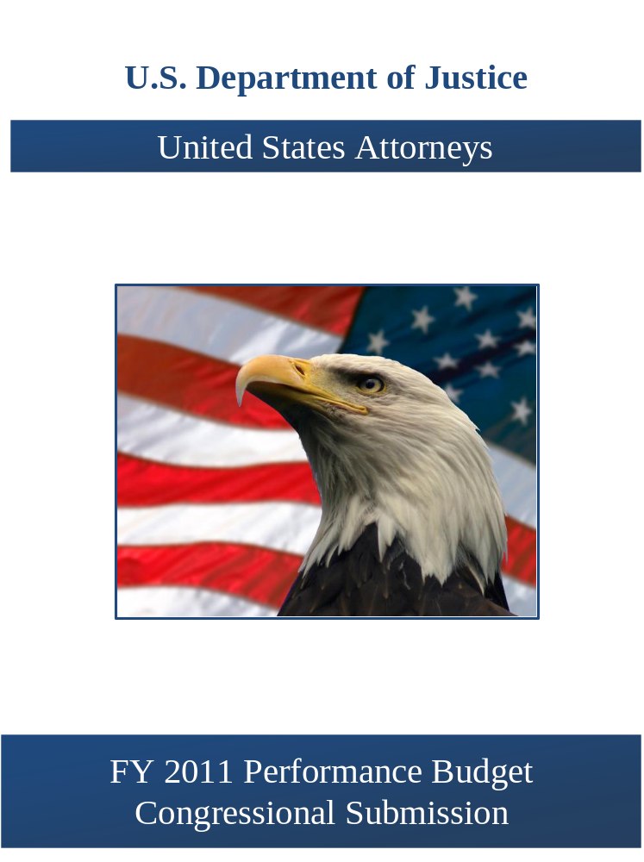

THIS PAGE INTENTIONALLY LEFT BLANK

Table of Contents

Page No.

I. Overview 1

II. Summary of Program Changes 18

III. Program Changes by Decision Unit to Strategic Goal 19

IV. Appropriations Language and Analysis of Appropriations Language 21

V. Decision Unit Justification 23

A. Criminal 24

1. Program Description 24

2. Performance Tables 25

3. Performance, Resources, and Strategies 27

B. Civil 29

1. Program Description 30

2. Performance Tables 32

3. Performance, Resources, and Strategies 34

C. Legal Education 35

1. Program Description 36

2. Performance Table 40

3. Performance, Resources, and Strategies 41

VI. Program Increases by Item 43

A. Combating Financial and Mortgage Fraud 43
B. International Organized Crime 49
C. Preserving Justice Initiative 53
E. E-Discovery 58

VII. Program Decreases by Item 62

A. Travel Reduction 62

VIII. E-Gov Initiatives 63

IX. Exhibits 65

- Organizational Chart
- Summary of Requirements
- Program Increases by Decision Unit
- Resources by DOJ Strategic Goal/Objective
- Justification for Base Adjustments
- Crosswalk of 2009 Availability
- Crosswalk of 2010 Availability
- Summary of Reimbursable Resources
- Detail of Permanent Positions by Category
- Financial Analysis of Program Changes
- Summary of Requirements by Grade
- Summary of Requirements by Object Class
- Status of Congressionally Requested Studies, Reports, and Evaluations

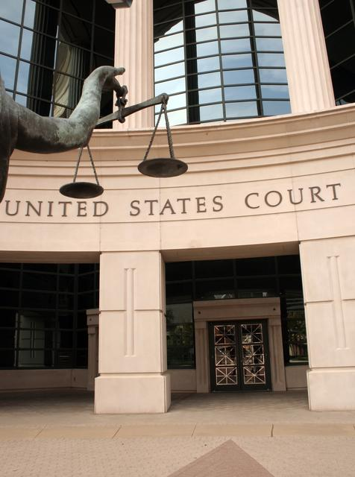

I. Overview for the United States Attorneys

A. Introduction

The United States Attorneys’ mission supports two of the Department of Justice’s strategic
goals - (1) prevent terrorism and promote the nation’s security, and (2) prevent crime, enforce federal laws and represent the rights and interests of the American people. The Fiscal Year (FY) 2011 budget request totals $2,041,269,000 for the United States Attorneys, including $22,367,000 in enhancements for Combating Financial Fraud, International Organized Crime, Preserving Justice, and E-Discovery.

The United States Attorneys serve as the nation’s principal litigators. In response to the mandates of the Constitution that required establishment of a system of federal courts, Congress enacted the Judiciary Act of 1789 directing the President to appoint, in each federal district, “a person learned in the law to act as an attorney for the United States.” Before 1870, the U.S. Attorneys acted independently, but since then they have worked under the direction of the U.S. Department of Justice.

There are 94 United States Attorneys’ Offices (USAOs) located throughout the United States, Puerto Rico, the Virgin Islands, Guam, and the Northern Mariana Islands. The 93 United States Attorneys (Guam and the Northern Mariana Islands are under the direction of a single U.S. Attorney) are appointed by, and serve at the discretion of, the President of the United States, with the advice and consent of the United States Senate. The map on page 3 depicts the United States Attorneys’ current district and branch office locations.

The United States Attorneys report to the Attorney General, through the Deputy Attorney General. Each United States Attorney serves as the chief federal law enforcement officer within his or her judicial district and, as such, is responsible for the prosecution of criminal cases brought by the federal government; the litigation and defense of civil cases in which the United States is a party; the handling of criminal and civil appellate cases before United States Courts of Appeals; and the collection of civil and criminal debts and restitutions owed the federal government which are administratively uncollectible.

The United States Attorneys and their Assistant United States Attorneys (AUSAs) serve in small towns and big cities, representing the interests of the United States. Through their hard work and dedication, justice is served throughout the nation. United States Attorneys’ Offices conduct

most of the trial work in which the United States is a party. Although the distribution of caseload varies between districts, each USAO has every category of cases and handles a mixture of simple and complex litigation. Each United States Attorney exercises wide discretion in the use of his/her resources to further the priorities of the local jurisdictions and needs of their communities.

United States Attorneys provide advice and counsel to the Attorney General and senior policy leadership through the Attorney General’s Advisory Committee (AGAC) and its various Subcommittees. The AGAC was established in 1973 to give United States Attorneys a voice in Department policies and to advise the Attorney General. The Committee, comprised of approximately 20 United States Attorney members who represent various federal judicial districts, geographic locations, and small, medium and large size offices, meets monthly with the Deputy Attorney General and Attorney General. The AGAC creates Subcommittees and working groups to address the Administration’s priorities. The Subcommittees include: Border and Immigration Law Enforcement; Civil Rights; Criminal Practice Subcommittee; Cyber/Intellectual Property; Native American Issues; Office of Management and Budget; Terrorism/National Security; Victim/Community Issues; Violent and Organized Crime; White Collar/Fraud. The Working Groups include: Child Exploitation and Obscenity; Controlled Substances and Asset Forfeiture Working Group; Environmental Issues; Health Care Fraud; Civil Chiefs; Criminal Chiefs; and Appellate Chiefs.

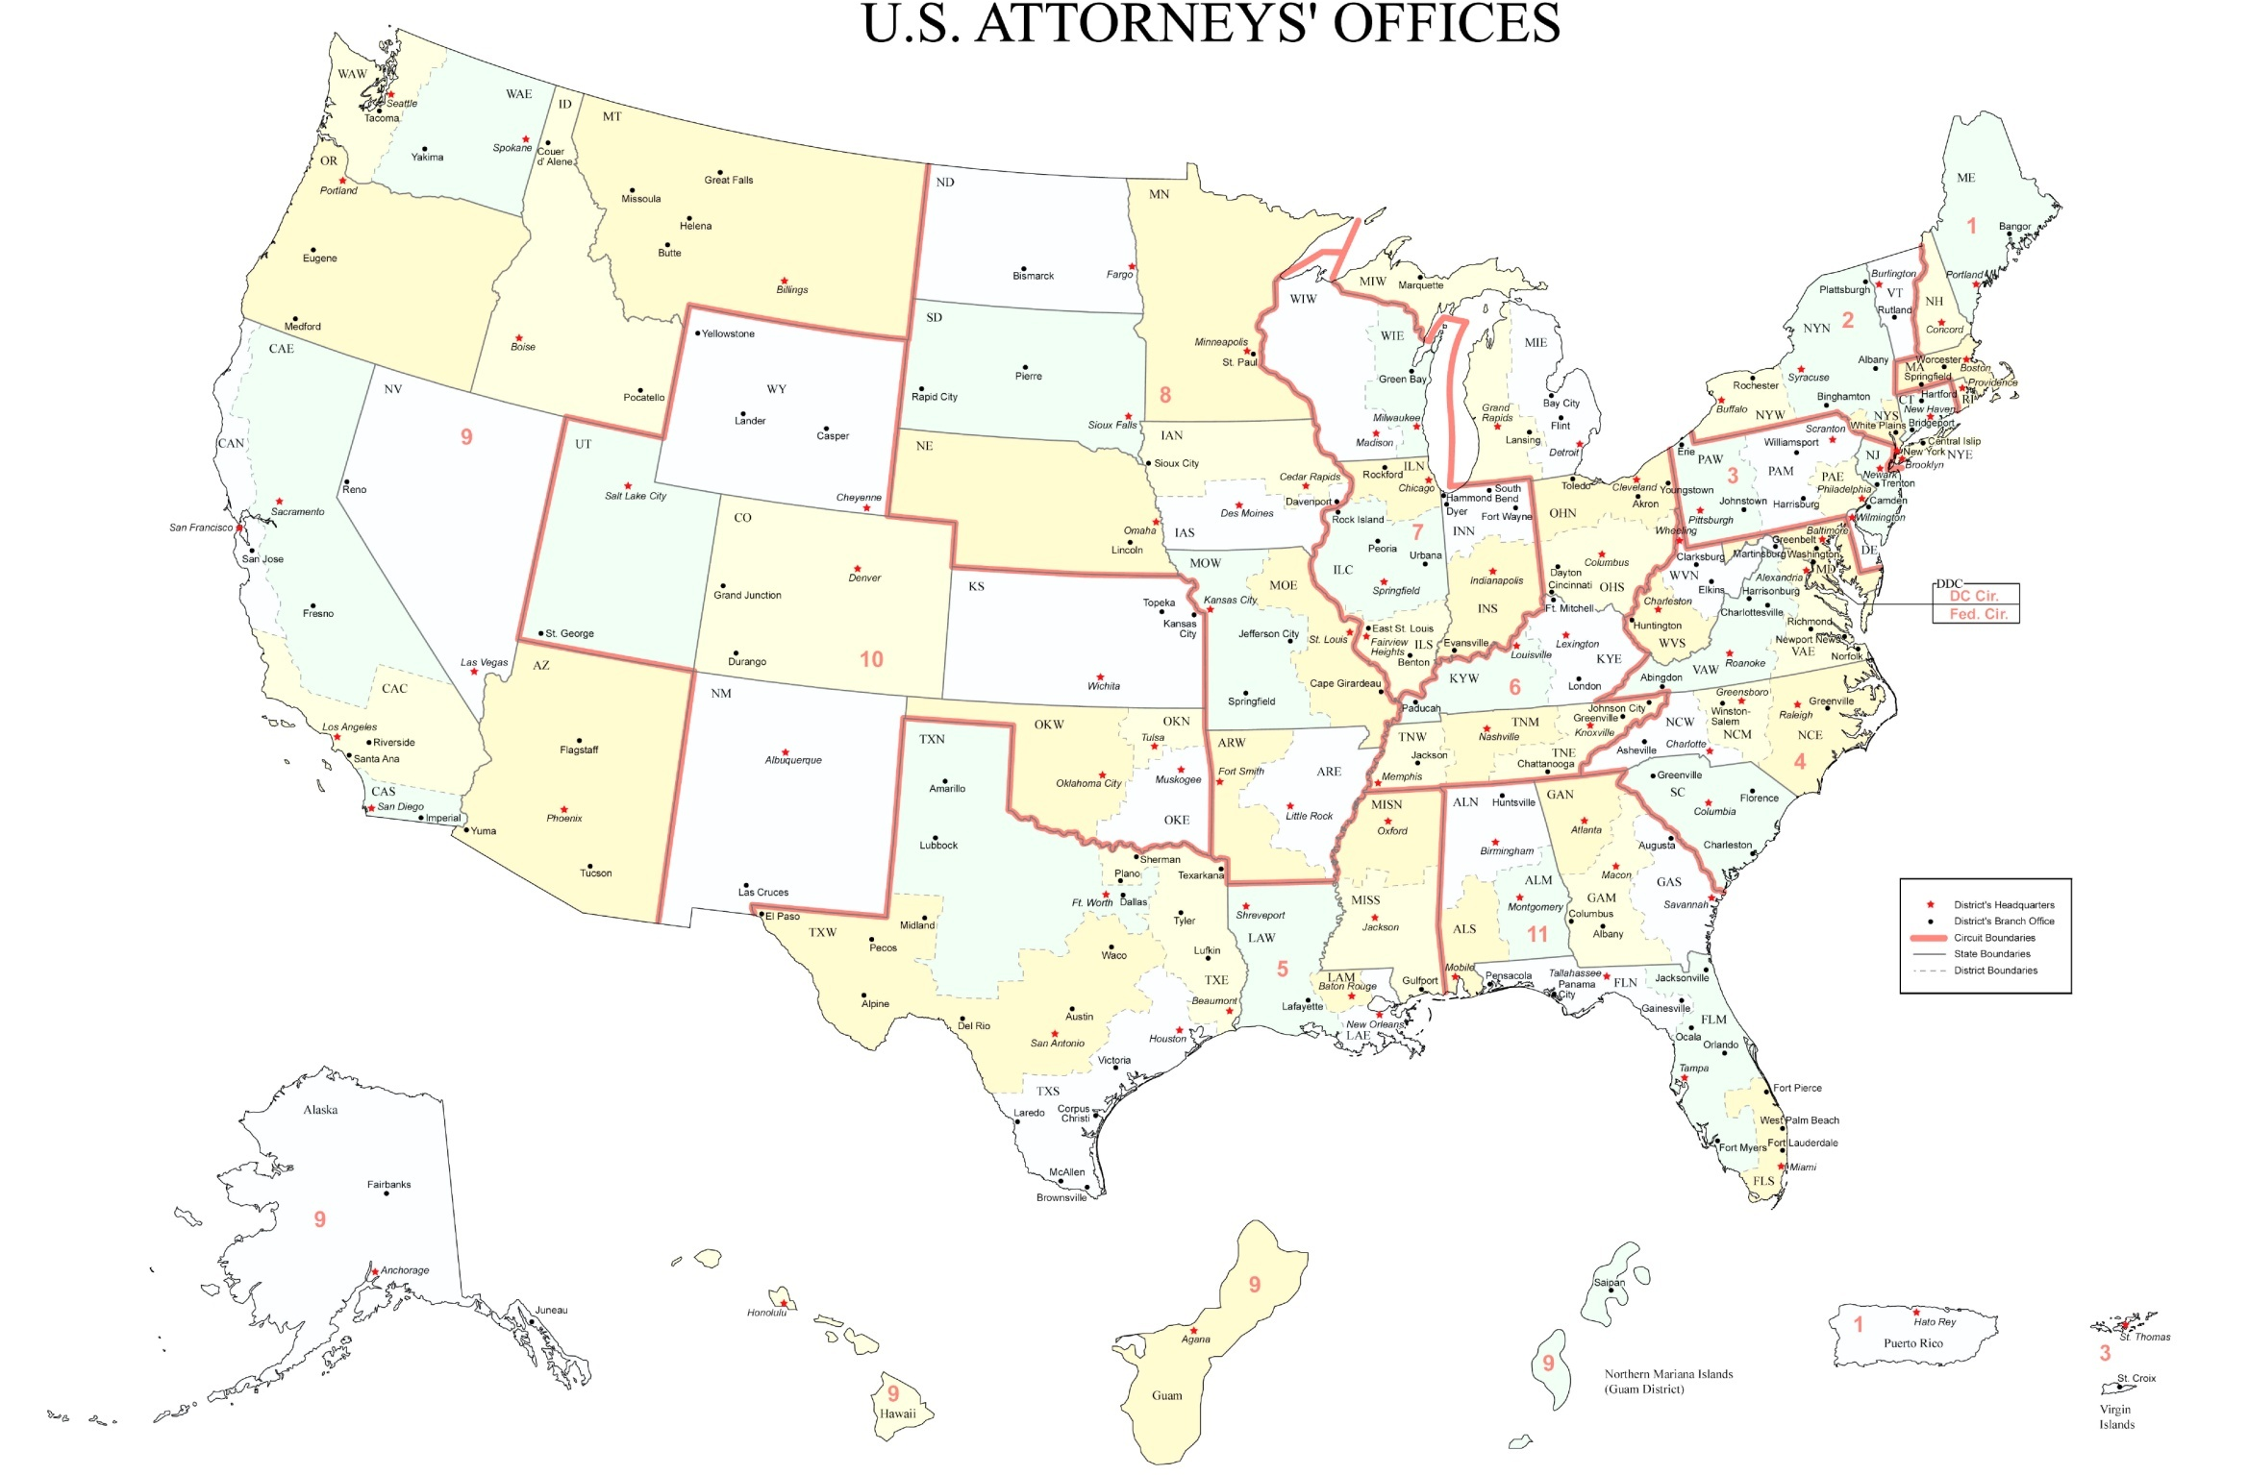


EXECUTIVE OFFICE FOR UNITED STATES ATTORNEYS

In 1953, Attorney General Order No. 8-53 established the Executive Office for United States Attorneys (EOUSA) to “provide general executive assistance and supervision to the offices of the United States Attorneys.” One of the original directives instructed the Executive Office to “serve as liaison, coordinator, and expediter with respect to the Offices of the United States Attorneys, and between these offices and other elements of the Department [of Justice].” Under the guidance of the Director of EOUSA, the EOUSA staff provides the 93 United States Attorneys with general executive assistance and direction; policy development; administrative management direction and oversight; operational support; and coordination with other components of the Department and other federal agencies. These responsibilities include legal, budgetary, administrative, and personnel services, as well as continuing legal education. EOUSA provides support and assistance to nearly 12,000 employees in more than 200 staffed offices throughout the country. See Exhibit A for an organization chart of EOUSA. Specific offices and functions of EOUSA are outlined below:

- Chief Operating Officer (COO) is a key advisor to the Director of EOUSA and the AGAC on nationwide issues. The COO manages and directs the following staffs: The Employee Assistance Program (EAP) provides free, confidential assessments, short-term counseling, and community referrals for EOUSA employees and their families. The Facilities and Support Services (FASS) Staff provides direct support and oversight of all USAOs in the areas of real property management, including space acquisition, relocation, design, repair, and management of rent payments. Support services include forms management, printing, and mail metering. The Acquisitions Staff supports both EOUSA and the USAOs by issuing contracts for supplies/services nationwide in compliance with applicable federal, departmental, and other regulations, polices, and procedures. The Personnel Staff develops and maintains a component-wide personnel program for attorneys and support staff throughout the USAOs and EOUSA. The Security Programs Staff provides security program support for USAOs, including policy and procedural assistance, training, education and awareness efforts, and emergency and contingency planning.

- Chief Financial Officer (CFO), through the Resource Management and Planning Staff (RMP), is responsible for budget formulation, budget execution, financial management, audit reviews, and long-range planning. The CFO is a key advisor to the Director of EOUSA, the AGAC, and AGAC’s Office Management and Budget (OM&B) Subcommittee. The CFO also provides the Director of EOUSA with expert advice on an annual budget of approximately $2.0 billion, FTE allocations, and reimbursable agreements with department and other federal agencies. The RMP staff consolidates resource needs and formulates an annual budget submission for presentation to the Department, the Office of Management and Budget (OMB), and Congress. It also manages the day-to-day financial operations through daily contact with USAOs and through review of regular accountability reports. An internal Audit and Review Staff participates with the Evaluation and Review Staff (EARS) in evaluating internal controls in USAOs. RMP also develops performance measures for the United States Attorneys in accordance with the Government Performance and Results Act (GPRA) and coordinates quarterly status reporting and program assessments.


- Chief Information Officer (CIO) is responsible for providing advice and assistance to the Director of EOUSA and senior staff to ensure that Information Technology (IT) is acquired and managed according to Department and EOUSA policies and procedures. The CIO ensures the integration of IT into strategic planning, acquisition, and program management processes to support the mission of the United States Attorney Community. The CIO directs and manages the following staffs: The Case Management Staff provides case management systems. The Office Automation Staff supports the purchase and installation of computer systems, equipment, and software, maintenance of hardware and software, and end-user training. The Telecommunications and Technology Development Staff provides administrative and technical support to USAOs in all telecommunications activities, including voice, data and video. The Information Security Staff ensures the confidentiality, integrity, and availability of Information and Information Systems to best support the mission of the United States Attorneys.


- In FY 2009, the IT program accomplished several goals related to implementing business improvements involving technology. The EOUSA/OCIO installed an enterprise-wide Employee Notification System (ENS) to notify United States Attorneys’ offices and EOUSA employees of emergency and non-emergency situations. The ENS system provides notifications via phone, cell, text, and E-Mail to the entire United States Attorneys’ community. The OCIO also upgraded 33 United States Attorneys’ offices to Enterprise Voice over Internet Protocol enterprise telephony solution, bringing the total number of offices installed to date to 54. In addition, the USA Mail project was completed, allowing 94 dispersed servers to be centralized and consolidated into 6 primary servers with full failover capability. Finally, the Litigation Support Technology Center posted an almost 200% increase in work orders completed, providing a range of services from document imaging, Optical Character Reader only, to Electronic Data Discovery and hosting databases for collaborative online reviews.

- Legal Initiatives Staff provides legal assistance and advice, management support, and policy guidance for EOUSA and the United States Attorneys on a variety of law enforcement initiatives. The Staff is comprised of Assistant United States Attorneys on detail, permanent attorneys, the Intelligence Specialist Program Manager, and permanent administrative staff. The attorneys act as liaisons between “Main Justice” and the USAO community, and help implement policy in the following areas: Terrorism, Computer Crime and Intellectual Property, Native American issues, Immigration and Southwest Border issues, Violent Crime and Gangs, Narcotics, Sentencing, and Civil Rights. In addition, the National Coordinators for Project Safe Neighborhood and Project Safe Childhood, and the National Program Manager for the Intelligence Specialist program, are on the Legal Initiatives Staff.

- Office of Legal Education (OLE) develops, conducts, and authorizes the training of all federal legal personnel. OLE coordinates legal education and attorney training for the Department of Justice, other federal departments and agencies, as well as state and local law enforcement. OLE is a separate decision unit of the budget and its functions and mission, which are largely completed at the National Advocacy Center (NAC) in Columbia, South Carolina, are discussed in greater detail in Section V.

- Legal Programs and Policy Office includes three staffs: Financial Litigation Staff, Legal Programs Staff, and Law Enforcement Coordinating Committee (LECC)/Victim-Witness Staff. The Financial Litigation Staff (FLS) supports the collection and enforcement efforts of district financial litigation programs. FLS assists in the development of financial litigation policy, development and implementation of procedures and programs, and provides liaison functions within the Department and with outside agencies. The Legal Programs Staff (LPS) coordinates asset forfeiture, health care fraud, civil issues, and white collar crime programs in USAOs and develops national policies and initiatives. In addition, LPS coordinates the activities of the Affirmative Civil Enforcement (ACE) Program, which uses civil statutes for federal law enforcement efforts in fighting economic fraud.


The Law Enforcement Coordinating Committee (LECC)/Victim-Witness Staff provides support through EOUSA for district LECC and Victim-Witness programs through liaison, monitoring, and assistance activities. LECC coordinators, at the district level, carry out the important role of coordination and liaison with federal, state, and local law enforcement, and with members of the community on various crime reduction programs. Each District’s LECC is under the supervision of the United States Attorney, who serves as the LECC chairperson or co-chairperson. Through the LECC program, training is provided to federal, state, and local law enforcement in areas such as anti-terrorism, gun crime, asset forfeiture, gang investigations, racial profiling, domestic violence, emerging drug trends, community policing, victim issues, and officer safety. USAOs’ Victim Witness personnel enhance and protect the necessary role of crime victims and witnesses in the criminal justice process, ensuring that the federal government does all it can to assist those individuals through an often extremely difficult process. Victim Witness personnel handle victim notification, explain to victims the criminal justice process, prepare victims and witnesses for testimony and allocution, coordinate their attendance at proceedings and accompany them, and provide victims with referrals and emergency assistance. Victims’ rights have taken on new importance since the passage of the Crime Victims’ Rights Act of 2004, which provided victims with enumerated rights and, for the first time at the federal level, the mechanisms to enforce their rights. Victims are now playing a more central role in the criminal process, and exercising their rights in greater numbers than ever before.


- Data Analysis Staff is the primary source of statistical information and analysis for EOUSA. The staff provides data and analysis to EOUSA components allowing them to respond to requests from, among others, the Department, the White House, Congress, and the public. The staff also provides the United States Attorney Community comprehensive quarterly analysis of work year, caseload and workload information and produces the United States Attorneys’ Annual Statistical Report. During FY 2009, the Data Analysis staff responded to approximately 1,200 requests for statistical and narrative information.


- General Counsel’s Office provides advice to USAOs and to EOUSA on a broad array of legal and ethical issues. It provides guidance to USAOs and EOUSA personnel regarding ethics and standards of conduct matters including conflicts of interest, recusals, outside activities, gifts and financial disclosures, allegations of misconduct, personnel legal issues, discovery requests and compliance with subpoenas. The General Counsel’s Office is also responsible for the employee relations programs of EOUSA and the USAOs.

- Freedom of Information and Privacy Act (FOIA) Staff processes all FOIA and Privacy Act (PA) requests for records located throughout EOUSA and the USAOs, provides legal guidance to USAOs concerning FOIA/Privacy Act issues, represents them in administrative appeals, and assists AUSAs and Department of Justice attorneys in litigation in federal courts by providing draft pleadings and preparing legal documents.


- Equal Employment Opportunity (EEO) Staff provides centralized leadership, coordination, and evaluation of all equal employment efforts within EOUSA and the USAOs. The EEO Staff is comprised of two components – Complaint Processing and Affirmative Employment/Special Emphasis Programs. The EEO mission supports the USAOs and EOUSA by providing timely, impartial and superior customer service in the areas of conflict resolution; EEO complaint processing; civil rights policy development and training; language assistance plans; and by conducting proactive diversity initiatives through outreach and recruitment.

- Evaluation and Review Staff (EARS) conducts a district evaluation program, enabling the Director of EOUSA to fulfill the responsibility of conducting reviews of internal management controls and preventing waste, loss, unauthorized use or misappropriation in federal programs, as required by the Federal Manager's Financial Integrity Act and OMB Circular No. A - 123. The EARS evaluation program reviews legal management, administrative operations and financial litigation in each USAO and provides on-site management assistance. The Financial Management (FM)-EARS evaluation program reviews USAOs’ financial management and operational practices. In FY 2009, EARS completed 30 evaluations, while FM-EARS conducted 29 site visits and 25 follow-up visits to ensure that those issues identified as a result of the evaluation process were corrected.

••• U.S. Attorney Community At a Glance •••

- 94 United States Attorneys’ Offices
  - 161 other staffed locations throughout the continental United States and United States Territories

- 93 United States Attorneys (Guam and the Northern Mariana Islands are under the direction of a single United States Attorney)

- EOUSA provides executive assistance and direction, support and policy development through its subordinate offices, which include:

  - Chief Operating Officer
  - Chief Financial Officer
  - Chief Information Officer
  - Legal Initiatives Staff
  - Office of Legal Education
  - Legal Programs and Policy Office
  - Data Analysis Staff
  - General Counsel’s Office
  - Freedom of Information and Privacy Act Staff
  - Equal Employment Opportunity Staff
  - Evaluation and Review Staff

CRIMINAL PROSECUTIONS

The USAOs investigate and prosecute the vast majority of criminal cases brought by the federal government – representing a more diverse workload than ever before. The types of cases include international and domestic terrorism; immigration; child exploitation and obscenity; firearms and violent crime; complex and time-consuming fraud – including health care, identity theft, white collar crime and public corruption, procurement, mortgage, Katrina-related, and student loan fraud; gangs and organized crime; drug enforcement; human trafficking and criminal civil rights enforcement. Many of these cases involve multiple defendants and are extremely complex. The nature of today’s crimes has required the U.S. Attorney Community to become conversant in a wide range of fields, such as banking and health care, computer technology, securities, foreign cultures and languages, and manufacturing processes affected by environmental and other federal regulations.

The United States Attorneys receive most of their criminal referrals, or “matters,” from federal investigative agencies, including the Federal Bureau of Investigation (FBI), the Drug Enforcement Administration (DEA), the Bureau of Alcohol, Tobacco, Firearms and Explosives (ATF), the United States Immigration and Customs Enforcement (ICE), the United States Secret Service, and the United States Postal Inspection Service. USAOs also receive criminal matters from state and local investigative agencies, as well as violations reported by private citizens. Following careful consideration of each criminal matter, the United States Attorneys decide the appropriateness of bringing criminal charges and, when deemed appropriate, initiate prosecution. Except for misdemeanor offenses and instances in which an alleged offender waives the right to a grand jury indictment, the United States Attorneys present evidence against an alleged offender to a grand jury. The grand jurors then decide whether to return an indictment and, if an indictment is returned, the United States Attorneys then present the criminal charges in open court at the arraignment of the defendant.
Federal Law Enforcement Partners


Although historically a large number of criminal defendants enter a plea of guilty prior to trial, the United States Attorneys must always fully investigate the crime, prepare the charging document, and be ready to go to trial. Consistent preparation for trial minimizes the risk of dismissal for noncompliance with the Speedy Trial Act and strengthens the government’s position in negotiations with defense counsel for a guilty plea. Pretrial discovery practice also strengthens the government’s position. When a guilty plea is not obtainable, a trial becomes necessary. The United States Attorneys then present factual evidence to the jury, or to the judge in a non-jury (bench) trial. If the defendant is convicted, the United States Attorneys must prepare and present evidence at the defendant’s sentencing hearing and then defend the conviction at post-trial hearings and appeals. The USAOs handle most criminal appeals at the intermediate appellate level. After filing an appeal brief, the United States Attorneys may be required to participate in oral arguments before the United States Courts of Appeals. If there is a further appeal, the United States Attorneys may be called upon to assist the Solicitor General in preparing the case for review by the United States Supreme Court.

CIVIL LITIGATION

The United States Attorneys initiate civil actions, referred to as affirmative litigation, to assert and protect the interests of the United States. They also defend the interests of the government in lawsuits filed against the United States, referred to as defensive civil litigation. In other civil cases, the United States is a third party, a creditor, or an intervener.

Examples of affirmative litigation include civil actions brought to: enforce the nation’s environmental, admiralty, and civil rights laws; represent the government’s interests in bankruptcy actions; recoup money and recover damages resulting from federal program and other fraud; and enforce administrative summonses and asset forfeiture litigation, which involve assets seized by federal, state, and local law enforcement.

Defensive litigation includes tort suits brought by those who allege suffering as a result of government action, adjudication of Social Security disability claims, alleged contract violations, habeas corpus petitions, and race, sex, and age discrimination actions. The USAOs represent and defend the government in its many roles – employer, regulator, law enforcer, medical care provider, revenue collector, contractor, procurer, property owner, judicial and correctional system manager, and as administrator of federal benefits. In those cases where the United States is sued, the Department of Justice must be its representative.

Civil defensive work is unique because it is non-discretionary and non-delegable. Unlike criminal divisions or sections, civil units of USAOs cannot employ “declination” criteria to manage or reduce the civil defensive caseload. All cases filed against the government, its agencies, and employees in their official capacities must be defended.

CRIMINAL AND CIVIL APPEALS

Appeals are generally very time-consuming, requiring a thorough review of the entire record in the case, the filing of a brief and reply brief, and, in most cases, participation in oral argument requiring travel to the city where the United States Courts of Appeals for the circuit is located. Furthermore, the complexity of appellate work and the time required to handle that work increases when convictions are based on complex facts, such as those found in organized crime drug enforcement and other narcotics cases, financial institution fraud, other organized crime, armed career criminal, public corruption, health care fraud, and computer fraud cases.

The appellate workload of the United States Attorneys fluctuates due to additional appeals prompted by Supreme Court rulings, legislative changes, and changes under the U.S. Sentencing Guidelines. In FY 2006, for example, the Supreme Court held that the Sixth Amendment right to jury trial applied to factual findings supporting certain sentencing enhancements under the U.S. Sentencing Guidelines, and that the Guidelines are advisory instead of mandatory. As a result, post-sentencing motions filed by incarcerated defendants increased by more than 10 percent for approximately two years.


CRIMINAL AND CIVIL DEBT COLLECTION

USAOs are responsible for collecting both criminal and civil debt for the U.S. Government. Each USAO has a Financial Litigation Unit (FLU) with the responsibility for both criminal and civil debt collection activities. In addition to the FLUs, USAOs have Affirmative Civil Enforcement (ACE) staff devoted to the collection of civil debts.

Debts are ordered to be collected from a criminal defendant when the defendant is sentenced by the court. These debts may be in the form of restitution to victims of crime, fines imposed by the court to penalize criminals, special assessments on each criminal conviction count, costs of prosecution and other costs, or forfeitures of appearance bonds. Interest may also be collected in certain cases. In instances where restitution is ordered, the USAOs are involved in collecting federal restitution payments, or restitution which is owed to the United States, and in collecting non-federal restitution, or that which is owed to private individuals and entities. As a result of the Mandatory Victims Restitution Act (MVRA), courts now must impose monetary restitution orders in all violent crimes and most property crimes. United States Attorneys are required to enforce restitution orders on behalf of all victims of federal crimes.
••• Debt Collection At a Glance •••

In FY 2009, the USAOs collected $4.5 billion of criminal and civil debts owed. Of the total debts collected, USAOs recovered:

(1) $2.2 billion in criminal debts; and
(2) $2.3 billion in civil debts.

The United States Attorneys’ collection efforts, handled by a very small percentage of the total workforce, returns to the Treasury over twice the $1.83 billion appropriated in the FY 2009 budget for the entire U.S. Attorney Community.

The U.S. Attorneys are also the legal representatives for other federal agencies to pursue repayment of debts. For example, when federal agencies lend money and the recipients default on repayment of the loans, or when federal agencies have paid on guaranteed loans and have not been repaid as provided for in the lending agreement, United States Attorneys pursue the repayment of debt. The Departments of Agriculture, Education, Health and Human Services, Housing and Urban Development, Transportation, Veterans Affairs, and the Small Business Administration are some of these client agencies. United States Attorneys file suit to obtain judgments to collect debts, foreclose on real property, compel physicians to repay or fulfill their commitment to the Public Health Service in return for education grants, sue to set aside fraudulent transfers of property which could be used to satisfy defaulted loans, and manage debtor repayment schedules. The below table illustrates the significant return of debts collected in the last six years:

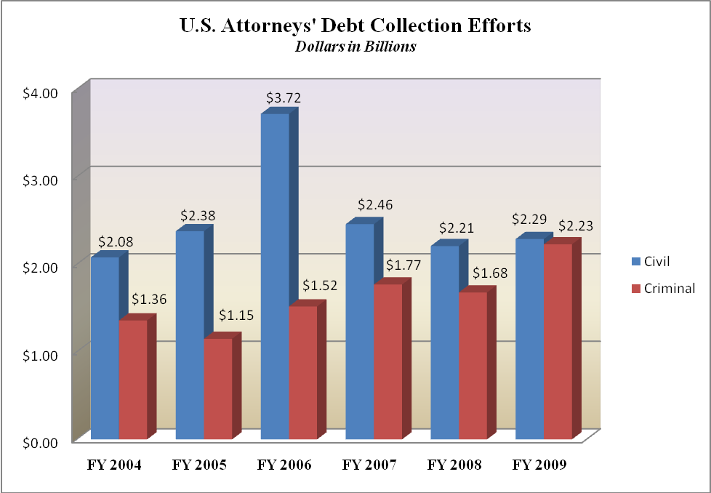

In FY 2009, the USAOs collected $4.5 billion of criminal and civil debts owed. Of the total debts collected, USAOs recovered: (1) $2.23 billion in criminal debts; and (2) $2.29 billion in civil debts. The United States Attorneys’ collection efforts, handled by a very small percentage of the total workforce, returns to the Treasury over twice the $1.83 billion appropriated in the FY 2009 budget for the entire United States Attorney Community
B. Issues, Outcomes, and Strategies

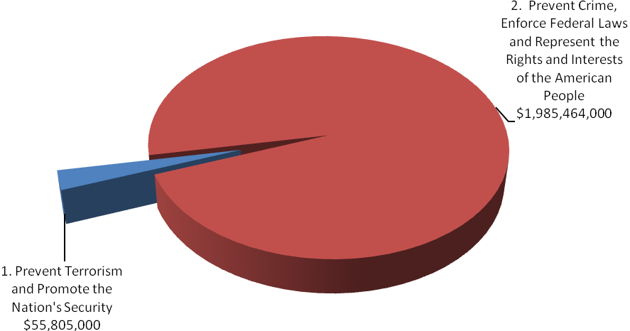

FY 2011 Total Request by DOJ Strategic Goal

The following is a brief summary of the Department’s Strategic Goals and Objectives in which the United States Attorneys play a role.

DOJ Strategic Goal 1: Prevent Terrorism and Promote the Nation’s Security ($55,805,000)

● Prosecute those who have committed, or intend to commit, terrorist acts in the United States (1.3).

DOJ Strategic Goal 2: Prevent Crime, Enforce Federal Laws and Represent the Rights and Interests of the American People ($1,985,464,000)

● Reduce the threat, incidence, and prevalence of violent crime (2.2).
● Prevent, suppress, and intervene in crimes against children (2.3).
● Reduce the threat, trafficking, use, and related violence of illegal drugs (2.4).
● Combat public and corporate corruption, fraud, economic crime, and cybercrime (2.5).
● Uphold the civil and constitutional rights of all Americans (2.6).
● Vigorously enforce and represent the interests of the United States in all matters over which the Department has jurisdiction (2.7).

C. Full Program Costs

This request funds the strategies that support the United States Attorneys’ objectives. We will continue to provide federal leadership in preventing and controlling crime and seeking just punishment of those guilty of unlawful behavior.

FY 2011 Budget Request by Decision Unit
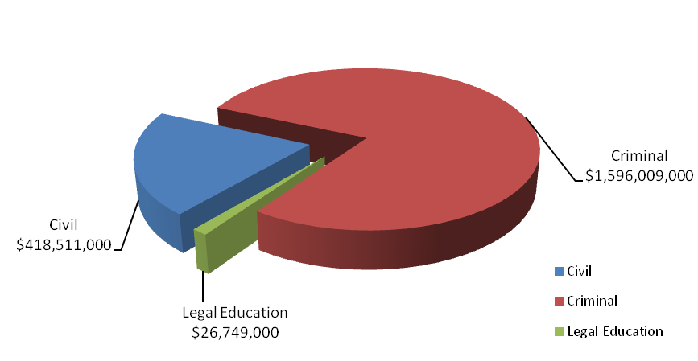

The United States Attorneys’ $2,041,269,000 budget request for FY 2011 is divided into three decision units: criminal, civil, and legal education. Some programs, as well as management and administration costs, cross decision units. Both performance and resource tables within each decision unit define the total costs of achieving the strategies the United States Attorneys will employ in FY 2011. The various resource and performance charts incorporate the costs of lower level strategies which also contribute to the achievement of objectives, but which may not be highlighted in detail in order to provide a concise narrative. Also included are the indirect costs of continuing activities, which are central to the operations of each decision unit.

D. Performance Challenges

The challenges that impede progress toward the achievement of agency goals are complex and ever-changing. National priorities since September 11th affected everyone in the law enforcement community as resources and personnel were redirected to prosecute the Global War on Terror. Illegal immigration and border security have become key components of the Nation’s counterterrorism strategy following September 11th. Federal prosecution of border crime is now a critical part of our Nation’s defense. Additionally, the current economic crisis requires that the United States Attorney Community focus attention on ever increasing mortgage and financial fraud, and bankruptcy cases. Internal agency dynamics, policy decisions, technological developments, and criminal behavior are factors that broadly impact law enforcement practices and pose challenges that demand attention.

The United States Attorney Community continues to work to become a more fiscally efficient organization. In order to ensure that costs remained within funded levels, cost savings measures were implemented, including:

- Reducing space and delaying renovations in District Offices;
- Reducing video and data telecommunication lines;
- Utilizing on-line law library services rather than hard copies;
- Limiting ordering of real time or hourly transcripts and translation services;
- Reducing travel; and
- Delaying spending on infrastructure for physical security and information technology.

However, even with these cost savings measures, positions were left vacant. In FY 2004, 198 Full Time Equivalents (FTE) were left unfilled; that number grew to a high of 1,180 FTE in October 2007.

Vacant positions had a substantial impact on the U.S. Attorneys’ workload. Criminal cases pending or what could be considered as “backlog” increased by 11 percent. Additionally, in the civil area, new cases filed decreased by 4.5 percent and the number of civil affirmative cases filed decreased by 21 percent between FY 2003 and FY 2006.

In FY 2008 and FY 2009, the U.S. Attorney Community began an aggressive campaign to fill positions previously left vacant. United States Attorneys’ Offices have been taking the necessary management steps to restructure the workforce by backfilling positions with lower salaried employees. Incremental increases in the average non-supervisory attorney salary (82 percent of the total attorney workforce are non-supervisors) are well below the cost-of-living adjustment over the last several years:

As positions were filled, workload statistics improved. By the end of FY 2008 (with higher on-board levels), criminal cases filed increased by 7.4 percent over the FY 2006 total; total cases pending increased by just 1 percent. Additionally, civil affirmative cases filed between the beginning of FY 2007 and the end of FY 2008 increased 21.5 percent. In FY 2009, the USAOs continued to fill vacant positions thereby increasing the number of criminal and civil cases filed. The United States Attorneys continue to implement cost saving measures that contribute to the organization meeting our financial goals.

External Challenges

A highly skilled, dynamic workforce is more important now than ever before. Since
September 11th, USAOs have taken on more responsibilities in new areas. AUSAs coordinate with state, local, and federal agencies in preventing, investigating, and prosecuting terrorist acts. Furthermore, AUSAs participate in disaster planning and emergency preparedness. These coordination activities involve non-traditional roles for AUSAs and present challenges as we continue combating terrorism.

Coordination with state, local, and federal agencies is not unique to combating terrorism. USAOs are actively involved in these activities in program areas ranging from border enforcement/prosecution to gun violence reduction to disrupting and dismantling drug organizations, and child exploitation. In the border enforcement and prosecution area, additional Border Patrol Agents are resulting in substantial increases in misdemeanor cases requiring even closer coordination with the U.S. Marshals Service, the Office of the Detention Trustee, the Bureau of Prisons, the Department of Homeland Security, the Courts and the local defense bar concerning the availability of bed space, prisoner transport, and translators for those who are detained.

In addition, the economy and emerging criminal activities, often driven by technology, such as cybercrime, are external challenges beyond our control. Downturns in the economy often correlate with increases in criminal activity. As a result of the recent economic crisis, the number of active FBI mortgage fraud investigations has tripled in the last three years. In addition, financial institutions have reported a record number of mortgage fraud cases to the Treasury Department — 10 times the number reported in 2001-2002. The reports document billions of dollars in losses. Further, the Housing and Urban Development Inspector General anticipates a greatly increased mortgage fraud caseload based on the new broadened standards for obtaining FHA-backed loans. Inevitably, these investigations will result in more referrals for prosecution to the USAOs throughout the country.

We will continue to focus on areas within our spheres of influence and control, concentrating on coordination efforts with state, local, and federal agencies and ensuring our workforce is trained for emerging and complex issues.

Internal Challenges

One internal challenge to the United States Attorney Community is keeping the workforce flexible and adaptable. Over the past few years, terrorism, corporate fraud, violent crime and gangs, immigration, internet-related crime, and child exploitation have emerged as important national priorities. The United States Attorney Community needs to be able to shift resources to respond to changes in case type and case load. The United States Attorneys have developed an effective allocation process that distributes new positions and funding to districts with the greatest demonstrated need. Necessary training is provided through the National Advocacy Center (NAC) to ensure that attorneys and support staff have the expertise in these areas. Regular reviews and monitoring of case work and USAOs’ needs are essential to continued responsiveness.

Another related internal challenge is the need to restructure the workforce and to grapple with the upcoming “brain drain” as Baby Boomers reach retirement age. Several years of using the tool provided by the Voluntary Early Retirement (VERA)/Voluntary Separation Incentive Payment (VSIP) authority have allowed offices to replace those taking the VERA/VSIP with employees hired at lower salaries and with a different mix of skill sets. Given the current economic condition, however, fewer employees are likely to voluntarily separate or retire, thereby reducing the flexibility of the USAOs to continue to restructure the workforce and achieve cost savings by hiring new employees at lower salaries.

E. Environmental Accountability

The United States Attorneys have begun implementation of an Environmental Management System in its 94 district offices and at the Executive Office for the United States Attorneys. The United States Attorneys will develop and implement an agency-wide, organizational environmental management system by the end of FY 2011 in accordance with the schedule established by the Department of Justice. The United States Attorneys will adopt agency requirements for environmental management and will also implement agency-wide programs, policies, and procedures to manage environmental aspects as needed on a more specific level.

II. Summary of Program Changes

For FY 2011, the United States Attorneys’ budget request is $2,041,269,000. The request includes $23,533,000 in enhancements, $1,166,000 in offsets, and 159 new positions (113 FTE). The following enhancements requested to support Presidential priorities are outlined in the chart below:

Item Name | Description |  |  |  | Page
Item Name | Purpose | Pos. | FTE | Dollars ($000) | Page
Combating Financial and Mortgage Fraud | Provides prosecution resources to enhance efforts in the areas of financial and mortgage fraud. | 109 | 82 | $17,224 | 44
International Organized Crime | This investment will add one strike force unit to target international organized crime activities that threaten our national security and undermine our economy. | 8 | 4 | 881 | 50
Preserving Justice Initiative | Provides necessary resources to perform the non-discretionary duty of the Department of Justice to protect and defend the United States, its agencies and employees in civil defensive litigation. | 30 | 15 | 3,428 | 54
E-Discovery | Develops a cadre of expertise in E-Discovery issues by augmenting support staff in the field and at the Litigation Technology Support Center. | 12 | 12 | 2,000 | 59
Travel Management Efficiencies | Achieve increased efficiencies and cost savings in travel expenditures. | 0 | 0 | (1,166) | 62
TOTAL |  | 159 | 113 | $22,367

III. Program Changes by Decision Unit to Strategic Goal

Item Name | Strategic Goal | Decision Unit | FTE | Dollars ($$$) | Number and Type of Positions
 |  |  |  |  | Position Series | No. of Positions in Series
Combating Financial and Mortgage Fraud | II | Criminal | 82 | $17,224 | 950  905 | 21  88
International  Organized Crime | I and II | Criminal | 4 | 881 | 950  905  901 | 2  5  1
Preserving Justice Initiative | II | Civil | 15 | 3,428 | 950  905 | 10  20
E-Discovery | I and II | Criminal | 12 | 2,000 | 905  300 | 2  10

THIS PAGE INTENTIONALLY LEFT BLANK

IV. Appropriations Language and Analysis of Appropriations Language

Appropriations Language

The 2011 Budget request includes proposed changes in the appropriations language listed and explained below. New language is italicized and underlined.

United States Attorneys, Salaries & Expenses

For necessary expenses of the Offices of the United States Attorneys, including inter-governmental and cooperative agreements, [$1,934,003,000] $2,041,269,000: Provided, That of the total amount appropriated, not to exceed $8,000 shall be available for official reception and representation expenses: Provided further, That not to exceed $25,000,000 shall remain available until expended.

THIS PAGE INTENTIONALLY LEFT BLANK

V. Decision Unit Justification

- CRIMINAL

 | Perm. Pos. | FTE | Amount
2009 Enacted with Rescissions | 8,150 | 8,116 | $1,433,467,000
2010 Enacted | 8,426 | 8,369 | 1,508,626,000
Adjustments to Base | (57) | 28 | 68,187,000
2011 Current Services | 8,369 | 8,397 | 1,576,813,000
2011 Program Increases | 129 | 98 | 20,105,000
2011 Program Offsets | … | … | (909,000)
2011 Request | 8,498 | 8,495 | 1,596,009,000
Total Change 2010-2011 | 72 | 126 | $87,383,000

Criminal Litigation—Information Technology Breakout (of Decision Unit Total) | Perm. Pos. | FTE | Amount
2009 Enacted with Rescissions | 285 | 285 | $102,935,000
2010 Enacted | 304 | 304 | 113,524,000
Adjustments to Base | 2 | 2 | 11,411,000
2011 Current Services | 306 | 306 | 124,935,000
2011 Program Increase | 6 | 6 | 1,148,000
2011 Request | 312 | 312 | 126,083,000
Total Change 2010-2011 | 8 | 8 | $12,559,000

1. Program Description–Criminal Decision Unit

The USAOs investigate and prosecute the vast majority of criminal cases brought by the federal government—including a more diverse and complex workload than ever before. For example, criminal caseloads include: international and domestic terrorism, illegal immigration, mortgage and disaster relief fraud, youth violence, firearms and gangs, child exploitation and obscenity, complex and time consuming white collar and health care fraud, financial institution and computer fraud, environmental crime, public corruption and organized crime, drug enforcement, civil rights violations, human trafficking and cases involving multiple defendants and international organizations.

The USAOs receive most of their criminal referrals, or "matters," from federal investigative agencies or become aware of criminal activities in the course of investigating or prosecuting other cases. They also receive criminal matters from state and local investigative agencies. Criminal violations are also reported to the USAOs by citizens. After careful consideration of each criminal matter, the U.S. Attorney decides the appropriateness of bringing criminal charges and initiates prosecution.

Criminal Workload
FY 2009 Cases Filed – 67,864
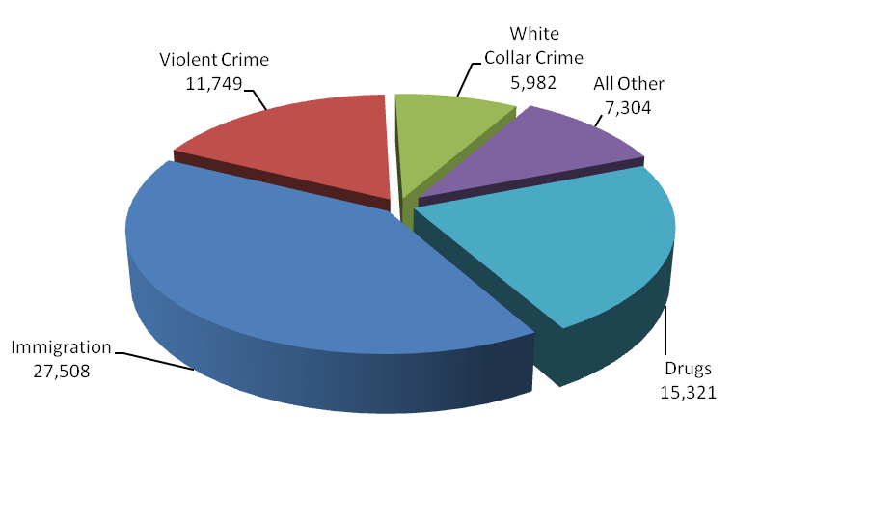

During FY 2009 the USAOs filed 67,864 criminal cases against 89,633 defendants in United States District Court. The number of new cases filed increased by 13 percent from FY 2005 to
FY 2009– going from 60,062 cases to 67,864.

A total of 67,052 cases against 88,821 defendants were closed during FY 2009. Of the 88,821 defendants whose cases were closed, 92 percent or 81,577, either pled guilty or were found guilty. Of these, 66,178 received prison sentences, and 263 guilty defendants received sentences of life imprisonment. The rate of convicted defendants who received prison sentences has consistently exceeded 80 percent over the last six years.
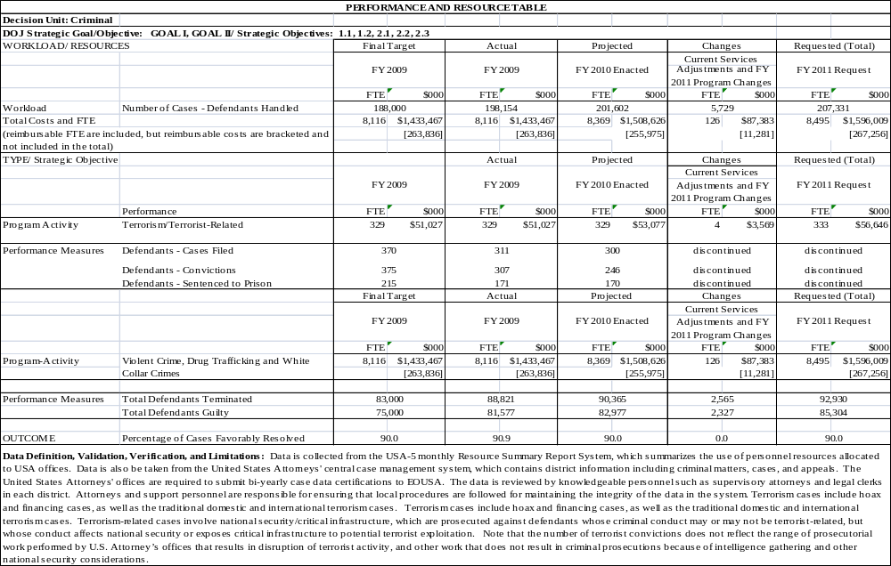
2. Performance Tables

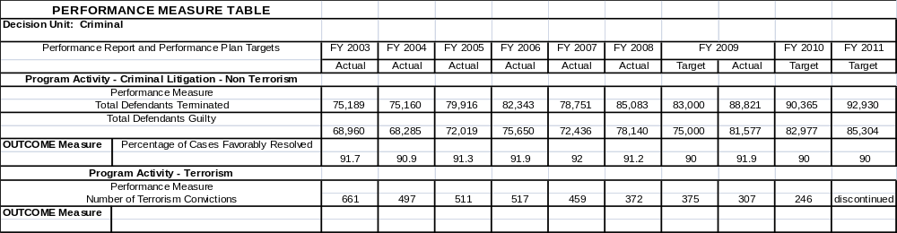

3. Performance, Resources, and Strategies

The Criminal Decision Unit contributes to the Department’s Strategic Goal I: Prevent Terrorism and Promote the Nation’s Security. Within this goal, the decision unit’s resources address the Department’s Strategic Objective: 1.3 - Prosecute those who have committed, or intend to commit, terrorist acts in the United States.

The Criminal Decision Unit also contributes to Goal II: Prevent Crime, Enforce Federal Laws and Represent the Rights and Interests of the American People. Within this goal, the decision unit’s resources address five of the Department’s Strategic Objectives: 2.2 - Reduce the threat, incidence, and prevalence of violent crime; 2.3 - Prevent, suppress, and intervene in crimes against children; 2.4 - Reduce the threat, trafficking, use, and related violence of illegal drugs; 2.5 - Combat public and corporate corruption, fraud, economic crime, and cybercrime; 2.6 - Uphold the civil and constitutional rights of all Americans; and 2.7 - Vigorously enforce and represent the interests of the United States in all matters for which the Department has jurisdiction.

a. Performance Plan and Report for Outcomes
In the criminal area, the performance measure for the U.S. Attorneys is criminal cases favorably resolved.

Criminal Cases Favorably Resolved

The USAOs handle most of the criminal cases prosecuted by the Department of Justice. The
U.S. Attorneys receive most of their criminal referrals from federal investigative agencies, including the FBI, DEA, ATF, ICE, and the United States Secret Service. Criminal referrals may also be received from state and local investigative agencies or U.S. Attorneys may become aware of criminal activities in the course of investigating or prosecuting other cases.

The United States Attorneys are called upon to respond to changing priorities and to become involved in specific crime reduction programs. After the events of September 11, 2001, the number one priority of the U.S. Attorneys became the prevention of terrorist acts and the investigation and prosecution of those involved in terrorist attacks. More recently, Southwest Border enforcement - responding to the enormous number of illegal aliens crossing the Southwest Border into the U.S. - has become critical. The United States Attorneys also have continued their longstanding commitment to address drug and violent crimes. The U.S. Attorneys continue to address the illegal use of firearms by those who commit crimes and accompanying acts of violence in our communities. Drug prosecutions continue to be a priority of the U.S. Attorneys, with particular emphasis on the operations of large drug organizations. Additionally, child exploitation cases and mortgage and other financial fraud are among the priorities of the U.S. Attorneys.

The performance measure for criminal litigation relates to the percentage of criminal cases favorably resolved. In FY 2009, cases involving 81,577 defendants were favorably resolved, resulting in a 91.9 percent of criminal cases favorably resolved. This outcome surpassed the 90 percent goal by almost 2 percent. The FY 2009 total included 81,270 defendants found guilty of non-terrorist criminal activity, such as violent crime, drug trafficking, and white collar crime.

b. Strategies to Accomplish Outcomes

In FY 2011, the U.S. Attorneys will continue to place a high priority on prosecution and security efforts in the war on terror as well as addressing other important priorities such as financial fraud, identity theft, white collar fraud, immigration, child exploitation, violent crime and gangs, and drug trafficking. As part of these efforts, enhancements totaling $22.367 million are requested to support the USAOs’ prosecution of Financial and Mortgage Fraud; International Organized Crime; Preserving Justice; and implementing E-Discovery. Other strategies include:

- Restructuring the workforce by backfilling positions with lower salaried employees.
- Leveraging technology to improve efficiency and enhance information flow organization-wide and with our partners.
- Regular reviews and monitoring of case and work load data.
- Ensuring sufficient resources are allocated to meet the caseloads, especially focusing on priority areas.
- Expanded training at the NAC to address substantive new areas as well as leadership and management.

B. CIVIL

Civil Litigation | Perm. Pos. | FTE | Amount
2009 Enacted with Rescissions | 2,142 | 2,225 | $382,817,000
2010 Enacted | 2,155 | 2,231 | 399,338,000
Adjustments to Base | -- | 7 | 15,990,000
2011 Current Services | 2,155 | 2,238 | 415,328,000
2011 Program Increases | 30 | 15 | 3,428,000
2011 Program Offsets | … | … | (245,000)
2011 Request | 2,185 | 2,253 | 418,511,000
Total Change 2010-2011 | 30 | 22 | $19,173,000

Civil Litigation—Information Technology Breakout (of Decision Unit Total) | Perm. Pos. | FTE | Amount
2009 Enacted with Rescissions | 79 | 79 | $27,449,000
2010 Enacted | 83 | 83 | 30,273,000
Adjustments to Base | 1 | 1 | 3,043,000
2011 Current Services | 84 | 84 | 33,316,000
2011 Program Increase | 2 | 2 | 287,000
2011 Request | 86 | 86 | 33,603,000
Total Change 2010-2011 | 3 | 3 | $3,330,000

1. Program Description–Civil Decision Unit

Civil litigation pursued by the United States Attorneys falls into two basic categories: affirmative civil litigation, where the United States is the plaintiff, and defensive civil litigation, where the United States is the defendant. Affirmative civil litigation cases are actions taken by U.S. Attorneys to assert and protect the government’s interests, and they include such issues as the enforcement of the nation’s environmental, admiralty, and civil rights laws, as well as the recovery of damages done to the government through fraud. U.S. Attorneys also use affirmative civil litigation to recoup money owed and recover damages done to the government. Defensive civil litigation cases are lawsuits brought against the government by those who allege suffering due to government actions, and they include such issues as the adjudication of Social Security disability claims, alleged contract violations, and alleged race, sex, and age discrimination. The U.S. Attorneys may also be called upon to represent the United States in cases which are not clearly defined as either affirmative or defensive civil litigation, but in which the government has an interest, such as bankruptcy cases in which the United States is a party. One key difference between affirmative and defensive civil litigation is that while U.S. Attorneys have some discretion in deciding which affirmative civil cases they will pursue, U.S. Attorneys must defend the government in all defensive civil litigation.

Affirmative civil cases can return substantial monies to the federal Treasury. In FY 2009, USAOs collected $2.29 billion in civil debts. For example, in FY 2009, the USAOs in the Districts of Massachusetts, Pennsylvania Eastern and Kentucky Eastern reached a global criminal and civil resolution with the drug manufacturer, Pfizer, for a record sum of $2.3 billion. Of this sum, Pfizer will pay $1.0 billion to resolve civil allegations that the company illegally promoted the drugs Bextra, Geodon, Zyvox, and Lyrica for uses not approved by the FDA. It also will resolve allegations that Pfizer paid kickbacks in connection with its marketing of Aricept, Celebrex, Lipitor, Norvasc, Relpax, Viagra, Zithromax, Zoloft, and Zyrtec. From 2002 through April 2005, Pfizer used false and misleading claims of safety and efficacy to promote Bextra for unapproved uses and for dosages above the approved level. The unapproved uses included the use of Bextra for acute pain and pre- and post-operative pain. The collection of this debt will begin in FY 2010 and is not included in the debt collection chart on page 12.

Civil matters and cases represent a significant part of the U.S. Attorneys’ workload. In FY 2009, U.S. Attorneys received 90,208 civil matters, which represented 35 percent of all of the 255,695 criminal and civil matters received during the fiscal year. Of the civil matters received, 71 percent or 64,156 were defensive matters, 10,920 or 12 percent were affirmative matters, and 15,132 or 17 percent were other civil matters. The United States Attorneys filed or responded to 81,303 civil cases in FY 2009, which represented 55 percent of the 149,167 criminal and civil cases filed during the fiscal year. Of the civil cases filed, 78 percent or 63,428 were defensive cases, 5,684 or 7 percent were affirmative cases, and 12,191 or 15 percent were other civil cases.

Civil Workload
FY 2009 Cases Filed/Responded To – 81,303
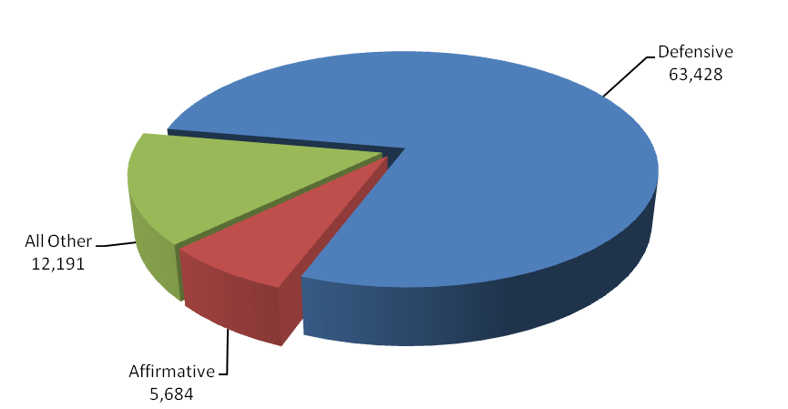

Between FY 2004 and FY 2009, the number of civil cases filed or responded to increased by
4 percent or 3,500 - from 77,803 cases to 81,303, and the number of civil cases referred to U.S. Attorneys increased by 5 percent or 3,892 - from 86,316 in FY 2004 to 90,208 cases in FY 2009. The number of defensive civil cases filed increased by 22 percent or 11,546 - from 51,882 cases in FY 2004 to 63,428 in FY 2009. A change in the interpretation of the U.S. Sentencing Guidelines in January 2005 increased the number of civil cases filed between FY 2006 and FY 2009. The number of affirmative cases filed has decreased by 24 percent or 1,830 - from 7,514 cases in FY 2004 to 5,684 in FY 2009.

In FY 2009, 91 percent of all judgments in affirmative civil cases were in favor of the United States, the highest favorable judgment rate of all case classes. Through affirmative litigation, the U.S. Attorneys collected $2.29 billion in civil debts owed to the United States, which is more than the U.S. Attorneys’ FY 2009 budget.

2. Performance Tables

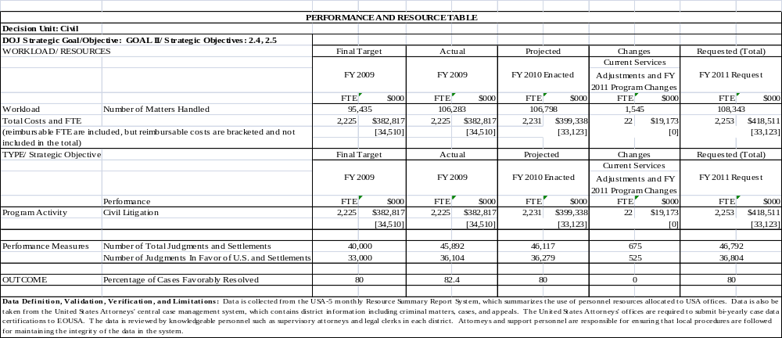

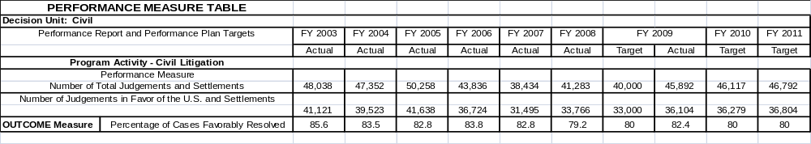

3. Performance, Resources, and Strategies

The Civil Decision Unit contributes to the Department’s Strategic Goal II: Prevent Crime, Enforce Federal Laws and Represent the Rights and Interests of the American People. Within this goal, the Civil Decision Unit’s resources specifically address two of the Department’s Strategic Objectives: 2.6 - Uphold the civil and Constitutional rights of all Americans, and 2.7 - Vigorously enforce and represent the interests of the United States in all matters for which the Department has jurisdiction.

a. Performance Plan and Report for Outcomes

Prosecution of civil litigation is an essential and vital component of the mission of the U.S. Attorneys. Civil cases prosecute fraud, waste, and abuse in federal programs and ensure that the government is fully compensated for the losses and damages caused by those who have enriched themselves at the government’s expense. In addition, all lawsuits filed against the government must be defended. U.S. Attorneys represented the government in 63,428 defensive civil cases that were filed in court during FY 2009. The U.S. Attorneys’ successes in civil litigation preserve taxpayer dollars and uphold the requirements and intent of federal laws and programs.
••• Mortgage Fraud At a Glance •••

In the District of New Jersey, Michael McGrath pleaded guilty in June, 2009 to mail and wire fraud and money laundering charges in connection with a $139 million fraud scheme that bankrupted U.S. Mortgage Corporation and its subsidiary, CU National Mortgage, LLC. As the former president of U.S. Mortgage, he conspired to fraudulently sell loans belonging to various credit unions and use the proceeds to fund U.S. Mortgage’s operations and his personnel investments. When U.S. Mortgage’s financial conditions deteriorated, he sold hundreds of loans to Fannie Mae without the knowledge and consent of the credit unions that owned the loans.

The performance measure for civil litigation relates to the percentage of judgments and settlements resolved in favor of the government. The target for FY 2009 was 80 percent and the actual figure was 82.4 percent.

b. Strategies to Accomplish Outcomes

The two biggest challenges for U.S. Attorneys are to maintain a high favorable resolution rate with existing resources and for AUSAs in particular to adjust to the increased use of technology in the practice of law. Technology is providing a means to increase productivity with existing resources. However, civil cases are increasingly “electronic” – meaning that technology plays a major role in areas such as electronic filing and E-Discovery. Some AUSAs and support staff have difficulty making the transition to these different approaches. Technical training and hiring employees with the appropriate skill sets are both part of the U.S. Attorneys’ strategy for the successful furtherance of our mission.

- LEGAL EDUCATION

Legal Education TOTAL | Perm. Pos. | FTE | Amount
2009 Enacted with Rescissions | 48 | 48 | $20,052,000
2010 Enacted | 48 | 48 | 26,039,000
Adjustments to Base | -- | -- | 722,000
2011 Current Services | 48 | 48 | 26,761,000
2011 Program Increases | … | … | …
2011 Program Offsets | … | … | (12,000)
2011 Request | 48 | 48 | 26,749,000
Total Change 2010-2011 | -- | -- | $710,000

Legal Education —Information Technology Breakout (of Decision Unit Total) | Perm. Pos. | FTE | Amount
2009 Enacted with Rescissions | 19 | 19 | $6,864,000
2010 Enacted | 20 | 20 | 7,568,000
Adjustments to Base | -- | -- | 761,000
2011 Current Services | 20 | 20 | 8,329,000
2011 Program Increases | -- | -- | …
2011 Request | 20 | 20 | 8,329,000
Total Change 2010-2011 | -- | -- | $761,000

1. Program Description–Legal Education

The Office of Legal Education (OLE) develops, conducts, and authorizes the training of all federal legal personnel [28 C.F.R. §0.22 (1990)]. OLE coordinates legal education and attorney training for the Department of Justice and other departments and agencies of the Executive Branch. Virtually all of OLE’s classroom training is conducted at the National Advocacy Center (NAC), a premier federal training facility in Columbia, South Carolina. The NAC features an integrated instructional and residential facility augmented by a conference and research center with student and support services on site.

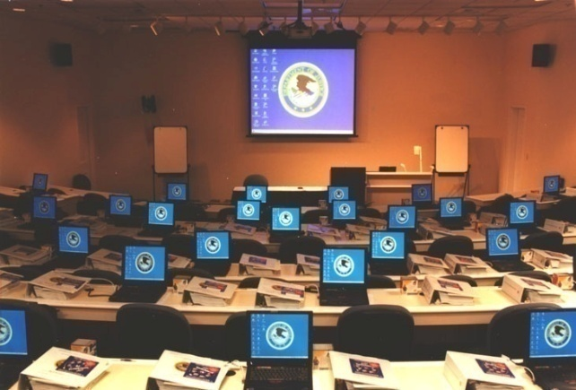
In FY 2009, OLE was responsible for the management of 303 events at the NAC, including 235 classroom events such as traditional advocacy training, national conferences, seminars, symposia and educational forums on substantive areas of the law provided. In FY 2009, approximately 23,725 individuals were trained, of which 16,624 attended live training through courses or other events hosted by OLE and 7,101 individuals received training through one of OLE’s distance education offerings, including continuing legal education programs broadcast via satellite, video-on-demand, and other means. Seventy-six percent of the 23,725 individuals, or approximately 17,993, were Justice employees in legal positions while the other 24 percent or 5,732 were non-Justice employees in legal positions with various federal agencies or state and local government. More than 4,044 individuals receiving training at the NAC attended courses in areas covered in the Department’s Strategic Plan, including Fraud and Cybercrime, Crimes Against Children, and Anti-Terrorism.


In FY 2007, OLE introduced Video on Demand (VOD), permitting users to view OLE programming “on demand” at their desktop. OLE continued to add new content to its VOD library accessed through JUSTLearn, and there are currently more than 519 programs available, including training videos on Criminal Trial Advocacy, Core Competencies in Federal Civil Law, and a New Employee Orientation video containing all of the mandatory programs new DOJ employees must view. In FY 2009, approximately 82,503 employees accessed the VOD library, viewing available videos more than 143,300 times. The “Week in Review” (WIR), a weekly series of news clips highlighting the accomplishments of the USAOs nationwide, continues to be among the more popular VOD offering with 34,735 viewers in FY 2009, up from the 22,320 viewers in FY 2007. Another new feature allows Training Officers to record in JUSTLearn other training events such as a group viewing of a Justice Television Network (JTN) show or VOD show, online courses, district-wide training, self-study, and college courses.

••• PARTNERS IN LEGAL EDUCATION •••
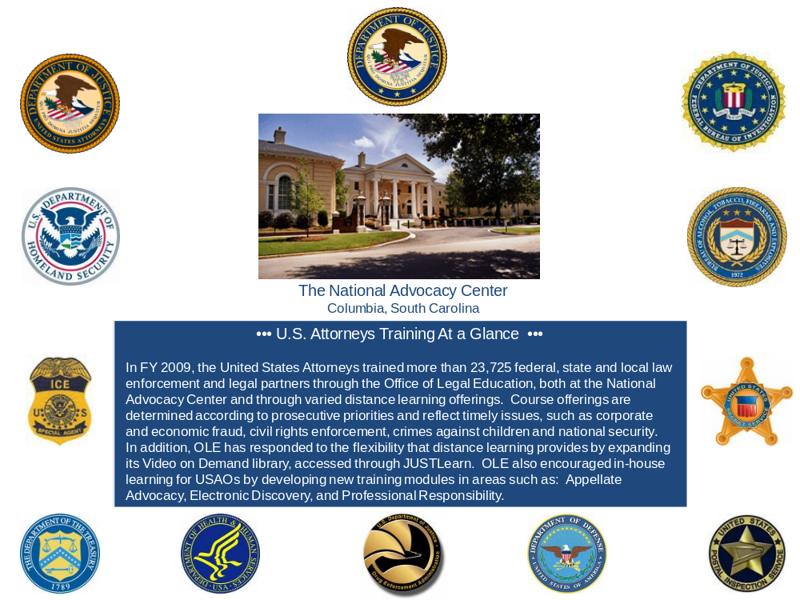
Since the opening of the NAC in April 1998, OLE has engaged in a collaborative effort with the National District Attorneys Association (NDAA) and the Executive Office for United States Trustees to create a premier training center that brings together federal, state, and local prosecutors to train in a state-of-the-art facility. In FY 2009, training for NDAA personnel was paid for through a grant administered by the Office of Justice Programs. During FY 2009,
1,513 people attended courses sponsored by these two training partners.

The Publications Unit of the Office of Legal Education edits and publishes the United States Attorneys’ Manual, the United States Attorneys’ Bulletin, and a number of practical skills manuals. OLE’s Publications Unit remained busy in FY 2008 with the publication of 6 editions of the United States Attorneys’ Bulletin on a variety of topics, including Asset Forfeiture, Identity Theft, Electronic Discovery, and Civil Rights, all of which are accessible on the Department of Justice intranet website. The Publications Unit continued to maintain and update the USABook Online Library, which has now grown to include hundreds of policy manuals, textbooks, and monographs and has become a federal practice encyclopedia. In FY 2009, the USABook site experienced nearly 2.5 million page views, up from 1.5 million in FY 2007.

OLE initiated the JTN during FY 2001. JTN is a satellite-based system that provides training and news to the 94 USAOs, as well as branch offices. The JTN schedule includes 40 hours of programming each week, and a 15 hour "re-feed" to the West Coast each workday. In FY 2009, OLE provided 2,030 hours of programming through JTN. In an effort to enhance its distance learning options for USAOs, OLE developed new training modules on Appellate Advocacy, Electronic Discovery, Professional Responsibility, and Retirement Planning, and updated the Grand Jury module. A copy of each module was sent to every district in FY 2008 to be used for in-house training.

Continuing legal education (CLE) credit is provided through OLE for many OLE-sponsored courses. OLE is the primary source of instruction for Department of Justice attorneys and AUSAs from the 94 USAOs. Basic programs for newly hired attorneys include criminal, civil, and appellate advocacy; federal practice seminars; and specialty courses in priority substantive areas of the law. Advocacy skills programs are available to new and advanced trial attorneys. The Federal Practice Program is designed for attorneys with litigation experience who are new to the federal civilian legal system (e.g., former state and military prosecutors), and as continuing training for Department of Justice attorneys after the basic criminal, civil, and appellate advocacy courses. In FY 2009, OLE provided an additional 8,500 CLE programs to USAO and Department of Justice attorneys over the Internet.

OLE continued its tradition of providing training support to Department of Justice personnel assisting foreign prosecutors through the Criminal Division’s Office of Overseas Prosecutorial Development, Assistance and Training (OPDAT). OLE hosted briefings and tours of the NAC for visiting prosecutors from Korea, Qatar, Bulgaria and Indonesia.

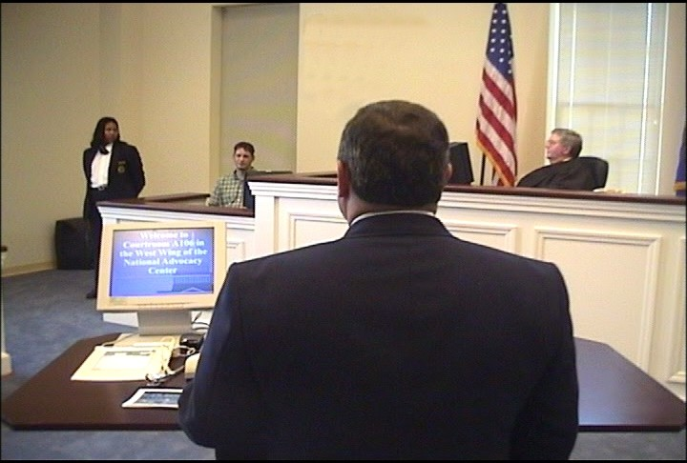
For all its programs, OLE uses experienced federal trial and appellate attorneys as instructors to present lectures, lead discussion groups, direct evidentiary exercises, and offer personalized critiques. Federal judges also participate in OLE's advocacy courses, presiding over mock trials and mock appellate arguments. The caliber of the OLE faculty and the use of sophisticated videotaping facilities provide students with unique training experiences in trial and appellate advocacy. A significant feature of the advocacy training is the use of "learn-by-doing" exercises which concentrate on courtroom skills. These exercises simulate courtroom activities and provide students with classroom critiques and individual video replay analysis. Finally, OLE is meeting the demand for attorney management training for senior criminal and civil attorneys by providing management courses for attorney supervisors of all levels.

OLE conducts programs on federal, civil, and administrative law practices for attorneys in the Executive Branch, including those in the Department of Justice. OLE offers training in civil discovery and trial techniques; negotiation techniques; and administrative law areas such as bankruptcy, the Freedom of Information Act, ethics, environmental law, federal employment, regulatory processes, government contracts, legal research and writing for attorneys, management of attorneys, and computer crime. Course instruction emphasizes the realities of federal practice. Federal attorneys from every agency, including the Department of Justice, are participants as well as advisors, curriculum developers, lecturers, and instructors. Most instructors come from a cadre of federal prosecutors. On a few occasions, OLE also contracts with professional educators as instructors for these courses.

OLE develops and administers paralegal courses covering basic and advanced skills in civil, criminal, and appellate practice. Training for other support staff personnel (e.g., legal assistants, systems managers, Administrative Officers and Budget Officers) in USAOs is provided through OLE, which develops the curriculum and recruits instructors.

2. Performance Table

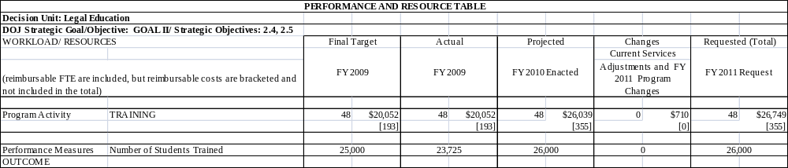

3. Performance, Resources, and Strategies

The Legal Education Decision Unit contributes to the Department’s Strategic Goal I: Prevent Terrorism and Promote the Nation’s Security. Within this goal, the decision unit’s resources address three of the Department’s Strategic Objective: 1.3 - Prosecute those who have committed, or intend to commit, terrorist acts in the United States.

The Legal Education Decision Unit also contributes to Goal II: Prevent Crime, Enforce Federal Laws and Represent the Rights and Interests of the American People. Within this goal, the decision unit’s resources address five of the Department’s Strategic Objectives: 2.2 - Reduce the threat, incidence, and prevalence of violent crime; 2.3 - Prevent, suppress, and intervene in crimes against children; 2.4 - Reduce the threat, trafficking, use, and related violence of illegal drugs; 2.5 - Combat public and corporate corruption, fraud, economic crime, and cybercrime; 2.6 - Uphold the civil and constitutional rights of all Americans; and 2.7 - Vigorously enforce and represent the interests of the United States in all matters for which the Department has jurisdiction.

a. Performance Plan and Report for Outcomes

The performance measure for this decision unit is the number of students trained. In FY 2009, OLE sponsored classroom training and other live events for 16,624 students. In addition, approximately 7,101 students were trained via satellite, videotape, and other means, for a total of 23,725 students trained in FY 2009.
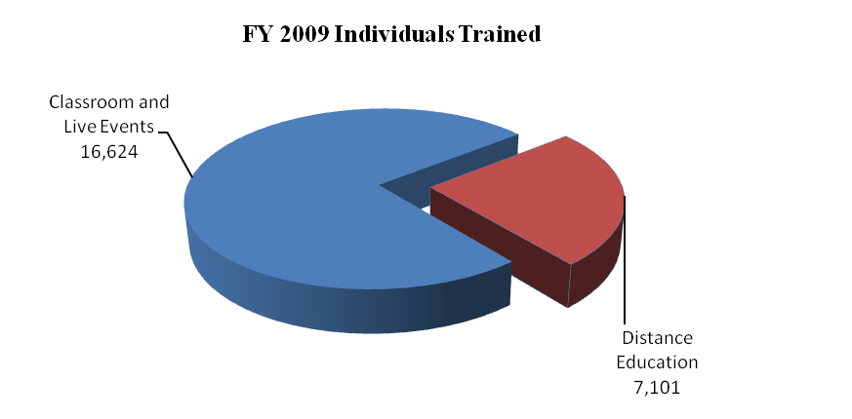
This compares with a total of 23,250 in FY 2008 – 17,500 students trained in-person and 5,750 students trained by satellite, videotape and other training. Seventy-six percent of the 23,725 individuals were Department of Justice employees in legal positions while the other 24 percent were non-Department of Justice employees in legal positions with various federal agencies or state and local government. OLE anticipates training a total of 26,000 students in each of
FYs 2010 and 2011 in combined classroom, satellite and other training.

DOJ DIV = DOJ Litigative Divisions
DOJ BUREAUS = FBI, DEA, ATF, BOP, NSD, etc
OTHER = State and Local
FED AGENCIES = DOD, HHS, DHS, USPS, etc

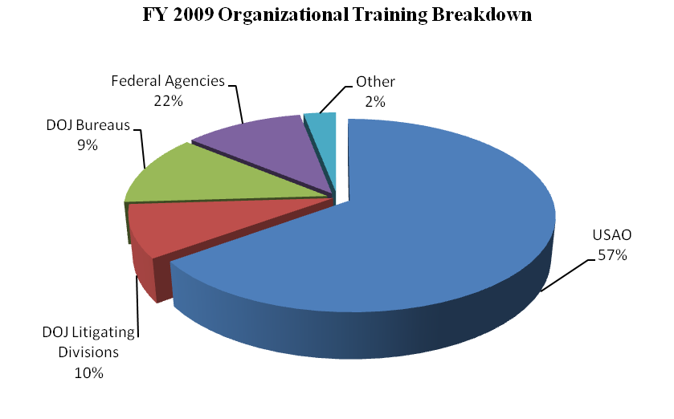

More than 4,400 of the participants receiving OLE training at the NAC attended courses in topical areas covered in the Department’s Strategic Plan, including Fraud and Cybercrime, Crimes Against Children, and Anti-Terrorism.

Overall in FY 2009, OLE was responsible for the management of 303 events, including traditional advocacy training, national conferences, seminars, symposia, and educational forums on substantive areas of the law. During FY 2008, OLE expanded VOD and approximately 82,500 individuals accessed the VOD library viewing available programs more than 143,300 times. There are now over 519 separate programs available through VOD. Additionally, during FY 2009, 1,513 people attended courses sponsored by OLE’s two training partners, the NDAA and the National Bankruptcy Training Institute.

b. Strategies to Accomplish Outcomes

The U.S. Attorneys will continue to ensure that high quality legal education is available for basic and advanced legal training through traditional classroom instruction and expanded use of JTN and distance learning. Enhanced training will be needed to support the requested Financial and Mortgagee Fraud, International Organized Crime, Preserve Justice, and E-Discovery initiatives.

VI. Program Increases by Item

Item Name: Combating Financial and Mortgage Fraud

Budget Decision Unit(s): Criminal

Strategic Goal(s) & Objective(s): Goal II: Prevent crime, enforce federal laws, and represent the rights and interests of the American people.
Objective 2.5: Combat public and corporate corruption, fraud, economic crime, and cybercrime.

Component Ranking of Item: 1

Program Increase: Positions: 109 Atty: 88 FTE 82 Dollars $17,224,000

Description of Item

In FY 2011, the United States Attorneys request a total of 109 positions (88 attorneys), 82 FTE, and $17,224,000 for Combating Financial and Mortgage Fraud. This FY 2011 request addresses two distinct funding issues, 1) base funding required in FY 2011 of $10,607,000, to fully fund the 55 positions (45 attorneys) that had been originally provided for with FY 2009 supplemental funding—which will expire at the end of FY 2010, and 2) an FY 2011 enhancement request of $6,617,000, for 54 positions (43 attorneys) to investigate and prosecute financial and mortgage fraud related cases. The resources will be allocated based on a competitive process with emphasis on districts experiencing a high prevalence of financial fraud.

Base Funding for Positions Received in FY 2009 Supplemental

The FY 2009 Supplemental Appropriations Act, P.L. 111-32, provided the United States Attorneys’ Offices (USAOs) 55 positions (45 attorneys) to investigate and prosecute mortgage fraud, predatory lending, financial fraud, and market manipulation matters. These prosecutorial resources will enable the U.S. Attorney community the ability to quickly address the increasing number of mortgage and financial fraud cases referred by the FBI for prosecution.

However, the FY 2009 Supplemental funding will expire at the end of FY 2010. Given the fact that varied and multi-faceted fraud cases will continue to increase into the foreseeable future and the fact that financial fraud cases are highly complex, frequently take a year or more to bring to completion, and given that the financial and mortgage crisis will continue to threaten the Nation's economic security, a permanent funding source is required. The request of $10,607,000 reflects the FY 2011 full year cost of the 55 positions.

FY 2011 Justification

The potential impact of mortgage fraud and financial fraud on financial institutions and the stock market is clear. Mortgage fraud and related financial industry corporate fraud have shaken the world’s confidence in the U.S. financial system. Not surprisingly, fraud schemes have adapted with the changing economy. Prosecutorial efforts can provide a deterrent to engage in financial fraud activities, as well as a means of recovering funds for fraud victims.

Financial Fraud Prosecutions – The United States Government’s current effort to reduce the impact of the current economic crisis and reinvigorate the economy provides innumerable opportunities for the nation’s white collar offenders. More than $700 billion in federal funds is being disbursed under the Treasury Department’s Troubled Asset Relief Program. Additional hundreds of billions of dollars of credit is now being provided through the Federal Reserve, and additional hundreds of billions are being disbursed through the FY 2009 stimulus bill. We stand on the precipice of the largest infusion of Government funds over the shortest period of time in our Nation’s history. Unfortunately, history teaches us that an outlay of so much money in such a short period of time will inevitably draw those seeking to profit criminally. This is especially
true where the funds are to be provided by new entities who are encouraged to distribute funds quickly. One need not look further than the recent outlay for Hurricane relief, Iraq reconstruction, or the not-so-distant efforts of the Resolution Trust Corporation as important lessons. To fully address this potential criminal vulnerability, it is essential that the appropriate resources be dedicated, in advance, to meet the challenges of deterring and prosecuting fraud in connection with these programs.

Integrity in business is essential for a strong America. Citizens rely on the honesty and integrity of government officials and corporate executives. At every level – federal, state and local – it is imperative that we enforce the laws that protect the integrity of our economic systems. Corporations must be held accountable for their utilization of investors’ assets, charities must be accountable for donations, and government must be accountable for the stewardship of taxpayers’ dollars.

USAOs around the country have made progress over the past several years in uncovering and prosecuting white collar crime. Several recent investigations have shown that when financial crimes are perpetrated, it costs investors billions of dollars and thousands of workers lose their jobs. Corporate fraud has become a significant problem. Losses in these types of cases have ranged from millions to billions of dollars and white collar crime and fraud impact a growing number of our citizens.

Mortgage Fraud Prosecutions – Mortgage Fraud Rescue Scams, which promise to help struggling homeowners stave off foreclosure and keep their homes, have proliferated as foreclosure rates increase. Single cases involving rescue scams may involve hundreds of homeowners who often end up unwittingly transferring ownership of their homes to con artists. Mortgage fraud and foreclosure rescue scams routinely involve millions of dollars in losses and multiple defendants, including mortgage brokers, real estate agents, appraisers, closing agents, and false buyers and sellers who receive kickbacks. In one case alone, a mortgage fraud scheme resulted in 166 felony counts. The defendant in United States v. Hill was sentenced to 28 years in prison and ordered to pay restitution of $41.7 million. The defendant was the owner and operator of numerous corporations. He portrayed himself as a real estate developer and either individually or through one or more of the corporations he controlled, purchased and sold numerous residential properties. The defendant oversaw the conspiracy, loan fraud, wire and mail fraud, and money laundering activity related to mortgages obtained in the sale of over 50 homes and over 250 condominiums in eight condominium complexes.

While any individual who makes false statements to obtain a mortgage has committed mortgage fraud, United States Attorneys focus their resources on organized schemes involving the repeated sale of multiple properties with fraudulently inflated values – especially when those schemes involve mortgage professionals. Based on existing investigations and mortgage fraud reporting, 80 percent of all reported fraud losses involve collaboration or collusion by industry insiders.

Current rising mortgage fraud trends include: equity skimming, property flipping, and mortgage related identity theft. Equity skimming schemes involve the use of corporate shell companies, corporate identity theft, and the use or threat of bankruptcy/foreclosure to dupe homeowners and investors. Property flipping consists of purchasing properties and artificially inflating their value through false appraisals. The artificially valued properties are then repurchased several times for a higher price by associates of the "flipper." After three or four sham sales, the properties are foreclosed on by victim lenders. In order to forestall foreclosure, and thereby delay exposure of
their schemes, mortgage scam artists may file false bankruptcy cases which will, at least temporarily, prevent foreclosure.

In compiling data on mortgage fraud trends, the FBI reviews Suspicious Activity Reports (SARs) filed by financial institutions and through the Department of Housing and Urban Development Office of the Inspector General. SARs from financial institutions have indicated a significant increase in mortgage fraud reporting. For example, there were over 35,000 SARs in FY 2005 and 46,000 in FY 2006. This number jumped in FY 2008 to more than 63,000 – an 80 percent increase over the FY 2005 levels.

Based on intelligence from SARs, complaints from industry, and leads from the 18 regional Mortgage Fraud Task Forces and 50 regional mortgage fraud working groups, the FBI has reallocated agent resources to address this crisis. To that end, the number of FBI agents investigating mortgage fraud has increased over 108 percent since FY 2007. In FY 2009, the FBI received an enhancement of 25 agents to address mortgage fraud and an additional 50 agents in the Enacted FY 2010 Budget. The FBI’s increase in mortgage fraud investigations does not include the increase in investigations handled by other law enforcement agencies, including HUD’s Office of the Inspector General, the Postal Inspection Service and the Internal Revenue Service.

Based on the projected case productivity of the additional FBI agents, the United States Attorneys require a requisite increase of a total of 88 Assistant United States Attorneys in order to prosecute these new cases. The number and complexity of white collar crime cases for the
United States Attorneys continues to grow. However, base resources have not kept pace with such growth. Pending United States Attorney cases for white collar fraud (which includes
mortgage fraud) increased 2% in FY 2009. Despite receiving 14 Assistant United States Attorneys for mortgage fraud in FY 2009 and 35 Assistant United States Attorneys in the FY 2010 Budget, the United States Attorneys cannot keep pace with new FBI resources and caseloads resulting from FBI financial crime investigations.

The collaboration of USAOs in each of the FBI’s Mortgage Fraud Task Forces and Working Groups, the targeted mortgage fraud training provided at the National Advocacy Center, and the enhanced ability to track mortgage fraud prosecutions through Legal Information Office Network System (LIONS) are resulting in significant accomplishments.

For example, in the District of New Jersey in June 2009, the former president and director of U.S. Mortgage, Michael McGrath, pleaded guilty to mail and wire fraud and money laundering charges in connection with a $139 million fraud scheme that bankrupted U.S. Mortgage Corporation and its subsidiary, CU National Mortgage, LLC. McGrath conspired to fraudulently sell loans belonging to various credit unions and use the proceeds to fund U.S. Mortgage’s operations and his personnel investments. The scheme started with the diversion of funds that
should have been paid to various credit unions for mortgage loans they had made and authorized CU National to sell to Fannie Mae. McGrath withheld these funds to help U.S. Mortgage address cash flow problems caused by losing investments in mortgage-backed securities he had made on the company’s behalf. When U.S. Mortgage’s financial conditions deteriorated, he sold hundreds of loans to Fannie Mae without the knowledge and consent of the credit unions that owned the loans. To accomplish the fraudulent loans, he executed documents assigning the loans from the credit unions to U.S. Mortgage in which he pretended to be an officer of the credit unions in question. He also caused subordinates at U.S. Mortgage to execute documents purporting to assign the loans from U.S. Mortgage to Fannie Mae. The scheme netted $139 million.

In June 2009, in the Northern District of Illinois, the former Chief Executive Officer of the former Home Mortgage Inc., Lawrence Luckett, was charged with bank fraud. According to the charges, Home Mortgage funded loans it made by borrowing money from other lenders. After issuing a mortgage, Home Mortgage sold the loan to a third party, typically a financial institution that invested in mortgages and used the proceeds from the sale of the loan to repay its lender. Between August 2007 and March 2008, Luckett and an employee he directed allegedly submitted requests to GMAC Bank and an affiliated lender for more than 450 fictitious residential mortgage loans, causing GMAC a loss in excess of $15 million. Luckett and his employee allegedly fabricated and submitted to GMAC documents related to borrowers, biographical and property information for non-existent loans purportedly to be made by Home Mortgage. Instead of using the money advanced by GMAC to fund loans, Luckett allegedly used the money to continue operations of Home Mortgage and to pay various personal expenses.

Impact on Performance
This initiative will address Strategic Goal II, Prevent crime, enforce federal laws, and represent the rights and interests of the American people, including Objective 2.5, Combat public and corporate corruption, fraud, economic crime, and cybercrime.

Prosecutorial efforts can provide a deterrent to engage in financial fraud activities, as well as a means of recovering funds for fraud victims. In the wake of the $160 billion savings and loan crisis of the 1980s, the Department of Justice realized more than 600 convictions and $130 million in restitution. This resulted from the dedication of 1,000 agents and forensic investigators and dozens of federal prosecutors. Current estimations point to global financial institutions losing more than $1 trillion in assets as a result of the economic crisis our country is now experiencing.

Combating Financial and Mortgage Fraud Initiative

Base Funding

FY 2009 Enacted |  |  |  | FY 2010 Enacted Budget |  |  |  | FY 2011 Current Services
Pos | Agt/  Atty | FTE | Dollars | Pos | Agt/  Atty | FTE | Dollars | Pos | Agt/  Atty | FTE | Dollars
2,219 | 1,441 | 2,219 | $290,095,000 | 2,262 | 1,476 | 2,240 | $303,397,000 | 2,262 | 1,476 | 2,262 | $305,158,000
Base funding amounts include all white collar crime resources, including financial and mortgage fraud, but does not include the FY 2009 Supplemental of 55 positions (45 attorneys) and $10.0 million.

Personnel Increase Cost Summary

Type of Position | Modular Cost  per Position | Number of Positions Requested | FY 2011  Request | FY 2012  Net Annualization  (change from 2011)
Attorney | 135,511 | 43 | $5,827,000 | $3,315,000
Paralegal | 71,796 | 11 | 790,000 | 362,000
Total Personnel |  | 54 | $6,617,000 | $3,677,000

Non-Personnel Increase Cost Summary

Non-Personnel Item | Unit Cost | Quantity | FY 2011 Request | FY 2012 Net  Annualization  (Change from 2011)
Total Non-Personnel | N/A | N/A | N/A | N/A

Total Request for this Item

 | Pos | Agt/Atty | FTE | Personnel | Non-Personnel | Total
Current Services | 2,262 | 1,476 | 2,262 | $303,158,000 | $1,404,000 | $305,158,000
Increases* | 109 | 88 | 82 | 17,224,000 | 0 | 17,224,000
Grand Total | 2,371 | 1,564 | 2,344 | $320,382,000 | $1,404,000 | $322,382,000
*Total increases include $10,607,000 for the annualization of 55 positions (45 attorneys) received in the FY 2009 Supplemental.

Item Name: International Organized Crime Prosecutions

Budget Decision Unit(s): Criminal

Strategic Goal(s) & Objective(s): Goal I: Prevent Terrorism and Promote the Nation’s Security.
Objective 1.3: Prosecute those who have committed or intend to commit terrorist acts in the United States.
Goal II: Prevent crime, enforce federal laws, and represent the rights and interests of the American people.
Objective 2.2: Reduce the threat, incidence, and prevalence of violent crime.
Objective 2.5: Combat public and corporate corruption, fraud, economic crime, and cybercrime.

Component Ranking of Item: 2

Program Increase: Positions 8 Atty 5 FTE 4 Dollars $881,000

Description of Item

In FY 2011, the United States Attorneys request 8 positions (5 attorneys), 4 FTE, and $881,000 for prosecutions associated with the Department’s International Organized Crime Initiative. In concert with the efforts of other components, this request will strengthen critical prosecutorial resources and capabilities and provide resources to support one new Organized Crime Strike Force. These additional resources are needed to enhance our ability to thwart international organized crime activities that threaten our national security and undermine our economy.

Justification

The Department of Justice’s Law Enforcement Strategy to Combat International Organized Crime (IOC Strategy or the Strategy) represents a major step forward in our national response to organized crime. It responds directly to the International Organized Crime Threat Assessment completed in October 2007. This assessment established that organized crime can no longer be associated exclusively with traditional, domestic groups, but is now fully international in its origin, composition, and scope. International organized crime poses unprecedented threats to the United States’ national and economic security. These threats range from attempts by organized criminals to 1) exploit our energy and other strategic sectors; 2) support terrorists and hostile governments; 3) manipulate our financial, securities, and commodities markets; and 4) other serious criminal activities.

The Strategy recognizes that the new realities of international organized crime (IOC) demand a strategic, targeted, and concerted U.S. Government response in which the Department will play a leading role. It presents a comprehensive plan to ensure that the federal law enforcement community has the tools, capabilities, and resources needed to reduce the growing threat IOC poses to the United States and its citizens. The Strategy emphasizes that its success will hinge on close cooperation among U.S. law enforcement, the intelligence community, and our non-law enforcement partners to marshal intelligence, target IOC figures and groups, and utilize all available means to thwart IOC activities.

The Council that developed the Strategy included the heads of the Department of Justice’s law enforcement organizations, as well as members of partner federal agencies such as the U.S. Immigration and Customs Enforcement, the Internal Revenue Service, the U.S. Postal Inspection Service and the Secret Service. The Attorney General, who by executive order is responsible for coordinating all federal law enforcement activity against organized crime, adopted the Strategy on April 7, 2008. The Strategy consists of nine strategic goals that emphasize programmatic areas cutting across all international organized crime threats. Some goals propose new tools and capabilities needed to combat IOC, while others enhance or improve existing tools and capabilities. Each strategic goal encompasses specific objectives and actions that will enable the Department and its law enforcement partners to achieve measurable results in combating the threats posed by international organized crime.

A key strategic goal in the IOC Strategy is to “pursue concerted, high-impact domestic law enforcement operations against International Organized Crime Targets.” The achievement of this goal – and the success of the strategy as a whole – will hinge on the ability of U.S. law enforcement to effectively and efficiently focus investigative, prosecutorial, and intelligence resources on thwarting international organized crime activities that threaten our national security and undermine our economy. This will require harnessing critical prosecutorial and intelligence resources and capabilities currently situated in United States Attorneys’ Offices (USAOs) across the country.

One of the most important prosecutorial resources available in USAOs to combat international organized crime is the Organized Crime Strike Force program. The Strike Forces are responsible for prosecuting cases against organized criminal enterprises operating in or affecting the United States. While the Organized Crime Strike Force program remains highly effective in the districts in which such task forces are in operation, the prosecutorial capacity is largely consumed by traditional organized crime cases, such as La Cosa Nostra (LCN), and other domestic organized crime entities, including gangs. Moreover, those districts themselves were selected primarily based on the original LCN threat. Accordingly, additional resources for districts addressing international organized crime are required to re-baseline and effectively implement the Strategy.

Impact on Performance

This initiative will address Strategic Goal I, Prevent terrorism and promote the nation’s security, including Objective 1.3, Prosecute those who have committed or intend to commit, terrorist acts in the United States and Strategic Goal II, Prevent crime, enforce federal laws, and represent the rights and interests of the American people, including Objective 2.2, Reduce the threat, incidence, and prevalence of violent crime and Objective 2.5, Combat public and corporate corruption, fraud, economic crime, and cybercrime..

Several of the Strategy’s objectives require extensive additional USAO participation and resources. As many of the law enforcement initiatives of the Strategy come to fruition and cases are brought forward, there will likely be capacity constraints in the USAOs that lead to prosecutorial bottlenecks. Indeed, many of the cases generated will be of a relatively complex nature (e.g. money laundering, asset forfeiture) or require extra time-intensive methods of investigation and proof (e.g. seeking international investigative assistance). The sheer number of cases is likely to continue to increase as well as specific initiatives such as information sharing and crosscutting law enforcement action generate more and more indictments.

Finally, because the USAOs are the primary criminal litigating arm of the Department, anticipated increases in other Agencies’ capacities in international organized crime will further result in increased demands being placed on prosecutors in the field. In particular, the increased international organized crime efforts anticipated in cyber and intellectual property crimes, international crimes, and in asset forfeiture will all require corresponding prosecutorial capacity in the USAOs. Because such cases are almost always prosecuted with local Assistant United States Attorneys, even extra capacity in other litigating divisions will place increased demands on the USAOs.

International Organized Crime Prosecutions Initiative

Base Funding

FY 2009 Enacted |  |  |  | FY 2010 Enacted Budget |  |  |  | FY 2011 Current Services
Pos | Agt/  Atty | FTE | Dollars | Pos | Agt/  Atty | FTE | Dollars | Pos | Agt/  Atty | FTE | Dollars
168 | 110 | 168 | $22,035,000 | 168 | 110 | 168 | $22,476,000 | 168 | 110 | 168 | $23,240,000
Base funding amounts include all organized crime resources including international organized crime.

Personnel Increase Cost Summary

Type of Position | Modular Cost  per Position | Number of Positions Requested | FY 2011  Request | FY 2012  Net Annualization  (change from 2011)
Attorney | 135,511 | 5 | $678,000 | $385,000
Paralegal | 71,796 | 2 | 144,000 | 65,000
Clerical | 59,308 | 1 | 59,000 | 29,000
Total Personnel |  | 8 | $881,000 | $479,000

Total Request for this Item

 | Pos | Agt/Atty | FTE | Personnel | Non-Personnel | Total
Current Services | 168 | 110 | 168 | $23,240,000 | $-- | $23,240,000
Increases | 8 | 5 | 4 | 881,000 | -- | 881,000
Grand Total | 176 | 115 | 172 | $24,121,000 | $-- | $24,121,000

Item Name: Preserving Justice Initiative

Budget Decision Unit(s): Civil

Strategic Goal(s) & Objective(s): Goal II: Prevent crime, enforce federal laws, and represent the rights and interests of the American people.
Objective 2.7: Vigorously enforce and represent the interests of the United States in all matters over which the Department has jurisdiction.

Component Ranking of Item: 3

Program Increase: Positions: 30 Atty: 20 FTE: 15 Dollars: $3,428,000

Description of Item

In FY 2011, the United States Attorneys are requesting 30 positions (20 attorneys), 15 FTE, and $3,428,000 for the Preserving Justice Initiative to augment resources for civil defensive litigation. The resources will be allocated based on a competitive process with emphasis on districts experiencing high civil defensive caseloads.

Additional funding for civil defensive Assistant United States Attorney (AUSA) positions is necessary to perform the non-discretionary duty of the Department of Justice to protect and defend the United States, its agencies and employees in civil defensive litigation. No money has been provided for additional civil defensive AUSA positions in more than 20 years. There has been, however, a significant increase in the number of civil defensive cases United States Attorneys’ Offices (USAOs) are required to defend. In addition, the defense of these cases has become more complex and costly. Continued rise in the number of civil defensive cases and associated costs are virtually guaranteed, due to a number of recent legislative changes in substantive areas of civil defensive practice and amendments to the Federal Rules of Civil Procedure, among other things. Resources will be allocated based on a competitive process to districts with significant civil defensive litigation caseloads.

Justification

Overview of Increases in Civil Defensive Litigation

Unlike most areas of litigation in which the Department is involved, USAOs do not have discretion on whether or not to defend the United States, its agencies or employees, acting within the scope of their federal employment. Rather, USAOs are required to provide a defense in an ever increasing number of cases. In FY 2009, 78 percent of all civil cases filed were defensive civil cases. From FY 2000 to FY 2009, the number of cases filed with the United States as defendant increased by 22 percent.

This rise can be accounted for, in part, by an increase in the number of Bivens cases, commercial litigation cases, and the growing number of Federal Tort Claims Act medical malpractice actions arising from care and treatment rendered by Community Health Centers (CHC). United States Attorneys’ Offices were called on to prepare appellate briefs when the circuit courts placed immigration cases on a fast track to eliminate the huge backlog of asylum cases. For example, Bivens case filings increased by 10 percent, and CHC malpractice claims increased by 81 percent. From FY 2004 to FY 2009, defensive commercial cases filed rose from 18,465 to 30,695, representing a 66 percent increase in commercial litigation cases that USAOs were called on to defend.

Increases in Civil Defensive Litigation Anticipated

CHC Cases

The increase in medical malpractice actions arising out of CHCs is anticipated to continue, warranting allocation of additional civil defensive attorney positions. Prior to 1995, United States Attorneys’ Offices did not have any of these actions to defend. This changed with the passage of the Federally Supported Health Centers Assistance Act of 1992 and 1995, granting medical malpractice liability protection through the Federal Tort Claims Act (FTCA) to federally-funded community health centers. Under the Act, health centers and their health care providers are considered Federal employees and are immune from lawsuits, with the Federal government acting as their primary insurer. The purpose of the law was to increase funding available for patient care services by reducing the expenditure of funds for spiraling malpractice insurance premiums.

The CHC program is expanded annually to include additional facilities and to extend coverage to new providers. In 1996, the Department of Health and Human Services (HHS), estimated that there were 14,234 CHC health care providers deemed employees of the United States for purposes of the FTCA. As of 2007, HHS estimated that there were 41,000 covered health care providers, representing an almost 200 percent increase over the preceding 11 years, in the number of covered providers whose care and treatment the USAOs are required to defend in the event of litigation. The American Recovery Reinvestment Act of 2009 (ARRA), provides for an additional $2.0 billion to expand the services provided and the population covered by CHCs.

A patient who alleges medical malpractice by a covered health center cannot sue the provider directly, but must file the claim against the United States. CHC cases are time consuming and expensive to litigate. They are serious and complex medical malpractice claims and require detailed medical records analysis involving considerable study by the attorneys, paralegals and nurse-paralegals. Patient records, which are often voluminous, must frequently be obtained from numerous non-federal providers at USAO expense. Experts and consultants must be retained in many fields to testify about medical issues relating to liability, long term health care, rehabilitation, psychological damage and economic issues such as lost future wages. Retention of experts in CHC cases is very costly. It is not unusual to pay one expert up to $25,000 to $30,000 for review, preparation and testimony in a malpractice case.

With additional professional support personnel, AUSAs will be able to make better use of their time. The availability of in-house nurse paralegals will enable AUSAs to develop an effective litigation strategy early in the life of the action, focus on the legal issues, and advance the litigation and or resolve meritorious cases more quickly with fewer attorney hours expended.

Bivens Litigation

An upsurge in Bivens litigation is expected to continue due to expansion of prison facilities and Department of Homeland Security (DHS) detention centers. As an example, in the Southern District of Indiana, cases filed in FY 2008 with the United States as defendant increased by 20 percent over filings for FY 2007. Part of the increase is attributable to a greater number of Bivens actions arising out of the Federal Correction Complex at Terre Haute, Indiana. An increase in the prison population, and the expansion of the medical and communication management units at that facility resulted in increased Bivens actions filed against federal prison guards and medical personnel.

Employment Discrimination Litigation

Although statistical employment cases make up only a small percentage of civil defensive cases, they consume more than 19 percent of civil defensive AUSA’s time.

Two recent legislative changes are anticipated to increase United States Attorneys Offices’ workload in defending employment discrimination actions. The Ledbetter v. Goodyear Tire & Rubber Co.,, 550 U.S. 618 (2007), held that the time limit for filing a charge of employment discrimination involving pay and raises with the Equal Employment Opportunity Commission (EEOC) is triggered only by the decision setting compensation, not by each paycheck affected by the discriminatory compensation-setting decision. Following that decision, the Lilly Ledbetter Fair Pay Act of 2009 was passed and could be interpreted, according to the plain meaning of its language, to require a government employee contact an EEO counselor within 45 days of receipt of any paycheck impacted by the original allegedly discriminatory act. Thus, claims could be brought years after the precipitating event. As such, most, if not all, EEO plaintiffs will likely raise claims for events that occurred throughout their tenure at the agency, not just for the act that finally brought them into the EEO office. This will result in a significant increase in AUSA workloads.

The second change that will impact the workload of civil AUSAs involves the Americans with Disabilities Act (ADA) Amendments of 2008 Pub. L. 110-325, 122 Stat. 3553-3559 (Sept. 25, 2008), which became effective on January 1, 2009. The Amendments substantially broaden the definition of "disability" by redefining "major life activities" to include not only individuals who are unable to walk, see, hear, etc., but also anyone with an impairment that substantially limits the operation of a "major bodily function" (e.g., immune system, and respiratory, digestive, circulatory, endocrine and reproductive functions). The net result is that it will be significantly easier to establish disability under the Act. The Amendments are likely to have a significant impact on civil defensive AUSAs’ caseloads.

Impact on Performance

This initiative will address Strategic Goal II, Prevent crime, enforce federal laws, and represent the rights and interests of the American people, including Objective 2.7, Vigorously enforce and represent the interests of the United States in all matters over which the Department has jurisdiction.

Providing increases in civil defensive resources will help USAOs meet both the current and future challenges faced defending the United States in a growing number of complex cases. The current and most pressing need is in the area of medical malpractice. Moreover, as previously mentioned, the number of covered health care providers and patient population served continues to sky rocket, fast approaching 20 million.
Preserving Justice Initiative

Base Funding

FY 2009 Enacted |  |  |  | FY 2010 Enacted |  |  |  | FY 2011 Current Services
Pos | Agt/  Atty | FTE | Dollars | Pos | Agt/  Atty | FTE | Dollars | Pos | Agt/  Atty | FTE | Dollars
683 | 442 | 683 | $89,098,000 | 683 | 442 | 683 | $90,880,000 | 683 | 442 | 683 | $93,970,000

Personnel Increase Cost Summary

Type of Position | Modular Cost  per Position | Number of Positions Requested | FY 2011  Request | FY 2012  Net Annualization  (change from 2011)
Attorneys | 135,511 | 20 | $2,710,000 | $1,542,000
Paralegals | 71,796 | 10 | 718,000 | 326,000
Total Personnel |  | 30 | $3,428,000 | $1,868,000

Non-Personnel Increase Cost Summary

Non-Personnel Item | Unit Cost | Quantity | FY 2011 Request | FY 2012 Net  Annualization  (Change from 2011)
Total Non-Personnel | N/A | N/A | $-- | $--

Total Request for this Item

 | Pos | Agt/Atty | FTE | Personnel | Non-Personnel | Total
Current Services | 683 | 442 | 683 | $93,970,000 | $-- | $93,970,000
Increases | 30 | 20 | 15 | 3,428,000 | -- | 3,428,000
Grand Total | 713 | 462 | 698 | $97,398,000 | $-- | $97,398,000

Item Name: E-Discovery

Budget Decision Unit(s): Criminal

Strategic Goal(s) & Objectives: Goal I: Prevent Terrorism and Promote the Nation’s Security.
Objective 1.3: Prosecute those who have committed or intend to commit terrorist acts in the United States.
Goal II: Prevent crime, enforce federal laws, and represent the rights and interests of the American people.
Objective 2.2: Reduce the threat, incidence, and prevalence of violent crime.
Objective 2.3: Prevent, suppress, and intervene in crimes against children.
Objective 2.4: Reduce the threat, trafficking, use and related violence of illegal drugs.
Objective 2.5: Combat public and corporate corruption, fraud, economic crime, and cybercrime.
Objective 2.6: Uphold the civil and Constitutional rights of all Americans.
Objective 2.7: Vigorously enforce and represent the interests of the United States in all matters over which the Department has jurisdiction.

Component Ranking of Item: 4

Program Increase: Positions 12 Atty 2 FTE 12 Dollars $2,000,000

Description of Item

In FY 2011, the United States Attorneys request 12 positions (2 attorneys), 12 FTE, and $2,000,000 to develop a cadre of experts in E-Discovery who can perform the analysis and guidance on E-Discovery issues, facilitate conversations between litigators and information technology staff, participate in discovery conferences and oversight of support staff processing electronically-stored information. This will be done by adding support staff to assist district field offices and adding staff to the Litigation Technology Support Center.

Justification

The proper handling of Electronic Discovery (E-Discovery) and Electronic Evidence in cases brought by or against the United States is critical to the effective and efficient administration of justice. Over the last several years, the private sector has directed its efforts at developing expertise on the part of attorneys and litigation technology specialists in order to advise clients on best practices for selecting and leveraging technology in litigation. The private sector’s efforts were driven largely by amendments to the Federal Rules of Civil Procedure, as well as developing case law that imposed severe sanctions upon clients and counsel not equipped to meet the challenges presented by electronically-stored information.

Based on interviews with E-Discovery specialists from large, private law firms, as well as gleaning best practices set forth by The Sedona Conference Working Group, a “mini think tank” of legal subject matter experts, it appears that the private sector is adapting to the demands of electronic discovery by developing a cadre of lawyers with more sophisticated technical expertise who perform a number of functions, including: analyzing and providing advice on the most difficult issues; facilitating conversations between litigating components and client’s technical staff; participating in, or monitoring, Rule 26 “meet and confer” conferences and Rule 16 Pretrial conferences; and overseeing non-technical litigation support staff who may be processing and handling electronically-stored information.

Over the past year the Department has undertaken a thorough review of its approach to handling document discovery in civil litigation. The Department’s review found that the U.S. Attorneys Offices have insufficient support staff to provide technical expertise in E-Discovery. Existing support staff focuses primarily on criminal cases, particularly on trial presentation. As a result, support staff are unable to devote sufficient time to the casework demands of the civil attorney and paralegal staff engaged in E-Discovery.

Notably, when attorneys obtain technical expertise early in a case, significant gain in efficiency, mitigation of the risk of sanctions, and a reduction of errors are achieved. For example, had the lawyers in the Fannie Mae Securities civil litigation had the benefit of technical expertise when decisions regarding their response to subpoenas were made, the agency might have saved $6 million, or more than 9 percent of its annual budget to produce backups of e-mails. This type of electronically stored information when is generally protected from protection when it is “not reasonably accessible”. Moreover, had the attorneys had the benefit of technical expertise, they might have argued that mandatory cost-shifting was warranted under Rule 45 because the request was unduly burdensome as to cost.

It is difficult to quantify the number of FTE currently devoted to support staff functions because most staff identified as “litigation support staff” are dedicated to trial preparation or criminal cases rather than to civil E-Discovery; other staff are cross-designated to handle E-Discovery functions on a collateral basis. Nonetheless, the best analysis of attorney-to-support ratios suggests that the Department’s civil litigating components all have more than a 20:1 ratio of attorneys to E-Discovery support staff. According to the Sedona Conference Working Group’s findings, such a ratio is too high to provide sufficient support staff services.

To address the need for more expertise in E-Discovery matters throughout the United States Attorneys community, the U.S. Attorneys request 12 positions, including 10 support and 2 attorneys, and $2,000,000. Districts’ E-Discovery needs will be met by what is envisioned to be E-Discovery teams that will be dedicated to supporting districts having document intensive E-Discovery cases and whose current resources limit their ability to adhere to E-Discovery requirements. Teams will directly support district by deploying to a specific district for a period of time, the length of which will be determined based on the E-Discovery issue/concern the district has. This team deployment methodology will allow the U.S. Attorneys the ability to dedicate E-Discovery support and expertise where and when it is required throughout the United States Attorney community while maintaining consistency and uniformity among districts and EOUSA with respect to how E-Discovery issues are addressed.

Impact on Performance

This initiative will address Strategic Goal I, Prevent Terrorism and Promote the Nation’s Security including Objective 1.3, Prosecute those who have committed, or intend to commit, terrorist acts in the United States and Strategic Goal II, Prevent crime, enforce federal laws, and represent the rights and interests of the American people, including Objective 2.2, Reduce the threat, incidence, and prevalence of violent crime, Objective 2.3, Prevent, suppress, and intervene in crimes against children, Objective 2.4, Reduce the threat, trafficking, use, and related violence of illegal drugs, Objective 2.5, Combat public and corporate corruption, fraud, economic crime, and cybercrime, Objective 2.6, Uphold the civil and Constitutional rights of all Americans, and Objective 2.7, Vigorously enforce and represent the interests of the United States in all matters over which the Department has jurisdiction.

The implementation of E-Discovery requires a strategic, thoughtful, and timely response to the myriad of issues surrounding this area. Failure to dedicate resources to this initiative will result in a high number of contempt decisions from judges, high costs associated with hiring contractors to extract electronic information from United States Attorneys’ databases, and potentially negatively impact the outcome of the case.

E-Discovery

Base Funding

FY 2009 Enacted |  |  |  | FY 2010 Enacted |  |  |  | FY 2011 Current Services
Pos | Agt/  Atty | FTE | Dollars | Pos | Agt/  Atty | FTE | Dollars | Pos | Agt/  Atty | FTE | Dollars
-- | -- | -- | $-- | -- | -- | -- | $-- | -- | -- | -- | $--

Personnel Increase Cost Summary

Type of Position | Modular Cost  per Position | Number of Positions Requested | FY 2011  Request | FY 2012  Net Annualization  (change from 2011)
Attorneys | $225,000 | 2 | $450,000 | N/A
Professional Support | $152,000 | 10 | $1,520,000 | N/A
Total Personnel |  | 12 | $1,970,000 | N/A
The positions are costed at a full-year rate.

Non-Personnel Increase Cost Summary

Non-Personnel Item | Unit Cost | Quantity | FY 2011 Request | FY 2012 Net  Annualization  (Change from 2011)
Total Non-Personnel | N/A | N/A | $30,000 | $--

Total Request for this Item

 | Pos | Agt/Atty | FTE | Personnel | Non-Personnel | Total
Current Services | -- | -- | -- | $-- | $-- | $--
Increases | 12 | 2 | 12 | $1,970,000 | $30,000 | $2,000,000
Grand Total | 12 | 2 | 12 | $1,970,000 | $30,000 | $2,000,000

VII. Program Offsets by Item

Item Name: Travel Management Efficiencies

Budget Decision Unit(s): Criminal, Civil and Legal Education

Strategic Goal(s) & Objective(s): Goals II: Prevent terrorism, and promote the nation’s security and Prevent crime, enforce federal laws, and represent the rights and interests of the American people.
Objective 2.7: Vigorously enforce and represent the interests of the United States in all matters over which the Department has jurisdiction.

Component Ranking of Item: 5

Program Increase: Positions: … Atty... FTE … Dollars $1,166,000

Description of Item

The Department is continually evaluating its programs and operations with the goal of achieving across-the-board economies of scale that result in increased efficiencies and cost savings. In FY 2011, DOJ is focusing on travel as an area in which savings can be achieved. For the United States Attorneys, travel or other management efficiencies will result in offsets of $1,166,000. This offset will be applied in a manner that will allow the continuation of effective law enforcement program efforts in support of Presidential and Departmental goals, while minimizing the risk to health, welfare and safety of agency personnel.

Justification

Due to efforts at reducing travel expenditures and achieving efficiencies in this area, the United States Attorneys can reduce travel costs by $1,166,000 in FY 2011.

Impact on Performance

This initiative will address Strategic Goal II, Prevent crime, enforce federal laws, and represent the rights and interests of the American people, including Objective 2.7, Vigorously enforce and represent the interests of the United States in all matters over which the Department has jurisdiction.

The reduction to travel expenditures is anticipated to have no adverse impact to United States Attorney operations.

VIII. E-Gov Initiatives

The Justice Department is fully committed to the e-Government (e-Gov) initiatives. The e-Gov initiatives serve citizens, business, and federal employees by delivering high quality services more efficiently. The Department is in varying stages of implementing e-Gov solutions and services including initiatives focused on integrating government-wide transactions, processes, standards adoption, and consolidation of administrative systems that are necessary tools for agency administration, but are not core to Department of Justice’s mission. To ensure that Department of Justice obtains value from the various initiatives, the Department actively participates in the governance bodies that direct the initiatives and we communicate regularly with the other federal agencies that are serving as the “Managing Partners” to ensure that the initiatives meet the needs of the Department and its customers. The Department believes that working with other agencies to implement common or consolidated solutions will help reduce the funding requirements for administrative and public-facing systems, thereby allowing focus on more of our limited resources for higher priority, mission related needs. The Department’s contributions to the Administration’s e-Gov projects will facilitate achievement of this objective.

a. Funding and Costs

The Department of Justice participates in the following e-Gov initiatives and Lines of Business (LoB):
Business Gateway | e-Travel | Integrated Acquisition Environment | Case Management LoB
Disaster Assistance Improvement | Federal Asset Sales | IAE – Loans & Grants – Dunn & Bradstreet | Geospatial LoB
Disaster Assistance Improvement Plan – Capacity Surge | Geospatial One-Stop | Financial Management LoB | Budget Formulation and Execution LoB
e-Authentication | GovBenefits.gov | Human Resources LoB | IT Infrastructure LoB
e-Rulemaking | Grants.gov | Grants Management LoB
e-Gov Initiatives and Lines of Business (LoB)

The Department of Justice e-Gov expenses – i.e. Department of Justice’s share of e-Gov initiatives managed by other federal agencies – are paid for from the Department’s Working Capital Fund (WCF). These costs, along with other internal e-Gov related expenses (oversight and administrative expenses such as salaries, rent, etc.) are reimbursed by the components to the WCF. The U.S. Attorneys’ reimbursement amount is based on the anticipated or realized benefits from an e-Gov initiative. As such, our reimbursement to the WCF was $765,000 for FY 2009 and $836,152 for FY 2010.

b. Benefits
The U.S. Attorneys established baseline cost estimates for each IT investment being modified, replaced, or retired due to the Department’s use of an e-Gov or Line of Business initiative. The U.S. Attorneys are measuring actual costs of these investments on an ongoing basis. As the U.S. Attorneys complete migrations to common solutions provided by an e-Gov or Line of Business initiative, the U.S. Attorneys expect to realize cost savings or avoidance through retirement or replacement of legacy systems and/or decreased operational costs. The list below represents only those e-Gov initiatives and Lines of Businesses where cost benefits are expected to be realized.
Litigation Case Management Systems (LCMS). The Justice Management Division is developing and implementing a Department-wide case management system which will replace EOUSA’s legacy systems, as part of the Case Management System LoB.
e-Qip. USAOs and EOUSA are using the government-wide e-Qip system for online personnel security processing for all new hires. This saves time, reduces postage costs, and overall streamlines the process.
e-HR. EOUSA awarded a contract to procure automated systems for recruitment and staffing, as well as on-boarding. OPM’s USAStaffing system will allow candidates to apply on-line, submit all necessary documents on-line, and receive notification regarding receipt of application and status reports. In addition, the system will be used to evaluate candidates, generate certificates of eligibles, and provide selecting officials with on-line access to applications. As a result, we will be able to streamline recruitment and hiring, deliver high quality service, and support the Pledge to Applicants. The HRWorx’s On-Boarding System will provide for automated offer letters and reporting instructions, as well as allow new employees to enter data required to populate multiple accession forms. The data and forms collected will be archived in preparation for another major human resources E-Gov initiative, electronic Official Personnel Folders
e-Travel. USAOs and EOUSA piggy back on a Department-wide contract with a travel provider to book their airline tickets, hotel reservations, and car rentals and substantial savings are associated with the on-line booking feature.

IX. EXHIBITS

Bivens cases allege violations of constitutional rights violations by federal officials acting within the scope of federal authorities.

