International Criminal Police Organization (INTERPOL)

U.S. National Central Bureau
(INTERPOL Washington)

U.S. Department of Justice (DOJ)

Washington, D.C.

FY 2011 Performance Budget

CONGRESSIONAL SUBMISSION

Table of Contents

 |  |  |  |  |  |  |  |  | Page No.
I. | Overview |  |  |  |  |  |  |  |  | 1
II. | Summary of Program Changes |  |  |  |  |  |  |  |  | 9
III. | Appropriations Language and Analysis of Appropriations Language |  |  |  |  |  |  |  |  | 9
IV. | Decision Unit Justification |  |  |  |  |  |  |  |  | 10
 | A. | U.S. National Central Bureau
 |  | 1. | Program Description
 |  | 2. | Performance Tables
 |  | 3. | Performance, Resources, and Strategies
V. | Program Increases by Item |  |  |  |  |  |  |  |  | 14
 | A. | Exploited and Missing Children |  |  |  |  |  |  |  | 14
 | B. | INTERPOL Operations and Command Center |  |  |  |  |  |  |  | 25
VI. | Program Offsets by Item |  |  |  |  |  |  |  |  | 33
 | A. | Adjust Travel Expenditures |  |  |  |  |  |  |  | 33
VII. | Exhibits
 | A. | Organizational Chart
 | B. | Summary of Requirements
 | C. | Program Increases by Decision Unit
 | D. | Resources by DOJ Strategic Goal/Objective
 | E. | Justification for Base Adjustments
 | F. | Crosswalk of 2009 Availability
 | G. | Crosswalk of 2010 Availability
 | H. | Summary of Reimbursable Resources
 | I. | Detail of Permanent Positions by Category
 | J. | Financial Analysis of Program Increases/Offsets
 | K. | Summary of Requirements by Grade
 | L. | Summary of Requirements by Object Class
 | M. | Status of Congressionally Requested Studies, Reports, and Evaluations  (Not Applicable)

INTERPOL Washington FY 2011 Performance Budget

Congressional Submission

I. Overview for the U.S. National Central Bureau of INTERPOL

A. Introduction

In FY 2011, the U.S. National Central Bureau of INTERPOL (INTERPOL Washington) requests a total of $37,018,000, 88 FTE, and 94 positions to prevent crime, enforce federal laws and prevent terrorism. This request includes a total program increase of $6,927,000, 9 FTE, and 17 positions (none of which are agents or attorneys). Of the program increase, INTERPOL Washington is requesting enhancements to IT budget base funding of $4,000,000 for technological expansion and enhancement of the 24/7 Command Center in the new building where INTERPOL Washington will move in FY 2010. With these resources, the INTERPOL Washington will be able to increase the number of quality cases related to terrorism, violent crime, drug trafficking, and cyber crime.

Electronic copies of the Department of Justice’s Congressional Budget Justifications and Capital Asset Plan and Business Case exhibits can be viewed or downloaded from the Internet using the Internet address: http://www.usdoj.gov/jmd/2011justification/.”

B. Background

The concept of achieving cooperation and information sharing among police agencies in different countries became a reality in 1923 with the creation of the International Criminal Police Organization, known today as INTERPOL. The Secretary of the Treasury realized the creation of the U.S. National Central Bureau, also known as INTERPOL Washington, in 1968 by naming its first Chief in 1969, a special agent with the U.S. Secret Service. The staff in 1969 numbered three: the Chief, a clerk and a translator. The organization has grown since that time and returned to its original home within the U.S. Department of Justice, but its history and mission have remained consistent: to facilitate international law enforcement cooperation; to transmit information of a criminal justice, humanitarian or other law enforcement related nature between law enforcement agencies; to respond to law enforcement requests; to coordinate and integrate information for investigations of an international nature, and to identify patterns and trends in criminal activities.

INTERPOL Washington is the link to the more than 18,000 U.S. federal, state and local law enforcement authorities and 187 other member countries for all INTERPOL related matters. This role firmly places INTERPOL Washington in the forefront of all INTERPOL and domestic law enforcement communication.

This role is enhanced by INTERPOL Washington’s aggressive strategy of expanding INTERPOL services throughout the United States. Expansion has led to an increasing number of law enforcement officers accessing INTERPOL information for the first time. These data exchanges often result in alerts and hits that require instantaneous responses and analytical review.

By expanding and providing access to INTERPOL information throughout the United States and abroad, critical attention must be paid to the analytical processes and tools that will be needed to decipher the valuable information flowing through INTERPOL Washington systems. For the first time one U.S. law enforcement office has the capability of accessing and visualizing information for various international checks conducted by domestic agencies on international systems. For example, during Fiscal Year 2009, police officers around the country ran over 12.6 million criminal history checks automatically against INTERPOL systems (Figure 1).

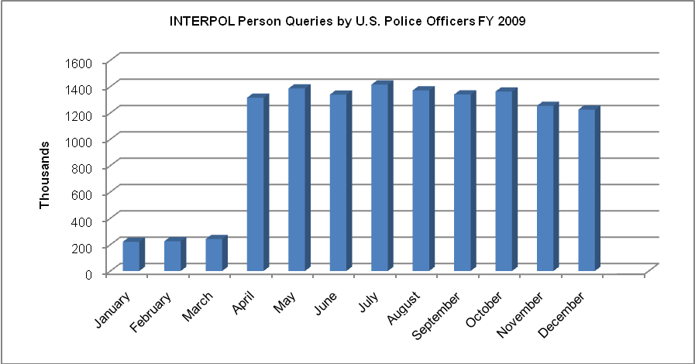
Figure 1
Note: Increase in queries as of April 2009 due to launch of federated query capability by the states of Maryland and Michigan. Previously, officers had to manually search each database.

Further INTERPOL Washington is also actively screening all inbound international flights for passports being reported as being lost and stolen to INTERPOL. This results in approximately 5 million checks a day with over 200 monthly hits requiring human review and analysis for proper vetting. INTERPOL expansion has been enhanced with its Biometric Exchange Program allowing fingerprints and mug shots to be shared and stored in domestic fingerprint systems for law enforcement purposes. Adding photographs to the biometric file places INTERPOL Washington in line with next generation systems that promise to support facial recognition capabilities.

Federal and state law enforcement agencies participate in the INTERPOL Washington through detailed personnel. As of December 2009, 25 law enforcement officers from 16 agencies, associated with nine Departments, Independent Agencies, or state police forces, augment staffing at the INTERPOL Washington. This is down from September 2009 at which time we had 30 law enforcement officers from 17 agencies, associated with 10 Department, Independent Agencies, or state police forces. Criminal Investigators, Intelligence Analysts, Inspectors and other subject matter experts are detailed to INTERPOL Washington for a specified period of time (generally 2 years). These personnel operate in divisions dedicated to specific investigative areas, typically with a nexus to their parent agency’s jurisdiction and expertise: Alien/Fugitive, Economic Crimes, Drugs, Terrorism and Violent Crimes, and State and Local Liaison. All of these major areas utilize the services and expertise of analysts to create and maintain the information contained in INTERPOL Washington case files. The analysts help to develop trends and patterns, and establish links and interrelationship in complex criminal cases.

C. Challenges

INTERPOL Washington is updating its strategic plan, but its mission remains essentially unchanged for FY 2011. INTERPOL Washington is facing new expectations unprecedented in its history as a result of an Inspector General audit conducted during FY 2008 and FY 2009. It is being called upon to assume added responsibilities and to view its role in fundamentally different ways. These new expectations come with a sense of urgency that change is required without delay. One of the themes running consistently through the OIG report is the recognition by the OIG that INTERPOL Washington has a wealth of intelligence data but that our data and electronic systems and our internal processes are antiquated and need to take greater advantage of advancing technologies and efficiencies.

This request includes specific outcome-based objectives as well as a range of enhancements that that will move INTERPOL Washington toward greater cooperation and information sharing among law enforcement organizations throughout the world. Our success can be evaluated based on how well our strategies address the challenges identified by ourselves and the OIG and by the progress made against the Department’s Goals to which we contribute.

Following is a brief summary of the Department’s Strategic Goals and Objectives in which INTERPOL Washington plays a role and how our proposed enhancements fit within those goals.

DOJ Strategic Goal 1: Prevent Terrorism and Promote the Nation’s Security (FY 2011 Request: $4,505,000)

- Prevent, disrupt, and defeat terrorist operations before they occur (1.1)
- Strengthen partnerships to prevent, deter, and respond to terrorism incidents (1.2)

DOJ Strategic Goal 2: Prevent Crime, Enforce Federal Laws and Represent the Rights and Interests of the American People (FY 2011 Request: $1,155,000)

- Strengthen partnerships for safer communities and enhance the Nation’s capacity to prevent, solve and control crime (2.1)
- Reduce the threat, incidence and prevalence of violent crime (2.2)
- Prevent, suppress and intervene in crimes against children (2.3)
- Reduce the threat, trafficking, use and related violence of illegal drugs (2.4)
- Combat public and corporate corruption, fraud, economic crime and cybercrime (2.5)

D. Full Program Costs

INTERPOL Washington is one decision unit and all requested funds will support the Department’s Strategic Goals and Objectives, and therefore each performance objective is linked with the costs of critical strategic actions. The request funds the strategies that support INTERPOL Washington objectives. Also, in keeping touch with more than 18,000 federal, state, and local law enforcement agencies and 187 other member countries, INTERPOL Washington has been able to identify emerging needs in the various communities that will require additional investment requirements.

Resources for each Strategic Goal and Objective that INTERPOL Washington supports are provided. The total costs include the following:

- Operating costs which include
  - The direct costs of all outputs, and
  - Common administrative systems
- Indirect costs which are U.S. dues obligation to INTERPOL

Figure 2

Both performance and resource tables define the total cost of achieving the strategies INTERPOL Washington will implement in FY 2011. Also included are the indirect costs of continuing activities, which are central to the operations of INTERPOL Washington.

E. Performance Challenges

The challenges that impede progress towards achievement of agency goals are complex and ever changing. Internal agency dynamics, political decisions, technological developments and criminal behavior are only a few factors that impact law enforcement practices and pose challenges that demand attention. The following situations are challenges that INTERPOL Washington sees as potential obstacles.

External Challenges: The increase in transnational crime and the risks associated with international terrorism result in a continually growing need for international law enforcement cooperation and access to international law enforcement information. The INTERPOL Washington’s responsibility to respond to increasing foreign and domestic requests places additional operational demands on the resources of this organization.

- Member countries expansion of INTERPOL databases to border points has led to a significant increase in cases and message traffic across the network (Figure 3).

Figure 3

- INTERPOL Washington has experienced an inconsistent level of detailed personnel to support its operational divisions, increasing the difficulty of fulfilling its mission (Figure 4).

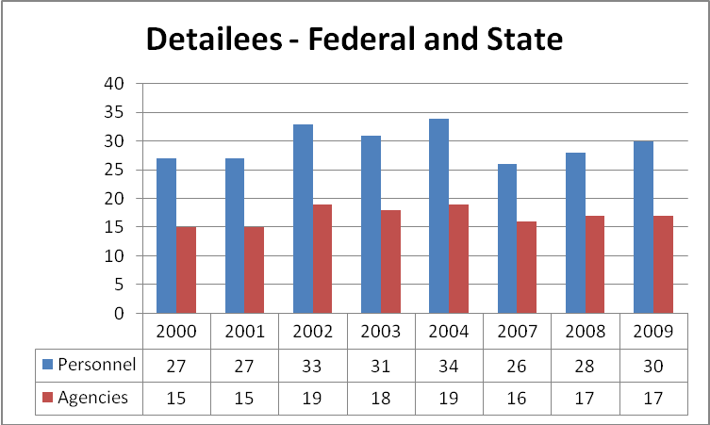
Figure 4
(No data available for 2005-2006)

- INTERPOL Washington receives no funding from participating agencies for operating expenses for their detailed personnel.
- Prior to Fiscal Year 2010, INTERPOL Washington had not received an increase in resources in approximately 15 years.
- Enhancing U.S. domestic agencies access to INTERPOL databases involves a number of technical, administrative and legal agreements that are slow to implement.

Funding U.S. Dues to the INTERPOL Organization

The INTERPOL General Assembly (IGA), in its September 2001 session, initiated an important policy change affecting member countries and their contributions. The IGA established a new dues structure whereby the six countries with the highest Gross Domestic Product would pay the highest dues. As a result, the United States’ contribution to INTERPOL increased from 5.56 percent in 2001 to 13.26 percent in 2006. The current proposal provides for an increasing responsibility for the U.S. through 2014 (Figure 5).

Figure 5

The resulting dues contribution, paid in Euro, has increased from €1.23 million in 2001 to €6.847 million in 2010. The current IGA proposal will raise the INTERPOL Washington dues payment to €9.884 million by 2014 assuming the INTERPOL budget increases at an inflationary rate only. However, past experience has led us to anticipate that the INTERPOL budget will continue to increase above a standard inflationary rate as it has done consistently and substantially primarily due to post-9/11 needs.

Another uncontrollable factor is the value of the U.S. dollar relative to the Euro. Beginning in 2003, the U.S. dollar’s value relative to the Euro began to decline, resulting in additional dues increases as the dollar “bought” fewer Euro. That decline continued through 2008 and is represented in Table 1.

Table 1
2010-2014 are estimated rates.
2010 Estimate from the Financial Forecast Center
2011-2014 Estimate from Historical Average 2/1/2007 - 12/15/2009

As a result of INTERPOL budget increases, escalating U.S. dues, and the U.S. dollar’s decline in value relative to the Euro, INTERPOL Washington’s required financial contribution to INTERPOL has increased significantly.

Internal Challenges: INTERPOL Washington faces many internal challenges in FY 2011, primarily in enhancing its analytical capability to ensure we are fully exploiting the wealth of intelligence to which this organization has access. Approximately 40 percent of INTERPOL Washington’s permanent workforce will be eligible for retirement in the next 3-4 years. In addition, 30 percent of the workforce is detailed from agencies with fluctuating support of the INTERPOL Washington mission. While the OIG noted that the numbers of personnel detailed from other agencies fluctuate over the years, current staffing from other law enforcement agencies is lower now than immediately after the terrorist acts of 9/11. To mitigate the skill gap that may occur as more and more tenured employees retire and detailees come and go, INTERPOL Washington must further develop its recruiting tools to attract qualified applicants into its ranks and to build a cadre of analytical subject matter experts on the various international crimes to which we respond.

F. Performance Assessment

No programs in this budget account have been subject to an OMB program assessment.

G. Environmental Management System

INTERPOL Washington does not yet have an Environmental Management System in place. However, INTERPOL Washington will develop and implement an agency-wide environmental management system by the end of FY 2011 in accordance with the schedule established by the Department of Justice. INTERPOL Washington will adopt agency requirements for environmental management and will also implement agency-wide programs, policies, and procedures to manage environmental aspects as needed on a more specific level to include policies related to acquisition.

II. Summary of Program Changes

Item Name | Description |  |  |  | Page
Item Name |  | Pos. | FTE | Dollars ($000) | Page
Exploited and Missing Children | To establish a child exploitation unit within the Terrorism and Violent Crime Division | 12 | 6 | 1,155 | 13
INTERPOL Operations and Command Center (IOCC) | To expand Notices Section to 24/7, right size resources in the Command Center and update technology | 5 | 3 | 4,505 | 22
Adjust Travel | Travel Management Efficiency | 0 | 0 | (36) | 33

III. Appropriations Language and Analysis of Appropriations Language

Appropriations Language

No changes proposed.

Analysis of Appropriations Language

No substantive changes proposed.

IV. Decision Unit Justification

Key INTERPOL Washington budget data for FY 2009-2011 is provided in the tables below:

A. United States National Central Bureau

INTERPOL Washington TOTAL | Perm. Pos. | FTE | Amount
2009 Enacted with Rescissions | 63 | 65 | 24,548
2009 Supplemental | 0 | 0 | 0
2009 Enacted w/Rescissions and Supplemental | 63 | 65 | 24,548
2010 Enacted | 77 | 73 | 30,091
Adjustments to Base and Technical Adjustments | 0 | 6 | 1,303
2011 Current Services | 77 | 79 | 31,394
2011 Program Increases | 17 | 9 | 5,660
2011 Program Offset | 0 | 0 | -36
2011 Request | 94 | 88 | 37,018
Total Change 2010-2011 | 17 | 9 | 6,927

1. Program Description

The U.S. National Central Bureau facilitates international law enforcement cooperation by serving as a police-to-police communications and intelligence network for both American and foreign police seeking assistance in criminal investigations. The INTERPOL Washington brings together international and U.S. police at federal, state, local, municipal, and tribal levels, providing a neutral territory where jurisdictions and mandates are interwoven to permit cooperation and assistance in combating international crime. INTERPOL Washington initiates and responds to criminal investigative requests; transmits national requests for international cooperation; facilitates requested police action or operations; and collects, analyzes, and shares relevant criminal intelligence.

3. Performance, Resources, and Strategies

a. Performance Plan and Report Outcomes

INTERPOL Washington will support DOJ’s Strategic Goals by executing the following functions:

- Coordinate arrangements for payment of the mandatory INTERPOL member dues;
- Communicate and exchange information between international and domestic law enforcement agencies;
- Ensure that the common interests of the United States are represented to the international law enforcement community;
- Delineate trends and patterns in international criminal activity;
- Provide leadership and expertise at global law enforcement symposia, conferences and meetings.
- Ensure access to INTERPOL data for U.S. federal, state, local, tribal and municipal law enforcement.

INTERPOL Washington will continue to facilitate cooperation among foreign and domestic law enforcement by making it easier to obtain information and evidence needed to pursue fugitives and track criminal activity.

b. Strategies to Accomplish Outcomes

The INTERPOL Washington has formed strategic partnerships with U.S. law enforcement agencies that have assigned agents to the INTERPOL Washington to initiate and respond to international inquiries. The INTERPOL Washington further participates in such international law enforcement initiatives as: Fusion Task Force (provides link analysis on terrorist groups and individuals); Millennium Project (Eastern European Organized Crime); Project Rockers (International Outlaw Motorcycle Gangs); Project Bridge (human trafficking); International Stolen Vehicle Programs, International Stolen/Lost Travel Documents Program and the INTERPOL Bioterrorism Program. The Notice and Diffusion program builds the capacity to rapidly identify and arrest known and internationally wanted individuals leading to their eventual extradition, deportation and/or prosecution.

The INTERPOL Washington will also continue to use its expertise to assist in halting international parental abductions in progress, pursue child abductors, and locate victim children.

Through INTERPOL, every law enforcement agency in the United States can contact police, customs, and immigration authorities in 187 other member countries. The anticipated outcome is the reduction of crime domestically and internationally.

V. Program Increases by Item

A. Item Name: Exploited and Missing Children Unit (EMC)

Budget Decision Unit(s): United States National Central Bureau (USNCB)
Strategic Goal(s) & Objectives: Goal 2; Objectives 2.2 & 2.3
Organizational Program: Terrorism and Violent Crime

Component ranking of items: 1 of 2

Program Increase: Positions 12 FTE 6 Dollars $1,155,000

Description of Item

The USNCB is in the unique position to facilitate the sharing of information between U.S. law enforcement agencies and foreign law enforcement agencies in reference to the global fight against child exploitation. The USNCB has proactively developed initiatives to track convicted sex offenders, combat sex tourism, and work to eliminate the incidence of children exposed to violence.

USNCB is requesting 12 positions and $1,155,000 to address child exploitation in the areas of missing and abducted children, sex tourism, tracking of convicted sex offenders, and expansion of the Green Notice program within the Terrorism and Violent Crime Division. These resources will assist in enforcing requirements outlined in the Adam Walsh Act of 2006. Through the I-24/7 Secure Communications system and utilizing INTERPOL’s Notice Systems, INTERPOL Washington can:

- Assist U.S. Marshals Service (USMS) and other law enforcement agencies with locating and apprehending fugitive and non-compliant sex offenders;
- Assist with the tracking of convicted sex offenders that relocate, visit, or are deported to foreign countries;
- Assist with tracking of convicted sex offenders that relocate or visit the U.S. from foreign countries;
- Utilize the INTERPOL Notice system to track selected convicted sex offenders to combat sex tourism;
- Assist Immigration and Customs Enforcement (ICE), Federal Bureau of Investigation (FBI), and other law enforcement agencies with evidence including internet child exploitation images;
- Assist the National Center for Missing and Exploited Children (NCMEC) in reference to locating missing children and alert law enforcement counterparts worldwide to published alerts on missing children; and work with domestic and foreign law enforcement to return these children.

With the implementation of the Adam Walsh Act, INTERPOL Washington is strategically expanding this program to accommodate the current increase and expected additional requests to arrest non-compliant fugitive sex offenders, track convicted sex offenders that travel to foreign countries, combat child sex tourism and locate missing and abducted children. INTERPOL Washington works hand in hand with domestic and foreign law enforcement agencies to support the Department of Justice’s Project Safe Childhood Initiative by providing criminal intelligence and investigative leads to rescue children from sexual abuse and prosecute obscenity cases. The program also coordinates law enforcement efforts involving several countries to dismantle international websites that contain images of child pornography. A recent initiative to further protect U.S. and foreign children from sexual abuse is the Green Notice Program. Green Notices are shared between INTERPOL National Central Bureaus (NCB) to alert law enforcement entities to the migratory movements of convicted child molesters between countries.

For FY 2011, the USNCB requests $1,155,000 for twelve INTERPOL Analysts (four at the GS-7/9 level, five at the GS-12 level, and three at the GS-13 level) to:

(1) Coordinate the publication of INTERPOL Yellow Notices for missing children and database entry into the INTERPOL global database of reported missing children;
(2) Process requests for INTERPOL Yellow Notices;
(3) Assist domestic law enforcement agencies in locating “cold case” missing children on a global scale;
(4) Coordinate with state missing children clearinghouses and the National Center for Missing Children (NCMEC) for data entry into INTERPOL’s Automated Search Facility (ASF);
(5) Train state and local law enforcement agencies on INTERPOL’s I-24/7 and multi-database capabilities as an investigative tool in targeting the location and recovery of reported missing children;
(6) Provide cyber investigation on child pornography images; and
(7) Track sexual predators.

Justification

Exploited and missing children cases are extremely complex and demand a greater focus of the analyst for resolution. Each case requires coordination with multiple law enforcement resources, an understanding of both criminal and civil statutes, and the ability to communicate in an international arena in a diplomatic and concise manner.

INTERPOL Washington is proposing to expand its current resources that are dedicated to the fight against child exploitation. INTERPOL Washington presently has two personnel who are responding to all INTERPOL Washington exploited and missing children cases as well as sexual offender cases and assisting U.S. and foreign law enforcement agencies in locating children and preventing hundreds of criminal acts against children. Each is working approximately 1,200 cases. With the FY 2011 request, we can achieve the Attorney General’s goal to make a significant impact in the global fight against these types of crimes.

- Missing and Abducted Children

INTERPOL Washington receives numerous leads on missing and abducted children on a daily basis. Working with the National Center for Missing and Exploited Children (NCMEC), INTERPOL Washington sends leads to foreign countries through INTERPOL’s I-24/7 network that connects the 188 member countries. A recent survey of the U.S. state missing children clearinghouses revealed there were over 33,000 missing children cases that were over 45 days old. INTERPOL Washington is proposing an initiative to issue Yellow Notices on all missing children cases that have an international nexus. Routinely this notice information can be entered into the foreign border checkpoints which allow for possible recovery of missing children. Also, specific leads on missing children located in foreign countries are coordinated through INTERPOL channels with law enforcement agencies to locate and take into protective custody those children who are the object of a current U.S. investigation.

A search of the INTERPOL ASF revealed there are only 311 INTERPOL Yellow Notices on missing U.S. children in the ASF database. The INTERPOL system of locating and verifying the identity of reported missing children is the only standardized law enforcement mechanism of its kind that provides a centralized database and secure law enforcement communications network. The INTERPOL ASF database is often referred to as the “international NCIC” and is accessed by all member countries. Based on the number of outstanding missing children cases and this proposed increase in resources, INTERPOL Washington would see a significant increase in Yellow Notices and the recovery of children.

Missing and Abducted Children Objectives:

- To process, review, and electronically publish Yellow Notice applications in coordination with appropriate law enforcement agencies, INTERPOL Washington, and the INTERPOL General Secretariat.

- To educate federal, state, and local agencies responsible for the investigation and entry into NCIC of missing/abducted children on INTERPOL’s Yellow Notice used for locating and recovering missing children.

- To advise investigators and managers of Yellow Notice application procedures.

- To increase coordination with missing children clearinghouses and NCMEC to assist in the processing of INTERPOL Yellow Notices and educational opportunities.

- To process an estimated 1,400 Notice Applications in the first year of this project.

- To increase Yellow Notices on active missing children cases.

- To increase Red Notices on parents wanted for taking children.

- To monitor the INTERPOL database for entry and removal of those cases that resulted in a successful location or recovery of a missing child.

- To adopt current information technology programs to expedite electronic processing of current cases by trained personnel at all levels of government and trusted partners.

If the FY 2011 request is approved, six of the 12 positions will be dedicated to missing and abducted children cases. INTERPOL Washington anticipates that with the resources requested, additional Yellow Notices can be processed on a daily basis and entered into the INTERPOL database of published notices. Additional training, law enforcement agency resources, automated enhancements, and coordination with trusted partners will cause the workload to increase by at least 200 percent. The ultimate goal is to make America safer for our children. As automation enhancements of border information becomes a standard, data matching with the INTERPOL ASF and border information could serve as both an investigative resource and a means to locate our missing children and track child predators.

- Tracking Convicted Sex Offenders and Combating Sex Tourism

INTERPOL Washington tracks convicted sex offenders who visit, relocate, and/or are deported to foreign countries. The federally mandated Adam Walsh Act requires all states and all U.S. Territories to register their Sex Offenders. Currently, there are 22 states actively participating in the INTERPOL Washington Sex Offender Program. In addition, Indian Territories have advised they will be seeking our assistance, and it is anticipated the 28 remaining states will begin to seek our assistance over the coming year. The work load in this area is projected to increase by approximately 400 percent. Since September 2009, INTERPOL Washington has not yet realized the expected increase in work load. This delay is likely attributable to the extension for compliance under the Adam Walsh Act until July 2010, which was granted by the Attorney General. It is anticipated this increase will occur at that time. Additionally, USNCB serves as the point of contact when foreign convicted sex offenders travel to the United States.

INTERPOL Washington will assist ICE, FBI, and other law enforcement agencies in combating sex tourism. In conjunction with agency initiatives such as ICE’s Project Angel Watch, INTERPOL Washington will issue Green Notices on tier III convicted sex offenders who are known to travel, thus warning member countries these individuals are attempting to gain admission to their country. Blue notices may also be issued upon request of the investigating agency. Green Notices are currently issued by INTERPOL Washington on foreign convicted sex offenders being deported to their home countries through the ICE Project Operation Predator. This initiative has seen a tremendous increase in notices issued and is expected to increase dramatically in the future.

Tracking Sex Offenders Objectives:

- To track known child predators through a nationwide tracking requirement. Tracking will verify return to place of residence and registration.

- To assist the U.S. Marshals Service and other federal, state, local and tribal law enforcement agencies apprehend non-compliant fugitive sex offenders that flee overseas with requested resources. This will also include coordinating investigations of sex offender fugitives that flee to the U.S.

- To compile statistics in conjunction with the travel of sexual offenders to forecast trends, to track sex tourism, to identify areas of international focus for the increase of these crimes, and to track the number of Green Notices specific to this crime.

If the FY 2011 request is approved, six of the 12 positions will be dedicated to tracking convicted sex offenders and combating sex tourism.

Statistics (July 2008-May 2009) and (May2009-present):

Southeast | FL | GA | NC | SC | AL | MS | LA | TN | VA | MD | DC | PR | AR | DE
Northeast | ME | MA | NY | CT | VT | NH | RI | NJ | PA | WV | OH | MI | KY | IN
Southwest | TX | NM | AZ | CA | NV | OK | KS | CO | UT | HI | OR
Northwest | WI | IL | MO | IA | MN | ND | WA | SD | NE | MT | WY | ID | AK

Impact on Performance (Relationship of Increase to Strategic Goals)

This USNCB program fully supports DOJ’s strategic priority, specifically DOJ’s Strategic Objectives 2.2: Reduce the threat, incidence, and prevalence of violent crime, 2.3: Including prevent, suppress, and intervene in crimes against children. INTERPOL Washington anticipates that with the resources requested, additional Yellow Notices can be processed on a daily basis and entered into the INTERPOL ASF.

Additional training, law enforcement agency resources, automated enhancements, and coordination with trusted partners will cause the work load to increase by at least 200 percent. The ultimate goal is to make America safer for our children. As automation enhancements of border information becomes a standard, data matching with the INTERPOL ASF and border information could serve as both an investigative resource and a means to locate our missing children, and track child predators.

Funding

Base Funding

FY 2009 Enacted (w/rec./supps) |  |  |  | FY 2010 Enacted |  |  |  | FY 2011 Current Services
Pos | Agt/Atty | FTE | $(000) | Pos | Agt/Atty | FTE | $(000) | Pos | Agt/Atty | FTE | $(000)
6 | 0 | 6 | 1,103 | 6 | 0 | 6 | 1,547 | 6 | 0 | 6 | 1,671

Personnel Increase Cost Summary

Type of Position | Modular Cost  per Position ($000) | Number of  Positions  Requested | FY 2011  Request ($000) | FY 2012  Net Annualization  (change from 2011)  ($000)
Analyst GS-7 | 80 | 4 | 320 | 268
Analyst GS-12 | 101 | 5 | 505 | 445
Analyst GS-13 | 110 | 3 | 330 | 258
Total Personnel |  | 12 | 1,155 | 971

Non-Personnel Increase Cost Summary

Non-Personnel Item | Unit Cost | Quantity | FY 2011 Request  ($000) | FY 2012 Net  Annualization  (Change from 2011)  ($000)
Total Non-Personnel |  |  | 0 | 0

Total Request for this Item

 | Pos | Agt/Atty | FTE | Personnel  ($000) | Non-Personnel  ($000) | Total  ($000) | FY 2012 Net  Annualization  (Change from 2011)  ($000)
Current Services | 6 |  | 6 | 1,671 | 0 | 1,671 | 1,671
Increases | 12 |  | 6 | 1,155 |  | 1,155 | 971
Grand Total | 18 |  | 12 | 2,826 |  | 2,826 | 2,642

B. Item Name: INTERPOL OPERATIONS AND COMMAND CENTER

Budget Decision Unit(s): United States National Central Bureau
Strategic Goal(s) & Objective(s): Goal 2; Objective 2.2
Organizational Program: INTERPOL OPERATIONS AND COMMAND CENTER

Component Ranking of Item: 2 of 2

Program Increase: Positions 5 FTE 3 Dollars $4,505,000

Description of Item

INTERPOL Washington is requesting an enhancement to its Notices program and information technology infrastructure capabilities within the INTERPOL Operations and Command Center. The request would fund an additional 5 positions, 3 FTE and $4,505,000 of which, $4,000,000 is for technology infrastructure in the 24/7 Command Center.

Justification

The INTERPOL Operations and Command Center (IOCC), which includes the Notices Section, is the first point of contact to the more than 18,000 U.S. federal, state and local law enforcement authorities for all INTERPOL related matters throughout the United States. This includes direct coordination with 187 different member countries seeking assistance from U.S. based law enforcement agencies. This role firmly places the IOCC in the forefront of all INTERPOL and domestic law enforcement communication. This role is enhanced by INTERPOL Washington’s aggressive strategy of expanding INTERPOL services throughout the United States as described in Background section of this submission.

As stated earlier, by expanding and providing access to INTERPOL information throughout the United States and abroad, critical attention must be paid to the resources and tools that will be needed to decipher the valuable information flowing through INTERPOL Washington systems. INTERPOL Washington is increasingly involved in national initiatives, which are resulting in greater participation from U.S. federal, state, and local law enforcement authorities. Our mission is shifting from that of a messaging service to producing analytical products due to such initiatives as the Stolen and Lost Travel Documents Program (a high-level immigration initiative with the Department of Homeland Security), Operation Vennlig (an anti-terrorism partnership with the Department of Defense and Federal Bureau of Investigations), and the Command Center’s Biometric Exchange Program. These products are used to facilitate information sharing among all law enforcement entities.

The Command Center’s Biometric Exchange program allows domestic and international fingerprint checks to be routinely processed. To support and extend this capability, IOCC analysts must have at their disposal the technology to rapidly support and identify individuals that have been arrested, detained or are attempting to enter the country. Through the development of its Biometric Exchange Program, INTERPOL Washington can serve in a validation role for all INTERPOL biometric matches that occur.

As INTERPOL information is further expanded to the land borders, it is critical that the INTERPOL Washington Command Center possesses the latest technology for identifying international threats as they emerge.

- Notices Section

Notice Program Analysts are responsible for receiving and processing new foreign diffusions and notices for further investigation by U.S. law enforcement agencies. Analysts query several databases such as NCIC, Triple I, TECS, Special Query 94, Customs Information System (CIS), Law Enforcement Support Center (LECS), Nlets Driver License queries, Choice Point and/or LexisNexis. The analyst must coordinate NCB’s in an effort to gather information about the location of the fugitive, respond to record checks on visa applicants, process fugitive locates, enter/update TECS records, enter NCIC entries within 24 hours, request Criminal Justice Information Systems (CJIS) fingerprint checks, maintain and update their case load at all times. The Notice Program is usually staffed by five permanent employees and two contractors, but does not have any coverage after 5:30pm weekdays, weekends, or on federal holidays; meanwhile INTERPOL Washington continues to receive notices and diffusions. With the requested new personnel, INTERPOL Washington will be able to stay up to date with the workflow and ensure notices and diffusions are received and processed 24 hours a day, 7 days a week, every day of the year.

On a Monday morning there’s an average of 10 notices and 25 diffusions in the Notice Program’s in-box for case analysis. As an example in January 2009, by having no weekend/holiday coverage (Inauguration and President’s Day) we had a total of
26 Notices/92 Diffusions in the in-box. The Analysts assigned to the Notice Program Section average a total caseload of 15,000 cases.

Figure 7 reflects monthly statistics on incoming notices/diffusions. During calendar year 2009, INTERPOL Washington received and processed 2,798 notices and 5,831 diffusions.

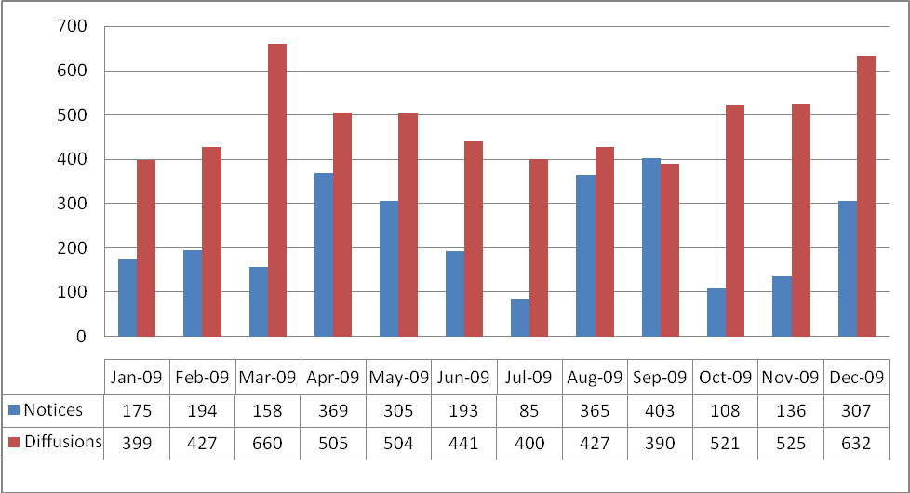
Figure 6
The above chart does not include the recurring need that requires analysts to review and update older cases when they come up each month for validation through the Compliance Office. There is an average of 150-200 cases per month for modifications. For the month of December 2009, Notice Program received 297 cases for modifications.

One of the themes running consistently through the OIG report is the recognition by the OIG that INTERPOL Washington must ensure timely dissemination of accurate information to domestic law enforcement regarding subject of notices and diffusions, review all active cases for additional queries to ensure all appropriate database searches have been conducted and whether additional pertinent information exists, and to eliminate the backlog of notices and diffusions. This request includes specific outcome-based objectives as well as a range of enhancements that will positively impact numerous OIG report recommendations, as well as move INTERPOL Washington toward greater cooperation and information sharing among law enforcement organizations throughout the world.

- Command Center Technology Enhancement

USNCB is requesting additional technological expansion and enhancement of the INTERPOL Operations and Command Center (IOCC) since it is the first responder for inquiries from the 18,000 U.S. law enforcement and 187 other member countries of INTERPOL. The request will provide state of the art technologies and infrastructure to maintain mission-critical functions in the event of any crisis, enhance collaborative and cooperative abilities, and lead toward greater participation amongst U.S. federal, state, and local law enforcement stakeholders in daily operations.

Workload coming through the IOCC is increasing every year. As Figure 8 below demonstrates, queries to the INTERPOL INSYST application using the I-24/7 network have increased since the beginning of the fiscal year. Each query must be vetted.

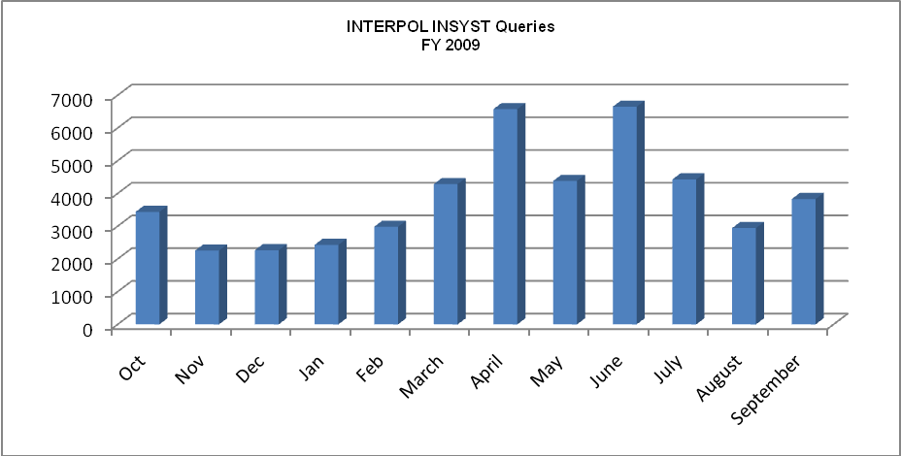
Figure 7

Consider the following:

- Since 2006, the number of new cases opened by IOCC has increased 19.28 percent.
- Since 2006, the number of documents analyzed and dispatched by IOCC has increased 37.96 percent.
- IOCC is responsible for handling all urgent matters occurring after hours, weekends, and holidays. These matters include fugitive detainments by national and international law enforcement agencies, suicides in progress, health/welfare inquiries and death notifications.

Currently, IOCC is on pace in 2009 to increase new cases opened by an additional 5 percent and documents analyzed and dispatched by an additional 13.75 percent.

In order to meet continued expansion and increased message flow requirements, USNCB is looking to expand the technological capacity of the IOCC by implementing automated solutions to meet its growing workload challenges. The requested contractor and IT upgrades will allow, for the first time, the capability of providing a high level overview of the type and locations of hits that are being generated throughout the U.S. This opens up the opportunity for future analysis and identifying predictive data trends. This value approach is critical in protecting the United States from foreign attacks and criminal activity that has international ties.

Other enhanced capabilities include but are not limited to real-time satellite feeds from all international news sources and expanded biometric systems for the fingerprint/photo identification exchange program initiative.

INTERPOL Washington’s command center provides the opportunity to stand up a truly international 24x7 command infrastructure for supporting all law enforcement within the United States. As INTERPOL Washington expands access, INTERPOL Washington staff will be required to have at their disposal accurate and up to date information. INTERPOL and National Law Enforcement Communications System (Nlets) communications will continue to increase as represented in Figure 3.

Figure 8

Some of the capabilities involve implementing the following technologies
- Surface touch screen technologies for dynamic mapping and displaying national hit profile information throughout the United States for identifying data trends and profiles.
  - Integrated geo-spatial elements for tagging of INTERPOL data utilizing geospatial coordinates already in place throughout the Nlets architecture
- Improved meeting and collaboration tools for real-time web collaboration from the desktop to any law enforcement agency or INTERPOL member country
- Complete video teleconferencing solutions for supporting INTERPOL Washington mission eliminating unnecessary government travel
- Complete workflow integration and input data tagging for all inbound structured data flows eliminating the need for repetitive data entry tasks
- Real-time satellite feeds from all international news sources
- Expanded biometric systems for fingerprint/photo identification exchange program initiative
  - INTERPOL Washington deployed an Integrated Automated Fingerprint Identification System (IAFIS) terminal in FY 2008. As a result of this new technology INTERPOL Washington is now able to add and query fingerprints to the FBI’s fingerprint repository (Figure 10), with an approximate return of hits at 8 percent of submissions. INTERPOL Washington also adds photos and demographic data to the Interstate Identification Index through this process. INTERPOL Washington has automated the download of INTERPOL data allowing for the better use of INTERPOL Washington staff for processing biometric information related to INTERPOL notices and diffusions. While these expansions provide unprecedented access by domestic law enforcement officers it does require that INTERPOL Washington command center have the resources at its disposal to process and handle these hits in a timely manner.

Figure 9

  - Real-time workflow queue monitoring and electronic display of all inbound electronic communications
  - Virtual desktop delivery systems to minimize the hardware footprint and to maximize workstation life cycles
  - Complete redundancy of all critical core service to maintain constant availability in the event of a emergency or national crisis
  - Provide mobile access for all essential employees to provide secure anywhere access including location ID’s to locate all critical staff members
  - Deploy emergency preparedness systems of automatic notification of all INTERPOL Washington staff, domestic law enforcement and INTERPOL member countries

Impact on Performance (Relationship of Increase to Strategic Goals)

Additional staffing and improved technology in the INTERPOL Operations and Command Center will place INTERPOL Washington in the unique role of bridging and supporting all INTERPOL and domestic law enforcement communications. This international command center will have at its disposal 187 member countries and over 18,000 law enforcement agencies. In that vein, this increased expansion of INTERPOL systems requires INTERPOL Washington to think strategically for supporting increased national usage with increased technical and analytical capabilities. Failing to act and use international law enforcement information to assist in the protection of the United States and its citizens would be a significant failure. During this era of transparent borders, being able to visualize and rapidly assist in any and all international law enforcement information is required.

Developing new technologies and increased staffing assists the organization in being more efficient in locating international fugitives, identifying bodies, recovering missing and abducted children and fighting terrorist networks. Analysts will be able to respond rapidly to requests from state, local and foreign law enforcement agencies and officials in support of their criminal investigations. Response times are critical when communicating with agencies and officials. INTERPOL Washington can also act proactively in identifying threats as they emerge by having immediate access to INTERPOL and domestic law enforcement systems, this combination is unique and provides an additional tool in the combat against international crime and terrorism.

Funding this enhancement will support implementation of the Attorney General’s law enforcement sharing initiatives by establishing a direct, standardized, electronic communications between U.S. law enforcement agencies and INTERPOL. These interconnections are facilitated and protected by INTERPOL Washington and the United States Department of Justice. Real time searches of INTERPOL systems by domestic law enforcement agencies will be limited in accordance with DOJ security requirements and INTERPOL rules for information sharing. All INTERPOL Washington initiatives are in line with ongoing DOJ and DHS law enforcement sharing initiatives and leverage the use and expansion of existing and developing information sharing environments.

Funding
Base Funding
FY 2009 Enacted (w/resc./supps) |  |  |  | FY 2010 Enacted |  |  |  | FY 2011 Current Services
Pos | Agt/Atty | FTE | $(000) | Pos | Agt/Atty | FTE | $(000) | Pos | Agt/Atty | FTE | $(000)
23 |  | 25 | 4,428 | 23 | 0 | 25 | 4,525 | 23 | 0 | 25 | 4,721

Personnel Increase Cost Summary
Type of Position | Modular Cost  per Position ($000) | Number of  Positions  Requested | FY 2011  Request ($000) | FY 2012  Net Annualization  (change from 2011)  ($000)
Analyst GS-12 | 101 | 5 | 505 | 445
Total Personnel | 101 | 5 | 505 | 445

Non-Personnel Increase Cost Summary
Non-Personnel Item | Unit Cost | Quantity | FY 2011 Request  ($000) | FY 2012 Net  Annualization  (Change from 2011)  ($000)
Software/Hardware Contractor Service Development | 2,000 | 1 | 2,000 | 2,000
Contractor Service Development | 1,110 | 1 | 1,110 | 1,110
Maintenance and Administration | 890 | 1 | 890 | 890
Total Command Center Technology | 4,000 |  | 4,000 | 4,000

Total Request for this Item
 | Pos | Agt/Atty | FTE | Personnel  ($000) | Non-Personnel  ($000) | Total  ($000) | FY 2012 Net  Annualization  (Change from 2011)  ($000)
Current Services | 23 |  | 25 | 4,721 | 2,232 | 6,953 | 6,953
Increases | 5 |  | 3 | 505 |  | 505 | 445
Increase IT | 0 |  | 0 | 0 | 4,000 | 4,000 | 4,000
Grand Total | 28 |  | 28 | 5,226 | 6,232 | 11,458 | 11,398

VI. Program Offsets by Item

A. Item Name: Travel Management Efficiency
Budget Decision Unit(s): United States National Central Bureau (USNCB)
Strategic Goal(s) & Objectives: Goal 2; Objectives 2.2 & 2.3
Organizational Program: INTERPOL Travel

Component ranking of items: 1 of 1

Program Reduction Positions 0 FTE 0 Dollars $-36,000

Description of Item
The Department is continually evaluating its programs and operations with the goal of achieving across-the-board economies of scale that result in increased efficiencies and cost savings. In FY 2011, DOJ is focusing on travel as an area in which savings can be achieved. For the INTERPOL Washington, travel or other management efficiencies will result in offsets of $36,000. This offset will be applied in a manner that will allow the continuation of effective law enforcement program efforts in support of Presidential and Departmental goals, while minimizing the risk to health, welfare and safety of agency personnel.

VII. Exhibits

34 states participate.
The Yellow Notice is used to report missing children and adults or to identify a person who is unable to identify him/herself.
Lifetime registrants
Seeking information on travel, documents, associates, etc.

