U.S. Department of Justice

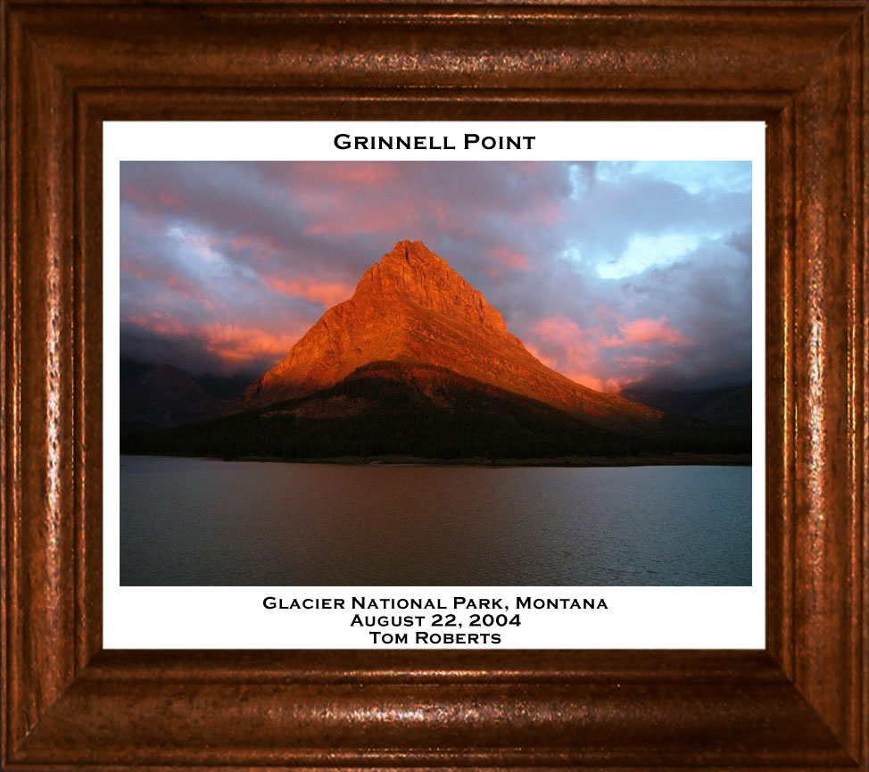

Environment and Natural Resources Division

(ENRD)

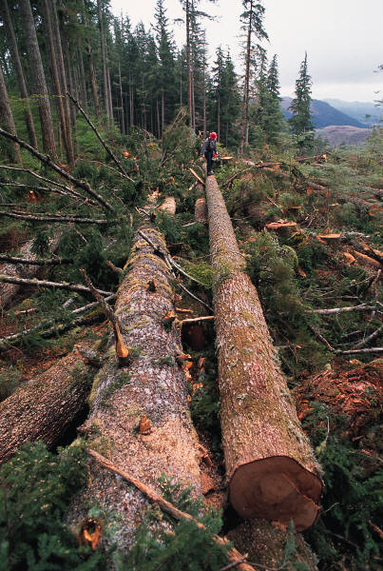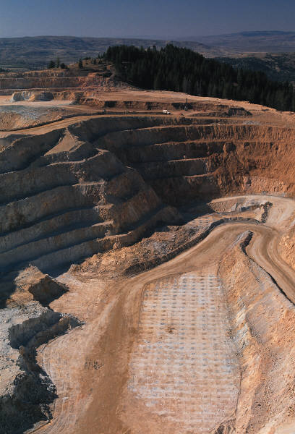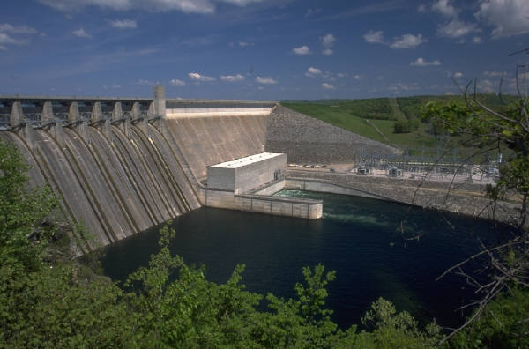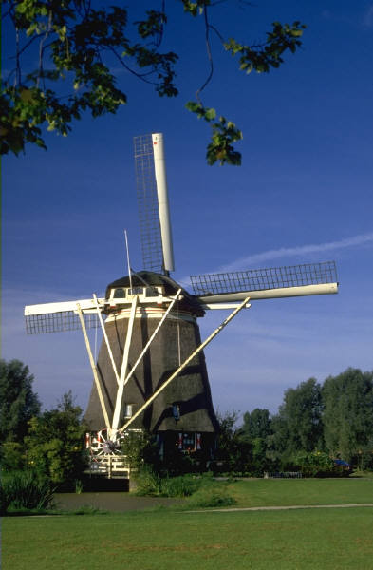

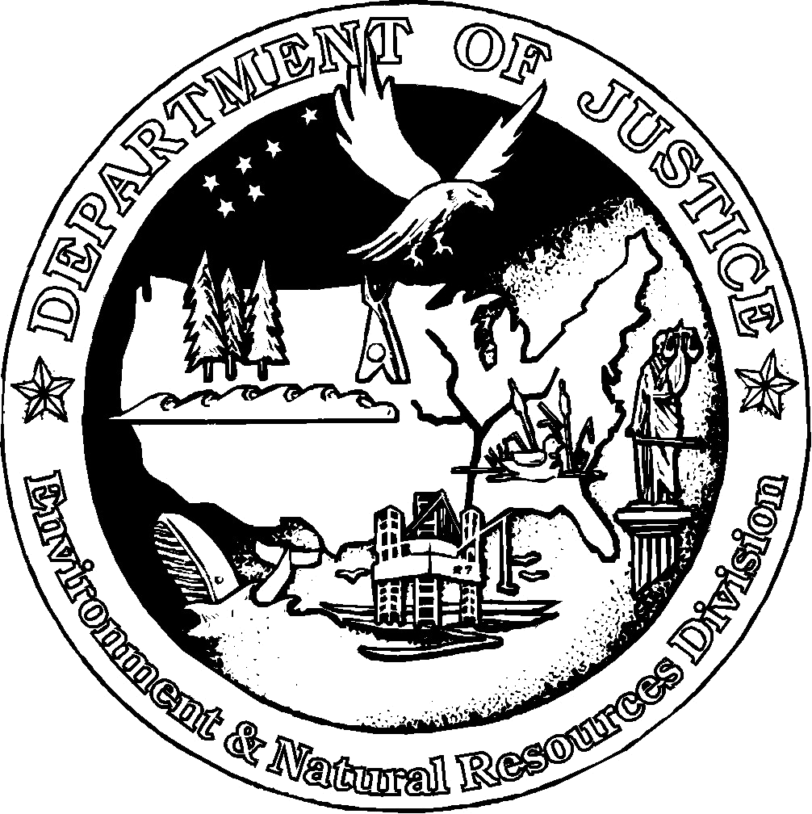

E N R D
E N R D

F Y 2 0 1 4

PERFORMANCE BUDGET

CONGRESSIONAL SUBMISSION

Table of Contents

Page No.

I. Overview 2

II. Summary of Program Changes

III. Appropriations Language and Analysis of Appropriations Language 10

IV. Decision Unit Justification 10

A. Environment and Natural Resources Division 11 1. Program Description 11
2. Performance Tables 23
3. Performance, Resources, and Strategies 26

V. Program Increases by Item

VI. Program Offsets by Item
VII. Exhibits

- Organization Chart
- Summary of Requirements
- Program Increases/Offsets by Decision Unit (Not applicable)
- Resources by DOJ Strategic Goal and Strategic Objective
- Justification for Base Adjustments
- Crosswalk of 2012 Availability
- Crosswalk of 2013 Availability
- Summary of Reimbursable Resources
- Detail of Permanent Positions by Category
- Financial Analysis of Program Increases/Offsets (Not applicable)
- Summary of Requirements by Grade
- Summary of Requirements by Object Class

Cover photo of Glacier National Park from DOJ/ENRD Employee Photo Contest.

I. Overview of the Environment and Natural Resources Division

A. Introduction:

Environment and Natural Resources Division (ENRD) Mission: The Environment and Natural Resources Division is a core litigating component of the U.S. Department of Justice. Founded more than a century ago, it has built a distinguished record of legal excellence. The Division functions as the Nation’s environmental and natural resources lawyer, representing virtually every federal agency in courts across the United States, and its territories and possessions in civil and criminal cases that arise under more than 150 federal statutes. Key client agencies are the U.S. Environmental Protection Agency (EPA), the U.S. Department of the Interior, the U.S. Army Corps of Engineers, the U.S. Department of Commerce, the U.S. Department of Agriculture, the U.S. Department of Homeland Security, the U.S. Department of Energy and the U.S. Department of Defense, among others. The Division’s litigation docket contains almost 7,000 active cases and matters.

The Division is currently organized into nine litigating sections (Appellate; Environmental Crimes; Environmental Defense; Environmental Enforcement; Indian Resources; Land Acquisition; Law and Policy; Natural Resources; and Wildlife and Marine Resources), and an Executive Office that provides administrative support. ENRD has a staff of nearly 650, more than 400 of whom are attorneys.

The Division is guided by its core mission, which has four key elements:
- Strong enforcement of civil and criminal environmental laws to ensure clean air, clean water, and clean land for all Americans;
- Vigorous defense of environmental, wildlife and natural resources laws and agency actions;
- Effective representation of the United States in matters concerning the stewardship of our public lands and natural resources; and
- Vigilant protection of tribal sovereignty, tribal lands and resources, and tribal treaty rights.

To accomplish this mission in FY 2014, the Division is requesting a total of $112,632,000 including 537 positions (370 attorneys), and 520 Full-Time Equivalents (FTE).

All communities deserve clean air, water and land in the places where they live, work, play and learn. The Division strives to ensure that all communities are protected from environmental harms, including those low-income, minority and tribal communities that too frequently live in areas overburdened by pollution. ENRD pursues the goals of Environmental Justice by ensuring that everyone enjoys the benefit of a fair and even-handed application of the nation’s environmental laws, and affected communities have a meaningful opportunity for input in the consideration of appropriate remedies for violations of the law.

ENRD also litigates to protect the Nation’s public lands and resources, ensuring that that these lands are protected and the Treasury collects the royalties and payments owed to the United States. The Division also litigates to protect almost 60 million acres of land, and accompanying natural resources, that the United States holds in trust for tribes and their members.

ENRD’s work furthers the Department’s strategic goals to prevent crime and enforce federal laws, defend the interests of the United States, promote national security, and ensure the fair administration of justice at the federal, state, local, and tribal levels. Most important, the Division’s efforts result in significant public health and other direct benefits to the American people through the reduction of pollution across the Nation and the protection of important natural resources.

Every day, the Division works with client agencies, U.S. Attorneys’ Offices, and state, local and tribal governments, to enforce federal environmental, natural resources, and wildlife laws. It also defends federal agency actions and rules when they are challenged in the courts, working to keep the Nation’s air, water and land free of pollution, advancing military preparedness and national security, promoting the nation’s energy independence, and supporting other important missions of our agency clients. The Division acquires land for purposes ranging from national parks to national security, protects tribal lands and natural resources, and works to fulfill the United States’ trust obligations to Indian tribes and their members.

ENRD performs its work with the constant understanding that our operations are funded by limited taxpayer dollars. Over the past few years, as described below, we have taken deliberate steps to reduce costs/services and limit resource expenditures. We take our role as responsible custodians of the public fisc very seriously; and we are proud of the short and long-term cost saving measures and efficiencies we have implemented to date.

Electronic copies of the Department of Justice’s Congressional Budget Justifications and Capital Asset Plan and Business Case exhibits can be viewed or downloaded from the Internet using the Internet address: http://www.justice.gov/02organizations/bpp.htm.

B. Issues, Outcomes, and Strategies:

As the Nation's chief environmental and public lands litigator, ENRD primarily supports the Justice Department’s Strategic Goal Two: Prevent Crime, Protect the Rights of the American People, and Enforce Federal Law.

The Division initiates and pursues legal action to enforce federal pollution abatement laws and obtain compliance with environmental protection and conservation statutes. ENRD also represents the United States in all matters concerning protection, use, and development of the nation's natural resources and public lands. The Division defends suits challenging all of the foregoing laws, and fulfills the federal government’s responsibility to litigate on behalf of Indian tribes and individual Indians. ENRD’s legal successes protect the federal fisc, reduce harmful discharges into the air, water, and land, enable clean-up of contaminated waste sites, and ensure proper disposal of solid and hazardous waste.

In affirmative litigation, ENRD obtains redress for past violations harming the environment, ensures that violators of criminal statutes are appropriately punished, establishes credible deterrents against future violations of these laws, recoups federal funds spent to abate environmental contamination, and obtains money to restore or replace natural resources damaged by oil spills or the release of other hazardous substances into the environment. ENRD also ensures that the federal government receives appropriate royalties and income from activities on public lands and waters.

By vigorously prosecuting environmental criminals, ENRD spurs improvements in industry practice and greater environmental compliance. Additionally, the Division obtains penalties and fines against violators, thereby removing the economic benefits of non-compliance and leveling the playing field so that companies complying with environmental laws do not suffer competitive disadvantages.

In defensive litigation, ENRD represents the United States in challenges to federal environmental and conservation programs and all matters concerning the protection, use, and development of the nation's public lands and natural resources. ENRD faces a growing workload in a wide variety of natural resource areas, including litigation over water quality and watersheds, the management of public lands and natural resources, endangered species and sensitive habitats, and land acquisition and exchanges. The Division is increasingly called upon to defend Department of Defense training and operations necessary to military readiness and national defense.

The Division’s current top enforcement priority is to hold fully accountable those responsible for the tragic loss of life and disastrous oil spill in the Gulf of Mexico. The Deepwater Horizon oil spill began on April 20, 2010, when explosions and fires destroyed the Mobile Offshore Drilling Rig Deepwater Horizon approximately 50 miles from the Mississippi River delta. Eleven people aboard the rig tragically lost their lives; many other men and women were injured. Oil flowed into the Gulf of Mexico for months. Ultimately, the Macondo Well was sealed on September 19, 2010, nearly five months after the blowout began. By that time, millions of barrels of oil had been discharged into the Gulf and upon adjoining shorelines, causing immense environmental and economic harm to the entire region.

In December 2010, as part of the multi-district litigation in the Eastern District of Louisiana, the United States brought suit against BP, Anadarko, MOEX, Transocean and others for civil penalties under the Clean Water Act and a declaration of liability under the Oil Pollution Act. Litigation in this unprecedented case is ongoing. Since filing its enforcement action, ENRD, in concert with the Civil Division, has taken or defended over 400 depositions, produced some 97 million pages in discovery, and tried the first of what is scheduled to be several phases of trial. In a massive, historic trial that began on February 25, 2013, the United States intends to prove that violations of federal safety and operational regulations caused or contributed to the oil spill and that the named defendants (not including insurers) are jointly and severally liable, without limitation, under the Oil Pollution Act for government removal costs, economic losses, and damage to natural resources due to the oil spill. The United States seeks civil penalties under the Clean Water Act, which prohibits the unauthorized discharge of oil into the nation’s waters. Because the defendants face civil penalty amounts in the billions of dollars, the breadth and depth of the defense they have mounted is unprecedented in an environmental case.

The immense and unprecedented discovery requirements involved in the Deepwater litigation, including the first phase of the massive civil trial that began on February 25, 2013, will likely continue through later trial phases even as the first phase proceeds. The outcome of the Department’s affirmative civil litigation is likely to be historic in the scale and scope of penalties and other redress we secure for the Nation.

In February 2012, the government reached a settlement agreement with MOEX, a minority lease holder in the BP well, for $70 million in civil penalties.

During fiscal year 2012, the Department continued its criminal investigation of the spill. The investigation is being conducted by the Deepwater Horizon Task Force, which was formed in March 2011 to consolidate the efforts of the Department’s Criminal Division, ENRD, and the U.S. Attorney for the Eastern District of Louisiana.

In February 2013, the U.S. District Court for the Eastern District of Louisiana approved a civil enforcement settlement and a criminal-plea agreement proposed by the United States for various Transocean companies – the owners and operators of the Deepwater Horizon. Under those settlements, the Transocean entities will pay penalties and fines totaling $1.4 billion – a record-setting, $1 billion in civil penalties (exclusive of the value of injunctive relief) plus another $400 million in criminal fines and related criminal relief.

Additionally, the Division supported the ongoing interagency administrative response critical to avoiding future disasters and to continuing responsible and safe drilling in the Gulf of Mexico and elsewhere. We were able to successfully resolve a number of high profile and contentious cases filed against client agencies arising from the Deepwater Horizon oil spill. Finally, ENRD continues to support the Gulf Coast Ecosystem Restoration Task Force, established by Executive Order and responsible in an advisory capacity for coordinating efforts to restore the Gulf Coast Region. The Task Force is responsible for coordinating intergovernmental responsibilities, planning and exchanging information so as to better implement Gulf Coast ecosystem restoration, and facilitating appropriate accountability and support throughout the restoration process.

C. Performance Challenges:

External Challenges

The Division has limited control over the filing of defensive cases, which make up nearly half of our workload. Court schedules and deadlines drive the pace of work and attorney time devoted to these cases. ENRD’s defensive caseload is expected to continue to increase in FY 2014 as a result of numerous external factors.

- The Division faces a huge influx of litigation under a 19th Century federal statute, commonly known as "R.S. 2477," which "recognized" the "right of way for the construction of highways over public lands, not reserved for public uses." The largest component of this docket is defensive litigation under the Quiet Title Act, 28 U.S.C. § 2409a, in which ENRD defends against claims, mostly by western states and counties, to R.S. 2477 rights-of-way on lands owned by the United States and managed by federal agencies. Since late 2011, we have witnessed an explosion in our R.S. 2477 caseload – the State of Utah alone has filed twenty-four new suits, covering 13,404 roads, against the federal government. Our local federal partners have indicated that they do not have resources available to help us litigate these important and time-consuming cases.
This caseload involves extensive discovery, 'ancient' historical facts, significant motion practice, and de novo trials.
- In FY 2013 and FY 2014, the Division anticipates that one to two of its Tribal Trust cases will go to trial. Those cases that do not proceed to trial during that time frame will have advanced in litigation, in formal alternative dispute resolution (ADR), or in informal settlement discussions, such that the Division will have to invest extensive resources to acquire, review, and produce documents and data, to take and defend depositions, to inform the United States’ responses to interrogatories, or to respond to informal discovery requests, so as to enable or support ADR or informal settlement discussions. Further, based on currently available information, the Division anticipates that 10-15 new tribes, maybe more, will file Tribal Trust cases in federal district court or the Court of Federal Claims. In the Tribal Trust cases, ENRD defends the United States in lawsuits brought by various Indian tribes, alleging that the government has breached its trust duties and responsibilities to the tribes by failing to provide “full and complete” historical accountings of tribal trust funds and non-monetary trust resources, failing to administer properly tribal accounts that receive revenues from economic activity on tribal trust lands, and failing to manage non-monetary tribal trust resources appropriately. While the Division has achieved success by reaching settlements with 64 tribes in 38 cases to date, there still remain 40 tribes that are maintaining 36 Tribal Trust cases in various district courts and in the United States Court of Federal Claims against the government. Thus, the Tribal Trust litigation – and ENRD’s needs so that it can continue to defend the best interests of the government – will continue in full force for the foreseeable future.
- The Environment and Natural Resources Division continues to devote significant resources to condemnation proceedings along the U.S. border with Mexico, related to the Secure Border Initiative (SBI). In order to build the Southwest border fence, ENRD’s Land Acquisition Section exercised the government’s eminent domain powers (under the Fifth Amendment of the Constitution) to acquire hundreds of miles of privately-owned property on behalf of the Department of Homeland Security and the Army Corps of Engineers. Valuation litigation, which will proceed into FY 2014, is the most resource-intensive stage of these actions, and we are currently in the midst of that process. This demanding project will continue for the foreseeable future.
- ENRD supports the defense and security missions of the Department of Defense and the Department of Homeland Security. From defending environmental challenges to critical training programs that ensure military preparedness, to acquiring strategic lands needed to fulfill the government’s military and homeland security missions, ENRD makes a unique and important contribution to defense and national security while ensuring compliance with the country’s environmental laws. The Division expects its Military Readiness Docket – to include litigation to defend training missions and strategic initiatives, expand military infrastructure, and defend chemical weapons demilitarization – to continue and expand in FY 2014.
- The Division continues to deal with a dramatic expansion of its Rails-to-Trails litigation, in which property owners along railroad corridors allege a taking of their property interests in violation of the Fifth Amendment as a result of the operation of the National Trails System Act (“Trails Act”). The courts have held that the Trails Act precludes abandonment of the corridors under state law, and results in the conversion of the railroad line into thousands of miles of recreational trails, which are also “railbanked” for possible future railroad reactivation. The Division presently defends more than 90 such suits, involving approximately 10,000 properties in over 30 states, with estimated aggregate claims in the hundreds of millions of dollars. These cases present considerable legal challenges, as both the underlying facts and the relevant property law in the various states are generally unfavorable to the United States. These cases also present considerable resource challenges, since each property conveyance and each property valuation must be analyzed on an individual basis. The number of hours the Division devotes to these cases has more than tripled in the past few years and, with many of these cases moving into the valuation stage, the portion of the Division’s expert witness funds being applied to these cases has increased several-fold. Given the complexity of the cases, our current rails-to-trails docket will not be fully resolved for several years, and we expect to see many additional such cases being brought against the United States in the coming years.
- ENRD also expects to receive a number of new, unusually cumbersome and increasingly complex civil and criminal environmental enforcement referrals from EPA under the Clean Water Act and Clean Air Act in FY 2013 and FY 2014.
- The Division continues to be involved in water rights litigation in nearly every western state, protecting the water rights associated with public lands and tribal reservations. These adjudications generally involve thousands of claimants and, in one instance, all of the water rights claimants in a state, and are extremely resource intensive. This litigation is generally non-discretionary, since the United States has waived its sovereign immunity to suit in general stream adjudications. As a result, the United States must assert its water rights claims in such an adjudication.

Internal Challenges

ENRD faces numerous challenges in balancing available personnel and resources against workload demands. Between FY 2009 and FY 2012, ENRD’s attorney work hours (the equivalent of law firm “billable hours”) increased by 6%.[1] Last fiscal year alone, the Division worked over 44,400 more attorney work hours than it did just three years earlier, while maintaining relatively flat attorney staffing levels. The average ENRD attorney worked 1,973 “billable” hours in FY 2012, compared to the national law firm average of 1,897 billable hours (in a firm of comparable size, as reported by the National Association for Law Placement, Inc.). Meanwhile, the Division’s ever expanding workload is expected to continue to grow in FY 2014.

Like other DOJ litigating components, we must provide resources for our attorneys that meet the changing, increasingly technological demands of the legal industry. With the introduction of new technologies and new requirements – such as e-filing, on-line document repositories, electronic trials, extranet docketing systems, etc. – we need to continually provide our workforce with the necessary hardware and systems to accommodate these business process challenges.

ENRD expects to encounter additional significant internal challenges refreshing aging hardware, developing and implementing required tracking systems, and complying with Department security mandates in FY 2014. For example, replacing the Division’s 7-year old Cisco networking equipment and 6-year old network printers will cost over $1 million. We also need to replace two mission-critical operational systems in FY 2014: our case management system (CMS) and our records management system (RMS). In addition, the Department has mandated the use of a cloud-based email system, which is expected to significantly increase ENRD’s per-mail box operating costs in FY 2014.

D. Environmental Accountability

The Department’s Environment and Natural Resources Division maintains a “Greening the Government” initiative in response to Executive Order 13423 (January 24, 2007), which requires all federal agencies to meet benchmarks for reductions in energy usage, water consumption, paper usage, solid waste generation, and other areas. Among other things, through the Executive Order, government agencies have been directed to reduce energy consumption by 30 percent by 2015. Congress mandated compliance with this Executive Order in recent appropriations legislation (Omnibus Appropriations Act, P. L. 111-8, §748 [2009]).

Energy Use at ENRD

Through ENRD’s Greening the Government Committee, and through other management and staff efforts, ENRD continued to encourage Best Practices which help the Division to minimize energy use. Our Best Practices entail such things as turning off lights (not only in offices, but also common areas, rest rooms, and hallways) when they are not needed; turning off computer monitors (or setting them to an energy saving mode) when not in the office; turning off other electronic devices when not in use; removing or disabling unnecessary light fixtures; encouraging use of stairs as opposed to elevators; and encouraging other energy efficient protocols.

In addition, in FY 2011, ENRD’s Executive Office, in conjunction with building management, had over 1,200 motion-activated lighting sensors installed in all Patrick Henry Building (PHB) ENRD offices and common areas. This improvement has helped us reduce energy levels within the building to FY 2006 levels of less than 8,000 kWh in keeping with Executive Order 13514, which focuses on Federal Leadership in Environmental, Energy, and Economic Performance.

The Environment Division’s Information Technology (IT) staff is keenly aware of its environmental responsibilities, buying energy efficient hardware before Energy Star became a Federal government mandate. To maximize energy efficiency we have expanded our virtual server infrastructure to our COOP site and field offices (reducing the count of physical servers by 37 percent), and we bought Dell® Energy Smart servers, an energy-saving technology that exceeds EPA’s Energy Star requirements. Together, the use of virtual server technology with Energy Smart servers has reduced the Division’s power requirements and heat output by 50 percent.

E. Achieving Necessary Cost Savings and Efficiencies in a Challenging Budget Environment

Over the past two fiscal years, ENRD has been engaged in an aggressive, focused effort to reduce spending and to achieve operational efficiencies. In February 2011, the Division created an internal $AVE Committee, a commission of ENRD managers, attorneys, and support staff tasked with analyzing the Division’s operating plan and spending reports, and identifying areas for potential cost savings. This effort – through which we have validated and confirmed that the Division is already a very “lean” and efficient organization – has been both challenging and rewarding. It has required many sacrifices in the daily work-life of ENRD’s employees and it has streamlined the functional operating capacity of the Division. ENRD’s $AVE Committee identified approximately $2 million in potential cost savings measures. Most of the cost-saving ideas proposed by the $AVE Committee were adopted and implemented. In the Spring of 2013, the Division reincarnated the $AVE Committee (“$AVE2”) to look at additional and more severe potential cost-saving measures.

By way of example, through the work of ENRD’s $AVE Committee, the Division reduced the number of fax machines (and costly associated phone/data lines) by over 50 percent. The Division also reduced the number of post office boxes it rents, requiring that multiple offices share a common box. Additionally, ENRD enhanced its regular internal inter-office mail delivery route to include several local federal agency offices, so as to reduce (by literally tens of thousands of dollars a year) the cost of commercial (Fed Ex, UPS, USPS) shipping to offices in Washington, D.C. Furthermore, the $AVE Committee significantly scaled-back the level of contractor-provided services – computer help desk, copying/graphics, mail room services – offered to Division personnel.

ENRD also implemented a number of cost saving measures in FY 2011 and FY 2012 outside the scope of the $AVE Committee, such as eliminating retreats and substantially reducing conference travel, curtailing low priority training, significantly reducing awards, and limiting operational travel. We have relied more and more upon videoconferencing and on-line collaborative meeting technologies as a substitute for traveling. Specifically, ENRD successfully reduced its total travel expenditures by nearly $400,000 between FY 2010 and FY 2011, and then cut travel by another $160,000 between FY 2011 and FY 2012. We have also instituted spending controls on otherwise valuable planning and management tools out of necessity. Our FY 2012 budget was reduced relative to FY 2010 and FY 2011 funding levels and – in addition to reducing staffing levels and scaling back the size of the Division – we have had to cut the above-mentioned operational functions and services in order to remain fiscally solvent. Fortunately, most, if not all, of the cost savings measures ENRD has implemented, or will implement, will have a long-term cost reduction impact (permanently changing our operational structure and culture).

II. Summary of Program Changes

III. Appropriations Language and Analysis of Appropriations Language

Please refer to the General Legal Activities Consolidated Justifications.

IV. Decision Unit Justification

Environment and Natural Resources Division | Direct Pos. | Estimate  FTE | Amount
2012 Enacted | 537 | 531 | 108,009
2013 Continuing Resolution with 0.612% Increase | 537 | 520 | 108,670
2013 Supplemental Appropriation – Sandy Hurricane Relief | 0 | 0 | 0
Base and Technical Adjustments | 0 | 0 | 3,962
2014 Current Services | 537 | 520 | 112,632
2014 Request | 537 | 520 | 112,632
Total Change 2012-2014 | 0 | 0 | 4,623

Environment and Natural Resources Division - Information Technology Breakout | Direct Pos. | Estimate  FTE | Amount
2012 Enacted | 20 | 20 | 7,444
2013 Continuing Resolution with 0.612% Increase | 21 | 21 | 6,676
Adjustments to Base and Technical Adjustments | 0 | 0 | 0
2014 Current Services | 21 | 21 | 6,740
2014 Request | 21 | 21 | 6,740
Total Change 2012-2014 |  |  | -704

1. Program Description

As stated in the Department of Justice Strategic Plan, ENRD works to:

- Investigate and prosecute environmental crimes, including both pollution and wildlife violations;

- Pursue cases against those who violate laws that protect public health, the environment, and natural resources;

- Defend against suits challenging federal statutes, regulations, and agency actions;

- Develop constructive partnerships with other federal agencies, state and local governments, and interested parties to maximize environmental compliance and stewardship of natural resources;

- Act in accordance with United States trust responsibilities to Indian tribes and individual Indians in litigation involving the interests of Indians. The United States holds close to 60 million acres of land and associated natural resources in trust for tribes and has a duty to litigate to protect this land and resources.

The Division focuses on both civil and criminal litigation regarding the defense and enforcement of environmental and natural resources laws and regulations, and represents many federal agencies in litigation (e.g., the Environmental Protection Agency, Department of Agriculture, Department of the Interior, Department of Defense, and Department of Homeland Security).

As the nation’s chief environmental litigator, ENRD strives to obtain compliance with environmental and conservation statutes. To this end, we seek to obtain redress of past violations that have harmed the environment, establish credible deterrence against future violations of these laws, recoup federal funds spent to abate environmental contamination, and obtain money to restore or replace natural resources damaged through oil spills or the release of other hazardous substances. The Division ensures illegal emissions are eliminated, leaks and hazardous wastes are cleaned up, and drinking water is safe. Our actions, in conjunction with the work of our client agencies, enhance the quality of the environment in the United States and the health and safety of its citizens.

Civil litigating activities include cases where ENRD defends the United States in a broad range of litigation and enforces the nation’s environmental and natural resources laws. Nearly one-half of the Division’s cases are defensive or non-discretionary in nature. They include claims alleging noncompliance with federal, state and local pollution control and natural resources laws. Civil litigating activities also involve the defense and enforcement of environmental statutes such as the Comprehensive Environmental Response, Compensation, and Liability Act (CERCLA), the Clean Air Act (CAA), the Clean Water Act (CWA), the National Environmental Policy Act (NEPA), and the Endangered Species Act (ESA).

ENRD’s Cases/Matters Pending By Client Agency (FY 2012)

ENRD’s Cases/Matters Pending By Case Type (FY 2012)

The Division defends Fifth Amendment taking claims brought against the United States alleging that federal actions have resulted in the taking of private property without payment of just compensation, thereby requiring the United States to strike a balance between the interests of property owners, the needs of society, and the public fisc. ENRD also brings eminent domain cases to acquire land for congressionally authorized purposes ranging from national defense to conservation and preservation. Furthermore, the Division assists in fulfillment of the United States trust responsibilities to Indian Tribes. ENRD is heavily involved in defending lawsuits alleging the United States has breached trust responsibilities to Tribes by mismanaging Tribal resources and failing to properly administer accounts that receive revenues from economic activity on Tribal lands. The effectiveness of our defensive litigation is measured by the percentage of cases successfully resolved and savings to the federal fisc.

Criminal litigating activities focus on identifying and prosecuting violators of laws protecting wildlife, the environment, and public health. These cases involve issues such as fraud in the environmental testing industry, smuggling of protected species, exploitation and abuse of marine resources through illegal commercial fishing, and related criminal activity. ENRD enforces criminal statutes designed to punish those who pollute the nation’s air and water; illegally store, transport and dispose of hazardous wastes; illegally transport hazardous materials; unlawfully deal in ozone-depleting substances; and lie to officials to cover up illegal conduct. The effectiveness of criminal litigation is measured by the percentage of cases successfully resolved. ENRD’s case outcome performance results are included in the Performance and Resources Table contained in this submission.

ACCOMPLISHMENTS

In FY 2012, the Division successfully litigated 890 cases while working on a total of 5,782 cases, matters, and appeals. We recorded over $508 million in civil and criminal fines, penalties, and costs recovered. The estimated value of federal injunctive relief (i.e., clean-up work and pollution prevention actions by private parties) obtained in FY 2012 exceeded $6.9 billion. ENRD’s defensive litigation efforts avoided costs (claims) of over $1.8 billion in FY 2012. The Division achieved a favorable outcome in 95 percent of cases resolved in FY 2012. In sum, ENRD continues to be a valuable investment of taxpayer dollars as the number of dollars returned to the Treasury exceeds ENRD’s annual appropriation many times over.

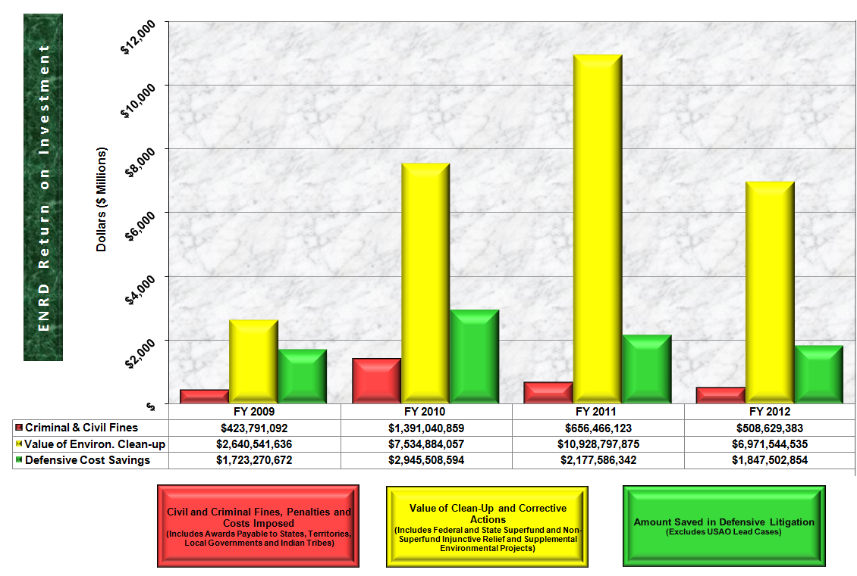

Below are notable successes from the Division’s civil and criminal litigation dockets during FY 2012.

Civil Cases

- Deepwater Horizon Oil Spill

In February 2013, the U.S. District Court for the E.D. of Louisiana approved settlements fashioned by the Department and federal agency partners to punish various Transocean companies involved in the Deepwater Horizon oil spill. The total civil penalty, criminal fine, and related criminal payments total $1.4 billion, comprised of a civil penalty of $1.0 billion, the largest civil penalty ever secured under any federal environmental law, and another $400 million to be paid under a cooperation-and-guilty-plea agreement with the Transocean company known as Transocean Deepwater, Inc.

Under the civil settlement, the $1 billion civil penalty will be paid under the Clean Water Act and the Resources and Ecosystems Sustainability, Tourist Opportunities and Revived Economies of the Gulf Coast States Act of 2012 (RESTORE Act). The RESTORE Act provides that almost 80 percent of the civil penalty collected here will be to be used to fund projects in the five Gulf States, to benefit environmental and economic benefit in that Region. Also under the civil enforcement settlement, which is embodied in a court order, the Transocean Defendants must implement measures to improve the operational safety and emergency response capability of all their drilling rigs working in the waters of the United States. The Transocean Defendants will be required to conduct these operational measures under court order for at least five years, and possibly longer, depending on quality of performance.

The $400 million, criminal-side payment includes: 1) A criminal fine; 2) Funds to improve environmental resources in the five Gulf States (Alabama, Florida, Louisiana, Mississippi, and Texas); and 3) A fund that will be used by the National Academy of Sciences to select and support research, development, education, and training calculated to reduce the chance of oil spills and to improve capacities for responding to such spills.

On February 17, 2012, the Department and federal agency partners announced an agreement with MOEX Offshore to settle its liability in the Deepwater Horizon oil spill. MOEX is one of eight parties sued by the Department in 2010 in connection with the Deepwater Horizon oil spill. According to the terms of the settlement, MOEX will pay $70 million in civil penalties to resolve alleged violations of the Clean Water Act—the largest to date under the Clean Water Act—and will spend $20 million on supplemental environmental projects to facilitate land acquisition projects in several Gulf states that will preserve and protect in perpetuity habitat and resources important to water quality.

- Tribal Trust Cases

The extraordinarily complex and multifaceted Tribal Trust cases command a large portion of ENRD’s time and resources. The Division represents the United States in 36 presently pending cases in which 40 Indian tribes demand “full and complete” historical trust accountings, monetary compensation for various breaches and mismanagement of trust, and trust reform measures relating to the United States’ management of the tribes’ trust funds and non-monetary trust assets (such as timber, oil and gas, agricultural and grazing, and rights of way) and trust lands. Many of these cases are in settlement negotiations, while others are in varying stages of trial preparation, and a couple are proceeding down parallel pre-trial preparation and settlement discussion tracks simultaneously. The Division has enjoyed success in the past fiscal year by engaging in discussions and reaching settlements with 64 tribes in 38 cases, while also conducting litigation, including a full-blown trial, in several cases. It has done so balancing its duties to defend client programs with an obligation to make whole any tribe that has suffered financial injury as a result of any trust fund or trust resource management practices. The Division is prepared to proceed with settlement discussions or ADR processes – or with trial preparations and trial – in the remaining 36 cases.

- Enforcement Under Comprehensive Environmental Response, Compensation and Liability Act (“CERCLA” or “the Superfund Act”)

At the end of September 2011, the Division reached an agreement for the cleanup of the Midnite Mine Superfund Site, located on the Spokane Indian Reservation in Northeastern Washington State. The site poses a threat to human health and the environment because it is centered around a former open pit uranium mine with heavy metals and elevated levels of radioactivity. Under the agreement, Newmont USA Limited, and Dawn Mining Company, LLC will design, construct and implement a cleanup plan for the site and will reimburse EPA’s costs for overseeing the work. Cleanup at the site is expected to cost $193 million. EPA will be reimbursed for approximately $25 million in costs already incurred. The United States, on behalf of the Department of the Interior, will contribute approximately $54 million toward past and future cleanup activities. The mining companies have agreed to secure funding that will be available should EPA have to take over the work.

The Division also reached agreement in May 2012 with Pharmacia Corporation and Bayer CropScience Inc., for payment of $4.25 million to federal and state governments (the natural resource trustees) to resolve claims for natural resource damages connected with the Industri-plex Superfund site located in Woburn, Mass. Of the $4.25 million settlement, over $3.8 million will be used by the trustees to implement natural resource restoration projects that may include the creation of new wetlands and the restoration, enhancement or protection of existing wetlands. The remaining amount of the settlement figure – more than $400,000 – will reimburse trustees for damages assessment costs.

- Addressing Air Pollution From Oil Refineries and other Clean Air Act Cases

ENRD and EPA reached an innovative agreement in April 2012 with Ohio-based Marathon Petroleum Company that already has significantly reduced air pollution from all six of the company’s petroleum refineries. In a first for the refining industry, Marathon has agreed to install state-of-the-art controls on waste combustion devices known as flares and to cap the volume of waste gas sent to flares. The settlement is part of EPA’s national effort to reduce air pollution from refinery, petrochemical, and chemical flares. When fully implemented, the agreement is expected to reduce harmful air pollution by approximately 5,400 tons per year and result in future cost savings for the company. The agreement, accompanied by a $460,000 civil penalty, resolves Marathon’s alleged violations of the Clean Air Act. Marathon also will spend an as yet undetermined sum to comply with the flaring caps required in the consent decree. Under the agreement, Marathon will also implement a project at its Detroit, Michigan refinery to remove another 15 tons per year of VOCs and another one ton per year of benzene from the air. At an estimated cost of $2.2 million, Marathon will install controls on numerous sludge handling tanks and equipment. Marathon’s six refineries, which are located in Robinson, Illinois; Catlettsburg, Kentucky; Garyville, Louisiana; Detroit, Michigan; Canton, Ohio; and Texas City, Texas, have a capacity of more than 1.15 million barrels per day.

The Division reached a settlement in May 2012 with QEP Field Services Co. (QEPFS), formerly Questar Gas Management Co., to resolve alleged violations of the Clean Air Act at five natural gas compressor stations on the Uintah and Ouray Reservation in Northeastern Utah. Under the proposed settlement, QEPFS will pay a $3.65 million civil penalty and pay $350,000 into a Tribal Clean Air Trust Fund to be established by the tribal member parties. The settlement also requires QEPFS to reduce its emissions by removing certain equipment, installing additional pollution controls, and replacing the natural gas powered instrument control systems with compressed air control systems. The Tribal Clean Air Trust Fund will fund beneficial environmental projects on the Uintah and Ouray Reservation, including projects to reduce emissions of air pollution on the reservation, mitigate the impacts of air pollution on tribal members, screen for air pollution related health impacts among tribal members, or educate tribal members about the impacts of air pollution on their health and the environment. The actions required in the settlement will eliminate approximately 210 tons of NOx, 219 tons of carbon monoxide, 17 tons of HAPs and more than 166 tons of VOCs per year. It will also conserve 3.5 million cubic feet of gas each year, which could heat approximately 50 U.S. households. The reduction in methane emissions (a greenhouse gas that is a component of natural gas) is equivalent to planting more than 300 acres of trees.

- Supporting Investments in Transportation Infrastructure

In FY 2011, the Division continued its effort to support the Department of Transportation’s investment in state and city efforts to improve transportation options in urban areas. In St. Paul Branch of the NAACP v. Federal Transit Admin., we worked with the United States Attorney’s Office in Minnesota to defend the Federal Transit Administration’s environmental impact disclosures for the Central Corridor Light Rail Transit Project connecting downtown St. Paul with downtown Minneapolis. The court ruled in favor of the agency on all claims but one, and declined to halt the project while the agency remedied its environmental disclosures. The court agreed with our argument that the public interest in the transit project, including the construction jobs it is bringing to the Twin Cities, outweighed the potential harm to plaintiffs. In Friends of Congaree Swamp v. Federal Highway Admin., ENRD also succeeded in defending a $37 million project to rebuild a series of four structurally deficient bridges and expand connecting causeways along U.S. Highway 601 within the Congaree National Park in South Carolina. Plaintiffs were successful in a prior challenge, and brought new claims challenging the revised environmental analysis. The South Carolina Department of Transportation also was a defendant in this suit and the Division worked very closely with it. As a result of the favorable decision, this important public safety work continues. Construction is expected to be completed in June 2013.

- Settling Liability for Natural Resource Damages

In FY 2012, ENRD reached a $6.8 million agreement with Freeport-McMoRan Corporation and Freeport-McMoRan Morenci, Inc. (Freeport-McMoRan) to settle federal and state natural resource damages claims related to the Morenci copper mine in southeastern Arizona. Freeport-McMoRan is alleged to be civilly liable for injuries to natural resources that resulted from hazardous substance releases at and from Freeport-McMoRan’s Morenci Mine site. Surface waters, terrestrial habitat and wildlife, and migratory birds are alleged to have been injured, destroyed or lost as a result of releases of hazardous substances such as sulfuric acid and metals. The $6.8 million payment will fund planning and implementation of projects to restore, replace or acquire the equivalent of wildlife and wildlife habitat in the vicinity of the impacted area.

- Enforcement of the Clean Water Act Through Publicly Owned Sewer Cases

The Division continues to reach agreements with municipalities to upgrade their sewage treatment plants. EPA’s Clean Water Act initiative focuses on reducing discharges from sewer overflows by obtaining cities’ commitments to implement timely, affordable solutions, including the increased use of green infrastructure and other innovative approaches. Raw sewage contains pathogens that threaten public health, leading to beach closures and public advisories against fishing and swimming. This problem particularly affects older urban areas, where minority and low-income communities are often located. The United States has reached similar agreements in the past with numerous municipal entities across the country including Mobile and Jefferson County, Alabama (Birmingham); Atlanta and Dekalb County, Georgia; Knoxville and Nashville, Tennessee; Miami-Dade County, Florida; New Orleans, Louisiana; Hamilton County (Cincinnati), Ohio; Northern Kentucky Sanitation District #1; and Louisville, Kentucky.

New agreements achieved in FY 2012 include those with Unalaska, Alaska, and Memphis, Tennessee. Unalaska will spend at least $18 million to upgrade its treatment plant over the next three years. The city will also pay a $340,000 penalty for past permit violations. Unalaska (commonly known as Dutch Harbor), serves as homeport to one of the nation’s most productive commercial fishing fleets, supporting both industrial-scale fishing and fish processing. During the height of the fishing season, Unalaska’s population more than doubles, reaching as high as 10,000. Unalaska Bay is protected for a number of uses, including boating, recreational and commercial fishing, and shellfish harvest. It also provides habitat for several endangered or threatened species, including northern sea otters and Steller’s eiders, a species of sea duck. However, the bay is currently listed as an impaired water-body, which means it fails to meet state water quality standards.

The city of Memphis, Tennessee, agreed in FY 2012 to improve the operation and maintenance of its sewer systems and to address the problem of grease buildup within the sewer lines. Memphis developed and will be required to implement a comprehensive fats, oil and grease (FOG) program. The city must perform a continuing sewer infrastructure assessment, rehabilitation, and maintenance program at an estimated cost of approximately $250 million. The city must also pay a civil penalty of $1.29 million, half of which will be paid to the United States. At the direction of the state, the other half will be paid by the city through its execution of certain state projects, including improvements to Memphis’ Geographic Information System (GIS) and implementation of an effluent color study to better delineate limits for the color of Memphis’ permitted discharges to the Mississippi River.

- Controlling Contaminated Storm Water Run-Off by Construction Companies

In the latest in a series of enforcement actions, the Ryland Group Inc., one of the nation’s largest homebuilders, agreed in October 2011 to pay a civil penalty of $625,000 to resolve alleged Clean Water Act violations at its construction sites, including sites located in the Chesapeake Bay Watershed. Keeping contaminated stormwater out of America’s waters is one of EPA’s national enforcement initiatives. Construction projects have a high potential for environmental harm because they disturb large areas of land and significantly increase the potential for erosion. Stormwater run-off can pick up construction pollutants and flow directly to the nearest waterway and degrade aquatic habitats and drinking water quality. Among Ryland’s alleged violations are failure to obtain permits, and failure to comply with permits it did have by not installing or implementing adequate stormwater controls or practices. Such practices include common-sense safeguards such as silt fences, phased site grading and sediment basins. Under the agreement, Ryland must also improve employee training and increase management oversight at all current and future construction sites. EPA estimates the settlement will prevent millions of pounds of sediment from entering U.S. waterways every year.

- Ensuring Industry Focuses on the Safety of the Public and Protection of the Environment

The Division reached an agreement in January 2012 with food processor Columbus Manufacturing Inc., in which the company agreed to pay a penalty of more than $600,000 and make $6 million in upgrades to settle Clean Air Act violations. In two releases of anhydrous ammonia at its South San Francisco processing plant, Columbus failed to identify hazards, maintain a safe facility, and comply with regulatory requirements for process safety management under the Clean Air Act. The company agreed to convert its refrigeration system to a safer technology that uses glycol and ammonia and to improve its alarm and ammonia release notification procedures. The first accidental ammonia release in February 2009, sent 217 pounds of poisonous gases into the atmosphere. Six months later in August 2009, the plant again released an ammonia cloud, this time approximately 200 pounds of anhydrous ammonia was released into the atmosphere. The August incident resulted in the evacuation of all facility employees and several neighboring businesses. Nearly 30 people from the downwind Genentech campus sought medical attention and 17 individuals were hospitalized. One person remained hospitalized for four days. In addition, off-ramps from Highway 101 and several local streets were shut down as a result of the release. EPA took action following the August 2009 incident, ordering Columbus to complete initial upgrades to its ammonia refrigeration system, including the replacement of safety relief valves and components with any signs of corrosion, and the proper labeling of all of its piping. In 2011, the company paid $850,000 in fines to San Mateo County as a result of the incident.

- Furthering the Nation’s Renewable Energy Agenda

The Division is actively defending challenges to permits and rights of way issued by the Bureau of Land Management (BLM) and the United States Forest Service to promote the development of renewable energy projects on western public lands. We successfully defeated motions for temporary restraining orders and/or preliminary injunctions for the Ivanpah Solar Project, Blythe Solar Project, and Sunrise Powerlink transmission project in California in the past fiscal year. The Division also successfully opposed efforts in Western Watersheds Project v. BLM to preliminarily enjoin the Spring Valley Wind Project located in Nevada. This represented the first decision on a wind energy project sited on federal land. The court concluded that the public has a strong interest in this project because “Congress and the President have clearly articulated that clean energy is a necessary part of America's future and it is important to Nevada's economic and clean energy goals.” Finally, we are working closely with BLM to defend the permit issued for the Cape Wind Project, America’s first offshore wind project.

In National Petrochemical & Refiners Ass’n v. EPA, industry petitioners challenged EPA’s efforts to ensure that the full volume of renewable fuels specified by Congress in the Energy Independence and Security Act for use in 2009 and 2010 were produced and used, notwithstanding the fact that EPA had been unable to promulgate regulations in time for calendar year 2009. In December 2010, the D.C. Circuit found not only that EPA acted reasonably in combining the 2009 and 2010 quantities in the 2010 regulation, but also that the regulation was not impermissibly retroactive. In November 2011, the Supreme Court declined to grant a petition for writ of certiorari in the case.

- Supporting Tribal Recognition and Sovereignty

The Division has continued its longstanding efforts in FY 2011 to support tribal jurisdiction and sovereignty. For example, in Water Wheel Camp Recreation Area, Inc. v. LaRance, ENRD filed an amicus brief in the Ninth Circuit supporting tribal court jurisdiction. The underlying dispute arose over a lease secured by Water Wheel Camp Recreation Area, Inc., for the development of tribal land on a reservation of the Colorado River Indian Tribes (CRIT). After CRIT obtained an eviction order and monetary judgment in tribal court against the company and its principal owner, both filed an action in federal district court arguing that the tribal court lacked jurisdiction. While the district court found that the tribal court had jurisdiction to adjudicate the tribe’s claims only as to the company, the Ninth Circuit held that the tribal court had jurisdiction as to the claims against both the company and its owner. Consistent with the argument made by the Division, the Ninth Circuit concluded that the tribe’s authority to regulate non-member use of tribal land is an inherent part of its power to exclude and that the tribe’s adjudicatory authority was coextensive with its regulatory authority over the land.

- Implementing Indian Water Rights Settlements Enacted by Congress

In 2010, Congress enacted five landmark Indian water rights settlements involving ENRD water rights adjudications. When fully implemented, this legislation will resolve complex and contentious Indian water rights issues in three western states. (The Taos Pueblo Indian Water Rights Settlement, the Aamodt Litigation Settlement Act, and the Navajo-San Juan River Basin Settlement in New Mexico; the Crow Tribe Water Right Settlement in Montana; and the White Mountain Apache Tribe in Arizona.) To implement this legislation, the Division must negotiate final agreements, and enter and defend consent decrees, all within short deadlines mandated by Congress.

Criminal Cases

- Vessel Pollution Cases

Over the past decade, working in conjunction with the U.S. Coast Guard (USCG), ENRD, through the Environmental Crimes Section (ECS), has built a successful vessel pollution prosecution practice, focusing on the prosecution of individuals and corporations involved in pollution from ships and the deliberate falsification of official ship records designed to conceal illegal pollution. The Vessel Pollution Program is an ongoing, concentrated effort to detect, deter, and prosecute those who illegally discharge pollutants from ships into the oceans, coastal waters and inland waterways. Over the past 10 years, the criminal penalties imposed in such cases have totaled more than $200 million, and responsible shipboard officers and shore-side officials have been sentenced to more than 17 years of incarceration. In FY 2011 alone, ENRD obtained $11.4 million in criminal fines related to Vessel Pollution prosecutions, and the number of referrals from the U.S. Coast Guard is increasing steadily. The initiative has resulted in a number of important criminal prosecutions of key segments of the commercial maritime industry, including cruise ships, container ships, tank vessels, and bulk cargo vessels.

For example, in FY 2012, two corporations were each sentenced to pay $1.2 million and serve three years of probation for violating the Act to Prevent Pollution from Ships (APPS). Efploia Shipping, a Marshall Islands corporation based in Greece, was the technical manager of the M/V Aquarosa, a 33,005 gross ton newly built cargo ship, constructed in China and registered in Malta. Aquarosa Shipping, a company based in Denmark, was the owner of the vessel. Both corporations pleaded guilty to four felony counts: obstruction of justice, making material false statements, and the environmental crimes of knowingly failing to maintain an accurate oil record book and knowingly failing to maintain an accurate garbage record book.

Senior ship engineers are alleged to have begun dumping oil contaminated bilge waste during the ship’s very first voyage after it was completed in 2010. One method involved removing the blocking mechanism inside a valve so that waste could be pumped overboard. Another method involved a so-called “magic pipe” consisting of a long rubber hose and metal flanges welded together onboard to bypass required pollution prevention equipment. The investigation began after an engineer complained to the U.S. Coast Guard when the ship arrived in Baltimore in February 2011. The crew member provided the Coast Guard with his cell phone containing 300 photographs showing how a magic pipe was being used to discharge sludge and oily waste overboard and to bypass the ship’s oily water separator, a required piece of pollution prevention equipment. Plastic garbage bags containing oil soaked rags were also dumped overboard. Under MARPOL, an international treaty to which the United States is a party and which is enforced by the APPS, ships must maintain an oil record book and a garbage record book in which all such discharges are recorded. Both defendants admitted to deliberately falsifying these required logs. Efploia Shipping and Aquarosa Shipping are required to implement a government approved environmental plan that includes audits conducted by an independent firm and review by a court appointed monitor. Each defendant must pay $275,000 in organizational community service payments to the National Fish & Wildlife Foundation for projects involving the Chesapeake Bay.

- Enforcing Laws Protecting Wildlife

In March 2012, the Division successfully prosecuted a Miami taxidermist for illegal trafficking in endangered and protected wildlife. From late 2009 to February 2011, the defendant illegally imported skins and remains of numerous species, including a king cobra, a pangolin, hornbills, birds of paradise, and the skulls of babirusa and orangutans. Despite the interception of two shipments in late 2009 that he ultimately forfeited and abandoned, he continued to solicit protected wildlife from his suppliers via the Internet, selecting specific animals from photographs. The parts or carcasses of the selected wildlife would then be shipped to him without the permits or declarations required by law. Some of the endangered and protected wildlife he selected was alive at the time it was photographed, including a wooly stork, a slow loris, and a hornbill, and later sent to him dead. The defendant incorporated various parts and segments of the wildlife into taxidermy pieces at a studio in downtown Miami. He offered these pieces through galleries and on the Internet for prices ranging up to $80,000. In December 2010, pieces were exhibited during Art Basel week at the Scope Art Fair in Miami, resulting in at least one significant sale and the subsequent illegal export of the piece to Canada.

In order to protect certain species of wildlife against over-exploitation, the United States is a signatory to an international treaty known as the Convention on International Trade in Endangered Species of Wild Fauna and Flora (CITES), under which trade in certain threatened species is regulated or even prohibited for commercial purposes. Federal law also prohibits the importation of fish or wildlife into the United States without proper declaration to both U.S. Customs and Border Protection (CBP) and the Fish & Wildlife Service (FWS).

- Enforcing the Clean Air Act at Oil Refineries

In December 2011, the Division successfully prosecuted the Pelican Refining Company, LLC, for felony violations of the Clean Air Act and obstruction of justice. Pelican was sentenced to pay a $12 million penalty, which includes a $10 million criminal fine (the largest ever in Louisiana for such violations) and $2 million in community service payments that will go toward various environmental projects in Louisiana, including air pollution monitoring. Pelican is also prohibited from future operations unless it implements an environmental compliance plan, which includes independent quarterly audits by an outside firm and oversight by a court appointed monitor. The company admitted that it had knowingly committed criminal violations of its operating permit at the refinery located in Lake Charles, Louisiana. The violations were discovered during a March 2006 inspection by the Louisiana Department of Environmental Quality (LDEQ) and the EPA, which identified numerous unsafe operating conditions. Pelican also pleaded guilty to obstruction of justice for submitting materially false reports to LDEQ, the agency that administers the federal Clean Air Act in Louisiana. To comply with its required Clean Air Act permit, the refinery was required to use certain key pollution prevention equipment, but that equipment was either not functioning, poorly maintained, improperly installed, improperly placed into service and/or improperly calibrated. For over a year the company used an emergency flare gun to re-light the flare tower at the refinery designed to burn off toxic gases and provide for the safe combustion of potentially explosive chemicals. The pilot light was not functioning properly and employees would take turns trying to shoot the flare gun to relight the explosive gasses.

- Protecting the Public Against Hazardous Waste

Freedman Farms Inc., a hog farming company, was sentenced in February 2012 to five years probation and ordered to pay $1.5 million in fines, restitution and community service payments for violating the Clean Water Act. Instead of directing hog waste to two lagoons for treatment and disposal, the company allowed it to be discharged directly into a stream that leads to the Waccamaw River through a large wetlands complex. Freedman Farms, located in Columbus County, North Carolina, is in the business of raising hogs for market, and this particular farm had some 4,800 hogs. The federal Clean Water Act makes it illegal to knowingly or negligently discharge a pollutant into a water of the United States. Manure from Concentrated Animal Feeding Operations (CAFOs), like Freedman Farms, if not properly controlled, can contaminate both surface waters and ground waters that may be used as drinking water sources and harm fish and other aquatic species. The company president was sentenced to six months in prison to be followed by six months of home confinement. Freedman Farms is also required to implement a comprehensive environmental compliance program and institute an annual training program.

- Performance and Resources Table

Performance and Resources Table (Cont.)

Performance Measure Table

3. Performance, Resources, and Strategies

The Environment and Natural Resources Division contributes to the Justice Department’s Strategic Goal Two: Prevent Crime, Protect the Rights of the American People, and Enforce Federal Law. The Division focuses on both civil and criminal litigation within this strategic objective. An explanation by litigating activity follows.

Criminal Litigating Activities

A. Performance Plan and Report for Outcomes

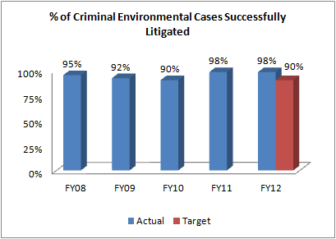

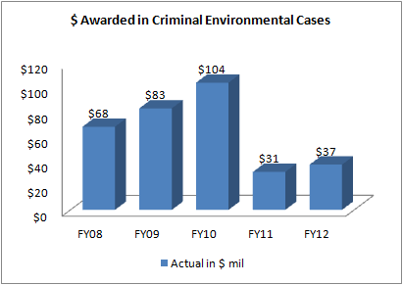

Data Collection and Storage: A majority of the performance data submitted by ENRD are generated from the Division’s Case Management System (CMS). Similarly, EOUSA data are extracted from their CMS.

Data Validation and Verification: The Division has instituted a formal data quality assurance program to ensure a quarterly review of the Division’s docket. The case systems data are monitored by the Division to maintain accuracy.

Data Limitations: Timeliness of notification by the courts.
Vigorous prosecution remains the cornerstone of the Department’s integrated approach to ensuring broad-based environmental compliance. It is the goal of investigators and prosecutors to discover and prosecute criminals before they have done substantial damage to the environment (including protected species), seriously affected public health, or inflicted economic damage on consumers or law-abiding competitors. The Department’s environmental protection efforts depend on a strong and credible criminal program to prosecute and deter future wrongdoing. Highly publicized prosecutions and tougher sentencing for environmental criminals are spurring improvements in industry practice and greater environmental compliance. Working together with federal, state and local law enforcement, the Department is meeting the challenges of increased referrals and more complex criminal cases through training of agents, officers and prosecutors, outreach programs, and domestic and international cooperation.

Performance Results

I. Performance Measure - Percent of Criminal Environmental Cases Successfully Resolved

- FY 2012 Target: 90%

- FY 2012 Actual: 98%

Discussion: In FY 2012, ENRD’s Environmental Crimes Section (ECS) had a strong year for criminal enforcement, successfully prosecuting 52 defendants and imposing fines and penalties totaling over $37 million.
In FY 2012, ECS successfully prosecuted a number of vessel pollution cases. The former captain of a Panama-flagged cargo ship that discharged hundreds of plastic pipes into the ocean was found guilty of obstructing a U.S. Coast Guard inspection of the vessel and obstruction of justice for creating a false and fictitious garbage log. The garbage log is required and regularly inspected by the U.S. Coast Guard. The captain was described by witnesses as having ordered hundreds of plastic pipes to be thrown into the ocean and not recorded the discharge in the ship’s garbage record book as required. The false record was then shown to the Coast Guard. The plastic pipes had previously contained insecticide and were used to fumigate a grain shipment. The discharge of plastic into the sea is prohibited under the International Convention to Prevent Pollution from Ships, known as MARPOL.
FY 2012 Performance Plan Evaluation: Our success rate of 98 percent exceeded our goal of 90 percent. Proposed legislation and judicial calendars can affect our overall performance, which can then realize peaks and valleys when large cases are decided. Our goal is to improve overall performance in a 5-year span.
FY 2013/2014 Performance Plan: We have set our target at 90 percent of cases successfully litigated for FY 2013 and FY 2014. ENRD targets are generally set at an attainable performance level so that there is no incentive to ramp up prosecutions or lawsuits against insignificant targets for “easy” wins solely to meet higher targets. Such an approach would do a disservice to the public by steering litigation away from more complicated problems facing the country’s environment and natural resources.

Public Benefit: The Division continues to produce successful criminal prosecutions relating to environmental statutes. These successes ensure compliance with the law and lead to specific improvements in the quality of the environment of the United States, and the health and safety of its citizens. Additionally, ENRD has had numerous successes in prosecuting vessels for illegally disposing of hazardous materials into United States waterways. These successes have improved the quality of our waterways and promoted compliance with proper disposition of hazardous materials. Also, the Division has successfully prosecuted numerous companies for violations of environmental laws which endangered their workers. Our successes lead to safer workplaces and fewer lives lost to hazardous conditions.

II. Performance Measure - $ Awarded in Criminal Environmental Cases

- FY 2012 Target: In accordance with Department guidance, targeted levels of performance are not projected for this indicator.

- FY 2012 Actual: $37.2 million

Discussion: In FY 2012, Eagle Recycling was sentenced to pay a $500,000 criminal fine and more than $70,000 in restitution and cleanup costs as a result of its guilty plea to conspiring to violate the Clean Water Act and to defrauding the United States. The company received three years of corporate probation and was ordered to formulate, fund and implement an environmental compliance plan to prevent future environmental violations at their North Bergen, N.J. operation. Eagle Recycling and other co-conspirators engaged in a multi-year scheme to illegally dump 8,100 tons of pulverized construction and demolition debris that was processed at Eagle Recycling’s solid waste management facility and then transported to a farmer’s property in Frankfort, N.Y. Eagle Recycling and other conspirators then concealed the illegal dumping by fabricating a New York State Department of Environmental Conservation (DEC) permit and forging the name of a DEC official on the fraudulent permit.

FY 2013/2014 Performance Plan: Not Applicable. In accordance with Department guidance, levels of performance for FY 2013 and FY 2014 are not projected for this indicator. Many factors affect our overall performance, such as proposed legislation, judicial calendars, etc. The performance of the Division tends to reflect peaks and valleys when large cases are decided. Therefore, we do not project targets for this metric annually, but our goal is to improve overall performance over a 5-year span.

Public Benefit: The Division continues to obtain criminal fines from violators, thereby removing economic benefits of non-compliance and leveling the playing field for law-abiding companies. Our prosecutorial efforts deter others from committing crimes and promote adherence to environmental and natural resources laws and regulations. These efforts result in the reduction of hazardous materials and wildlife violations and improve the quality of the United States’ waterways, airways, land, and wildlife, thereby enhancing public health and safety.

B. Strategies to Accomplish Outcomes

The Division will continue efforts to obtain convictions and to deter environmental crimes through initiatives focused on vessel pollution, illegal timber harvesting, laboratory fraud, chlorofluorocarbon (CFC) smuggling, wildlife smuggling, transportation of hazardous materials, and worker safety. ENRD will also continue to prosecute international trafficking of protected species of fish, wildlife, and plants with a host of international treaty partners.

Illegal international trade in wildlife is second in size only to the illegal drug trade, and our criminal prosecutors work directly on these cases, as well as assist United States Attorneys Offices and share ENRD expertise nationwide with state and federal prosecutors and investigators. We will focus on interstate trafficking and poaching cases on federal lands, and seek to ensure that wildlife conservation laws are applied uniformly and enforced across the country, seeking consistency in these criminal prosecutions and a vigorous enforcement program that serves as an international role model.

ENRD has partnered with other federal agencies, such as EPA, to pursue litigation against criminal violators of our nation’s environmental policies. Egregious offenders are being brought to justice daily. The Division has worked collaboratively to identify violators who pose a significant threat to public health. By prosecuting criminal violations of regulations, ENRD is forcing compliance and discouraging continued disregard for public health.

Civil Litigating Activities
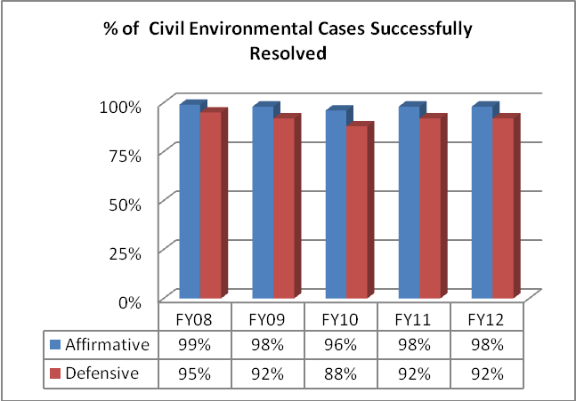

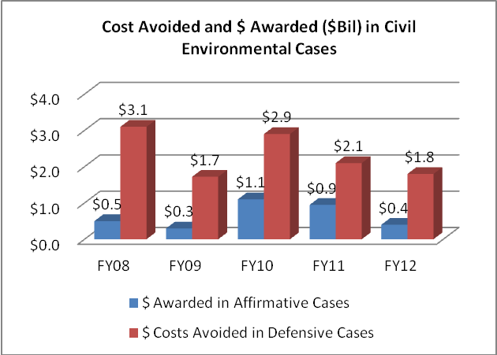

Data Collection and Storage: A majority of the performance data submitted by ENRD is generated from the Division’s Case Management System (CMS).

Data Validation and Verification: The Division has instituted a formal data quality assurance program to ensure a quarterly review of the Division’s docket. The systems data is constantly being monitored by the Division to maintain accuracy.

Data Limitations: Timeliness of notification by the courts

A. Performance Plan and Report for Outcomes

The Department enforces environmental laws to protect the health and environment of the United States and its citizens, defends environmental challenges to government programs and activities, and represents the United States in all matters concerning the protection, use, and development of the nation's natural resources and public lands, wildlife protection, Indian rights and claims, and the acquisition of federal property.

Performance Results

I. Performance Measure - Percent of Civil Environmental Cases Successfully Resolved

- FY 2012 Target:
85% Affirmative; 75% Defensive

- FY 2012 Actual:
98% Affirmative; 92% Defensive

Discussion: In FY 2012, ENRD ensured that harmful sediments are removed from rivers, state-of-the-art pollution control devices are added to factories to provide cleaner air, sewage discharges are eliminated, and damaged land and water aquifers are restored. ENRD also worked successfully to ensure the integrity of municipal wastewater treatment systems. Each year, hundreds of billions of gallons of untreated sewage are discharged into the nation’s waters from municipal wastewater treatment systems that are overwhelmed by weather conditions they are not designed to handle.
In FY 2012, the Division reached a settlement with the Metropolitan Water Reclamation District of Greater Chicago (MWRD) to resolve claims that untreated sewer discharges were released into Chicago area waterways during flood and wet weather events. MWRD will pay a civil penalty of $675,000 and work to complete a tunnel and reservoir plan to increase its capacity to handle wet weather events and address combined sewer overflow discharges. MWRD will use skimmer boats to remove trash and debris from the water in overflows so it can be collected and properly managed, making waterways cleaner and healthier. MWRD is also required to implement a green infrastructure program that will reduce stormwater runoff by distributing rain barrels and developing projects to build green roofs, rain gardens or use pervious paving materials in urban neighborhoods.
FY 2012 Performance Plan Evaluation: We exceeded our affirmative and defensive civil litigation goals – affirmative by 13 percent, and defensive by 17 percent. The Division continues its strong record of success in civil environmental enforcement of federal pollution abatement laws, and compliance with environmental protection and conservation statutes. ENRD obtains redress for past violations harming the environment and establishes credible deterrents against future violations of these laws, recoups federal funds spent to abate environmental contamination, and obtains money to restore or replace natural resources damaged by oil spills or the release of other hazardous substances into the environment.

FY 2013/2014 Performance Plan: Considering our past performance, we aim to achieve litigation success rates of 85 percent Affirmative and 75 percent Defensive (average of 80 percent) for FY 2013 and FY 2014. ENRD’s targets are set lower than the actual performance so that there is no incentive to ramp up prosecutions or lawsuits against easy targets solely to meet an “ambitious” goal. This sort of easy approach would do a disservice to the public by steering litigation away from more difficult problems facing the country’s environment and natural resources. Several years of data demonstrate that our targets are set at achievable levels and do not deter high performance.

Public Benefit: The success of the Department ensures the correction of pollution control deficiencies, reduction of harmful discharges into the air, water, and land, clean-up of chemical releases, abandoned waste, and proper disposal of solid and hazardous waste. In addition, the Department’s enforcement efforts help ensure military preparedness, safeguard the quality of the environment in the United States, and protect the health and safety of its citizens.

II. Performance Measure - Costs Avoided and $ Awarded in Civil Environmental Cases

- FY 2012 Target: In accordance with Department guidance, targeted levels of performance are not projected for this indicator.

- FY 2012 Actual: $1.8 billion avoided; $398 million awarded
Discussion: The Division had several important civil litigation successes in FY 2012 in cases seeking civil penalties and other monetary recoveries. We continued to successfully litigate Clean Air Act (CAA) claims against operators of coal-fired electric power generating plants and cement manufacturers. These types of violations, litigated by ENRD’s Environmental Enforcement Section (EES), arise from companies engaging in major life extension projects on their facilities without installing required state-of-the-art pollution controls. The resulting tens of millions of tons of excess air pollution has adversely affected human health, degraded forests, damaged waterways, and contaminated reservoirs.
In FY 2012, the Division reached an agreement with CalPortland Company (CPC), a major producer of Portland cement and building materials in the United States. The company agreed to pay a $1.4 million penalty (one of the largest for a single cement facility) to resolve alleged violations of the Clean Air Act at its cement plant in Mojave, California. CPC will spend an estimated $1.3 million on pollution controls that will reduce harmful emissions of nitrogen oxides (NOx) and sulfur dioxide (SO2), pollutants that can lead to childhood asthma and smog. The plant is located in Kern County, California, which has some of the worst air pollution in the country. The pollutants covered in the settlement contribute to the formation of ground-level ozone or smog. Exposure to even low levels of ozone can cause respiratory problems, and repeated exposure can aggravate pre-existing respiratory diseases. CPC is alleged to have made significant modifications to its plant, resulting in increased emissions of NOx, SO2 and carbon monoxide, without first obtaining a Clean Air Act-required permit and without installing necessary pollution control equipment. The settlement ensures that the proper equipment, estimated to cost $1.3 million to install and $500,000 per year to operate, once installed will reduce future emission levels. These measures are expected to reduce pollution each year from the plant by at least 1,200 tons of NOx and 360 tons of SO2.

FY 2013/2014 Performance Plan: Not Applicable. In accordance with Department guidance, levels of performance are not projected for this indicator. There are many factors that affect our overall performance, including proposed legislation and judicial calendars. The overall performance of the Division can be affected when large cases are decided, so we do not project annually, but our goal is to improve overall performance in a 5-year span.

III. Efficiency Measures

1) Total Dollar Value Awarded per $1 Expenditures
[Affirmative]

2) Total Dollars Saved the Government per $1 Expenditures [Defensive]

- FY 2012 Target: $81 awarded; $22 saved

- FY 2012 Actual: $109 awarded; $26 saved

Discussion: The Division had a commendable FY 2012 in its efforts to secure commitments by polluters to take action to remedy their violations of the nation's environmental laws. Actions taken by the Division in federal courts resulted in over $6.9 billion in settlements and court ordered injunctive relief. Additionally, the Division saved the government more than $1.8 billion in defensive litigation. These successes and the Division’s enforcement work have produced significant gains for the public fisc, public health, and the environment. The Division routinely saves the American taxpayers hundreds of millions of dollars each year – many times the Division’s annual budget. Accordingly, in FY 2012, ENRD exceeded its performance goal of total dollars saved the government per $1 expenditures.

FY 2013/2014 Performance Plan: The Division has an exemplary record in protecting the environment, Indian rights, and the nation’s natural resources, wildlife, and public lands, and will continue to establish ambitious targets through FY 2014. The Division will monitor future year performance levels and make the necessary adjustments so that targets reflect actual performance levels. The Division anticipates continued success through vigorous enforcement efforts which generally will produce settlements and significant gains for the public and the public fisc.

Public Benefit: The Division’s efforts to defend federal programs, ensure compliance with environmental and natural resource statutes, win civil penalties, recoup federal funds spent to abate environmental contamination, ensure military preparedness, and ensure the safety and security of our water supply, demonstrate that the United States’ environmental laws and regulations are being vigorously enforced. Polluters who violate these laws are not allowed to gain an unfair economic advantage over law-abiding companies. The deterrent effect of the Division’s work encourages voluntary compliance with environmental and natural resources laws, thereby improving the environment, the quality of our natural resources, and the safety and health of U.S. citizens.

B. Strategies to Accomplish Outcomes

As our environment changes, so do the actions we take to preserve the health and life of those residing within the borders of the United States. Environmental groups and other interested parties challenge Administration policies every year. ENRD is responsible for defending federal agencies carrying out Administration policies every day. The Division has realized some remarkable successes to date. In an effort to continue our successful record of litigation, the Division has sought new and creative ways to utilize our limited resources. For example, ENRD has adopted a policy of “porosity,” whereby cases involving the responsibilities of different sections within ENRD can be litigated by a single attorney, rather than two of three attorneys from different sections. As such, ENRD’s porosity policy allows us to litigate case in a manner that conserves resources, without regard to bureaucratic distinctions within the Division. This policy has also resulted in more flexibility to shift workloads between attorneys when they become overburdened. Although cross-training staff grows our workforce’s skills and abilities, it does not address long-term caseload issues.

The Division works collaboratively with client agencies towards adjudications, mediations, alternative dispute resolution (ADR), and settlements. These alternative methods of resolution are less contentious and save the government expenses associated with full-blown litigation. Water rights adjudications, reclamations, and inverse takings cases are typically handled in settlement mode versus litigation mode. Settlements often result in the most favorable outcome, and reach the largest number of people.

VII. Exhibits

A. Organization Chart

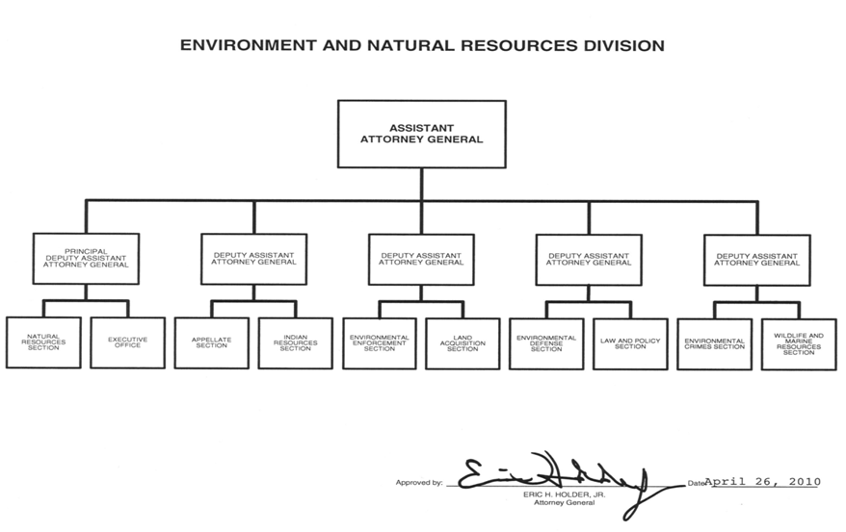

B. Summary of Requirements

Exhibit B
B. Summary of Requirements, (Cont.)

Exhibit B
D. Resources by DOJ Strategic Goal and Strategic Objective

Exhibit D
E. Justification for Base Adjustments

Exhibit E
E. Justification for Base Adjustments (Cont.)

Exhibit E
F. Crosswalk of 2012 Availability

Exhibit F

G. Crosswalk of 2013 Availability

Exhibit G
H. Summary of Reimbursable Resources

Exhibit H
- Detail of Permanent Positions by Category

Exhibit I
K. Summary of Requirements by Grade

Exhibit K
L. Summary of Requirements by Object Class

Exhibit L

[1] DOJ/ENRD maintains a reliable and robust attorney time keeping system, in which all litigation and non-case related time is tracked contemporaneous with work being performed. The Division’s time data is audited regularly by DOJ/OIG, GAO and other parties; and the Division’s time information is relied upon by federal courts for cost recovery, attorneys’ fees, and other purposes.

