THIS PAGE INTENTIONALLY LEFT BLANK

Table of Contents

Page No.

I. Overview 1

II. Summary of Program Changes 16

III. Appropriations Language and Analysis of Appropriations Language 17

IV. Decision Unit Justification 19

A. Criminal 19

1. Program Description 20

2. Performance Tables 21

3. Performance, Resources, and Strategies 23

B. Civil 26

1. Program Description 27

2. Performance Tables 29

3. Performance, Resources, and Strategies 31

C. Legal Education 32

1. Program Description 33

2. Performance Table 37

3. Performance, Resources, and Strategies 39

V. Program Increases by Item...................................................................................... 41

VI. Program Offsets by Item.......................................................................................... 44

VII. Exhibits 45

- Organizational Chart
- Summary of Requirements
- Program Increases/Offsets by Decision Unit
- Resources by DOJ Strategic Goal and Objective
- Justification for Base Adjustments
- Crosswalk of FY 2012 Availability
- Crosswalk of FY 2013 Availability
- Summary of Reimbursable Resources
- Detail of Permanent Positions by Category
- Financial Analysis of Program Changes
- Summary of Requirements by Grade
- Summary of Requirements by Object Class

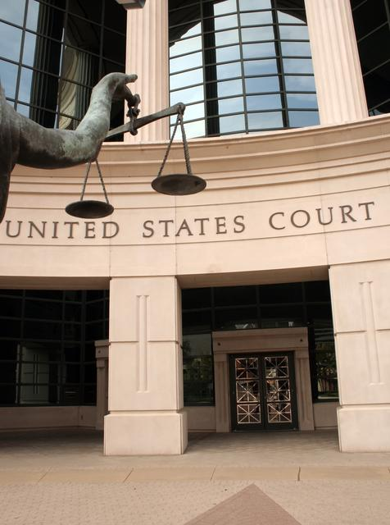

I. Overview for the United States Attorneys

A. Introduction

The United States Attorneys’ mission supports two of the Department of Justice’s strategic
goals - (1) to prevent terrorism and promote the nation’s security consistent with the rule of law, and (2) to prevent crime, protect the rights of the American people, and enforce federal law. In FY 2014, the United States Attorneys’ request $2,007,717,000 and 10,814 positions, of which 5,566 are attorneys. The budget request includes a program increase of 190 positions (including 120 attorneys), 95 FTE, and $26,500,000; and program offsets totaling $17,500,000.

Electronic copies of the Department of Justice’s Congressional Budget Justifications and Capital Asset Plan and Business Case exhibits can be viewed or downloaded from the internet using the Internet address: http://www.justice.gov/02organizations/bpp.htm.

The United States Attorneys serve as the nation’s principal litigators. In response to the mandates of the Constitution that required establishment of a system of federal courts, Congress enacted the Judiciary Act of 1789 directing the President to appoint, in each federal district, “a person learned in the law to act as an attorney for the United States.” Before 1870, the United States Attorneys acted independently, but since then they have worked under the direction of the U.S. Department of Justice.

There are 94 United States Attorneys’ Offices (USAOs) located throughout the United States, Puerto Rico, the Virgin Islands, Guam, and the Northern Mariana Islands. The 93 United States Attorneys (Guam and the Northern Mariana Islands are under the direction of a single U.S. Attorney) are appointed by, and serve at the discretion of, the President of the United States, with the advice and consent of the United States Senate. The map on page 3 depicts the United States Attorneys’ current district and branch office locations.

The United States Attorneys report to the Attorney General through the Deputy Attorney General. Each United States Attorney serves as the chief federal law enforcement officer within his or her judicial district and, as such, is responsible for the prosecution of criminal cases brought by the federal government; the litigation and defense of civil cases in which the United States is a party; and the handling of criminal and civil appellate cases before United States Courts of Appeals.

The United States Attorneys and their Assistant United States Attorneys (AUSAs) serve in small towns and big cities, representing the interests of the United States. Through their hard work and dedication, justice is served throughout the nation. The USAOs conduct most of the trial work in which the United States is a party. Although caseloads vary by districts, each USAO has a diverse docket of cases and a mix of simple and complex litigation. Each United States Attorney exercises wide discretion in the use of his or her resources to further local priorities and serve community needs.

United States Attorneys provide advice and counsel to the Attorney General and senior policy leadership through the Attorney General’s Advisory Committee (AGAC) and its various subcommittees and working groups. The AGAC was established in 1973 to give United States Attorneys a voice in Department policies and to advise the Attorney General. The Committee is comprised of approximately 19 members, including 16 United States Attorneys, a Criminal Chief, a Civil Chief and an Appellate Chief. The Committee members meet regularly with the Deputy Attorney General and Attorney General, and represent various federal judicial districts, geographic locations, and different sized offices. The AGAC has subcommittees and working groups to address the Administration’s priorities.

The subcommittees include:
- Border and Immigration Law Enforcement
- Civil Rights
- Criminal Practice Subcommittee
- Cyber/Intellectual Property
- LECC/Victim/Community Issues
- Native American Issues
- Office Management and Budget
- Terrorism/National Security
- Violent and Organized Crime
- White Collar/Fraud

The working groups include:
- Administrative Officers
- Appellate Chiefs
- Child Exploitation and Obscenity
- Civil Chiefs
- Controlled Substances and Asset Forfeiture
- Criminal Chiefs
- Department
- Environmental Issues
- Forensic Science
- Health Care Fraud
- Local Government Coordination
- Medical Marijuana
- Security
- Service Members and Veterans Rights

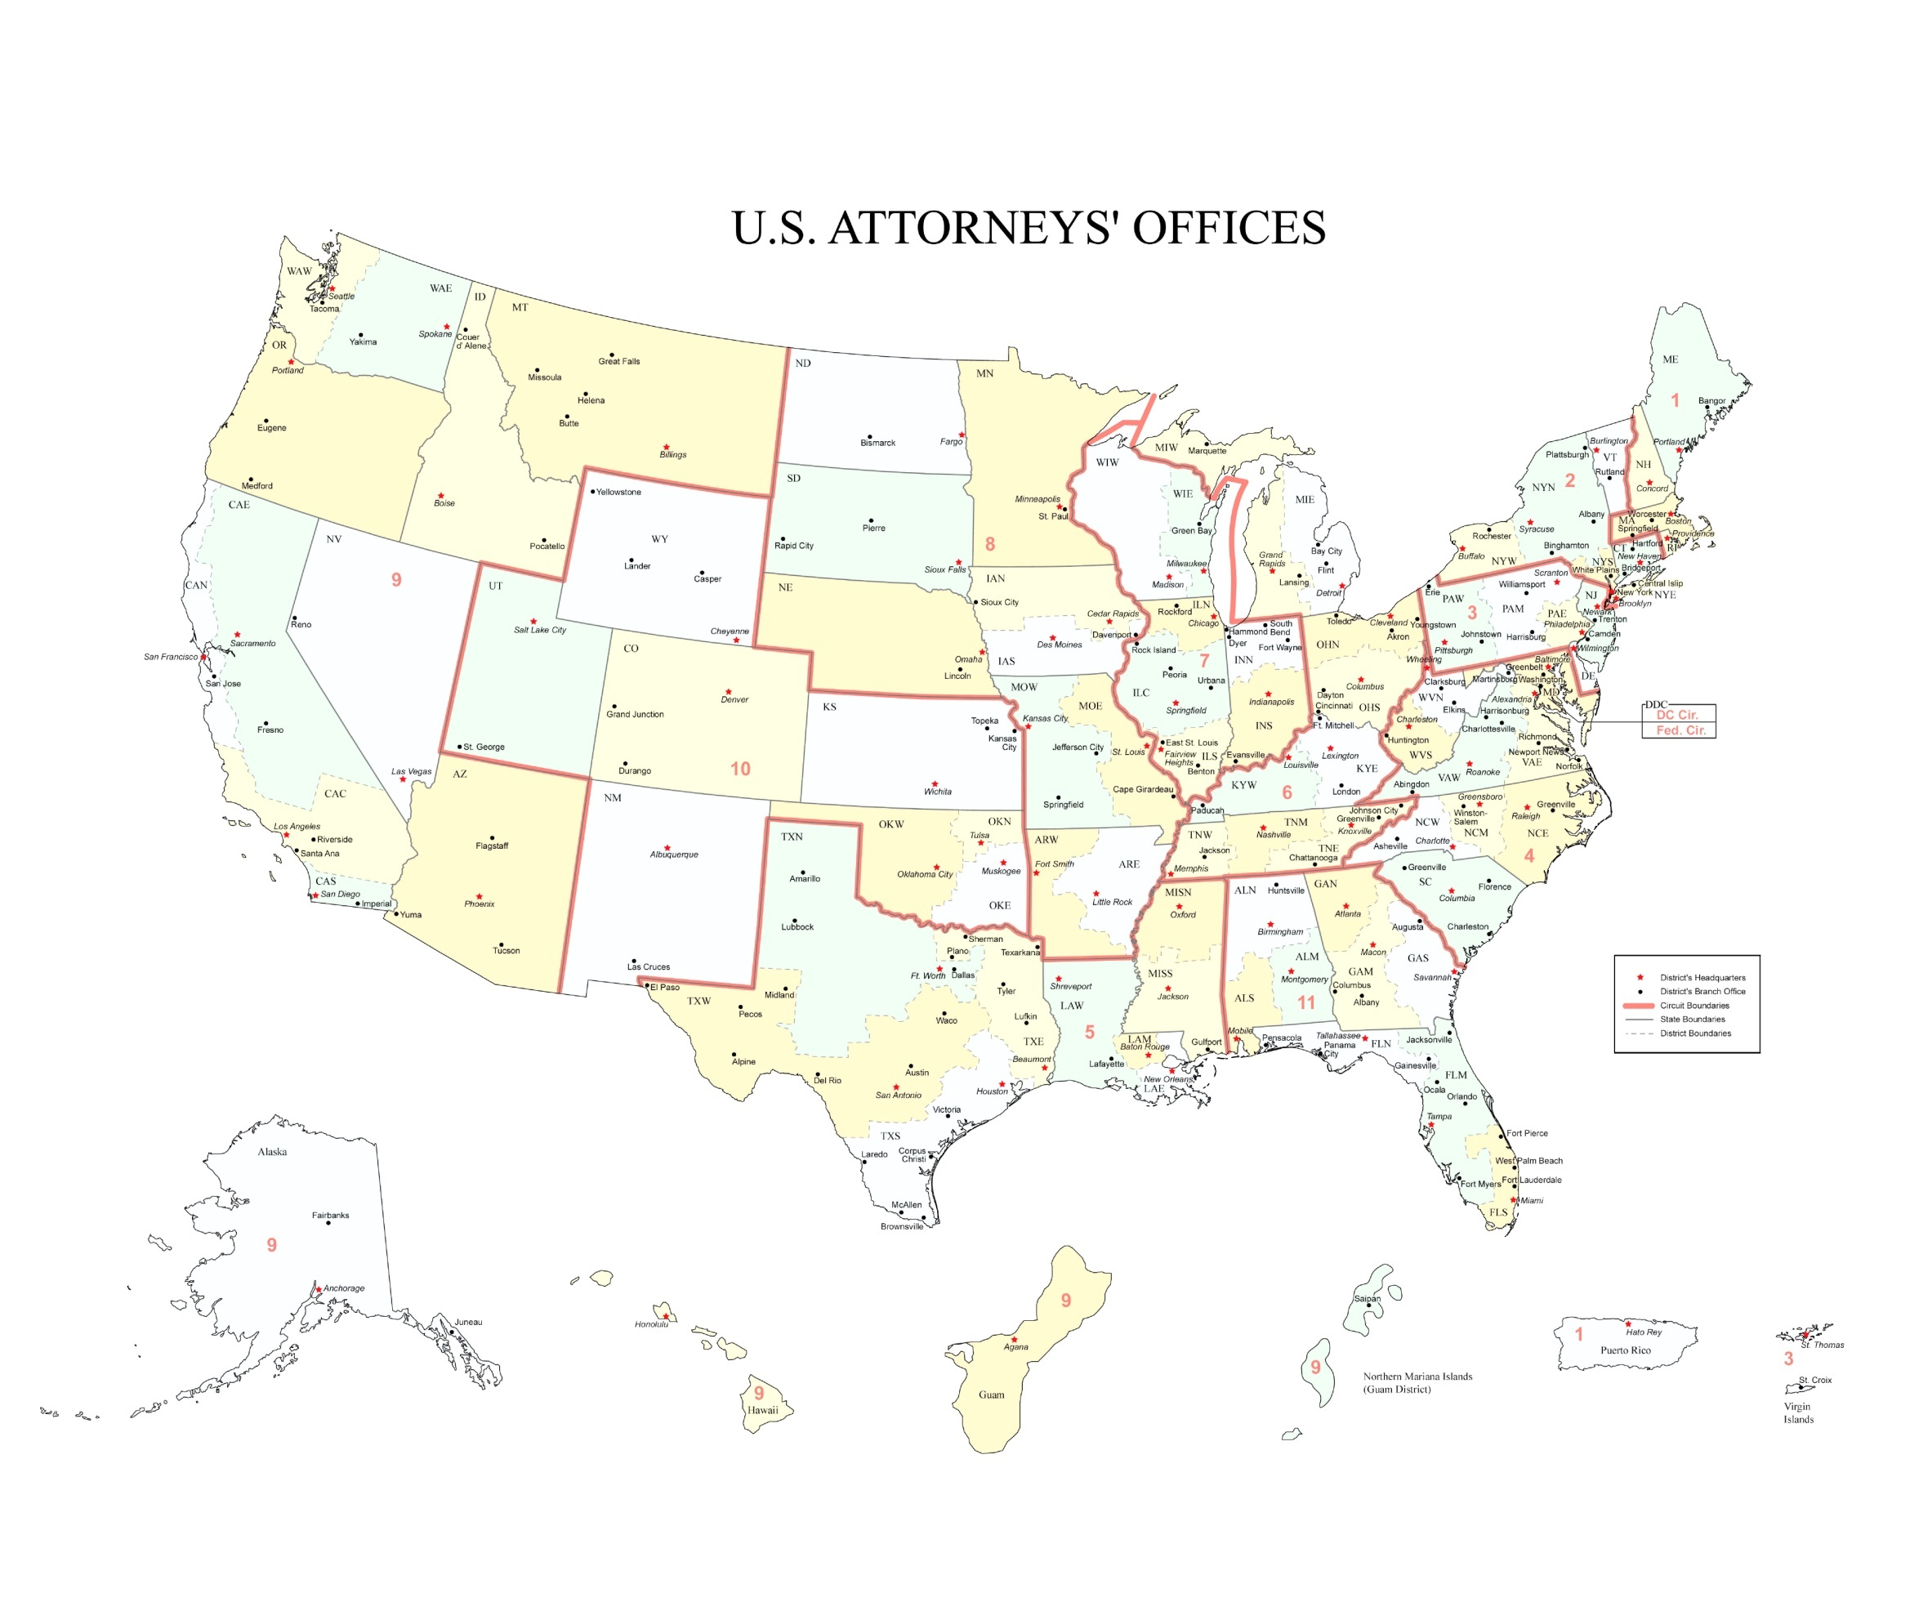

EXECUTIVE OFFICE FOR UNITED STATES ATTORNEYS
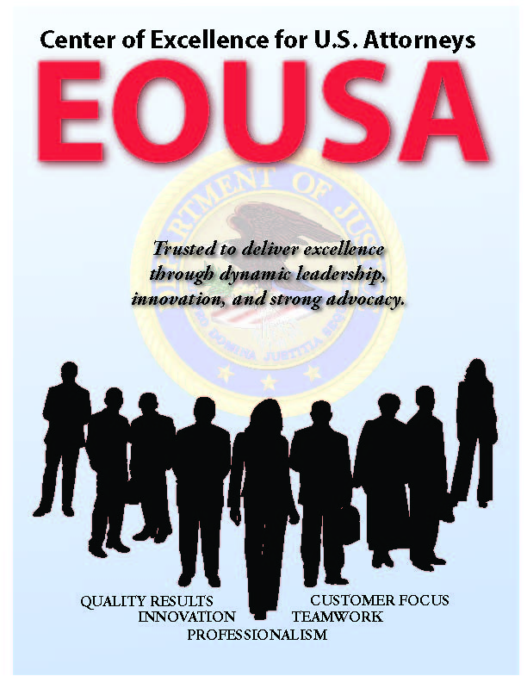
In 1953, Attorney General Order No. 8-53 established the Executive Office for United States Attorneys (EOUSA) to “provide general executive assistance and supervision to the offices of the United States Attorneys.” One of the original directives instructed the Executive Office to “serve as liaison, coordinator, and expediter with respect to the Offices of the United States Attorneys, and between these offices and other elements of the Department [of Justice].” Under the guidance of the Director of EOUSA, EOUSA staffs provide the 94 United States Attorneys’ Offices with general executive assistance and supervision; policy development; administrative management direction and oversight; operational support; and coordination with other components of the Department and other federal agencies. These responsibilities include legal, budgetary, administrative, and personnel services, as well as continuing legal education. EOUSA provides support and assistance to approximately 11,600 employees in 250 staffed offices throughout the country. See Exhibit A for an organization chart of EOUSA. As depicted in the organization chart, specific offices and functions of EOUSA fall under the Director of EOUSA. The Director has a Principal Deputy Director and Chief of Staff and three Deputy Directors.

The Principal Deputy Director and Chief of Staff has responsibility and oversight of the three Deputy Directors and the Office of Planning, Evaluation, and Performance (PEP). The PEP office comprises three staffs: the Evaluation and Review Staff (EARS); the Data Analysis Staff; and the Planning and Performance Staff. Functions of these three staffs are outlined below:

- Evaluation and Review Staff (EARS): The Director of EOUSA is required under 28 C.F.R. Part 0.22 to evaluate the performance of the USAOs, to make appropriate reports, and to take corrective actions if necessary. An evaluation program enables EOUSA to fulfill this responsibility. Important to meeting these regulatory and statutory requirements, the evaluation program provides on-site management assistance to United States Attorneys, as well as a forum for evaluators and the office being evaluated to share information and innovative ideas. The feedback provided to EOUSA and the Department assists in future planning on possible improvements, and provides information about the work being performed in offices around the country.


- The Data Analysis Staff is the primary source of statistical information and analysis for EOUSA. The staff provides data and analysis to EOUSA components allowing them to respond to requests from, among others, the Department, the White House, Congress, and the public. The staff also provides the United States Attorney community comprehensive quarterly analysis of work-year, caseload and workload information and produces the United States Attorneys’ Annual Statistical Report. During FY 2012, the Data Analysis Staff responded to 5,010 requests for statistical, narrative and analytical information. In FY 2014, the United States Attorneys’ community will continue to assess data analysis capabilities to identify cost-effective crime reduction strategies.

- The Planning and Performance Staff serves as both the forward-looking evaluator of USAO needs, as well as the assessor of USAO performance relative to allocated staffing resources. This unit’s work introduces into the decision-making process a metrics-based foundation which allows USAO management to evaluate the work of line AUSAs by utilizing objective data.

The Deputy Director for Administration and Management has responsibility over four program/functional areas; these include Financial Management and Planning, Information Technology, Human Resources, and Operations. Specific functions of these program areas are outlined below:

- The Chief Financial Officer (CFO), through the Financial Management and Planning Staff (FMP), is responsible for budget formulation, budget execution, financial management, audit reviews, the detailee program, and long-range planning. The CFO is a key advisor to the Director of EOUSA. The CFO also provides the Director of EOUSA with expert advice on an annual budget of approximately $2 billion, full-time equivalent (FTE) allocations, and reimbursable agreements with the Department and other federal agencies. The FMP staff consolidates resource needs and formulates an annual budget submission for presentation to the Department, the Office of Management and Budget (OMB), and Congress. It also manages the day-to-day financial operations through daily contact with the USAOs and through review of regular accountability reports. An internal Audit and Review Staff participates with the EARS in evaluating internal controls in the USAOs and is also responsible for preparing districts for the annual independent federal financial audit. The Detailee Program Staff initiates and coordinates all detail assignments, both internal and external to our community. The Financial Systems Support Group (FSSG) provides financial systems support and expertise to the USAOs on all Departmental and EOUSA automated financial and accounting systems. FMP also develops performance measures for the United States Attorneys in accordance with the Government Performance and Results Act (GPRA) and coordinates quarterly status reporting and program assessments.


- The Chief Information Officer (CIO) is responsible for providing advice and assistance to the Director of EOUSA and the senior staff to ensure that Information Technology (IT) is acquired and managed according to Department and EOUSA policies and procedures. The CIO ensures the integration of IT into strategic planning, acquisition, and program management processes to support the mission of the United States Attorney community. The CIO directs and manages the following staffs: The Case Management Staff provides case management systems. The Office Automation Staff supports the purchase and installation of computer systems, equipment and software, maintenance of hardware and software, and end-user training. The Telecommunications and Technology Development Staff provides administrative and technical support to the USAOs in all telecommunications activities, including voice, data and video. The Information Security Staff ensures the confidentiality, integrity, and availability of information and information systems to best support the mission of the United States Attorneys. Currently, the Records Information Management Staff is developing an Enterprise Information Management (EIM) system to both expand and reorganize the electronic records and document management capabilities of all USAOs. The Enterprise Voice-over Internet Protocol (EVoIP) Staff implements and maintains the next generation telephone service/system that integrates into the computer system, creating a more effective method of communication to maximize return on investment and contribute to the mission statement of the United States Attorneys organization at approximately 250 sites worldwide.

- The Human Resources Staff assists EOUSA and the USAOs by providing employment services in such areas as position classifications, staffing, compensation, employee benefits, performance management, pre-employment security, and employee assistance. Staff members are responsible for policy, guidance, personnel actions, training, resources, and initiatives related to these programs and activities.

- The Operations Section is made up of three functional areas as follows: The Facilities and Support Services (FASS) Staff provides direct support and oversight of all USAOs in the areas of real property management, including space acquisition, relocation, design, repair, and management of rent payments. Support services include forms management, printing, and mail metering. The Acquisitions Staff supports both EOUSA and the USAOs by issuing contracts for supplies/services nationwide in compliance with applicable federal, departmental, and other regulations, polices, and procedures. The Security Programs Staff provides security program support for the USAOs, including policy and procedural assistance, training, education and awareness efforts, and emergency and contingency planning.

The Deputy Director and Counsel to the Director oversees the Legal and Victim Programs Staff as well as the Communications and Law Enforcement Coordination Staff.

- The Office of Legal and Victim Programs (OLVP) includes four staffs: Asset Recovery, White Collar and Civil Litigation, Victim-Witness and Indian, Violent and Cyber Crimes. The Asset Recovery Staff (ARS) supports the collection and enforcement efforts of district financial litigation programs, asset forfeiture programs and bankruptcy. ARS assists in the development of financial litigation policy, development and implementation of procedures and programs, and provides liaison functions within the Department and with outside agencies. The White Collar and Civil Litigation Staff (WCCL) provides guidance and support to the USAOs in the areas of health care fraud, white collar crime and civil defensive litigation and assist in the development of national policies and initiatives. In addition, WCCL coordinates the activities of the Affirmative Civil Enforcement Program, which uses civil statutes for federal law enforcement efforts in fighting economic fraud. The Indian, Violent and Cyber Crimes Staff (IVCC) provides guidance and support to the USAOs in the areas of Native American issues, computer crime and intellectual property, immigration and border security, violent crime and gangs, and narcotics. The staff also provides management support for Project Safe Neighborhoods and Project Safe Childhood.

The Victim-Witness Staff provides guidance and support for personnel in the USAOs who handle victim notification, explain to victims the criminal justice process, prepare victims and witnesses for testimony and allocution, coordinate and accompany victims and witnesses to court proceedings, and provide victims with service referrals and emergency assistance. Victims’ rights have taken on new importance since the passage of the Crime Victims’ Rights Act of 2004, which provided victims with enumerated rights and, for the first time at the federal level, the mechanisms to enforce their rights. Victims are now playing a more central role in the criminal process and exercising their rights in greater numbers than ever before.

- The Communications and Law Enforcement Coordination Staff (CLEC) supports EOUSA and the USAOs in the coordination of key initiatives with federal, state, local, and
tribal law enforcement partners, works closely with the Department’s Office of Public Affairs, handles external communication responsibilities, and conducts outreach to community groups. Community outreach activities and crime prevention and reduction efforts are examples of the many priorities within the United States Attorney community. In FY 2014, the United States Attorneys will continue to expand district community outreach and engagement efforts.

The CLEC also manages the Law Enforcement Coordination (LEC) Program in the USAOs. At the district level, LEC coordinators carry out the important role of coordination and liaison with federal, state, and local law enforcement, and with members of the community on various crime reduction programs. Each district’s LEC Committee is under the supervision of the United States Attorney, who serves as the committee chairperson or co-chairperson. Through the LEC program, training is provided to federal, state, and local law

enforcement in areas such as anti-terrorism, gun crime, asset forfeiture, gang investigations, racial profiling, domestic violence, emerging drug trends, community policing, victim issues, and officer safety.

The Deputy Director for Legal Management provides managerial guidance to the following offices and staffs:


- The Office of Legal Education (OLE) develops, conducts, and authorizes the training of all federal legal personnel. OLE coordinates legal education and attorney training for the Department of Justice, other federal departments and agencies, as well as state and local law enforcement. OLE is a separate decision unit of the budget and its functions and mission, which are largely completed at the National Advocacy Center (NAC) in Columbia, South Carolina, are discussed in greater detail in Section IV.

- The Freedom of Information and Privacy Act (FOIA) Staff processes all FOIA and Privacy Act requests for records located throughout EOUSA and the USAOs, provides legal guidance to the USAOs concerning FOIA/Privacy Act issues, represents them in administrative appeals, and assists AUSAs and Department of Justice attorneys in litigation in federal courts by providing draft pleadings and preparing legal documents.

- The Equal Employment Opportunity (EEO) Staff which provides centralized leadership, coordination, and evaluation of all equal employment efforts within EOUSA and the USAOs is comprised of two components – Complaint Processing and Affirmative Employment/Special Emphasis Programs. The EEO mission supports the USAOs and EOUSA by providing timely and impartial customer service in the areas of conflict resolution; EEO complaint processing; civil rights policy development and training; language assistance plans; and by conducting proactive diversity initiatives through outreach and recruitment.


- The General Counsel’s Office (GCO) provides advice to the USAOs and EOUSA on a broad array of legal and ethical issues. The GCO provides guidance to USAOs and EOUSA personnel regarding ethics and standards of conduct matters including conflicts of interest, recusals, outside activities, gifts and financial disclosures, allegations of misconduct, personnel legal issues, discovery requests and compliance with subpoenas. The GCO is also responsible for the employee relations programs of EOUSA and the USAOs.


CRIMINAL PROSECUTIONS

The USAOs investigate and prosecute the vast majority of criminal cases brought by the federal government – representing a more diverse workload than ever before. The types of cases include international and domestic terrorism; immigration; child exploitation and obscenity; firearms and violent crime; identity theft; public corruption; procurement, securities and mortgage fraud; gangs and organized crime; drug enforcement; human trafficking; and criminal civil rights. Many of these cases involve multiple defendants and are extremely complex. The nature of
today’s crimes has required the United States Attorney community to become conversant in a wide range of fields, such as banking and health care, computer technology, securities, foreign cultures and languages, and manufacturing processes affected by environmental and other federal regulations.

The United States Attorneys receive most of their criminal referrals, or “matters,” from federal investigative agencies, including the Federal Bureau of Investigation (FBI), the Drug Enforcement Administration (DEA), the Bureau of Alcohol, Tobacco, Firearms and Explosives (ATF), the United States Immigration and Customs Enforcement (ICE), the United States Secret Service, and the United States Postal Inspection Service. The USAOs also receive criminal matters from state and local investigative agencies, as well as violations reported by private citizens. Following careful consideration of each criminal matter, the United States Attorneys decide the appropriateness of bringing criminal charges and, when deemed appropriate, initiate prosecution. Except for misdemeanor offenses and instances in which an alleged offender waives the right to a grand jury indictment, the United States Attorneys present evidence against an alleged offender to a grand jury. The grand jury then decides whether to return an indictment and, if so, the United States Attorney then presents the criminal charges in open court at the defendant’s arraignment.

Federal Law Enforcement Partners
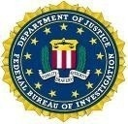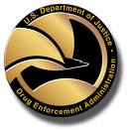

Although historically a large number of criminal defendants plead guilty prior to trial, a United States Attorney must always fully investigate the crime, prepare the charging document, and be ready to go to trial. Consistent preparation for trial minimizes the risk of dismissal for noncompliance with the Speedy Trial Act and strengthens the government’s position in negotiations with defense counsel for a guilty plea. Pre-trial discovery practice also strengthens the government’s position. When a defendant does not plead, a trial is necessary. The United States Attorney then presents factual evidence to the jury, or to the judge in a non-jury (bench) trial. If the defendant is convicted, the United States Attorney must prepare and present evidence at the defendant’s sentencing hearing and defend the conviction at post-trial hearings and on appeal. The USAOs handle most criminal appeals at the intermediate appellate level. After filing an appeal brief, the United States Attorney may be required to participate in oral argument before a United States Court of Appeals. If there is a further appeal, the United States Attorney
may be called upon to assist the Solicitor General in preparing the case for review by the United
States Supreme Court.

CIVIL LITIGATION

The United States Attorneys initiate civil actions, referred to as affirmative litigation, to assert and protect the United States’ interests. They also defend the United States’ interests in lawsuits filed against the government, referred to as defensive civil litigation. In other civil cases, the United States is a third party, creditor, or intervener.

Examples of affirmative litigation include civil actions brought to: enforce the nation’s environmental, admiralty, and civil rights laws; represent the government’s interests in bankruptcy actions; recoup money and recover damages resulting from federal program and other fraud; enforce administrative summonses; and forfeit assets seized by federal, state, and local law enforcement.

Defensive litigation includes actions seeking monetary damages for alleged torts, contract violations, and discrimination by the United States, its agents and employees. It also includes defending: suits challenging government administrative actions, including Social Security disability determinations: habeas corpus petitions, and constitutional challenges to statutes and other federal policies. The USAOs represent and defend the government in its many roles – as employer, regulator, law enforcer, medical care provider, revenue collector, contractor, procurer, property owner, judicial and correctional systems managers, and administrator of federal benefits. When the United States is sued, the Department of Justice must be its legal representative.

Civil defensive work is unique because it is non-discretionary and non-delegable. Unlike criminal matters, civil defensive cases cannot be declined to manage or reduce an office’s caseload. All cases filed against the United States, its agencies, and employees in their official capacities must be defended.

CRIMINAL AND CIVIL APPEALS

Appeals are generally time-consuming, requiring a thorough review of the entire record in the case, the filing of a brief and reply brief, and, in many cases, participation in oral argument before the Court of Appeals in the city where the circuit is based. Furthermore, the complexity of appellate work and the time required to handle that work increases when convictions are based on complex facts, such as those commonly found in cases involving drug trafficking, organized crime, financial and mortgage fraud, and public corruption.

The appellate workload of the United States Attorneys fluctuates due to appeals and post-sentencing motions prompted by Supreme Court rulings, legislative changes, and amendments to the United States Sentencing Guidelines (Guidelines). For example, in FY 2008, the Guidelines were amended to increase the amount of crack cocaine needed to trigger offense levels under § 2D1.1.

CRIMINAL AND CIVIL DEBT COLLECTION

The USAOs are responsible for collecting both criminal and civil debt for the federal government. Each USAO has a Financial Litigation Unit (FLU) responsible for criminal and civil debt collection activities as well as an Affirmative Civil Enforcement staff devoted to civil debt collection.

Debts are ordered to be collected from a criminal defendant when the defendant is sentenced by the court. These debts may be in the form of restitution to crime victims, fines imposed by the court to penalize criminals, special assessments on each criminal conviction count, costs of prosecution and other costs, or forfeitures of appearance bonds. Interest may also be collected in certain cases. When restitution is ordered, the USAOs are involved in collecting federal restitution payments, or restitution which is owed to the United States, and in collecting non-federal restitution, or that which is owed to private individuals and entities. As a result of the Mandatory Victims Restitution Act (MVRA), courts must impose monetary restitution orders in all violent crimes and most property crimes. United States Attorneys are required to enforce restitution orders on behalf of all federal crime victims.


The United States Attorneys are also the legal representatives for other federal agencies to pursue repayment of debts. For example, when federal agencies lend money and the recipients default on repayment, or when federal agencies have paid on guaranteed loans that have not been repaid as provided for in the lending agreement, the United States Attorneys pursue repayment of the debt. The Departments of Agriculture, Education, Health and Human Services, Housing and

Urban Development, Transportation, Veterans Affairs, and the Small Business Administration are some of these client agencies. The United States Attorneys file suit to obtain judgments to collect debts, foreclose on real property, compel physicians to repay or fulfill their commitment to the Public Health Service in return for education grants, sue to set aside fraudulent transfers of property which could be used to satisfy defaulted loans, and manage debtor repayment schedules. The table below illustrates the significant amount of debts collected each year from FY 2005 through FY 2012.

Debt Collection Chart (in billions)
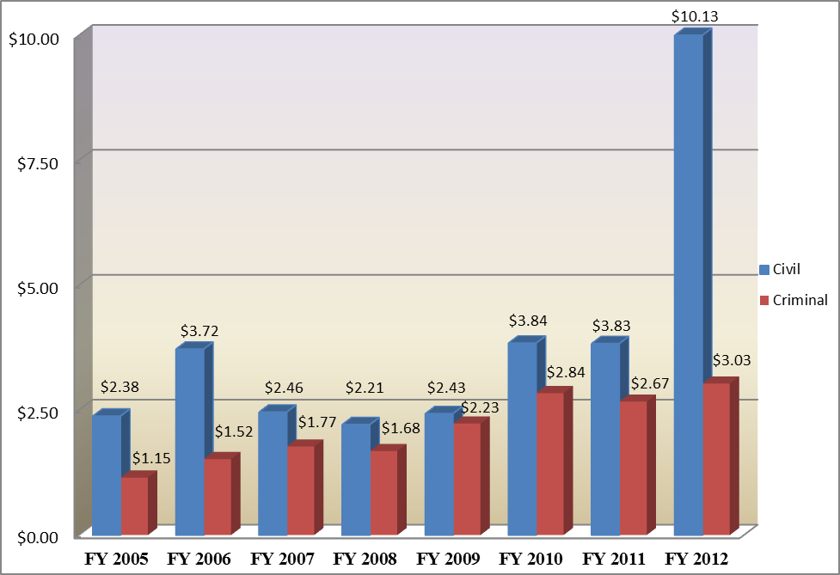
In FY 2012, the USAOs collected $13.1 billion of criminal and civil debts owed. Of the total debts collected, USAOs recovered: (1) $3.0 billion in criminal debts; and (2) $10.1 billion in civil debts. Recoveries in the areas of health care and financial and mortgage fraud contributed to the surge in collections in FY 2012. The United States Attorneys’ FY 2012 collection efforts, handled by a very small percentage of the total workforce, returned to the Treasury over six times the $1.96 billion appropriated in the FY 2012 budget for the entire United States Attorney community.

B. Issues, Outcomes, and Strategies

The following chart and descriptions are a brief summary of the Department’s Strategic Goals and Objectives in which the United States Attorneys play a role.

FY 2014 Total Request by DOJ Strategic Goal

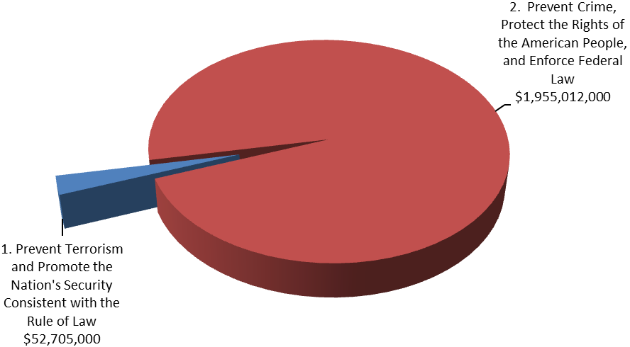

DOJ Strategic Goal 1: Prevent Terrorism and Promote the Nation’s Security Consistent with the Rule of Law ($52,705,000)

● Prosecute those involved in terrorist acts (1.2).

DOJ Strategic Goal 2: Prevent Crime, Protect the Rights of the American People, and Enforce Federal Law ($1,955,012,000)

● Combat the threat, incidence, and prevalence of violent crime (2.1).
● Prevent and intervene in crimes against vulnerable populations; uphold the rights of, and improve services to, America’s crime victims (2.2).
● Combat the threat, trafficking, and use of illegal drugs and the diversion of licit drugs (2.3).
● Combat corruption, economic crimes, and international organized crime (2.4).
● Promote and protect Americans’ civil rights (2.5).
● Protect the federal fisc and defend the interests of the United States (2.6).

C. Full Program Costs

The United States Attorneys’ $2,007,717,000 budget request for FY 2014 is divided into three decision units: criminal, civil, and legal education.

FY 2014 Budget Request by Decision Unit
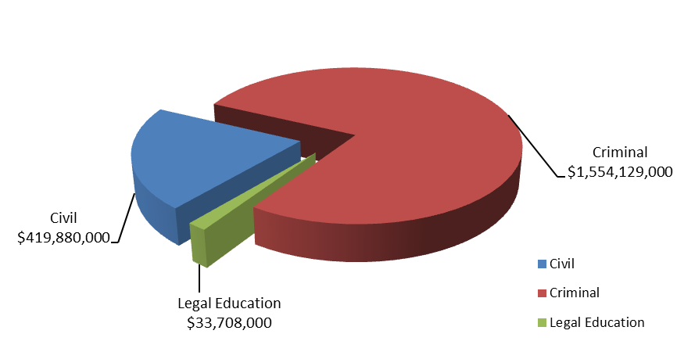
Some programs, as well as management and administration costs, cross decision units. Both performance and resource tables within each decision unit define the total costs of achieving the strategies the United States Attorneys will employ in FY 2014. The various resource and performance charts incorporate the costs of lower level strategies which also contribute to the achievement of objectives, but which may not be highlighted in detail in order to provide a concise narrative. Also included are the indirect costs of continuing activities, which are central to the operations of each decision unit. This request will fund the United States Attorneys’ role in supporting the Department’s Strategic Plan. We will continue to provide federal leadership in preventing and controlling crime and seeking just punishment of those guilty of unlawful behavior.

D. Performance Challenges

The challenges that impede progress toward the achievement of agency goals are complex and ever-changing. National priorities were shifted after September 11th as resources and personnel were redirected to prosecute the Global War on Terror, impacting everyone in the law enforcement and intelligence community. The current economic climate requires that the United States Attorney community continue to focus attention on financial and mortgage fraud. Technological developments and criminal behavior are factors that broadly impact law enforcement practices and pose challenges that demand attention.

External Challenges

The United States Attorneys, as with other federal organizations throughout the entire federal government, continue to face external challenges.

Coordination activities with federal, state, and local agencies involve non-traditional roles for AUSAs and present challenges as we continue to coordinate efforts in areas such as combating terrorism, financial and mortgage fraud, border enforcement/prosecution, gun violence reduction, disrupting and dismantling drug organizations, and child exploitation. In FY 2014, the United States Attorneys will continue to expand district community outreach and engagement efforts.

In addition, the economy and emerging criminal activities, many of which are often driven by technology such as cybercrime, are external challenges beyond our control. Downturns in the economy often correlate with increases in criminal activity. As a result of the recent economic climate, the number of active FBI mortgage fraud investigations has more than tripled in the last four years. The reports document billions of dollars in losses. Inevitably, these investigations will result in more referrals for prosecution to the USAOs throughout the country.

We will continue to focus on areas within our spheres of influence and control, concentrating on coordination efforts with federal, state, and local agencies, and ensuring our workforce is trained for emerging and complex issues.

Internal Challenges

One internal challenge to the United States Attorney community is keeping the workforce flexible and adaptable. Over the past few years, terrorism, financial and mortgage fraud, violent crime and gangs, immigration, internet-related crime, and child exploitation have emerged as important national priorities. The United States Attorney community needs to be able to shift resources in order to respond to changes in case type and case load. The United States Attorneys have developed an effective allocation process that distributes new positions and funding to districts with the greatest demonstrated need. Necessary training is provided through the NAC to ensure that attorneys and support staff have the necessary expertise in these areas. Regular reviews and monitoring of case work, resources and USAOs’ needs are essential to continued responsiveness.

II. Summary of Program Changes

In FY 2014, the United States Attorneys’ budget request is $2,007,717,000, which includes a program increase of $26,500,000 and program offsets of $17,500,000. The following program changes are outlined in the chart below:

Item Name | Description |  |  |  | Page
Item Name | Purpose | Pos. | FTE | Dollars ($000) | Page
Financial and Mortgage Fraud | These prosecutorial resources will enable the United States Attorney community to quickly address the increasing number of financial and mortgage fraud cases. | 190 | 95 | 26,500 | 43
Overhead Reductions | The United States Attorneys will focus on reducing overhead costs in areas which include, but are not limited to the following: space, telecommunications, operations and maintenance of equipment, guard services, security investigations and centralized common administrative services. | 0 | 0 | (17,500) | 46
TOTAL |  | 190 | 95 | 9,000

III. Appropriations Language and Analysis of Appropriations Language

Appropriations Language

SALARIES AND EXPENSES, UNITED STATES ATTORNEYS

For necessary expenses of the Offices of the United States Attorneys, including inter-governmental and cooperative agreements, [$1,974,378,000] $2,007,717,000: Provided, That of the total amount appropriated, not to exceed $7,200 shall be available for official reception and representation expenses: Provided further, That not to exceed $25,000,000 shall remain available until expended.

THIS PAGE INTENTIONALLY LEFT BLANK

IV. Decision Unit Justification

- CRIMINAL

Criminal Litigation | Perm. Pos. | FTE | Amount
2012 Enacted | 8,422 | 7,719 | 1,527,000,000
2013 Continuing Resolution* | 8,422 | 7,731 | 1,531,451,000
Adjustments to Base and Technical Adjustments | (5) | (5) | 20,965,000
2014 Current Services | 8,417 | 7,726 | 1,552,416,000
2014 Increases | 114 | 57 | 15,485,000
2014 Offsets | 0 | 0 | (13,772,000)
2014 Request | 8,531 | 7,783 | 1,554,129,000
Total Change 2013-2014 | 109 | 52 | 22,678,000
*The 2013 Continuing Resolution includes the 0.612% funding provided by the Continuing Appropriations Resolution, 2013 (P.L. 112-175, Section 101(c)).

Criminal Litigation  Information Technology Breakout | Perm. Pos. | FTE | Amount
2012 Enacted | 325 | 325 | 140,436,000
2013 President’s Budget | 325 | 325 | 142,683,000
Adjustments to Base and Technical Adjustments | 19 | 19 | 4,583,000
2014 Current Services | 344 | 344 | 147,266,000
2014 Request | 344 | 344 | 147,266,000
Total Change 2013-2014* | 19 | 19 | 4,583,000
*In order to more accurately reflect Information Technology resources across the United States Attorneys’ three Decision Units, adjustments have been made within each of the Decision Units in FY 2014.

1. Program Description–Criminal Decision Unit

The USAOs investigate and prosecute the vast majority of criminal cases brought by the federal government - with a more diverse and complex workload than ever before. For example, criminal caseloads include: international and domestic terrorism, immigration and border security, firearms and gangs, child exploitation and obscenity, complex fraud schemes (including health care fraud, financial and mortgage fraud and computer fraud), environmental crime, public corruption, organized crime, drug enforcement, civil rights violations, human trafficking and cases involving multiple defendants and international organizations.

The USAOs receive most of their criminal referrals, or "matters," from federal investigative agencies or become aware of criminal activities in the course of investigating or prosecuting other cases. They also receive criminal matters from state and local investigative agencies, as well as those reported to the USAOs by citizens. After careful consideration of each criminal matter, the United States Attorney decides the appropriateness of bringing criminal charges and initiates prosecution.
Criminal Workload
FY 2012 Cases Filed – 63,118
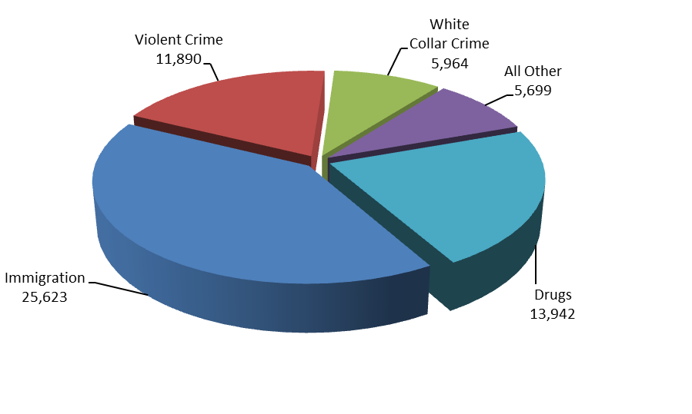
During FY 2012, the USAOs filed 63,118 criminal cases against 85,621 defendants in United States District Court. The number of new cases filed increased by approximately five percent from FY 2005 to FY 2012 – rising from 60,062 cases to 63,118.

A total of 65,230 cases against 87,709 defendants were closed during FY 2012. Of the 87,709 defendants whose cases were closed, 92 percent or 80,963, either pled guilty or were found guilty. Of these, 64,626 received prison sentences, and 148 guilty defendants received sentences of life imprisonment. The rate of convicted defendants who received prison sentences has been 80 percent over the last two years.

3. Performance, Resources, and Strategies

The Criminal Decision Unit contributes to the Department’s Strategic Goal I: Prevent Terrorism and Promote the Nation’s Security Consistent with the Rule of Law. Within this goal, the decision unit’s resources address the Department’s Strategic Objective: 1.2 - Prosecute those involved in terrorist acts.

The Criminal Decision Unit also contributes to Goal II: Prevent Crime, Protect the Rights of the American People, and Enforce Federal Law. Within this goal, the decision unit’s resources address six of the Department’s Strategic Objectives: 2.1 - Combat the threat, incidence, and prevalence of violent crime; 2.2 - Prevent, and intervene in crimes against vulnerable populations; uphold the rights of, and improve services to, America’s crime victims; 2.3 – Combat the threat, trafficking, and use of illegal drugs and the diversion of licit drugs; 2.4 - Combat corruption, economic crimes, and international organized crime; 2.5 – Promote and protect Americans’ civil rights; and 2.6 – Protect the federal fisc and defend the interests of the United States.

a. Performance Plan and Report for Outcomes

In the criminal area, the performance measure for the United States Attorneys is the percentage of criminal cases favorably resolved.

The USAOs handle the majority of criminal cases prosecuted by the Department of Justice, most of which are received as criminal referrals from federal investigative agencies, including the FBI, DEA, ATF, ICE, and the United States Secret Service. Criminal referrals may also be received from state and local investigative agencies or United States Attorneys may become aware of criminal activities in the course of investigating or prosecuting other cases.

The United States Attorneys are called upon to respond to changing priorities and to become involved in specific crime reduction programs. After the events of September 11, 2001, the number one priority of the United States Attorneys became the prevention of terrorist acts and the investigation and prosecution of those involved in plotting and carrying out terrorist attacks.

In recent years, the United States Attorneys has seen a dramatic increase in the number of financial and mortgage fraud cases filed. Financial industry fraud has shaken the world’s confidence in the United States financial system. Losses in financial fraud cases have ranged from millions of dollars to billions of dollars. Mortgage fraud and foreclosure rescue scams routinely involve millions of dollars in losses and multiple defendants, including mortgage brokers, real estate agents, appraisers, closing agents, and false buyers and sellers who receive kickbacks. The United States Attorneys have expanded criminal investigations and prosecutions of financial and mortgage fraud, predatory lending, and market manipulation matters. Efforts to combat financial and mortgage fraud will play a key role not only in ensuring that those who have engaged in fraudulent activities will be held accountable for their illegal conduct, but in deterring future fraudulent conduct and in recovering funds for fraud victims.

In FY 2012, cases involving 80,963 defendants were favorably resolved, resulting in 92.3 percent criminal cases favorably resolved. This outcome surpassed the 90 percent goal by almost two percent.

b. Strategies to Accomplish Outcomes

In FY 2014, the United States Attorneys will continue to place a high priority on prosecution related to national security as well as addressing other important priorities such as financial and mortgage fraud, identity theft, immigration, child exploitation, violent crime and gangs, cybercrime and intellectual property, and drug trafficking.

The United States Attorneys are adjusting to the increased use of technology in the practice of law. While technology provides a means to increase productivity with existing resources, some USAO personnel have difficulty transitioning to new technological solutions. As criminal cases are increasingly “electronic” – meaning that technology plays a major role in areas such as electronic case filing and e-discovery, technical training and hiring employees with the appropriate skill sets are critical to the successful furtherance of our mission.

Other strategies include:

- Regular reviews and monitoring of case and workload data.
- Leveraging technology to improve efficiency and enhance information flow organization-wide and with our partners.
- Continue to look at operational efficiencies in order to preserve human capital which is our most valuable resource.
- Continue to address emerging training needs through the Office of Legal Education.

c. Priority Goals

The United States Attorneys contributes to two priority goals:

Financial Fraud and Healthcare Fraud: Protect the American people from financial and healthcare fraud: In order to efficiently and effectively address financial fraud and healthcare fraud, by the end of FY 2013, increase by 5 percent over FY 2011 levels, the number of investigations completed per Department of Justice attorney working on financial fraud and healthcare fraud cases; additionally for use in appropriate cases, institute a system for tracking compliance by corporate defendants with the terms of judgments, consent decrees, settlements, deferred prosecution agreements, and non-prosecution agreements.

Vulnerable People: Protect those most in need of help - with special emphasis on child exploitation and civil rights. The Department will address these issues by efficiently leveraging law enforcement and prosecutorial assets across the Department in a coordinated manner, including but not limited to: enforcing the Adam Walsh Act by bringing to justice unregistered sex offenders and others who prey on our children; prosecuting hate crime cases under the authority of the Matthew Shepard Hate Crime Prevention Act; battling human trafficking crimes; and working collaboratively with state and local police in proactive task forces around the country to stop those who prey on our most vulnerable citizens.

By September 30, 2013, working with state and local law enforcement agencies, protect potential victims from abuse and exploitation by achieving a 5 percent increase for three sets of key indicators:

  - Open investigations concerning non-compliant sex offenders, sexual exploitation of children, human trafficking.
  - Matters/investigations resolved concerning sexual exploitation of children and human trafficking.
  - Number of children depicted in child pornography that are identified by the FBI.

The United States Attorneys’ progress regarding these two goals is reported quarterly to the Department.

B. CIVIL

Civil Litigation | Perm. Pos. | FTE | Amount
2012 Enacted | 2,154 | 1,930 | 402,059,000
2013 Continuing Resolution* | 2,154 | 1,933 | 407,020,000
Adjustments to Base | 0 | 0 | 5,573,000
2014 Current Services | 2,154 | 1,933 | 412,593,000
2014 Increases | 76 | 38 | 11,015,000
2014 Offsets | 0 | 0 | (3,728,000)
2014 Request | 2,230 | 1,971 | 419,880,000
Total Change 2013-2014 | 76 | 38 | 12,860,000
*The 2013 Continuing Resolution includes the 0.612% funding provided by the Continuing Appropriations Resolution, 2013 (P.L. 112-175, Section 101(c)).

Civil Litigation  Information Technology Breakout | Perm. Pos. | FTE | Amount
2012 Enacted | 95 | 95 | 37,450,000
2013 Request | 95 | 95 | 38,049,000
Adjustments to Base | 0 | 0 | 1,370,000
2014 Current Services | 95 | 95 | 39,419,000
2014 Request | 95 | 95 | 39,419,000
Total Change 2013-2014* | 0 | 0 | 1,370,000
*In order to more accurately reflect Information Technology resources across the United States Attorneys’ three Decision Units, adjustments have been made within each of the Decision Units in FY 2014.

1. Program Description–Civil Decision Unit

Civil litigation pursued by the United States Attorneys falls into two basic categories: (1) affirmative civil litigation, in which the United States is the plaintiff; and (2) defensive civil litigation, in which the United States is the defendant. Affirmative civil litigation cases are actions taken by United States Attorneys to assert and protect the government’s interests. They include such issues as the enforcement of the nation’s environmental, admiralty, and civil rights laws, as well as the recovery of damages sustained by the government through fraud. United States Attorneys also use affirmative civil litigation to recoup money owed and recover damages sustained by the government. Defensive civil litigation includes actions seeking monetary damages for alleged torts, contract violations, and alleged discrimination by the United States, its agencies and employees. The United States Attorneys may also be called upon to represent the United States in cases which are not clearly defined as either affirmative or defensive civil litigation, but in which the government has an interest, such as bankruptcy cases in which the United States is a party. One key difference between affirmative and defensive civil litigation is that while United States Attorneys have some discretion in deciding which affirmative civil cases they will pursue, they must defend the government in all defensive civil litigation.

Affirmative civil cases can return substantial monies to the federal Treasury. In FY 2012, USAOs collected $10.1 billion in civil debts, which is more than three times the United States Attorneys’ budget. The following cases are just a few examples of the United States Attorneys’ affirmative civil successes in FY 2012:

- The Financial Fraud Enforcement Task Force’s efforts resulted in a landmark agreement between the federal government, the attorneys general of 49 states and the District of Columbia, on the one hand, and the nation’s five largest mortgage servicers, on the other, to address mortgage loan servicing and foreclosure abuses. The five settling companies are the Bank of America Corporation, JP Morgan Chase & Co., Wells Fargo & Company, Citigroup Inc. and Ally Financial Inc. (formerly GMAC). Among its other provisions – which included significant relief for struggling homeowners – the settlement included resolutions under the False Claims Act that returned more than $900 million to federal mortgage insurance programs, including programs designed to promote home ownership by families and veterans. In addition, the agreement provides substantial financial relief to homeowners and establishes significant new homeowner protections for the future. From these efforts, the Department recovered over $5 billion in civil collections.

- In July 2012, GlaxoSmithKline (GSK) agreed to plead guilty and to pay $3 billion to resolve its criminal and civil liability arising from the company’s unlawful promotion of certain prescription drugs, its failure to report certain safety data, and its civil liability for alleged false price reporting practices. The resolution is the largest health care fraud settlement in U.S. history and the largest payment ever by a drug company. The lengthy investigation was handled by the District of Massachusetts.

- The USAO in the Eastern District of Virginia reached a settlement with Nelnet, Inc. in which the company paid $57.7 million to settle allegations of fraud in connection with a

government subsidy program for federal student loans. Nelnet fraudulently received a subsidy it was not entitled to, causing the government to pay double the applicable interest rate for subsidized student loans.

Civil matters and cases represent a significant part of the U.S. Attorneys’ workload. In FY 2012, U.S. Attorneys received 102,312 civil matters, which represented 39 percent of all of the 262,078 criminal and civil matters received during the fiscal year. Of the civil matters received, 73 percent or 74,931 were defensive matters, 11,314 or 11 percent were affirmative matters, and 16,067 or 16 percent were other civil matters. The United States Attorneys filed or responded to 92,593 civil cases in FY 2012, which represented 59 percent of the 155,711 criminal and civil cases filed during the fiscal year. Of the civil cases filed, 74,485 or 80 percent were defensive cases; 5,665 or six percent were affirmative cases; and 12,443 or 13 percent were other civil cases.
Civil Workload
FY 2012 Cases Filed/Responded To – 92,593

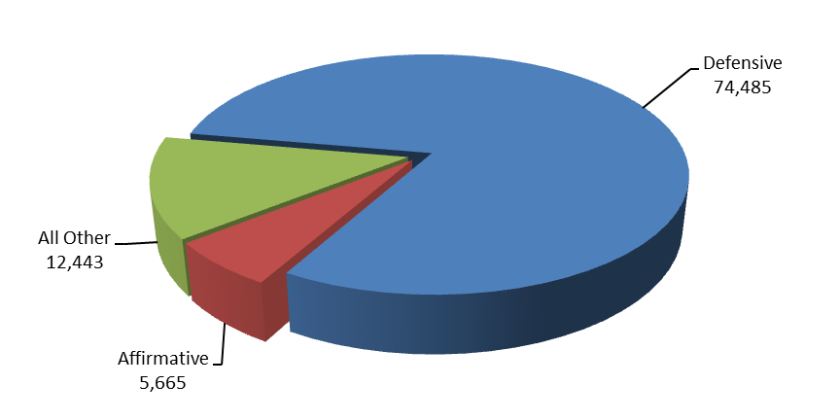
Between FY 2004 and FY 2012, the number of civil cases filed or responded to increased by
19 percent or 14,790 - from 77,803 cases 92,593, and the number of civil cases referred to United States Attorneys increased by 19 percent or 15,996 - from 86,316 in FY 2004 to 102,312 cases in FY 2012. The number of defensive civil cases filed increased by 44 percent or 22,603 - from 51,882 cases in FY 2004 to 74,485 in FY 2012. A change in the interpretation of the United States Sentencing Guidelines in January 2005 increased the number of defensive civil cases filed between FY 2006 and FY 2010.

In FY 2012, 90.6 percent of all judgments in affirmative civil cases were in favor of the United States, the highest favorable judgment rate of all case classes. Through affirmative litigation, the United States Attorneys collected $10.1 billion in civil debts owed to the United States, which is vastly more than the United States Attorneys’ entire FY 2012 budget.

3. Performance, Resources, and Strategies

The Civil Decision Unit contributes to the Department’s Strategic Goal II: Prevent Crime, Protect the Rights of the American People, and Enforce Federal Law. Within this goal, the Civil Decision Unit’s resources specifically address two of the Department’s Strategic Objectives: 2.5 – Promote and protect American’ civil rights, and 2.6 – Protect the federal fisc and defend the interests of the United States.

a. Performance Plan and Report for Outcomes

Prosecution of civil litigation is an essential and vital component of the mission of the United States Attorneys. Civil affirmative litigation seeks redress for fraud, waste, and abuse in federal programs and ensures that the government is fully compensated for the losses and damages caused by those who have enriched themselves at the government’s expense. In addition, all lawsuits filed against the federal government must be defended. United States Attorneys represented the federal government in 74,485 defensive civil cases that were filed in court during FY 2012. The United States Attorneys’ successes in civil litigation preserve taxpayer dollars and uphold the requirements and intent of federal laws and programs. The performance measure for civil litigation relates to the percentage of judgments and settlements resolved in favor of the government.

b. Strategies to Accomplish Outcomes

As civil cases are increasingly “electronic” – meaning that technology plays a major role in areas such as electronic case filing and e-discovery, the technological and resource needs of our civil cases continue to grow. While technology provides a means to increase productivity with existing resources, some USAO personnel have difficulty transitioning to new technological solutions thereby placing greater demands on technical training and hiring employees with the appropriate skill sets.

Other strategies include:

- Regular reviews and monitoring of case and workload data.
- Leveraging technology to improve efficiency and enhance information flow organization-wide and with our partners.
- Continue to look at operational efficiencies in order to preserve human capital which is our most valuable resource.
- Continue to address emerging training needs through the Office of Legal Education.

C. LEGAL EDUCATION

Legal Education | Perm. Pos. | FTE | Amount
2012 Enacted | 53 | 53 | 30,941,000
2013 Continuing Resolution* | 53 | 53 | 33,524,000
Adjustments to Base | 0 | 0 | 184,000
2014 Current Services | 53 | 53 | 33,708,000
2014 Request | 53 | 53 | 33,708,000
Total Change 2013-2014 | 0 | 0 | 184,000
*The 2013 Continuing Resolution includes the 0.612% funding provided by the Continuing Appropriations Resolution, 2013 (P.L. 112-175, Section 101(c)).

Legal Education  Information Technology Breakout | Perm. Pos. | FTE | Amount
2012 Enacted | 23 | 23 | 9,362,000
2013 Request | 23 | 23 | 9,512,000
Adjustments to Base | (19) | (19) | (7,626,000)
2014 Current Services | 4 | 4 | 1,886,000
2014 Request | 4 | 4 | 1,886,000
Total Change 2013-2014* | (19) | (19) | (7,626,000)
*In order to more accurately reflect Information Technology resources across the United States Attorneys’ three Decision Units, adjustments have been made within each of the Decision Units in FY 2014.

1. Program Description–Legal Education

The Office of Legal Education (OLE) develops, conducts, and authorizes the training of all federal legal personnel [28 C.F.R. §0.22 (1990)]. OLE coordinates legal education and attorney training for the Department of Justice (DOJ) and other departments and agencies of the Executive Branch. Virtually all of OLE’s classroom training is conducted at the National Advocacy Center (NAC), a premier federal training facility in Columbia, South Carolina. The NAC features an integrated instructional and residential facility augmented by a conference and research center with student and support services on site.

In FY 2012, OLE was responsible for the management of 295 courses and events at the NAC, as well as offsite locations, including traditional advocacy skills training, seminars on substantive areas of the law, leadership training, and automated litigation support training. In FY 2012, OLE trained 23,115 individuals, including 16,479 who attended live training through courses or other events hosted by OLE and 6,636 individuals who received training through one of OLE’s distance education offerings, including continuing legal education (CLE) programs broadcast via satellite on OLE’s Justice Television Network (JTN), and CLE programs co-sponsored by OLE in USAOs using OLE training modules and materials. Seventy-nine percent of the 23,115 individuals trained were DOJ employees, while the other 21 percent were non-DOJ employees with various federal agencies or state and local governments.

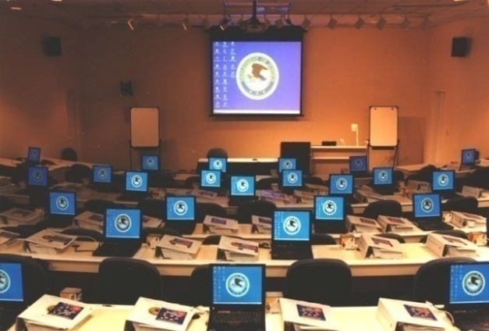
More than 9,444 individuals received training in areas covered in the Department’s Strategic Plan, including Financial and Mortgage Fraud and Cybercrime, Crimes Against Children, Anti-Terrorism, Violent Crime/Gun Violence Reduction, Drug Enforcement, Official Corruption, Bankruptcy and Sound Management.

Recognizing the need to provide more distance learning opportunities, OLE continued to update and expand its Video on Demand (VOD) library, permitting USAO and DOJ litigating division employees to view OLE programming “on demand” at their desktop through OLE’s Learning Management System, JUSTLearn. There are currently more than 1,000 programs available, including programs on Brady/Giglio, E-Discovery, and a New Employee Orientation. In FY 2012, approximately 78,055 DOJ employees accessed the VOD library, viewing available videos more than 208,083 times. In FY 2012, OLE migrated to a new Learning Management System, LearnDOJ. This new system is utilized by other DOJ components and is administered by the Justice Management Division. LearnDOJ gives OLE increased functionality to build Individual Development Plans, assessment tools, and greater compliance management. It is also available via the Internet and can function as a virtual training system with the ability to integrate technologies such as Adobe Connect.

••• PARTNERS IN LEGAL EDUCATION •••

OLE’s Publications Unit edits and publishes the United States Attorneys’ Manual, the United States Attorneys’ Bulletin, and a number of practical skills manuals. OLE published six editions

of the United States Attorneys’ Bulletin on a variety of topics, including Obtaining and Admitting Electronic Evidence, Violent Crimes, Financial Intelligence, Community Outreach,
Environmental Crimes and Criminal Discovery, all of which are accessible on the DOJ Internet website. The Publications Unit continued to maintain and update the USABook, an online legal resource available on the Department intranet that includes electronic versions of all OLE publications, forms including indictment and jury instructions for all circuits, and many significant monographs and policy manuals, and has become a federal practice encyclopedia. In FY 2012, the USABook site experienced millions of page views. Its front page alone received over 288,000 page views in FY 2012, making the most viewed page on DOJNet.

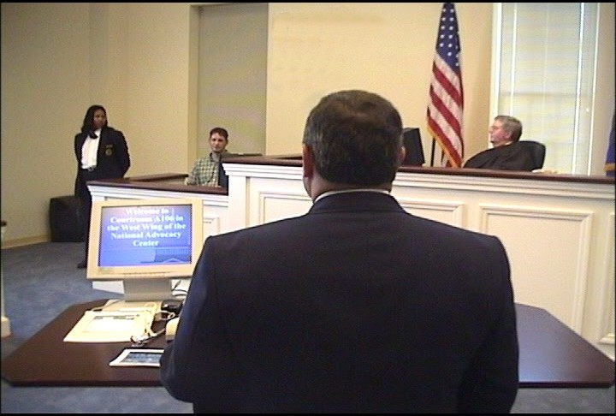

OLE’s Justice Television Network (JTN) is a satellite-based system that provides training to more than 260 locations, including all 94 USAOs and Department of Justice components. During its 25 hours of weekly broadcast, JTN ran 757 programs, including 33 shows eligible for Continuing Legal Education (CLE).

OLE also broadcast events held at Main Justice, including press conferences by the Attorney General and other key Department officials, the Director’s Awards Ceremony, and ceremonies commemorating other significant events.

In an effort to enhance distance learning options for USAOs and provide needed mandatory training, OLE developed new training modules on Professionalism for DOJ Attorneys, and Legal Ethics for Agency Counsel. A copy of each module was sent to every district and to eight federal agencies outside the Department to be used for in-house training.

CLE credit is provided through OLE for many OLE-sponsored courses. OLE is the primary source of instruction for DOJ attorneys and AUSAs from the 94 USAOs. Basic programs for newly hired attorneys include criminal, civil, and appellate advocacy; federal practice seminars; and specialty courses in priority substantive areas of the law. Advocacy skills programs are available to new and experienced trial attorneys. The Criminal Federal Practice course is designed for attorneys with litigation experience who are new to the federal civilian legal system

(e.g., former state and military prosecutors), and as continuing training for Department of Justice attorneys after the basic criminal and civil trial advocacy courses. In FY 2012, OLE continued to
provide additional web-based CLE through its contract with West Legal Ed Center, offering 24-hours a day access to more than 7,000 CLE programs from more than 50 leading CLE providers.

During FY 2012, Department attorneys viewed 8,160 West Legal Ed programs, further expanding OLE’s ability to provide needed training.

OLE continued its tradition of providing training support to Department of Justice personnel assisting foreign prosecutors through the Criminal Division’s Office of Overseas Prosecutorial Development, Assistance and Training (OPDAT). OLE hosted visiting foreign prosecutors from Columbia, Pakistan, the Philippines, and Kenya. OLE also provided staff to assist in training efforts abroad in Columbia, Mexico, Moldova, the Philippines, and Puerto Rico.

For all its programs, OLE uses experienced federal trial and appellate attorneys as instructors to present lectures, lead discussion groups, direct evidentiary exercises, and offer personalized critiques. Federal judges also participate in OLE's advocacy courses, presiding over mock trials and mock appellate arguments. The caliber of the OLE faculty and the use of sophisticated videotaping facilities provide students with unique training experiences in trial and appellate advocacy. A significant feature of the advocacy training is the use of "learn-by-doing" exercises which concentrate on courtroom skills. These exercises simulate courtroom activities and provide students with classroom critiques and individual video replay analysis. OLE is also meeting the demand for attorney management training for senior criminal and civil attorneys by providing management courses for attorney supervisors of all levels. Additionally, the Justice Leadership Institute provides leadership training to USAO attorney and support staff supervisors.

OLE conducts programs on federal, civil, and administrative law practices for attorneys in the Executive Branch, including those in the Department of Justice. OLE offers training in civil discovery and trial techniques; negotiation techniques; and administrative law areas such as bankruptcy, the Freedom of Information Act, ethics, environmental law, federal employment, regulatory processes, government contracts, legal research and writing for attorneys, management of attorneys, and computer crime. Course instruction emphasizes the realities of federal practice. Federal attorneys from every agency, including the Department of Justice, are participants as well as advisors, curriculum developers, lecturers, and instructors. Most instructors come from a cadre of federal prosecutors.

OLE develops and administers paralegal courses covering basic and advanced skills in civil, criminal, and appellate practice. Training for other support staff personnel (e.g., systems managers, Administrative Officers and Budget Officers) in USAOs is provided through OLE, which develops the curriculum and recruits instructors.

THIS PAGE LEFT INTENTIONALLY BLANK

3. Performance, Resources, and Strategies

The Legal Education Decision Unit contributes to the Department’s Strategic Goal I: Prevent Terrorism and Promote the Nation’s Security Consistent with the Rule of Law. Within this goal, the decision unit’s resources address the Department’s Strategic Objective: 1.2 - Prosecute those involved in terrorist acts.

The Legal Education Decision Unit also contributes to Goal II: Prevent Crime, Protect the Rights of the American People, and Enforce Federal Law. Within this goal, the decision unit’s resources address six of the Department’s Strategic Objectives: 2.1 - Combat the threat, incidence, and prevalence of violent crime; 2.2 - Prevent, and intervene in crimes against vulnerable populations; uphold the rights of, and improve services to, America’s crime victims; 2.3 – Combat the threat, trafficking, and use of illegal drugs and the diversion of licit drugs; 2.4 - Combat corruption, economic crimes, and international organized crime; 2.5 – Promote and protect Americans’ civil rights; and 2.6 – Protect the federal fisc and defend the interests of the United States.

a. Performance Plan and Report for Outcomes

The performance measure for this decision unit is the number of students trained. In FY 2012, OLE sponsored classroom training and other live events for 16,479 individuals. In addition, approximately 6,636 individuals were trained through one of OLE’s distance education offerings, including continuing legal education programs broadcast via satellite, and other means, for a total of 23,115 students trained in FY 2012.

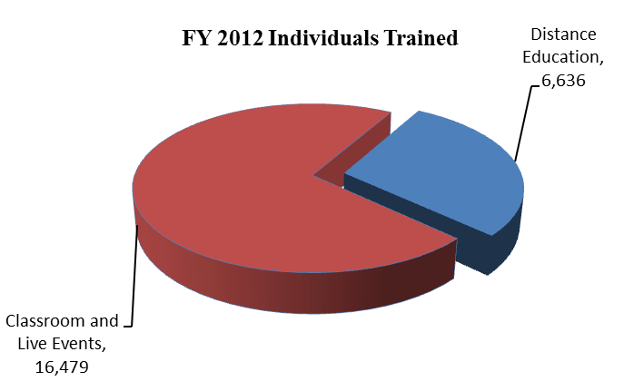

This compares with a total of 24,627 in FY 2011 – 17,219 individuals trained in-person and 7,408 individuals trained by satellite, videotape and other training. Seventy-nine percent of the 23,115 individuals trained in-person were DOJ employees in legal positions while the other

21 percent were non- DOJ employees in legal positions with various federal agencies or state and local government. OLE anticipates training a total of 26,000 individuals in FYs 2013 through 2014 in combined classroom, satellite and other training.

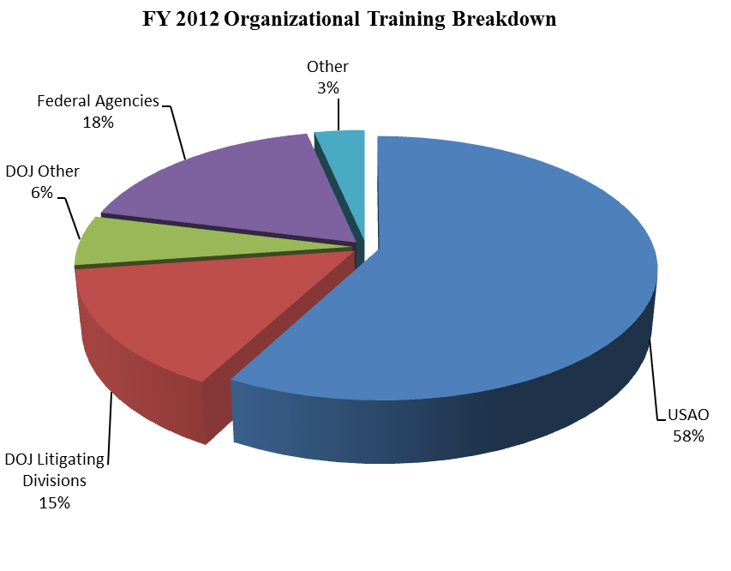
DOJ DIV = DOJ Litigative Divisions
DOJ BUREAUS = FBI, DEA, ATF, BOP, etc.
OTHER = State and Local
FED AGENCIES = DOD, HHS, DHS, USPS, etc.
More than 9,444 individuals receiving training at the NAC attended courses in areas covered in the Department’s Strategic Plan, including Fraud and Cybercrime, Crimes Against Children, and Anti-Terrorism, Violent Crime/Gun Violence Reduction, Drug Enforcement, Civil Rights Enforcement, Official Corruption, Bankruptcy, and Sound Management.

Overall in FY 2012, OLE was responsible for the management of 295 events, including traditional advocacy training, seminars and educational forums on substantive areas of the law. During FY 2012, OLE expanded VOD and approximately 78,055 DOJ employees accessed the VOD library viewing available programs more than 208,083 times. There are now over 1,000 separate programs available through VOD.

b. Strategies to Accomplish Outcomes

The United States Attorneys will continue to ensure that high quality legal education is available for basic and advanced legal training through traditional classroom instruction and expanded use of JTN and distance learning.

V. Program Increases by Item

Item Name: Financial and Mortgage Fraud

Budget Decision Unit(s): Criminal and Civil Litigation

Strategic Goal(s) & Objective(s): Goals II: Prevent Crime, Protect the Rights of the American People, and Enforce Federal Law.
Objective 2.4: Combat corruption, economic crimes, and international organized crime.
Objective 2.6: Protect the federal fisc and defend the interests of the United States.

Component Ranking of Item: 1

Program Increase: Positions 190 Attorney 120 FTE 95 Dollars $26,500,000

Description of Item

Losses in financial and mortgage fraud cases have ranged from millions of dollars to billions of dollars. Mortgage fraud and foreclosure rescue scams routinely involve millions of dollars in losses and multiple defendants, including mortgage brokers, real estate agents, appraisers, closing agents, and false buyers and sellers who receive kickbacks. It is imperative that the Department enforce the laws that protect the integrity of our economic system.

The FY 2014 President’s Budget includes a program enhancement of 190 positions (including 120 attorneys) and $26,500,000 -- including $6,677,220 in non-personnel funding. At the end of FY 2012, the FBI had more than 2,300 mortgage fraud investigations pending with 71 percent involving losses of $1 million or more. In FY 2012, the United States Attorneys’ Offices filed 443 mortgage fraud cases against 812 defendants. This is a 387 percent increase in the number of cases filed compared to just four years ago, in FY 2008. Moreover, the USAOs convicted 875 defendants of mortgage fraud in FY 2012, which is a 980 percent increase over the same four-year time period. Additional positions in the United States Attorneys’ offices are necessary to keep pace with such increased investigative and prosecutorial activity. These resources will enable the Department to hold accountable criminals who perpetrate financial and mortgage fraud, deter future perpetrators of fraud, and recover monies stolen from the U.S. taxpayer. The non-personnel funds requested will enable the United States Attorneys’ Offices to do such things as develop investigative leads through data analytics services, conduct computer research in specialized financial databases, and obtain additional equipment and software for EOUSA’s Litigation Technology Service Center to store and analyze data in financial and mortgage fraud cases.

Justification

The United States Attorneys will expand criminal investigations and prosecutions of mortgage fraud, predatory lending, financial fraud, and market manipulation matters. These prosecutorial resources will enable the United States Attorney community to quickly address the increasing number of financial and mortgage fraud cases referred by the Federal Bureau of Investigations (FBI) for prosecution.

Recent data from Treasury’s Financial Crimes Enforcement Network (FinCEN) show that mortgage fraud will continue to be a significant issue for law enforcement. Specifically, in the second quarter of calendar year 2012, financial institutions submitted 17,476 mortgage loan fraud Suspicious Activity Reports (SARs), with a marked increase in the number of SARS involving foreclosure rescue scams and similar schemes targeting homeowners facing foreclosure or default on their mortgages. Based on this second quarter data, FinCEN projects that the number of foreclosure rescue SAR filings in 2012 will increase by 70 percent over 2011. Second quarter data from 2012 also show that the total number of all SARs filed increased by nine percent over the second quarter of 2011, rising from 203,468 to 220,854. These fraud indicators demonstrate the need for additional investigative and prosecutorial resources to properly address this serious economic crime.

The United States Attorneys will also expand civil enforcement efforts to continue to obtain recoveries from individuals and companies that have defrauded the government by violating the terms of federal contracts, grants, loans, and subsidies.

The United States Attorneys will continue to work closely with the Departments’ Criminal and Civil Divisions to investigate and pursue significant financial crimes and other violations related to the financial crisis and economic recovery efforts. Additionally, the United States Attorneys will strengthen their anti-fraud efforts at the local level through increased participation in regional mortgage fraud working groups and task forces.

Impact on Performance

This initiative will address Strategic Goal II, Prevent Crime, Protect the Rights of the American People, and Enforce Federal Law, including Objective 2.4, Combat corruption, economic crimes, and international organized crime. and Objective 2.6, Protect the federal fisc and defend the interests of the United States.

We have seen a dramatic increase in the number of mortgage fraud cases filed over the last several years. Additional resources to combat financial and mortgage fraud will play a key role not only in ensuring that those who have engaged in fraudulent activities will be held accountable for their illegal conduct, but in deterring future fraudulent conduct and in recovering funds for fraud victims.

Financial and Mortgage Fraud Initiative

Funding
Base Funding

FY 2012 Enacted |  |  |  | FY 2013 CR |  |  |  | FY 2014 Current Services
Pos | Atty | FTE | $(000) | Pos | Atty | FTE | $(000) | Pos | Atty | FTE | $(000)
1,952 | 1,276 | 1,952 | 309,241,234 | 1,952 | 1,276 | 1,952 | 309,241,234 | 1,952 | 1,276 | 1,952 | 314,993,121
Base funding amounts include all white collar crime (criminal) and all civil affirmative fraud resources, including financial and mortgage fraud.

Personnel Increase Cost Summary

Type of Position | Modular Cost  per Position ($000) | Number of  Positions  Requested | FY 2014  Request  ($000) | FY 2015  Net Annualization  (change from 2014)  ($000) | FY 2016  Net Annualization  (change from 2015)  ($000)
Attorney | 114,580 | 120 | 13,749,600 | 10,266,240
Forensic Accountant | 96,935 | 20 | 1,938,700 | 1,404,960
Investigator | 88,805 | 40 | 3,552,200 | 2,484,760
Paralegal | 58,228 | 10 | 582,280 | 436,310 | 160,630
Total Personnel |  | 190 | 19,822,780 | 14,592,270 | 160,630

Non-Personnel Increase Cost Summary

Non-Personnel  Item | Unit Cost | Quantity | FY 2014 Request  ($000) | FY 2015 Net  Annualization  (Change from 2014)  ($000) | FY 2016 Net  Annualization  (Change from 2015)  ($000)
Investigative Tools | N/A | N/A | 6,677,220 | (5,177,220) | 0
Total Non-Personnel | N/A | N/A | 6,677,220 | (5,177,220) | 0

Total Request for this Item

 | Pos | Atty | FTE | Personnel  ($000) | Non-Personnel  ($000) | Total  ($000) | FY 2015 Net  Annualization  (Change from 2014)  ($000) | FY 2016 Net  Annualization  (Change from 2015)  ($000)
Current Services | 1,952 | 1,276 | 1,952 | 314,993,121 | 0 | 314,993,121 | 0 | 0
Increases | 190 | 120 | 95 | 19,822,780 | 6,677,220 | 26,500,000 | 9,415,050 | 0
Grand Total | 2,142 | 1,396 | 2,047 | 334,815,901 | 6,677,220 | 341,493,121 | 9,415,050 | 160,630

VI. Program Offsets by Item

Item Name: Overhead Reductions

Budget Decision Unit(s): Criminal, Civil and Legal Education

Strategic Goal(s) & Objective(s): Goals I and II: Prevent terrorism, and Promote the Nation’s Security Consistent with the Rule of Law; and Prevent Crime, Protect the Rights of the American People, and Enforce Federal Law.

Objective: All

Component Ranking of Item: 2

Program Decrease: Positions 0 Attorney 0 FTE 0 Dollars $17,500,000

Description of Item

The United States Attorney community is continually evaluating its programs and operations with the goal of achieving efficiencies and reducing overall costs. In FY 2014, the United States Attorneys will focus on reducing overhead costs in areas which include, but are not limited to space, telecommunications, operations and maintenance of equipment, guard services, security investigations and centralized common administrative services. These overhead reductions will result in an offset of $17,500,000.

Impact on Performance

These overhead expense reductions will cut waste and promote efficiencies thereby focusing funding on essential and mission critical efforts.

VII. EXHIBITS

