Civil Division
United States Department of Justice

Radiation Exposure Compensation Act Trust Fund

FY 2010 PERFORMANCE BUDGET
Congressional Submission

May 2009

Table of Contents

Page No.

I. Overview 1

II. Summary of Program Changes N/A

III. Appropriations Language and Analysis of Appropriations Language N/A

IV. Decision Unit Justification

1. Program Description 1
2. Performance Tables N/A
3. Performance, Resources, and Strategies 4
a. Performance Plan and Report for Outcomes
b. Strategies to Accomplish Outcomes

V. Exhibits

- Organizational Chart N/A
- Summary of Requirements
- Program Increases by Decision Unit N/A
- Resources by DOJ Strategic Goal/Objective
- Justification for Base Adjustments
- Crosswalk of 2008 Availability
- Crosswalk of 2009 Availability
- Summary of Reimbursable Resources N/A
- Detail of Permanent Positions by Category N/A
- Financial Analysis of Program Increases/Offsets N/A
- Summary of Requirements by Grade N/A
- Summary of Requirements by Object Class
- Status of Congressionally Requested Studies, Reports, and Evaluations N/A
- Modular Costs for New Positions N/A
- Information on Overseas Staffing N/A

Radiation Exposure Compensation Act Trust Fund

Overview

On October 5, 1990, Congress passed the Radiation Exposure Compensation Act (RECA or the Act). The Act offers an apology and monetary compensation to individuals who contracted certain cancers and other serious diseases as a result of their exposure to radiation released during above-ground atmospheric nuclear weapons tests or as a result of their occupational exposure while employed in the uranium industry during the build-up to the Cold War. This unique program was designed as an alternative to litigation in that the statutory criteria do not require claimants to establish causality. Specifically, if the claimant can satisfy the requirements outlined in the statute, which include demonstrating that he or she contracted a compensable disease after working or residing in a designated location for a specified period of time, he or she qualifies for compensation. The amount of the award is statutorily prescribed and ranges from $50,000 to $100,000, depending on claimant category. Congress charged the Attorney General with responsibility for adjudicating claims under the Act.

“It is the purpose of this Act to establish a procedure to make partial restitution to the individuals… for the burdens they have borne for the Nation as a whole. …The Congress apologizes on behalf of the Nation to the individuals… and their families for the hardships they have endured.”

Radiation Exposure Compensation Act

The Department of Justice (DOJ) established the Radiation Exposure Compensation Program (the Program) within the Civil Division. The Program commenced operations in April 1992. Since its inception, 29,760 claims have been filed and nearly $1.4 billion has been awarded to claimants (as of March 5, 2009).

Electronic copies of DOJ’s Congressional Budget Justifications and Capital Asset Plan and Business Case exhibits can be viewed or downloaded from the Internet using the Internet address: http://www.usdoj.gov/jmd/2010justification/.
Mission Statement: Fairly and expeditiously adjudicate claims, fully consistent with the Radiation Exposure Compensation Act, as amended; educate the public about the Act; and develop strategies for improving the Program.
Program Description

The Program office is located in Washington, D.C. and is administered by a staff of four attorneys, 12 claims examiners, and two contractor employees within the Civil Division’s Torts Branch. The support staff reviews claims packages, assists claimants with their applications, and manages physical case files. The Civil Division strives to process and resolve claims fairly and efficiently.

Background
From 1945 through 1962, the United States conducted nearly 200 atmospheric nuclear weapons tests while building the arsenal that became the cornerstone of the nation’s Cold War security strategy. Essential to the development of nuclear weapons was the mining and processing of uranium ore that was conducted by tens of thousands of workers. Many workers filed class action lawsuits that were eventually dismissed by the appellate courts. Congress then devised a program to make partial restitution to the individuals who developed serious illnesses after their exposure to radiation released during above-ground atmospheric nuclear tests or following their employment in the uranium industry. Congress passed the Radiation Exposure Compensation Act on October 5, 1990, and later broadened the scope of the Act’s coverage on July 10, 2000.

Implementing regulations issued by the Department were designed to utilize existing records so that claims could be resolved in a reliable, objective, and non-adversarial manner, with little administrative cost to the United States or to the person filing the claim.

The Act established monetary compensation for specified diseases in three defined populations: uranium miners, millers, and ore transporters, who receive $100,000; individuals present at test site locations, who receive $75,000 (on-site participants); and individuals who lived downwind of the Nevada Test Site, who receive $50,000 (downwinders). The map below shows the geographic areas covered by the Act. Although the vast majority of claims are filed by people living in the Four Corners Region (Utah, Colorado, New Mexico, and Arizona), the Program has awarded compensation to individuals residing in every state as well as several foreign countries.
The claimant population also includes several Native American tribes.

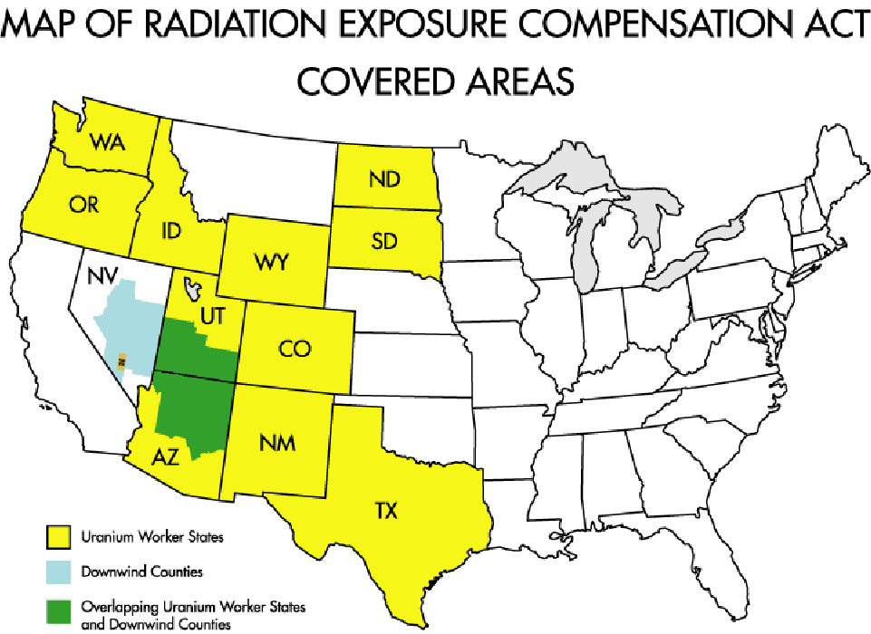

The Program regularly engages in outreach activities on the Navajo, Hopi, and Yavapai Apache Indian reservations to meet with tribal leaders, conduct town hall meetings, and assist members in filing claims. Today, the RECA Program is at the center of a broad inter-agency network that comprises the comprehensive federal radiation compensation system. The RECA Program works in concert with the Departments of Health and Human Services, Labor, Veterans Affairs, and Defense to administer the Act.

Proposed Legislation
Legislation to amend RECA has been introduced in the current session of Congress. On March 19, 2009, Congresswoman Bordallo introduced a bill (H.R. 1630) to include the Territory of Guam as a “downwind” area. On February 24, 2009, the Idaho Statesman and the Salt Lake Tribune reported that Congressmen Jim Matheson (D-Utah), Mike Simpson (R-Idaho), and Walt Minnick (D-Idaho) wrote a letter to House Judiciary Committee Chairman John Conyers (D-Mich) and Republican Ranking Member Lamar Smith (R-Texas), requesting a congressional hearing to consider the expansion of RECA’s “downwind” area to include additional counties in Utah and Idaho. Current workload and funding projections do not account for the possible impact of any scientific studies or substantive statutory changes.

Funding History
The RECA Trust Fund was subject to discretionary appropriations from FY 1992 to FY 2001. Following enactment of the 2000 Amendments, the appropriation became insufficient to meet the increase in the number of claims deemed eligible for compensation. In 2002, Congress addressed the problem within the Department of Defense Authorization Act for FY 2002, which established annual funding against mandatory spending caps. However, by 2003 the increased rate of new claim filings and approvals proved the caps to be inadequate, and a funding shortfall ensued. Working in close coordination, the appropriators and authorizers effectively devised legislative solutions to the funding problems. The following statutes ensure that all compensable RECA claims will be fully funded throughout the life of the Program.

- The Consolidated Appropriations Act for 2005 contained language that made funding for the RECA Trust Fund mandatory and indefinite beginning in FY 2006. Henceforth, the Fund has exclusively paid Section 4 claimants (downwinders and on-site participants).

- The National Defense Authorization Act for FY 2005 requires that RECA Section 5 claimants (uranium miners, millers, and ore transporters) be paid out of the Energy Employees Occupational Illness Compensation Fund.

Claim Statistics
Over the past 17 years, nearly 30,000 claims have been filed with the Program, including 8,497 denials and 20,694 approvals. Approximately 71 percent of adjudicated claims have been approved. Total RECA awards over the life of the Program exceed $1.35 billion (as of March 5, 2009). Approximately 150 new claims are filed each month. Of those claims that have been denied since 1992, only 12 claimants have sought review in federal district court.

The Civil Division’s projections for claim filings, adjudications, and awards have been reviewed by the Department of Justice’s independent auditor since FY 2005. Using historic data, a model has been developed to estimate the contingent liability associated with RECA awards through the sunset of the program in FY 2022.

Performance, Resources, and Strategies

Performance Plan and Report for Outcomes
The Radiation Exposure Compensation Program supports Goal 2 of the Department of Justice’s Strategic Plan, specifically Objective 2.7: “Vigorously enforce and represent the interests of the United States in all matters over which the Department has jurisdiction.”

The Program’s primary objective is to implement civil justice reform initiatives to resolve categories of claims for which traditional litigation has proven ineffective and to administer compensation programs enacted by Congress that offer non-litigation solutions for radiation exposure claimants.

Strategies to Accomplish Outcomes
The Program will employ the following strategies to accomplish this mission:

- Hire skilled claims examiners to conduct the initial review of claims, freeing the Program attorneys to conclude the adjudication and render the final determination.

- Access external data sources, such as the Social Security Administration, the National Institute for Occupational Safety and Health, the Public Health Service, and state cancer and tumor registries to assist claimants in securing the necessary documentation in support of their claims.

- Coordinate with the Department of Labor’s (DOL) Energy Employees Occupational Illness Compensation Program to ensure that eligible Section 5 RECA claimants receive compensation in a timely manner. This includes review of RECA claimant files to determine eligibility pursuant to the Energy Employees Occupational Illness Compensation Program Act.

- Brief Members of Congress and their staffs as requested; provide information to Members and the public in an open, timely, and complete manner.

- Coordinate with the Department of Health and Human Services’ Radiation Exposure Screening and Education Program to assist grantees in providing relevant information on the RECA Program to individuals screened for disease in the affected geographic regions.

- Use a toll-free phone line and website to communicate with claimants.

- Conduct outreach by traveling to areas with populations of potential claimants and participating in roundtable discussions held by congressional delegations for their constituents. In FY 2008, Program staff traveled to the Navajo, Hopi, San Carlos Apache, Yavapai Apache, and Spokane Indian Reservations to meet with tribal leaders, respond to questions about the Program, and conduct town hall meetings to assist tribal members with filing successful claims. The Program has also participated in public outreach in conjunction with DOL representatives at events held in Shiprock and Grants, New Mexico; Grand Junction, Colorado; Moab, Utah; Flagstaff, Kayenta, and Tuba City, Arizona; Riverton, Wyoming; and Spokane, Washington. During FY 2009, Program staff traveled to Shiprock, New Mexico, to train the Navajo Office of Uranium Workers in assisting tribal members with filing RECA claims.

Radiation Exposure Compensation Act Workload
Claims Filed and Approved
(Dollars in Thousands)
 | FY 2004  Actual | FY 2005  Actual | FY 2006  Actual | FY 2007  Actual | FY 2008  Actual | FY 2009 Estimate | FY 2010  Estimate
Section 4 Claims:
Downwinders
Pending, Beginning of Year | 1,582 | 1,537 | 1,139 | 1,093 | 423 | 680 | 521
Claims Filed | 1,517 | 1,367 | 999 | 1,038 | 1,128 | 1,925 | 915
Claims Approved | 1,163 | 1,457 | 902 | 1,361 | 996 | 1,288 | 730
Value of Approvals | $58,150 | $72,850 | $45,100 | $68,050 | $49,800 | $64,450 | $36,500
On-Site Participants
Pending, Beginning of Year | 260 | 268 | 247 | 208 | 91 | 136 | 92
Claims Filed | 231 | 268 | 174 | 148 | 159 | 278 | 135
Claims Approved | 99 | 181 | 80 | 156 | 91 | 128 | 71
Value of Approvals | $7,053 | $12,666 | $5,548 | $11,280 | $6,438 | $9,550 | $5,500
Subtotal Section 4 Claims
Pending, Beginning of Year | 1,842 | 1,805 | 1,386 | 1,301 | 514 | 816 | 613
Claims Filed | 1,748 | 1,635 | 1,173 | 1,186 | 1,287 | 2,203 | 1,050
Claims Approved | 1,262 | 1,638 | 982 | 1,517 | 1,087 | 1,416 | 801
Value of Approvals | $65,203 | $85,516 | $50,648 | $79,330 | $56,238 | $74,000 | $42,000
Section 5 Claims (Uranium Miners, Millers, and Ore Transporters)
Pending, Beginning of Year | 971 | 813 | 644 | 761 | 294 | 204 | 0
Claims Filed | 715 | 943 | 1,087 | 659 | 700 | 665 | 632
Claims Approved | 539 | 845 | 786 | 749 | 487 | 609 | 443
Value of Approvals | $53,900 | $84,507 | $78,600 | $74,876 | $48,700 | $60,900 | $44,300
TOTAL
Pending, Beginning of Yr | 2,813 | 2,618 | 2,030 | 2,062 | 808 | 1,020 | 613
Claims Filed | 2,463 | 2,578 | 2,260 | 1,845 | 1,987 | 2,868 | 1,682
Claims Approved | 1,801 | 2,483 | 1,768 | 2,266 | 1,574 | 2,025 | 1,244
Claims Denied | 857 | 683 | 460 | 833 | 597 | 765 | 446
Total Adjudications  (Approved + Denied) | 2,658 | 3,166 | 2,228 | 3,099 | 2,171 | 2,790 | 1,690
Approval Rate | 68% | 78% | 79% | 73% | 73% | 73% | 74%
Value of Approvals | $119,103 | $170,023 | $129,248 | $154,206 | $104,938 | $134,900 | $86,300

