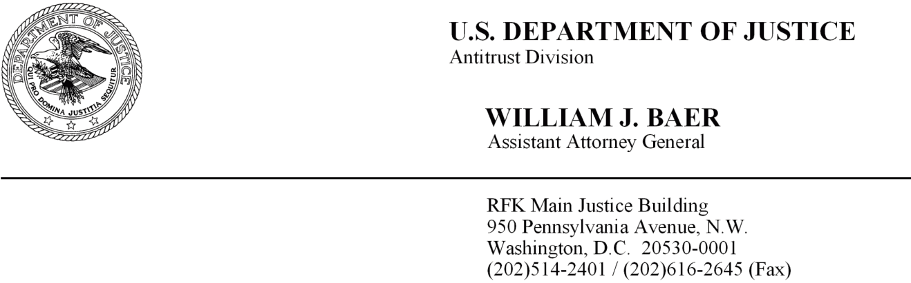

September 23, 2014

David A. Clanton, Esq. Baker & MacKenzie LLP
815 Connecticut Avenue, NW Washington, DC 20006

Valarie C. Williams, Esq. Alston & Bird LLP
One Atlantic Center 1201 Peachtree Street
Atlanta, GA 30309

Re: Flexi-Van Leasing, Inc. and Direct ChassisLink, Inc. Business Review Letter Request

Dear Mr. Clanton and Ms. Williams:

This letter responds to your request for the issuance of a business review letter pursuant to the Department of Justice's Business Review Procedure, 28 C.F.R. § 50.6.¹
You have requested, on behalf of Flexi-Van Leasing, Inc. ("FVLI") and Direct ChassisLink, Inc. ("DCLI"), a statement of the Department's present enforcement intentions regarding a proposed Chassis Use Agreement at the ports of Los Angeles and Long Beach, California ("LA/LB"). Chassis are used for the intermodal transportation of marine containers. FVLI and DCLI are chassis leasing companies that also manage chassis pools operating at the LA/LB port complex. FVLI and DCLI propose to enter a Chassis Use Agreement that would allow the interchange of chassis among the pools managed by each of FVLI and DCLI. The FVLI and DCLI pools will continue to compete for business, and leasing terms and rates will continue to be set independently
by each chassis provider. After initial implementation, the parties intend that the Agreement will become open to other pools operating at LA/LB.

1January 22, 2014 Letter from David Clanton and Valarie Williams to Assistant Attorney General William
J. Baer.

At LA/LB, there are six chassis pools operating in 13 different terminals. FVLI manages the Los Angeles/Long Beach Basin Chassis Pool ("LABP"). DCLI manages the Grand Alliance Chassis Pool ("GACP"). DCLI also manages and owns the DCLI Pool.
The remaining pools at LA/LB are the West Coast Chassis Pool ("WCCP") and two steamship-specific pools.

Growth in cargo volume at the ports of LA/LB, fueled by the chassis industry transition, has caused increased marine terminal congestion at the port complex. This has led to long truck lines and delayed deliveries. Currently, motor carriers must drop off
the chassis at one of the locations operated by the pool from which the chassis originated, which often is a different location from where the motor carriers go for their next pick up. In addition, motor carriers at LA/LB often must make "split moves" in which they drop off a container at one location, and then need to go to a different location to drop off the chassis. This contributes to congestion at the terminals, wastes the motor carriers' time and money, and frequently leads to chassis shortages or dislocations.

You have made the following representations in your letter and follow-up information to the Department:

The parties propose to enter into the Chassis Use Agreement in order to establish a "gray" chassis concept. The gray chassis concept extends benefits associated with individual pools by allowing the interchange of chassis across multiple pools, which encompasses several terminals, container yards, rail ramps and other locations within the greater LA/LB port complex. You represent that the increased flexibility created by the interchangeability will enhance customer service, improve chassis productivity and respond to the desire of LA/LB port authorities to achieve better overall utilization of the region's chassis fleets. You represent that after a period of initial implementation, the parties intend to permit open participation by any other pools and third parties in the LA/LB port complex.

The proposed agreement would allow users of any of the pools managed by FVLI or DCLI to interchange chassis among each others' pools. Pursuant to this arrangement, a chassis user could pick up a chassis from one of the DCLI-managed pool start/stop locations and eventually return it to one of the FVLI-managed start/stop locations, and vice versa.

You represent that the parties will continue to (a) manage their respective pools;
(b) independently establish their published merchant haulage rates for motor carriers in the region; (c) compete openly with one another and other chassis providers for steamship line customers that desire to participate in the gray chassis pool; and (d) negotiate independently with other users in the region for access to chassis.

In addition, you represent that the parties will use a third-party service provider to support the operation of the agreement. The third-party service provider will have access

to information required to allow the parties to track chassis usage, and that the type of information exchanged is industry standard practice and necessary to implementing cooperative chassis pools. No information will be exchanged regarding customer pricing or other competitively sensitive terms.

Based on your representations and our investigation of the particular facts and circumstances relating to competitive conditions related to the supply of chassis at LA/LB, it does not appear likely that the proposed Chassis Use Agreement between FVLI and DCLI, as presented to the Division, will produce anticompetitive effects.

The Department has no present intention to challenge the proposed Chassis Use Agreement between FVLI and DCLI. This letter expresses the Department's current enforcement intentions and is predicated on the accuracy of the information and assertions you have presented to us in your January 22, 2014 letter, March 4, 2014e­
mails², March 5, 2014 e-mails³, April 14, 2014 e-mail⁴, April 15, 2014 e-mail⁵ , April 25,
2014 e-mail6, April 30, 2014 e-mail⁷, June 9, 2014 e-mail⁸ , August 18, 2014 e-mail9 and in oral communications to the Department.

This statement is made in accordance with the Department's Business Review Procedure, 28 C.F.R. § 50.6. Pursuant to its terms, your business review request and this letter will be made publicly available immediately, and any supporting data will be made publicly available within thirty (30) days of the date of this letter, unless you request that any part of the material be withheld in accordance with Paragraph 10(c) of the Business Review Procedure.

Sinerely,

William J. Baer

2 E-mails from David A. Clanton to Michele Cano on March 4, 2014 at 6:12pm and 10:12pm. 3 E-mails from Jimmy Heidenreich to Michele Cano on March 5, 2014 at 4:05pm and 4: 10pm. 4 E-mail from David A. Clanton to Michele Cano on April 14, 2014 at 3:34pm.
5 E-mail from Valarie Williams to Michele Cano on April 15, 2014 at 9:57am.
6 E-mail from David A. Clanton to Michele Cano on April 25, 2014 at 12:21pm.
7 E-mail from David A. Clanton to Michele Cano on April 30, 2014 at 4:0lpm.
8 E-mail from David A. Clanton to Michele Cano on June 9, 2014 at 3:52pm.
9 E-mail from David A. Clanton to Michele Cano on August 18, 2014 at 4:55pm.

