Latest CCM Request for the disciplined practitioner’s pages (English & Spanish)

<http://www.justice.gov/eoir/list-of-currently-disciplined-practitioners>

<http://www.justice.gov/eoir/lista-de-abogados-disciplinados-actualmente>

////////////// 1st task when editing disciplined practitioners page code //////////////

Remove the *red italics* code by searching with the browser bar tool using last names (Source Code view):

(This CCM Request will use the 2 names from 05-26-15 -Justin Moongyu Lee +Guillermo Suarez M.)

<em><span style="color:rgb(255, 0, 0)"> </span></em>

<em> <span style="color:rgb(255, 0, 0)"> </em>

////////////// sanity-check for page code artifacts //////////////

Search document to see if either of these are still present in code:

em>

rgb(255, 0, 0)">

NOTE: If an entry was in red italics and contained “aka” then after the red italics is removed, recode for:

<em>aka</em>

////////////// add new names to “Recent updates to the list” (in alphabetical order!) //////////////

Marisa Aguilar, Jerry Goh, Justin Moongyu Lee

////////////// update the top right-hand margin to reflect the date this information is posted //////////////

For the spelling of a month in Spanish, go to: <http://www.freetranslation.com/>

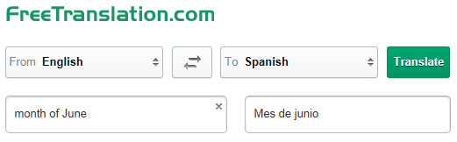

|  |  |  |  |  |  |
| --- | --- | --- | --- | --- | --- |
| **Marisa Aguilar** | **Indiana** | **6/9/15** |  |  |  |

*Marisa Aguilar Indiana 6/9/15*

AguilarMarisa-ImmediateSuspension.pdf = UPLOAD aguilarmarisa-immediatesuspension.pdf

////////////// code insert for this Immediate Suspension //////////////

<tr>

<td><em><span style="color:rgb(255, 0, 0)">Marisa Aguilar</span></em></td>

<td><em><span style="color:rgb(255, 0, 0)">Indiana</span></em></td>

<td><em><a href="/sites/default/files/pages/attachments/2015/06/--/aguilarmarisa-immediatesuspension.pdf" target="_blank" style="color:rgb(255, 0, 0)">6/9/15</a></em> (PDF)</td>

<td>&nbsp;</td>

<td>&nbsp;</td>

<td>&nbsp;</td>

</tr>

|  |  |  |  |  |  |
| --- | --- | --- | --- | --- | --- |
| **Jerry Goh** | **Dallas, TX** | **4/9/13** | **Suspended - 6 months** | **4/9/13** | **Yes –**  **6/4/15** |

Jerry Goh Dallas, TX 4/9/13 Suspended - 6 months 4/9/13 *Yes – 6/4/15*

GohJerry-Reinstatement.pdf = UPLOAD gohjerry-reinstatement.pdf

////////////// code insert for this Reinstatement //////////////

<td><em><a href="/sites/default/files/pages/attachments/2015/06/--/gohjerry-reinstatement.pdf" target="_blank" style="color:rgb(255, 0, 0)">Yes S&iacute; - 6/4/15</a></em> (PDF)</td>

|  |  |  |  |  |  |
| --- | --- | --- | --- | --- | --- |
| **Justin Moongyu Lee** | **Los Angeles, CA** | **5/14/15** | **Indefinite Suspension** | **5/14/15** | **No** |

Justin Moongyu Lee Los Angeles, CA 5/14/15 *Indefinite Suspension 5/14/15* No

LeeJustinMoongyu-FinalOrder.pdf = UPLOAD leejustinmoongyu-finalorder.pdf

////////////// code insert for this Final Order //////////////

<td><em><span style="color:rgb(255, 0, 0)">Suspensi&oacute;n Indefinida Indefinite Suspension</span></em></td>

<td><em><a href="/sites/default/files/pages/attachments/2015/06/--/leejustinmoongyu-finalorder.pdf

" target="_blank" style="color:rgb(255, 0, 0)">5/14/15</a></em> (PDF)</td>

<td>No</td>

</tr>

//////////// IMPORTANT! ////////////

The dates for the immediate suspension and final order ALWAYS match within an entry, but the date for a reinstatement will be different than the dates displayed for the immediate suspension and final order.

//////////// latest correct path in Drupal for uploaded files ////////////

/sites/default/files/pages/attachments/2015/--/--/ … .pdf

Drupal template code inserts for the disciplined practitioner’s pages

////////////// template = **Immediate Suspension** code insert //////////////

Los Angeles, CA Los &Aacute;ngeles, CA

<tr>

<td><em><span style="color:rgb(255, 0, 0)"></span></em></td>

<td><em><span style="color:rgb(255, 0, 0)"></span></em></td>

<td><em><a href="/sites/default/files/pages/attachments/2015/--/--/-immediatesuspension.pdf" target="_blank" style="color:rgb(255, 0, 0)"></a></em> (PDF)</td>

<td>&nbsp;</td>

<td>&nbsp;</td>

<td>&nbsp;</td>

</tr>

////////////// template= **Final Order** code insert //////////////

Suspensi&oacute;n Indefinida Indefinite Suspension

Suspendido - 90 d&iacute;as Suspended - 90 days

Suspendido - 6 meses Suspended - 6 months

Suspendido - 2 a&ntilde;os Suspended - 2 years

Inhabilitado Disbarred

Censura p&uacute;blica Public Censure

<td><em><span style="color:rgb(255, 0, 0)"></span></em></td>

<td><em><a href="/sites/default/files/pages/attachments/2015/--/--/-finalorder.pdf" target="_blank" style="color:rgb(255, 0, 0)"></a></em> (PDF)</td>

<td>No</td>

</tr>

////////////// template = **Reinstatement** code insert //////////////

<td><em><a href="/sites/default/files/pages/attachments/2015/--/--/-reinstatement.pdf" target="_blank" style="color:rgb(255, 0, 0)">Yes S&iacute; - 0/00/15</a></em> (PDF)</td>

////////////// recent chronology of disciplined practitioners entries //////////////

**06-15-15**

Marisa Aguilar

Jerry Goh

Justin Moongyu Lee

**05-26-15**

Justin Moongyu Lee

Guillermo Suarez M. (is M. as a last name a miss-spelling?)

**05-13-15**

Brad Alexander

Yehlen D. Brooks

Peter S. Gordon

David Gruen

////////////// how to determine where *red italics* appear //////////////

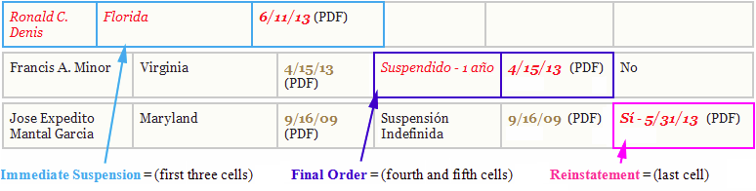

Note: The *italics* font style should always be removed when the text color is returned to black (exception = *aka*).

Here are some of the special Spanish language characters to pay attention to:

|  |  |  |
| --- | --- | --- |
| Suspensión | Los Ángeles | Sí |
| día / días | *ver* + *más arriba* = (*see* + *above*) | Inglés |
| año / años | *ver* + *más abajo* = (*see* + *below*) | en español |

Here are a few Spanish language spelling issues that **may or may not** need to be used:

|  |  |  |
| --- | --- | --- |
| Distrito de Columbia | Nueva Hampshire | Carolina del Norte |
| Nueva York | Nuevo México | Carolina del Sur |
| Nueva Jersey | Los Ángeles | Pensilvania (not used now) |