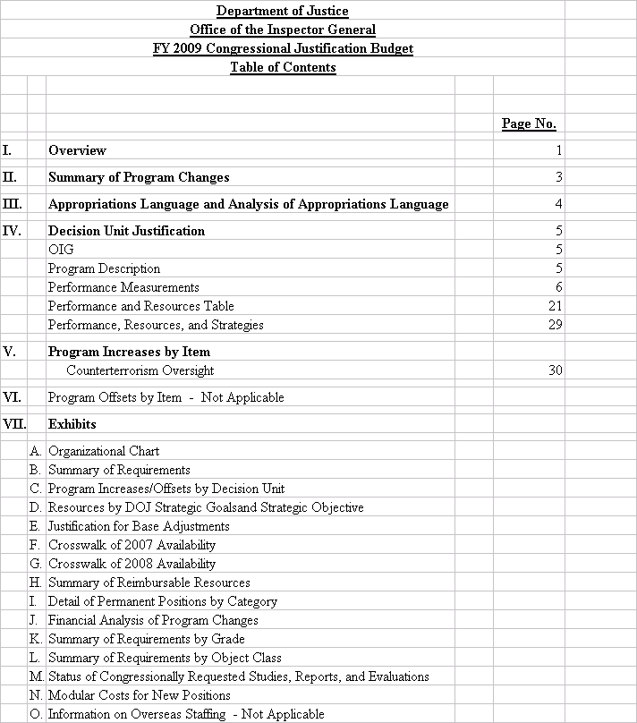

I. Overview for Office of the Inspector General

FY 2009 Congressional Justification Request

1. Introduction

The Office of the Inspector General (OIG) was statutorily established in the Department of Justice (Department) on April 14, 1989. The OIG investigates allegations of fraud, waste, abuse, and misconduct by Department employees, contractors, and grantees and promotes economy and efficiency in Department operations. The OIG is an independent entity within the Department that reports to both the Attorney General and Congress on issues that affect the Department’s personnel or operations.

The OIG has jurisdiction over all complaints of misconduct against Department employees in the Federal Bureau of Investigation (FBI); Drug Enforcement Administration (DEA); Federal Bureau of Prisons (BOP); U.S. Marshals Service (USMS); Bureau of Alcohol, Tobacco, Firearms and Explosives (ATF); U.S. Attorneys’ Offices (USAO); Office of Justice Programs (OJP); and other Offices, Boards and Divisions. The OIG investigates alleged violations of criminal and civil law, regulations, and ethical standards arising from the conduct of Department employees in their numerous and diverse activities. The OIG also audits and inspects Department programs and assists management in promoting integrity, economy, efficiency, and effectiveness.

In fiscal year (FY) 2009, the Department’s top priority will continue to be detecting and preventing terrorism. The Department requested more than $3.3 billion towards that effort in
FY 2008. In addition, the Department estimates that it will request approximately $2.2 billion for information technology (IT) annually. The OIG, through its audits, inspections, investigations, and reviews, will help ensure that the substantial funding provided to support these Department of Justice priorities are used efficiently, effectively, and for their intended purposes.

The OIG is committed to assisting the Attorney General and Congress in overseeing the use of counterterrorism resources, strengthening the Department’s internal financial systems, improving grant management and accountability, ensuring the effectiveness and security of computer systems, and promoting public confidence in the integrity of the Department’s programs and employees. The OIG’s request for FY 2009 totals $75.681 million, 450 full-time permanent positions, and 430 direct workyears. This request represents an adjustment-to-base increase of $3.878 million and program enhancements for 16 positions, 8 workyears and $1.2 million for Counterterrorism Oversight.

The OIG helps the Department pursue its strategic goals and objectives through its investigations, audits, inspections, and program reviews. The OIG has two general goals that support the Department’s strategic goals: “detect and deter misconduct in programs and operations within or financed by the Department,” and “promote the efficiency and effectiveness of Department programs and operations.” To meet the first goal, the OIG targets investigative resources on allegations of fraud, bribery, civil rights violations, theft, sexual crimes, and official misconduct against Department employees or others who conduct business with the Department. To meet the second goal, the OIG targets resources on reviews of Department programs to promote the economy, efficiency, and effectiveness of those programs.

Like any organization, the OIG must deal with a variety of internal and external challenges that affect its work. These include the decisions Department employees make while carrying out their numerous and diverse duties that may increase or decrease the number of allegations the OIG receives; Department support for the OIG’s mission; and financial support from the Office of Management and Budget (OMB) and Congress.

The OIG’s biggest internal challenge is in the area of human capital. In this regard, the OIG is working to ensure that it continues to hire high-quality employees who have the appropriate skill sets for its complex mission.

Electronic copies of the Department of Justice’s Congressional Budget Justifications and Capital Asset Plan and Business Case Exhibits can be viewed or downloaded from the Internet address:
http://www.usdoj.gov/jmd/2009justification/.

The OIG has not been selected for a Program Assessment Rating Tool (PART) review.

II. Summary of Program Changes

Office of the Inspector General
($ in thousands)
Item Name | Description | Pos. | FTE | Dollars | Page
Counterterrorism Oversight | The OIG is requesting 6 program analysts, 4 auditors, 2 attorneys, 2 criminal investigators, and 2 operations research analysts for Counterterrorism Oversight. | 16 | 8 | $1,200 | 30
 | Total | 16 | 8 | $1,200

III. Appropriations Language and Analysis of Appropriations Language

Appropriations Language

OFFICE OF THE INSPECTOR GENERAL
Salaries and Expenses

For necessary expenses of the Office of Inspector General, [$70,603,000] $75,681,000, including not to exceed $10,000 to meet unforeseen emergencies of a confidential character.

Analysis of Appropriations Language
No substantive changes proposed.

IV. Decision Unit Justification

A. OIG
The OIG is one decision unit.

OIG | Perm. Pos. | FTE | Amount
2007 Enacted w/Rescissions | 449 | 460 | 70,603,000
2007 Supplementals (transfer from FBI) | … | … | 500,000
2007 Enacted w/Rescissions and Supplementals | 449 | 460 | 71,103,000
2008 Requirements | 434 | 445 | 70,603,000
Adjustments to Base and Technical Adjustments | … | … | 3,878,000
2009 Current Services | 434 | 445 | 74,481,000
2009 Program Increases | 16 | 8 | 1,200,000
2009 Request | 450 | 453 | 75,681,000
Total Change 2008-2009 | 16 | 8 | 5,078,000
Note: The FTEs above include reimbursables.

1. Program Description
The OIG operates as a single decision unit encompassing audits, inspections, investigations, and reviews.

OIG-Information Technology (IT)  Breakout (of Decision Unit Total) | Perm.  Pos. | FTE | Amount
2007 Enacted with Rescissions | 10 | 10 | $4,807,000
2007 Supplementals | … | … | …
2007 Enacted w/Rescissions and Supplementals | 10 | 10 | $4,807,000
2008 Requirements | 10 | 10 | $4,807,000
Adjustments to Base and Technical Adjustments | … | … | …
2009 Current Services | 10 | 10 | $4,807,000
2009 Program Increases | … | … | …
2009 Request | 11 | 11 | $4,921,000
Total Change 2008-2009 | … | … | $0

The OIG has no IT investment request for FY 2009.

PERFORMANCE MEASUREMENTS

Because of the nature of its work, the OIG provides both qualitative (narrative) and quantitative (indicators) performance information to better enable the Department, Congress, and public to assess the value of the work it performs. That information follows.

The OIG does not set targets for certain law enforcement activities since those measures could be construed as “bounty hunting.” For such law enforcement measures, the OIG reports historical results.

In addition, consistent with previous budget submissions, the performance indicators cover all of the OIG’s programs, whether funded from direct appropriations or reimbursements.

Examples of Recent OIG Reviews

The FBI’s Use of National Security Letters
In March 2007, as required by the Patriot Reauthorization Act, the OIG issued a report examining the FBI’s use of national security letters (NSL). Under five statutory provisions, the FBI can use NSLs to obtain – without a court order – records such as customer information from telephone companies, Internet service providers, financial institutions, and consumer credit companies. The Patriot Act broadened the FBI’s authority to use such letters by lowering the threshold standard for issuing them, allowing the special agents in charge of FBI field offices to sign NSLs, and permitting the FBI to use NSLs to obtain full credit reports in international terrorism investigations. The Patriot Reauthorization Act directed the OIG to review the FBI’s use and effectiveness of NSLs, including any improper or illegal uses of these authorities.

Our review, which covered the period from 2003 to 2005, found that the FBI’s use of NSL authorities has increased in the years since the enactment of the Patriot Act in October 2001. In 2000, the last full year prior to the Patriot Act’s passage, the FBI issued approximately 8,500 NSL requests. After the Patriot Act was passed, the FBI dramatically increased its use of NSLs, issuing approximately 39,000 NSL requests in 2003, 56,000 in 2004, and 47,000 in 2005, according to the database the FBI maintains for the purpose of reporting its NSL usage to Congress. In total, during the 3-year period covered by our review, the FBI issued more than 143,000 NSL requests. However, the OIG concluded that these statistics, which were based on information from the FBI’s database, significantly understated the total number of NSL requests issued by the FBI because the database was inaccurate and did not include all NSL requests. For example, our examination of case files at 4 FBI field offices found approximately 22 percent more NSL requests in case files we examined than were recorded in the database for those same files.

Our review also examined the effectiveness of NSLs, which are used by the FBI for various purposes, including developing evidence to support applications for orders issued under the Foreign Intelligence Surveillance Act (FISA), developing links between subjects of FBI investigations and other individuals, providing leads and evidence to allow FBI agents to initiate or close investigations, and corroborating information obtained by other investigative techniques. FBI personnel told the OIG that they believe NSLs are indispensable investigative tools in many counterterrorism and counterintelligence investigations.

As directed by Congress, the OIG also examined whether there was any improper or illegal use of NSL authorities. The OIG found that from 2003 to 2005 the FBI identified 26 possible intelligence violations involving its use of NSLs. The possible violations included issuing NSLs without proper authorization, making improper requests under the statutes cited in the NSLs, and conducting unauthorized collection of telephone or Internet e-mail transactional records. In addition to the possible violations reported by the FBI, our review of 77 FBI case files and 293 NSLs in 4 field offices found an additional 22 possible violations. They included improper requests under the pertinent NSL statute and unauthorized collection, due either to FBI or third party error.

The OIG review also identified more than 700 instances in which the FBI improperly obtained telephone toll billing records and subscriber information from 3 telephone companies by issuing “exigent letters” signed by personnel in the FBI’s Counterterrorism Division rather than by issuing NSLs. These exigent letters stated they were being issued due to exigent circumstances and the FBI was in the process of obtaining subpoenas for the information. However, the OIG found that the exigent letters were sometimes sent when there was no emergency; that in some instances there were no underlying national security investigations, or documentation of such investigations, tying the exigent letter requests with pending investigations; and that subpoenas had not in fact been submitted to the USAOs’ as represented in the letters.

The OIG’s review recognized the significant challenges the FBI faced during the period covered by the review and the major organizational changes it was undergoing in that period. Nevertheless, the OIG concluded that the FBI engaged in serious misuse of NSL authorities and in several instances acquired information it was not lawfully authorized to obtain under NSL statutes, such as obtaining consumer full credit reports in counterintelligence investigations.

The OIG made 10 recommendations to the FBI relating to its use of NSLs, including improving its database to ensure that it captures timely, complete, and accurate data on NSLs; issuing additional guidance to field offices to assist in identifying possible intelligence violations arising from the use of NSLs; and taking steps to ensure that it employs NSLs in accordance with the requirements of NSL authorities, Department guidelines, and internal policy. The FBI concurred with all of our recommendations and agreed to implement corrective actions.

The FBI’s Use of Section 215 Orders
Similarly, in March 2007 the OIG also issued a congressionally mandated report on the FBI’s use of Section 215 orders to obtain business records. Section 215 of the Patriot Act allows the FBI to seek an order from the Foreign Intelligence Surveillance Court to obtain “any tangible thing,” including books, records, and other items from any business, organization, or entity if the item is for an authorized investigation to protect against international terrorism or clandestine intelligence activity.

Section 215 did not create any new investigative authority but instead significantly expanded existing authority by broadening the types of records that can be obtained and lowering the evidentiary threshold to obtain an order. Public concerns about the scope of this expanded authority centered on the FBI’s ability to obtain library records. However, the OIG review found that the FBI did not obtain Section 215 orders for any library records during the 2002 to 2005 period covered by our review.

Our review found that from 2002 to 2005 the Department, on behalf of the FBI, obtained a total of 21 “pure” Section 215 applications – requests for any tangible item that were not associated with any other FISA authority. In addition, the Department obtained 141 “combination” Section 215 requests that were added to a FISA application for pen register/trap and trace orders to obtain subscriber information.

Our review did not identify any instances involving improper or illegal use of pure Section 215 orders. However, we found no instance in which the information obtained from a Section 215 order resulted in a major case development, such as disruption of a terrorist plot. We also found that little of the information obtained through Section 215 orders had been disseminated to intelligence agencies outside the Department. However, FBI personnel said they believe the kind of intelligence gathered from Section 215 orders was essential to national security investigations, and the importance of the information was sometimes not known until much later in an investigation – for example, when the information was linked to some other piece of intelligence. FBI officials and Department attorneys stated that Section 215 authority had been useful because it was the only compulsory process for certain kinds of records that could not be obtained through alternative means, such as grand jury subpoenas or NSLs.

The OIG review also found that the FBI had not used Section 215 orders as effectively as it could have because of legal, bureaucratic, or other impediments to obtaining these orders. For example, after passage of the Patriot Act neither the Department nor the FBI issued implementing procedures or guidance on the expansion of Section 215 authority. In addition, we found significant delays within the FBI and the Department in processing requests for Section 215 orders. Finally, we determined through our interviews that FBI field offices did not fully understand Section 215 orders or the process for obtaining them.

The FBI’s Sentinel Case Management System
Since 2002, the OIG has reviewed and monitored the FBI’s efforts to upgrade its information technology (IT) systems. The FBI’s most recent effort is the Sentinel program, a project to replace the FBI’s antiquated Automated Case Support system with a modern case management system. In December 2006, the OIG issued its second Sentinel audit and found that the FBI had made significant progress in addressing many of the concerns highlighted in our first audit. However, we identified several additional issues, such as an uncertainty over total project costs and a lack of contingency planning for identified project risks that warrant continued monitoring by the FBI. The second report contain 5 recommendations that focus on further reducing risks to the Sentinel project, including updating the estimate of total project costs as actual cost data becomes available, developing contingency plans for significant project risks, and filling vacancies in the Sentinel Program Management Office.

The OIG’s third audit of the Sentinel project was issued in August 2007 and determined that the FBI has implemented several management controls and processes designed to help it adequately manage the development of Sentinel and bring it to a successful conclusion. We also found that the FBI has made progress addressing most of the concerns we identified in our two previous audits. However, we concluded that the FBI must make additional progress in certain areas, such as the implementation of its earned value management system and risk management. The FBI agreed with these recommendations.

The BOP’s Monitoring of Mail for High-Risk Inmates
In September 2006, the OIG issued a report that evaluated the BOP’s efforts to prevent terrorists and other high-risk inmates from using the mail or the cover of a foreign language to commit criminal or terrorist activities. The OIG review concluded that the BOP’s monitoring of inmate mail and other forms of communication was deficient in several respects: 1) the BOP does not read all the mail for terrorists and other high–risk inmates on its mail monitoring lists, 2) the BOP does not have enough proficient translators to translate inmate mail written in foreign languages, and 3) the BOP does not have sufficient staff trained in intelligence techniques to analyze whether terrorists’ communications contain suspicious content. In addition to the deficiencies in its mail monitoring efforts, the OIG also found that the BOP is unable to effectively monitor high-risk inmates’ verbal communications, which include telephone calls, visits with family and friends, and cellblock conversations.

According to BOP officials, BOP staff is expected to read 100 percent of the mail for inmates placed on mail monitoring lists. However, staff members at 7 of the 10 institutions that we visited told us they were not reading 100 percent of the mail for these inmates, and the percentage of mail read had decreased since FY 2005 due to staff reallocations.

BOP staff also randomly read the mail of inmates not on monitoring lists in order to gather intelligence. However, staff at seven institutions told us that the high volume of mail, short processing deadlines, and staff reallocations have resulted in a decrease in the amount of random reading of inmate mail.

In addition, the OIG found that the BOP does not have adequate agency-wide procedures for translating inmate mail written in a foreign language. Instead, the BOP relies primarily on BOP staff volunteers to translate mail as a collateral duty. We also found shortcomings in the BOP’s translation efforts, including the fact that: 1) the BOP does not ensure that the staff used to translate inmate communications meet language proficiency requirements, 2) the BOP does not have enough staff members fluent in foreign languages to provide necessary translations, and 3) BOP supervisors do not consistently support translating as a collateral duty for their staff.

In general, we found that the BOP’s intelligence capability to analyze the contents of terrorist inmates’ mail is not well developed. The BOP offers only limited intelligence training to its staff to enable them to identify suspicious content in the mail of terrorist inmates. The OIG also found that the BOP was not meeting its own internal goals for telephone monitoring of high-risk inmates, and thus, may be missing opportunities to gather intelligence about terrorist or criminal activity. In addition, we found that the Department does not have a policy requiring that all inmates arrested for international terrorism-related crimes be reviewed to determine whether they should be placed under Special Administrative Measures (SAMs), the most restrictive conditions that can be placed on an inmate’s communications. We concluded that unless such a review is required, there is no guarantee that international terrorist inmates will receive the heightened security and communications monitoring they require during incarceration.

The OIG review also reported on the BOP’s ongoing and proposed initiatives that should help improve the monitoring of communications for terrorists and other high-risk inmates. The BOP initiatives include building stronger foreign language translation and intelligence analysis capabilities through increased training of staff and use of electronic tools such as translation software, enhancing information sharing between its databases that contain information on inmate communications to facilitate intelligence analyses, consolidating terrorist inmates in a few institutions in order to concentrate the resources required to monitor them, limiting the volume of mail and other types of communication available to terrorists or other high-risk inmates, and attempting to eliminate unsolicited “junk mail” for inmates.

The 15 recommendations in the OIG report, all of which were accepted by the Department, have resulted in 100 percent monitoring of all terrorist and other high-risk inmates’ written and telephone communications; more foreign language and intelligence training for prison staff who perform the monitoring; increased use of electronic tools such as language translation software, e-mail for inmate correspondence, and databases that facilitate intelligence analyses; establishment of a Counterterrorism Unit to manage counterterrorism intelligence and language translation across the prisons; establishment of a Communication Management Unit to house inmates who require increased monitoring of their communications; and new policies to limit the volume of mail and other types of communication available to terrorists or other high-risk inmates. The recommendations also resulted in the Federal Bureau of Investigation forging stronger relationships with federal prisons to better gather and share information about terrorist inmates and their contacts on the outside. In addition, the Department developed new procedures to ensure that terrorist and other high-risk inmates are systematically reviewed to determine whether they should be placed under SAMS. Collectively, the initiatives taken in response to the OIG report represent a significant change how the Department of Justice works to reduce the threat that terrorist inmates can continue to pose to national security during their incarceration.

The Department’s Reporting Procedures for Loss of Sensitive Electronic Information
In June 2007, the OIG issued a report on the policies and procedures that Department components are required to follow to respond to and report on computer security incidents, including incidents involving the loss of personally identifiable information (PII) or classified information. Recent incidents at federal agencies have highlighted the risk that PII and other sensitive data can be compromised when computers or storage media such as disks, CD-ROMs, and flash drives are lost or stolen. We examined the policies and procedures of nine Department components for responding to these incidents: ATF, the BOP, the Criminal Division, the DEA, EOUSA, the FBI, JMD, the Tax Division, and the USMS.

Our review found that the Department has developed standardized reporting procedures, known as an Incident Response Plan template, that all Department components are required to follow to report computer security incidents, including those involving PII or classified information. However, as of May 2007, two of the nine components had not updated their Incident Response Plans to conform to the Department’s November 2006 template revision, which requires all computer security incidents involving PII to be reported within 1 hour. We also found that one component did not always follow its own or the Department’s reporting procedures and was not reporting any classified computer incidents to the Security and Emergency Planning Staff as required in the Department’s Security Program Operating Manual.

The review found indications that most of the components were not reporting computer security incidents in a timely manner. Components were not always reporting such incidents to the Department of Justice Computer Emergency Readiness Team within the timeframes established in the Department’s Incident Response Plan template. In particular, we found that the Department and the components were not meeting the 1-hour reporting timeframe the Office of Management and Budget established for computer security incidents involving PII. Further, neither the Department nor any of the components we reviewed have developed procedures for notifying affected individuals in the event of a loss of PII. The Department concurred with the eight report recommendations, and the Office of the Chief Information Officer responded to the report’s eight recommendations on behalf of the Department of Justice (Department). The Office of the CIO stated that:
- the Department of Justice Computer Emergency Readiness Team will update the Incident Response Plan template with procedures to cover reporting of after-hours incidents
- it would issue a clarification to the components to ensure their procedures for reporting classified incidents comply with the standards in the Department’s Security Program Operating Manual.
- it would work with the Office of Management and Budget and the United States Computer Emergency Readiness Team to clarify the 1-hour reporting requirement. and once clarified, it will develop reporting metrics to track the components’ compliance with the reporting timeframes.
- the Department’s Chief Privacy and Civil Liberties Officer asked OMB specifically if the Department could develop its own definition of PII in response to an OIG recommendation. The Office of the CIO and the Department’s Chief Privacy and Civil Liberties Officer will continue working with OMB on the issue.
- it would review the “Best Practices” identified in the OIG report, as well as “Best Practices” identified by other government agencies, and evaluate the feasibility of implementing them across the Department.

National Firearms Registration and Transfer Record
At the request of members of Congress, the OIG reviewed ATF’s effectiveness in maintaining the records of registrations and transfers of weapons covered by the National Firearms Act (NFA). Congress passed the NFA in 1934 to limit the availability of machine guns, short-barreled shotguns, short-barreled rifles, silencers, and other similar weapons that were often used by criminals. The NFA imposed a tax on the manufacture, import, and distribution of the weapons it covered and required ATF to collect the taxes and maintain NFA weapon ownership records in a central registry, the National Firearms Registration and Transfer Record (NFRTR).

Our evaluation found that since 2004, ATF’s NFA Branch, which maintains the NFRTR database, has improved significantly both its processing time for applications to register or transfer ownership of NFA weapons and its process for responding to customer inquiries. These improvements can be attributed to the NFA Branch placing a priority on customer service, hiring additional staff, and establishing a working relationship with the NFA weapons industry.

However, management and technical deficiencies exist that have limited ATF’s ability to adequately address errors in the NFRTR database. We found that NFA Branch staff have not processed applications or entered database information uniformly, which has resulted in errors in records, reports, and queries as well as inconsistent decisions on NFA weapons registration and transfer applications. The processes were not uniform because: (1) the NFA Branch had not established adequate standard operating procedures for processing applications and working with the NFRTR, (2) no structured training was given to NFA Branch staff members when they were hired, (3) NFA Branch managers did not communicate regularly with staff members, and (4) staff members who reviewed and processed applications received conflicting direction from their supervisors.

Further, because the NFA Branch lacked guidelines, it was not timely in correcting errors and discrepancies in the NFRTR database after they were identified by ATF investigators during compliance inspections of federal firearms licensees. Discrepancies between the NFRTR database and licensees’ inventories were frustrating and time consuming for field office staff and were disconcerting for licensees who could be referred for criminal investigation for violations discovered in compliance inspections. However, we did not find evidence that individual weapons owners or federal firearms licensees had been sanctioned or criminally prosecuted because of errors in the database, as some citizens asserted in letters to their congressional representatives. We also found that ATF has not updated the software programming for the NFRTR database, which the NFA Branch considers to be flawed. The technical programming flaws introduce errors in records and make it more difficult for staff to ensure that decisions based on NFRTR reports and queries are correct.

To help improve the processing of NFA applications and reduce errors in the NFRTR, the OIG made eight recommendations, among them that ATF develop comprehensive, standard operating procedures for the NFA Branch and standard training for its staff as well as an action plan to fix the technical programming flaws and errors in the NFRTR database. ATF concurred with all of the recommendations and has initiated a series of management actions to address the recommendations made by the OIG in the review of the National Firearms Registration and Transfer Record. The Office of Enforcement Programs and Services is working with ATF’s website staff to create a home page for the NFA Branch that will make it easier for citizens to access the information they need to properly register and transfer NFA weapons. The home page will contain NFA Branch contact information, as well as direct links to NFA-related documents such as the newly created NFA Handbook. Additionally, ATF is updating the NFA Branch standard operating procedures (SOP) and will assign a staff member to complete the SOP manual by February 2008. ATF will continue communicating with NFA Branch staff through monthly staff meetings and periodic emails on regulatory changes and will incorporate these communication procedures in the SOP manual. ATF has requested funding to temporarily add seven contractors to work on imaging and indexing NFA weapons registration and transfer forms to address the existing 17-month backlog. Moreover, ATF has also asked for funding to increase the permanent number of contractors working on the imaging and indexing project from two to four.

Follow-up Review of Judicial Security
In September 2007, the OIG’s Evaluation and Inspections Division completed a follow-up review of the USMS’s progress in evaluating and responding to threats made against federal judges and other court personnel that the USMS protects. The earlier report, issued in March 2004, concluded that the USMS needed to take immediate steps to improve its ability to assess and respond to threats to the federal judiciary. Our September 2007 report found that, while the USMS recently has made some progress, efforts to improve its abilities to assess reported threats and identify potential threats against the judiciary languished until recently.

Our review found that as of October 1, 2006, more than 2 years after issuance of our 2004 report, the USMS had a backlog of 1,190 threat assessments. From our random sample of 568 of the 2,018 threats reported to USMS headquarters in FYs 2005 and 2006, we found that about two-thirds of the threats were not assessed within established timeliness standards. However, beginning in FY 2007 and during our follow-up review, the USMS assigned additional resources to address the backlog and assess new threats more quickly. As a result, the backlog has been eliminated. Yet, the USMS acknowledged that the assessments produced under the current process were of limited utility and further improvements to its threat assessment process were necessary. The USMS stated that it planned to change the threat assessment process in FY 2008.

Our review also found that the USMS made only limited progress with its Office of Protective Intelligence program, established, in part, to provide a centralized unit to proactively identify potential threats against federal judges, U.S. attorneys, and other court personnel. Three years after its creation, the office lacked the staff to develop protective intelligence on potential threats. Although the USMS added staff to the office beginning in May 2005, the additional resources primarily were assigned to reduce the backlog of pending threats and assess new threats rather than to proactively identify potential threats.

Our review also determined that the USMS successfully implemented a home alarm program for federal judges and as of July 2007 installed about 95 percent of the requested home alarms. An OIG survey of federal judges on safety and security issues resulted in 88 percent responding that they either were “very” or “somewhat” satisfied with the home alarm program. Additionally, 87 percent responded that they either were “very” or “somewhat” satisfied with the USMS’s performance in providing protection. In response to questions about measures the USMS should take to further improve judicial security, most judges considered improving intelligence collection and analysis capacity most important.

In addition, we found that the USMS has begun enhancing its Technical Operations Group to provide sophisticated technological support for judicial security investigations and intelligence work. The USMS also said it is developing a Rapid Deployment Team program to respond to significant incidents involving judicial security around the country.

The OIG concluded that the USMS must exhibit a greater sense of urgency in improving its capability to assess reported threats against the judiciary, creating and sharing protective intelligence on potential threats, and completing the implementation of enhanced security measures. We made six recommendations, and the USMS concurred with five.

Conditions in the Moultrie Courthouse
In response to a request from the Senate Appropriations Committee, the OIG’s Evaluation and Inspections Division examined health, safety, and security conditions in areas used by the USMS in the H. Carl Moultrie I Courthouse in Washington, D.C. The Moultrie Courthouse, constructed 31 years ago, houses the District of Columbia Superior Court, Court of Appeals, and Family Court. The USMS provides security for judicial officials and prisoners in the courthouse.

Our review documented 166 serious, uncorrected failures to meet federal health, safety, and security standards in the cellblock and USMS administrative area in the courthouse. These substandard conditions created unacceptable working conditions for the USMS staff assigned to the District of Columbia Superior Court and safety risks for both staff and prisoners.

The OIG found that the District of Columbia Courts have taken some steps to address these issues, but we concluded that the substandard conditions would continue to exist until the Courts and the USMS agreed on health, safety, and security standards that applied to the space and who would be responsible for requesting funds to repair and improve the space to meet these standards.

Development of the Department’s Integrated Wireless Network
In March 2007, the OIG issued an audit report on the progress of the Integrated Wireless Network (IWN), an approximately $5 billion joint project between the Department and the Departments of Homeland Security (DHS) and Treasury that is intended to address federal law enforcement requirements to communicate across agencies, allow interoperability with state and local law enforcement partners, and meet mandates to use federal radio frequency spectrum more efficiently. The OIG review concluded that the IWN project is at high risk of failure, and the partnership between the Department and the DHS is fractured. As a result, despite over 6 years of development and more than $195 million in funding, the IWN project does not appear to be on the path to providing the seamless interoperable communications system that was envisioned. The causes for the high risk of project failure include uncertain and disparate funding mechanisms for IWN, the fractured IWN partnership, and the lack of an effective governing structure for the project.

The Department’s Internal Controls Over Terrorism Reporting
Several components, including the FBI, Criminal Division, and EOUSA, collect terrorism-related statistics to help measure the Department’s counterterrorism efforts. In February 2007, the OIG issued an audit report on the accuracy of 26 terrorism-related statistics issued by these three Department components and found that all but two of the 26 statistics were inaccurate. Some were overstated and some were understated. We also found that he Department’s collection and reporting of these statistics was decentralized and haphazard. The OIG made recommendations to help improve the accuracy of these statistics. In response to the audit, EOUSA, the Criminal Division, and the FBI agreed to implement internal controls to ensure that terrorism-related statistics are reported accurately in the future.

The Department’s Grant Closeout Process
In December 2006, the OIG audited the process used by the Department to close out the billions of dollars in grants that it distributes annually to state, local, and tribal governments and other organizations. We found that timely grant closeout continues to be a significant problem within the Department. Only 13 percent of the 60,933 grants in our sample were closed within 6 months after the grant end date, as required by OJP and Office on Violence Against Women (OVW) policy. We also identified a backlog of over 12,000 expired grants more than 6 months past the grant end date that had not been closed, of which 67 percent had been expired for more than 2 years. We recommended that the department improve the timeliness of grant closeouts, drawdowns on expired grants, and management of unused grant funds on expired grants. Since issuance of our report, the Department has closed more than 9,000 expired grants. However, OJP and OVW still need to implement procedures to ensure that grants are closed within 6 months after the grant end date and that grantees are prohibited from drawing down grant funds after the end of the 90-day liquidation period unless an extension is requested by the grantee and approved by the awarding agency.

The FBI’s Control Over Weapons and Laptop Computers
In February 2007, the OIG issued a follow-up audit of the FBI’s efforts to improve controls over its weapons and laptop computers. Since our initial report in 2002, we found that the FBI has made progress in decreasing the rate of loss for its weapons and laptops. However, we determined that at least 10 of the 160 laptops reported missing or stolen during the 44-month review period covered by this audit contained sensitive or classified information and the FBI could not determine whether 51 additional lost or stolen laptops contained sensitive or classified information. Although the FBI improved its controls since our previous audit by establishing deadlines for reporting lost and stolen weapons and laptops, entering those losses into the National Crime Information Center, and referring the losses for investigation, FBI personnel have not consistently followed these procedures. We made 13 recommendations to the FBI to improve its management controls over weapons and laptops. In response, the FBI has outlined a plan for taking corrective action to address all of our recommendations.

The DEA’s International Operations
Since 2003, the DEA has increased the number of its foreign offices, bolstered its international funding, and augmented the number of personnel assigned to combat foreign drug trafficking and organizations. The OIG reviewed the DEA’s international operations and in February 2007 issued a report that concluded the DEA has established valuable relationships with its foreign counterparts that assist its efforts to combat major drug trafficking organizations that affect the United States. DEA performance data indicates that its international offices are pursuing high-priority cases and have succeeded in disrupting and dismantling many drug trafficking organizations. In addition, we found that the DEA’s international partners speak positively about the DEA’s training of foreign law enforcement personnel.

Our audit also found that certain aspects of the DEA’s international operations could be improved. For example, the DEA does not have a standardized system to track leads and requests for assistance received by its foreign offices. Without such a system, the DEA could not objectively assess the quantity or quality of support that its foreign offices provided to other DEA offices and law enforcement agencies.

Our audit also revealed deficiencies with the DEA’s management and oversight of its Vetted Unit Program, an initiative that involves screening and training foreign law enforcement personnel and funding them to perform work on behalf of the DEA. The deficiencies included poor recordkeeping, inadequate practices for paying foreign personnel who participate in the Vetted Unit Program, exceeding the recommended ratio of DEA advisors assigned to monitor the program compared to the number of foreign personnel participating in the program, insufficient evidence of training, and failure to perform exit briefings of outgoing foreign personnel leaving the program.

The OIG made 22 recommendations to assist the DEA in improving the management and operation of its international activities. The DEA agreed with the majority of our recommendations and outlined a plan for corrective action.

Oversight of Intergovernmental Agreements
In March of 2007, the OIG Audit Division issued an audit of the oversight of Intergovernmental Agreements (IGA) within the Department. The IGAs examined in this audit were formal agreements between the USMS and state or local governments to house federal detainees in return for an agreed-upon rate. In FY 2005, the Department spent $750 million, or 75 percent of its $1 billion detention budget, on IGAs. A significant challenge for the Department is to obtain needed detention space for USMS detainees without overpaying for it.

Due to the increase in the number of arrests by federal authorities and the shortage of federally owned detention space, the Department increasingly depends on state and local governments to provide detention space for detainees. Consequently, the USMS, the component responsible for housing and transporting federal detainees from the time they are taken into federal custody until they are acquitted or incarcerated, has about 1,600 IGAs for detention services.

Since 1995, the OIG has audited 31 individual IGAs between the USMS and state and local governments for detention space and questioned almost $60 million in costs from these audits. The OIG found significant deficiencies with how per-inmate costs paid by the Department (known as the “jail-day rates”) were established and monitored, including a lack of adequate training for the analysts responsible for negotiating the IGAs and a failure to attempt to recover overpayments from the state and local governments.

However, the Office of the Federal Detention Trustee (OFDT), which manages the Department’s detention resource allocations, believes that the audited IGAs were negotiated fixed price agreements and therefore has directed the USMS not to seek reimbursements of the overpayments identified by the OIG. The OIG concluded that OFDT’s directive is overbroad and incorrect and recommended that the USMS review each of the audits to determine if repayment or offsets of future payments to the jails are warranted.

In addition, the OIG noted that OFDT is revising its process for entering into IGAs by developing an automated system called eIGA. This system would allow Department analysts to use statistical models to derive an optimal jail-day rate based on a core rate established using historical IGA rates that are adjusted based on various cost factors. The OIG concluded that while the eIGA system could be a positive step in improving the process, improvements are necessary. Specifically, althought eIGA will collect a jail’s expense information, the OFDT does not plan on presenting this information to the IGA analysts as a single rate for comparison to a jail’s proposed rate or the adjusted core rate. Presenting the cost information as a single rate will give the USMS more leverage in its negotiations with state and local facilities and help control rising detention costs by reducing negotiated jail-day rates.

The OIG made 10 recommendations to improve the IGA process and ensure that negotiated jail-day rates are fair and reasonable. The USMS agreed with six of our recommendations. The OIG and the Department are discussing how to resolve the remaining recommendations.

Follow-up Review of the Terrorist Screening Center
The OIG completed a follow-up review in September 2007, of the Terrorist Screening Center (TSC), a multi-agency effort administered by the FBI to consolidate terrorist watchlists and provide around-the-clock responses for screening individuals. Our follow-up review determined that the TSC has made improvements since our previous audit was completed in 2005. However, the Center has not ensured that information in its consolidated database is complete and accurate, its management of the watchlist database continues to have significant weaknesses, and the database continues to lack important safeguards for ensuring data integrity.

Audits of the Department’s Conference Expenditures
In September 2007, the OIT issued a report, undertaken at the request of the Senate Appropriations Committee, which examined the nine most expensive Department conferences held in the United States and the most expensive international conference held between October 2004 and September 2006 and the single most expensive international conference held during the same time period. We determined that Department conference sponsors adequately justified reasons to hold the conferences, but inconsistently performed and documented cost comparisons among potential sites. In addition, the Department did not maintain a single financial system capable of providing the actual costs of Department conferences. We also found the cost of some meals and receptions that the conferences were extravagant, and travel vouchers submitted by federal employees who attended the conferences failed to deduct one or more meals provided at the conferences. The OIG made 14 recommendations to address these issues, which the Department agreed to implement/.

The FBI Management of Confidential Case Funds and Telecommunication Costs
This audit, issued in January 2008, assessed the FBI’s controls on the use of confidential case funds. We found the FBI lacked an adequate financial system necessary to manage confidential case funds effectively. For example, FBI personnel could not track details pertaining to confidential payments, such as commercial vendor names and invoice numbers. The report also found that the sheer volume of bills, coupled with the inconsistent way various FBI field divisions handle confidential case funds, has resulted in the FBI routinely paying covert telecommunication costs late and having FI surveillance lines terminated for non-payment. Furthermore, nearly one-half of the sampled FBI field division employees had financial histories that indicated personal monetary problems.

To address our findings, we recommend improvements for how the FBI processes, tracks, and monitors confidential case funds and telecommunication costs. The FBI agreed with most of the recommendations and is working to implement them. The FBI also stated they are developing a new financial management system and are referring some of the recommendations to the pertinent officials.

ATFs National Firearms Registration and Transfer Record and Gun Show Enforcement Program
In June 2007, the OIG issued two reports that addressed ATF firearm enforcement programs of significant interest to Congress. The first review targeted ATF’s effectiveness in maintaining the records of registrations and transfers of weapons covered by the National Firearms Act (NFA), passed in 1934, which limits the availability of machine guns, short-barreled shotguns, short-barreled rifles, silencers, and other similar weapons. Subsequently, the NFA imposed a tax on the manufacture, import, and distribution of the weapons it covered and required ATF to collect the taxes and maintain NFA weapon ownership records in a central registry, the National Firearms Registration and Transfer Record (NFRTR).

Our evaluation found that since 2004, ATF’s NFA Branch, which maintains the NFRTR database, has improved significantly both its processing time for applications to register or transfer ownership of NFA weapons and its process for responding to customer inquiries. These improvements can be attributed to the NFA Branch placing a priority on customer service, hiring additional staff, and establishing a working relationship with the NFA weapons industry.

However, management and technical deficiencies exist that have limited ATF’s ability to adequately address errors in the NFRTR database. We found that NFA Branch staff have not processed applications or entered database information uniformly, which has resulted in errors in records, reports, and queries as well as inconsistent decisions on NFA weapons registration and transfer applications. The processes were not uniform because: 1) the NFA Branch had not established adequate standard operating procedures for processing applications and working with the NFRTR, 2) no structured training was given to NFA Branch staff members when they were hired, 3) NFA Branch managers did not communicate regularly with staff members, and 4) staff members who reviewed and processed applications received conflicting direction from their supervisors.

To help improve the processing of NFA applications and reduce errors in the NFRTR, the OIG made eight recommendations. ATF concurred with all of the recommendations and has initiated a series of management actions to address the recommendations. The Office of Enforcement Programs and Services is working with ATF’s website staff to create a home page for the NFA Branch that will make it easier for citizens to access the information they need to properly register and transfer NFA weapons. Additionally, ATF is updating the NFA Branch standard operating procedures (SOP) and will assign a staff member to complete the SOP manual by February 2008. ATF will continue communicating with NFA Branch staff through monthly staff meetings and periodic e-mails on regulatory changes and will incorporate these communication procedures in the SOP manual. ATF has requested funding to temporarily add 7 contractors to work on imaging and indexing NFA weapons registration and transfer forms to address the existing 17-month backlog. Moreover, ATF also has asked for funding to increase the permanent number of contractors working on the imaging and indexing project from two to four.

The second OIG report addressed ATF’s investigative operations at gun shows. Gun shows received widespread attention in February 2006 when Congress held two hearings to examine the law enforcement techniques ATF agents used at eight gun shows held in Richmond, Virginia, from May 2004 through August 2005. We found that ATF does not have a formal gun show enforcement program, but conducts investigative operations at gun shows when ATF has law enforcement intelligence on illegal firearms activity that has occurred or is likely to occur at specific gun shows. Although ATF’s operations at gun shows constituted a small percentage of its overall investigative activities during our study period (FY 2004 through FY 2006) the operations resulted in 121 arrests and 83 convictions of individuals engaged in firearms trafficking, and seizures of 5,345 firearms that were purchased or offered for sale illegally. In addition, we found that ATF conducted most (77 percent) of its investigative operations at gun shows as part of ongoing investigations of specific suspects whose illegal activity happened to occur at gun shows. The remaining ATF investigative operations (23 percent) were aimed at illegal firearms activity occurring specifically at gun shows in identified cities, states, or geographic regions.

We found that the Washington Field Division, which includes the Richmond III Field Office, was the only one of ATF’s 23 field divisions that used “blanket” residency checks. After the August 2005 Richmond gun show, ATF Headquarters’ officials decided that blanket residency checks of gun buyers, while lawful, were not an effective practice.

Based on the operational plans that we reviewed for investigative operations at gun shows, we found that ATF Special Agents, overall, had complied with ATF Headquarters’ policies and procedures for planning such operations. Most gun show promoters and all state and local law enforcement personnel we interviewed were supportive of ATF operations at gun shows. Only the two Richmond-area gun show promoters whose shows were involved in congressional hearings expressed concern about ATF’s activities at gun shows. We found that with the exception of some Richmond-area gun shows, ATF conducted its investigative operations at gun shows covertly without incident and without complaints from promoters, vendors, or the public. No recommendations were made as a result of the findings.

Examples of Recent Investigations Division Cases

False Statements
An investigation by the OIG’s Dallas Field Office determined that a former FBI Special Agent in Charge (SAC) concealed material facts from the FBI regarding his association with a Mexican national allegedly involved in money laundering and drug trafficking. In addition, the former SAC made false statements in Office of Government Ethics Public Financial Disclosure Reports submitted to the FBI for 2002 and 2003 regarding $100,000 in gifts allegedly received from the Mexican national. The SAC was employed by the FBI for 23 years and served as the SAC of the El Paso Division from July 2001 to November 2003. He retired from the FBI on November 7, 2003, 2 days after his OIG interview. In August 2006, the former SAC was convicted in the Western District of Texas with making false statements. On January 5, 2007, the former SAC was sentenced to 6 months’ incarceration and 3 years’ supervised release. He was also ordered to pay a $10,000 fine and perform 200 hours of community service.

Fraud
A joint investigation by the OIG’s Fraud Detection Office and the New York Field Office led to the arrest of a painter at the World Trade Center on charges that he received more than $1 million from the September 11 Victim Compensation Fund based on his fraudulent claim that he was permanently disabled and unable to work as a result of back injuries sustained during the September 11, 2001, terrorism attacks. Videotape evidence gathered by the OIG demonstrated that the painter continued to engage in physical activities, such as bicycling and dancing, which were inconsistent with the injuries he claimed. In addition, the OIG found that the painter continued to paint houses in his neighborhood and fraudulently concealed from the hearing officer a back injury that he sustained in a motor vehicle accident that occurred prior to September 11, 2001. Judicial proceedings continue.

Sexual Abuse
A joint investigation by the OIG and the FBI led to a 23-count indictment of 6 BOP correctional officers assigned to the Federal Correctional Institution in Tallahassee, Florida, on charges of conspiracy to sexually abuse female inmates and introduction of contraband. OIG investigators developed evidence that the correctional officers were involved in a scheme to provide contraband to female inmates in exchange for sexual favors and money. Three of the correctional officers pled guilty and two correctional officers were convicted by a jury trial. Sentences for the correctional officers ranged from probation to 1 year incarceration and $6,000 in fines. The sixth correctional officer and OIG special agent William “Buddy” Sentner were killed in an exchange of gunfire initiated by the correctional officer during the execution of the arrest warrants.

Theft
An investigation by the Fraud Detection Office led to the indictment of several leaders of a
Las Vegas, Nevada, church on charges of conspiracy, mail fraud, wire fraud, theft of government property, false statements, and obstruction of justice. OIG investigators determined that the church leaders – a civilian pastor, his wife, and a civilian minister – received a $423,000 Bureau of Justice Assistance grant through the Alliance Collegiums Association of Nevada to fund the creation of a prisoner re-entry program for southern Nevada. Rather than establish the program, the individuals expended more than $330,000 for personal use, and thereafter created false documents to cover up their activities. The pastor’s wife also was charged with bank fraud, identity theft, bankruptcy fraud, and misuse of a social security number. The three civilians pled guilty and received sentences ranging from three years’ probation to two years’ incarceration with restitution and fines totaling over $32,400.

Bribery
An investigation by the OIG’s New York Field Office developed evidence that a BOP correctional officer provided contraband, including drugs, to inmates housed at the Metropolitan Correctional Center New York in exchange for cash payments totaling $8,000. The correctional officer was arrested, pled guilty, and was sentenced in the Southern District of New York to 18 months of incarceration and 3 years of supervised release on charges of bribery and introduction of contraband. The BOP correctional officer resigned from his position as a result of this investigation.

Embezzlement
An investigation by the OIG’s Miami Field Office led to the arrest of a DEA special agent on charges of converting the property of another, embezzlement of public funds, and money laundering. An indictment returned in the Northern District of Georgia alleged that the special agent, who served as a team leader and evidence custodian at the DEA’s Atlanta Airport Task Force from early 2003 to January 2005, embezzled cash seized from money couriers for drug organizations by instructing local police officers to turn over seized money to him without counting it. The special agent allegedly stole more than $200,000, and used a portion of the embezzled money to build a custom home in Orlando, Florida.

A separate investigation by the OIG’s Houston Area Office led to the arrest and guilty plea of a former FBI telecommunications specialist assigned to the Houston Field Division on charges of embezzlement and theft. OIG investigators developed evidence that the telecommunications specialist stole $27,000 from telephone company checks intended for the FBI as refunds for overpayment for telephone services. The FBI employee resigned from her position as a result of this investigation. She was sentenced to 3 years’ probation and ordered to pay $27,322 in restitution.

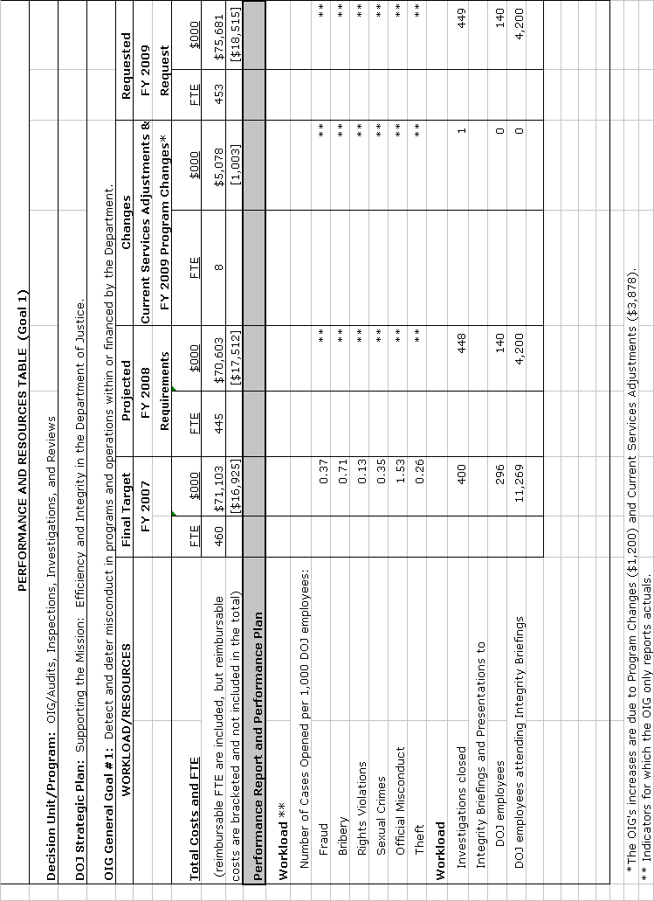

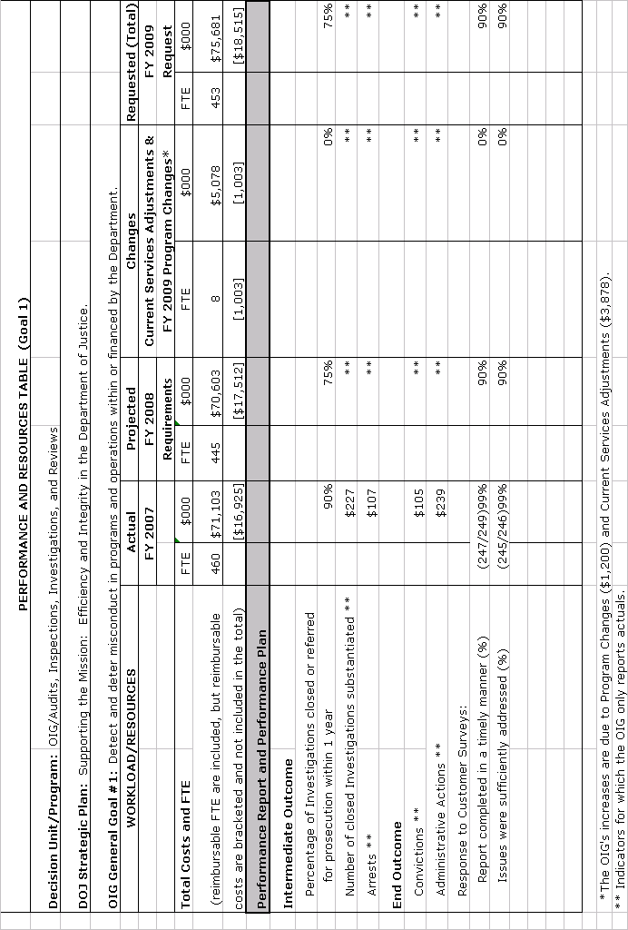
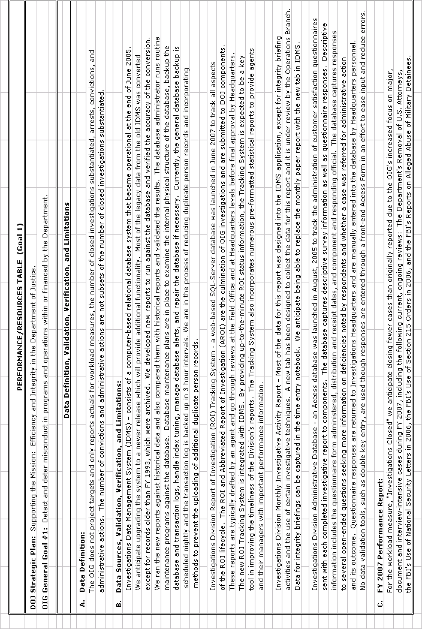
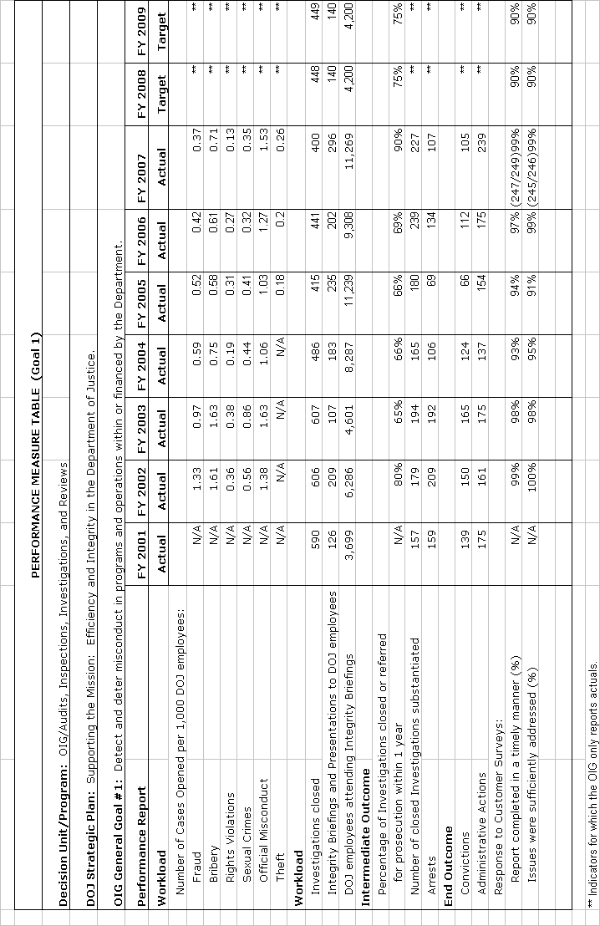
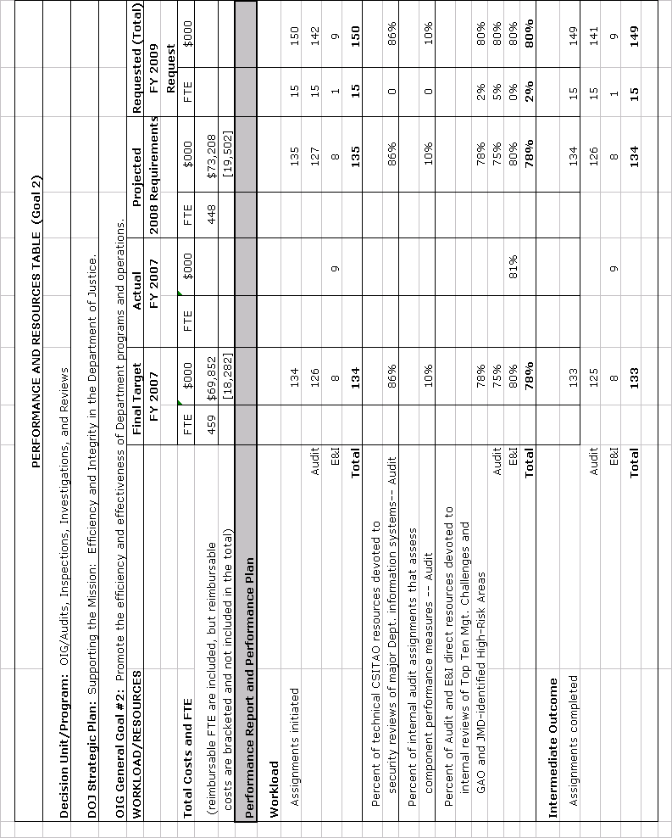
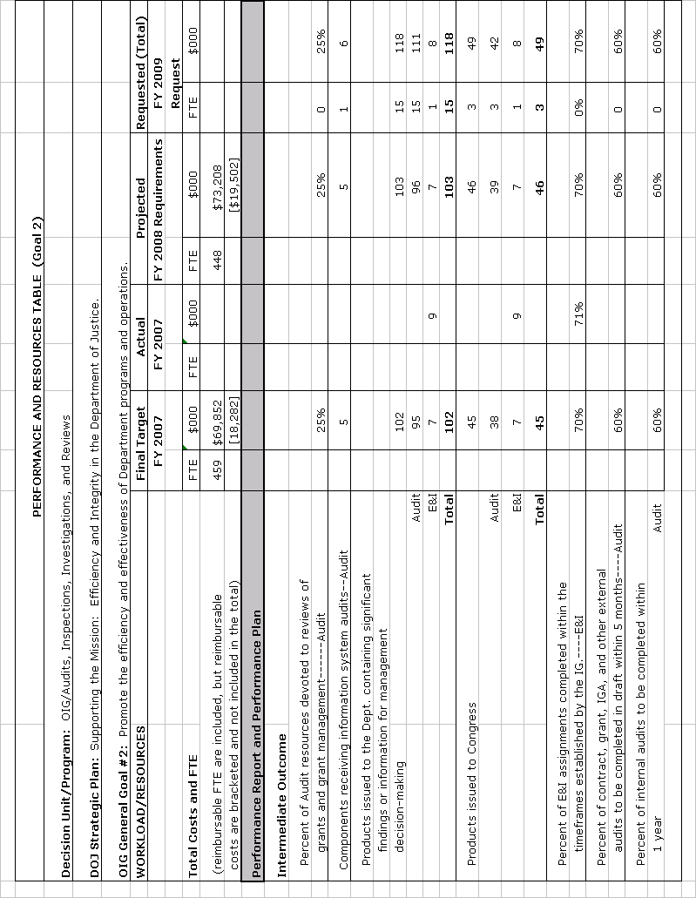
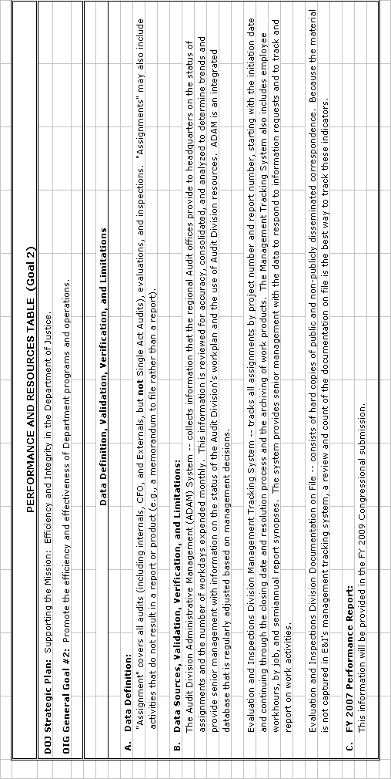
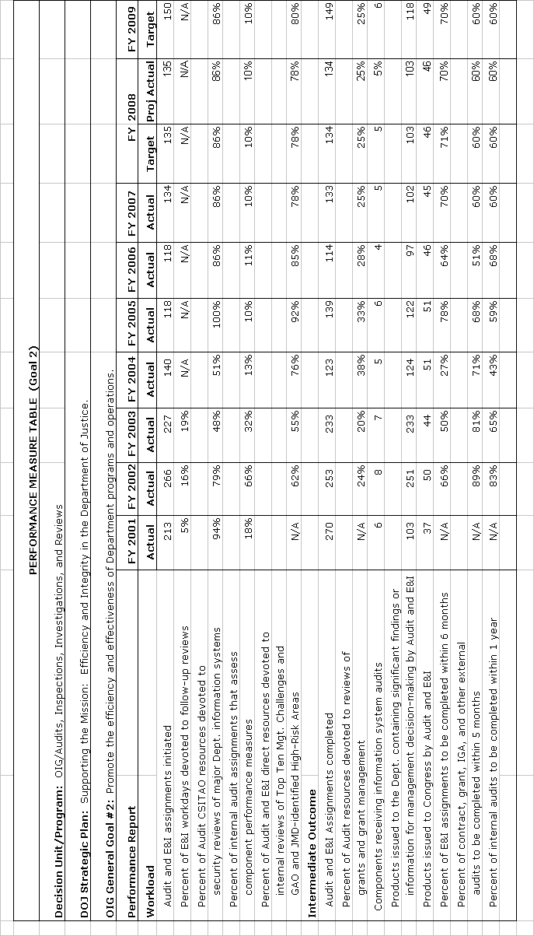
Performance, Resources, and Strategies

a. Performance Plan and Report for Outcomes

For the Department’s programs and activities to be effective, Department personnel, contractors, and grantees must conduct themselves in accordance with the highest standards of integrity, accountability, and efficiency. The OIG was established to detect and prevent misconduct and mismanagement on the part of the Department’s personnel and in its programs. The OIG investigates alleged violations of criminal and civil laws, regulations, and ethical standards arising from the conduct of the Department’s employees in their numerous and diverse activities. In addition, the OIG assists management in promoting integrity, economy, efficiency, and effectiveness within the Department and in its financial, contractual, and grant relationships with others using the coordinated efforts of the OIG’s investigative, audit, inspection, and special review resources.

The OIG continues to review its performance measures and targets, especially in light of the changing nature of the cases it investigates and the nature of the Department programs it reviews. Today’s work is much more complex and expansive than it was only a few years ago. The number of documents to be reviewed, the number of people to interview, the amount of data to examine, and the analytical work involved in many OIG reviews are significantly greater than in prior years. This is especially true for reviews of sensitive Department programs such as the review of the FBI’s use of national security letters, as well as for cross-cutting work that covers multiple components, such as the OIG’s recent reviews of component’s disciplinary programs or their handling of shooting incidents. These multi-component reviews can be particularly valuable in identifying “best practices” within the Department and ensuring consistency across component programs.

b. Strategies to Accomplish Outcomes

The OIG will investigate allegations of bribery, fraud, abuse, civil rights violations, and violations of other laws and procedures that govern Department employees, contractors, and grantees, and will develop cases for criminal prosecution and civil and administrative action. The OIG will use its audit, inspection, and attorney resources to review Department programs or activities identified as high-priority areas in the Department’s strategic plan and devote resources to review the Department’s Top Management and Performance Challenges.

V. Program Increases by Item
Item Name: Counterterrorism Oversight

Budget Decision Unit: Audits, Inspections, Investigations, and Reviews
Strategic Goal & Objective: Supporting the Mission: Efficiency and Integrity
in the Department of Justice
Organizational Program: OIG

Component Ranking of Item: 1 of 1
Program Increase: Positions +16 Agt/Atty +0/+2 FTE +8 Dollars +$1,200,000

Description of Item
The OIG is requesting 7 program analysts, 6 auditors, 2 attorneys, and 1 operations research analyst for Counterterrorism Oversight.

Justification
Specifically, the requested positions would be deployed in the following area:

Preventing and Combating Terrorism
The Department’s top priority continues to be the prevention, investigation, and prosecution of terrorist activities against U.S. citizens and interests. As funding for the Department’s counterterrorism efforts continue to increase, so does the need to monitor and evaluate these Department programs. This request will enable the OIG to assist the Department in ensuring that its counterterrorism funds are put to the most effective use.

The FBI’s highest priority is the prevention of terrorist attacks on the United States. The accomplishment of this critical national security mission requires the FBI to collect, analyze, and appropriately disseminate intelligence and other information needed to disrupt terrorist activities. However, past congressional investigations and OIG reports have found weaknesses in the FBI’s efforts. Given the importance of the FBI’s counterterrorism mission, the additional requested positions will enable the OIG to expand its oversight program in the counterterrorism area.

Moreover, additional resources in FY 2009 will enable the OIG to undertake new reviews in these critical areas. With these positions, the OIG will continue to examine issues such as the FBI’s use of National Security Letters and Section 215 orders to obtain business records, its efforts to develop its Sentinel case management system, and its progress in hiring, training, and retaining intelligence analysts. The OIG will continue to conduct audits and reviews on topics such as the Department’s involvement with the National Security Agency program known as the “terrorist surveillance program”, the operations of the Terrorist Screening Center, the Department’s internal controls over terrorism reporting, intelligence sharing, and the BOP’s efforts to improve the monitoring of communications for terrorists and other high-risk inmates.

Impact on Performance (Relationship of Increase to Strategic Goals)
All personnel requests are in direct support of the Department’s Strategic Goals and Objectives. The OIG is a key player in meeting the Department’s Strategic Goals and Objectives by providing leadership in integrity, efficiency and effectiveness, and management excellence.
See the performance indicator charts for the description of the OIG’s general goals and the plan performance for the FY 2009 enhancements.
Funding
(Dollars in Thousands)

The OIG operates as a single decision unit encompassing audits, inspections, investigations, and reviews. By the nature of its mission, the OIG must be able to move its resources and funding freely across all functions to address new priorities. Therefore, base funding for the OIG is only meaningful at the single decision unit level.

Personnel Increase Cost Summary
Type of  Position | Modular Cost  Per Position ($000) | Number of  Positions Requested | FY 2009  Request  ($000) | FY 2010  Net Annualization  ($000)
Attorney (GS-15) | 101 | 2 | 202 | 212
Program Analyst (GS-14) | 89 | 1 | 89 | 78
Operations Research Analyst (GS-13) | 79 | 1 | 79 | 73
Auditor (GS-13) | 79 | 4 | 316 | 272
Auditor (GS-9) | 56 | 2 | 112 | 110
Program Analyst (GS-12) | 71 | 4 | 284 | 292
Program Analyst (GS-9) | 56 | 2 | 112 | 110
Total Personnel |  | 16 | $1,200 | $1,147

Total Request for This Item
 | Pos | Agt/Atty | FTE | Personnel | Non-Personnel | Total
Increases | 16 | 0/2 | 8 | $1,200 | $0 | $1,200
Grand Total | 16 | 0/2 | 8 | $1,200 | $0 | $1,200

