United States Parole Commission

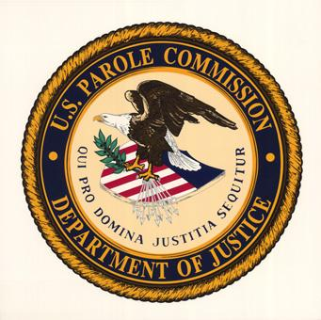

FY 2010
Congressional Budget Justification

April 27, 2009

Department of Justice
United States Parole Commission
Fiscal Year 2010 Performance Budget

Table of Contents

Page

I Overview
A Introduction 3
B Trends, Relevant Issues and Outcomes 6
C Full Program Costs 7
D Performance Challenges 8

II Summary of Program Changes - N/A

III Appropriation Language & Analysis of Appropriation Language 10

IV Decision Unit Justification 11

V Program Increases - N/A

VI Exhibits
A Organization Chart
B Summary of Requirements
C Program Increases/Offsets by Decision Unit - NA
D Resources by DOJ Strategic Goal/Objective
E Justification for Base Adjustments
F Crosswalk of 2008 Availability
G Crosswalk of 2009 Availability
H Summary of Reimbursable Resources - N/A
I Detail of Permanent Positions by Category
J Financial Analysis of Program Changes - NA
K Summary of Requirements by Grade
L Summary of Requirements by Object Class
M Status of Congressionally Requested Studies, Reports, and Evaluations - N/A

I. Overview for the U.S. Parole Commission

A. Introduction

For FY 2010, the President’s Budget includes a total of $12,859,000, 85 positions (6 attorneys) and 87 FTE for the United States Parole Commission (USPC).

Electronic Copies of the Department of Justice’s Congressional Budget Justifications and Capital Asset Plan and Business Case exhibits can be viewed or downloaded from the Internet using the Internet address: http://www.usdoj.gov/jmd/2010justification/.

Mission.

The mission of the U.S. Parole Commission is to promote Public Safety and strive for justice and fairness in the exercise of its authority to release and supervise offenders under its jurisdiction.
Jurisdiction: The United States Parole Commission has jurisdiction over the following types of cases:
- All Federal offenders who committed an offense before November 1, 1987;
- All D.C. Code offenders;
- Uniform Code of Military Justice Offenders who are confined in a Bureau of Prisons’ institution;
- Transfer treaty cases (U.S. citizens convicted in foreign countries, who have elected to serve their sentence in this country); and
- State Probationers and Parolees in the Federal Witness Protection Program.
I. Federal Offenders (offenses committed before November 1, 1987). The Parole Commission has the responsibility for:
- granting or denying parole to federal offenders who committed their offenses before November 1, 1987 and who are not otherwise ineligible for parole;
- making determinations regarding the initial conditions of supervision;
- modification of the conditions of supervision for changed circumstances;
- early discharge from supervision, issuance of a warrant or summons for violation of the conditions of supervision; and
- revocation of release for such offenders released on parole or mandatory release supervision.
Supervision in the community is provided by United States Probation Officers.

- D.C. Code Offenders

  - granting or denying parole to D.C. Code offenders who committed their offenses before August 5, 2000, and who are not otherwise ineligible for parole;
  - making determinations regarding the initial conditions of parole and of supervised release;
  - modification of the conditions of supervision for changed circumstances;
  - early discharge from supervision;
  - issuance of a warrant or summons for violation of the conditions of supervision; and
  - revocation of release for offenders released on parole or mandatory release supervision.

Supervision in the community is provided by Supervision Officers of the Court Services and Offender Supervision Agency (CSOSA) of the District of Columbia and United States Probation Officers.
III. Uniform Code of Military Justice Offenders. The Parole Commission has the responsibility for granting or denying parole to parole-eligible Uniform Code of Military Justice offenders who are serving a sentence in a Bureau of Prisons' institution. Concurrent with this jurisdiction, the Commission is also responsible for:
- making determinations regarding the initial conditions of supervision;
- modification of the conditions of supervision for changed circumstances;
- issuance of a warrant or summons for violation of the conditions of supervision; and
- revocation of release for such offenders released on parole supervision.
Supervision in the community for military parolees is provided by United States Probation Officers.
IV. Transfer-Treaty Cases. The Parole Commission has the responsibility for conducting hearings and setting release dates for U.S. citizens who are serving prison terms imposed by foreign countries and who, pursuant to treaty, have elected to be transferred to the United States for service of that sentence. This includes:
- offenders who committed their offenses after October 31, 1987. The Parole Commission applies the federal sentencing guidelines promulgated by the United States Sentencing Commission in determining the time to be served in prison before release; and
- offenders who committed their offenses before November 1, 1987. The Parole Commission applies the parole guidelines that are used for parole-eligible federal and military offenders.
- State Probationers and Parolees in Federal Witness Protection Program. The Parole Commission has the responsibility for :
- making determinations regarding the initial conditions of supervision;
- modification of the conditions of supervision for changed circumstances;
- issuance of a warrant or summons for a violation of the conditions of supervision; and
- revocation of release for certain state probationers and parolees who have been placed in the federal witness protection program.

Supervision in the community is provided by United States Probation Officers.

Organizational Structure .

- The Chairman and Commissioners render decisions in National Appeals Board cases; create and maintain a national parole policy; grant or deny parole to all eligible federal and District of Columbia prisoners; establish conditions of release; and modify parole conditions and/or revoke the parole or mandatory/supervised releases of offenders who have violated the conditions of supervision.

The Executive Office provides management and advisory services to the Commissioners; managers and staff in the areas of human resources management and training; budget and financial management; contracts and procurement; facilities and property management; telecommunications; and security.

- The Office of Case Operations conducts parole hearings with federal and D.C. prisoners and parole revocation hearings with parole violators; plans and schedules parole hearing dockets; ensures that victims and witnesses are given an opportunity for input into the parole decision-making process; and administrates the records management program.

- The Office of Case Services monitors the progress of prisoners and parolees through pre-release and post-release; prepares and issues warrants and warrant supplements; drafts letters of reprimand; requests and analyzes preliminary interviews; and issues parole certificates.

- The Office of Information Technology is responsible for delivering and supporting information technology systems and services; maintaining and reporting statistical workload data.
- The Office of the General Counsel advises the Commissioners and staff on interpretation of the agency's enabling statutes; drafts implementing rules and regulations; and assists U.S. Attorney's Offices in defending the Commission against lawsuits brought by prisoners and parolees. The office also oversees responses to requests submitted under the Freedom of Information Act and Privacy Act.

B. Trends, Relevant Issues and Outcomes

The Commission’s budget for 2010 addresses the following strategic goals that the Attorney General has announced as priorities of the Department of Justice:

Strategic Goal 2: Prevent Crime, Enforce Federal Laws and Represent the Rights and Interests of the American people

Strategic Objective 2.1 - Strengthen partnerships for safer communities and enhance the Nation’s capacity to prevent, solve and control crime.

- Work with local law enforcement agencies to increase appearance of officers at Revocation hearings. Develop video presentation for the law enforcement agencies to increase understanding of the role of USPC.
- Work with the D.C. Metropolitan Police Department (MPD) to target parolees and supervised releasees that live in or visit the MPD-designated Hot Spots in the District of Columbia.
- Collaboration with CSOSA: Issue warrants in a timely fashion to remove violent offenders from the Washington, D.C. streets. Conduct hearings that look at intermediate sanctions for offenders and to help prevent behavior (drugs, alcohol) that leads to criminal activities. Conduct USPC Reprimand Sanction hearings to address non-compliant behavior and to demand a commitment to make positive behavioral changes to comply with the conditions of release.
- D.C. Jail and Corrections: Develop better processes to conduct probable cause and revocation hearings for Technical Parole Violators.

Strategic objective 2.2 - Reduce the threat, incidence and prevalence of violent crime.
Strategic objective 2.3 - Prevent, suppress, and intervene in crimes against children.

The U.S. Parole Commission has the authority to find by a preponderance of evidence that an offender under USPC supervision has committed another crime (even if the offender was not convicted of that crime by the Courts) and return the offender back to prison.

- Target violent crime committed with a firearm.
- Reduce recidivism among violent offenders by developing risk assessment instruments and guidelines to identify high risk offenders who need to return to incarceration and intense supervision sanctions.
- Establish conditions of release and act swiftly to return offenders to prison when they have demonstrated deviant behavior.
- Promote community safety by enhancing supervision of offenders under supervision in the community who are involved in gang activity, sex offenses, gun-related offenses, and domestic violence.
- Conduct a recidivism study and adjust guidelines for the D.C. population that identify high risk offenders.

Strategic Goal III: Ensure the Fair and Efficient Operation of the Federal Justice System.

Strategic Objective 3.1 - Protect judges, witnesses, and other participants in federal proceedings, and ensure the appearance of criminal defendants for judicial proceedings or confinement.

Review all parole release and revocation of release cases to institute a search for victims of violent crime and coordinate this search with the D.C. Superior Court system, Federal Courts, the U.S. Attorney’s office, and the D.C. and federal supervision agencies.
- Build a collaborative community approach to assisting victims and witnesses. Enhance decision-making through cooperation with external partners in criminal justice to ensure that the victim’s input is considered prior to a decision.
- Improve security for victim/witness. Develop policies and procedures to incorporate video conferencing for victim and witness input.

Strategic Objective 3.4 - Provide services and programs to facilitate inmates’ successful reintegration into society, consistent with community expectations and standards.

The U.S. Parole Commission makes release decisions for persons convicted of violent crimes and establishes release conditions to ensure that these individuals are supervised in the community to the maximum extent possible.

- supervise, revoke, and release federal and District of Columbia offenders to reduce recidivism and protect the public;
- issue release and revocation decisions within the statutory deadline;
- support reentry;
- establish and apply sanctions that are consistent with public safety and the appropriate punishment for crimes involving sex offenders, gangs, crimes of violence with firearms, and domestic violence;
- coordinate with other public safety agencies; and
- establish and implement guidelines to reduce recidivism.

C. Full Program Costs

The FY 2010 budget for the United States Parole Commission (USPC) is $12,859,000; 85 full time permanent positions (6 attorneys) and 87 workyears.

 | Positions | Workyears | Amount ($000s)
FY 2008 Appropriation enacted with rescission | 93 | 95 | $11,462
FY 2009 Requirements | 85 | 87 | 12,570
FY 2010:Adjustments to base and Technical Adjustments |  |  | 289
 | 85 | 87 | 12,859

D. Performance Challenges

Alternatives to Incarceration

- Reprimand Sanction Hearings Program

This program provides a graduated sanction, short of revocation, that permits the Commission to address non-compliant offender behavior and to encourage a commitment from the offender to make positive behavioral changes to comply with the conditions of release. USPC continues to work with our criminal justice partners to promote the success in the Reprimand Sanction Hearings Program.

- RSAT - Residential Substance Addiction Treatment

This program will provide treatment interventions and support service for offenders with addictive alcohol and drug abuse behavior. The Commission will have an in-treatment option to address addiction rather than incarceration.

- Reentry Sanction Center

This program provides the Commission with a 28-day in-house program to evaluate the offender’s needs and determine the proper treatment program that could be from 90-days to one year. The Commission has to determine appropriate sanctions for long-term treatment for offenders with histories of abusing substances (including PCP) and violating their release conditions.

- Rewards Program

Guidelines for a reward system for violation free behavior must be established and tested. This program would promote success of offenders in the community. The Commission has a major task of finding protocols that address methods of treatment for PCP and other drug usage.

Reducing Recidivism

Identifying and implementing directives and/or special conditions which may assist offenders in successfully completing their periods of supervision. Greater emphasis on reentry strategies, such as substance abuse, mental health, housing, and employment will be needed to reduce recidivism while producing successful outcomes.

Automation

Major partners of the U.S. Parole Commission are continuously making significant progress in automating much of their business processes. In order for the Commission to best communicate with its partners and the offender population, automation is essential to:
  - improve timeliness and accuracy of decisions.
- make management decisions and develop efficient sanctions based on the offender population.
- collect data and properly report and record recidivism rates and other performance measures.

Human Resources Specialization

- A condition of supervision that is essential for one offender many not be appropriate for another. Staff expertise in complex criminal cases provides the background and knowledge to document cases, address legal issues, and challenge lawsuits brought by supervised releasees. However, current staff does not have the specific expertise or resources to monitor and decide on complex issues surrounding gang cases, domestic violence cases, gun cases, violent offender cases, and sexual assault cases. Specialized training of staff is slow and unproductive due to the consistent onslaught of requests for warrants or other sanctions.

Increased Police Efforts

- The District of Columbia Metropolitan Police Department (MPD) is increasing their efforts to make communities safer by focusing on the investigation and arrest of offenders committing violent crimes. Their increased efforts will require the Commission to increase its capacity to accommodate these efforts as well as the pursuit of specialized caseloads for better management and efficiencies. MPD reported the following preliminary figures for targeted crimes committed in 2008:
Violent Crime: 8,409 Sex Offense: 453 Robbery: 4,461
Armed Assault: 2,860 Burglaries: 3,767

Testimony of Witnesses

- The supervised release caseload represents some of the most complex and difficult workload managed by the Commission. The Commission is required to conduct contested revocation hearings to decide whether violations of release have occurred. This may require the Commission to secure the presence and testimony of witnesses. Despite receiving a subpoena, witnesses often fail to appear at the hearings causing them to be rescheduled.

- Appropriation Language and Analysis of Appropriations Language

For necessary expenses of the United States Parole Commission as authorized by law, [$12,570,000] $12,859,000 (Department of Justice Appropriations Act, 2009).

Analysis of Appropriation Language

No substantive changes proposed.
Decision Unit Justification.

United States Parole Commission
U.S. Parole Commission TOTAL | Perm. Pos. | FTE | Amount
2008 Enacted with Rescissions | 96 | 98 | 11,462,000
2008 Supplementals | 0 | 0 | 0
2008 Enacted w/Rescissions and Supplementals | 96 | 98 | 11,462,000
2009 Enacted | 85 | 87 | 12,570,000
Adjustment to Base and Technical Adjustments |  |  | 289
2010 Current Services | 85 | 87 | 12,859,000
2010 Request | 85 | 87 | 12,859,000
Total Change 2009-2010 |  |  | 289

1. Program Description

The U.S. Parole Commission makes parole release decisions for eligible federal and District of Columbia (D.C.) prisoners, determines the conditions of parole or supervised release, issues warrants and revokes parole and supervised release for violation of the conditions of release. Through the administration of a national parole policy that enables the consistent application of rational guidelines, the Commission contributes to the Department's priority of ensuring public safety through impartial decision-making that provides incentives for good behavior while discouraging recidivist conduct.

Responsibilities

- Issue warrants for violation of supervision
- Determine probable cause for revocation process
- Make parole release decisions
- Authorize method of release and the condition under which release occurs
- Prescribe, modify and monitor compliance with the terms and conditions governing offender’s behavior while on parole or mandatory or supervised release
- Revocation of parole, mandatory or supervised release of offenders
- Release from supervision those offenders who no longer pose a risk to public safety
- Promulgate rules, regulations, and guidelines for the exercise of its authority and the implementation of a national parole policy.

Parole Guidelines: Parole guidelines structure incarceration and release decision-making and are built around a two-dimensional matrix that considers offense severity and offender risk. For each combination of offense severity and risk, the guidelines indicate a range of time to be served. The Commission may release outside the guideline range if it determines there is good cause for doing so. Inmates are furnished a written notice stating the reason(s) for the Commission's determination and a summary of the information relied upon. The guidelines have played a significant role over the past two decades in reducing sentencing disparity.
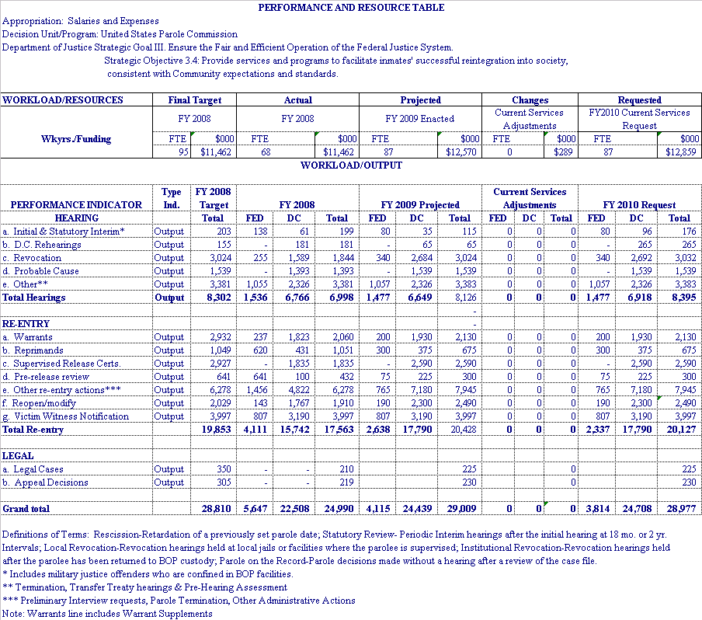
2. Performance, Resources and Strategies

Much of the D.C. caseload is driven by requests for warrants as a result of violations of the terms and conditions of parole. In contrast to the federal system where the failure rate is about 20 percent, D.C. parolees have a failure rate of around 50 percent. When a warrant is issued, a request for a preliminary interview follows, and a hearing follows.

Local revocation hearings are held at facilities in the locality where a parolee has been arrested, and they require much more work because the hearings are adversarial. An offender may contest the charges and is entitled to representation by an attorney, along with the ability to call witnesses. Additionally, these hearings are more costly to the Commission, because they often involve travel to a remote location, where the examiner is only able to handle a particular case. In an institutional hearing, the parolee has admitted to the charges or been convicted of new criminal activity, and the issues to be heard involve the degree of responsibility and the length of additional incarceration. Institutional hearings are less costly, because the examiner can handle several cases during one docket. The Commission has determined that local revocations are about 2-3 times as labor intensive as institutional hearings. In FY 2010, the Commission projects that the total prisoner and parolee population, federal and D.C., including D.C. supervised releases, will be 11,901. The D.C. population under the Commission’s jurisdiction is estimated to be 2,100 prisoners and 6,600 parolees and supervised releases. The following table illustrates changes in the Commission’s total caseload from 2001 through 2010:

Population under U.S. Parole commission Jurisdiction
As of  9/30 | Federal Offenders |  | D.C. Offenders
As of  9/30 | Incarcerated | Parole  Supervision | Incarcerated |  | Supervised
As of  9/30 | Incarcerated | Parole  Supervision | Parole Eligible |  |  | Parole | SRAA
2001 | 3,699 | 4,136 | 6,391 |  |  | 5,100 est. | …
2002 | 2,606 | 3,755 | 6,021 |  |  | 4,815 | 47
2003 | 2,325 | 3,392 | 5,430 |  |  | 5,313 | 278
2004 | 2,079 | 3,096 | 4,888 |  |  | 4,762 | 748
2005 | 1,848 | 2,893 | 4,213 |  |  | 4,658 | 1,213
2006 | 1,700 | 2,690 | 4,100 |  |  | 4,060 | 1,788
2007 | 1,600 | 2,502 | 3,075 |  |  | 3,530 | 2,300
2008 | 1,355 | 2,378 | 3,099 |  |  | 3,015 | 3,421
2009 est. | 1,200 | 2,259 | 2,500 |  |  | 2,895 | 3,650
2010 est. | 1,055 | 2,146 | 2,100 |  |  | 2,750 | 3,850

EXHIBITS

