
Civil Division
United States Department of Justice

Radiation Exposure Compensation Act Trust Fund

FY 2012 Performance Budget
Congressional Budget Submission

Table of Contents

Page No.

I. Overview 1

II. Decision Unit Justification

1. Program Description 1
2. Performance Tables N/A
3. Performance, Resources, and Strategies 5
a. Performance Plan and Report for Outcomes
b. Strategies to Accomplish Outcomes

III. Exhibits

- Organizational Chart#
- Summary of Requirements
- Program Increases by Decision Unit#
- Resources by DOJ Strategic Goal/Objective
- Justification for Base Adjustments
- Crosswalk of 2010 Availability
- Crosswalk of 2011 Availability
- Summary of Reimbursable Resources#
- Detail of Permanent Positions by Category#
- Financial Analysis of Program Increases/Offsets#
- Summary of Requirements by Grade#
- Summary of Requirements by Object Class
- Status of Congressionally Requested Studies, Reports, and Evaluations#

#Not applicable

Radiation Exposure Compensation Act Trust Fund

Overview

On October 5, 1990, Congress passed the Radiation Exposure Compensation Act (the Act or RECA). The Act offers an apology and monetary compensation to individuals who contracted certain cancers and other serious diseases as a result of their exposure to radiation released during above-ground atmospheric nuclear weapons tests or as a result of their occupational exposure while employed in the uranium industry during the build-up to the Cold War. This unique program was designed as an alternative to litigation in that the statutory criteria do not require claimants to establish causality. Specifically, if the claimant can satisfy the requirements outlined in the statute, which include demonstrating that he or she contracted a compensable disease after working or residing in a designated location for a specified period of time, he or she qualifies for compensation. Congress charged the Attorney General with responsibility for adjudicating claims under the Act.

“It is the purpose of this Act to establish a procedure to make partial restitution to the individuals… for the burdens they have borne for the Nation as a whole. …The Congress apologizes on behalf of the Nation to the individuals… and their families for the hardships they have endured.”

Radiation Exposure Compensation Act

The Department of Justice (DOJ) established the Radiation Exposure Compensation Program (the Program) within the Civil Division. The Program commenced operations in April 1992. Since its inception, 33,107 claims have been filed and over $1.5 billion has been awarded in connection with 23,408 approved claims (as of January 1, 2011).

The Program is responsible for providing outreach to affected communities. Many claims are filed by individuals living in and around the Four Corners region of Utah, Colorado, New Mexico, and Arizona. This claimant population includes members of several Native American tribes. The Program has implemented a new outreach program, involving student interns from the Four Corners region. By utilizing students from these communities in the outreach efforts, the Program hopes that greater access can be established to remote areas of the Indian reservations to aid an increasing number of potential claimants in the application process.

Program Description
Mission Statement: Fairly and expeditiously adjudicate claims, fully consistent with the Radiation Exposure Compensation Act, as amended; educate the public about the Act; and develop strategies for improving the Program.

The Program office is located in Washington, D.C., and is administered by a staff of five attorneys, 11 claims examiners, and two contractor employees within the Civil Division’s Torts Branch. The support staff reviews claims packages, assists claimants with their applications, and manages physical case files. The Civil Division strives to process and resolve claims fairly and efficiently and has far surpassed its goals for the timely processing and adjudication of claims.
Background
From 1945 through 1962, the United States conducted nearly 200 atmospheric nuclear weapons tests while building the arsenal that became the cornerstone of the nation’s Cold War security strategy. The mining and processing of uranium ore that was conducted by tons of thousands of workers was essential to the development of nuclear weapons. Many workers filed class action lawsuits that were eventually dismissed by the appellate courts. Congress then devised a program to make partial restitution to the individuals who developed serious illnesses after their exposure to radiation released during above-ground atmospheric nuclear tests or following their employment in the uranium industry. Congress passed the Radiation Exposure Compensation Act on October 5, 1990, and later broadened the scope of the Act’s coverage on July 10, 2000.

Department issued regulations were designed to utilize existing records so that claims could be resolved in a reliable, objective, and non-adversarial manner, with little administrative cost to the United States or to the person filing the claim.

The Act established monetary compensation for individuals who contracted specified diseases in three defined populations: uranium workers (uranium miners, millers, and ore transporters), who receive $100,000; individuals present at test site locations (on-site participants), who receive $75,000; and individuals who lived downwind of the Nevada Test Site (downwinders), who receive $50,000.

The geographic areas covered by the Program relative to each claimant population are defined below:

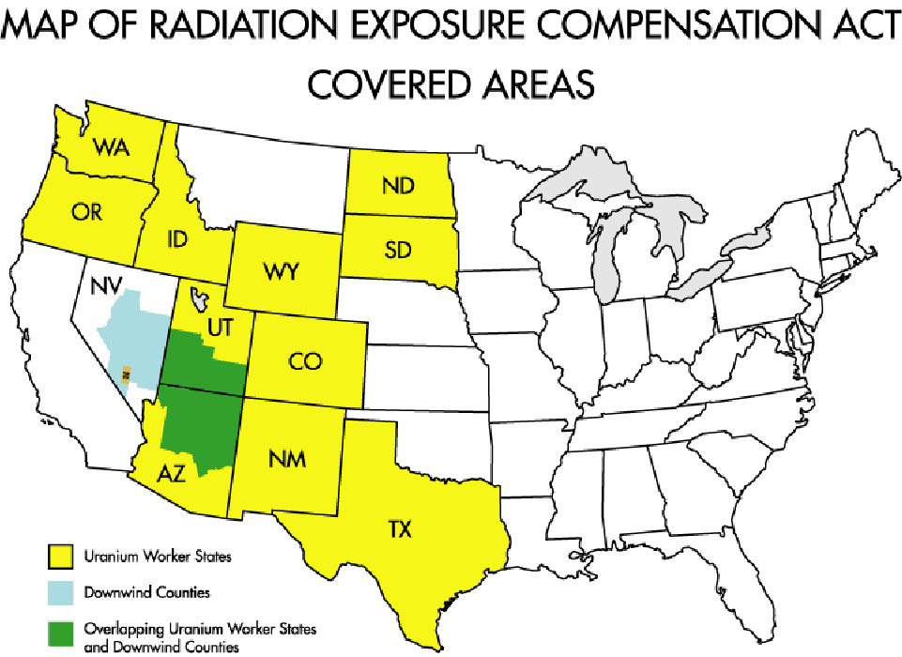

The Program has awarded compensation to individuals residing in every state as well as several foreign countries.

Today, the RECA Program is at the center of a broad inter-agency network that comprises the comprehensive federal radiation compensation system. The RECA Program works in concert with the Departments of Health and Human Services (HHS), Labor, Veterans Affairs, and Defense to administer the Act.

Outreach
The Program regularly engages in outreach activities to educate relevant communities on the availability of compensation under the Act and the application process. During FY 2010, Program staff traveled to the Navajo Indian Reservation in Shiprock, New Mexico to conduct two outreach training events. At both events, Program staff met with tribal leaders, assisted claimants with pending claims, and coordinated training sessions for local case workers at the Office of Navajo Uranium Workers, an office chartered by the Navajo Nation to assist tribal members in filing RECA claims. RECA staff also visited Salt Lake City, Utah to examine records and to discuss potential sources of documentary evidence for establishing RECA’s eligibility criteria for downwinder claimants.

In FY 2010, RECA organized a new outreach program involving undergraduate and graduate students. This program was designed to accomplish more effective outreach to Native American populations in the Four Corners region of New Mexico, Arizona, Utah, and Colorado. This outreach effort brought college or graduate students to Washington, D.C., mainly from the Four Corners region, where they were educated about the RECA Program, the claims application process, and the types and sources of information needed to successfully adjudicate claims. The curriculum focused particularly on special concerns and difficulties faced by Native American populations in successfully presenting RECA claims. Upon returning to the Four Corners region, the students were offered part-time employment conducting intensive RECA outreach efforts in their communities.

Two training sessions took place during the summer of FY 2010, and the students who completed the June session have finished their part-time employment. The second session students began their part-time employment in January. The students employed in the outreach program have traveled into the tribal communities to provide information to potentially eligible persons, assist eligible persons in preparing RECA applications, and educate social workers and medical professionals in the Four Corners region on the existence and requirements of the Program. The interns have already made major strides in improving RECA’s outreach and have yielded impressive results in their ability to reach out to a wide network of potential claimants. Since the start of their employment, interns have developed 49 claims, five of which have been filed with the RECA Program (and remain pending). Additionally, interns have published four articles in local papers and newsletters, spoken at 16 community engagements, and hosted 30 outreach meetings.

Funding History
The RECA Trust Fund was subject to discretionary appropriations from FY 1992 to FY 2001. Following enactment of the 2000 Amendments, the appropriation became insufficient to meet the increase in the number of claims deemed eligible for compensation. In 2002, Congress addressed the problem within the Department of Defense Authorization Act for FY 2002, which established annual funding against mandatory spending caps. However, by 2003 the increased rate of new claim filings and approvals proved the caps to be inadequate, and a funding shortfall ensued. Working in close coordination, the appropriators and authorizers effectively devised legislative solutions to the funding problems. The following statutes ensure that all eligible RECA claims will be paid in a timely manner throughout the life of the Program.

- The Consolidated Appropriations Act for 2005 contained language that made funding for the RECA Trust Fund mandatory and indefinite beginning in FY 2006. Henceforth, the Fund has exclusively paid Section 4 claimants (downwinders and onsite participants).

- The National Defense Authorization Act for FY 2005 requires that RECA Section 5 claimants (uranium miners, millers, and ore transporters) be paid out of the Energy Employees Occupational Illness Compensation Fund.

Claim Statistics
Over the life of the program, over 33,000 claims have been filed with the Program. This includes 9,276 denials and 23,408 approvals, which is an approximate 72 percent approval rate. Total RECA awards over the life of the Program exceed $1.5 billion (as of January 1, 2011). Approximately 160 new claims are filed each month. Of those claims that have been denied since 1992, only 11 claimants have sought review in federal district court. The Division estimates that approximately $72,000,000 in approvals will be paid out in FY 2012.

Performance, Resources, and Strategies

Performance Plan and Report for Outcomes
The Radiation Exposure Compensation Program supports Goal 2 of the Department of Justice’s Strategic Plan, specifically Objective 2.7: “Vigorously enforce and represent the interests of the United States in all matters over which the Department has jurisdiction.”

The Program’s primary objective is to implement civil justice reform initiatives to resolve categories of claims for which traditional litigation has proven ineffective and to administer compensation programs enacted by Congress that offer non-litigation solutions for radiation exposure claimants.

Strategies to Accomplish Outcomes
The Program will employ the following strategies to accomplish this mission:

- Hire skilled claims examiners to conduct the initial review of claims, freeing the Program attorneys to conclude the adjudication and render the final determination.

- Access external data sources, such as the Social Security Administration, the National Institute for Occupational Safety and Health, the Public Health Service, and state cancer and tumor registries to assist claimants in securing the necessary documentation in support of their claims.

- Coordinate with the Department of Labor’s (DOL) Energy Employees Occupational Illness Compensation Program to ensure that eligible Section 5 RECA claimants receive compensation in a timely manner. This includes review of claimant files to decide eligibility pursuant to the Energy Employees Occupational Illness Compensation Program Act.

- Brief Members of Congress and their staffs as requested; provide information to Members and the public in an open, timely, and complete manner.

- Coordinate with the Department of Health and Human Services’ Radiation Exposure Screening and Education Program to assist grantees in providing relevant information on the RECA Program to individuals screened for disease in the affected geographic regions.

- Use a toll-free phone line and website to communicate with claimants and publish regularly updated statistical information on data.gov.

- Conduct outreach by traveling to areas with populations of potential claimants and participating in roundtable discussions held by congressional delegations for their constituents.

Radiation Exposure Compensation Act Workload
Claims Filed and Approved
(Dollars in Thousands)
 | FY 2006  Actual | FY 2007  Actual | FY 2008  Actual | FY 2009 Actual | FY 2010  Actual | FY 2011  Estimate | FY 2012  Estimate
Section 4 Claims:
Downwinders
Pending, Beginning of Year | 1,139 | 1,093 | 424 | 366 | 296 | 300 | 298
Claims Filed | 999 | 1,038 | 1,131 | 1,137 | 1,128 | 1,275 | 1,321
Claims Approved | 902 | 1,360 | 985 | 1,053 | 1,037 | 1,190 | 1,212
Value of Approvals | $45,100 | $68,000 | $49,250 | $52,650 | $51,850 | $59,500 | $60,600
On-Site Participants
Pending, Beginning of Year | 247 | 208 | 91 | 70 | 52 | 60 | 47
Claims Filed | 174 | 148 | 158 | 191 | 247 | 273 | 241
Claims Approved | 80 | 156 | 91 | 115 | 133 | 166 | 151
Value of Approvals | $5,548 | $11,280 | $6,438 | $8,437 | $9,656 | $12,475 | $11,325
Subtotal Section 4 Claims
Pending, Beginning of Year | 1,386 | 1,301 | 515 | 436 | 348 | 360 | 345
Claims Filed | 1,173 | 1,186 | 1,289 | 1,328 | 1,375 | 1,548 | 1,562
Claims Approved | 982 | 1,516 | 1,076 | 1,168 | 1,170 | 1,356 | 1,363
Value of Approvals | $50,648 | $79,280 | $55,688 | $61,087 | $61,506 | $71,975 | $71,925
Section 5 Claims (Uranium Miners, Millers, and Ore Transporters)
Pending, Beginning of Year | 643 | 760 | 294 | 205 | 216 | 191 | 172
Claims Filed | 1,087 | 659 | 700 | 575 | 453 | 448 | 437
Claims Approved | 786 | 748 | 486 | 332 | 296 | 314 | 305
Value of Approvals | $78,600 | $74,776 | $48,600 | $33,200 | $29,600 | $31,400 | $30,500
TOTAL
Pending, Beginning of Yr | 2,029 | 2,061 | 809 | 641 | 564 | 551 | 517
Claims Filed | 2,260 | 1,845 | 1,989 | 1,903 | 1,828 | 1,996 | 1,999
Claims Approved | 1,768 | 2,264 | 1,562 | 1,500 | 1,466 | 1,670 | 1,668
Claims Denied | 460 | 833 | 597 | 482 | 467 | 510 | 501
Total Adjudications  (Approved + Denied) | 2,228 | 3,097 | 2,159 | 1,982 | 1,933 | 2,180 | 2,169
Approval Rate | 79% | 73% | 72% | 76% | 76% | 77% | 77%
Value of Approvals | $129,248 | $154,056 | $104,288 | $94,287 | $91,106 | $103,375 | $102,425

