THIS PAGE INTENTIONALLY LEFT BLANK

Table of Contents

Page No.

I. Overview 1

II. Summary of Program Changes 19

III. Appropriations Language and Analysis of Appropriations Language 21

IV. Decision Unit Justification 23

A. Criminal 23

1. Program Description 24

2. Performance Tables 25

3. Performance, Resources, and Strategies 27

B. Civil 29

1. Program Description 30

2. Performance Tables 33

3. Performance, Resources, and Strategies 35

C. Legal Education 36

1. Program Description 37

2. Performance Table 41

3. Performance, Resources, and Strategies 43

V. Program Increases by Item 46

VI. Program Offsets by Item………………………………………………………….. 48

VII. Exhibits 51

- Organizational Chart
- Summary of Requirements
- Program Increases by Decision Unit
- Resources by DOJ Strategic Goal/Objective
- Justification for Base Adjustments
- Crosswalk of FY 2010 Availability
- Crosswalk of FY 2011 Availability
- Summary of Reimbursable Resources
- Detail of Permanent Positions by Category
- Financial Analysis of Program Changes
- Summary of Requirements by Grade
- Summary of Requirements by Object Class
- Status of Congressionally Requested Studies, Reports, and Evaluations

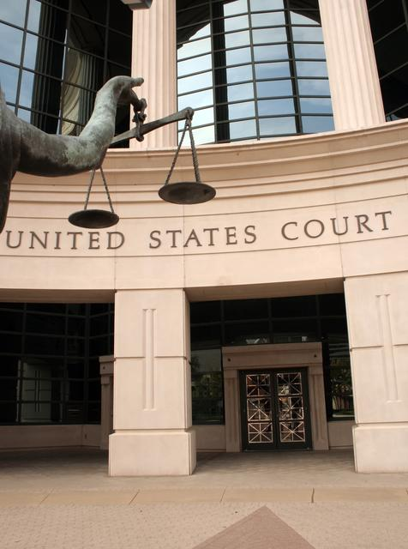

I. Overview for the United States Attorneys

A. Introduction

The United States Attorneys’ mission supports two of the Department of Justice’s strategic
goals - (1) to prevent terrorism and promote the nation’s security, and (2) to prevent crime, enforce federal laws and represent the rights and interests of the American people. In FY 2012, the United States Attorneys’ request 10,676 positions, including 5,480 attorneys, 10,787 FTE, and $1,995,149,000. The budget request includes a program enhancement of $2,000,000 for Enhanced Data Analysis and program offsets of $3,186,000.

Electronic copies of the Department of Justice’s Congressional Budget Justifications and Capital Asset Plan and Business Case exhibits can be viewed or downloaded from the internet using the Internet address: http://www.justice.gov/02organizations/bpp.htm.

The United States Attorneys serve as the nation’s principal litigators. In response to the mandates of the Constitution that required establishment of a system of federal courts, Congress enacted the Judiciary Act of 1789 directing the President to appoint, in each federal district, “a person learned in the law to act as an attorney for the United States.” Before 1870, the United States Attorneys acted independently, but since then they have worked under the direction of the U.S. Department of Justice.

There are 94 United States Attorneys’ Offices (USAOs) located throughout the United States, Puerto Rico, the Virgin Islands, Guam, and the Northern Mariana Islands. The 93 United States Attorneys (Guam and the Northern Mariana Islands are under the direction of a single U.S. Attorney) are appointed by, and serve at the discretion of, the President of the United States, with the advice and consent of the United States Senate. The map on page 3 depicts the United States Attorneys’ current district and branch office locations.

The United States Attorneys report to the Attorney General through the Deputy Attorney General. Each United States Attorney serves as the chief federal law enforcement officer within his or her judicial district and, as such, is responsible for the prosecution of criminal cases brought by the federal government; the litigation and defense of civil cases in which the United States is a party; and the handling of criminal and civil appellate cases before United States Courts of Appeals.

*The FTE listed in this budget reflect an FTE level developed using the authorized FTE level in FY 2010 and differ from the FTE listed in the FY 2012 President’s Budget Appendix, which were developed using FY 2010 on-board levels.

The United States Attorneys and their Assistant United States Attorneys (AUSAs) serve in small towns and big cities, representing the interests of the United States. Through their hard work and dedication, justice is served throughout the nation. United States Attorneys’ Offices (USAOs) conduct most of the trial work in which the United States is a party. Although the distribution of caseload varies between districts, each USAO handles every category of cases as well as a mixture of simple and complex litigation. Each United States Attorney exercises wide discretion in the use of his/her resources to further the priorities of the local jurisdictions and needs of their communities.

United States Attorneys provide advice and counsel to the Attorney General and senior policy leadership through the Attorney General’s Advisory Committee (AGAC) and its various Subcommittees. The AGAC was established in 1973 to give United States Attorneys a voice in Department policies and to advise the Attorney General. The Committee, comprised of approximately 20 United States Attorney members who represent various federal judicial districts, geographic locations, and different sized offices, meets monthly with the Deputy Attorney General and Attorney General. The AGAC has Subcommittees and working groups to address the Administration’s priorities. The Subcommittees include:

- Border and Immigration Law Enforcement
- Civil Rights; Criminal Practice Subcommittee
- Cyber/Intellectual Property
- LECC/Victim/Community Issues
- Native American Issues
- Office Management and Budget
- Terrorism/National Security
- Violent and Organized Crime
- White Collar/Fraud.

The Working Groups include:
- Child Exploitation and Obscenity
- Controlled Substances and Asset Forfeiture
- Environmental Issues
- Health Care Fraud
- Civil Chiefs
- Criminal Chiefs
- Appellate Chiefs

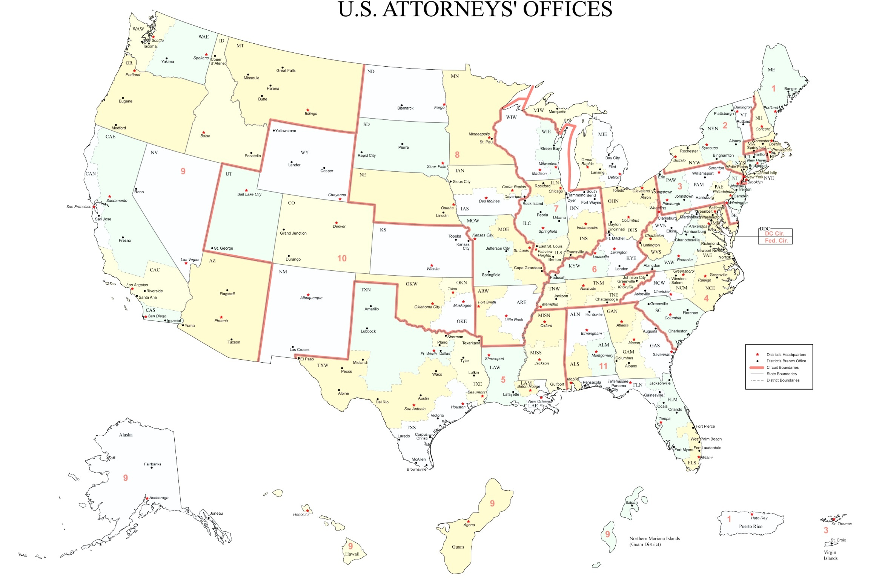

EXECUTIVE OFFICE FOR UNITED STATES ATTORNEYS
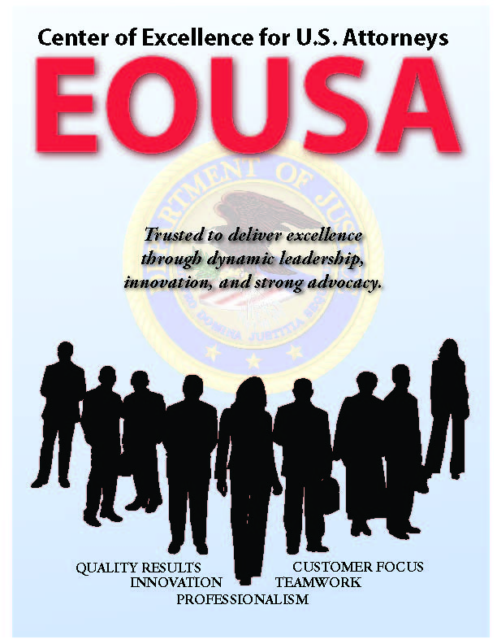
In 1953, Attorney General Order No. 8-53 established the Executive Office for United States Attorneys (EOUSA) to “provide general executive assistance and supervision to the offices of the United States Attorneys.” One of the original directives instructed the Executive Office to “serve as liaison, coordinator, and expediter with respect to the Offices of the United States Attorneys, and between these offices and other elements of the Department [of Justice].” Under the guidance of the Director of EOUSA, the EOUSA staff provides the 93 United States Attorneys with general executive assistance and direction; policy development; administrative management direction and oversight; operational support; and coordination with other components of the Department and other federal agencies. These responsibilities include legal, budgetary, administrative, and personnel services, as well as continuing legal education. EOUSA provides support and assistance to over 12,000 employees in more than 250 staffed offices throughout the country. See Exhibit A for an organization chart of EOUSA. As depicted in the organizational chart, specific offices and functions of EOUSA fall under the Director of EOUSA. The Director has a Principle Deputy Director and Chief of Staff and three Deputy Directors.

The Principle Deputy Director and Chief of Staff has responsibility and oversight of the three Deputy Directors and the Office of Planning, Evaluation, and Performance (PEP). The PEP office comprises four staffs: the Evaluation and Review Staff (EARS); the Data Analysis Staff; the AUSA Detailee Program Staff; and the Planning and Performance Staff. Functions of these four staffs are outlined below:

- Evaluation and Review Staff (EARS): The Director of the Executive Office of United States Attorneys (EOUSA) is required under 28 C.F.R. Part 0.22 to evaluate the performance of the United States Attorneys’ Offices, to make appropriate reports, and to take corrective actions if necessary. An evaluation program enables EOUSA to fulfill this responsibility. Important to meeting these regulatory and statutory requirements, the evaluation program provides on-site management assistance to United States Attorneys, as well as a forum for evaluators and the office being evaluated to share information and innovative ideas. The feedback provided to EOUSA and the Department assists in future planning on possible improvements, and provides information about the work being performed in offices around the country.


- The Data Analysis Staff is the primary source of statistical information and analysis for EOUSA. The staff provides data and analysis to EOUSA components allowing them to respond to requests from, among others, the Department, the White House, Congress, and the public. The staff also provides the United States Attorney community comprehensive quarterly analysis of work-year, caseload and workload information and produces the United States Attorneys’ Annual Statistical Report. During FY 2010, the Data Analysis Staff responded to 1,966 requests for statistical and narrative and analytical information, an increase of 49.3 percent when compared to the previous fiscal year of 1,317.

- The Detailee Program Staff initiates and coordinates all detail assignments associated with EOUSA and United States Attorney’s Office staff. Detailees provide temporary assistance in specific program areas to USAOs, EOUSA and Department components in need of additional manpower for short periods of time.

- The Planning and Performance Staff serves as both the forward-looking evaluator of United States Attorney’s Offices’ (USAO) needs, as well as assessing USAO performance relative to allocated staffing resources. This unit’s work introduces into the decision-making process a metrics-based foundation and provides for USAO management to evaluate the work of line AUSAs by utilizing objective data.

The Deputy Director for Administration and Management has responsibility over four program/functional areas; these include Financial Management and Planning, Information Technology, Operations, and Human Resources. Specific functions of these program areas are outlined below:

- The Chief Financial Officer (CFO), through the Financial Management and Planning Staff (FMP), is responsible for budget formulation, budget execution, financial management, audit reviews, and long-range planning. The CFO is a key advisor to the Director of EOUSA, the AGAC, and AGAC’s Office Management and Budget (OM&B) Subcommittee. The CFO also provides the Director of EOUSA with expert advice on an annual budget of approximately $2 billion, FTE allocations, and reimbursable agreements with the Department and other federal agencies. The FMP staff consolidates resource needs and formulates an annual budget submission for presentation to the Department, the Office of Management and Budget (OMB), and Congress. It also manages the day-to-day financial operations through daily contact with USAOs and through review of regular accountability reports. An internal Audit and Review Staff participates with the Evaluation and Review Staff (EARS) in evaluating internal controls in USAOs and is also responsible for preparing districts for the annual independent federal financial audit. The Financial Systems Support Group (FSSG) provides financial systems support and expertise to USAOs on all Departmental and EOUSA automated financial and accounting systems. FMP also develops performance measures for the United States Attorneys in accordance with the Government Performance and Results Act (GPRA) and coordinates quarterly status reporting and program assessments.


- The Chief Information Officer (CIO) is responsible for providing advice and assistance to the Director of EOUSA and the senior staff to ensure that Information Technology (IT) is acquired and managed according to Department and EOUSA policies and procedures. The CIO ensures the integration of IT into strategic planning, acquisition, and program management processes to support the mission of the United States Attorney community. The CIO directs and manages the following staffs: The Case Management Staff provides case management systems. The Office Automation Staff supports the purchase and installation of computer systems, equipment and software, maintenance of hardware and software, and end-user training. The Telecommunications and Technology Development Staff provides administrative and technical support to USAOs in all telecommunications activities, including voice, data and video. The Information Security Staff ensures the confidentiality, integrity, and availability of information and information systems to best support the mission of the United States Attorneys. Currently, the Records Information Management Staff is developing an Enterprise Information Management (EIM) system to both expand and reorganize the electronic records and document management capabilities of all USAOs. The Enterprise Voice-over Internet Protocol (EVoIP) Staff implements and maintains the next generation telephone service/system that integrates into the computer system, creating a more effective method of communication so as to maximize return on investment and contribute to the mission statement of the United States Attorneys organization at over 250 sites worldwide.

- The Operations Staff is made up of four functional areas as follows: The Employee Assistance Program (EAP) provides free, confidential assessments, short-term counseling, and community referrals for EOUSA employees and their families. The Facilities and Support Services (FASS) Staff provides direct support and oversight of all USAOs in the areas of real property management, including space acquisition, relocation, design, repair, and management of rent payments. Support services include forms management, printing, and mail metering. The Acquisitions Staff supports both EOUSA and the USAOs by issuing contracts for supplies/services nationwide in compliance with applicable federal, departmental, and other regulations, polices, and procedures. The Security Programs Staff provides security program support for USAOs, including policy and procedural assistance, training, education and awareness efforts, and emergency and contingency planning.

- The Human Resources department maintains responsibility over the Personnel Staff which assists EOUSA and USAOs in their efforts by providing employment services in such areas as position classifications, staffing, compensation, employee benefits, performance management, and pre-employment security. Staff members are responsible for policy, guidance, personnel actions, training, resources, and initiatives related to these programs and activities.

The Deputy Director and Counsel to the Director oversees the Legal and Victim Programs Staff as well as all Communications and Law Enforcement Coordination Staff.

- The attorneys and support staff reporting to the Deputy Director and Counsel to the Director provide legal assistance and advice, management support, and policy guidance for EOUSA and the United States Attorneys on a variety of law enforcement initiatives. The staff members serve as liaisons between main justice and the USAO community and help to implement policy and coordinate Department efforts on a wide variety of legal areas, including terrorism and civil rights.

- The Office of Legal and Victim Programs (OLVP) includes four staffs: Asset Recovery, White Collar and Civil Litigation, Victim-Witness and Indian, Violent and Cyber Crimes. The Asset Recovery Staff (ARS) supports the collection and enforcement efforts of district financial litigation programs, asset forfeiture programs and bankruptcy. ARS assists in the development of financial litigation policy, development and implementation of procedures and programs, and provides liaison functions within the Department and with outside agencies. The White Collar and Civil Litigation Staff (WCCLS) coordinates health care fraud, civil issues, and white collar crime programs in USAOs and develops national policies and initiatives. In addition, WCCLS coordinates the activities of the Affirmative Civil Enforcement Program, which uses civil statutes for federal law enforcement efforts in fighting economic fraud. The Indian, Violent and Cyber Crimes Staff (IVCCS) coordinates Native American issues, computer crime and intellectual property, immigration, Southwest Border issues, violent crime and gangs, and narcotics issues. The staff also provides management support for Project Safe Neighborhood and Project Safe Childhood.

The Victim-Witness Staff provides guidance and support for personnel in the USAOs who handle victim notification, explain to victims the criminal justice process, prepare victims and witnesses for testimony and allocation, coordinate their attendance and accompany them to proceedings, and provide victims with referrals and emergency assistance. Victims’ rights have taken on new importance since the passage of the Crime Victims’ Rights Act of 2004, which provided victims with enumerated rights and, for the first time at the federal level, the mechanisms to enforce their rights. Victims are now playing a more central role in the criminal process and exercising their rights in greater numbers than ever before.

- The Communications and Law Enforcement Coordination Staff (CLECS) supports EOUSA and the USAOs in the coordination of key initiatives with federal, state, local, and tribal law enforcement partners, conducts outreach to community groups, works closely with the Department’s Office of Public Affairs, and handles external communication responsibilities. The CLECS also manage the law Enforcement Coordination (LEC) Program in the USAOs. At the district level, LEC coordinators carry out the important role of coordination and liaison with federal, state, and local law enforcement, and with members of the community on various crime reduction programs. Each district’s LEC Committee is under the supervision of the United States Attorney, who serves as the committee chairperson or co-chairperson. Through the LEC program, training is provided to federal, state, and local law enforcement in areas such as anti-terrorism, gun crime, asset forfeiture, gang investigations, racial profiling, domestic violence, emerging drug trends, community policing, victim issues, and officer safety.

The Deputy Director for Legal Management provides managerial guidance to the following offices and staffs:


- The Office of Legal Education (OLE) develops, conducts, and authorizes the training of all federal legal personnel. OLE coordinates legal education and attorney training for the Department of Justice, other federal departments and agencies, as well as state and local law enforcement. OLE is a separate decision unit of the budget and its functions and mission, which are largely completed at the National Advocacy Center (NAC) in Columbia, South Carolina, are discussed in greater detail in Section IV.

- The Freedom of Information and Privacy Act (FOIA) Staff processes all FOIA and Privacy Act requests for records located throughout EOUSA and the USAOs, provides legal guidance to USAOs concerning FOIA/Privacy Act issues, represents them in administrative appeals, and assists AUSAs and Department of Justice attorneys in litigation in federal courts by providing draft pleadings and preparing legal documents.

- The Equal Employment Opportunity (EEO) Staff which provides centralized leadership, coordination, and evaluation of all equal employment efforts within EOUSA and the USAOs. The EEO Staff is comprised of two components – Complaint Processing and Affirmative Employment/Special Emphasis Programs. The EEO mission supports the USAOs and EOUSA by providing timely, impartial and superior customer service in the areas of conflict resolution; EEO complaint processing; civil rights policy development and training; language assistance plans; and by conducting proactive diversity initiatives through outreach and recruitment.


- The General Counsel’s Office provides advice to USAOs and to EOUSA on a broad array of legal and ethical issues. It provides guidance to USAOs and EOUSA personnel regarding ethics and standards of conduct matters including conflicts of interest, recusals, outside activities, gifts and financial disclosures, allegations of misconduct, personnel legal issues, discovery requests and compliance with subpoenas. The General Counsel’s Office is also responsible for the employee relations programs of EOUSA and the USAOs.

••• U.S. Attorney Community at a Glance •••

- 94 United States Attorneys’ Offices
  - 161 other staffed locations throughout the continental United States and United States Territories

- 93 United States Attorneys (Guam and the Northern Mariana Islands are under the direction of a single United States Attorney)

- EOUSA provides general executive assistance and supervision to the offices of the United States Attorneys

CRIMINAL PROSECUTIONS


The USAOs investigate and prosecute the vast majority of criminal cases brought by the federal government – representing a more diverse workload than ever before. The types of cases include international and domestic terrorism; immigration; child exploitation and obscenity; firearms and violent crime; complex and time-consuming fraud – including health care, identity theft, white collar crime and public corruption, procurement, mortgage, and student loan fraud; gangs and organized crime; drug enforcement; human trafficking; and criminal civil rights enforcement. Many of these cases involve multiple defendants and are extremely complex. The nature of today’s crimes has required the United States Attorney community to become conversant in a wide range of fields, such as banking and health care, computer technology, securities, foreign cultures and languages, and manufacturing processes affected by environmental and other federal regulations.

The United States Attorneys receive most of their criminal referrals, or “matters,” from federal investigative agencies, including the Federal Bureau of Investigation (FBI), the Drug Enforcement Administration (DEA), the Bureau of Alcohol, Tobacco, Firearms and Explosives (ATF), the United States Immigration and Customs Enforcement (ICE), the United States Secret Service, and the United States Postal Inspection Service. USAOs also receive criminal matters from state and local investigative agencies, as well as violations reported by private citizens. Following careful consideration of each criminal matter, the United States Attorneys decide the appropriateness of bringing criminal charges and, when deemed appropriate, initiate prosecution. Except for misdemeanor offenses and instances in which an alleged offender waives the right to a grand jury indictment, the United States Attorneys present evidence against an alleged offender to a grand jury. The grand jurors then decide whether to return an indictment and, if so, the United States Attorneys then present the criminal charges in open court at the arraignment of the defendant.
Federal Law Enforcement Partners
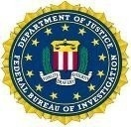

Although historically a large number of criminal defendants enter a plea of guilty prior to trial, the United States Attorneys must always fully investigate the crime, prepare the charging document, and be ready to go to trial. Consistent preparation for trial minimizes the risk of dismissal for noncompliance with the Speedy Trial Act and strengthens the government’s position in negotiations with defense counsel for a guilty plea. Pre-trial discovery practice also strengthens the government’s position. When a guilty plea is not obtainable, a trial becomes necessary. The United States Attorneys then present factual evidence to the jury, or to the judge in a non-jury (bench) trial. If the defendant is convicted, the United States Attorneys must prepare and present evidence at the defendant’s sentencing hearing and then defend the conviction at post-trial hearings and appeals. The USAOs handle most criminal appeals at the intermediate appellate level. After filing an appeal brief, the United States Attorneys may be required to participate in oral arguments before the United States Courts of Appeals. If there is a further appeal, the United States Attorneys may be called upon to assist the Solicitor General in preparing the case for review by the United States Supreme Court.

CIVIL LITIGATION

The United States Attorneys initiate civil actions, referred to as affirmative litigation, to assert and protect the interests of the United States. They also defend the interests of the government in lawsuits filed against the United States, referred to as defensive civil litigation. In other civil cases, the United States is a third party, a creditor, or an intervener.

Examples of affirmative litigation include civil actions brought to: enforce the nation’s environmental, admiralty, and civil rights laws; represent the government’s interests in bankruptcy actions; recoup money and recover damages resulting from federal program and other fraud; and enforce administrative summons and asset forfeiture litigation, which involve assets seized by federal, state, and local law enforcement.

Defensive litigation includes tort suits brought by those who allege suffering as a result of government action, adjudication of Social Security disability claims, alleged contract violations, habeas corpus petitions, and race, sex, and age discrimination actions. The USAOs represent and defend the government in its many roles – employer, regulator, law enforcer, medical care provider, revenue collector, contractor, procurer, property owner, judicial and correctional system manager, and as administrator of federal benefits. In those cases where the United States is sued, the Department of Justice must be its representative.

Civil defensive work is unique because it is non-discretionary and non-delegable. Unlike criminal divisions or sections, civil units of USAOs cannot employ “declination” criteria to manage or reduce the civil defensive caseload. All cases filed against the government, its agencies, and employees in their official capacities must be defended.

CRIMINAL AND CIVIL APPEALS

Appeals are generally very time-consuming, requiring a thorough review of the entire record in the case, the filing of a brief and reply brief, and, in most cases, participation in oral argument requiring travel to the city where the United States Courts of Appeals for the circuit is located. Furthermore, the complexity of appellate work and the time required to handle that work increases when convictions are based on complex facts, such as those found in organized crime drug enforcement and other narcotics cases, financial institution fraud, other organized crime, armed career criminal, public corruption, health care fraud, and computer fraud cases.
The appellate workload of the United States Attorneys fluctuates due to additional appeals prompted by Supreme Court rulings, legislative changes, and changes under the U.S. Sentencing Guidelines. In FY 2006, for example, the Supreme Court held that the Sixth Amendment right to jury trial applied to factual findings supporting certain sentencing enhancements under the U.S. Sentencing Guidelines, and that the Guidelines are advisory instead of mandatory. As a result, post-sentencing motions filed by incarcerated defendants increased by more than 10 percent for approximately two years.

CRIMINAL AND CIVIL DEBT COLLECTION

USAOs are responsible for collecting both criminal and civil debt for the U.S. Government. Each USAO has a Financial Litigation Unit (FLU) with the responsibility for both criminal and civil debt collection activities. In addition to the FLUs, USAOs have Affirmative Civil Enforcement staff devoted to the collection of civil debts.

Debts are ordered to be collected from a criminal defendant when the defendant is sentenced by the court. These debts may be in the form of restitution to victims of crime, fines imposed by the court to penalize criminals, special assessments on each criminal conviction count, costs of prosecution and other costs, or forfeitures of appearance bonds. Interest may also be collected in certain cases. In instances where restitution is ordered, the USAOs are involved in collecting federal restitution payments, or restitution which is owed to the United States, and in collecting non-federal restitution, or that which is owed to private individuals and entities. As a result of the Mandatory Victims Restitution Act (MVRA), courts now must impose monetary restitution orders in all violent crimes and most property crimes. United States Attorneys are required to enforce restitution orders on behalf of all victims of federal crimes.

The U.S. Attorneys are also the legal representatives for other federal agencies to pursue repayment of debts. For example, when federal agencies lend money and the recipients default on repayment of the loans, or when federal agencies have paid on guaranteed loans and have not been repaid as provided for in the lending agreement, United States Attorneys pursue the repayment of debt. The Departments of Agriculture, Education, Health and Human Services, Housing and Urban Development, Transportation, Veterans Affairs, and the Small Business Administration are some of these client agencies. United States Attorneys file suit to obtain judgments to collect debts, foreclose on real property, compel physicians to repay or fulfill their commitment to the Public Health Service in return for education grants, sue to set aside fraudulent transfers of property which could be used to satisfy defaulted loans, and manage debtor repayment schedules. The below table illustrates the significant return of debts collected in the last six years:
••• Debt Collection at a Glance •••

In FY 2010, the USAOs collected $6.68 billion of criminal and civil debts owed. Of the total debts collected, USAOs recovered:
(1) $2.84 billion in criminal debts; and
(2) $3.84 billion in civil debts.

The United States Attorneys’ collection efforts, handled by a very small percentage of the total workforce, returns to the Treasury over three times the $1.93 billion appropriated in the FY 2010 budget for the entire U.S. Attorney community.

Debt Collection Chart (in billions)
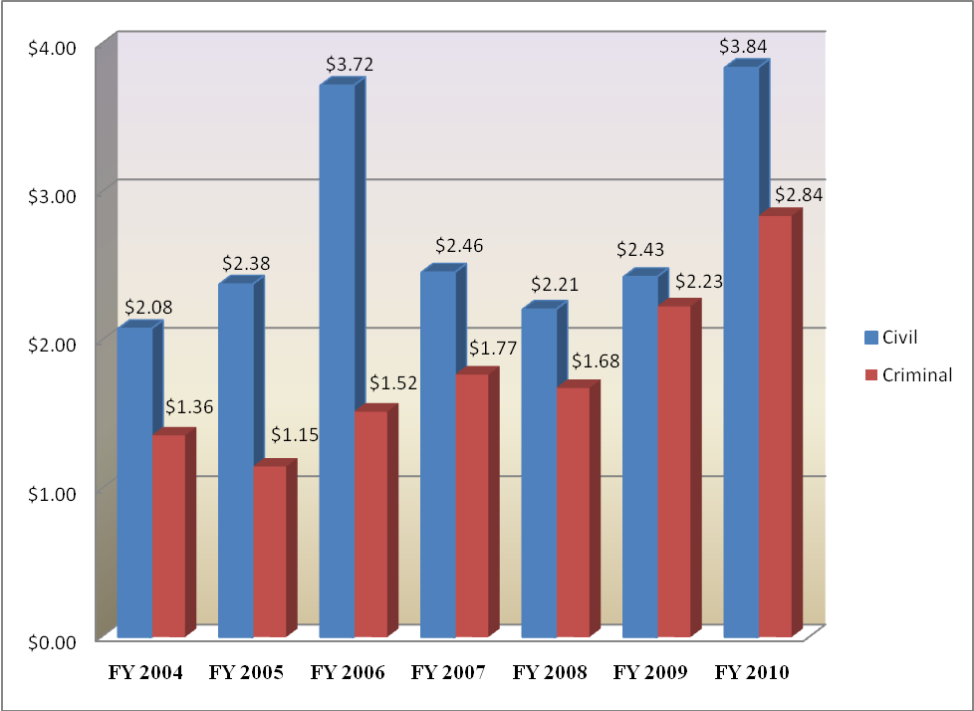

In FY 2010, the USAOs collected $6.68 billion of criminal and civil debts owed. Of the total debts collected, USAOs recovered: (1) $2.84 billion in criminal debts; and (2) $3.84 billion in civil debts. The United States Attorneys’ FY 2010 collection efforts, handled by a very small percentage of the total workforce, returned to the Treasury over three times the $1.93 billion appropriated in the FY 2010 budget for the entire United States Attorney community.
B. Issues, Outcomes, and Strategies

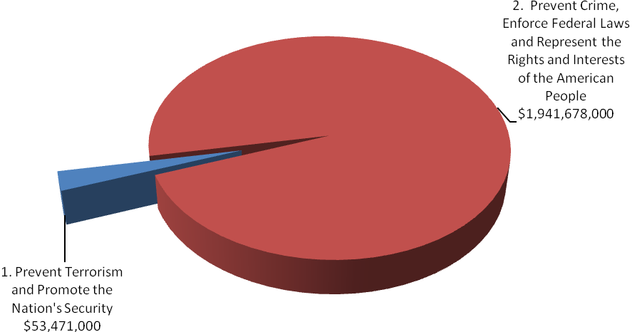

FY 2012 Total Request by DOJ Strategic Goal

The following is a brief summary of the Department’s Strategic Goals and Objectives in which the United States Attorneys play a role.

DOJ Strategic Goal 1: Prevent Terrorism and Promote the Nation’s Security ($53,471,000)

● Prosecute those who have committed, or intend to commit, terrorist acts in the United States (1.3).

DOJ Strategic Goal 2: Prevent Crime, Enforce Federal Laws and Represent the Rights and Interests of the American People ($1,941,678,000)

● Reduce the threat, incidence, and prevalence of violent crime (2.2).
● Prevent, suppress, and intervene in crimes against children (2.3).
● Reduce the threat, trafficking, use, and related violence of illegal drugs (2.4).
● Combat public and corporate corruption, fraud, economic crime, and cybercrime (2.5).
● Uphold the civil and constitutional rights of all Americans (2.6).
● Vigorously enforce and represent the interests of the United States in all matters over which the Department has jurisdiction (2.7).

C. Full Program Costs

This request will fund the strategies that support the United States Attorneys’ objectives. We will continue to provide federal leadership in preventing and controlling crime and seeking just punishment of those guilty of unlawful behavior.

FY 2012 Budget Request by Decision Unit
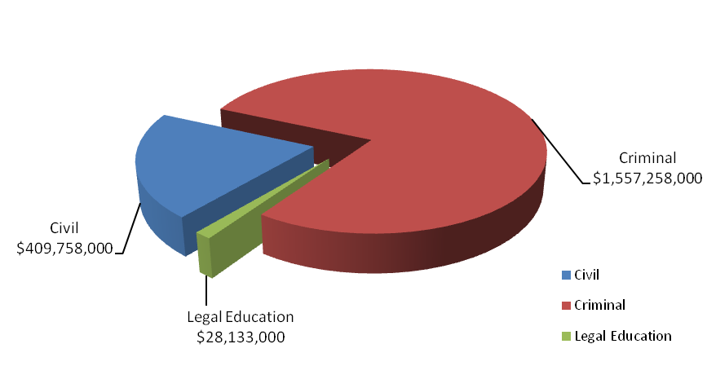
The United States Attorneys’ $1,995,149,000 budget request for FY 2012 is divided into three decision units: criminal, civil, and legal education. Some programs, as well as management and administration costs, cross decision units. Both performance and resource tables within each decision unit define the total costs of achieving the strategies the United States Attorneys will employ in FY 2012. The various resource and performance charts incorporate the costs of lower level strategies which also contribute to the achievement of objectives, but which may not be highlighted in detail in order to provide a concise narrative. Also included are the indirect costs of continuing activities, which are central to the operations of each decision unit.

D. Performance Challenges

The challenges that impede progress toward the achievement of agency goals are complex and ever-changing. National priorities were shifted after September 11th as resources and personnel were redirected to prosecute the Global War on Terror, impacting everyone in the law enforcement and intelligence community. Illegal immigration and border security have also become key components of the Nation’s counterterrorism strategy. Federal prosecution of border crime is now a critical part of our Nation’s defense. Additionally, the current economic climate requires that the United States Attorney community focus attention on ever increasing mortgage and financial fraud, and bankruptcy cases. Internal agency dynamics, policy decisions, technological developments, and criminal behavior are factors that broadly impact law enforcement practices and pose challenges that demand attention.

Between FY 2004 and FY 2006, the United States Attorneys made a concerted effort to become more fiscally efficient. During these years, the United States Attorneys implemented several cost savings measures including:

- Reducing video and data telecommunication lines
- Better utilization of online law library services rather than hard copies
- Limiting ordering of real time or hourly transcripts and translation services
- Reducing travel

These cost saving measures ensured solvency during those difficult budget years. Though these cost saving measures were successful, and continue to be implemented today, the United States Attorney community continues to strive to be a more fiscally efficient organization. Since FY 2007, the United States Attorneys have implemented several additional cost savings initiatives including:

- Bulk purchasing of toner
- Consolidated purchasing of cell phones/PDAs
- Introduction of an EVoIP system
- Establishment of the Litigation Technology Service Center (LTSC) at the NAC in Columbia, S.C.

Between FY 2004 and FY 2006, criminal cases pending, or what could be considered as “backlog”, increased by 11 percent. Additionally, in the civil area, new cases filed decreased by 4.5 percent and the number of civil affirmative cases filed decreased by 21 percent between FY 2003 and FY 2006.

In FY 2008 and FY 2009, the U.S. Attorney community began an aggressive hiring campaign to fill vacancies. USAOs are taking the necessary management steps to restructure the workforce by backfilling positions with lower salaried employees thereby filling more positions. At the end of FY 2009, only 300 positions were left unfilled.

As positions were filled, workload statistics improved. By the end of FY 2008 (with higher on-board levels), criminal cases filed increased by 7.4 percent over the FY 2006 total; total cases pending increased by just one percent. Additionally, civil affirmative cases filed between the beginning of FY 2007 and the end of FY 2008 increased 21.5 percent. In FY 2010, the USAOs continued to fill vacant positions thereby increasing the number of criminal and civil cases filed. The United States Attorneys continue to implement cost saving measures that contribute to meeting its financial goals.

External Challenges

A highly skilled, dynamic workforce is more important now than ever before. Since
September 11th, USAOs have taken on more responsibilities in new areas. AUSAs coordinate with state, local, and federal agencies in preventing, investigating, and prosecuting terrorist acts. Furthermore, AUSAs participate in disaster planning and emergency preparedness. These coordination activities involve non-traditional roles for AUSAs and present challenges as we continue combating terrorism.

Coordination with federal, state, and local agencies is not unique to combating terrorism. USAOs are actively involved in these activities in program areas such as border enforcement/prosecution, gun violence reduction, disrupting and dismantling drug organizations, and child exploitation. In the border enforcement and prosecution area, additional Border Patrol Agents are resulting in substantial increases in misdemeanor cases requiring even closer coordination with the U.S. Marshals Service, the Office of the Detention Trustee, the Bureau of Prisons, the Department of Homeland Security, the Courts and the local defense bar concerning the availability of bed space, prisoner transport, and translators for those who are detained.

In addition, the economy and emerging criminal activities, many of which are often driven by technology such as cybercrime, are external challenges beyond our control. Downturns in the economy often correlate with increases in criminal activity. As a result of the recent economic climate, the number of active FBI mortgage fraud investigations has tripled in the last three years. In addition, financial institutions have reported a record number of mortgage fraud cases to the Treasury Department — 10 times the number reported in 2001-2002. The reports document billions of dollars in losses. Furthermore, the Housing and Urban Development Inspector General anticipates a greatly increased mortgage fraud caseload based on the new broadened standards for obtaining FHA-backed loans. Inevitably, these investigations will result in more referrals for prosecution to the USAOs throughout the country.

We will continue to focus on areas within our spheres of influence and control, concentrating on coordination efforts with federal, state, and local agencies, and ensuring our workforce is trained for emerging and complex issues.

Internal Challenges

One internal challenge to the United States Attorney community is keeping the workforce flexible and adaptable. Over the past few years, terrorism, corporate fraud, violent crime and gangs, immigration, internet-related crime, and child exploitation have emerged as important national priorities. The United States Attorney community needs to be able to shift resources to respond to changes in case type and case load. The United States Attorneys have developed an effective allocation process that distributes new positions and funding to districts with the greatest demonstrated need. Necessary training is provided through the National Advocacy Center (NAC) to ensure that attorneys and support staff have the necessary expertise in these areas. Regular reviews and monitoring of case work and USAOs’ needs are essential to continued responsiveness.

Another related internal challenge is the need to restructure the workforce and to grapple with the upcoming “brain drain” as Baby Boomers reach retirement age. Several years of using the tool provided by the Voluntary Early Retirement (VERA)/Voluntary Separation Incentive Payment (VSIP) authority have allowed offices to reallocate resources.

II. Summary of Program Changes

For FY 2012, the United States Attorneys’ budget request is $1,995,149,000, which includes total program changes of ($1,186,000). The following changes are outlined in the chart below:

Item Name | Description |  |  |  | Page
Item Name | Purpose | Pos. | FTE | Dollars ($000) | Page
Enhanced Data Analysis | The requested increase will be used to analyze data to identify and assess cost-effective crime reduction strategies, thereby ensuring that law enforcement investigations are conducted in a manner that leads to strong case presentation and results in effective prosecutions. |  |  | 2,000 | 46
Administrative Efficiencies | Achieve increased efficiencies and cost savings by reducing spending on various administrative items, such as printing, publications, travel, conferences, supplies, and general equipment. |  |  | (1,999) | 49
Extend Technology Refresh | Realize savings by extending the refresh rate of desktops and laptops by one year. |  |  | (987) | 50
Reduce Physical Footprint | Achieve cost savings from the consolidation of regional offices, thereby reducing the number of locations. This offset only applies to rent, and does not include staff reductions. |  |  | (200) | 51
TOTAL |  |  |  | (1,186)

THIS PAGE INTENTIONALLY LEFT BLANK

III. Appropriations Language and Analysis of Appropriations Language

Appropriations Language

SALARIES AND EXPENSES, UNITED STATES ATTORNEYS

For necessary expenses of the Offices of the United States Attorneys, including inter-governmental and cooperative agreements, 1,995,149,000: Provided, That of the total amount appropriated, not to exceed $8,000 shall be available for official reception and representation expenses: Provided further, That not to exceed $25,000,000 shall remain available until expended.

Note – A full year 2011 appropriation for this account was not enacted at the time the budget was prepared; therefore, this account is operating under a continuing resolution (P.L. 111-242, as amended). The amounts included for 2011 reflect the annualized level provided by the continuing resolution.

Analysis of Appropriations Language

No substantive changes proposed.

Note: – The FY 2012 President’s Budget uses the FY 2011 President’s Budget language as a base so all language is presented as new.

THIS PAGE INTENTIONALLY LEFT BLANK

IV. Decision Unit Justification

- CRIMINAL

Criminal Litigation | Perm. Pos. | FTE | Amount
2010 Enacted | 8,424 | 8,368 | 1,507,210,000
2011 Current Rate | 8,424 | 8,368 | 1,507,210,000
Adjustments to Base | 47 | 138 | 50,953,000
2012 Current Services | 8,471 | 8,506 | 1,558,163,000
2012 Program Increases | 0 | 0 | 1,580,000
2012 Program Offsets | 0 | 0 | (2,485,000)
2012 Request | 8,471 | 8,506 | 1,557,258,000
Total Change 2010-2012 | 47 | 138 | $50,048,000

Criminal Litigation—Information Technology Breakout (of Decision Unit Total) | Perm. Pos. | FTE | Amount
2010 Enacted | 325 | 325 | $137,705,000
2011 Current Rate | 325 | 325 | 134,034,000
Adjustments to Base | 0 | 0 | 3,485,000
2012 Current Services | 325 | 325 | 137,519,000
2012 Program Increase | 0 | 0 | 0
2012 Request | 325 | 325 | 137,519,000
Total Change 2010-2012 | 0 | 0 | ($186,000)
Information Technology (IT) Breakout above correspond to the IT resources associated with the United States Attorneys’ direct appropriation.

1. Program Description–Criminal Decision Unit

The USAOs investigate and prosecute the vast majority of criminal cases brought by the federal government—with a more diverse and complex workload than ever before. For example, criminal caseloads include: international and domestic terrorism, illegal immigration, mortgage and disaster relief fraud, youth violence, firearms and gangs, child exploitation and obscenity, complex and time consuming white collar and health care fraud, financial institution and computer fraud, environmental crime, public corruption and organized crime, drug enforcement, civil rights violations, human trafficking and cases involving multiple defendants and international organizations.

The USAOs receive most of their criminal referrals, or "matters," from federal investigative agencies or become aware of criminal activities in the course of investigating or prosecuting other cases. They also receive criminal matters from state and local investigative agencies, as well as those reported to the USAOs by citizens. After careful consideration of each criminal matter, the United States Attorney decides the appropriateness of bringing criminal charges and initiates prosecution.
Criminal Workload
FY 2010 Cases Filed – 68,591

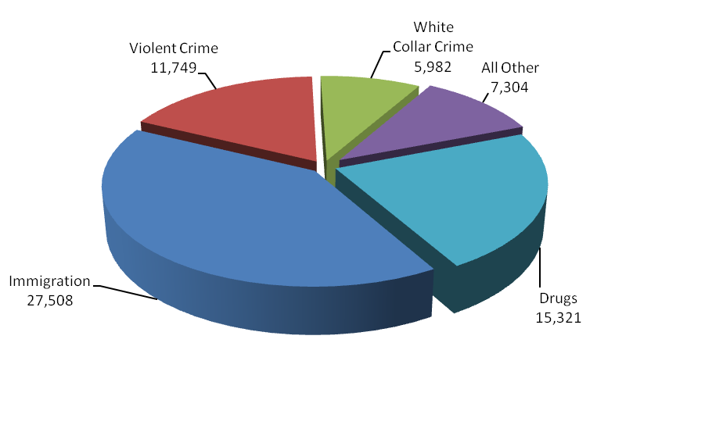
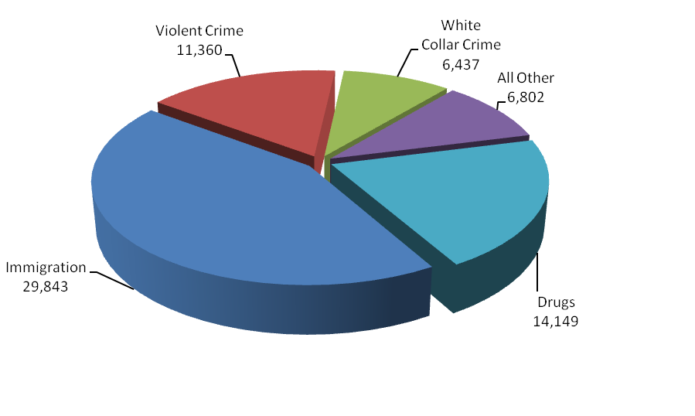
During FY 2010 the USAOs filed 68,591 criminal cases against 91,047 defendants in United States District Court. The number of new cases filed increased by 14 percent from FY 2005 to
FY 2010 – rising from 60,062 cases to 68,591.

A total of 67,697 cases against 88,369 defendants were closed during FY 2010. Of the 88,369 defendants whose cases were closed, 93 percent or 81,934, either pled guilty or were found guilty. Of these, 66,275 received prison sentences, and 182 guilty defendants received sentences of life imprisonment. The rate of convicted defendants who received prison sentences has consistently exceeded 80 percent over the last 11 years.
2. Performance Tables

3. Performance, Resources, and Strategies

The Criminal Decision Unit contributes to the Department’s Strategic Goal I: Prevent Terrorism and Promote the Nation’s Security. Within this goal, the decision unit’s resources address the Department’s Strategic Objective: 1.3 - Prosecute those who have committed, or intend to commit, terrorist acts in the United States.

The Criminal Decision Unit also contributes to Goal II: Prevent Crime, Enforce Federal Laws and Represent the Rights and Interests of the American People. Within this goal, the decision unit’s resources address five of the Department’s Strategic Objectives: 2.2 - Reduce the threat, incidence, and prevalence of violent crime; 2.3 - Prevent, suppress, and intervene in crimes against children; 2.4 - Reduce the threat, trafficking, use, and related violence of illegal drugs; 2.5 - Combat public and corporate corruption, fraud, economic crime, and cybercrime; 2.6 - Uphold the civil and constitutional rights of all Americans; and 2.7 - Vigorously enforce and represent the interests of the United States in all matters for which the Department has jurisdiction.

a. Performance Plan and Report for Outcomes

In the criminal area, the performance measure for the U.S. Attorneys is the percentage of criminal cases favorably resolved.

Criminal Cases Favorably Resolved

The USAOs handle the majority of criminal cases prosecuted by the Department of Justice, most of which are received as criminal referrals from federal investigative agencies, including the FBI, DEA, ATF, ICE, and the United States Secret Service. Criminal referrals may also be received from state and local investigative agencies or U.S. Attorneys may become aware of criminal activities in the course of investigating or prosecuting other cases.

The United States Attorneys are called upon to respond to changing priorities and to become involved in specific crime reduction programs. After the events of September 11, 2001, the number one priority of the U.S. Attorneys became the prevention of terrorist acts and the investigation and prosecution of those involved in terrorist attacks. More recently, Southwest Border enforcement – responding to the enormous number of illegal aliens crossing the Southwest Border into the U.S. – has become critical. The United States Attorneys continue to address the illegal use of firearms by those who commit crimes and accompanying acts of violence in our communities. Drug prosecutions remain a priority of the United States Attorneys as well, with particular emphasis on the operations of large drug organizations. Furthermore, child exploitation cases and mortgage and other financial fraud are also among the priorities.

The performance measure for criminal litigation relates to the percentage of criminal cases favorably resolved. In FY 2010, cases involving 81,934 defendants were favorably resolved, resulting in 92.7 percent criminal cases favorably resolved. This outcome surpassed the 90 percent goal by almost three percent.

b. Strategies to Accomplish Outcomes

In FY 2012, the U.S. Attorneys will continue to place a high priority on prosecution and security efforts in the war on terror as well as addressing other important priorities such as mortgage and financial fraud, identity theft, white collar fraud, immigration, child exploitation, violent crime and gangs, cybercrime and intellectual property and drug trafficking. Other strategies include:

- Ensuring sufficient resources are allocated to meet the caseloads, especially focusing on priority areas.
- Restructuring the workforce by backfilling positions with lower salaried employees.
- Regular reviews and monitoring of case and workload data.
- Leveraging technology to improve efficiency and enhance information flow organization-wide and with our partners.
- Expanded training at the NAC to address substantive new areas as well as leadership and management.

B. CIVIL

Civil Litigation | Perm. Pos. | FTE | Amount
2010 Enacted | 2,155 | 2,231 | $399,338,000
2011 Current Rate | 2,155 | 2,231 | 399,338,000
Adjustments to Base | 0 | 0 | 10,656,000
2012 Current Services | 2,155 | 2,231 | 409,994,000
2012 Program Increases | 0 | 0 | 420,000
2012 Program Offsets | 0 | 0 | (656,000)
2012 Request | 2,155 | 2,231 | 409,758,000
Total Change 2010-2012 |  |  | $10,420,000

Civil Litigation—Information Technology Breakout (of Decision Unit Total) | Perm. Pos. | FTE | Amount
2010 Enacted | 95 | 95 | $36,721,000
2011 Current Rate | 95 | 95 | 35,742,000
Adjustments to Base | 0 | 0 | 930,000
2012 Current Services | 95 | 95 | 36,672,000
2012 Program Increase | 0 | 0 | 0
2012 Request | 95 | 95 | 36,672,000
Total Change 2010-2012 | 0 | 0 | ($49,000)
Information Technology (IT) Breakout above correspond to the IT resources associated with the United States Attorneys’ direct appropriation.

1. Program Description–Civil Decision Unit

Civil litigation pursued by the United States Attorneys falls into two basic categories: (1) affirmative civil litigation, in which the United States is the plaintiff; and (2) defensive civil litigation, in which the United States is the defendant. Affirmative civil litigation cases are actions taken by U.S. Attorneys to assert and protect the government’s interests. They include such issues as the enforcement of the nation’s environmental, admiralty, and civil rights laws, as well as the recovery of damages done to the government through fraud. U.S. Attorneys also use affirmative civil litigation to recoup money owed and recover damages done to the government. Defensive civil litigation cases are lawsuits brought against the government by those who allege suffering due to government actions, and they include such issues as the adjudication of Social Security disability claims, alleged contract violations, and alleged race, sex, and age discrimination. The U.S. Attorneys may also be called upon to represent the United States in cases which are not clearly defined as either affirmative or defensive civil litigation, but in which the government has an interest, such as bankruptcy cases in which the United States is a party. One key difference between affirmative and defensive civil litigation is that while U.S. Attorneys have some discretion in deciding which affirmative civil cases they will pursue, U.S. Attorneys must defend the government in all defensive civil litigation.

Affirmative civil cases can return substantial monies to the federal Treasury. In FY 2010, USAOs collected $3.9 billion in civil debts. For example, the USAO in the Eastern District of Virginia reached a settlement with Massachusetts-based EMC Corporation in which the company paid $87.5 million to resolve allegations that the information technology company violated the False Claims Act and the federal Anti-kickback Act. The United States alleged that EMC misrepresented its commercial pricing practices causing the General Services Administration (GSA) to enter into a contract with prices that were higher than they would have been had the information company not made false representations. The United States also alleged that the company engaged in an illegal kickback scheme to influence the government to purchase the company’s products.

Civil matters and cases represent a significant part of the U.S. Attorneys’ workload. In FY 2010, U.S. Attorneys received 92,198 civil matters, which represented 36 percent of all of the 252,894 criminal and civil matters received during the fiscal year. Of the civil matters received, 72 percent or 66,418 were defensive matters, 10,063 or 11 percent were affirmative matters, and 15,717 or 17 percent were other civil matters. The United States Attorneys filed or responded to 83,599 civil cases in FY 2010, which represented 55 percent of the 152,190 criminal and civil cases filed during the fiscal year. Of the civil cases filed, 65,678 or 79 percent were defensive cases; 5,297 or 6 percent were affirmative cases; and 12,624 or 15 percent were other civil cases.

Civil Workload
FY 2010 Cases Filed/Responded To – 83,599
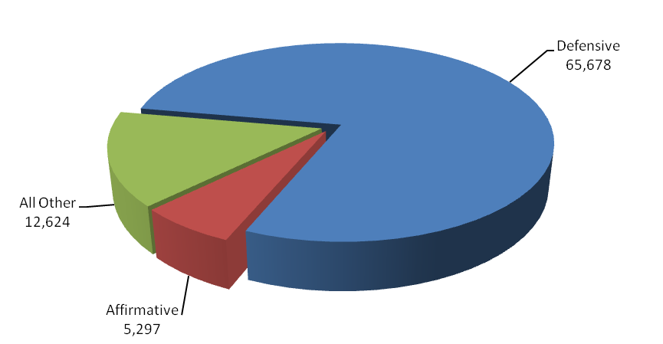

Between FY 2004 and FY 2010, the number of civil cases filed or responded to increased by
7 percent or 5,796 - from 77,803 cases to 83,599, and the number of civil cases referred to U.S. Attorneys increased by 7 percent or 5,882 - from 86,316 in FY 2004 to 92,198 cases in FY 2010. The number of defensive civil cases filed increased by 27 percent or 13,796 - from 51,882 cases in FY 2004 to 65,678 in FY 2010. A change in the interpretation of the U.S. Sentencing Guidelines in January 2005 increased the number of defensive civil cases filed between FY 2006 and FY 2010.

In FY 2010, 95.4 percent of all judgments in affirmative civil cases were in favor of the United States, the highest favorable judgment rate of all case classes. Through affirmative litigation, the U.S. Attorneys collected $3.8 billion in civil debts owed to the United States, which is more than the U.S. Attorneys’ entire FY 2010 budget.

THIS PAGE INTENTIONALLY LEFT BLANK

2. Performance Tables

3. Performance, Resources, and Strategies

The Civil Decision Unit contributes to the Department’s Strategic Goal II: Prevent Crime, Enforce Federal Laws and Represent the Rights and Interests of the American People. Within this goal, the Civil Decision Unit’s resources specifically address two of the Department’s Strategic Objectives: 2.6 - Uphold the civil and Constitutional rights of all Americans, and 2.7 - Vigorously enforce and represent the interests of the United States in all matters for which the Department has jurisdiction.

a. Performance Plan and Report for Outcomes

Prosecution of civil litigation is an essential and vital component of the mission of the U.S. Attorneys. Civil cases prosecute fraud, waste, and abuse in federal programs and ensure that the government is fully compensated for the losses and damages caused by those who have enriched themselves at the government’s expense. In addition, all lawsuits filed against the government must be defended. U.S. Attorneys represented the government in 65,698 defensive civil cases that were filed in court during FY 2010. The U.S. Attorneys’ successes in civil litigation preserve taxpayer dollars and uphold the requirements and intent of federal laws and programs.

The performance measure for civil litigation relates to the percentage of judgments and settlements resolved in favor of the government. The target for FY 2010 was 80 percent and the actual figure was 81.9 percent.

b. Strategies to Accomplish Outcomes

The two biggest challenges for U.S. Attorneys are to maintain a high favorable resolution rate with existing resources and for employees, AUSAs in particular, to adjust to the increased use of technology in the practice of law. Technology is providing a means to increase productivity with existing resources. However, civil cases are increasingly “electronic” – meaning that technology plays a major role in areas such as electronic filing and E-Discovery. Some AUSAs and support staff have difficulty making the transition to these different approaches. Technical training and hiring employees with the appropriate skill sets are both part of the U.S. Attorneys’ strategy for the successful furtherance of our mission.

C. LEGAL EDUCATION

Legal Education | Perm. Pos. | FTE | Amount
2010 Enacted | 50 | 49 | $27,455,000
2011 Current Rate | 50 | 49 | 27,455,000
Adjustments to Base | 0 | 1 | 723,000
2012 Current Services | 50 | 50 | 28,178,000
2012 Program Offsets | 0 | 0 | (45,000)
2012 Request | 50 | 50 | 28,133,000
Total Change 2010-2012 | 0 | 1 | $678,000

Legal Education —Information Technology Breakout (of Decision Unit Total) | Perm. Pos. | FTE | Amount
2010 Enacted | 23 | 23 | $9,180,000
2011 Current Rate | 23 | 23 | 8,936,000
Adjustments to Base | 0 | 0 | 232,000
2012 Current Services | 23 | 23 | 9,168,000
2012 Program Increase | 0 | 0 | 0
2012 Request | 23 | 23 | 9,168,000
Total Change FY 2010- FY 2012 | 0 | 0 | ($12,000)
Information Technology (IT) Breakout above correspond to the IT resources associated with the United States Attorneys’ direct appropriation.

1. Program Description–Legal Education

The Office of Legal Education (OLE) develops, conducts, and authorizes the training of all federal legal personnel [28 C.F.R. §0.22 (1990)]. OLE coordinates legal education and attorney training for the Department of Justice and other departments and agencies of the Executive Branch. Virtually all of OLE’s classroom training is conducted at the National Advocacy Center (NAC), a premier federal training facility in Columbia, South Carolina. The NAC features an integrated instructional and residential facility augmented by a conference and research center with student and support services on site.

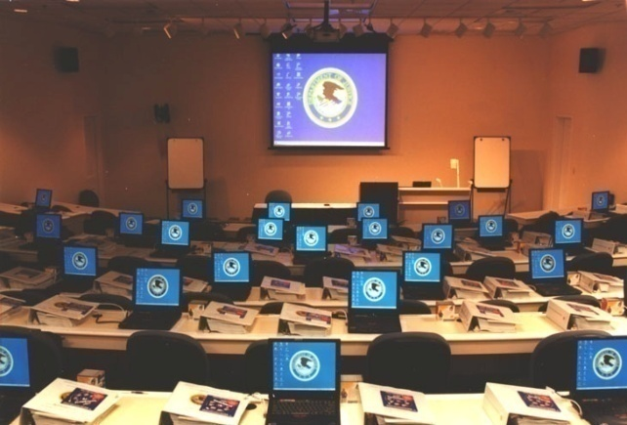
In FY 2010, OLE was responsible for the management of 329 events at the NAC, including 276 classroom events, such as traditional advocacy training, national conferences, seminars, symposia and educational forums on substantive areas of the law. In FY 2010, approximately 24,620 individuals were trained, of which 18,005 attended live training through courses or other events hosted by OLE and 6,615 individuals received training through one of OLE’s distance education offerings, including continuing legal education programs broadcast via satellite, video-on-demand, and other means. Eighty-four percent of the 24,620 individuals, or approximately 20,681, were Justice Department employees in legal positions, while the other 16 percent or 3,939 were non-Justice employees in legal positions with various federal agencies or state and local government. More than 6,065 individuals receiving training at the NAC attended courses in areas covered in the Department’s Strategic Plan, including Fraud and Cybercrime, Crimes Against Children, Anti-Terrorism, Violent Crime/Gun Violence Reduction, Drug Enforcement, Official Corruption, Bankruptcy and Sound Management.

In FY 2007, OLE introduced Video on Demand (VOD), permitting users to view OLE programming “on demand” at their desktop. OLE continued to add new content to its VOD library accessed through JUSTLearn, and there are currently more than 934 programs available, including training videos on Advocacy Skills, Brady/Giglio, E-Discovery, Emergency Management and Crisis Response, and a New Employee Orientation video containing all of the mandatory programs new DOJ employees must view. In FY 2010, approximately 114,486 DOJ employees accessed the VOD library, viewing available videos more than 230,497 times. The “Week in Review” (WIR), a weekly series of news clips highlighting the accomplishments of the USAOs nationwide, continues to be among the more popular VOD offering with 28,607 viewers in FY 2010, up from the 22,320 viewers in FY 2007. Another new feature allows Training Officers to record in JUSTLearn other training events such as a group viewing of a Justice Television Network (JTN) show or VOD show, online courses, district-wide training, self-study, and college courses.

••• PARTNERS IN LEGAL EDUCATION •••

The Publications Unit of the Office of Legal Education edits and publishes the United States Attorneys’ Manual, the United States Attorneys’ Bulletin, and a number of practical skills manuals. OLE’s Publications Unit remained busy in FY 2010 with the publication of six editions of the United States Attorneys’ Bulletin on a variety of topics, including Economic Espionage, Expert Witnesses, Project Safe Neighborhoods, and Mortgage Fraud, all of which are accessible on the Department of Justice intranet website. The Publications Unit continued to maintain and update the USABook Online Library, which has now grown to include hundreds of policy manuals, textbooks, and monographs and has become a federal practice encyclopedia. In FY 2010, the USABook site experienced nearly 2.58 million page views.

OLE initiated the JTN during FY 2001. Justice Television Network is a satellite-based system that provides training and news to the 94 USAOs, as well as branch offices. The JTN schedule includes 40 hours of programming each week, and a 15 hour "re-feed" to the West Coast each workday. In FY 2010, OLE provided 1,826 hours of programming through JTN. In an effort to enhance its distance learning options for USAOs, OLE developed new training modules on Accounting Fraud, Managing the E-Discovery Process, Introduction to FOIA, and Securities Fraud, among others. A copy of each module was sent to every district in FY 2010 to be used for in-house training.

Continuing Legal Education (CLE) credit is provided through OLE for many OLE-sponsored courses. OLE is the primary source of instruction for Department of Justice attorneys and AUSAs from the 94 USAOs. Basic programs for newly hired attorneys include criminal, civil, and appellate advocacy; federal practice seminars; and specialty courses in priority substantive areas of the law. Advocacy skills programs are available to new and advanced trial attorneys. The Federal Practice Program is designed for attorneys with litigation experience who are new to the federal civilian legal system (e.g., former state and military prosecutors), and as continuing training for Department of Justice attorneys after the basic criminal, civil, and appellate advocacy courses. In FY 2010, OLE provided an additional 8,500 CLE programs to USAO and Department of Justice attorneys over the Internet through our contract with West Legal Ed.

OLE continued its tradition of providing training support to Department of Justice personnel assisting foreign prosecutors through the Criminal Division’s Office of Overseas Prosecutorial Development, Assistance and Training (OPDAT). OLE hosted briefings and tours of the NAC for visiting prosecutors from Mexico, Colombia, Zambia, and Moldova.

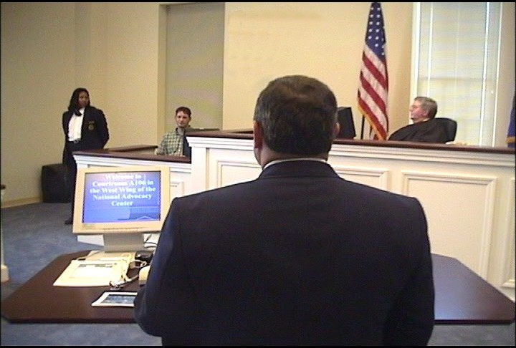
For all its programs, OLE uses experienced federal trial and appellate attorneys as instructors to present lectures, lead discussion groups, direct evidentiary exercises, and offer personalized critiques. Federal judges also participate in OLE's advocacy courses, presiding over mock trials and mock appellate arguments. The caliber of the OLE faculty and the use of sophisticated videotaping facilities provide students with unique training experiences in trial and appellate advocacy. A significant feature of the advocacy training is the use of "learn-by-doing" exercises which concentrate on courtroom skills. These exercises simulate courtroom activities and provide students with classroom critiques and individual video replay analysis. OLE is also meeting the demand for attorney management training for senior criminal and civil attorneys by providing management courses for attorney supervisors of all levels. Additionally, the recently formed Justice Leadership Institute provides leadership training to USAO attorney and support staff supervisors.

OLE conducts programs on federal, civil, and administrative law practices for attorneys in the Executive Branch, including those in the Department of Justice. OLE offers training in civil discovery and trial techniques; negotiation techniques; and administrative law areas such as bankruptcy, the Freedom of Information Act, ethics, environmental law, federal employment, regulatory processes, government contracts, legal research and writing for attorneys, management of attorneys, and computer crime. Course instruction emphasizes the realities of federal practice. Federal attorneys from every agency, including the Department of Justice, are participants as well as advisors, curriculum developers, lecturers, and instructors. Most instructors come from a cadre of federal prosecutors. On a few occasions, OLE also contracts with professional educators as instructors for these courses.

OLE develops and administers paralegal courses covering basic and advanced skills in civil, criminal, and appellate practice. Training for other support staff personnel (e.g., legal assistants, systems managers, Administrative Officers and Budget Officers) in USAOs is provided through OLE, which develops the curriculum and recruits instructors.

2. Performance Table

THIS PAGE INTENTIONALLY LEFT BLANK

3. Performance, Resources, and Strategies

The Legal Education Decision Unit contributes to the Department’s Strategic Goal I: Prevent Terrorism and Promote the Nation’s Security. Within this goal, the decision unit’s resources address three of the Department’s Strategic Objective: 1.3 - Prosecute those who have committed, or intend to commit, terrorist acts in the United States.

The Legal Education Decision Unit also contributes to Goal II: Prevent Crime, Enforce Federal Laws and Represent the Rights and Interests of the American People. Within this goal, the decision unit’s resources address five of the Department’s Strategic Objectives: 2.2 - Reduce the threat, incidence, and prevalence of violent crime; 2.3 - Prevent, suppress, and intervene in crimes against children; 2.4 - Reduce the threat, trafficking, use, and related violence of illegal drugs; 2.5 - Combat public and corporate corruption, fraud, economic crime, and cybercrime; 2.6 - Uphold the civil and constitutional rights of all Americans; and 2.7 - Vigorously enforce and represent the interests of the United States in all matters for which the Department has jurisdiction.

a. Performance Plan and Report for Outcomes

The performance measure for this decision unit is the number of students trained. In FY 2010, OLE sponsored classroom training and other live events for 18,005 students. In addition, approximately 6,615 students were trained via satellite, videotape, and other means, for a total of 24,620 students trained in FY 2010.
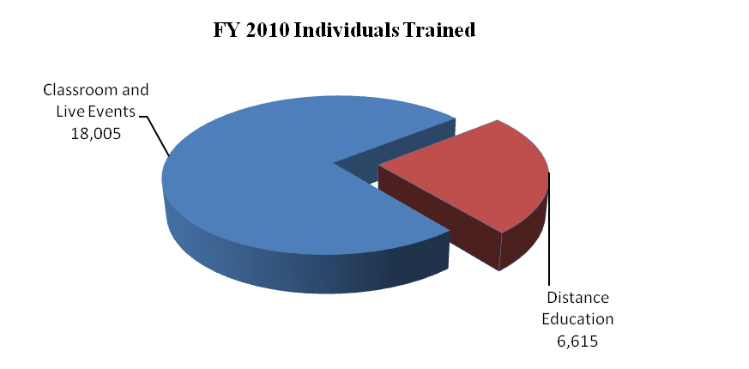
This compares with a total of 23,725 in FY 2009 – 16,624 students trained in-person and 7,101 students trained by satellite, videotape and other training. Eighty-four percent of the 24,620 individuals trained in-person was Department of Justice employees in legal positions while the other 16 percent were non-Department of Justice employees in legal positions with various federal agencies or state and local government. OLE anticipates training a total of 26,000 students in each of FYs 2011 and 2012 in combined classroom, satellite and other training.

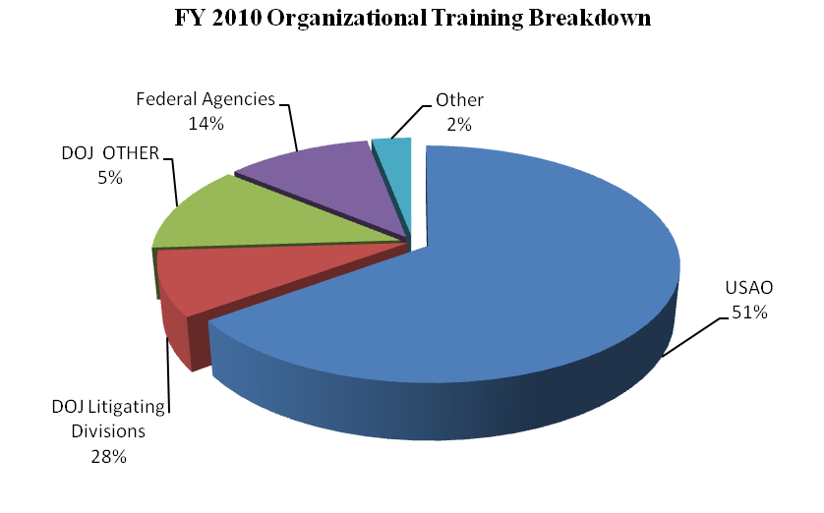
DOJ DIV = DOJ Litigative Divisions
DOJ BUREAUS = FBI, DEA, ATF, BOP, etc.
OTHER = State and Local
FED AGENCIES = DOD, HHS, DHS, USPS, etc.
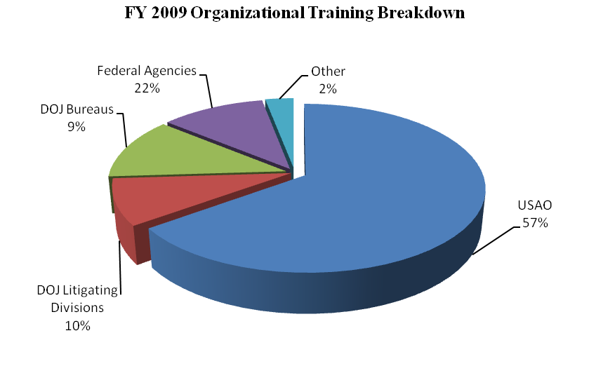

More than 6,065 individuals receiving training at the NAC attended courses in areas covered in the Department’s Strategic Plan, including Fraud and Cybercrime, Crimes Against Children, and Anti-Terrorism, Violent Crime/Gun Violence Reduction, Drug Enforcement, Civil Rights Enforcement, Official Corruption, Bankruptcy, and Sound Management.

Overall in FY 2010, OLE was responsible for the management of 329 events, including traditional advocacy training, national conferences, seminars, symposia, and educational forums on substantive areas of the law. During FY 2010, OLE expanded VOD and approximately 114,486 DOJ employees accessed the VOD library viewing available programs more than 230,497 times. There are now over 934 separate programs available through VOD. Additionally, during FY 2010, 2,151 people attended courses sponsored by OLE’s two training partners, the NDAA and the National Bankruptcy Training Institute.

b. Strategies to Accomplish Outcomes

The U.S. Attorneys will continue to ensure that high quality legal education is available for basic and advanced legal training through traditional classroom instruction and expanded use of JTN and distance learning. Enhanced training will be needed to support the request for terrorism and national security prosecutions, civil rights field enforcement, violent crime and gang prosecutions, cybercrime and intellectual property prosecutions and pharmaceutical drug diversion prosecution initiatives.

THIS PAGE INTENTIONALLY LEFT BLANK

V. Program Increases by Item

Item Name: Enhanced Data Analysis Program

Budget Decision Unit(s): Criminal and Civil Litigation

Strategic Goal(s) & Objective(s): Goals II: Promote the nation’s security and Prevent crime, enforce federal laws, and represent the rights and interests of the American people.
Objective: All

Component Ranking of Item: 1

Program Increase: Positions: 0 Attorney: 0 FTE 0 Dollars $2,000,000

Description of Item

The United States Attorneys’ request $2,000,000 in non-personnel resources to analyze data to identify and assess cost-effective crime reduction strategies. The additional funding will be used by the U.S. Attorneys to ensure that law enforcement investigations are conducted in a manner that leads to strong case presentation and results in effective prosecutions, thereby improving the effectiveness of all of the Department’s law enforcement activities. The requested enhancement will enable the U.S. Attorneys to work with the Bureau of Justice Statistics (BJS) and a broader community of interest to expand the use of data analysis techniques and to quantitatively assess the impacts of different crime reduction programs.

This funding will provide EOUSA the IT contractor resources needed to study and enhance current prosecutorial data collection capabilities, trend evaluations and performance matrix development. The EOUSA and United States Attorneys will work in close consultation with BJS in the analysis of their law enforcement data and crime statistics to better allocate and evaluate USAO prosecutorial resources.

Impact on Performance

This initiative will address Strategic Goal II.

Enhanced Data Analysis

Base Funding

FY 2010 Enacted |  |  |  | FY 2011 President’s Budget |  |  |  | FY 2012 Current Services
Pos | Agt/  Atty | FTE | Dollars | Pos | Agt/  Atty | FTE | Dollars | Pos | Agt/  Atty | FTE | Dollars
0 | 0 | 0 | $0 | 0 | 0 | 0 | $0 | 0 | 0 | 0 | $0

Personnel Increase Cost Summary

Type of Position | Modular Cost  per Position | Number of Positions Requested | FY 2012  Request | FY 2013  Net Annualization  (change from 2012)
Attorneys | N/A | N/A | N/A | N/A
Paralegal | N/A | N/A | N/A | N/A
Total Personnel | N/A | N/A | N/A | N/A

Non-Personnel Increase Cost Summary

Non-Personnel Item | Unit Cost | Quantity | FY 2012 Request | FY 2013 Net  Annualization  (Change from 2012)
Total Non-Personnel | N/A | N/A | $2,000,000 | $0

Total Request for this Item

 | Pos | Agt/Atty | FTE | Personnel | Non-Personnel | Total
Current Services | 0 | 0 | 0 | $0 | $0 | $0
Increases | 0 | 0 | 0 | $0 | $2,000,000 | $2,000,000
Grand Total | 0 | 0 | 0 | $0 | $2,000,000 | $2,000,000

VI. Program Offsets by Item

Item Name: Administrative Efficiencies

Budget Decision Unit(s): Criminal, Civil and Legal Education

Strategic Goal(s) & Objective(s): Goals I and II: Prevent terrorism, and promote the nation’s security and Prevent crime, enforce federal laws, and represent the rights and interests of the American people.
Objective: All

Component Ranking of Item: 1

Program Decrease: Positions: 0 Attorney: 0 FTE 0 Dollars ($1,199,000)

Description of Item

The Department is continually evaluating its programs and operations with the goal of achieving across-the-board economies of scale that result in increased efficiencies and cost savings. In FY 2012, the Department is focusing on areas in which savings can be achieved, which include, but are not limited to: printing, publications, travel, conferences, supplies, and general equipment. For U.S. Attorneys, these administrative efficiencies will result in an offset of $1,999,000. This reduction to administrative items will demonstrate that the Department plans to institute substantive efficiencies without unduly taxing either the people or the missions of DOJ.

Impact on Performance

This initiative will address Strategic Goal II.
The reduction in administrative expenditures is anticipated to have no adverse impact to United States Attorney operations.

Item Name: Extend Technology Refresh

Budget Decision Unit(s): Criminal, Civil and Legal Education

Strategic Goal(s) & Objective(s): Goals I and II: Prevent terrorism, and promote the nation’s security and Prevent crime, enforce federal laws, and represent the rights and interests of the American people.
Objective: All

Component Ranking of Item: 2

Program Decrease: Positions: 0 Attorney: 0 FTE 0 Dollars ($987,000)

Description of Item

As desktops and laptops are used primarily for basic office automation applications (e.g., spreadsheets and word processing), replacing this inventory at a slower rate is expected to have minimal impact on Department operations. In FY 2012, the Department is proposing to extend the refresh rate of all desktops and laptops by one year, resulting in an offset of $987,000 for the U.S. Attorneys.

Impact on Performance

This initiative will address Strategic Goal II.
The reduction in expenditures is anticipated to have no adverse impact to United States Attorney operations.

Item Name: Reduce Physical Footprint

Budget Decision Unit(s): Criminal, Civil and Legal Education

Strategic Goal(s) & Objective(s): Goals I and II: Prevent terrorism, and promote the nation’s security and Prevent crime, enforce federal laws, and represent the rights and interests of the American people.
Objective: All

Component Ranking of Item: 3

Program Decrease: Positions: 0 Attorney: 0 FTE 0 Dollars ($200,000)

Description of Item

In the current fiscal environment, it is imperative for DOJ to consider the best and most efficient use of existing resources, including whether the current geographic footprint of offices continues to make sense in an era of technology, which makes communication and outreach easier than ever before. In FY 2012, the Department is consolidating 44 of 1,165 sub-regional office locations (or 3.8 percent of all DOJ sub-regional offices), which will allow components to better utilize existing workspace, as well as enhance information sharing and the ability of regional offices to de-conflict efforts and reduce duplicative work. Components will also realize additional savings from the consolidation of facilities and operations services including maintenance, IT systems management, shipping, parking, and other related services. For the U.S. Attorneys, $200,000 in offset savings will be achieved through reductions to or consolidation of field office space. To minimize the impact on components’ operational capability, this offset applies only to GSA rent; staffing reductions are not proposed.

Impact on Performance

This initiative will address Strategic Goals I and II.
The reduction in field office expenditures is anticipated to have no adverse impact to United States Attorney operations.

VII. EXHIBITS

