United States Marshals Service
FY 2013 Performance Budget
President’s Budget Submission

Justice Prisoner and Alien Transportation System
Revolving Fund



February 2012

This page left intentionally blank
Table of Contents

I. Overview of the Justice Prisoner and Alien Transportation System (JPATS) 4
II. Appropriation Language and Analysis of Appropriations Language (N/A) 10
III. Decision Unit Justification 10
A. Justice Prisoner and Alien Transportation System 10
1. Program Description 10
2. Performance Tables 11
3. Performance, Resources, and Strategies 14

VI. Exhibits

A. Organizational Chart
B. Summary of Requirements
C. Program Increases/Offsets by Decision Unit (N/A)
D. Resources by DOJ Strategic Goal and Strategic Objective
E. Justification for Base Adjustments (N/A)
F. Crosswalk of 2011 Availability
G. Crosswalk of 2012 Availability (N/A)
H. Summary of Reimbursable Resources
I. Detail of Permanent Positions by Category
J. Financial Analysis of Program Increases/Offsets (N/A)
K. Summary of Requirements by Grade
L. Summary of Requirements by Object Class
M. Status of Congressionally Requested Studies, Reports, and Evaluations (N/A)
N. Information on Overseas Staffing (N/A)
O. Schedule of Aircraft

I. Overview of the Justice Prisoner and Alien Transportation System (JPATS)

A. Introduction

JPATS was created on October 1, 1995, by merging the United States Marshals Service (USMS) National Prisoner Transportation System and Immigration and Naturalization Service (INS) Air Transport Branch. This merger was based on an August 15, 1994 memorandum in which the Attorney General directed the consolidation (by FY 1996) of the prisoner and detainee air transportation functions that were being performed by the USMS and INS into a single entity to be managed by the USMS. The JPATS mission is to transport federal detainees, deportable aliens and prisoners, including pretrial, sentenced individuals, whether in the custody of the USMS or the Bureau of Prisons (BOP). JPATS also provides prisoner transportation for the Department of Defense (DOD), state, and local law enforcement agencies on a reimbursable, space-available basis. JPATS transports prisoners and detainees in a cost-effective manner without sacrificing the safety of the public, federal employees, or those in custody.

In 1997, Coopers & Lybrand prepared a JPATS 5-Year Strategic Plan that included a recommendation that JPATS be funded through a revolving fund to allow flexibility in its financial planning, operational decision-making, and the delivery of services. On October 1, 1998, JPATS began operating as a revolving fund activity with the goal of having all operating costs reimbursed by customer agencies. The benefits of the JPATS Revolving Fund are: 1) it is a no-year account with a consistent funding stream from the customer agencies; 2) it operates under the concept of full-cost recovery; 3) it provides for multi-year funding/leasing authority for capital acquisitions; and 4) it has authority to retain proceeds from the disposal of JPATS aircraft and parts. The JPATS Revolving Fund provides stability in costs to the customer agencies since the fund can absorb, on a short-term basis, cost fluctuations for operating expenses such as fuel and major aircraft maintenance. It also simplifies the task of replacing aircraft and obtaining major aircraft parts by enabling managers to extend the cost of equipment purchases or equipment leases over several years, and to plan the procurement of equipment, or equipment lease agreements when needed.

JPATS receives compulsory guidance from the General Services Administration (GSA), which is charged with monitoring the effective use of all government aircraft in accordance with Office of Management and Budget (OMB) requirements. JPATS follows GSA directives with assistance from Justice Management Division’s (JMD) Facilities and Administrative Services Staff (FASS), a member of GSA’s Interagency Committee for Aviation Policy (ICAP). FASS serves as an effective intermediary between JPATS and GSA, passing along technical and operational advice from GSA-ICAP to JPATS, while transmitting JPATS data to GSA through the Federal Aviation Interactive Reporting System (FAIRS). ICAP provides direct assistance to JPATS through programs like the ICAP Aviation Resources Management (ARMS), which engages professional aviators from other government programs in safety reviews of JPATS operations. The ARMS program offers a comprehensive survey, on request, of an agency's flight program (management/administration, operations, maintenance, safety, and training). GSA puts together a team of aviation experts, which generally spends about two weeks on-site with the requesting agency's aviation program. JPATS completed an ARMS review in December 2007 with no significant findings. Another ARMS review is scheduled for the summer or early fall of 2012.
JPATS adheres to all of the Federal Aviation Administration (FAA) public sector aviation rules and regulations regarding aviation safety, operations, and maintenance. JPATS has always been an organizational component within the USMS. However, since FY 2007, OFDT has managed JPATS. The FY 2013 Budget proposes to merge OFDT into USMS to align detention resources with operations, reducing duplicative bureaucracy within the financial and administrative processes. Implementation of the merger will begin in FY 2012 to allow for full year savings to be realized in FY 2013, and USMS related JPATS services will be funded by the Federal Prisoner Detention (FPD) appropriation. The JPATS Revolving Fund budget reflects the anticipated revenue and expenditures that are related to the movement of detainees and prisoners. Program funding requirements are identified in the budget submission of each customer agency.

B. Issues, Outcomes, and Strategies

JPATS coordinates with customer agency representatives to ensure that:

- We operate a safe and secure transportation system for the United States, ensuring the humane treatment of our prisoner and detainee population, the safety of our staff, and the protection of the American public.

- We support the judicial system through the reliable and timely transportation of prisoners and detainees while maintaining a balanced level of service to our customers.

- We maintain financial integrity while managing the revolving fund; being a trusted agent and exercising the highest standard of care with customer agencies’ appropriations by ensuring a cost effective transportation system.

Following the disengagement of Immigration and Customs Enforcement (ICE) as a customer in FY 2011, JPATS developed and implemented a reorganization and right sizing plan. As of June 30, 2011 two JPATS transportation sites in Alexandria, Louisiana and Mesa, Arizona were officially closed, while a new site in Las Vegas, Nevada became fully operational in January 2011.

With the resulting change in mission requirements, the opportunity arose for re-thinking the strategic course of JPATS. JPATS is taking a broader view of the costs and challenges of transporting prisoners timely and cost effectively, expanding its strategic planning to include the costs of housing in-transit prisoners. The organization is focusing its strategies on the optimization of the transportation system, including air and ground, the challenges of housing prisoners briefly and at minimal costs, and a strategy to maximize the use of transportation dollars. JPATS faces many challenges with implementing this comprehensive mission approach of accountability for total prisoner costs.

JPATS currently leases two aircraft to meet its mission requirements. JPATS did not exercise the 2011 option year on the most recent long-term aircraft lease and continues to analyze leasing options and the alternative of aircraft ownership. The JPATS-owned medium aircraft in Las Vegas, Nevada further supports the remaining JPATS customers’ needs. The Puerto Rico operation remains a single leased aircraft and crew, as the mission was originally established, and JPATS continues to pursue disposal of the JPATS owned Beechcraft 99 aircraft. See Exhibit O for additional information about the make-up of the JPATS fleet.

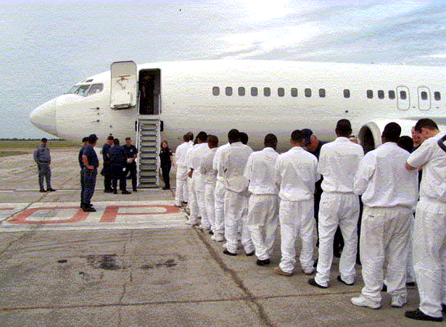

The Oklahoma City hangar capital lease was fully executed in FY 2011. The previous annual lease payment of nearly $1 million per year has been reduced to a little over $60,000. The cost savings from the executed capital lease allows the JPATS revolving fund to affect the billing rates or divert the funding to other requirements.

JPATS’ mission supports one of the three goals within the DOJ Strategic Plan:

DOJ Strategic Goal III: Ensure and Support the Fair, Impartial, Efficient, and Transparent Administration of Justice at the Federal, State, Local, Tribal, and International Levels

- Protect judges, witnesses, and other participants in federal proceedings; apprehend fugitives; and ensure the appearance of criminal defendants for judicial proceedings or confinement (Goal III, Objective 3.2)

JPATS supports the DOJ Strategic Plan by moving prisoners and detainees as quickly, safely, and as cost effectively as possible. The following chart shows the actual and projected levels of air transportation movements and flight hours for all JPATS customer agencies from FY 2003 to
FY 2012:

Fiscal Year | Air Movements | Flight Hours
2003 | 175,220 | 11,635
2004 | 176,519 | 11,746
2005 | 181,951 | 10,512
2006 | 213,138 | 11,674
2007 | 244,137 | 14,069
2008 | 229,392 | 13,171
2009 | 196,524 | 10,524
2010 | 206,353 | 10,631
2011 | 100,470 | 4,239
2012 (Est.) | 69,658 | 4,196
.
The 10 year period covered on the table provides the trend in flying hours and movements accomplished, reflecting the steady increase from 2003 through 2010 while providing services to Immigration and Custom Enforcement Agency (ICE). In 2011, the disengagement of ICE as a customer significantly reduced the requirements, and is evident in the resulting reduction of flying hours and movements accomplished.

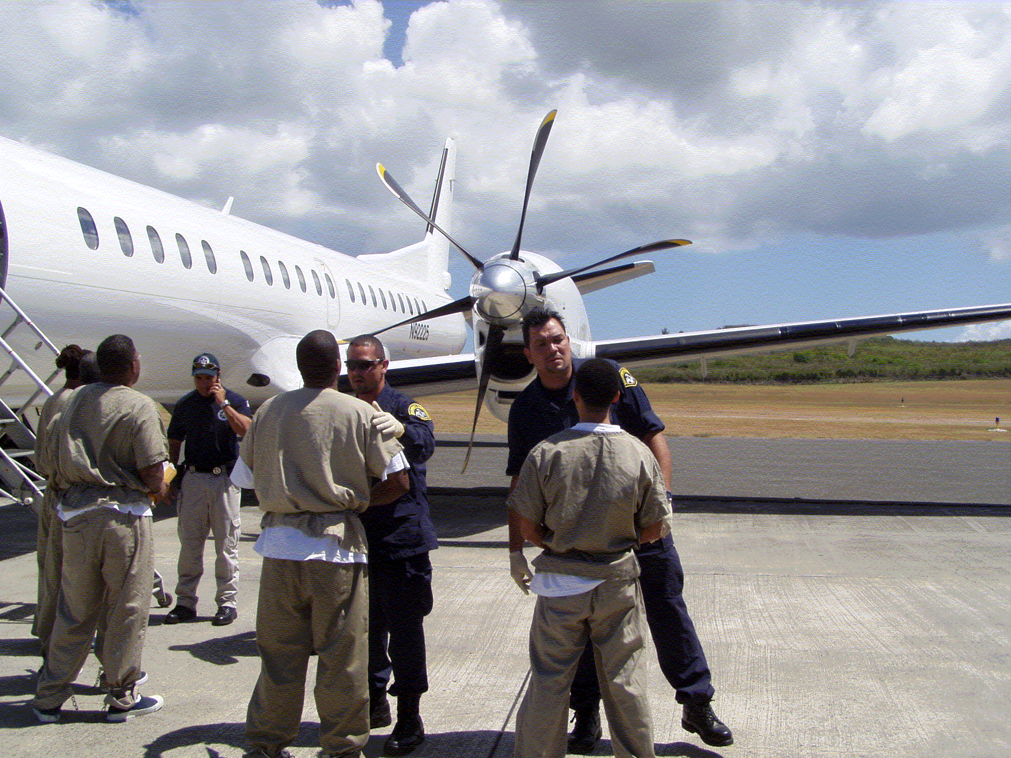

C. Full Program Costs

On October 1, 1998, JPATS began operating as a revolving fund activity with total operating costs being reimbursed by customer agencies. A price-per-flying-hour methodology was developed by the JPATS Business Office in conjunction with financial and operational staff members from the Justice Management Division (JMD), BOP, ICE, and the USMS. This methodology was implemented in 2003, and replaced the price-per-movement methodology that was used during the first three years of JPATS operation. The goal was to develop an accurate, fair, and equitable pricing methodology for all agencies with full cost recovery. This was accomplished by following OMB Circular A-126 guidelines that identify fixed and variable cost categories and by establishing specific prices-per-flying-hour for JPATS customers. Using this methodology, fixed and variable costs were identified by aircraft frame size (large, medium, or small). In FY 2002, JPATS budget projections began incorporating an additional tool known as “activity based costing” to further refine the accuracy of customer pricing initiatives. In FY 2006, the methodology was further refined to a price-per-flight-hour-per-seat basis. Customers are billed based on the number of flight hours and the number of seats they actually utilize to move their prisoners/detainees. Aircraft usage requirement projections are provided by the customer agencies prior to the beginning of the budget cycle.

D. Performance Challenges

JPATS faces a variety of challenges in accomplishing its mission. These challenges fall into two broad categories:

External Challenges

JPATS must continually anticipate the future needs of the customer. The JPATS aviation program is subject to a variety of influences and regulations external to the Department of Justice and its workload is generated by the projected needs of other federal agencies, particularly the federal judiciary. When major new initiatives are introduced with little lead time for planning and budgeting, the detention/transportation community is inadequately prepared to address those changes.

JPATS is impacted by the number of court deadline extensions that occur. In some Districts, court dates may be rescheduled as many as five times. The approaches to establishing court deadlines and extending deadlines vary greatly from District to District. This is one of the factors that contribute to scheduling backlogs. This issue is a priority concern for JPATS as it directly impacts JPATS’ basic mission objective and the judicial process.

Internal Challenges

The greatest internal challenge is ensuring the safety of the aircraft, staff, and prisoners/detainees. A Safety Officer and a formal safety program are in place to meet this challenge. The Safety Officer provides constant monitoring of the aviation program and conducts numerous training sessions each year to help JPATS continue to meet its high standards of aviation safety. The JPATS Aviation department has moved forward with initiatives to address weaknesses identified by both the Chief of Aviation and the Aviation Resource Management Survey (ARMS) conducted by the Interagency Committee for Aviation Policy (ICAP) in 2007. The post-Reduction in Force (RIF) organizational structure added a Standardization and Training Officer position, with targeted goals of more comprehensive programs in both areas. The next ARMS is projected for late summer/early fall 2012.

A significant internal challenge is ensuring that JPATS has access to an adequate number of aircraft to meet customer demands. When a leased aircraft requires maintenance, the aircraft leasing company must locate a replacement aircraft for the scheduled mission. If a replacement aircraft cannot be immediately located, or if a JPATS-owned aircraft requires unscheduled maintenance, JPATS either locates another leased aircraft or reschedules the mission. The acquisition strategy of leasing newer, more reliable aircraft will increase the operational readiness of the air fleet, reducing unscheduled downtime, and enabling JPATS to meet customer missions.

A common issue that challenges timely transportation movement is insufficient documentation on the prisoner movement request (Form 106) which impacts the procedures used to ensure safety during a flight. Information needed, and often excluded, may include items such as a history of violence, type of crime, etc., which is usually noted in the comments section of this form. JPATS schedulers have taken time from their assigned duties to attempt to acquire and/or clarify this information. Even with their efforts, the results are inconsistent and often insufficient information remains an issue.

Another internal challenge is managing the various schedules and limitations of the flight staff. Each scheduled flight must have the appropriate number of flight personnel/security officers to secure the prisoners/detainees being transported, to include a Public Health Service (PHS) nurse, contracted medical support, or emergency medical technician to attend to any urgent health issues. Enforcing mandated crew rest times, arranging security personnel schedules to maximize availability, and ensuring the medical personnel are available is critical to timely transportation.

JPATS did not have an established system to identify trends in either ground or air transportation. With the purchase and implementation of the JPATS Management Information System’s transportation module, the development of methods to track trends has begun. The capability does not exist to simulate significant impacts on ground and air routes such as occurs when a facility shuts down. Without the tools to simulate events of magnitude, agencies cannot respond quickly or effectively. While ground transportation has some agility to respond to changes in service requirements this is not true for the JPATS air component. Even with an eye on changing trends, the fleet and contract structure currently in-place, does not provide the flexibility to respond to changing requirements in a timely and effective manner.

Identification of internal issues is critical to any organization’s optimal performance. JPATS’ actions such as the acquisition of technological tools, like JMIS, are assisting in optimizing travel routes and providing data to establish trend patterns that impact transportation performance. Identification of time spent resolving Form 106 issues, and recognizing improved communications as a spark to improvement, leads to change and more effective uses of schedulers’ time. As each challenge is identified, studied, and resolved, the organization develops a continuous performance improvement cycle.

At all airlift stops, except the Northwest Loop, JPATS currently provides ground security for the loading and transferring of prisoners/detainees. The USMS District and BOP personnel provide the security for the Northwest Loop airlift stops. Through a standardized training program and the use of standardized weapons, these specialized security personnel strengthen the safety of prisoner movements. Meeting these challenges will ensure that the JPATS missions will fly as scheduled in the safest manner possible.

II. Appropriation Language and Analysis of Appropriations Language (N/A)

Not applicable because the JPATS Revolving Fund is not an appropriated account.

III. Decision Unit Justification

A. Justice Prisoner and Alien Transportation System

JPATS – TOTAL | Perm. Pos. | FTE | Amount ($000)
2011 Operating Level | 123 | 123 | $59,721
2012 Adjustments to Base and Technical Adjustments | 0 | 0 | (2,146)
2012 Changes to Operating Level | 0 | 0 | 0
2012 Operating Level | 123 | 123 | 57,575
2013 Changes to Operating Level | 0 | 0 | (8,858)
2013 Operating Level | 123 | 123 | 48,717
Total Change 2012-2013 | 0 | 0 | (8,858)

*Note-Depreciation is not included

1. Program Description

JPATS currently moves federal prisoners and detainees by air, including sentenced, pretrial and deportable aliens, whether in the custody of the U.S. Marshals Service (USMS), or Bureau of Prisons (BOP). JPATS also transports Department of Defense and state and local prisoners on a reimbursable, space-available basis. The JPATS goal is to move prisoners safely and securely, in the most cost efficient manner possible.

Customer agencies provide projected aircraft utilization requirements. JPATS estimates non-federal requirements based on historical data. Due to the disengagement of ICE in FY 2011 and the corresponding reduction in customer requirements, JPATS has closed three operational locations. The FY 2013 budget reflects a more stabilized program based upon organizational and customers’ requirements.

JPATS is committed to ensuring that each scheduled flight is staffed with qualified flight personnel to safely operate each aircraft, that adequate security officers are present to ensure the safety of the detainees/prisoners being transported, and that at least one medical professional is present for any medical emergency on all medium and large aircraft which transport the majority of our prisoners. In response to current and projected external influences JPATS operational support FTE has been significantly reduced since the departure of ICE as a customer in 2011. However, JPATS will continue to safely and efficiently satisfy service demands. The chart below shows the projected personnel requirements by location in FY 2013:

Personnel Requirements by Location
 | Kansas City, MO | Oklahoma City, OK | Puerto Rico | Las Vegas, NV | Total
JPATS Total | 52 | 57 | 1 | 13 | 123

2. Performance Tables
PERFORMANCE AND RESOURCES TABLE
Decision Unit: Justice Prisoner and Alien Transportation System
DOJ Strategic Goal/Objective: III: Ensure and Support the Fair, Impartial, Efficient, and Transparent Administration of Justice at the Federal, State, Local, Tribal, and International Levels. 3.2 Protect judges, witnesses, and other participants in federal proceedings; apprehend fugitives; and ensure the appearance of criminal defendants for judicial proceedings or confinement.
WORKLOAD/ RESOURCES |  | Target |  | Actual |  | Projected |  | Projected |  | New FY2012 Target |  | Requested (Total)
 |  | FY 2011 |  | FY 2011 |  | FY 2012 President’s Budget |  | FY2012  Projected Changes |  | FY 2012 Program |  | FY 2013 Request
1. Number of requests for air and ground transportation of prisoners (definition modified) See metric #1 identified under “New Metrics” below |  | 232,488 |  | 109,700 |  | 102,427 |  | N/A |  | 111,117 |  | 114,450
Total Costs and FTE (reimbursable FTE are included, but reimbursable costs are bracketed and not included in the total.) |  | FTE | $000 | FTE | $000 | FTE | $000 | FTE | $000 | FTE | $000 | FTE | $000
 |  | 123 | $57,575 | 123 | $59,098 | 123 | $57,575 | 0 | $0 | 123 | $57,575 | 123 | $48,717
TYPE/ STRATEGIC OBJECTIVE | PERFORMANCE | FY 2011 Requirements |  | FY 2011  Actual |  | FY 2012 Requirements |  | FY 2012  Projected Changes |  | FY 2012 Program |  | FY 2013 Request
Program Activity |  | FTE | $000 | FTE | $0 | FTE | $000 | FTE | $000 | FTE | $000 | FTE | $000
Program Activity | 1. Prisoner Movement | 123 | $57,575 | 123 | $59,098 | 123 | $57,575 | (0) | $0 | 123 | $57,575 | 123 | $48,717
Performance Measure | 1. Number of prisoner and detainee air movements accomplished. | 69,658 |  | 100,470 |  | N/A |  | N/A |  | N/A |  | N/A
Performance Measure | 2. Number of hours to accomplish air movements. | 3,985 |  | 4,239 |  | N/A |  | N/A |  | N/A |  | N/A
Efficiency Measure | 3. Average cost per hour for large aircraft. | $15,172 |  | $13,945 |  | N/A |  | N/A |  | N/A |  | N/A
Efficiency Measure | 4. Average cost per hour for small aircraft. | $6,490 |  | $8,096 |  | N/A |  | N/A |  | N/A |  | N/A
Efficiency Measure | 5. Average age of JPATS owned (in use) aircraft (years). | 20 |  | 19 |  | N/A |  | N/A |  | N/A |  | N/A
Performance Measure | 6. Percent of time JPATS owned aircraft not available to fly due to unscheduled maintenance | 3.8% |  | 14.8% |  | N/A |  | N/A |  | N/A |  | N/A
Performance Measure | 7. Number of:
Performance Measure | a. Incidents on JPATS movements | 0 |  | 0 |  | 0 |  | 0 |  | 0 |  | 0
Performance Measure | b. Injuries on JPATS aircraft
Performance Measure | i. Prisoner injuries | 0 |  | 0 |  | 0 |  | 0 |  | 0 |  | 0
Performance Measure | ii. JPATS personnel injuries | 0 |  | 0 |  | 0 |  | 0 |  | 0 |  | 0
Outcome Measures | 8. Number of:
Outcome Measures | a. Accidents involving JPATS aircraft | 0 |  | 0 |  | 0 |  | 0 |  | 0 |  | 0
Outcome Measures | b. Escapes from JPATS aircraft | 0 |  | 0 |  | 0 |  | 0 |  | 0 |  | 0
New Metrics modified and submitted for approval |  | FY 2011 |  | FY 2011 |  | FY 2012 President’s Budget |  | FY2012  Projected Changes |  | FY 2012 Program |  | FY 2013 Request
1. Number of requests for air and ground transportation of prisoners |  | N/A |  | N/A |  | N/A |  | N/A |  | 111,117 |  | 114,450
2. Transportation Unit Cost |  | N/A |  | N/A |  | N/A |  | N/A |  | $1,830 |  | $1,887

A. Definition of Terms or explanations for Indicators.

Workload:
1. JPATS receives requests to move prisoners and determines the appropriate mode of transportation (i.e., ground and/or air movement). JPATS uses the JPATS Transportation module within the JPATS Management Information System (JMIS), to schedule and track movements electronically.
Performance Measure:
In keeping with the change in strategic approach of JPATS, the following performance measure has been developed to encompass the goals of the organization.

Total Workload: The workload being modified to include the number of ground, as well as air transportation requests. This gives a broader view of actions needed to facilitate prisoner movements.

Performance Measure 1: Transportation Unit Cost
Data Definition: The total cost per prisoner (transportation coordinated by JPATS) incurred from the prisoner’s point of origin to final destination. Component costs include the cost of transporting the prisoner (by air, bus, van, and car) and the cost of housing the prisoner while in-transit. The cost of BOP-provided in-transit housing and bus transportation is included as part of the reported costs.
Data Collection and Storage: Data describing prisoner transportation and the costs associated with transportation and housing is maintained in several databases. The USMS JPATS Management Information System (JMIS) data system maintains information describing prisoner movements such as the points of origin and final destination, how the prisoner was moved, and where the prisoner was housed, as applicable, while in-transit. JMIS also maintains information describing the cost of air movements and JPATS-coordinated ground transportation. BOP provides information describing the cost of BOP-sponsored bus transportation. The USMS Justice Detainee Information System (JDIS), and the eIGA system and other records that had been managed by OFDT, provide information describing the cost of non-federal housing. Data is maintained on each prisoner transported by JPATS. Data from the various systems is aggregated together by JMIS to determine the prisoner-specific total transportation costs.
Data Validation and Verification: Component data is provided to JPATS by the various agencies. JPATS validates the data for completeness and to ensure that the data provided is within historical parameters.
Data Limitations: Maintaining prisoner transportation data is a labor-intensive process. The reliability of the component data is often compromised by invalid data entry. Accordingly, labor-intensive data analysis is often required to ensure that the data provided to JPATS passes certain logical tests. Additionally, data describing the cost of BOP-sponsored transportation is based on standardized formulae provided by the BOP for calculating the cost of operating their buses. The costs of BOP-provided in-transit housing are based on BOP-reported per capita cost of operating BOP facilities, particularly the Federal Transfer Center in Oklahoma City.
B Factors Affecting FY 2012 and FY 2013 Plans. JPATS’ strategic plan has been modified to encompass the efforts to optimize use of the transportation network. In doing so, the performance metrics have been developed to capture the entire workload of transportation requests and performance related to the entire prisoner cost of transportation, including in-transit housing. The improved measure of Transportation Unit Cost shows the cost effectiveness of strategies to reduce total transportation time, strategies to optimize routing (since there are normally several legs to the trip), strategies to maximize seat utilization, and strategies to utilize the most cost effective housing available. As such, the measure is extremely effective in capturing the interdependence of transportation and housing.
While JPATS could continue to capture accidents or escapes, none have ever occurred. Since the objective is to strive for improvement, JPATS feels strongly that the Transportation Unit Cost is the best portrayal of increased efficiency in time, service, and cost management.

PERFORMANCE MEASURE TABLE

Decision Unit: Justice Prisoner and Alien Transportation System
Decision Unit: Justice Prisoner and Alien Transportation System |  | FY 2002 | FY 2003 | FY 2004 | FY 2005 | FY 2006 | FY 2007 | FY 2008 | FY 2009 | FY 2010 | FY 2011 | FY 2012 | FY 2013
 |  | Actual | Actual | Actual | Actual | Actual | Actual | Actual | Actual | Actual | Actual | Target | Target
Performance Measure | Number of prisoner and detainee air movements accomplished (Discontinued in FY 2012) | 162,695 | 175,220 | 176,519 | 181,951 | 213,138 | 244,137 | 229,392 | 196,524 | 206,353 | 100,470 | N/A | N/A
Performance Measure | Number of hours to accomplish air movements  (Discontinued in FY 2012) | 11,363 | 11,635 | 11,746 | 10,512 | 11,674 | 14,069 | 13,171 | 10,524 | 10,631 | 4,239 | N/A | N/A
Efficiency Measure | Average cost per hour for large aircraft  (Discontinued in FY 2012) | $8,385 | $7,522 | $7,999 | $8,542 | $8,642 | $8,406 | $10,568 | $10,335 | $10,908 | $13,945 | N/A | N/A
Efficiency Measure | Average cost per hour for small aircraft  (Discontinued in FY 2012) | $3,712 | $3,181 | $4,062 | $3,939 | $5,327 | $4,680 | $5,694 | $5,204 | $7,499 | $8,096 | N/A | N/A
Efficiency Measure | Average age of JPATS owned (in use) aircraft (years)  (Discontinued in FY 2012) | 25 | 14 | 22 | 24 | 21 | 21 | 22 | 22 | 25 | 19 | N/A | N/A
Performance Measure | Percent of time JPATS owned aircraft not available to fly due to unscheduled maintenance  (Discontinued in FY 2012) | 10.0% | 4.0% | 4.0% | 4.0% | 4.0% | 4.0% | 2.5% | 2.6% | 8.0% | 14.8% | N/A | N/A
Performance Measure | Incidents on JPATS movements  (Discontinued in FY 2012) | 0 | 0 | 1 | 2 | 0 | 1 | 0 | 1 | 0 | 0 | N/A | N/A
Performance Measure | Prisoner injuries on JPATS aircraft  (Discontinued in FY 2012) | 0 | 0 | 0 | 0 | 0 | 0 | 0 | 0 | 0 | 0 | N/A | N/A
Performance Measure | JPATS personnel injuries on JPATS aircraft  (Discontinued in FY 2012) | 6 | 3 | 0 | 2 | 0 | 0 | 0 | 0 | 0 | 0 | N/A | N/A
Outcome Measure | Accidents involving JPATS aircraft  (Discontinued in FY 2012) | 0 | 0 | 0 | 1 | 0 | 0 | 0 | 0 | 0 | 0 | N/A | N/A
Outcome Measure | Escapes From JPATS aircraft  (Discontinued in FY 2012) | 0 | 0 | 0 | 0 | 0 | 0 | 0 | 0 | 0 | 0 | N/A | N/A
New Metric
Performance Measure | Transportation Unit cost | N/A | N/A | N/A | N/A | N/A | N/A | N/A | N/A | N/A | N/A | $1,830 | $1,887
Footnote: A change to the performance metrics for JPATS was requested and approved in FY 2011 and effective in FY 2012. The new metric of Transportation Unit Cost replaced all previous performance measures submitted.

3. Performance, Resources, and Strategies

A. Performance Plan and Report for Outcomes

At all airlift stops, except the Northwest Loop, JPATS currently provides ground security for the loading and transferring of prisoners/detainees. The USMS District and BOP personnel provide the security for the Northwest Loop airlift stops. Through a standardized training program and the use of standardized weapons, these specialized security personnel strengthen the safety of prisoner movements. The designated Safety Officer provides constant monitoring of the aviation program and conducts numerous training sessions each year to help JPATS continue to meet its high standards of aviation safety. Also, the acquisition strategy of leasing newer, more reliable aircraft has increased the operational readiness of the air fleet, reducing unscheduled downtime and enabling JPATS to meet customer missions.

B. Strategies to Accomplish Outcomes

In FY 2011, JPATS brought about a broader strategic approach to the business of JPATS. The plan focused on total cost per prisoner to include the cost of transporting the prisoner (by air, bus, van, and car) and the cost of housing the prisoner while in-transit. The cost of BOP-provided in-transit housing and bus transportation is included as part of the reported costs for performance measures in FY 2012. The JPATS organization is the major supplier of the air transportation and coordination for the ground transportation. To more accurately reflect current trends and presidential mandates for agency savings, the organization focuses on capturing total costs and proactively adopting methods to reduce the costs of transporting and housing in-transit prisoners.

