
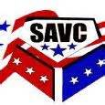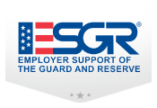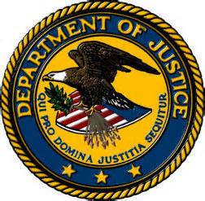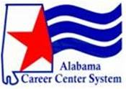

Veterans Town Hall:

Employment Rights

6 June 2015 at 2 locations:

Tillman's Corner Senior Center at 10 a.m.

5863 Nevius Rd., Mobile

VFW Post 5660 at 2 p.m.

950 Nichols Ave., Fairhope
An opportunity to have your questions answered regarding employment rights under the American’s with Disabilities Act (ADA), Uniformed Services Employment & Re-employment Rights Act (USERRA), and employment laws. On site assistance will be available. More info: mobile.vets@alcc.alabama.gov

