U.S. Department of Justice

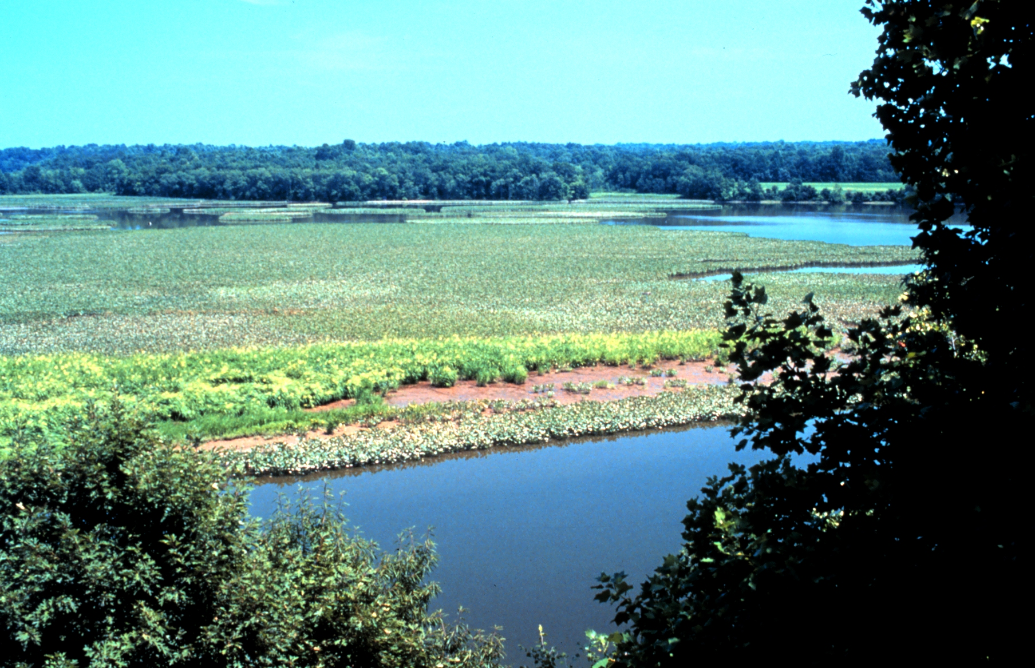

Environment and Natural Resources Division

(ENRD)

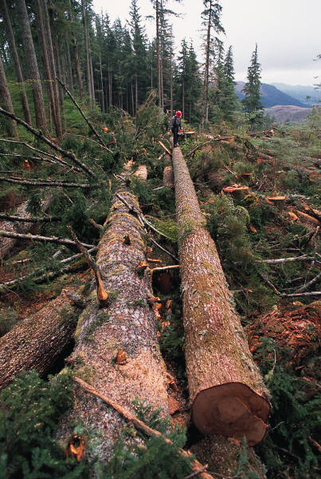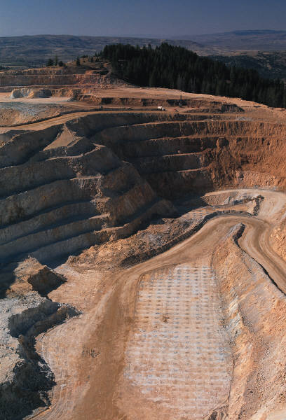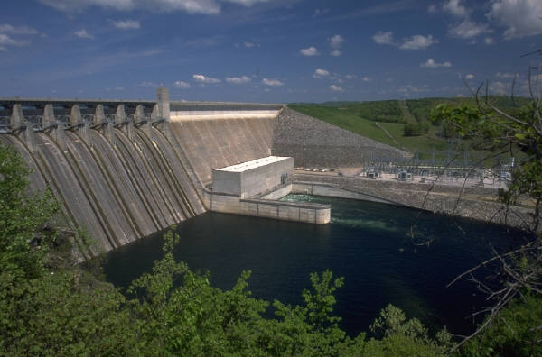

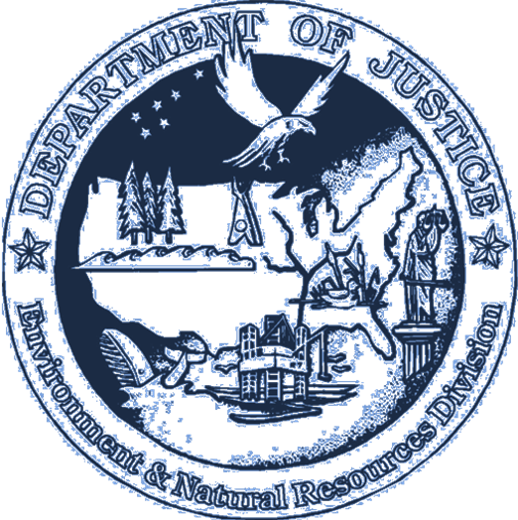

E N R D
E N R D

F Y 2 0 1 3

PERFORMANCE BUDGET

CONGRESSIONAL SUBMISSION

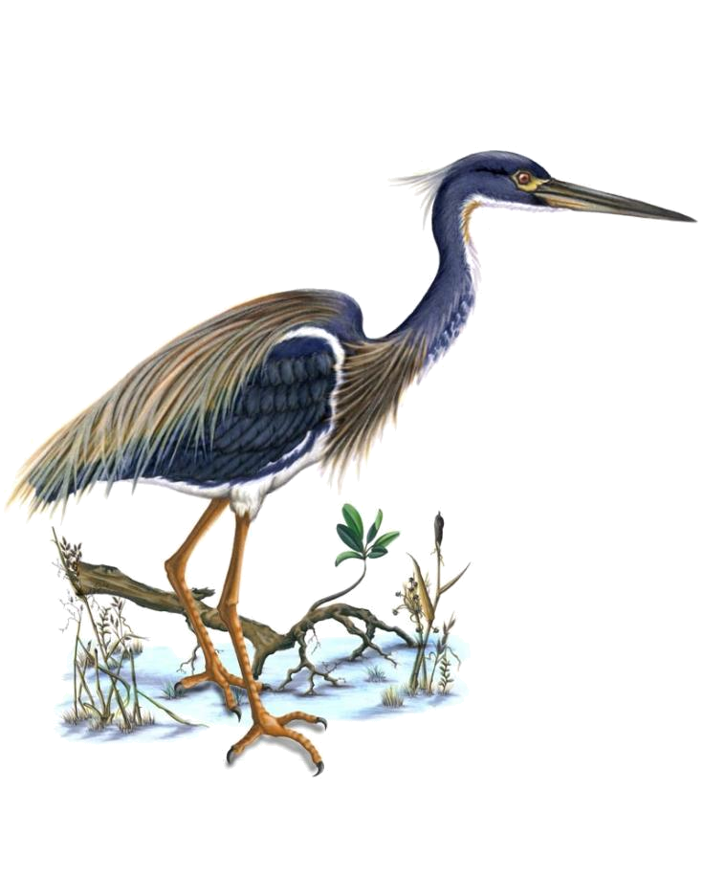

Table of Contents

Page No.

I. Overview 2

II. Summary of Program Changes 8

III. Appropriations Language and Analysis of Appropriations Language 8

IV. Decision Unit Justification 9

A. Environment and Natural Resources Division 1. Program Description 9
2. Performance Tables 21
3. Performance, Resources, and Strategies 24

V. Program Increases by Item N/A

VI. Program Offsets by Item 32
VII. Exhibits

- Organization Chart
- Summary of Requirements
- FY 2013 Program Increases/Offsets by Decision Unit
- Resources by DOJ Strategic Goal and Strategic Objective
- Justification for Base Adjustments
- Crosswalk of 2011 Availability
- Crosswalk of 2012 Availability
- Summary of Reimbursable Resources
- Detail of Permanent Positions by Category
- Financial Analysis of Program Increases/Offsets
- Summary of Requirements by Grade
- Summary of Requirements by Object Class

Cover photo of Jug Bay, part of the Chesapeake Bay National Estuarine Research Reserve -- courtesy of the NOAA Photo Library -- www.photolib.noaa.gov

Information in text boxes is courtesy of the Chesapeake Bay Program -- www.chesapeakebay.net

I. Overview of the Environment and Natural Resources Division

A. Introduction:

Environment and Natural Resources Division (ENRD) Mission: ENRD’s mandate is to enforce civil and criminal environmental laws and programs that protect human health and the environment, including natural resources, and to defend suits challenging those laws and agency programs. To accomplish this mission in FY 2013, the Division is requesting a total of $110,360,000, including 537 positions (370 attorneys), and 582 Full-Time Equivalents (FTE).

Electronic copies of the Department of Justice’s Congressional Budget Justifications and Capital Asset Plan and Business Case exhibits can be viewed or downloaded from the Internet using the Internet address: http://www.justice.gov/02organizations/bpp.htm#budgetinfo

B. Issues, Outcomes, and Strategies:

As the Nation's chief environmental litigator, ENRD supports the Justice Department’s Strategic Goal Two: Prevent Crime, Protect the Rights of the American People, and Enforce Federal Law; and more specifically, Strategic Objective 2.6: Protect the federal fisc and defend the interests of the United States.

The Division initiates and pursues legal action to enforce federal pollution abatement laws and obtain compliance with environmental protection and conservation statutes. ENRD also represents the United States in all matters concerning protection, use, and development of the nation's natural resources and public lands. The Division defends suits challenging all of the foregoing laws, and fulfills the federal government’s responsibility to litigate on behalf of Indian tribes and individual Indians. ENRD’s legal successes protect the federal fisc, reduce harmful discharges into the air, water, and land, enable clean-up of contaminated waste sites, and ensure proper disposal of solid and hazardous waste.

In affirmative litigation, ENRD obtains redress for past violations harming the environment, ensures that violators of criminal statutes are appropriately punished, establishes credible deterrents against future violations of these laws, recoups federal funds spent to abate environmental contamination, and obtains money to restore or replace natural resources damaged by oil spills or the release of other hazardous substances into the environment. ENRD also ensures that the federal government receives appropriate royalties and income from activities on public lands and waters.

By vigorously prosecuting environmental criminals, ENRD spurs improvements in industry practice and greater environmental compliance. Additionally, the Division obtains penalties and fines against violators, thereby removing the economic benefits of non-compliance and leveling the playing field so that companies complying with environmental laws do not suffer competitive disadvantages.

In defensive litigation, ENRD represents the United States in challenges to federal environmental and conservation programs and all matters concerning the protection, use, and development of the nation's public lands and natural resources. ENRD faces a growing workload in a wide variety of natural resource areas, including litigation over water quality and watersheds, the management of public lands and natural resources, endangered species and sensitive habitats, and land acquisition and exchanges. The Division is increasingly called upon to defend Department of Defense training and operations necessary to military readiness and national defense.

ENRD continues to work closely with the Department’s leadership, the Civil Division, other DOJ components (e.g., USAO, FBI), and a host of federal agencies to pursue civil enforcement actions, under the Clean Water Act and the Oil Pollution Act, and other applicable statutes, against potentially responsible parties involved in the April 2010 Deepwater Horizon oil rig explosion and oil spill. ENRD’s civil lawsuit, filed in December 2010 against nine parties responsible for the explosion and sinking of the rig and the subsequent oil spill (the largest oil spill in the Nation’s history), is part of a multi-district litigation action involving hundreds of plaintiffs. A massive civil trial is currently scheduled for February 2012. The discovery requirements involved in the Deepwater litigation are unprecedented. The outcome of the Department’s civil Deepwater litigation is likely to be historic in terms of the scale and scope of monetary penalties and redress imposed. ENRD and the Civil Division have established a robust, jointly-administered web portal which allows federal parties to effectively and efficiently share documents, databases, dockets and other relevant materials and information. The FY 2010 supplemental appropriation (P.L. 111-212) included $10 million for the Department of Justice for litigation related to the Deepwater Horizon oil spill. The FY 2013 request includes $750,000 for annualization for ENRD.

The Division also continues to defend the Department of the Interior, and specifically the Bureau of Ocean Energy Management, Regulation and Enforcement, against challenges – under the National Environmental Policy Act, the Administrative Procedures Act, the Outer Continental Shelf Lands Act, the Endangered Species Act, and other statutes – from companies and organizations to Interior’s decisions, actions and policies related to deepwater drilling and oil and gas exploration lease transactions. Several of these cases have been concluded, dismissed, or are otherwise not in active district court litigation. However, we continue to handle cases involving challenges to the Department of the Interior’s leasing, planning and permitting decisions, and we expect cases of this nature will remain active for some time to come.
ENRD defends the federal government in lawsuits alleging the United States has breached its trust responsibilities to Indian Tribes by failing to provide “full and complete” historical accountings of tribal trust funds and non-monetary trust resources, failing to administer properly tribal accounts that receive revenues from economic activity on Tribal lands, and failing to manage properly tribal non-monetary trust resources. There are 72 Tribal Trust cases filed by 112 Tribes currently pending in various U.S. District Courts (40 cases) and in the U.S. Court of Federal Claims (32 cases). For these Tribal Trust cases, the Division is obligated, among other things, to identify, locate, review, scan, manage, and produce over 400 million pages of documents relevant to tribal trust fund accounts and non-monetary tribal trust resources or assets. The Tribal Trust litigation will continue in full force for the foreseeable future, with one or more trials expected in FY 2012 and FY 2013.

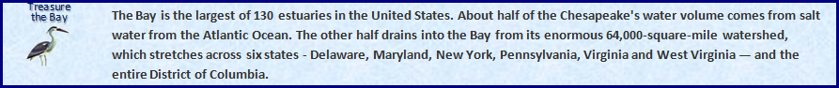

C. Performance Challenges:

External Challenges

The Division has limited control over the filing of defensive cases, which make up the majority of our workload. Court schedules and deadlines drive the pace of work and attorney time devoted to these cases. ENRD’s defensive caseload is expected to increase in FY 2013 as a result of numerous factors.

- In FY 2012 and FY 2013, the Division anticipates that one or more Tribal Trust cases will go to trial. Additionally, we expect the cases will continue to mature into more advanced stages of litigation, requiring extensive resources to acquire, review and produce documents, to take and defend depositions, and to respond to the discovery demands of over 100 Indian tribes.
- ENRD expects that our docket will continue to reflect more Climate Change litigation in FY 2012 and FY 2013. Climate Change litigation has already required substantial Division resources in recent years. The litigation thus far has been primarily defensive in nature, with the Division, for example, responding to allegations that client agencies have failed to consider greenhouse gas emissions or climate change impacts when making agency decisions under the Clean Air Act, the Endangered Species Act, and the National Environmental Policy Act.
- The Environment and Natural Resources Division continues to devote significant resources to condemnation proceedings along the U.S. border with Mexico, related to the Secure Border Initiative (SBI). In order to build the Southwest border fence, ENRD’s Land Acquisition Section exercised the government’s eminent domain powers (under the Fifth Amendment of the Constitution) to acquire hundreds of miles of privately-owned property on behalf of the Department of Homeland Security and the Army Corps of Engineers. Valuation litigation, which will proceed into FY 2013, is the most resource-intensive stage of these actions, and we are currently in the midst of that process. This demanding project will continue for the foreseeable future.
- ENRD supports the defense and security missions of the Department of Defense and the Department of Homeland Security. From defending environmental challenges to critical training programs that ensure military preparedness, to acquiring strategic lands needed to fulfill the government’s military and homeland security missions, ENRD makes a unique and important contribution to defense and national security while ensuring compliance with the country’s environmental laws. The Division expects its military readiness docket – to include litigation to defend training missions and strategic initiatives, expand military infrastructure, and defend chemical weapons demilitarization – to continue and expand in FY 2013.

ENRD expects to receive a number of civil and criminal environmental enforcement referrals from EPA concerning clean air, clean water and clean land. As EPA has placed a substantial emphasis on environmental justice, we expect some of these cases to involve situations in which a disproportionate adverse environmental or human health effect on an identifiable low-income/minority community or federally-recognized tribe consistent with Executive Order 12898 (“Federal Actions to Address Environmental Justice in Minority Populations and Low Income Populations”). In addition, the Division is reviewing its own cases to make sure that environmental justice is appropriately taken into account and advanced in its work. Accordingly, the Division will need to devote additional resources to ensure protection of the nation’s air, water and other resources for all Americans under the Environmental Justice order and other applicable federal laws and regulations.

Internal Challenges

ENRD faces numerous challenges in balancing available personnel and resources against workload demands. Like other litigating components, we must provide resources for our attorneys that meet the changing, increasingly technological demands of the legal industry. With the introduction of new technologies and new requirements – such as e-filing, on-line document repositories, electronic trials, extranet docketing systems, etc. – we need to continually provide our workforce with the necessary hardware and systems to accommodate these business process challenges.

ENRD expects to encounter additional significant internal challenges while developing and implementing information technology requirements in FY 2013. For example, both desktop PCs and laptop PCs in ENRD will achieve their “end of life” in FY 2013. Additionally, we will be required to update our network infrastructure, which will no longer be supported by the manufacturer in FY 2013, as well as our printers. These hardware upgrades will cost hundreds of thousands if not millions of dollars in FY 2013. We also expect to replace two mission-critical systems in FY 2013: our case management system (CMS) and our records management system (RMS). Both systems will entail significant work and significant expense in FY 2013.

Also in FY 2013, in response to the Paperwork Reduction Act (USC Title 44, Chapter 35), ENRD expects to complete its implementation of electronic Official Personnel Files (eOPF). The Department-coordinated eOPF effort will require time, personnel resources, and money from ENRD and other required DOJ participants.

In addition to the technology challenges facing ENRD in FY 2013, we expect to continue to encounter residual macroeconomic challenges which impact staffing in the Division. ENRD’s historical attorney attrition over the past several years has ranged from 8-14%. In any given year – under positive economic conditions and normal levels of turnover – some percentage of our attorney workforce leaves ENRD for positions at law firms. This did not happen in the past few fiscal years. Attorneys are instead choosing to remain at ENRD due to a general slowdown in the legal profession, once again, related to the slowdown in the overall economy. This phenomenon continues to impede our ability to manage our budgetary and personnel resources to a measurable extent through attrition.

To access the Exhibit 300 submission regarding information technology for ENRD and other DOJ components, please go to: (http://www.usdoj.gov/jmd/2013justification/exhibit300/.)

D. Environmental Accountability

The Department’s Environment and Natural Resources Division has undertaken a “Greening the Government” initiative in response to Executive Order 13423 (January 24, 2007), which requires all federal agencies to meet benchmarks for reductions in energy usage, water consumption, paper usage, solid waste generation, and other areas. Among other things, through the Executive Order, government agencies have been asked to reduce energy consumption by 30% by 2015. Congress mandated compliance with this Executive Order in recent appropriations legislation (Omnibus Appropriations Act, Pub. L. 111-8, § 748 [2009]).


Earth Day at ENRD

Since 2004, ENRD has held an annual Earth Day service celebration at Marvin Gaye Park in Northeast Washington, D.C. In those seven years, the Division has been able to help the park plant over $10,000 worth of trees and landscaping. T-shirt and mug sales help cover the cost of this annual park revitalization event. In total, ENRD has devoted over 5,000 hours of employee time to planting trees, removing trash, laying sod, and gardening. In both 2007 and 2008, ENRD received community service awards from the Department of Justice for its Earth Day event.

ENRD celebrated Earth Day again on April 28, 2011 at Marvin Gaye Park. Nearly 150 volunteers, including Deputy Attorney General James Cole, Assistant Attorney General Ignacia Moreno and representatives from several DOJ components, participated in the event. Working side by side with the Washington Parks and People Foundation, ENRD volunteers broke ground on the first neighborhood-based nursery for plants and an environmental education resource center.

Energy Use at ENRD

Through ENRD’s Greening the Government Committee, and through other management and staff efforts, ENRD continued to encourage Best Practices which help the Division to minimize energy use. Our Best Practices entail such things as turning off lights (not only in offices, but also common areas, rest rooms, and hallways) when they are not needed; turning off computer monitors (or setting them to an energy saving mode) when not in the office; turning off other electronic devices when not in use; removing or disabling unnecessary light fixtures; encouraging use of stairs as opposed to elevators; and encouraging other energy efficient protocols.

In addition, in FY 2011, ENRD’s Greening the Government Committee, in conjunction with GSA, had over 1,200 motion-activated lighting sensors installed in all Patrick Henry Building (PHB) ENRD offices and common areas. This improvement will help us reduce the government's environmental impact pursuant to Executive Order 13514, which focuses on Federal Leadership in Environmental, Energy, and Economic Performance. It will decrease the building’s energy usage and help building management to obtain Leadership in Energy and Environmental Design (LEED) Certification.

The Environment Division’s Information Technology (IT) staff is keenly aware of its environmental responsibilities, buying energy efficient hardware before Energy Star became a Federal Government mandate. To maximize energy efficiency, with our most recent server procurement we employed virtual server technology (which allows us to buy 37% fewer servers), and we installed exclusively Dell® Energy Smart servers, an energy-saving technology that exceeds EPA’s Energy Star requirements. Together, the use of virtual server technology with Energy Smart servers will reduce the Division’s power requirements and heat output by 50%.

ENRD continues to encourage employees to walk, bike and use public transportation when commuting to and from work. In addition to offering the traditional transit subsidy benefit (for employees who utilize public transportation and car pools), as of FY 2010, ENRD’s pilot commuter benefits program for bicycle commuters has been adopted by Justice Management Division for implementation throughout the whole Department. The program is made possible by the Bicycle Commuter Benefit Act, which was recently added to IRS Code Section 132(f).

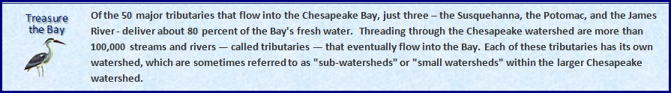

E. Achieving Necessary Cost Savings and Efficiencies in a Challenging Budget Environment

Over the past two fiscal years, ENRD has been engaged in an aggressive, focused effort to reduce spending and to achieve operational efficiencies. In February 2011, the Division created an internal $AVE Committee, a commission of ENRD managers, attorneys, and support staff tasked with analyzing the Division’s operating plan and spending reports, and identifying areas for potential cost savings. This effort, although both valuable and necessary – and through which we have validated and confirmed that the Division is already a very “lean” and efficient organization – has been both challenging and rewarding. It has required many sacrifices in the work-life of ENRD’s employees and it has streamlined the functional operating capacity of the Division. ENRD’s $AVE Committee identified approximately $2 million in potential cost savings measures. As of January 2012, 18 of the 22 cost-saving ideas proposed by the $AVE Committee have been adopted and implemented.

By way of example, through the work of ENRD’s $AVE Committee, the Division has reduced the number of fax machines (and costly associated phone/data lines) by over 50%. The Division has also reduced the number of post office boxes it rents, requiring that multiple offices share a common box. Additionally, ENRD enhanced its regular internal inter-office mail delivery route to include several local federal agency offices, so as to reduce (by literally tens of thousands of dollars a year) the cost of commercial (Fed Ex, UPS, USPS) shipping to offices in Washington, D.C. Furthermore, the $AVE Committee significantly scaled-back the level of in-house services – computer help desk, copying/graphics, litigation support – offered to Division personnel.

ENRD also implemented a number of cost saving measures in FY 2011, outside the scope of the $AVE Committee, such as eliminating retreats and conference travel, curtailing training (i.e., no developmental training; only functionally-required training, such as that which is required to maintain a COTR or IT security certification, is approved), significantly reducing awards, and limiting operational travel. We have implemented spending limits on otherwise valuable planning and management tools out of necessity. Our FY 2011 budget was reduced relative to FY 2010 funding levels and – in addition to reducing staffing levels and scaling back the size of the Division – we have had to cut other operational functions and services in order to remain fiscally solvent. Fortunately, most, if not all, of the cost savings measures ENRD has implemented, or will implement, in FY 2012 will have a long-term cost reduction impact (permanently changing our operational structure and culture).

II. Summary of Program Changes

Item Name | Description |  |  |  | Page
Item Name |  | Pos. | FTE | Dollars ($000) | Page
IT Savings | IT efficiencies and management reform | - | - | $(84) | 32

III. Appropriations Language and Analysis of Appropriations Language

Please refer to the General Legal Activities Consolidated Justifications.

IV. Decision Unit Justification

- Environment and Natural Resources Division | Perm. Pos. | FTE | Amount ($000)
2011 Enacted | 459 | 513 | 108,010
2012 Enacted | 537 | 582 | 108,009
Adjustments to Base and Technical Adjustments | 0 | 0 | 2,435
2013 Current Services | 537 | 582 | 110,444
2013 Program Offsets | 0 | 0 | -84
2013 Request | 537 | 582 | 110,360
Total Change 2012-2013 | 0 | 0 | 2,351

1. Program Description

As stated in the Department of Justice Strategic Plan, ENRD works to:

- Investigate and prosecute environmental crimes, including both wildlife and pollution violations;

- Pursue cases against those who violate laws that protect public health, the environment, and natural resources;

- Defend U.S. interests against suits challenging statutes and agency actions;

- Develop constructive partnerships with other federal agencies, state and local governments, and interested parties to maximize environmental compliance and stewardship of natural resources;

- Act in accordance with United States trust responsibilities to Indian tribes and individual Indians in litigation involving the interests of Indians.

The Division focuses on both civil and criminal litigation regarding the defense and enforcement of environmental and natural resource laws and regulations, and represents many federal agencies in litigation (e.g., the Environmental Protection Agency, Department of Agriculture, Department of the Interior, Department of Defense, and Department of Homeland Security.)

As the nation’s chief environmental litigator, ENRD strives to obtain compliance with environmental and conservation statutes. To this end, we seek to obtain redress of past violations that harmed the environment, establish credible deterrence against future violations of these laws, recoup federal funds spent to abate environmental contamination, and obtain money to restore or replace natural resources damaged through oil spills or the release of other hazardous substances. The Division ensures illegal emissions are eliminated, leaks and hazardous wastes are cleaned up, and drinking water is safe. Our actions, in conjunction with the work of our client agencies, enhance the quality of the environment in the United States and the health and safety of its citizens.
Civil litigating activities include cases where ENRD defends the United States in a broad range of litigation and enforces the nation’s environmental laws. The majority of the Division’s cases are defensive or non-discretionary in nature. They include claims alleging noncompliance with federal, state and local pollution control and natural resource laws. Civil litigating activities also involve the defense and enforcement of environmental statutes such as the Comprehensive Environmental Response, Compensation, and Liability Act (CERCLA), the Clean Air Act (CAA), the Clean Water Act (CWA), the National Environmental Policy Act (NEPA), and the Endangered Species Act (ESA).

ENRD’s Cases/Matters Pending By Client Agency (FY 2011)

ENRD’s Cases/Matters Pending By Case Type (FY 2011)

The Division defends Fifth Amendment taking claims brought against the United States alleging that federal actions have resulted in the taking of private property without payment of just compensation, thereby requiring the United States to strike a balance between the interests of property owners, the needs of society, and the public fisc. ENRD also prosecutes eminent domain cases to acquire land for congressionally authorized purposes ranging from national defense to conservation and preservation. Furthermore, the Division assists in fulfillment of United States trust responsibilities to Indian Tribes. ENRD is heavily involved in defending lawsuits alleging the United States has breached trust responsibilities to Tribes by mismanaging Tribal natural resources and failing to properly administer accounts that receive revenues from economic activity on Tribal lands. The effectiveness of our defensive litigation is measured by percent of cases successfully resolved and savings to the federal fisc.

Criminal litigating activities focus on identifying and prosecuting violators of laws protecting wildlife, the environment, and public health. These cases involve issues such as fraud in the environmental testing industry, smuggling of protected species, exploitation and abuse of marine resources through illegal commercial fishing, and related criminal activity. ENRD enforces criminal statutes designed to punish those who pollute the nation’s air and water; illegally store, transport and dispose of hazardous wastes; illegally transport hazardous materials; unlawfully deal in ozone-depleting substances; and lie to officials to cover up illegal conduct. The effectiveness of criminal litigation is measured by the percentage of cases successfully resolved. ENRD’s case outcome performance results are included in the Performance and Resources Table contained in this submission.

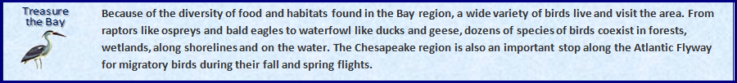

ACCOMPLISHMENTS

In FY 2011, ENRD successfully concluded 1,047 cases from a total of 6,766 pending cases, matters and appeals. We recorded approximately $656 million in civil and criminal fines, penalties, and costs recovered. The estimated value of federal injunctive relief (i.e., clean-up work and pollution prevention actions by private parties) as a result of cases litigated by ENRD in FY 2011 totaled $10.9 billion. Through our defensive litigation efforts in FY 2011, we avoided costs (claims) of more than $2.1 billion. The Environment Division received 2,196 new cases and matters and filed 1,043 cases in FY 2011. ENRD achieved a favorable outcome in 94 percent of cases resolved.

Below are notable successes from the Division’s civil and criminal litigation dockets.

Civil Cases

- Enhancing Pipeline Safety

The Division, EPA, and the U.S. Department of Transportation, reached an agreement with BP Exploration Alaska, Inc. (BP Alaska) under which the company will pay a $25 million civil penalty and carry out a system-wide pipeline integrity management program, as part of a settlement for spilling more than 5,000 barrels of crude oil from the company’s pipelines on the North Slope of Alaska in 2006. The penalty is the largest per-barrel penalty to date for an oil spill. The settlement also addresses Clean Air Act violations arising out of BP Alaska’s improper asbestos removal along the pipeline in the aftermath of the spill.

BP Alaska is required to develop a $60 million system-wide program to manage pipeline integrity for the company’s 1,600 miles of pipeline on the North Slope. The program will address corrosion and other threats to these oil pipelines and require regular inspections and adherence to a risk-based assessment system. BP Alaska has already spent $200 million replacing the lines that leaked on the North Slope.

- Enforcement Under Comprehensive Environmental Response, Compensation and Liability Act (“CERCLA” or “the Superfund Act”)

The Division reached a settlement with ConocoPhillips Company and Sasol North America Inc. to resolve their liability to EPA under CERCLA and to settle claims for natural resources damages for contamination in the Calcasieu Estuary of Louisiana. The companies will reimburse the EPA Superfund more than $4.5 million and will complete a removal action valued at about $10 million to clean up Bayou Verdine, a waterway that flows into the Calcasieu River. The southern reaches of Bayou Verdine are dominated by heavy industry and face resulting industrial discharges.

Over the past several years, federal and state trustees worked cooperatively with ConocoPhillips and Sasol North America to assess injuries and to develop a restoration plan. Under the terms of settlement with state and federal natural resource trustees (the National Oceanic and Atmospheric Administration (NOAA), the Department of the Interior (DOI), the Louisiana Department of Environmental Quality (LDEQ), and the Louisiana Department of Wildlife and Fisheries (LDWF), the companies will reimburse the trustees nearly $1.2 million for a share of past natural resource damages assessment costs, perform a restoration project in the Sabine Wildlife Refuge, and pay an additional $750,000 for future monitoring of the restoration project.
- Enforcing Superfund Clean-up Obligations in Bankruptcy Cases
This past year, the Division participated with numerous other federal agencies, 22 states, local governments in Illinois, and the Navajo Nation to reach a global bankruptcy settlement with chemical company Tronox Inc. and its affiliated debtors. In compensation for monies previously expended by the government and penalties for which Tronox is liable on behalf of predecessor companies, the company will pay $270 million to the government and to five newly created environmental response trusts that will take title to the company’s contaminated properties. These properties include former nuclear fuel processing facilities, former service stations, and current and former chemical production facilities. Tronox will transfer to the governments and trusts an 88 percent share of the company’s interest in a pending lawsuit against its former parent company Kerr-McGee Corporation, and its parent company Anadarko Petroleum Corporation. These defendants allegedly fraudulently transferred valuable assets out of Tronox, leaving the company with insufficient funds to pay billions of dollars of environmental liabilities. The United States has intervened in the lawsuit. Tronox will also create and fund with a portion of the $270 million, a litigation trust to conduct the lawsuit after the effective date of Tronox’s plan of reorganization.
- Clean Air Act Power Plants Cases
ENRD continues to successfully litigate Clean Air Act (“CAA”) claims against operators of coal-fired electric power generating plants. These violations arise from companies engaging in major life extension projects on aging facilities without installing required state-of-the-art pollution controls. The resulting tens of millions of tons of excess air pollution adversely affects the health of the elderly, the young, and asthma sufferers, degrades forests, damages waterways, and contaminates reservoirs.
ENRD recently settled a case with Duke Energy, one of the largest electric power companies in the nation. Duke will spend approximately $85 million to significantly reduce harmful air pollution at an Indiana power plant and pay a $1.75 million civil penalty. The settlement also requires Duke to spend $6.25 million on environmental mitigation projects. Duke must either repower two units at its Gallagher plant with natural gas or shut them down to remove all sulfur dioxide pollution. This natural gas repowering will also reduce other air pollutants, including nitrogen oxides, particulate matter, mercury, and carbon dioxide. Duke is required to install new pollution controls for sulfur dioxide at two other units at the plant. The work and projects that are required by the settlement will, when fully implemented, result in substantial improvements to the air quality for the communities that are the most heavily impacted by the Gallagher plant’s emissions.
Duke Energy represents the 17th settlement secured by the federal government as part of a national enforcement initiative to control harmful emissions from coal-fired power plants under the Clean Air Act’s new source review requirements. The total combined sulfur dioxide and nitrogen oxide emission reductions secured from these settlements will exceed 2 million tons each year once all the required pollution controls have been installed and implemented.
- Addressing Air Pollution From Oil Refineries

The Division continued to make progress in its national initiative to combat CAA violations within the petroleum refining industry. HOVENSA LLC, owner of the second largest petroleum refinery in the United States, agreed to pay a $5.375 million civil penalty and spend more than $700 million in new pollution controls to resolve Clean Air Act violations at its St. Croix, U.S. Virgin Islands, refinery. The settlement requires more stringent emission limits and aggressive monitoring, leak-detection and repair practices to reduce emissions from refinery equipment and process units. The company is alleged to have made modifications to its refinery that increased emissions without first obtaining pre-construction permits and installing required pollution control equipment. The Clean Air Act requires major sources of air pollution to obtain such permits before making changes that would result in a significant emissions increase of any pollutant. High concentrations of SO₂ and NOx, two key pollutants emitted from refineries, can have adverse impacts on human health, and are significant contributors to acid rain, smog and haze.

Once fully implemented, the pollution controls required by the settlement are estimated to reduce emissions of nitrogen oxides (NOx) by more than 5,000 tons per year and sulfur dioxide (SO₂) by nearly 3,500 tons per year. The settlement will also result in additional reductions of volatile organic compounds, particulate matter, carbon monoxide and other pollutants that affect air quality. Additional pollution-reducing projects at the refinery’s coking unit under the settlement will also reduce greenhouse gas emissions by over 6,100 tons per year.

HOVENSA is one of the 10 largest refineries in the world and has the capacity to refine more than 525,000 barrels of crude oil per day. This is the 28th in a series of multi-issue, multi-facility settlements being pursued by EPA under its National Petroleum Refinery Initiative to improve compliance among petroleum refiners and to reduce significant amounts of air pollution from refineries nationwide through comprehensive, company-wide enforcement settlements. With the HOVENSA settlement, 105 refineries operating in 32 states and territories – more than 90 percent of the total refining capacity in the United States – are under judicially enforceable agreements to significantly reduce emissions of pollutants. Refiners have agreed to invest over $6 billion in new pollution controls designed to reduce emissions of sulfur dioxide, nitrogen dioxide and other pollutants by over 360,000 tons per year.

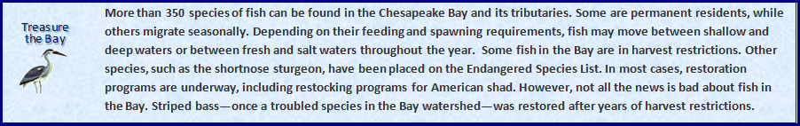

- Additional Enforcement of the Clean Air Act

In a settlement with Rocky Mountain Pipeline System LLC, Western Convenience Stores Inc. and Offen Petroleum Inc., the three gasoline distributors agreed to pay $2.5 million to resolve claims that they illegally mixed and distributed more than one million gallons of gasoline that did not meet Clean Air Act emissions and fuel quality requirements. Such gasoline can result in increased emissions from car tailpipes, affect vehicle performance, and in some cases can damage engines and emissions controls. At two terminals in Dupont and Fountain, Colo., between 2006 and 2009, the companies allegedly produced millions of gallons of illegal gasoline by mixing natural gasoline, a byproduct of natural gas production, and ethanol with gasoline previously certified to meet Clean Air Act requirements. The blended gas was distributed and sold by Western Convenience Stores, Inc. (Western), and Offen Petroleum, Inc. (Offen), at retail gasoline stations in Colorado and Nebraska.

The Clean Air Act allows refiners to produce gasoline by adding other fuel sources to previously certified gasoline, but anyone using this method must ensure that the blended gasoline still meets applicable emissions and fuel standards. They must also comply with sampling, testing, and quality assurance requirements to ensure that the gasoline meets these standards. The companies’ operations may have resulted in the introduction into the environment of a total of more than 10 tons of excess emissions of volatile organic compounds (VOCs), which can lead to higher levels of ozone. Human exposure to ozone can cause lung damage, aggravate asthma, and cause difficulty breathing. EPA sets gasoline standards to reduce air pollutants from motor vehicles, such as volatile organic compounds, particulate matter, and toxic air pollutants, because they contribute to serious public health and environmental problems. The companies will install a geodesic dome cover on a gasoline storage tank at one of the terminals where the fuel blending took place. The cover is expected to reduce VOC emissions by more than 8.6 tons annually.

In another Clean Air Act case, the Division reached an agreement with Mississippi-based PowerTrain Inc., Wood Sales Inc., and Tool Mart Inc., (collectively known as “PowerTrain”) to resolve claims that the company imported and sold almost 80,000 nonroad engines and equipment that violated Clean Air Act emission standards. Power Train will jointly pay a civil penalty of $2 million, implement a plan to ensure that future imports comply with Clean Air Act regulatory requirements, and implement projects to offset the excess pollution from these engines. In one of its projects, estimated to cost $600,000, PowerTrain will provide subsidies for consumers to replace older, dirtier wood stoves with efficient, EPA-certified wood stoves.

- Enforcement of the Clean Water Act Through Publicly Owned Sewer Cases
In FY 2011, the Division reached an agreement with the state of Connecticut and the Town of Greenwich, Connecticut, under which the town will pay a $200,000 penalty and rehabilitate a critical wastewater collection system that serves three of the town’s major wastewater pump stations. The agreement settles allegations of Clean Water Act violations stemming from two major ruptures of the town’s sewage system that resulted in millions of gallons of raw sewage flowing into Cos Cob Harbor, a tributary to the Long Island Sound.
In addition to paying a $200,000 penalty to be split equally between the federal and state governments, the town will replace the section of the force main which previously failed, and evaluate the need to replace other sections. In the event of another rupture, the town is required to pay additional penalties and replace some or all of the older sections. The town must develop a strategy for communicating with other entities, such as utilities, to facilitate emergency repairs that may be required in the future.
- Controlling Contaminated Storm Water Run-Off by Construction Companies
The Division reached a settlement with Beazer Homes USA Inc., a national residential homebuilder. The company will pay a $925,000 civil penalty to resolve alleged Clean Water Act violations at its construction sites in 21 states. The company is alleged to have failed to obtain storm water permits in some cases, or failed to prevent or minimize the discharge of pollutants such as silt and debris in storm water runoff where permits were obtained. Beazer will implement a company-wide storm water program, including additional training, inspections, and reporting to improve compliance at current and future construction sites around the country. The settlement will result in a reduction of approximately 10.4 million pounds of pollutants to the Chesapeake Bay watershed.
This settlement is the latest in a series of enforcement actions to address storm water violations from construction sites around the country. In the last several years, EPA and DOJ have reached consent decrees with nine residential construction companies for storm water violations resulting in approximately $6.3 million in penalties. In 2009, Beazer ranked as the nation’s 10th-largest home building company.
- Protecting the Public Against Hazardous Waste

Mahard Egg Farm Inc., a Texas corporation operating in both Texas and Oklahoma, agreed to pay a $1.9 million penalty to resolve claims that the company failed to comply with the Clean Water Act at its egg production facilities. The civil penalty is the largest ever to be paid in a federal enforcement action involving a concentrated animal feeding operation (CAFO), and is in addition to approximately $3.5 million that Mahard will spend on remedial measures to bring the company into compliance with the law and protect the environment and human health. The company is alleged to have operated one facility without a permit, discharged pollutants or otherwise failed to comply with the terms of its permits at six other facilities, and failed to ensure safe drinking water for its employees.

Most egg production facilities generate various wastes, including wet or dry manure from chicken houses, wastewater from the egg-washing process and compost from chicken carcasses. If done properly, these wastes may be sold or contained on-site in manure storage lagoons prior to being applied to nearby fields. However as a result of Mahard’s alleged historic practice of over-applying waste to its fields, the soils at its facilities are extremely high in nutrients (nitrogen and phosphorus). During and after rainfall, these nutrients are discharged into area streams and waterways. In addition, at several facilities, Mahard abandoned inactive and improperly designed manure lagoons rather than closing them as required by law. Mahard has committed to comprehensive, system-wide changes in order to bring each of its seven CAFO facilities into compliance with applicable state and federal laws, permits, and regulations and to restore the lands so as to prevent future discharges to area waterways.

- Reducing Air and Water Pollution at Other Diverse Facilities

Arch Coal Inc., the second largest supplier of coal in the United States, agreed to pay a $4 million penalty to settle alleged violations of the Clean Water Act in Virginia, West Virginia and Kentucky and to implement changes to its mining operations in those states to ensure compliance with the Clean Water Act. The company agreed to take measures that will prevent an estimated two million pounds of pollution from entering the nation’s waters each year. Arch will also implement a treatment system to reduce discharges of selenium, a pollutant found in mine discharges. Selenium runoff from mining operations can build up in streams and have an adverse impact on aquatic organisms.

Arch Coal was alleged to have committed numerous excess discharges of iron, total suspended solids, manganese and other pollutants, reflecting deficiencies in operation and maintenance of wastewater treatment systems in place at four of the company’s mining facilities. The company agreed to implement a series of inspections, audits, and tracking measures to ensure treatment systems are working properly and that future compliance is achieved. The company is also required to develop and implement a compliance management system to help foster a top-down, compliance and prevention-focused approach to Clean Water Act issues. Under the settlement, $2 million of the $4 million civil penalty will be paid to the United States and the remaining $2 million will be divided between West Virginia and Kentucky based on the percentage of alleged violations in each state.

- Tribal Trust Cases

The extraordinarily complex and multifaceted Tribal Trust cases command a large portion of ENRD’s time and resources. The Division represents the United States in 72 cases brought by 112 Indian tribes demanding accountings and damages, and alleging breach of trust and other claims relating to funds and non-monetary assets (such as timber rights, oil and gas rights, grazing, mining, and other interests) on some 45 million acres of land. Many of these cases are in settlement negotiations and others are in the early stages of pre-trial preparation. The Division has enjoyed success in the past fiscal year in formally (i.e., via Alternative Dispute Resolution proceedings) and informally engaging with the tribes, and it has fairly balanced its duties to defend client programs with an obligation to make whole any tribe that has suffered financial injury as a result of any trust fund or trust resource management practices. The Division has settled a handful of cases, had others dismissed on procedural grounds, and is prepared to proceed with discovery and trial in yet others.

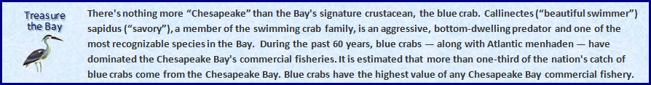

Criminal Cases

- Vessel Pollution Cases

Over the past decade, working in conjunction with the U.S. Coast Guard (USCG), ENRD, through the Environmental Crimes Section (ECS), has built a successful vessel pollution prosecution practice, focusing on the prosecution of individuals and corporations involved in pollution from ships and the deliberate falsification of official ship records designed to conceal illegal pollution. The Vessel Pollution Program is an ongoing, concentrated effort to detect, deter, and prosecute those who illegally discharge pollutants from ships into the oceans, coastal waters and inland waterways. Over the past 10 years, the criminal penalties imposed in such cases have totaled more than $200 million, and responsible shipboard officers and shore-side officials have been sentenced to more than 17 years of incarceration. The initiative has resulted in a number of important criminal prosecutions of key segments of the commercial maritime industry, including cruise ships, container ships, tank vessels, and bulk cargo vessels.

For example, four corporations involved in owning and operating a fleet of vessels regularly visiting New Orleans pleaded guilty and agreed to pay a $1 million penalty and be banned from doing business in the United States for the next five years. Stanships Inc. (Marshall Islands), Stanships Inc. (New York), Standard Shipping Inc. and Calmore Maritime Ltd., collectively the owners and operator of the M/V Americana, a Panamanian registered cargo vessel, each pleaded guilty to a total of 32 felony counts for violations of the Act to Prevent Pollution from Ships, Ports and Waterways Safety Act and obstruction of justice. The four corporations will be prohibited from further business in the United States during the maximum five year period of probation, during which the company owner is banned from owning or technically managing vessels. Of the $1 million penalty, $250,000 will be devoted to community service payments to help conservation, protection, restoration, and management projects to benefit fish and wildlife habitats and resources in the Eastern District of Louisiana.

The government’s investigation was initiated by a crew member informing the U.S. Coast Guard that the ship was illegally dumping sludge and oily waste overboard using a so-called “magic pipe” to bypass required pollution prevention equipment. The defendants admitted deliberate dumping and creating a false Oil Record Book to conceal the illegal discharges from the Coast Guard. The defendants also were charged with violating the Ports and Waterways Safety Act because they failed to report a hazardous situation that threatened U.S. ports and waters, involving the failure of the ship’s generators. In this case, the defendants admitted violating the terms of probation for a prior sentencing; Stanships Inc. (Marshall Islands) had already been sentenced for deliberate discharges in U.S. waters and concealing illegal pollution in falsified ship records from the M/V Doric Glory.

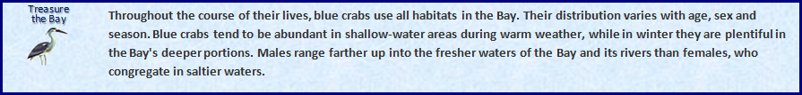

- Enforcing the Laws Against Overfishing
The Division continued to prosecute violations of the Lacey Act, a federal law that prohibits individuals or corporations from creating false records for fish or wildlife, and from transporting, selling, or buying fish and wildlife harvested illegally. In FY 2010 and FY 2011, a Washington, D.C., fish wholesaler, two of its employees, and a fisherman were found guilty of illegally harvesting and purchasing rockfish from 1995 through 2007. The charges resulted from an investigation and analysis beginning in 2003 by an interstate task force formed by the U.S. Fish and Wildlife Service, the Maryland Natural Resources Police and the Virginia Marine Police, Special Investigative Unit. In excess of one million pounds of striped bass worth more than $5 million were illegally harvested and sold through a number of schemes that involved the failure to affix required tags to the fish, fishing during closed season, falsely affixing required tags, taking fish in violations of size restrictions, falsifying required harvest records, and creating false receipts and records to conceal the harvests and sales from state regulators. The investigations and prosecutions resulted in the conviction of 19 individuals in Maryland, Virginia, and the District of Columbia, in addition to three corporate fish wholesalers. Combined, the individuals have been sentenced to more than 11 years in prison, and total fines and restitution have exceeded $1,361,000.
- Enforcing the Laws Protecting Wildlife
The Kaua‘i Island Utility Cooperative (KIUC) reached a plea agreement to resolve violations of the Endangered Species Act (ESA) and Migratory Bird Treaty Act (MBTA) that stemmed from the "taking" of several Newell’s shearwaters, a federally protected threatened species. Under the ESA, "take" means to harass, harm, pursue, hunt, shoot, wound, kill, trap, capture or collect, or to attempt to engage in any such conduct. KIUC admitted that it knew Newell’s shearwaters could collide with its power lines and that such collisions could kill and otherwise harm the birds. KIUC further admitted it knew that young shearwaters could be harmed by lights. But KIUC also admitted that it undertook limited or insufficient modifications to lines and lights and that several Newell’s shearwaters were found dead near power lines and lights. Necropsies of some birds concluded that they died from blunt force trauma consistent with a collision with a power line or other solid object.
KIUC was sentenced to the maximum statutory fine of $40,000 and a period of probation of 18 months with specific conditions intended to avoid additional violations. KIUC agreed to modify, reconfigure, and monitor power lines and apply for an incidental take permit that would authorize, as required by law, the taking of such threatened species under certain conditions and requirements. As community service, KIUC must make a payment of $225,000 to an account, established at the National Fish and Wildlife Foundation, to benefit protected seabirds on Kaua‘i.
The Newell’s shearwater (known in the Hawaiian language as ‘a‘o) is a seabird native to the Hawaiian Islands. The majority of the world’s population of Newell’s shearwaters nests on the island of Kaua‘i, specifically in burrows on inland mountains. Adult Newell’s shearwaters fly between the ocean and these nesting areas from spring through fall of each year. Young shearwaters leave these inland mountain nests and make their first flight to the sea from September to December each year, typically at night. The young birds use mountain air currents or physical drop offs to become airborne. If a young shearwater falls to the ground in a location without conditions such as those that occur in the inland mountains or at sea, it usually will be unable to regain flight.
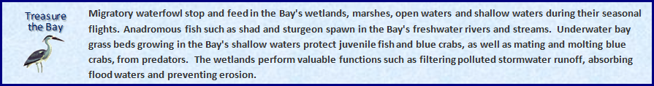

- Performance and Resources Table

Performance and Resources Table (Cont.)

Performance Measure Table

3. Performance, Resources, and Strategies

The Environment and Natural Resources Division contributes to the Justice Department’s Strategic Goal Two: Prevent Crime, Enforce Federal Laws, and Represent the Rights and Interests of the American People; and, more specifically, Strategic Objective 2.7: Vigorously enforce and represent the interests of the United States in all matters over which the Department has jurisdiction. The Division focuses on both civil and criminal litigation within this strategic objective. An explanation by litigating activity follows.

Criminal Litigating Activities

A. Performance Plan and Report for Outcomes

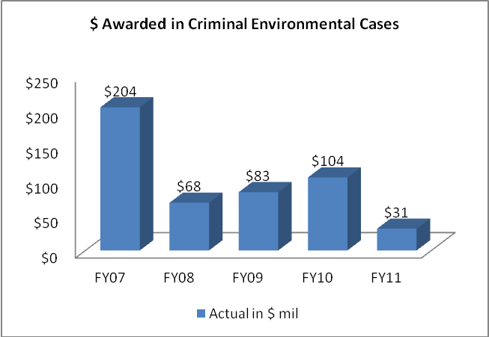
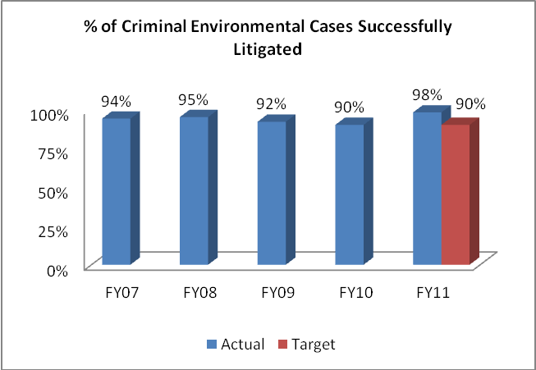

Data Collection and Storage: A majority of the performance data submitted by ENRD are generated from the Division’s Case Management System (CMS). Similarly, EOUSA data are extracted from their CMS.

Data Validation and Verification: The Division has instituted a formal data quality assurance program to ensure a quarterly review of the Division’s docket. The case systems data are monitored by the Division to maintain accuracy.

Data Limitations: Timeliness of notification by the courts.

Vigorous prosecution remains the cornerstone of the Department’s integrated approach to ensuring broad-based environmental compliance. It is the goal of investigators and prosecutors to discover and prosecute criminals before they have done substantial damage to the environment (including protected species), seriously affected public health, or inflicted economic damage on consumers or law-abiding competitors. The Department’s environmental protection efforts depend on a strong and credible criminal program to prosecute and deter future wrongdoing. Highly publicized prosecutions and tougher sentencing for environmental criminals are spurring improvements in industry practice and greater environmental compliance. Working together with federal, state and local law enforcement, the Department is meeting the challenges of increased referrals and more complex criminal cases through training of agents, officers and prosecutors, outreach programs, and domestic and international cooperation.

Performance Results

I. Performance Measure - Percent of Criminal Environmental Cases Successfully Resolved

- FY 2011 Target: 90%

- FY 2011 Actual: 98%

Discussion: In FY 2011, ECS successfully prosecuted a number of cases, including U.S vs. David Place. In that case, an antique dealer was sentenced to 33 months in prison for illegally importing and trafficking in narwhal tusks and sperm whale teeth. The market value of the goods illegally imported and sold by the defendant was determined to be between $200,000 and $400,000. Sperm whales are listed as “endangered” under the Endangered Species Act (ESA), and narwhals are listed as “threatened” under the ESA. Both species are also covered by the Convention on International Trade in Endangered Species of Wild Fauna and Flora (CITES). It is illegal to import parts of either into the United States without the requisite permits/certifications, and without declaring the merchandise at the time of importation to U.S. Customs and Border Protection and the U.S. Fish and Wildlife Service.
FY 2011 Performance Plan Evaluation: Our success rate of 98% exceeded our goal of 90%. Proposed legislation and judicial calendars can affect our overall performance, which can then realize spikes and valleys when large cases are decided. Our goal is to improve overall performance in a 5-year span.
FY 2012/2013 Performance Plan: We have set our target at 90 percent of cases successfully litigated for FY 2012 and FY 2013. ENRD targets are generally set at an attainable performance level so that there is no incentive to ramp up prosecutions or lawsuits against insignificant targets for “easy” wins solely to meet higher targets. Such an approach would do a disservice to the public by steering litigation away from more complicated problems facing the country’s environment and natural resources.

Public Benefit: The Division continues to produce successful criminal prosecutions relating to environmental statutes. These successes ensure compliance with the law and lead to specific improvements in the quality of the environment of the United States, and the health and safety of its citizens. Additionally, ENRD has had numerous successes in prosecuting vessels for illegally disposing of hazardous materials into United States waterways. These successes have improved the quality of our waterways and promoted compliance with proper disposition of hazardous materials. Also, the Division has successfully prosecuted numerous companies for violations of environmental laws which endangered their workers. Our successes lead to safer workplaces and fewer lives lost to hazardous conditions.

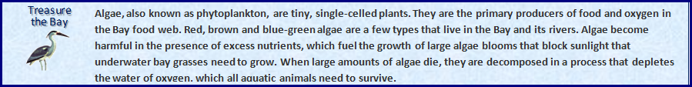

II. Performance Measure - $ Awarded in Criminal Environmental Cases

- FY 2011 Target: In accordance with Department guidance, targeted levels of performance are not projected for this indicator.

- FY 2011 Actual: $31.2 million

Discussion: In FY 2011, ENRD successfully prosecuted Eagle Recycling of New Jersey, which pleaded guilty to Clean Water Act violations for filling wetlands, and to committing wire fraud to conduct that filling. The company and other co-conspirators engaged in a multi-year scheme to illegally dump in New York 8,100 tons of pulverized construction and demolition debris that had first been processed in New Jersey. They concealed the dumping by fabricating a New York State Department of Environmental Conservation (DEC) permit and forging the name of a DEC official.

The company agreed to pay a criminal fine of $500,000, to implement an environmental compliance plan at its North Bergen facility, and to pay restitution which potentially includes cleanup costs at the Frankfort, N.Y., site.

FY 2012/2013 Performance Plan: Not Applicable. In accordance with Department guidance, levels of performance for FY 2012 and FY 2013 are not projected for this indicator. Many factors affect our overall performance, such as proposed legislation, judicial calendars, etc. The performance of the Division tends to reflect peaks and valleys when large cases are decided. Therefore, we do not project targets for this metric annually, but our goal is to improve overall performance over a 5-year span.

Public Benefit: The Division continues to obtain criminal fines from violators, thereby removing economic benefits of non-compliance and leveling the playing field for law-abiding companies. Our prosecution efforts deter others from committing crimes and promote adherence to environmental and natural resource laws and regulations. These efforts result in the reduction of hazardous materials and wildlife violations and improve the quality of the United States’ waterways, airways, land, and wildlife, thereby enhancing public health and safety.

B. Strategies to Accomplish Outcomes

The Division will continue efforts to obtain convictions and to deter environmental crimes through initiatives focused on vessel pollution, illegal timber harvesting, laboratory fraud, chlorofluorocarbon (CFC) smuggling, wildlife smuggling, transportation of hazardous materials, and worker safety. ENRD will also continue to prosecute international trafficking of protected species of fish, wildlife, and plants with a host of international treaty partners.

Illegal international trade in wildlife is second in size only to the illegal drug trade, and our criminal prosecutors work directly on these cases, as well as assist United States Attorneys Offices and share ENRD expertise nationwide with state and federal prosecutors and investigators. We will focus on interstate trafficking and poaching cases on federal lands, and seek to ensure that wildlife conservation laws are applied uniformly and enforced across the country, seeking consistency in these criminal prosecutions and a vigorous enforcement program that serves as an international role model.

ENRD has partnered with other federal agencies, such as EPA, to pursue litigation against criminal violators of our nation’s environmental policies. Egregious offenders are being brought to justice daily. The Division has worked collaboratively to identify violators who pose a significant threat to public health. By prosecuting criminal violations of regulations, ENRD is forcing compliance and discouraging continued disregard for public health.

Civil Litigating Activities

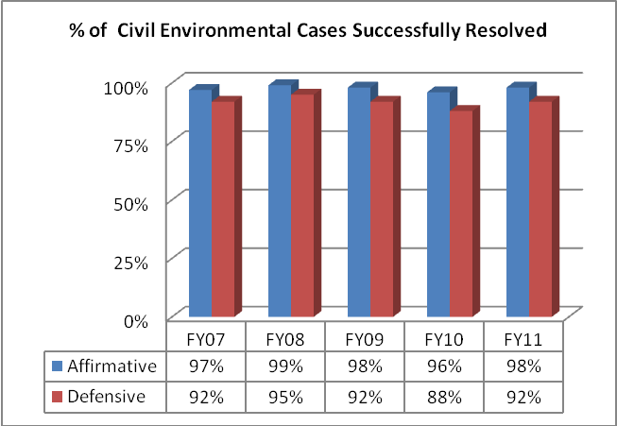

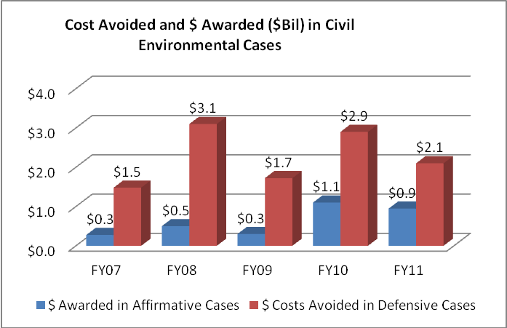

Data Collection and Storage: A majority of the performance data submitted by ENRD is generated from the Division’s Case Management System (CMS).

Data Validation and Verification: The Division has instituted a formal data quality assurance program to ensure a quarterly review of the Division’s docket. The systems data is constantly being monitored by the Division to maintain accuracy.

Data Limitations: Timeliness of notification by the courts

A. Performance Plan and Report for Outcomes

The Department enforces environmental laws to protect the health and environment of the United States and its citizens, defends environmental challenges to government programs and activities, and represents the United States in all matters concerning the protection, use, and development of the nation's natural resources and public lands, wildlife protection, Indian rights and claims, and the acquisition of federal property.

Performance Results

I. Performance Measure - Percent of Civil Environmental Cases Successfully Resolved

- FY 2011 Target:
85% Affirmative; 75% Defensive

- FY 2011 Actual:
98% Affirmative; 92% Defensive

Discussion: In FY 2011, ENRD ensured that harmful sediments are removed from rivers, state-of-the-art pollution control devices are added to factories to provide cleaner air, sewage discharges are eliminated, and damaged land and water aquifers are restored. ENRD also worked successfully to ensure the integrity of municipal wastewater treatment systems. Each year, hundreds of billions of gallons of untreated sewage are discharged into the nation’s waters from municipal wastewater treatment systems that are overwhelmed by weather conditions they are not designed to handle.

In FY 2011, the Division reached a settlement with Terra Industries Inc., one of the nation’s largest producers of nitric acid and nitrogen fertilizers. The company has agreed to pay $625,000 in civil penalties to settle alleged violations of the federal Clean Air Act at nine of its plants in Iowa, Mississippi and Oklahoma. Terra will also spend an estimated $17 million to install and implement new controls and technologies that are expected to reduce harmful nitrogen oxide emissions at its facilities by at least 1,200 tons per year. Terra is a major U.S. producer of nitrogen fertilizers, including anhydrous ammonia, urea, ammonia nitrate, and urea-ammonium nitrate (UAN). The company also produces nitric acid, a key intermediate in the manufacture of ammonium nitrate and UAN. Nitric acid production results in the emission of nitrogen oxides, which can cause lung damage, worsen respiratory diseases, contribute to acid rain and lead to the formation of smog. Terra allegedly constructed, modified and operated its facilities without obtaining appropriate pre-construction and operating permits, and without installing best available control technology for controlling air pollution. Terra also allegedly violated the Clean Air Act by failing to comply with applicable air emission limits and ongoing requirements for emissions monitoring, recordkeeping and reporting at some of its facilities.

FY 2011 Performance Plan Evaluation: We exceeded our goals-- Affirmative by 13%, and Defensive by 17%. The Division continues its strong record of success in civil environmental enforcement of federal pollution abatement laws, and compliance with environmental protection and conservation statutes. ENRD obtains redress for past violations harming the environment and establishes credible deterrents against future violations of these laws, recoups federal funds spent to abate environmental contamination, and obtains money to restore or replace natural resources damaged by oil spills or the release of other hazardous substances into the environment.

FY 2012/2013 Performance Plan: Considering our past performance, we aim to achieve litigation success rates of 85% Affirmative and 75% Defensive (average of 80%) for FY 2012 and FY 2013. ENRD’s targets are set lower than the actual performance so that there is no incentive to ramp up prosecutions or lawsuits against easy targets solely to meet an “ambitious” goal. This sort of easy approach would do a disservice to the public by steering litigation away from more difficult problems facing the country’s environment and natural resources. Several years of data demonstrate that our targets are set at achievable levels and do not deter high performance.

Public Benefit: The success of the Department ensures the correction of pollution control deficiencies, reduction of harmful discharges into the air, water, and land, clean-up of chemical releases, abandoned waste, and proper disposal of solid and hazardous waste. In addition, the Department’s enforcement efforts help ensure military preparedness, safeguard the quality of the environment in the United States, and protect the health and safety of its citizens.

II. Performance Measure - Costs Avoided and $ Awarded in Civil Environmental Cases

- FY 2011 Target: In accordance with Department guidance, targeted levels of performance are not projected for this indicator.

- FY 2011 Actual: $2.177 billion avoided; $564 million awarded

Discussion: The Division had several important civil litigation successes in FY 2011 in cases seeking civil penalties and other monetary recoveries. We continued to successfully litigate Clean Air Act (CAA) claims against operators of coal-fired electric power generating plants. These types of violations, litigated by ENRD’s Environmental Enforcement Section (EES), arise from companies engaging in major life extension projects on their facilities without installing required state-of-the-art pollution controls. The resulting tens of millions of tons of excess air pollution has adversely affected human health, degraded forests, damaged waterways, and contaminated reservoirs.
In FY 2011, the Division reached an agreement with Consol Energy Inc., the largest producer of coal from underground mines in the United States. The company will pay a $5.5 million civil penalty for Clean Water Act violations at six of its mines in West Virginia. Consol will spend an additional estimated $200 million in pollution controls that will reduce discharges of harmful mining wastewater into Appalachian streams and rivers. The company has agreed to build and operate an advanced wastewater treatment plant using reverse osmosis technology near Mannington, W.V., to remove high levels of chloride from mining wastewater. When completed, the plant will be the largest such treatment plant in Appalachia and capable of treating 3,500 gallons of mine water per minute, substantially reducing chloride and other salts in mining waters discharged to streams. This treatment will eliminate over 96 million pounds of total dissolved solids, including over 11 million pounds of chloride. High levels of chloride and dissolved solids can harm aquatic life, clog irrigation devices, and carry toxic chemicals that impact drinking water. Consol is alleged to have operated six mines that violated the pollution discharge limits in their Clean Water Act permits hundreds of times over the last four years, into the Monongahela watershed and tributaries of the Ohio River.

FY 2012/2013 Performance Plan: Not Applicable. In accordance with Department guidance, levels of performance are not projected for this indicator. There are many factors that affect our overall performance, including proposed legislation and judicial calendars. The overall performance of the Division can be affected when large cases are decided, so we do not project annually, but our goal is to improve overall performance in a 5-year span.

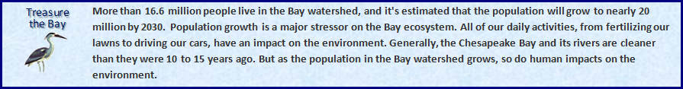

III. Efficiency Measures

1) Total Dollar Value Awarded per $1 Expenditures
[Affirmative]

2) Total Dollars Saved the Government per $1 Expenditures [Defensive]

- FY 2011 Target: $80 awarded; $21 saved

- FY 2011 Actual: $174 awarded; $30 saved

Discussion: The Division had a commendable FY 2011 in its efforts to secure commitments by polluters to take action to remedy their violations of the nation's environmental laws. Actions taken by the Division in Federal courts resulted in over $10.9 billion in settlements and court ordered injunctive relief. Additionally, the Division saved the government more than $2.1 billion in defensive litigation. These successes and the Division’s enforcement work have produced significant gains for the public fisc, public health, and the environment. The Division routinely saves the American taxpayers hundreds of millions of dollars each year – many times the Division’s annual budget. Accordingly, in FY 2011, ENRD exceeded its performance goal of total dollars saved the government per $1 expenditures.

FY 2012/2013 Performance Plan: The Division has an exemplary record in protecting the environment, Indian rights, and the nation’s natural resources, wildlife, and public lands, and will continue to establish ambitious targets through FY 2013. The Division will monitor future year performance levels and make the necessary adjustments so that targets reflect actual performance levels. The Division anticipates continued success through vigorous enforcement efforts which generally will produce settlements and significant gains for the public and the public fisc.

Public Benefit: The Division’s efforts to defend federal programs, ensure compliance with environmental and natural resource statutes, win civil penalties, recoup federal funds spent to abate environmental contamination, ensure military preparedness, and ensure the safety and security of our water supply, demonstrate that the United States’ environmental laws and regulations are being vigorously enforced. Polluters who violate these laws are not allowed to gain an unfair economic advantage over law-abiding companies. The deterrent effect of the Division’s work encourages voluntary compliance with environmental and natural resource laws, thereby improving the environment, the quality of our natural resources, and the safety and health of United States citizens.

B. Strategies to Accomplish Outcomes

As our environment changes, so do the actions we take to preserve the health and life of those residing within the borders of the United States. Environmental groups and other interested parties challenge Administration policies every year. ENRD is responsible for defending federal agencies carrying out Administration policies every day. The Division has realized some remarkable successes to date. In an effort to continue our successful record of litigation, the Division has sought new and creative ways to utilize our limited resources. ENRD has adopted a policy of “porosity” whereby specialized attorneys are provided an opportunity to work on cases outside of their expertise to gain perspective and depth. This policy has resulted in more flexibility to shift workloads between attorneys when they become overburdened. Although cross-training staff grows our workforce’s skills and abilities, it does not address long-term caseload issues.

The Division works collaboratively with client agencies towards adjudications, mediations, alternative dispute resolution (ADR), and settlements. These alternative methods of resolution are less contentious and save the government expenses associated with full-blown litigation. Water rights adjudications, reclamations, and inverse takings cases are typically handled in settlement mode versus litigation mode. Settlements have the best outcome, and reach the largest number of people. In order to continue achieving successful settlements, ENRD must remain committed to collaborative negotiations with all interested parties. If a policy shift occurs, ENRD will be forced to take a more aggressive litigation stance, which would be costly without demonstrating added value for the Federal Government.

VI. Program Offsets by Item

Item Name: Information Technology Efficiencies

Budget Decision Unit: Environment and Natural Resources Division

Strategic Goal & Objective: Strategic Goal Two, Objective 2.6: Protect the federal fisc and defend the interests of the United States.

Organizational Program: Information Technology

Component Ranking of Item: 1 of 1

Program Reduction: Positions 0 Agt/Atty 0 FTE 0 Dollars -$84,000

As part of its effort to increase IT management efficiency and comply with OMB’s direction to reform IT management activities, the Department is implementing a cost saving initiative as well as IT transformation projects. To support cost savings, the Department is developing an infrastructure to enable DOJ components to better collaborate on IT contracting, which should result in lower IT expenditures. In FY 2013, the Department anticipates realizing savings on all direct non-personnel IT spending through IT contracting collaboration. These savings will not only support greater management efficiency within components but will also support OMB’s IT Reform plan by providing resources to support major initiatives in Cybersecurity, data center consolidation, and enterprise e-mail systems. The savings will also support other Department priorities in the FY 2013 request. The offset to support these initiatives for ENRD is $84,000.

Funding

Non-Personnel Reduction Cost Summary

Non-Personnel Item | Unit | Quantity | FY 2013  Request  ($000) | FY 2014 Net  Annualization (change from 2013)  ($000) | FY 2015 Net  Annualization (change from 2014)  ($000)
Total Non-Personnel |  |  | ($84)

VII. Exhibits

