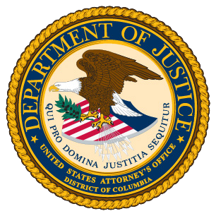 |  | U.S. Department of Justice  Jeanine Ferris Pirro  United States Attorney for the  District of Columbia  Patrick Henry Building  601 D St. NW.  Washington, D.C. 20579
PRESS RELEASE
FOR IMMEDIATE RELEASE  August 21, 2026 | For Information Contact:  Public Affairs  USADC.Media@usdoj.gov  http://www.justice.gov/usao/dc/index.html
Notice Regarding AVA Health Care Center

WASHINGTON - On August 12, 2026, the United States District Court for the District of Columbia issued an order authorizing the use and disclosure of records for patients treated by AVA Health Care Center, which operated at 7603 Georgia Avenue, NW, and 2706 Bladensburg Road NE, Washington, D.C.

If you are a patient whose records were disclosed, the person holding the records, or the Part 2 program, you have an opportunity to seek revocation or amendment of the order by filing a motion with the clerk of the court pursuant to Title 42, Code of Federal Regulations, Section 2.66. Your opportunity is limited to the presentation of evidence regarding the statutory and regulatory criteria for the issuance of the court order.

For further information regarding this notice, please contact Special Agent Ryan Stranahan of the Federal Bureau of Investigation at (786) 459-0798 or rstranahan@fbi.gov.

##

