WILL I BE NOTIFIED OF THE SENTENCE AND RESTITUTION?
WILL I BE ABLE TO MAKE A
STATEMENT AT SENTENCING?
Except in limited circumstances, under federal law, victims have the right to not be excluded from public court proceedings, including sentencing.
Victims also have the right to be reasonably heard at sentencing. If you would like to speak to the judge at sentencing, please contact the USAO or the U.S. Probation
Office as soon as possible.
Yes. You will receive notice from the U.S. Attorney’s Office advising you of the sentence imposed and the amount of restitution ordered payable to you, if any. In the event enough restitution is collected by the U.S. District Clerk’s Office to make a payment, a payment will be sent to you in the form of a U.S. Treasury check. It is important that if restitution is ordered on your behalf that you keep our office updated of your current contact information. You will also be automatically enrolled in the Bureau of Prisons Victim Notification program which enables victims to receive notice of a prisoner’s escape, release, furlough, death, etc.

VICTIM IMPACT STATEMENTS: KNOW YOUR RIGHTS

Northern District of Alabama

U N I T E D S T A T E S
A T T O R N E Y ’ S O F F I C E

WHAT IS RESTITUTION?
Restitution is part of a sentence that requires offenders to “make amends” to their victim(s) for any loss, damage, or injury resulting from the crime. Some examples of expenses you may have paid or owe include medical bills or supplies; eyeglasses or hearing aid replacement or repair; counseling costs; lost wages (in limited circumstances); funeral expenses; lost, stolen or damaged property, which may include crime scene cleanup; and the repair or replacement of door locks and security devices. It is important to provide copies of any bills or other proof of money you have spent or expect to spend in the future.
In addition to medical or counseling bills, you may be able to include any wages that you lost as a result of the crime. If you have any questions regarding whether you can include this financial loss on your financial impact statement, please contact the USAO.

CRIME VICTIM
COMPENSATION
Did you know that you may be able to receive financial help from the Crime Victim Compensation Program? This program can pay victims back for certain types of out-of-pocket expenses for physical or emotional injuries received as a direct result of the crime. These expenses include medical bills, counseling costs, funeral bills, and lost wages. This is not the same as restitution. You can file for benefits immediately following the crime, even if no arrest has been made. You may be able to receive money to help you with some of your medical bills even before you go to court. If you would like more information on the benefits available, or how to apply for compensation, please contact our office for assistance or contact the Alabama Crime Victims Compensation Program at 800-541-9388.

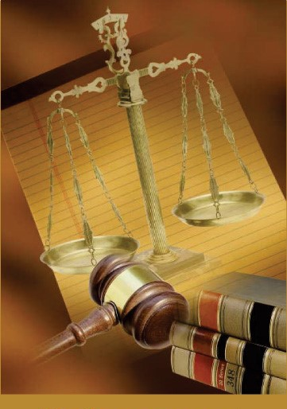
Victim-Witness Program
Tonja Benninger-Holtkamp
Victim Assistance Specialist
205-244-2093

The Impact of The Crime

WHAT IS A VICTIM IMPACT STATEMENT?
Victim impact statements can be either written or oral statements that are presented to the judge to review before sentencing the defendant. Written impact statements are submitted to the United States Attorney’s Office and then forwarded to the U.S. Probation Office to be included as part of the Presentence Investigation Report submitted to the judge prior to sentencing.
Victim impact statements describe the emotional, physical, and financial impact you and others have suffered as a direct result of the crime. Since some victims are uncomfortable with completing a formal written statement for review, the judge may also consider a personal letter. Written Victim Impact Statements are usually seen by the defendant and the defense attorney.
Written victim impact statements differ from oral victim impact statements in some respects. You are afforded the right, under the Crime Victims’ Rights Act, to be reasonably heard at the sentencing. If you would like to speak at the sentencing, it is important to contact the
U.S. Attorney’s Office Victim Witness
Coordinator as soon as possible, and prior to
the hearing.

WHAT IS THE PURPOSE OF THE VICTIM IMPACT STATEMENT?
1. It provides an opportunity to express in your own words what you, your family, and others close to you have experienced as a result of the crime. Many victims also find it helps provide some measure of closure to the ordeal the crime has caused.
- The victim impact statement assists the judge when he or she decides what sentence the defendant should receive. Although the judge will decide the defendant’s sentence based primarily on the pre-sentence report and certain sentencing guidelines, the judge should consider your opinion before making a decision.
- Finally, it includes a financial loss statement which is used to verify and assess the financial impact of the crime upon you. This information is used by the Judge to determine any money the defendant may have to pay you for expenses you have paid or money you owe because of the crime. When the judge orders the defendant to pay the victim it is called “restitution.” If the judge orders the defendant to pay you restitution, there is no guarantee that the defendant will be able to pay you the entire amount ordered.

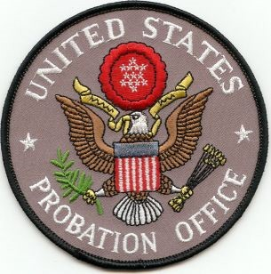

WHAT IS A PRE-SENTENCE REPORT?
The Victim Impact Statement is an important part of the Presentence Investigation Report (PSR) prepared by the U.S. Probation Office. A PSR includes, among other things, the defendant’s criminal and social history; the details of the crime; the financial, social, psychological, and, if relevant, medical impact of the crime on the victims; and any victim impact statements. The PSR helps the Judge determine the proper sentence to impose.
Sometime prior to the sentencing hearing, the U.S. Probation Office may contact you, either by phone or letter, to inquire about the impact the crime has had on you.

