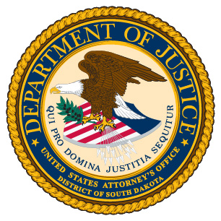

**DEPARTMENT OF JUSTICE**

**United States Attorney Ronald A. Parsons, Jr.**

**District of South Dakota**

FOR IMMEDIATE RELEASE CONTACT: Ace Crawford

Date: January 29, 2020 Phone: 605.341.1915

**U.S. Attorney Ron Parsons Statement on Pending Expiration of Emergency Prohibition of Fentanyl Analogues**

“***There is no legitimate reason for anyone to possess or distribute fentanyl analogues. They are weapons of mass destruction, capable of killing a human being almost immediately upon ingestion or contact in extremely minute amounts.”***

The opioid crisis has impacted almost every community in South Dakota. In an effort to combat this deadly drug epidemic, the Drug Enforcement Administration used its statutory authority in February 2018 to issue a temporary emergency two-year order that made all fentanyl-related substances illegal. Working hand-in-hand with federal, state, local, and tribal law enforcement here in South Dakota, this office has vigorously prosecuted anyone caught trafficking in fentanyl or fentanyl-related substances. Nationally, as well as locally, we have seen a substantial supply impact from DEA’s temporary scheduling of fentanyl-related substances during the past two years, with a 50 percent decrease in fentanyl-related substances encountered across the United States.

However, the DEA’s emergency prohibition of fentanyl analogues expires at midnight on February 6, 2020, unless Congress acts to extend it. This is a looming catastrophe. Fentanyl and its analogues are responsible for dozens of overdoses and multiple deaths in South Dakota.  Without action by Congress, law enforcement will not have all of the tools needed to protect South Dakotans from the onslaught of these extraordinarily dangerous substances.

Fentanyl and its chemical analogues are illegally distributed in the United States through two primary methods. Many are designed and manufactured in China, ordered over the Dark Web by drug dealers, and then shipped to them using the U.S. mail and private delivery companies. Increasingly, however, the Mexican cartels responsible for making most of the methamphetamine and heroin smuggled across our southern border and sold in the U.S. have begun making fentanyl and related substances themselves and selling them through their distribution networks.

There is no legitimate reason for anyone to possess or distribute fentanyl analogues. They are weapons of mass destruction, capable of killing almost immediately upon ingestion or contact in extremely minute amounts.

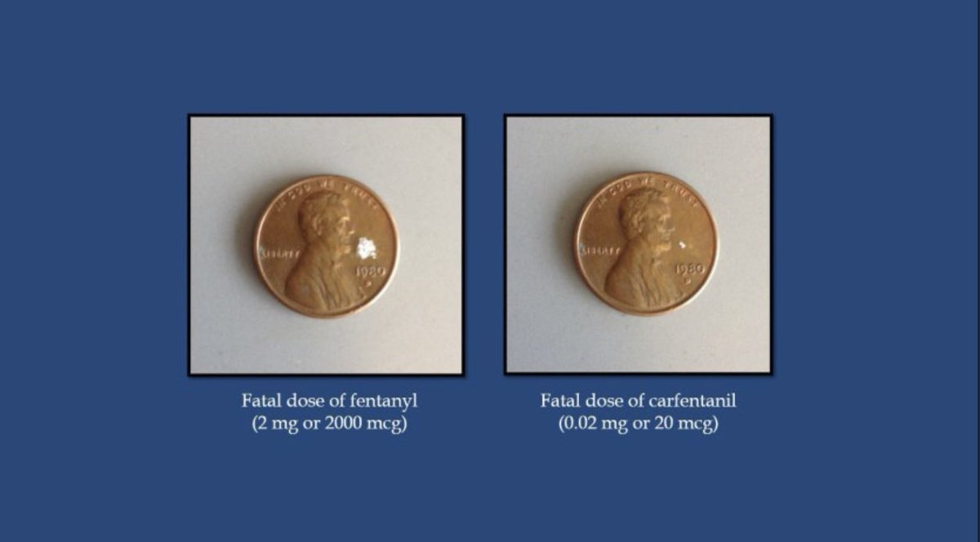

On behalf of the United States Department of Justice, I am urging Congress to give us the tools we need to continue our efforts against the distribution of fentanyl analogues here in South Dakota.  This fight is far from over.  We need every tool we have to target these fatally dangerous drugs. Congress must take action immediately to extend the scheduling of these dangerous substances.

# # #